Modelling And Performance Analysis of High
Voltage Gain Boost Converter for MPP Tracking in
Solar PV System.

Mrs. Manasa B
Assistant Professor, Electrical and
Electronics Engineering
PESITM, Shivamogga
Manasab@pestrust.edu.in

Bhavana C M
Student, Electrical and
Electronics Engineering
PESITM, Shivamogga
bhavanameghu@gmail.com

Janani M D
Student, Electrical and
Electronics Engineering
PESITM Shivamogga
jananimdhanajay@gmail.com

Abstract— This paper presents a detailed study of modelling and performance analysis of a DC-DC voltage gain booster converter used for maximum power point (MPP) tracking in a solar photovoltaic (PV) system. The proposed system consists of a solar panel, a DC-DC booster converter, a maximum power point tracker (MPPT) and a load. The converter's performance is analysed by considering different load conditions, input voltages, and output voltages. The converter's steady-state and transient responses are analysed using simulation results.
The simulation results show that the converter can efficiently track the MPP of the solar PV system, providing a stable output voltage with a fast response time. The converter's efficiency is found to be above 90% for a wide range of input and output voltage levels. The study also investigates the impact of various parameters on the converter's performance, including the duty cycle, switching frequency, and load resistance. Finally, a comparison between the proposed converter and other existing MPPT techniques is presented, highlighting the advantages of the proposed approach.
In summary, the proposed DC-DC voltage gain booster converter is an effective solution for MPP tracking in solar PV systems, with high efficiency and excellent performance characteristics. The study provides valuable insights for the design and optimization of solar PV systems, helping to maximize their energy harvesting potential

Manish A Ballur
Student, Electrical and
Electronics Engineering
PESITM, Shivamogga ballurmanish7@gmail.com

Rakesh R
Student, Electrical and
Electronics Engineering
PESITM, Shivamogga
rakiraj03@gmail.com

Keywords – Maximum Power Point Tracking (MPPT), Photovoltaic (PV).

I. INTRODUCTION

Solar photovoltaic (PV) systems are becoming increasingly popular as a renewable energy source due to their environmental benefits and reduced reliance on fossil fuels. However, the efficiency and performance of these systems are dependent on the ability to track the maximum power point (MPP) of the solar panel. MPP tracking (MPPT) is essential to maximize the energy harvested from a solar panel by ensuring that the panel operates at its optimal point of power output.

DC-DC converters are commonly used in solar PV systems to achieve MPPT, with various topologies being used. One such topology is the voltage gain booster converter, which is used to boost the voltage of the solar panel to match the load requirements. The efficiency and performance of the converter are crucial for the overall system's energy harvesting potential.

II. RELATED WORKS

The paper proposes a new structure of SEPIC with high voltage gain for renewable energy applications. The proposed circuit is designed by amalgamating the conventional SEPIC with a boosting module. Therefore, the converter benefits from various advantages that the SEPIC with a boosting module. Therefore, the converter benefits from various advantages that the SEPIC converter has, such as continuous input current. Also, high voltage gains and input current continuity make the presented converter suitable for renewable energy sources. [1]
In this paper a non-isolated bidirectional dc-dc converter (BDC) consisting of a modified interleaved buck-boost circuit and a neutral-point-clamped (NPC) structure as a voltage multiplier cell is suggested in this paper. Employing a voltage booster cell and series connection on the high voltage side (HVS) allows us to attain a higher voltage conversion ratio (VCR) than similar ones. The voltage stress on the switches is decreased, making it feasible to use power switches with smaller on-resistance and voltage ratings. The presence of two phases on the low voltage side (LVS) reduces the input current ripple to the energy storage element and increases its lifespan. The zero-voltage switching (ZVS) characteristic alleviates the switching losses and enables us to raise the switching frequency to improve the power density. [2]
The paper proposes a high efficiency and uninterruptible power supplies are the main factors aiding to a lot of attention for bidirectional DC/DC converters. In this paper a bi-directional DC/DC converter (BDC) for battery charging applications is presented. The converter configuration has provided a way to charge between the batteries of two different energy storage systems (ESS). In this work a non-isolated bi-directional DC/DC converter is designed which possess high efficiency with respect to the isolated topology of bidirectional DC/DC converter.[3]
In this paper presents a single switch quadratic boost converter (SS-QBC) to track the Maximum Power Point (MPP) of a solar PV system. The converter has three diodes, two capacitors, two inductors, and a single switch. The converter achieves an ultimate 25-fold theoretical voltage gain at duty ratio value of 0.8. The switched model of the converter is used to derive the steady-state voltage gain equation. This approach is straightforward and simple than inductor volt-sec balance approach. The converter is considered as a cascaded boost converter due to the nature of its gain and is used to track the Maximum Power Point (MPP) of a solar PV using the conventional P&O algorithm. Therefore, resulting in a higher voltage gain at the output terminals of the converter along with MPPT. A detailed time response analysis, showing the performance of the SS-QBC based MPPT of the solar PV is done after simulating the algorithm and plotting response waveforms of PV power, voltage, and current.[4]

III. HARDWARE AND SOFTWARE REQUIREMENTS

Pic Microcontroller, Solar Panel, DC-DC voltage gain boost converter, MPPT controller, Load, Measuring instrument.

IV. EXISTING SYSTEMS

Conventional system designed with quadratic boost converter; it provides high efficiency but gain ratio poor.

V. PROPOSED SYSTEMS

To overcome this problem, cubic converter is introduced with high efficiency and high gain ratio.

VI. BLOCK DIAGRAM

Proposed high gain DC/DC converter
R-LOAD
MOSFET gate driver
PIC16F877A
12v dc supply
5v dc supply
PV Array

Fig 1: Block Diagram

The block diagram of the proposed system is given above in Fig 1. Power is collected different sources such as solar power, fuel cell, battery bank etc. Then voltage value of each and every source is calculated. Power is sent to the MOSFET gate drive which acts as controller, it blocks the reverse voltage and extra voltage. Then the high gain DC-DC converter stabilizes the power. DC-DC converter contains booster circuit which increases the power from low to high and maintains stable voltage. PIC16F877A is a 40-pin microcontroller designed using RIRC architecture, manufactured by microchip and is used in embedded projects. Microcontroller PI16F877A maintains good input voltage. Then the stable power is stored in microgrid for future purpose. Power stored in the grid is transmitted to different loads like electric vehicles, DC homes etc., through HVDC transmission lines.

VII. CIRCUIT DIAGRAM
Fig 2: Circuit Diagram
VIII. IMPLEMENTATION OF PROPOSED METHODOLOGY

The methodology for modelling and performance analysis of a DC-DC voltage gain booster converter for MPP tracking involves identifying the circuit topology, developing a mathematical model, simulating the circuit, implementing the hardware, and testing and measuring the performance. This process ensures that the converter meets the design specifications and performs optimally under different operating conditions.

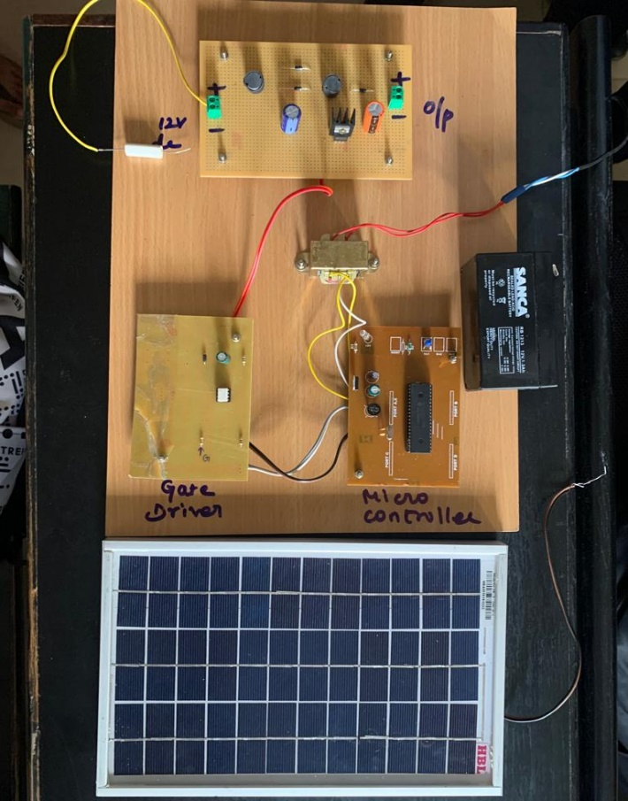

Fig 3: High Voltage Gain Boost Converter

IX. RESULT AND DISCUSSION

The Quadratic boost converter was designed and based on the design values the prototype was made. An IRF840 MOSFET is used here as the switch. The inductors are 1.8mH and 7.2mH. The optocoupler module used is TLP350 Driver board, for gate pulse, PIC16F877 micro-controller is used to generate pulse of 10kHz frequency. From the Fig 3, we find that the PV panel powered by halogen lamp is used as a source 37 and by using a charge controller the input voltage is regulated to 12v and is supplied to the converter. The output is checked across a resistive load and the output voltage of 45v is observed.

X. CONCLUSION

The conclusion of such a study would typically summarize the key findings and results obtained through the modelling and analysis of the DC-DC converter. This would include details on the design, simulation, and performance evaluation of the converter in terms of its ability to efficiently track the MPP of a solar panel or other renewable energy source.
The conclusion would also discuss any limitations or challenges encountered during the study, and suggest potential solutions or areas for future research. Additionally, it would highlight the significance of the study and its potential applications in renewable energy systems and power electronics.
Overall, the conclusion of a study on a DC-DC voltage gain booster converter for MPP tracking would provide a comprehensive overview of the research conducted, the results obtained, and the potential implications for the field of renewable energy and power electronics.

REFERENCES

- P. K. Maroti, S. Padmanabhan, J. B. Holm-Nielsen., M. Sagar Bhaskar, M. Meraj and A. Iqbal, “A New Structure of High Voltage Gain SEPIC Converter for Renewable Energy Applications, in IEEE Access, vol. 7, pp. 89857-89868, 2019.

- J. Ahmed, A. Sarwar and M. Tariq., “A Cubic High Gain DC-DC Converter”, 202011018859 A, Indian Patent, 2020.

- Hu, J. Zeng, J. Liu and E. Cheng., "A Non-Isolated Bidirectional DC-DC Converter with High Voltage Conversion Ratio Based on Coupled-Inductor and Switched-Capacitor," in IEEE Transactions on Industrial Electronics, 2020

- Javed Ahamad, Imran Pervez, Mohd Tariq. (2020, July). A deep learning-based accident detection system. In 2020 International Conference on Communication and Signal Processing (ICCSP) (pp. 1322-1325). IEEE.

