Efficient IOT SERVICE DEPLOYMENT VIA DECENTRALIZED EDGE-TO-CLOUD LOAD BALANCING
Ms.S.R.Sri Abirami¹, A.Prakash², S.Dhinesh kumar³.
¹Associate Professor, Department of Information Technology, Nandha Engineering College-Erode- 638052, Tamilnadu, India.
^{2,3}UG Scholar, Information Technology, Nandha Engineering College-Erode- 638052, Tamilnadu, India.
E-mail: ericknandhu666@gmail.com
ABSTRACT
Virtual Machines (VMs) in cloud systems are scheduled for hosts based on how quickly they use resources, like hosts with the most RAM, without taking into account how they will be used over time. Likewise, by and large, the booking and situation processes are computational costly and influence execution of conveyed VMs.An algorithm for scheduling virtual machines (VMs) in the cloud that employs the PSO technique and takes into account the resource consumption of VMs that are already running over time is presented in this work.
INTRODUCTION
CLOUD COMPUTING
The next generation of computational paradigm is cloud computing. By utilizing the idea of virtualization, Cloud Computing is rapidly consolidating itself as the future of distributed on-demand computing. It is emerging as a crucial backbone for a variety of internet businesses. However, one of today's most successful business models is the Internet-enabled business, or e-business. Computing is being transformed into a model of services that are commoditized and delivered in a manner similar to traditional utilities like water in order to meet the requirements of internet-enabled businesses. Services can be accessed by users in accordance with their needs, regardless of where they are hosted or how they are delivered. A few processing ideal models have vowed to convey this utility figuring.
One such dependable computing paradigm is cloud computing. There are two parts to cloud computing architecture: the front end and the back end. These two closures are associated by Web or Intranet. Client devices like mobile phones, thin clients, and fat clients make up the front end. For clients to access the cloud computing system, an interface and applications are required. The various servers and data storage systems make up the back end. Another server is known as the "Central Server." A focal server is utilized for directing the cloud framework. In addition, it keeps an eye on all traffic and responds immediately to customer requests.
LITERATURE REVIEW
IDENTITY-BASED REMOTE DATA INTEGRITY CHECKING WITH PERFECT DATA PRIVACY PRESERVING FOR CLOUD STORAGE." Remote data integrity checking (RDIC) enables a data storage server, such as a cloud server, to demonstrate to a verifier that it is in fact storing the data of a data owner A number of RDIC protocols have been proposed in the literature up to this point. However, the majority of the constructions have a problem with complicated key management because they rely on expensive public key infrastructure (PKI), which may make it harder to use RDIC in practice. By employing a key-homomorphic cryptographic primitive, we propose a novel construction of the identity-based (ID-based) RDIC protocol to reduce system complexity and the cost of establishing and managing the public key authentication framework in PKI-based RDIC schemes. We make ID-based RDIC and its security model official, protecting it from a malicious cloud server and protecting zero-knowledge privacy from a third-party verifier. During the RDIC process, the proposed ID-based RDIC protocol does not disclose any of the stored data to the verifier. In the generic group model, the new construction has been shown to be secure against the malicious server and achieves zero knowledge privacy against a verifier. The results of extensive security analysis and implementation show that the proposed protocol is proven to be safe and can be used in real-world applications.
Identity-based remote data integrity checking, a novel primitive for secure cloud storage, was the subject of our investigation in this paper. We formalized the security model for this primitive's soundness and complete data privacy, two crucial characteristics. We demonstrated the viability and complete data privacy of a novel construction of this primitive. The proposed protocol's efficacy and practicality were demonstrated by both the numerical analysis and the implementation. In PDP, the owner of a data file creates some metadata for the file, sends it to a remote server with the metadata, and then deletes the file from its local storage. A response to a challenge from the verifier is computed by the server to produce evidence that the server correctly stores the original file. The verifier can check the response's accuracy to see if the file remains unchanged. Due to its spot-checking approach, PDP is a practical method for verifying cloud data integrity. In particular, a file is broken up into blocks, and a verifier only tests the integrity of a small number of clocks chosen at random[1].
PROPOSED FRAMEWORK
The goal is to propose the idea of VM booking as per asset checking information removed from past asset usages and dissect the past VM use levels by utilizing two arrangement methods, for example, PSO to plan VMs by enhancing execution. The proposed VM booking calculation upgrades the VM determination stage in light of continuous checking information assortments and examination of physical and virtual assets. Our point is to reinforce VM planning for request to integrate models connected with the genuine VM usage levels, so VMs can be put by limiting the punishment of generally execution levels. The enhancement plans include examination on the generally sent VMs to incorporate (a) expansion of use levels and (b) minimization of the presentation drops.
The reality that clients, have underutilized VMs and don't have a similar asset utilization design throughout the day. At last, Cloud the board processes, for example, VM position, influence previously conveyed frameworks (for instance this could include throughput drop in a data set group) too stacked VMs will quite often take computer processor times from adjoining VMs. These address straightforward cases that show the requirement for a more refined VM planning that could further develop execution. The information dataset of VMId, central processor, Smash , BW. The cloud , in which computer processor , Slam , Data transmissions is made.
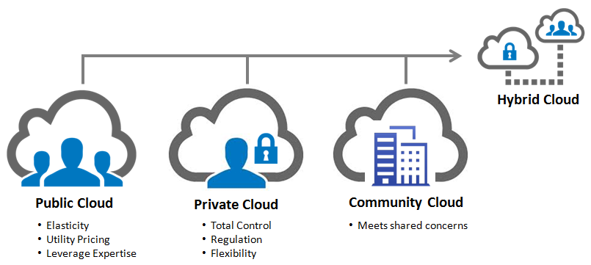

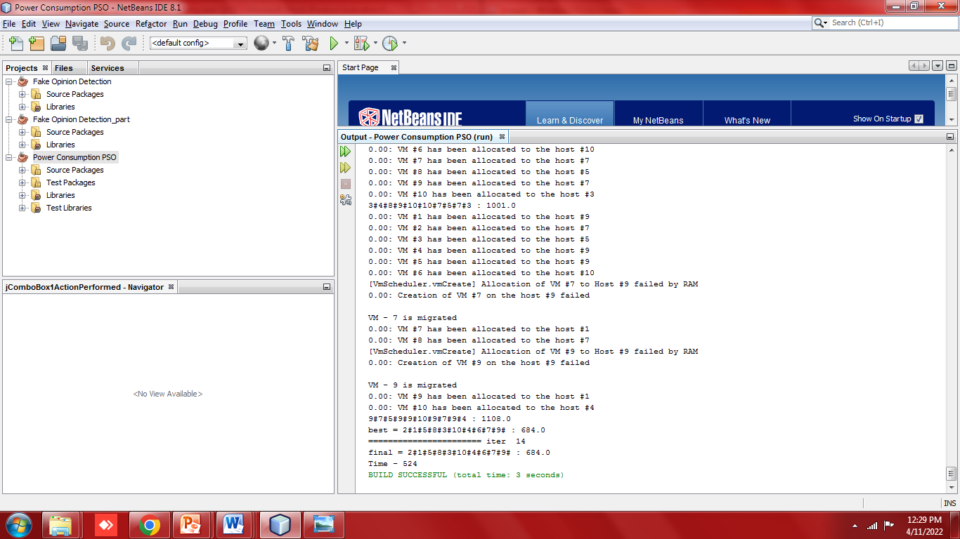

The VM machine of the designation is finished with of VM id has been allotted to the host of that specific host id. The movement of the VM is done so the distributed host is schedulred.out supervision. A training dataset is fed into the classification algorithm in a supervised model.

MODULE DESCRIPITION
- VM BOOKING
- CHARACTERIZATION CALCULATION
- PARTICLE MULTITUDE STREAMLINING
- ADVANCEMENT PLAN
VM PLANNING
The proposed calculation upgrades the VM choice stage in light of ongoing dataset checking information assortments and examination of physical and virtual assets. Our point is to fortify VM planning. To integrate rules connected with the real VM use levels, so VMs can be set by limiting the punishment of generally speaking execution levels. The streamlining plans include examination to the generally conveyed VMs to incorporate (a) expansion of use levels and (b) minimization of the exhibition drops. An observing motor that permits online asset use checking information assortment from VMs. The motor is equipped for gathering framework information in view of span and stores it to a web-based cloud administration that makes it accessible for information handling. Information is gathered each a minuscule time stretch (for example 1 second) and is put away in a brief neighbourhood document.
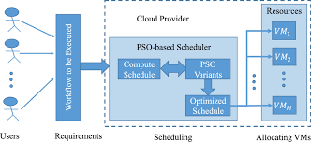
FIGURE VM RESOURCE MONITORING PROCESS VM SCHEDULING

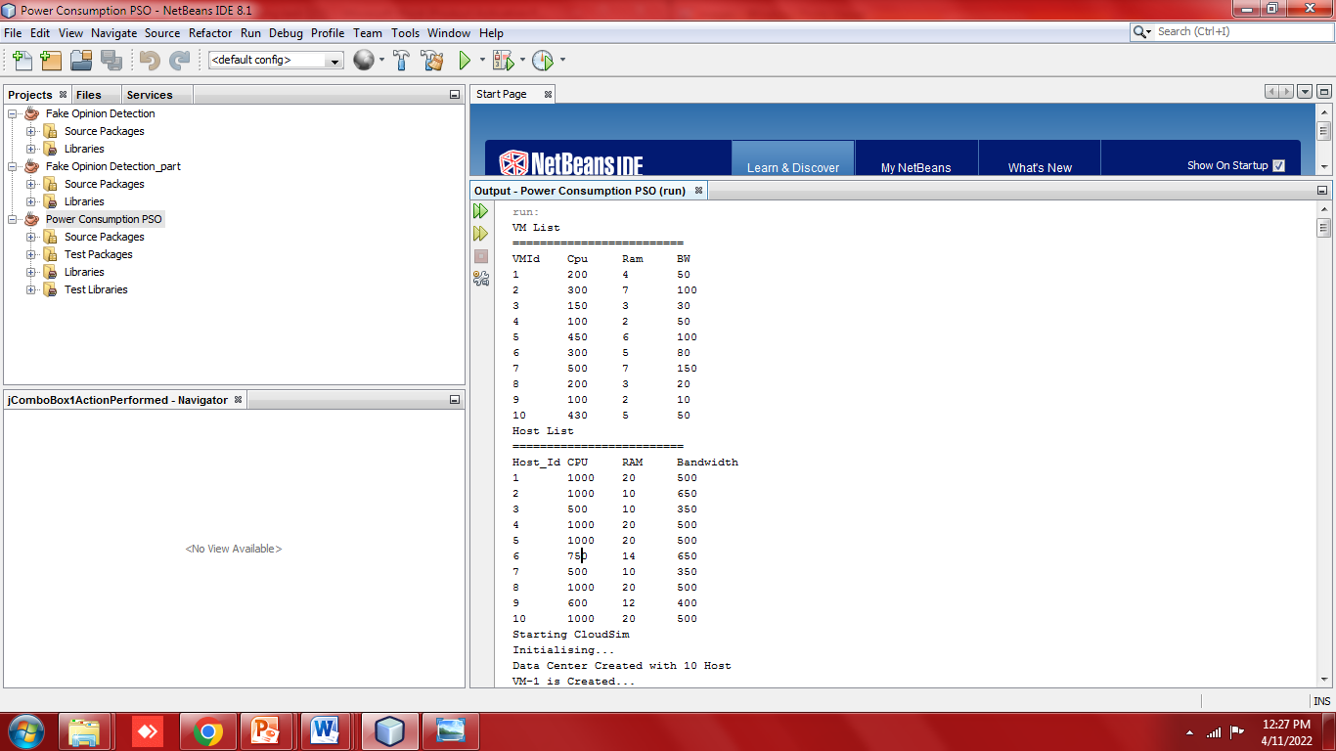

ARRANGEMENT CALCULATION
At the point when directed AI calculations are considered for grouping reason, the info dataset is wanted to be a marked one.
MOLECULE MULTITUDE IMPROVEMENT
Molecule swarm streamlining (PSO) is one of the bio-roused calculations and it is a straightforward one to look for an ideal arrangement in the arrangement space. It is not quite the same as other streamlining calculations so that main the goal capability is required and it isn't subject to the angle or any differential type of the goal. It likewise has not very many hyper boundaries.
RESULTS
The emphasis is on the CloudSim that is an open source programming to assemble private and public mists. Cloudsim default arrangement includes setting VMs by choosing the host with the most accessible memory until the VMs number surpasses the breaking point. Likewise, the asset examination in light of past asset utilization by fostering an AI model that investigations VMs asset use on-the-fly. Virtual Machines (VMs) are planned to has as per their moment asset use (for example to has with most accessible Slam) disregarding their by and large and long haul usage. Likewise, by and large, the booking and arrangement processes are computational costly and influence execution of conveyed VMs. In this way the conventional VM situation calculation doesn't consider past VM asset usage levels.
To defeat this VM booking calculation is carried out. The idea of VM planning as indicated by asset observing information removed from past asset usages (counting VMs and VMs) and the asset information are ordered utilizing the improvement strategies PSO, in this way playing out the booking. The calculation assesses past asset use levels and arranges as indicated by the general asset utilization. Toward the end the rundown of applicant has is populated and the assets are positioned appropriately. Exhaustively, by utilizing this calculation VMs are re-positioned by the chose advancement conspire and in light of their VM use. For instance we use as informational collection asset data from 24 hours checking and as preparing set a multi day asset use observing. The investigation are (a) as indicated by usage levels over the long haul by portraying it as low, medium and weighty and (b) as per proceeds with information (for example memory percent that increments over the long haul). The calculation plays out a weighting interaction for the chose VMs as indicated by various highlights (for example Central processor, Smash rate).
The formula for computing absolute error is:
e_{a} = | x_{m} - x_{t} |

CONCLUSION
Different virtual machine arrangement calculations were utilized for planning by picking actual machines as per the framework information (for example utilization of computer chip, memory, transfer speed) in cloud framework. The present VM position doesn't consider of realtime VM asset use levels. Here we another VM position calculation in light of past VM utilization encounters is proposed then the VM use is checked and the information gets prepared utilizing AI models (PSO) to work out the forecast of the VM asset use, to in like manner place VMs. A calculation that permits VM position as per PM and VM utilization levels and computational learning strategy in light of the idea of dissecting past VM asset use as per verifiable records to improve the PM determination stage was presented. A VM position calculation in light of continuous virtual asset observing was presented where AI models is utilized to prepare and gain from past virtual machine assets utilization. Hence, an observing motor is expected with asset utilization information. The count of the actual machine gets decreased by 4 by utilizing PSO classifier than Help Vector Machine (SVM) classifier. The errand performed by 10 virtual machine
REFERENCES
[1] Y. Yong, M. H. Au, and G. Ateniese, Identity-basedremote data integrity checking with perfect data privacypreserving for cloud storage, IEEE Transactions onInformation Forensics and Security, vol. 12, no. 4, pp.767–778, 2020.
[2] U. Wazir, F. G. Khan, S. Shah, Service level agreementin cloud computing: A survey, International Journal of Computer Science and Information Security, vol. 14, no.6, p. 324, 2021.
[3] P. Narwal, D. Kumar, and M. Sharma, A review ofgame-theoretic approaches for secure virtual machineresource allocation in cloud, in Proceedings of theSecond International Conference on Information andCommunication Technology for Competitive Strategies,2021.
[4] N. K. Sharma and A. Joshi, Representing attribute basedaccess control policies in owl, in 2016 IEEE TenthInternational Conference on Semantic Computing(ICSC),2020, pp. 333–336.
[5] Z. Ismail, C. Kiennert, J. Leneutre, and L. Chen,Auditing a cloud provider’s compliance with databackup requirements: A game theoretical analysis, IEEETransactions on Information Forensics and Security, vol.11, no. 8, pp. 1685–1699, 2021.

