DESIGN AND TESTING OF IMPROVING FOOT CONTROL HANDYCAPED VECHICLE WITH STEERING SYSTEM
Veera kumaran V¹, Makesh M², satheesh T³
¹Department of mechanical engineering, PG scholar of engineering design,
Paavai engineering college, namakkal
^{2&3} Faculty of mechanical engineering,Paavai engineering college, namakkal

---------------------------------------------------------------------***---------------------------------------------------------------------

Abstract- Transportation has become an integral part of people’s everyday life. At certain times, in large countries like India, people are forced to travel more than 200 km from their work place to their place of residence. People with disabilities in lower extremities and hands have difficulties in travelling and cannot travel these long distances. They use devices such as wheel chair, crutches and artificial limbs for mobility. These however cannot be used for long distance outdoor transportation. Therefore, the aim of this study is to design and fabricate ‘Foot operated system’ for armless people. The system will be using “Rack And Pinion” arrangement, which converts rotary motion into linear motion. The system consists of wheels, internal threaded cylinder, lead screw, linkages, rotating pinion and rack. This system is compact and thus will be used for long distance transportation. The main objective of the project is to design a foot operated system for handicapped people and will be useful in military purpose. This system will be cost effective and easy to operate. Key words: Disabled People, Disability, Foot Operated System, Rack and Pinion.
Key Words: Key words: Disabled People, Disability, Foot Operated System, Rack and Pinion .

1. INTRODUCTION

Now a days transportation has become great difficulty to and individual to reach the destination on time. Everyone has their own vehicle and people with all body parts are fortunate. But it is unfortunate for partially disable people with hands. Disability is the repercussion of an impairment which can be mental, physical, emotional, vision, sensory. Disabilities can occur in upper extremities as well as in lower extremities. Thus these people become more dependants and lose their confidence. Due to this effect, they stand a great disadvantage in using public as well as private transportation facilities. A national level survey conducted in India by the Central Government of India once in ten years revealed that, around 27 million people which are about 2.21% of the Indians are differently able. Among them, around 14.98 million were men while 11.84 million were women. Thus, the percentage of disabled people in rural area was higher than those in ii urban areas. A total of 5.43 million people were identified with disabilities in movement which was the highest among other categories such as hearing, seeing etc. in terms of numbers of people affected.the expansion device may occur frequently.

1.1 .Objectives

To design and manufacture vehicle which can be operated by disable people. · To manufacture a car for long distance transport. · To reduce the dependency on others to perform daily duties. · To develop a system at affordable cost.

1.2 Problem Statement

To develop an automobile system which will help disabled people to drive vehicle with the help of their foot?

3. LITERATURE REVIEW

A Low Cost Mobility Solution for Physically Challenged People; “Pranchal Srivastava, Raj Kumar Pal” iii The most common approach used in most powered wheelchairs is having two motors for traction each driving a wheel on either side of the machine. Forward motion is achieved by keeping the speeds of the motors identical in one direction and the other direction for reverse motion. Turns are executed by making the speeds of the motors different. The radius of turn depends on the speed difference. This system depicts three novel approaches for cost effectiveness and efficient working, firstly having a powered wheel chair drive with a gear mechanism which is used to generate proper speed of the wheels on the either side with single power motor. The advantage of this system is that it makes the system control easy and cheap. Secondly, utilization of waste brake energy for battery charging which lead to reduced cost of powered wheel in the long run.

Dual Steered Three Wheeler For Differently Able People; “Arun Raju C , Anish Raman C , Veerappan K.R. Venkat Narayanan The aim of this study is to design and fabricate a 3 wheeler with dual steering system for people with locomotive disabilities .A greater steering effort is required in the case of a four wheeler compared to a three wheeler. Hence, a three wheeler was selected instead of a four wheeler. In this case, handle bar steering system and leg steering system can be individually steered with hands and legs respectively, enabling its utility people with disabilities in upper extremities. Sprocket chain system was used in leg steering system. A 98cc Kinetic Honda Engine was used as the power source and the engine was placed towards the rear end of the vehicle. Single Rated and double rated suspension spring was used in the front and rear drive shaft respectively. Sprocket chain system was used in leg steering system.

An Efficient Car Driving Controller System Design for Physically Challenged People Using Arm Processor; “Katari Ramaiah, T. Mallikarjun” The aim of the technology is to help those handicapped who don’t have healthy hands to run a vehicle by giving the voice commands. In this the driver need not use the steering ii instead his head. This vehicle is only for those handicapped those who can nod head well. Four switches are interfaced over the neck of the driver, and the vehicle can be controlled by the head movement. Corresponding tactile switches are activated according to the movement of the head, and towards the conclusion the practical difficulties are described and the possible solutions are discussed.

coefficient of performance (COP) and found that the relationship between relative capacity index and sub-cooling heat exchanger effectiveness was nearly linear were as the refrigerant flow rate decreases with the increasing effectiveness of the heat exchanger.

4. METHODOLOGY
The methodology provides us the sequence operations The system consists of an internally threaded pinion and one externally threaded lead screw which are engaged like nut and bolt arrangement. C-clamp is used to transfer the motion of lead screw. A rack is connected to C-clamp. The rack is engaged to first pinion. This pinion is centrally aligned with second pinion. One more rack is connected to this pinion to convert rotary motion into linear motion. The wheels are at both ends of the rack.

5. PROBLEM OF STATEMENT
The system consists of an internally threaded pinion and one externally threaded lead screw which are engaged like nut and bolt arrangement. C-clamp is used to transfer the motion of lead screw. A rack is connected to C-clamp. The rack is engaged to first pinion. This pinion is centrally aligned with second pinion. One more rack is connected to this pinion to convert rotary motion into linear motion. The wheels are at both ends of the rack.
5.1uses
- A spatial 3 DOF linkage for joystick applications.
- Perhaps the simplest linkage is the lever, which is a link that pivots around a fulcrum attached to ground, or a fixed point. As a force rotates the lever, points far from the,

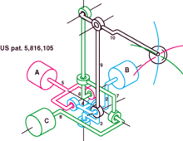

5.2EXAMPLE

- Hand crank on a pencil sharpener
- Familiar examples include:
- Hand-powered cranks
- Mechanical pencil sharpener
- Manually operated car window
- The carpenter’s brace is a compound crank.
- The crank se that drive a handcycle athrough its handles.
- Foot-powered cranks
- The crankset that drives a bicycle via the pedals.
- Engines
- Animation showing piston and crankshaft motion in an internal combustion engine such as an automobile engine

- The suction temperature of the compressor is too high to the normal operating condition.
- The inner parts of the compressor may affect due to friction and it reduce the life of the compressor.
- At the certain range the performance the VCR system doesn’t increases it remains constant or decreases.

5.3 DISADVANTAGES

- One wheel of such gear is designed to work with its complementary wheel and no other.
- Must be precisely mounted.
- The shafts' bearings must be capable of supporting significant forces.

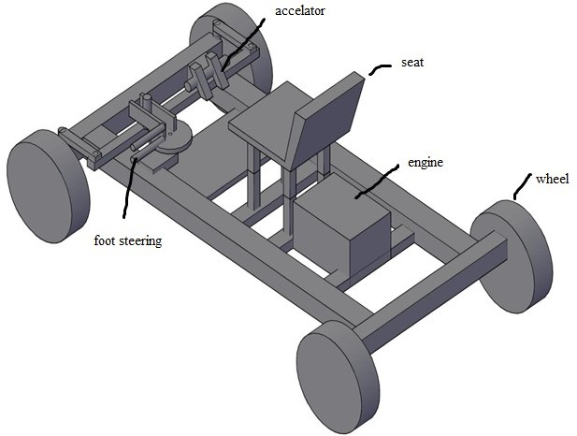
Fig.1.5 Designed model of LHSX

SOLIDWORKS

The model is designed in the SOLIDWORKS 2021 based on the design calculation of the liquid suction heat exchanger.
6.ANALYSIS MECHANICS AND FUNCTION

- Main article:wheel and axle.
- The low resistance to motion is explained as follows refer to friction.
- The normal force at the sliding interface is the same.
- The sliding distance is reduced for a given distance of travel.
- The coefficient of friction at the interface is usually lower.
- Bearings are used to help reduce friction at the interface. In the simplest and oldest case the bearing is just a round hole through which the axle passes.
Subtractive methods:
- Thread cutting
- Thread cutting, as compared to thread forming and rolling, is used when full thread depth is required, when the quantity is small, when the blank is not very accurate, when threading up to a shoulder is required, when threading a tapered thread, or when the material is brittle.￼￼
- Taps and dies
Main articles: Tap and die, and Die head.
- A common method of threading is cutting with taps and dies. Unlike drill bits, hand taps do not automatically remove the chips they create. A hand tap cannot cut its threads in a single rotation because it creates long chips which quickly jam the tap are possibly breaking.

8. RESULT AND DISCUSSION
- Wheels
- Internal threaded cylinder
- Lead screw
- Linkages
- The normal force at the sliding interface is the same.
- The sliding distance is reduced for a given distance of travel.
- The coefficient of friction at the interface is usually lower.
- Slider crank mechanism

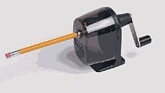

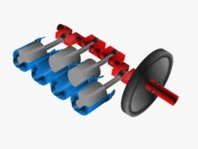

9. CONCLUSION

These modified disabled vehicles work on multi-power supply system, such as in solar powered vehicles, with the help of solar panel supplies electric power to the batteries when it got energised and thus the charging system charged and governs the electric DC motor to run the vehicle. In case of hybrid tricycles, they utilise the alternative mode of power for transportation which will be helpful for the differently abled people to reach their destination. Hence, provide the guide line for the new innovationshe %.

REFERENCES

[1] Jawale P R, Gabhane A R, Baje K G and Patil D N, “A Review on Modern Hybrid Tricycle for Handicapped Person”, International Journal of Research in Advent Technology, Special Issue Nation Conference “CONVERGENCE 2017”,( E-ISSN: 2321-9637), April 2017,pp.113-118.
[2] Ravi Solanki, Jigar Rathod and Vaibhav Patel, “Modification of Delta Tricycle”, International Journal

