DEVELOPMENT OF SPRAYING DRONE FOR PRECISION AGRICULTURE USING DEEP LEARNING

OMKAR REMJE
Department of Computer Science & Engineering,
MIT ADT University, Loni-Kalbhor
Phone: - +91 9527748872,
Email: - omkar12remje@gmail.com

Contents
Abstract
Acronyms
- Introduction
1.1 Goals & Purpose
1.2 Agricultural Drone
1.3 Applications
1.4 Specification of requirements

- Related Work
2.1 Latest Development in Hexa-Copter drone Design
2.2 Sensor Equipment’s

- Theory and Background
3.1 Hexa-copter
3.1.1 Parts of Hexa-copter Drone
3.2 Software
3.3 Electrical Circuit

- Method
4.1 Phases of project
4.2 Choosing a hexa-copter frame
4.3 Modelling the hexa-copter
4.4 Hardware choices

- Design of Drone
5.1 Hexa-copter Frame
5.2 Block Diagram

- Conclusion
6.1 Future Scope
- Reference

ACRONYMS

3D Three Dimensional.
ESC Electronic Speed Controller.
FEA Finite Element Analysis.
GPS Global Positioning System.
LiPo Lithium-ion Polymer.
RADAR Radio Detection and Ranging.
UAV Unmanned Aerial Vehicle.
PDB Power Distribution Board
FC Flight Controller

ABSTRACT

UAV (Unmanned Aerial Vehicle) is a flying robot capable of flying without on board pilot. It is controlled either manually or autonomously. This paper deals with agricultural spraying drones in agricultural environments by using deep learning. Use of big manned helicopters and other aerial vehicles could be replaced for some applications by UAV’s making those applications cheap and accessible. Moreover, because the component market for this type of vehicles is in continuous growth, new concepts have emerged to improve the stability and reliability of the multi copters, but efficient solutions with reduced costs are still expected.
The flight parameters extracted from the sensor systems comprising accelerometers, gyroscopes, magnetometers, barometers, GPS antenna and adjustments were performed accordingly, when needed.
For the intelligent spraying purpose, we have developed a hexa-copter drone. Hexa-copter Drone is designed from the ground-up to be a fully customizable platform suitable for a wide range of applications. Made with high quality materials and the system can handle very harsh operating conditions and still perform tasks with unprecedented flexibility and ease of operation.
The drone focuses on the precious spraying on the agricultural land by using the hexa-copter drone by using deep learning, CNN. Artificial intelligence tools like Deep learning and Convolutional Neural Network (CNN) are gaining popularity in this field as they provide optimum solution for plant disease identification. Earlier, the pest spraying was done by manual observation. This method is arduous and prone to error. Several plant diseases cannot be recognized by bare human eyes. Early disease occurrences are minute in nature. In order to improve the quality of production and yield in plants, it is essential to identify the symptoms in their initial stages and treat the diseases. For training the Deep Learning system we have used the potato’s diseases. For that we have scanned more than 2000 images.

Keyword:-
Unmanned Aerial Vehicle, Agriculture drone, Pesticide spraying, Crop monitoring, Precision agriculture, Hexa-copter.

1 INTRODUTION
The population is increasing rapidly, which is making food security a challenging task. According to Food and Agriculture Organization (FAO) of the United Nation, more than 815 million people are chronically hungry and 64% of the chronically hungry are in Asia. The world needs to increase food production by approximately 50% by the year 2050 to feed a population of nine billion. On the other hand, the basic resources for agriculture production such as land and water are becoming scarcer every day. In a study done in 2018, it has been revealed that 9.2% of people on earth had extreme degrees of food availability problems. Any further decreases in the amount of food will result in a very pathetic condition. There was also a moderate level food insecurity problem (i.e., up to 17.2% of the total populace), which means that they did not have customary access to nutritious and adequate food. The combination of moderate and extreme degrees of food availability problem carries the approximate 26.4% of the total populace.
The crop production and food supply networks were severely affected by the COVID-19 pandemic. The basic requirements in the field of agriculture like labour, seeds, fertilizers, and pesticides were not available timely to many farmers and has resulted in less production. Many Asian countries are at a developing stage, and they are confronting with the issue of a high populace and their agrarian efficiency is much lower when compared with technologically advanced nations. India is facing a similar issue. This is due to its low-level agriculture technology, lesser power availability, and unskilled farmers, etc. Almost 73% of the Indian population is dependent on the agriculture sector directly or indirectly. Indian farming is still being done in a conventional manner. Farmers are using conventional techniques for seed planting, composts, and pesticides application, etc. The traditional techniques used for pesticides and fertilizer spraying require more time and are less effective, thus there is a need for technological advancement in this segment. COVID-19 pandemic made the monitoring of crop, fertilizer, and pesticide spraying very difficult for conventional farmers. The utilization of Drone in agriculture is a suitable solution to overcome these difficulties. Utilizing proper information collected by drones, agronomists, rural specialists, and farmers may improve their activities to increase the yields.
For smart farming and Precision Agriculture (PA), aerial remote sensing is one of the most important technologies. Aerial remote sensing, with the help of drones, utilizes the images of different wavelengths and measures the vegetation indices to recognize the several conditions of crops. In the past decades, manned aircraft or satellites were used for capturing desired images that were utilized for precision agriculture.

Drone monitoring systems help the farmers for observing the aerial views of the harvest. This gives information related to the water system, soil variety, pests, and fungal infestations. Crops images, collected by the drones, have information in the range of infrared and visual spectral. Different features from these images can be extracted, which gives information about the health of plants in a manner that cannot be seen with the naked eye. Another important feature of this technology is its capability to monitor the yield regularly i.e. on each week, or even at each hour. The frequent availability of crop information helps farmers to take corrective action for better crop management.
Applications of drones in precision farming can be studied based on the payload devices. Payload is the weight a drone can carry. The two main categories studied here are crop health monitoring, and pesticide spraying. In this paper, after a brief introduction about the use of UAV technology in the agriculture field, their different types used for agriculture monitoring have been reviewed. Further, a discussion about capturing high-resolution images and their analysis for crop health monitoring are done. Improvements in pesticide spraying drone and development of a drone capable for spot spraying has been reviewed.

  - Goals and Purpose
The first goal of the project is to create a Hexa-Copter drone which is at affordance price of the farmer, which is well equipped ad easy to use.
The second goal is that it has all necessary equipment’s so that the farmer or the person using the drone

  - Agricultural Drone
Initially, the drone was originated as a military tool and was given different names such as Unmanned Aerial Vehicle (UAV), Miniature Pilotless Aircraft, or Flying Mini Robots. Nowadays it is being utilized in the business sector, infrastructure sector, farming, security, insurance claims, mining, entertainment, telecommunication, and transport sector, etc. The drone has a powerful market opportunity as is evident from the data given in. Such a broad application of drones has resulted in a very fast improvement in drone technology, thereby making it more user-friendly day by day.

  - Applications
Its ability of VTOL and hover in the position with proper stability and manoeuvrability brings many mission options into possibilities. This makes the Unmanned Aerial Vehicle (UAV) versatile and may be used for various purposes. Few application areas are described here:
• Aerial surveillance: UAV these days are widely used for aerial surveillance. Aerial surveillance drones includes conservation drones mostly used for wildlife conservation. It is also used by different organisation like military forums for aerial surveillance for their specific purpose.
• Photogrammetry: Different organisations use this vehicle for photogrammetric purpose where the high-resolution aerial images taken by the UAV is used for generating 3D images of the landscapes and generate maps.
• Delivery robot: These days different companies are using UAV as their delivery Kit or robot. Domino’s Pizza uses its Domo-copter (Oct-copter) for delivering Pizza to its customers.
• Precision farming: Developed countries are using this vehicle for precision farming where the crops are continuously inspected and the corresponding action are taken for greater productivity.
• Rescue missions: This vehicle could also be used for rescue purpose and delivering medicine kit for casualties where manned vehicle is riskier to take.

  - Specification of requirements

Some aspects to take into consideration when constructing a drone are the following:
• Lift capacity: It is important to know the weight of all components so that the total weight is not heavier than the total thrust from the motors.
• Energy: The amount of energy on a drone is limited to the capacity of the battery. Increasing the capacity of the battery means adding more weight, more weight means more thrust is needed, more thrust means a higher energy consumption, therefore conservation of energy is important. Every system on the drone uses power and the total usage in comparison to the total capacity needs to be balanced.
• Thrust Capacity: Simply put, drone thrust is the amount of upward force your drone can produce when at full throttle. You are probably not the only one with a juvenile snicker when reading “thrust” so many times, so lets’ just get it out of the way. The amount of thrust a drone generates tells you how much the drone can lift. If a drone’s thrust is less than the weight of the drone then you do not have a flying machine, you have a paperweight.
• Material of the drone: - All aerospace systems need to be lightweight. The lighter the structure, the more efficient it operates, the longer range it can cover, the greater payload it can carry, and the longer it can stay aloft. Since UAVs fly unmanned, they require sensors, cameras, and electronics. Reducing the weight of the structure allows it to carry more sensors, more payload.

- RELATED WORKS

2.1. Latest Developments in Hexa-copter Drones Design
Darvishpoor et al. present in a complex review many different configurations, flight mechanisms and applications in which drones are currently employed. The UAVs are categorized, and their characteristics, advantages and drawbacks are discussed. This study also presents vertical take-off and landing (VTOL) hexa-copter drones in a flat configuration, used by the last mile delivery drone, the HexH2O seaplane drone, an anti drone hexa-copter, which uses a net to capture rogue drones; power tower cleaning hexa-copters; and agriculture, inspection, survey and mapping hexa-copters. presents a generic methodology that analyses the sizing aspect of the
Multi-copter drones with electric propulsion, which allows configuration optimization for different applications. The study starts from a set of algebraic equations based on scaling laws and models that have resemblances. In the next phase, the optimization of the drone sizing is analysed through a proposed methodology. The obtained results are validated by comparing the characteristics of existing multi-copter and performance predictions of these configurations which were performed considering different flight types and payload variants.
In the case of the classic hexa-copter, studies have been carried out on mounting the rotors under certain tilt angles, this modification allowing the hexa-copter to be fully actuated in the sense that all six degrees of freedom associated with the three translational and three rotational movements become independently controllable. These types of platforms are still the subject of study, making it difficult to explain which type of structure is suitable for a application. One of the proposed approaches to obtain a structure close to the one already mentioned is to develop a scheme to optimize the construction design of the drone. Aspects related to the design and optimization of hexa-copter drones can be found in several variants proposed by Gupta et al.

2.2. Sensors Equipment
In addition to the propulsion system, the sensors with which the drone is equipped play a critical role in terms of manoeuvrability, stability, command, and control of the drone. The sensors also capture information from the surrounding environment (images, video, GPS location, photogrammetry, LIDAR), depending on the specific missions or activities that the drone is meant to perform.
Hussein and Nouacer provide a source design pattern for building new drone systems, which includes blocks of the drones and relations between them that are distributed into four main groups: flight navigation, flight control, flight management and mission supervision.
Severin and Soffker treat the problem of optimization of the sensors used for altitude estimation mounted on multi-copter drones employed for spraying the vineyards. The study makes a comparison between a variety of low-cost sensors for measuring the distance between the drone and ground level, sensors which are most appropriate for vineyard-spraying drones. The signals were acquired from ultrasound, radar and Doppler sensors and were filtered using a Kalman filter. The study describes a variety of measures employed to improve the assessed altitude of the drone and to enhance the trustworthiness regarding the relative altitude approximation of the multi-copter drone.
In Pena et al.’s WILD HOPPER UAV study, a 600 L platform designed for forest firefighting is presented. The paper reveals a multilayer steadiness system for enhanced stability of the drone during the flight in severe conditions. WILD HOPPER is equipped with a range of sensors which include thermal cameras, geo localization and navigation systems: satellite navigation and a new technology based on visual attitude estimation methods.
The study presented by Ravin et al. explains the extraction and analysis of GPS data from three different drone manufacturers, followed by analysis and representation of the positioning data as flight paths. GPS-related data from any drone’s flight is of vital importance as it helps in establishing a legal framework for operating a drone in a country’s airspace. In terms of sensors, all these data are obtained from the GPS antenna/antennae mounted on the drone.
In the case of the classic hexa-copter, studies have been carried out on mounting the rotors under certain tilt angles, this modification allowing the hexa-copter to be fully actuated in the sense that all six degrees of freedom associated with the three translational and three rotational movements become independently controllable. These types of platforms are still the subject of study, making it difficult to explain which type of structure is suitable for a particular type of application. One of the proposed approaches to obtain a structure close to the one already mentioned is to develop a scheme to optimize the construction design of the drone. Aspects related to the design and optimization of hexa-copter drones can be found in several variants proposed by Gupta et al., Suprapto et al. , Setiono et al. , Verbeke et al. , Abarca et al. and Arellano-Quintana et al.

3 THEORY AND BACKGROUND
The theory is divided into three parts
- Hexa-copter (Drone): - It describes how the hexa-copter works what are the different parts are and what relevance they hold and how they work.

- Software: - Explain what software is intended to be used mainly for programming Deep learning and drone designing.

- Electrical Circuit: - Explains the connection of the motors and the ESC and the APM, Battery etc.

3.1 Hexa-copter
The propellers are arranged in a circle around the main body of the hexa-copter. A pair of leg-like appendages at the bottom allow the machine to land on the ground in a stable manner. The quadcopter is a more powerful flyer because of its six propellers than the quadcopter, and is also capable of carrying heavier loads.
The hexa-copter offers a significant advantage due to its six propellers. Even if one of those propellers fail, the other five can keep the machine flying. This means motor failure in one of the propellers does not mean the drone will come crashing down, damaging the equipment attached to it. If two propellers fail, the device will not be able to fly, but it will remain stable enough to reach the ground safely.
A hexa-copter can reach higher altitudes than a quadcopter, and travels faster. Since hexa-copters are more expensive, they are usually used for transporting more precious cargo which cannot survive a crash. They are also much larger than quadcopters, and more difficult to assemble and store.
The propeller on a hexa-copter uses a pitch mechanism while a Hexa-copter has a fixed pitch. This means that a helicopter can keep a constant speed on the propeller while using the pitch mechanism to move, the Hexa-copter need to change the rotation speed on some rotors to be able to move. By increasing and decreasing the speed on the motors the hexa-copter can create different movements, up, down, forward, backward, pitch, roll and yaw. Changing the speed up and down requires more energy than changing the pitch mechanism in a helicopter.

3.1.1 Parts of the hexa-copter Drone
The following are the main parts of the hexa-copter drone.
Frame
The frame is basically the body of the hexa-copter. Shape and material can vary depending on size and design. A larger frame often has more arms than a small frame and a large frame is often built in carbon fibre or aluminium or both combined while a small one often is in plastic.
The motor axes create a circle and the diameter of this circle is used to specify the size of the hexa-copter. The size is usually measured in millimetres. This size determines the maximum size of the propellers and by adding longer arms larger propellers can be used.
Propellers
• Size & pitch:
Propellers are normally named after their size and pitch by referring to a four-digit number (1045). The two first digits describe the radius and the two last digits describe the pitch, both measured in inches. The pitch is defined as” the distance a propeller would move in one revolution if it were moving through a soft solid, like a screw through wood.”.
• Material:
Commonly used material for propellers is carbon fibre, plastic. Carbon fibre is more expensive than plastic and wood but has the advantages such as less vibration, lighter and stronger.
• Number of blades:
The number of blades on the propeller can vary and the most common are two, three or four blades. By increasing number of blades, the characteristics are changed, more blades result in a higher thrust while the efficiency is decreased.
Motors
The most common motor used on a hexa-copter is brushless Direct Current (DC) motor, this due to a high efficiency, small size, and low cost. Some important parameters are the following:
• Size:
The name of a motor for hexa-copters often contains a four-digit number. This number specifies the size of the motor in millimetres. An example is the Sunnysky X4110S 460KV, where 4110 is the number specifying the size. 41 is the diameter of the stator while 10 is the height, so this motor has a stator which is 41 mm wide and 10 mm high.
• KV:
When choosing motor the KV value is important. This is a value that describes the motors rotation relative to the voltage supplied, the Revolutions Per Minute (RPM) per Volt (RPM/Volt).
Thrust to weight ratio:
This is a useful guideline when building a hexa-copter. It says that the thrust of all the motors together should be at least twice the weight of the drone. This guideline is used to ensure that the motors always have enough thrust to handle, e.g., situations where it needs to make rapid movements or strong winds. It is calculated by the following formula:

Thrust to weight ratio = Thrust
Weight

The thrust to weight ratio can have multiple variations because of the different types of thrusts, and weights. For instance:
Thrust — Could either be available value during normal engine conditions, maximum available value or in the afterburner conditions, where the thrust available is maximum.
Weight — There are different types of aircraft weights such as gross weight, the maximum take-off weight, weight at different fuel levels, say 50% or 100%, and empty weight.
Electronic Speed Controllers (ESCs)
An ESC is an electrical circuit that is used to control the speed on the motor. This is done using a Pulse-Width Modulation (PWM) signal which the flight controller circuit sends to the ESC. Based on the PWM signal the ESC transform the power from a DC battery to a three phase Alternating Current (AC) like signal which control the speed of the motor.
Batteries
One of the most used batteries for hexa-copters is the Lithium-ion Polymer (LiPo) battery. Two important parameters when describing batteries are the capacity, measured in ampere hours (Ah), and voltage, measured in volts (V). The nominal voltage of a single LiPo cell is 3.7 V, and when fully charged it can reach up to 4.2 V.

3.2 SOFTWARES
Autocad:-
AutoCAD is a commercial computer-aided design and drafting software application. Developed and marketed by Autodesk, AutoCAD was first released in December 1982 as a desktop app running on microcomputers with internal graphics controllers. Before AutoCAD was introduced, most commercial CAD programs ran on mainframe computers or minicomputers, with each CAD operator (user) working at a separate graphics terminal. AutoCAD is also available as mobile and web apps. AutoCAD is primarily used for Dimensional drawings, and even though 3D modelling is available in AutoCAD other computer-aided design software like Fusion 360, Inventor and Solidworks are preferred in 3D modelling.
EAGLE :-
It is a scriptable electronic design automation (EDA) application with schematic capture, printed circuit board (PCB) layout, auto-router and computer-aided manufacturing (CAM) features. EAGLE stands for Easily Applicable Graphical Layout Editor.
EAGLE contains a schematic editor, for designing circuit diagrams. Schematics are stored in files with .SCH extension, parts are defined in device libraries with .LBR extension. Parts can be placed on many sheets and connected together through ports.
The PCB layout editor stores board files with the extension .BRD. It allows back-annotation to the schematic and auto-routing to automatically connect traces based on the connections defined in the schematic.
Jupyter Notebook
It is a (formerly IPython Notebook) is a web-based interactive computational environment for creating notebook documents. Jupyter Notebook is built using several open-source libraries, including IPython, ZeroMQ, Tornado, jQuery, Bootstrap, and MathJax. A Jupyter Notebook application is a browser-based REPL containing an ordered list of input/output cells which can contain code, text (using Github Flavored Markdown), mathematics, plots and rich media.
3.3 Electrical Circuits
An electrical drawing is a type of technical drawing that shows information about power, lighting, and communication for an engineering or architectural project. Any electrical working drawing consists of "lines, symbols, dimensions, and notations to accurately convey an engineering's design to the workers, who install the electrical system on the job.

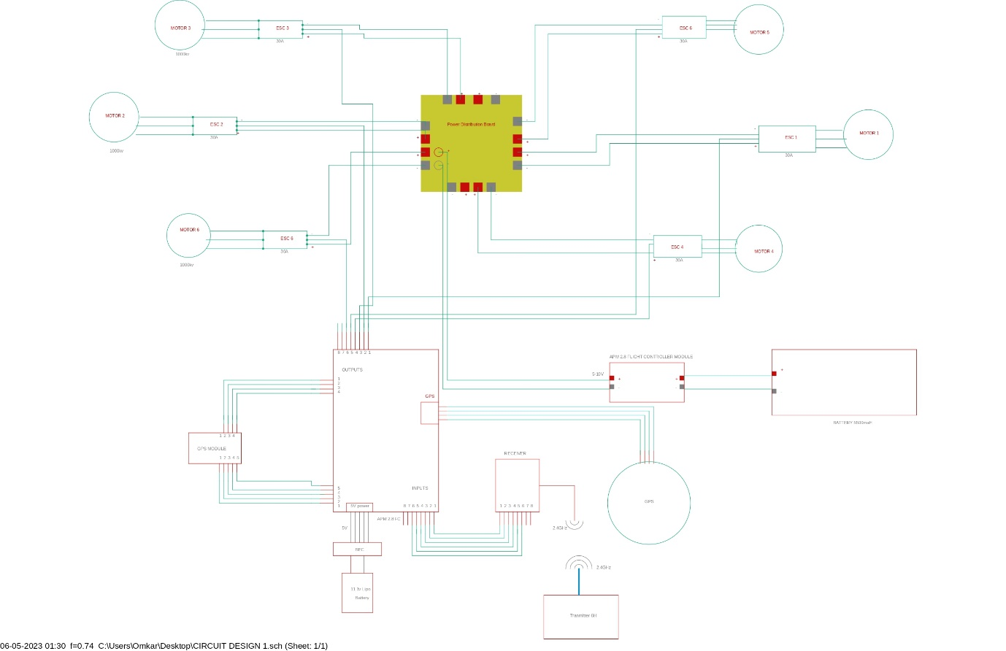
The hexa-copter design consist of the six BLDC motor, six ESC, one PDB , one GPS module, one FC , Power Module and Battery, Transmitter and Receiver.

4 METHOD
4.1 Phases of Project
The project was created in a structured way following with three phases:
- Phase one - Phase one is when the planning of the project, and gathering of a theoretical base takes place. Some examples of activities during the phase are researching other similar projects, formulating a specification of requirements, defining project limitations, setting up a time plan, familiarising with new software etc. After phase one a rough plan of execution is finished and ready to be used for phase two.

- Phase two - The second phase contain the basis for the project methodology and focus on implementing and testing the theoretical ideas from phase one into practice. The methodology content is structured around three main steps, step one is the simulation part where a digital 3D model is created. The second step is the creation and assembly of hardware by using the results from the simulations. Mechanical design iterations are made using CAD design and additive manufacturing, other parts need to be purchased, e.g., motors and electronics. The end of the second phase contain integration with other systems, testing, etc.

- Phase three - Under the third phase the work completed during phase two is evaluated and analysed, the final report is finalised containing conclusions, results along with thought, discussions, and future improvements.

4.2 Choosing a hexa-copter frame
Quadcopters require fewer motors, ESCs and propellers but are vulnerable if any of those parts fail during flight. A six, or more, rotor copter has a bigger chance of staying in the air if a propeller or any part driving a propeller fail. A good control system can potentially compensate for the loss of thrust by increasing the speed on the other working propellers, but depending on what thrust to weight ratio the copter has it might not be enough. It is not only the thrust that gets affected but also the steering, a hexacopter can, if it loses one propeller, shut the paired parallel propeller down and be steered as a quadcopter, the same goes for a octacopter which can be steered as a hexacopter. A quadcopter however cannot simply be downgraded to a tricopter since the steering works differently.
The final frame choice was based on future potential, a higher chance of handling motor failure and costs. The hexacopter can handle motor failure better than a quadcopter while still being more cost effective to build in comparison to a octocopter and above. Therefore for the project we have choosen the hexacopter frame.

4.3 Modelling the hexacopter
The software used for simulations has support for working multicopter models but no hexa-copter models that could be modified to add on a prototype. To create models to be used in the project and for construction calculations the AutoCAD software was used.
There were many accurate digital models of the hexa-copter frame. The frame of the hexa-copter consists of a bottom plate, a top plate, six arms, a motor on each arm and propellers. Starting out the measurements had to be estimated only from knowing that F550 describes the diameter between propellers. The aim in the end was how ever to have an identical CAD model.

4.4 Choosing the hardware for hexacopter
4.4.1 Hexacopter Hardware
Most of the parts on a hexacopter are dependent on each other and when choosing one part it puts a new set of demands on another. The one most important characteristic to figure out is the weight if the hexacopter, since that in turn puts demand on all parts except the ones handling calculations for navigation.
- Motor: The motors together with the propellers needed to provide enough thrust to lift the hexa-copter with the gripping module and a payload of up to 20% of the total weight. Since the aim is to follow a 2:1 thrust to weight ratio, the total minimum thrust needed to be at least 14.4 kg.
To choose the motor a lot research was done and the following aspects were taken into consideration:

- Thrust: Of course, thrust depends on what propeller is fitted and most manufacturers provide data sheets providing information on how much thrust is gained depending on what battery voltage and propeller is provided.
- KV-value: The KV-value is in part also connected to what wattage the motor can handle. If the motor has a low KV-value less heat is created and the motor can be mounted with wider, or more pitched propellers, which provides more thrust.
- Size: The aluminium arms chosen had to be able to fit the motors that were picked.
- Weight: The weight was not a huge deciding factor since the other attributes are more important, but it was still taken into consideration when choosing motors.
- Cost: The cost of motors can vary a lot and since six of them are needed, as well as spares, it was important to not choose motors that were too expensive, since that would impact what other parts were possible to choose.

- Propeller: The recommended propeller size from the manufacturer was Ryze DJI Tello but to get a slightly more responsive hexa-copter 1045 propellers 10-inch dia 4.5 inch pitch were chosen. This also provided more thrust which made the motors able to hover on a lower RPM than with the propellers. The potential downside of choosing a more pitched propeller is that the wattage, and with that the heat, will increase in comparison to the chart, since the air friction will increase.

- Battery: The motor choice decided the battery voltage, which was 11.1V and 3 cells (3S). More Ah gives longer flight time, but also adds on more weight, which gives a shorter flight time, the key was to find good middle ground. Most airlines only allow LiPo batteries.

- ESC: When choosing the ESC, it must be compatible with the motors and the battery. ESCs are sold in 5 A steps and as a safety precaution 30 A ESCs were chosen.

- Flight controller: For our project we I have taken APM 2.8 FC APM 2.8 Multicopter Flight Controller is an upgraded version of 2.5 and 2.6 with a Built-in Compass for FPV RC Drone. The sensors are exactly the same as the APM 2.6 flight controller. However, the module has the option to use the built-in compass an external compass via a jumper. This makes the APM 2.8 ideal for use with multi-copters and rovers. The APM 2.8 Multicopter Flight Controller is a complete open-source autopilot system. This is the best-selling technology that won the prestigious Outback Challenge UAV competition. It allows the user to turn any fixed, rotary-wing. In addition, it turns multirotor vehicles (even cars and boats) into a fully autonomous vehicle. meanwhile, it can perform programmed GPS missions with waypoints.

- Power Distribution Board: The 100A Multirotor ESC Power Distribution Battery Board for Quadcopter is a lightweight distribution board which will power your multi-rotor aircraft easily. Simply solder a battery connection onto the two central terminals, and you have got eight pairs of connections to use – perfect for quadcopters, hexacopters, and even octocopters. These boards are great for smaller multirotor builds. They are compact and lightweight and offer large solder pads – making them easy to work with. These boards can handle some serious current – up to 20A per output for a quadcopter build or drop that down to 10A each for an octocopter.

- GPS Module: Neo 7M GPS module that includes an HMC5883L digital compass. The new NEO 7 series is a high sensitivity, low-power GPS module that has 56 channels and outputs precise position updates at 10Hz. This GPS module also comes with a moulded plastic case which keeps the module protected against the elements making it ideal for use on your aircraft or quadcopter. This Neo 7M GPS module uses an active circuitry ceramic patch antenna to provide an excellent GPS signal which outperforms the older Neo 6 series modules. This Neo 7 module also includes a rechargeable backup battery to allow for HOT starts and also includes an I²C EEPROM to store the configuration settings. Out of the box this GPS module is configured to run at 38400 Baud and is configured to run with APM/Pixhawk systems. This GPS module includes two cables, a 6pin connector for the GPS module, and a 4-pin connector for the i2c compass.

5 DESIGN OF DRONE
  - Hexa-copter Frame
The hexa-copter frame is designed with light weight material aluminium and wood. The arms and the landing gears of the drone are made from aluminium and the hexagonal plates are made from wood. Which gives us the weight of 1.25Kg approx.
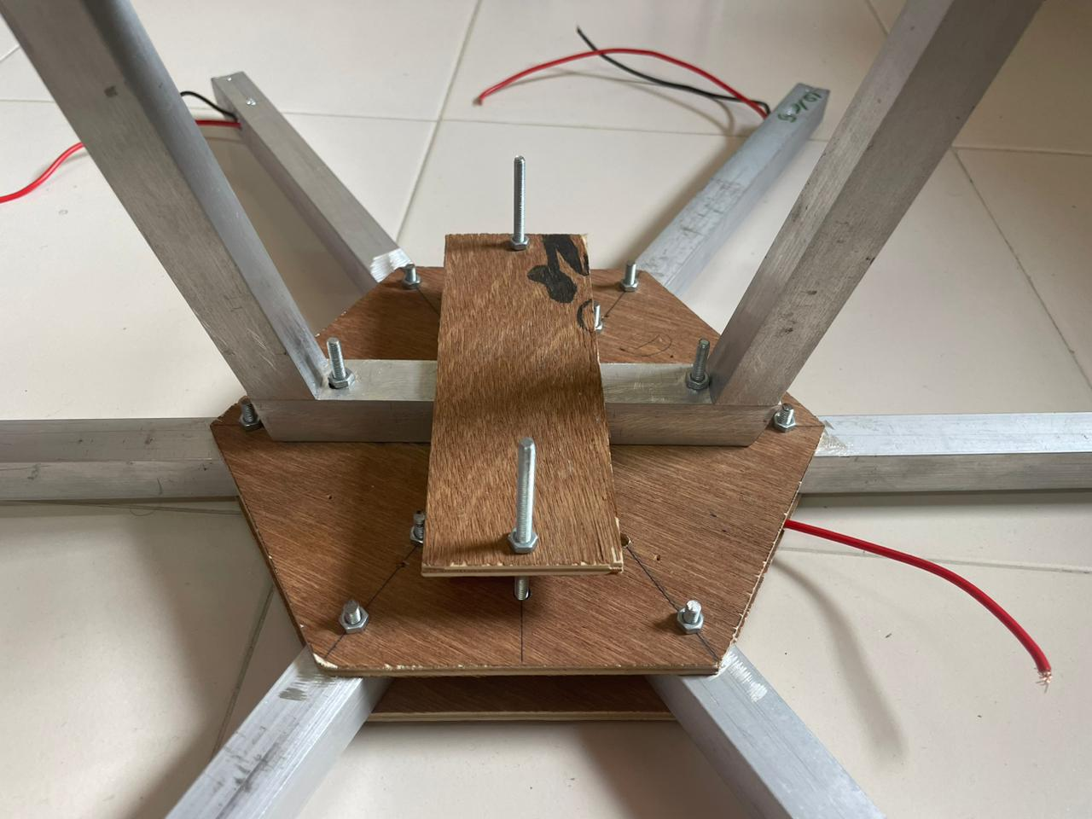

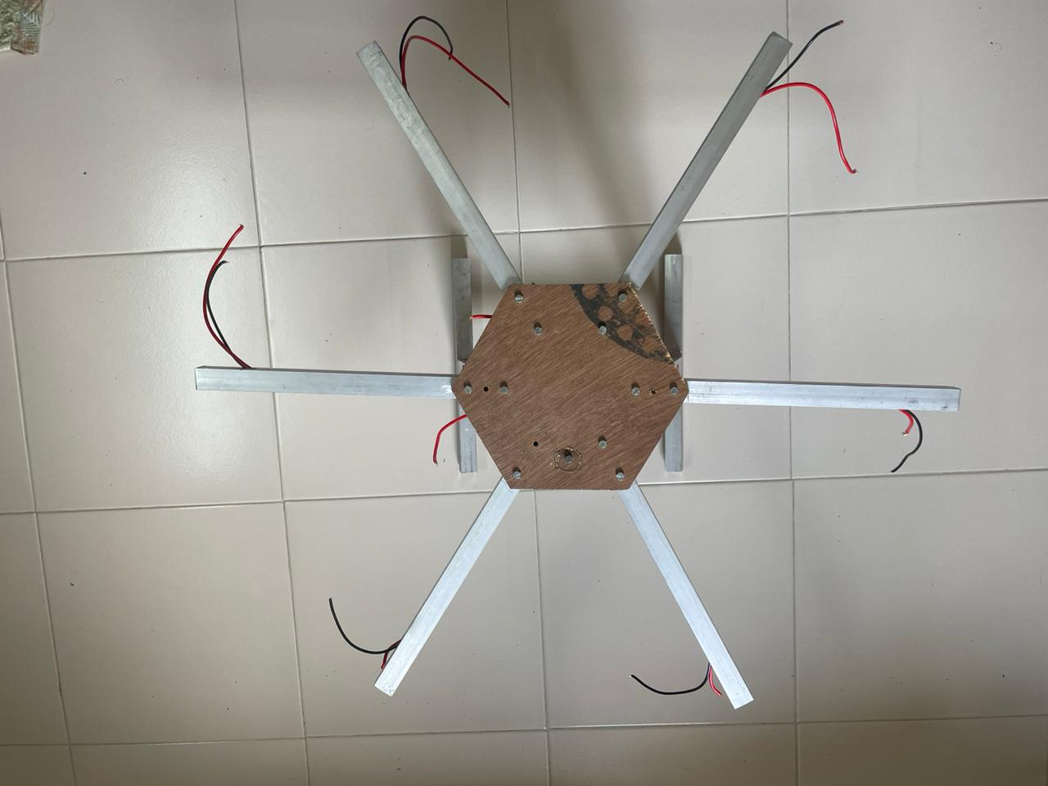

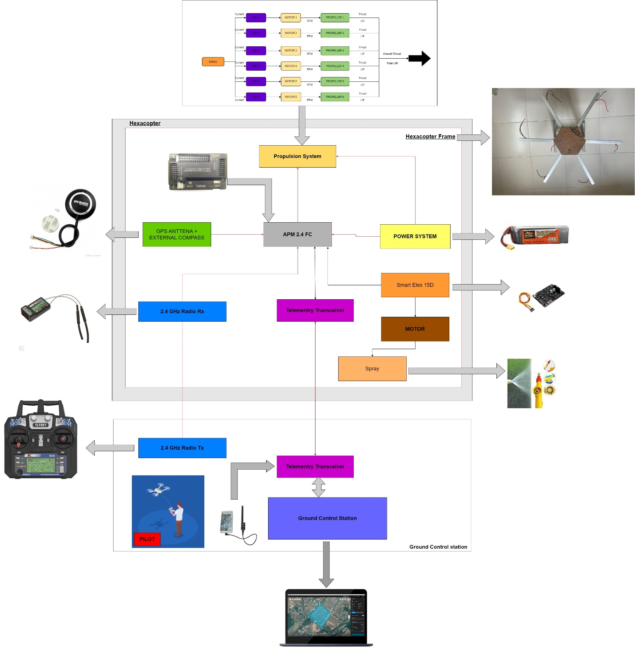
  - Block Diagram

6 CONCLUSIONS
In this paper I have designed a drone mounted spraying mechanism for Agricultural purpose and for spraying disinfectants. This method of spraying pesticides on Agricultural fields reduces the number of labours, time, cost and the risk involved to the personnel involved in spraying the liquids. This drone can also be used in spraying disinfectant liquids over buildings, water bodies and highly populated areas.
As the cost of the drone is less and it sis light weighted which can easily spray fertilizers on the agricultural field.

  - FUTURE SCOPE
➢ Under the current COVID19 Pandemic situation, it can be used to sanitize large hotspots areas without going there in person.
➢ Manual control can be changed into autonomous control with GPS technology and auto return home option.
➢ With image processing techniques, the drone can be involved in surveillance to determine the pest attack on the plants, condition of ripening fruit.

- REFERENCE

- S. Bhandari, S. Pathak, R. Poudel “A report on Design and Development of Hexa-copter (KU copter)”

- Best Drones For Agriculture 2020: The Ultimate Buyer’s Guide n.d. https://bestdroneforthejob.com/drone-buying-guides/agriculture-drone-buyers-guide/ [accessed December 1, 2020].

- Karan Kumar Shaw, Vimalkumar R. Design and Development of a Drone for Spraying Pesticides, Fertilizers and Disinfectants. Int J Eng Res 2020;V9. https://doi.org/10.17577/ijertv9is050787.

- Balaji B, Sai Kowshik Chennupati Srkc. Design of UAV (Drone) for Crop, Weather Monitoring and for Spraying Fertilizers and Pesticides. IJRTI1803008 Int J Res Trends Innovat (WwwIjrtiOrg) 2018;3:42–7.

- Optimization of Pesticide Spraying Tasks via Multi-UAVs Using Genetic Algorithm Math Probl Eng, 2017 (2017), 10.1155/2017/7139157.

- Y. Huang, W.C. Hoffmann, Y. Lan, W. Wu, B.K. Fritz Development of a Spray System for an Unmanned Aerial Vehicle Platform Appl Eng Agric, 25 (2009), pp. 803-809 https://doi.org/10.13031/2013.29229

- Anand K, G R. An Autonomous UAV for Pesticide Spraying. Int J Trend Sci Res Dev 2019;3:986–90. https://doi.org/10.31142/ijtsrd23161.

- B.S. Faiçal, H. Freitas, P.H. Gomes, L.Y. Mano, G. Pessin, A.C.P.L.F. de Carvalho, et al.

- An adaptive approach for UAV-based pesticide spraying in dynamic environments
Comput Electron Agric, 138 (2017), pp. 210-223, 10.1016/j.compag.2017.04.011

- Chu, P.H.; Huang, Y.T.; Pi, C.H.; Cheng, S. Autonomous Landing System of a VTOL UAV on an Upward Docking Station Using Visual Servoing. IFAC-PapersOnLine 2022, 55, 108–113.

- Latif, Ghazanfara; * | Alghazo, Jaafara | Maheswar, R.b | Vijayakumar, V.c | Butt, Mohsind ,Deep learning based intelligence cognitive vision drone for automatic plant diseases identification and spraying, https://content.iospress.com/articles/journal-of-intelligent-and-fuzzy-systems/ifs189132

- Real-time recognition of spraying area for UAV sprayers using a deep learning approach, https://doi.org/10.1371/journal.pone.0249436.

- K.P. Ferentinos, Deep learning models for plant disease detection and diagnosis Comput Electron Agric, 145 (2018), pp. 311-318, 10.1016/j.compag.2018.01.009.

- Hyun-Sik Son; Deok-Keun Kim; Seung-Hwan Yang; Young-Kiu Choi, Real-Time Power Line Detection for Safe Flight of Agricultural Spraying Drones Using Embedded Systems and Deep Learning, https://ieeexplore.ieee.org/abstract/document/9780149/authors#authors.

- Andreas Kamilaris, Deep learning in agriculture: A survey, Computers and Electronics in Agriculture Volume 147, April 2018, https://www.sciencedirect.com/science/article/abs/pii/S0168169917308803.

