VISHWAKARMA INSTITUTE OF TECHNOLOGY DEPARTMENT OF INSTRUMENTATION AND CONTROL

VEHICLES EXHAUST SMOKE DETECTION AND LOCATION TRACKING

Parth Wadkar Vishwakarma Institiute of Technology,Pune parth.wadkar20@vit.edu | Varad Wangikar  Vishwakarma Institute of Technology, Pune  Varad.wangikar20@vit.edu | Mayur Chauhan  Vishwakarma Institute of Technology, Pune  Mayur.chauhan21@vit.edu
Pratik Ingawale  Vishwakarma Institute of Technology, Pune  Pratik.ingwale21@vit.edu | Om Khandelot  Vishwakarma Institute of Technology, Pune  Om.khandelot21@vit.edu

Abstract : In recent years, automatic vehicle monitoring has become a crucial situation that can be made achievable by using the following technology. Environmental awareness was given prominence at the start of the twenty-first century. One of the primary issues with the Air pollution is the environment. The main pollutants produced by automobiles are carbon and nitrogen oxides, which can now be quickly found using semiconductor gas sensors. The system is made up of a GSM board, an IoT module, and a GPS board. The GPS system communicates the co-ordinates to the local RTO when the gas sensor detects the gas created as a result of excessive pollution. The micro-controller board calculates the proportion and, if it is higher than the stated limit as per Bharat Stage 6 rules, it determines the proportion. The received warnings will be saved, and the car will automatically give guidance to a nearby safe zone if the warnings are received more than three times or if the pollution level significantly increases. IoT and GPS technologies are used to automatically identify the safe zones. If this technology is used, it is possible to meet the safety, pollution reduction, and accident avoidance criteria.

Keywords: Arduino uno, MQ 9 gas sensor, IoT, GSM Technology, GPS module.

INTRODUCTION:
Environmental awareness was given prominence at the start of the 21st century. Air pollution is one of the main issues with the environment. Due to the discovery of the ozone layer hole, we are all now aware of the negative impacts of greenhouse gases, which are caused by the greenhouse effect, which is a result of air pollution. All other types of life on earth are also negatively impacted by air pollution in addition to the environment. Inhaled air pollutants have a major negative influence on human health because they affect the respiratory system, the lungs, and the blood, which circulates the pollutants throughout the body. Additionally, these chemicals are dumped on plants, soil, and water, which increases human exposure and has an impact on marine life. Aside from industries, one of the main sources of air pollution is vehicles. The main pollutants produced by automobiles are carbon and nitrogen oxides, which can now be quickly found using semiconductor gas sensors. As a result, a solution that would greatly aid in lowering car pollution is proposed in this essay.

ELEMENTS OF A SYSTEM
The system is made up of various components, which are listed below:

  - ARDUINO UNO

  - MQ9 SENSOR
  - GSM MODULE
  - GPS MODULE
  - BATTERY
  - LCD DISPLAY (16*2 )

II.i. Arduino uno :
One of Arduino's standard boards is the UNO. The Italian word UNO here is for "one." To identify the initial release of the Arduino Software, it was given the moniker UNO. It was also the first USB board that Arduino had ever released. The Arduino UNO's ATmega328P microprocessor serves as its core. Compared to other boards, like the Arduino Mega board, etc., it is simple to use. The board is made up of shields, various circuits, and digital and analogue Input/Output (I/O) pins. The Arduino board's USB connection is used to link the board to a computer through a USB cable. The cable functions as the board's power supply and serial port. Due of its unusual dual functionality, it is simple for beginners to
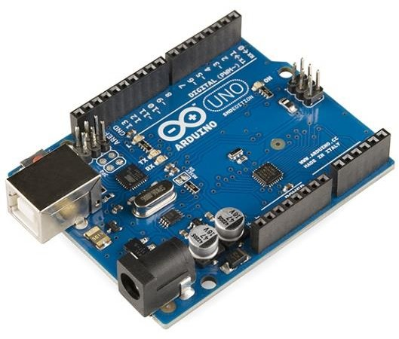

II.ii MQ 9 Sensor:
The MQ9 Gas Sensor belongs to the MQ Gas Sensors family, which also includes the MQ 2, MQ 4, MQ 3, and MQ 135 Gas Sensors. It is mostly used to find gases like propane, methane, and carbon monoxide.
This MQ9 smoke sensor has a sensing component made primarily of ceramic with an aluminum-oxide base that has been coated in tin dioxide (SnO2) and is housed in a stainless steel mesh. The resistivity of the sensing element changes each time gas comes into contact with it. The concentration of the gases present is then determined by measuring the change. To get the sensor into the operating window, it needs to be preheated using a small heating element that is available. It is capable of detecting the presence of LPG, propene, hydrogen, carbon monoxide, and methane gas. It can be used to detect gas leaks in pipelines and to sound an alarm in the event of a gas leak at home because CO is a dangerous gas that can be fatal at concentrations of above 300 ppm.

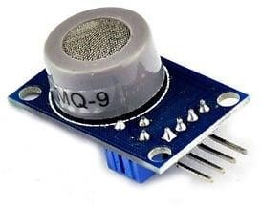

GSM module :
The global standard for mobile phones is GSM. As may be seen in the abbreviation for the Global System for Mobile Communications Since it is a second- generation cellular network, it is also occasionally referred to as 2G. You need to receive the Connection Point Name (APN) and a username/password from the network operator in order to use GPRS for internet access and for the Arduino to request or serve webpages. For more information on utilising the shield's data capabilities, refer to the information in Connecting to the Internet. GSM allows for the

sending and receiving of phone calls, SMS text messaging, and data connection, among other things (via GPRS).
A GSM modem is the Arduino GSM shield.
The Arduino GSM shield resembles a phone from the standpoint of a mobile operator. The Arduino GSM shield seems exactly like a modem to Arduino.
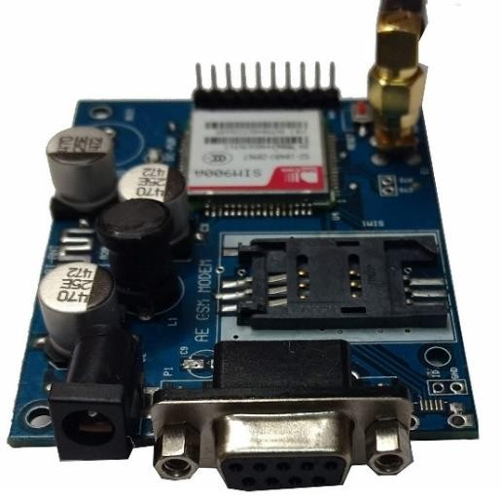

GPS module :
Based on the NEO-6M, this is an entire GPS module. In order to provide the greatest positioning information possible, this device uses the most recent technology and has a larger built-in 25 x 25mm active GPS antenna with a UART TTL connector. Additionally, a battery is supplied to help you get a GPS lock more quickly. With the ardupilot mega v2, this updated GPS module can be used. To improve performance with your Ardupilot or other Multirotor control platform, this GPS module provides the best position data possible. This board's NEO-6M GPS engine is a decent one with high precision binary output. Additionally, it has a high sensitivity for applications indoors. The NEO-6M GPS Module contains an internal battery for backup power and an EEPROM for configuration settings storage. The GPS antenna can be mounted in a variety of ways to ensure that it always has a clear view of the sky for optimal performance because the antenna is connected to the
module by a ufl cable. Because of this, using it with automobiles and other mobile apps is powerful. The GPS module has four pins on its serial TTL output: TX, RX, VCC, and GND.To configure the GPS, alter the settings, and do much more, you can download the u-center software.
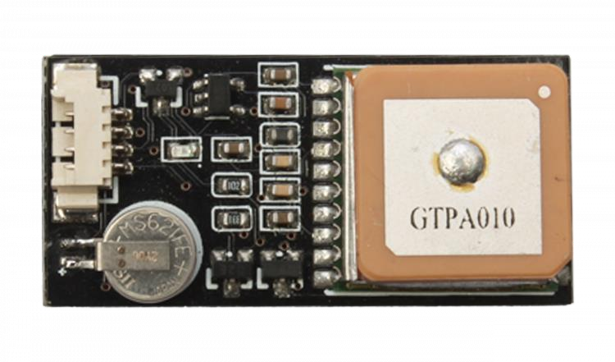

CONCEPT OF THE PROJECT:
Gas emissions from vehicles have recently become a serious concern, making emission control and management essential. As a result, by putting in place this technology, which routinely monitors the car's flue gas outlet for CO emissions, when a vehicle's rate of gas emissions exceeds the aforementioned levels of Stage 6 regulations, it sounds an alarm, making it simple to identify the overly polluting vehicle. Vehicle smokes can thereby lower pollution rates.

PROPOSED SYSTEM:

The overall block diagram of the proposed system is given in figure The block diagram mainly consists of the following elements:
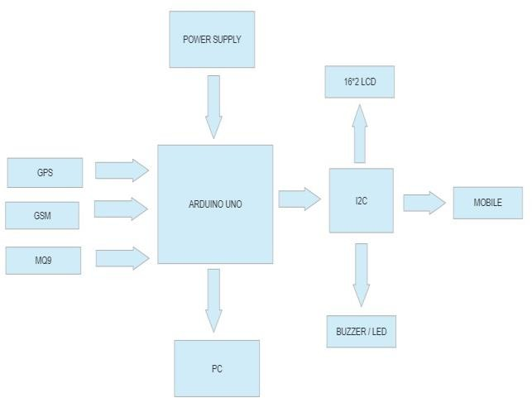

  - Detector
  - Microcontroller
  - Global Positioning System (GPS)
  - Global system for mobile communication(GSM)

The system is made up of a GSM board, an IoT module, and a Gps navigation system. The microprocessor board determines the percentage and if it is higher than the given limit, for example 6%, after the gas sensor detects the gas created as a result of excessive pollution. The GPS system is turned on, the car's coordinates are registered, and they are sent to the local traffic control division along with a warning signal that is received by the owner vehicle. The cautions that were given will be kept.

WORKING:
The MQ-9 CO gas sensor and Microcontroller system are turned on when the car's engine is started. The three tasks that the microcontroller is programmed to perform are comparison, timer, and triggering circuit. Two inputs are provided to the microcontroller: one is the output from the smoke sensor, and the other is the pre-set threshold value that is determined by the government in accordance with the Bharat Stage 6% guidelines. The microcontroller activates the timer circuit, IoT, and GPS modules as well as sets off an alarm to alert the driver that his car may be experiencing pollution-related problems when the smoke sensor output exceeds the threshold value. In addition to the timer being triggered, the GPS is also triggered. The microcontroller sends a trigger pulse to GPS when the pollution level hits the upper limit. When the GPS transmitting system detects a trigger pulse, it is programmed to display the vehicle's location. The smoke emission data will be computed by the MQ-9 gas sensor. Comparisons are made between the emission values and the preset values. Both an alert message and an alarm will sound. When the smoke value exceeds the preset value, the GSM module will notify the driver through SMS.

CIRCUIT DIAGRAM

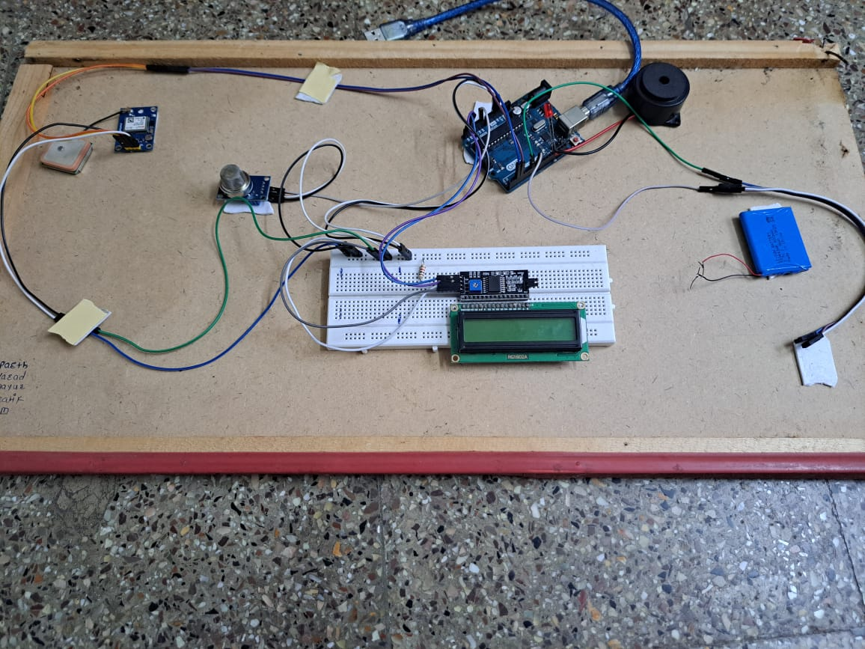
Fig: Circuit Diagram

EXPERIMENTAL RESULTS

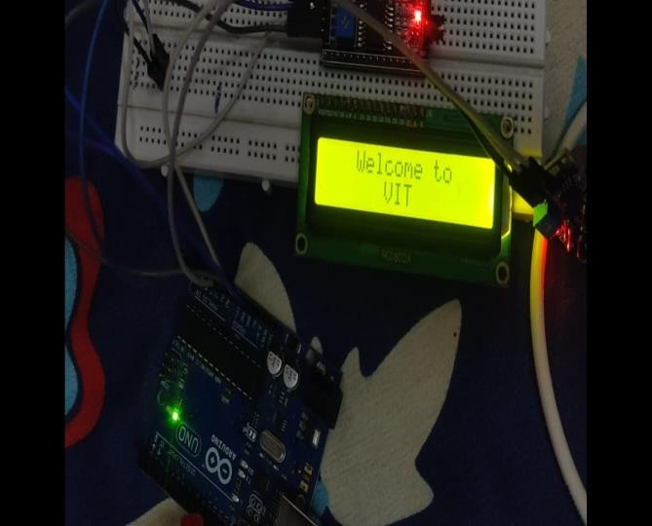
FIG 01: Message on LCD Display

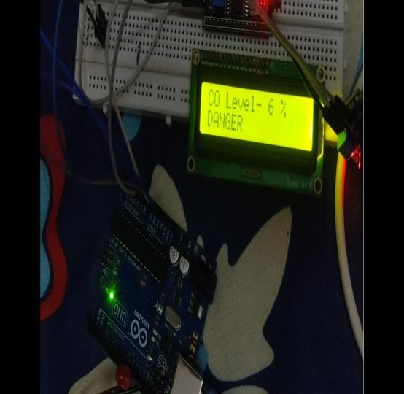
FIG 02: Altering message on LCD DISPLAY

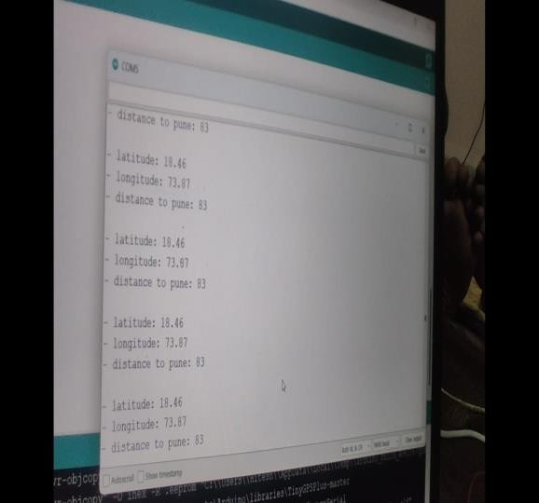
FIG 03: Results of GPS Module on serial moniter
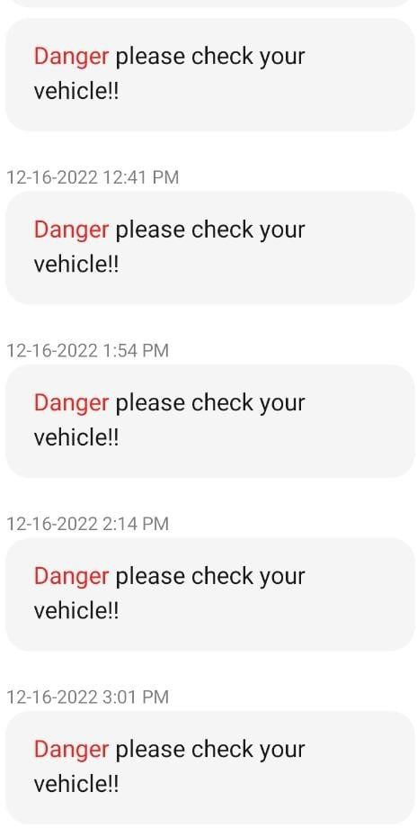

Fig 04: SMS on phone through GSM Module

- CONCLUSIONS & FUTURE SCOPE
By implementing this technology we conclude that the smoke exhaust from the vehicles is detected by the sensor accurately and it will send the notification to the user on the display of the vehicles also it has ability to check whether the vehicles is over polluting or not. As it is an atomized technology it does not required any man power to work and the accuracy of the system is high. Also we have added one more features for the safety purposes of the vehicles that is location tracking .In the future scope we will work on the piezo electric sensor or devices to give the power supply which will be generated through vehicles vibrations without any external power supply like battery .The energy which is generated will be further used to run the GSM and GPS module .

REFERENCES
- B. Ugur Toreyin, Yigithan Dedeoğlu " Wavelet based real-time smoke detection in video , 2005

- Thou-Ho Chen ,Yen-Hui Yin, " The smoke detection for early fire-alarming system base on video processing " , 2006

- DongKeun Kim , " Smoke Detection in Video"
, 2009

- Huseyin ozkaramanlı; Hasan Demirel , " Fire and smoke detection without sensors: Image processing based approach" , 2007

- Rodrigo Caballero, Hongcheng Wang " Video- based Smoke Detection: Possibilities,Techniques, and Challenges ,2007

- Yu Chunyu, Fang Jun , " Video Fire Smoke Detection Using Motion and Color Features" , 2009

