Design And fabrication of Overhead Water Tank Cleaning Machine model
Mr.Pradhnyayausagar Bapu Kothari , Mr.Anuj muley ,Mr.Prashant Ladekar, Mr.Humendrakumar Ladekar , Mr.Nikeshkumar Pandhare, Mr.Rohan Khandare, Mr.Sanket Tarak
UG Students, Department of Mechanical Engineering,TGPCET college, Nagpur
Assiatant professor In Department of Mechanicle Engineering,TGPCET college, Nagpur

ABSTRACT
The tank cleaner project aims to develop a mechanism that can be adjusted and fitted in tanks of varying sizes. The system comprises a motor that rotates to remove moss and other harmful materials present in the water and the tank. The primary goal of this system is to clean the tank and the water, ensuring that they remain free of any harmful substances.
The tank cleaner project aims to design a mechanism that is easy to operate, requires minimal maintenance and is cost-effective. The motor in the mechanism rotates at a predetermined speed, generating the required force to remove the moss and other contaminants. This cleaning action not only improves the water quality but also prevents the growth of harmful organisms that can be dangerous to humans and animals.
The tank cleaner mechanism is suitable for use in different settings, including homes, industries, and agriculture. It is designed to handle different types of tanks, ranging from small to large tanks. The system is adjustable, making it possible to fit it to tanks of different shapes and sizes.
In conclusion, the tank cleaner project is an innovative solution to the problem of keeping tanks and water free from harmful substances. It provides a cost-effective and efficient way of cleaning tanks, making it a viable option for a wide range of applications.

Key words : Cylindrical water tank, Gear, Scrub, Torque, Water Tank, Motor, Brush, Arms ,

- INTRODUCTION
- The importance of maintaining clean water in tanks cannot be overstated, as it plays a critical role in ensuring the health and safety of both humans and animals. Harmful substances such as moss and other contaminants can quickly accumulate in tanks, making them a breeding ground for dangerous organisms. Therefore, the need for an effective tank cleaning system has become increasingly important.
- The tank cleaner project aims to develop a mechanism that can be adjusted and fitted in tanks of varying sizes to remove moss and other harmful materials present in the water and the tank. The project seeks to design a system that is easy to operate, requires minimal maintenance, and is cost-effective.
- This thesis explores the development of the tank cleaner mechanism and its effectiveness in cleaning tanks and water. It discusses the various design considerations taken into account in developing the system, including motor selection, adjustment mechanism, and cleaning mechanism. The thesis also examines the performance of the tank cleaner mechanism in different tank sizes and shapes.
- Furthermore, the thesis presents the results of various tests carried out to evaluate the cleaning effectiveness of the system, including the removal of moss and other contaminants from the tank. It also discusses the implications of the findings and the potential applications of the tank cleaner system in different settings.

- DESIGN OBJECTIVE

By design, a water tank or container should no longer damage the water. Water is vulnerable to numerous ambient terrible influences, which include bacteria, viruses, algae, adjustments in pH, accumulation of minerals, and gathered fuel line. The infection can come from loads of origins which include piping, tank production materials, animal and bird feces, mineral and fuel line

intrusion. A successfully designed water tank works to deal with and mitigate those terrible effects. Water tanks need to be cleaned yearly to lessen the transport of algae, bacteria, and viruses to humans or animals. A survey was made to test when and how the tanks are cleaned. The document says that more than 75% of the overall population clean the tank manually. Most of the tanks mounted are overhead watered tanks. The dust accumulates inside the base and inside the regions where arms do not reach. People may also

- REASON FOR CLEANING OVERHEAD WATER TANK
A safety-primarily based information article related copper poisoning as originating from a plastic tank. The article indicated that rainwater becomes accumulates and is stored in a plastic tank and that the tank did nothing to mitigate the low pH. The water was delivered into the houses with copper piping, the copper released via way of means of the excessive acid rainwater and brought about poisoning in humans. Since the plastic tank is an inert container, it does not have an effect on the incoming water. A good exercise could be to research any water supply periodically and deal with it accordingly, on this case, the accumulated acid rain needs to be analysed, and pH adjusted earlier than being added right into the home water delivery system. The release of copper because of acidic water can be monitored with the aid of

using numerous technology, starting with pH strips and going to more state-of-the-art pH monitors, imply pH which while acidic or caustic, a few with conversation capabilities. Most of the algae increases at an optimal pH, among 8..7. degree this is impartial or decrease can assist to lessen the bloom of algae. Potential, surprise products will assist to easy swimming pools or water tanks from algae. In this manner, no one wants to apply a vacuum cleaner to get rid of algae. There isn't any causative link between the plastic tank and copper poisoning, a way to the trouble is to screen saved rainwater with pH signs and upload suitable remedy materials. As time is going through, sediments and dangerous materials might also additionally relax and get deposited on the bottom and walls of the surface. This deposition contaminates the water and makes it not worthy of use. Then slowly the breeding takes place and a few chemical reactions arise as noted above.

- PROBLEM STATEMENT
In ongoing investigations, it has been discovered that no automation based machine utilized in cleaning of overhead tank. This is a direct consequence of the sporadic shape and different height of the tanks. With past overview made an endeavor to make a machine via automation process for cleaning tank. A substitute arrangement has made an arrangement to tackle this issue. In India, the use of Sintex tanks by the individuals is around 71%. After examinations made the data that have confronted a great deal of troubles like constant work in the messy spots, sporadic installment and different reasons.

- LITERATURE SURVEY

SR.NO | Title of the Paper | AUTHORS | Name of Journal /ISSN No./Volume Number/Year | Conclusion from Research Paper
1 | Automatic Overhead Water Tank Cleaning System: A Review and an Approach | Shubham Shrivastav, Hari Om Kumar (2016) | International Journal of Advanced Engineering Research and Science (IJAERS) | Adjustment of the system inside the tank Is difficult
2 | "Computerized robot to clean water tank underwater" | Pramod b jachaket (2016) | international Journal of Scientific & Engineering Research Volume 11, Issue 6, June-2020 ISSN 2229-5518 | Softwares in water tank cleaning will become expensive in the context of india
3 | "Design and manufacture of drain cleaning system" | Ms. Smita gourkhedeet | International Journal of research and Engineering  ISSN 1258 6258 | Continues lubrication has to be there for less heating and less friction in linkages
4 | Fabrication of Water Tank Cleaning Machine | Mr. Shubham Samrit1 , Mr.Divyarajsingh Mandale2 ,Mr. Ankit | Impact Factor Value 4.046 e-ISSN: 2456-3463 International Journal of Innovations in Engineering and Science, Vol. 3, No.5, 2018 | Clening of water tank in circulation of brushes is better than brushes in linear motion (up and down)
5 | utomatic Water Tank Cleaning Machine | Prof. Shinde R.S.5 | international Research Journal of Engineering and Technology (IRJET) e-ISSN: 2395 -0056 Volume: 04 Issue: 02 | Feb -2017 www.irjet.net p-ISSN: 2395-0072 | Rack and pinion is very useful in having linear motion

- METHODOLOGY
The working of a system is shown as seen in the above methodology, the very first step is the removal of water. The water is removed from the tank to initiate the process.
After the water is removed, the machine is inserted into the tank. The machine should be carefully inserted and check whether it is placed properly inside the tank.
Now when the machine is inserted and placed properly, one should open the foldings and start cleaning the tank. It has to open in such a way that the brushes are in contact with the surfaces of the tank.
Take out the dirty water by using suction pump.
After the tank is cleaned properly, close the foldings and remove the machine from the tank.
Remove the dirty water which was being cleaned from the tank. After purification, fill purified water withinside the tank And then clean the tank cleaning machine once more properly. Repeat the same method a few times.

- PROPOSED SYSTEM

The main components used for making overhead water tank cleaning machines are
  - Gear Motor .
Gear motor is used to produce high torque with low speed. The motor used has specifications as single-phase 220V, 15A which produces power of 0.35 HP and frequency of 50 Hz and the shaft speed is 75 rpm.

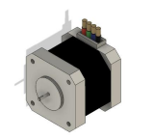
Fig 7.1 Gear Motor

  - Four Bar Linkage
A plane linkage consisting of four links pinned from tail to head in a closed loop with lower or closed joints. It is a plane mechanism consisting of four links that form rotating kinematic pairs. The four-bar linkage is arranged in such a way that it adjusts the inner diameter of the tank.

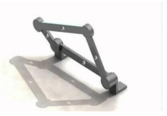
Fig 7.2 Four Bar Linkage

  - Rack and Pinion
A rack and pinion is a type of linear actuator that comprises a pair of gears which converts rotational motion into linear motion. A circular gear called “the pinion” engages teeth on a linear “gear” bar called “the rack”. Rotational motion applied to the pinion causes the rack to move relative to the pinion. the motor attached to the rack is moved in the vertical direction along the guideway with the help of the handle attached to the pinion.
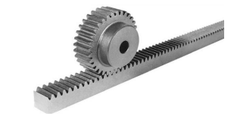
Fig 7.3 Rack and Pinion

  - Brush
The brushes are made up of Poly Vinyl Chloride (PVC) polymer. Brushes attached to the ends of four bar linkage revolve due to rotation of motor shaft to clean the inner surface of the tank.


Fig 7.4 Brush

7.5 Suction pump
To remove sedimented dirt after using machine
18 watt water lifting submersible pump.

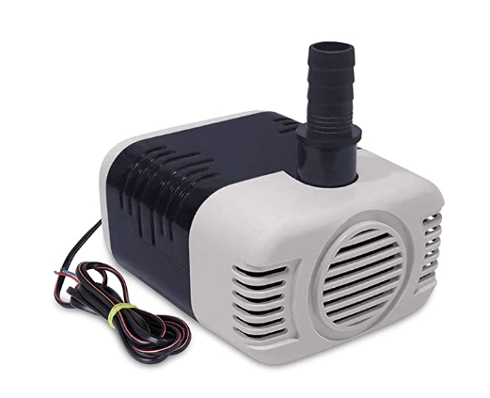
Fig 7.5 Suction pump

- PROPOSED DIAGRAM

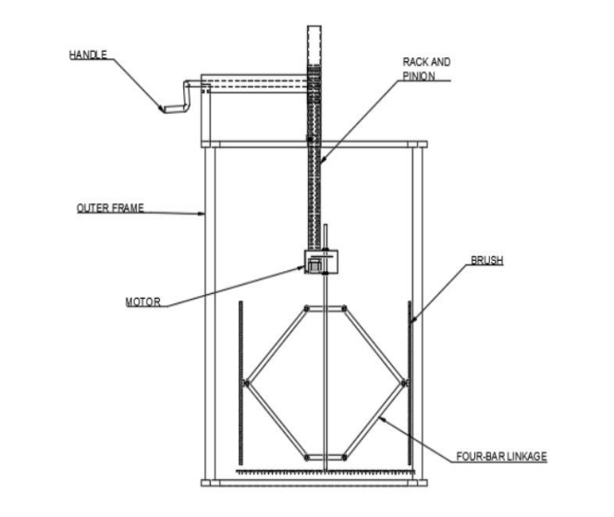
Four bar linkages
Brush
Rac k And Pinion
Handle
Suction pump
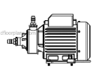
Outer frame
Motor

motor
Fig 8.1 Assembled design of Machine

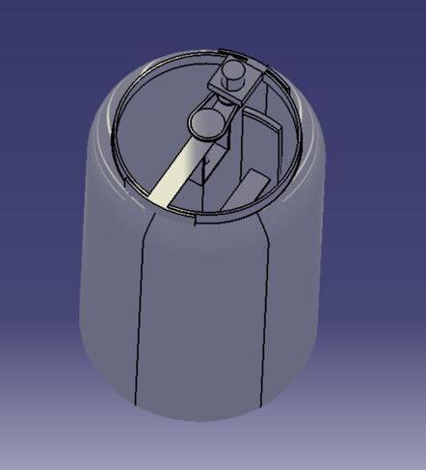

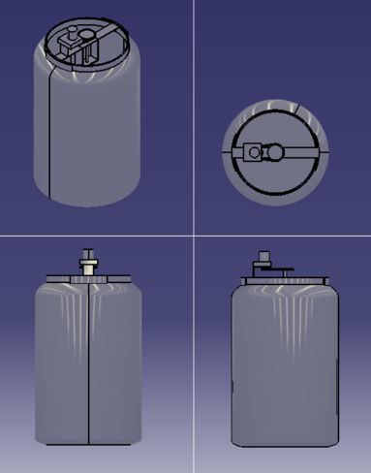

- CONCLUSION

In conclusion, the tank cleaner project is a valuable and innovative solution for effectively and efficiently cleaning tanks. Tanks are used in various industries, such as agriculture, manufacturing, and healthcare, to store and transport different types of liquids. Over time, harmful substances and contaminants can accumulate in the tanks, leading to a wide range of problems, including health hazards, equipment damage, and reduced efficiency.
motor
The tank cleaner system offers several advantages over traditional cleaning methods, including adaptability to tanks of varying sizes and shapes, environmentally friendly cleaning solutions, energy efficiency, and minimal maintenance requirements. The system also promotes a cleaner and healthier environment for all, reducing the risks associated with harmful substances and contaminants. The tank cleaner system is the result of a comprehensive design process that incorporates various modules, including the motor, rotating arm, cleaning brush, and control panel. These modules work together seamlessly to achieve efficient and effective cleaning of tanks. The system may also include sensors for automatic cleaning cycles and monitoring of tank contamination levels.
Overall, the tank cleaner project represents a significant contribution to the field of tank cleaning, and its benefits extend far beyond the industries that use tanks. The system has the potential to improve the quality of life for all, promoting cleaner and healthier environments and reducing the risks associated with harmful substances and contaminants. The tank cleaner system is an innovative and valuable solution that has the potential to revolutionize the way we clean tanks.
In conclusion, the tank cleaner project is a valuable and innovative solution for effectively and efficiently cleaning tanks. Tanks are used in various industries, such as agriculture, manufacturing, and healthcare, to store and transport different types of liquids. Over time, harmful substances and contaminants can accumulate in the tanks, leading to a wide range of problems, including health hazards, equipment damage, and reduced efficiency.
system may also include sensors for automatic cleaning cycles and monitoring of tank contamination levels.
Overall, the tank cleaner project represents a significant contribution to the field of tank cleaning, and its benefits extend far beyond the industries that use tanks. The system has the potential to improve the quality of life for all, promoting cleaner and healthier environments and reducing the risks associated with harmful substances and contaminants. The tank cleaner system is an innovative and valuable solution that has the potential to revolutionize the way we clean tanks.

- Refrences

1]. M. S. Triantafyllou and G. S. Triantafyllou, “An efficient swimming vehicle”. Guo, T. Fukuda, and K. Asaka, “A new type of fishlike underwater microrobot,” IEEE/ASME Trans. Mechatron., vol. 8, no. 1, pp. 136–141, Mar. 2003.

[2]. W. S. N. Trimmer and K. J. Gabriel, “Design considerations for a practical electrostatic micromotor,” Sens. Actuators, vol. 11, no. 2, pp. 126-173, Jan. 1987.

[3]. T. Schaub, "Spread frequency shift keying", IEEE Trans. Commun., vol. 42, no. 4,pp. 182-296, Aug. 1993.

[4]. Brown J. A. , “vacuum tanker for cleaning storage tanks,” Process Engineering, vol. 21, no. 5, pp.138- 180,Sep. 1989. [5]. Dr. R. K. Bansal, “ Kinematics of machine”, Laxmi Publications (P) Ltd ., vol. 1, no. 4, pp. 23-287,Nov. 2011.

5]. Dr. R. K. Bansal, “ Kinematics of machine”, Laxmi Publications (P) Ltd ., vol. 1, no. 4, pp. 23-287,Nov. 2011.

[6]. Shubham Shrivastav, Hari Om Kumar, “Design and Development of Cylindrical Water tank cleaner”, IEEE Trans. Commun.,vol. 6, no. 1, pp. 1-7,Feb. 2016.

[7]. Vikramsingh R. Parihar, Overview and an Approach to Real Time Face Detection and Recognition, International Advanced Research Journal in Science, Engineering and Technology (IARJSET), Volume 4, Issue 9, PP 39-46, Sept 2017

[8]. Vikramsingh R. Parihar, Neural Network and Fuzzy Logic Based Controller For Transformer Protection, International Journal of Current Engineering and Scientific Research (IJCESR), Volume 4, Issue 9, PP 33-38 , Sept 2017

