Detecting Skimming Devices in ATMs through
image processing

Mr SANTHOSH B J
Assistant Professor
“Dept of CS&E
BGS Institute of Technology
Adichunchanagiri University
Mandya, India”
santhoshbj@bgsit.ac.in

VIJAY A S VIDYA R GOWDA SHUBHA KHADRI L SANIYA SABA
“Dept of CS&E “Dept of CS&E “Dept of CS&E “Dept of CS&E
BGS Institute of Technology BGS Institute of Technology BGS Institute of Technology BGS Institute of Technology
Adichunchanagiri University Adichunchanagiri University Adichunchanagiri University Adichunchanagiri University
Mandya, India" Mandya, India” Mandya, India” Mandya, India”
Vijayshekar129@gmail.com vidyargowda3@gmail.com shubhakhadri1@gmail.com saniyasaba016@gmail.com

Abstract - Skimmer is used for card skimming Unauthorized extraction of data from cash card magnetic stripes Cash card. Information is copied to another blank card Thieves use magnetic stripes to extract cash. Name of the actual account holder. Skimming works by replacing his ATM-like card reader with a disguised fake card reader. The counterfeit reader captures all credit card data, a debit card or an ATM card going through a skimmer. This research makes a technological suggestion for image processing to identify skimming devices when they are linked to an ATM. A semi-automated system with MATLAB for analysis indicates the processing of captured images. The proposed solution detects skimming devices using a systematic set of actions when connecting to an ATM using an existing ATM read the image and all additional items are linked to the machine. To enable integration, the algorithm may be expanded. Minimize the likelihood of card cloning/skimming crimes by converting the result using an additional external system.
Keywords - skimming; semi-automated; cloning crime; magnetic stripes

- INTRODUCTION

Skimming is the word for theft of criminal money. Getting money is the primary goal of skimming. Cooper describes this 50 years ago in 2014 [1], “Skimming means stealing a few bucks from your Employers, or even billions of well-orchestrated scams We've seen it in countless Hollywood movies.” skimming but using complex and clever tricks hardware is difficult to find unless you know what to demand. Additionally, credit cards and the bank information used by the credit card sector are the major focus of today's high-tech world.
ATM (automated teller machine) skimmer There are usually two critical parts attached to ATM hardware. With a micro camera pointed at the PIN-PAD, take a picture of the victim. When you enter your PIN (Personal Identification Number). Magnetic card reader to retrieve card details Clone/duplicate a map to create another map (Figure 1). Cloned card information is immediately available you can use any ATM in the world. Only after obtaining a monthly statement, checking your account online, or receiving an SMS (short message service) can the true cardholder be identified.

Most ATM card-skimming Criminals Electronically "Scan" Magnetic Stripes Breaks into the backside of the card, stealing card data and PINs in the process of ATM transactions. This is done by invisible/unrecognized attachments using the above portable electronic devices ATM devices such as handheld electronic card readers and Mini cameras [2]. You can easily do this by collecting data as suggested in [2]: -
- You can clone Debit! Credit! Cash card.
- Obtain a personal identification number (PIN).
- Withdraw funds using combined information from your account.

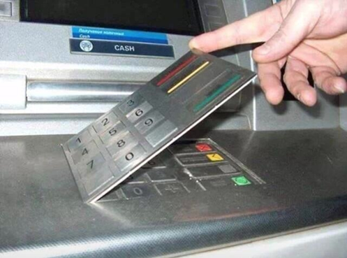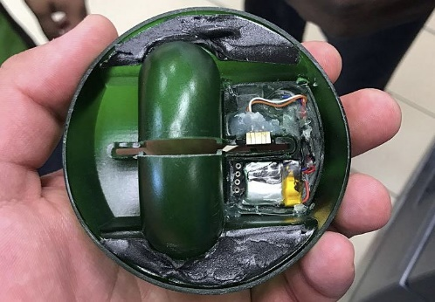

Figure 1: Skimmed devices

According to Cooper, similar things may occur in POS (Point of Sale) terminals used by registrars and accoutres in restaurants and retail establishments with/without the information of the employees. As all banks are linked through the global banking system (Visa/MasterCard), While the crime might occur in your area and the fraudulent transaction could come from anywhere in the globe, the cardholder's information could be exploited by criminal organisations right away or sold to other organised crime organisations [2].

According to the police, after carefully examining the security measures taken by banks at ATMs frequented by a large number of clients each day, Bank ATMs cannot be made secure by installing concealed cameras or hiring security personnel around-the-clock. A complete monitoring system may assist ATM operators (Private Companies ATMs or Bank ATMs) in minimising the cost of transaction disputes and enhancing the brand image by installing surveillance cameras [4] in addition to following crime-fighting regulations; however, settling such disagreements may be difficult since employee pay hours may rise if an employee spends hours looking through the tape, which sometimes results in a lack of the necessary proof to settle the dispute and may even lead to consumer distrust.

Even though CCTV cameras are put in every ATM, they are only utilised to capture what happens in front of the machine; banks only consult the tape after a problem has occurred to take corrective action. The installation of tools to copy bank cards, fraudsters may still manipulate ATMs in the presence of these cameras by installing a second camera to capture the user inputting their PIN, producing duplicate cards to be used locally, or selling the data to other parties. This is crucial since it will show if any ATMs are being skimmed.

The degree of security is to be raised as a result of this activity. ATM by developing a programme that reads TOM data The image of an ATM that recognises irregularities and sends warnings may be combined with other automation systems to take the appropriate actions to stop ATM destruction, among other things. Actively skimming and stealing loyalty card information Protection and effective use.

Section II will focus on Technologies introduced by ATM operators A researcher who proposed an innovative card prevention idea in addition, each technology was rigorously evaluated and analysed. The approach is described in Section III. Then, use the suggested method to get the outcome. The findings are further examined and discussed in Section IV. Section V provides an overview of the whole body of study and the projected future efforts.

- LITERATURE REVIEW

According to ATM trading group Skimming More than $2 billion in fraud losses annually, the number is increasing every year around the world This will force ATM manufacturers to innovate further. A new method to prevent fraud related to card skimming [5]. The problem of ATM skimming protection and detection systems has been the subject of several research.

Shin et al. 2011 [6] Framework Proposal for Prevention Financial Fraud by Digital Cloning of ATM Cards Steganography and Watermarks: The thumbprint hash function and client login information are used to create the watermark. However, this solution Requires the installation of additional equipment such as an ATMs Card accepting devices that also read thumbprints Mentioned in [7]. Such a solution would prevent disability and Prevent people from using machines. Therefore, its use is required Another new authentication system such as voice recognition Retinal scans requires an extra budget for upgrades like this.

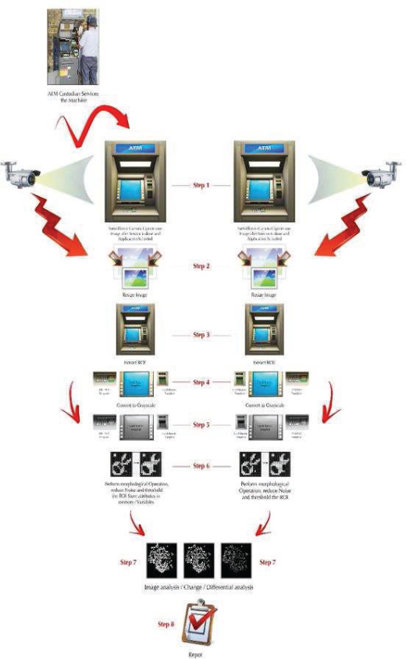
Figure 2. Workflow for reaching the final result with the proposed algorithm

Rao and Appendar 2013 [8] provide an overview. Data mining methods including clustering, decision-making trees, Bayesian networks, and artificial neural networks are used as solutions to prevent plastic card fraud and fraudulent transactions. On the other hand, it is also said that training takes time and requires the provision of data and situations; otherwise, the decision tree would encounter the "wrong" issue. False negatives and positives. This is because both the technology and the quantity of data handled are tremendous. To encode the training data, we merely need to extract the important features. Additional levels were recommended by Meshram and Yeganti in 2013 [9]. Secure the transaction process flow by adding additional phases. A confidential inquiry is posed to the user. By asking about secrets, security is increased logically.

Questions that require a cryptographic algorithm to be implemented. When the card is received by the user or cardholder from the bank, decide on your secret question and respond. Cardholders are constantly asked questions about this data, which is encrypted in the banking system. Use your debit card at an ATM.

An anti-skimmer was created by Nixdorf in 2014 [10]. A mix of skimmer devices is used for detection and resolution. A double layer of protection against skimming assaults, a detector and skimmer jamming feature, and improved map data security. Wincor Nixdorf was the first ATM supplier, and it also offered such services globally and was assessed. Not only changes around the card reader, Interference field to prevent skimmers from spying on your data Magnetic strips for bank and credit cards. Where this is not practicable, this solution is implemented and deployed on the computers. You will be seen as a criminal. This model is Electromagnetic interference fields around card reader slots It prevents criminals from reading the inserted data. map. The solutions offered by Wincor Nixdorf cover this perfectly. Known skimmer technologies and the products manufactured with them steal information from ATM cards' magnetic stripes. However, modern gadgets and tendencies after it gained popularity, however, the solution must be changed to account for this. criminal technology's continued growth [10]. ATMs too Operators should invest in this solution and carry out the necessary preparatory study to make sure it complies with the current ATM model.

Intelligent technology has been created by Diebold Incorporation. It's called the Active Edge approach, and they think it's one. An unbeatable solution to the card skimming problem. Technology based on surface detecting sensors, card jitter and signal blocking, tamper obvious bezel designs, etc. was offered by several providers. A representative from Diebold explained: Gradually Overcome -The Good Man Was Ten Feet Tall Wands and villains he builds an 11-foot ladder. " [Five]. active edge This approach requires every user to put their card into the machine. Using the long edge as opposed to the usual entrance technique Card with the shorter edge should be inserted first. Active Edge will move the map to A 90-degree turn will stop all modern skimming equipment from working. Read magnetic stripe card details Prevents skimmer devices from stealing your data [Five). There is also communication with the ATM centre. The processing unit is encrypted to prevent the capture of Tracked data.

Here is what we know about how to spot skimming equipment: There is not much literature on ATMs with image processing. Here, we provide a novel method of detecting skimming devices. A device that uses image processing software.

- PROPOSED METHODOLOGY

The suggested algorithm's process is shown in Figure 2. Automate a methodical series of procedures to look for skimming. A device when connected to an ATM.

step 1: The ATM manager will provide ATM services as usual Procedures for refilling cash, emptying machines, activating alarms building the system, start the proposed application, ATMs.

Step 2: Surveillance camera film ATM Pictures will continue to be taken every 5 minutes.

Step 3: Recorded images are reduced to their original size of 25D44 to improve processing speed.

Step 4: Display thumbnails in the correct position on the GUI screen “Graphical User Interface”

Step 5: A card reader, on-screen buttons, and a PIN pad are all used to display ROI (region of interest) images. Set the location manually through the GUI application interface (Figure 3). Specify (“start row, start column, end row, end column”).

Step 6: Transform the base image to a grayscale image

Step 7: Template comparison is done as follows:

Do the following:
- The target image should be changed to a grayscale version. Observe how the pictures are not aligned. Between them, there is a little offset. These areas look like this in the picture I extracted which never changes. this area Receipt printer can instantly print the usage status of your bank account Transaction completed.

- Extract Perform basic image registration. Find the card reader by looking for it in the base picture. Patches are included in both base and target image photographs. Find the offsets' vertical and horizontal dimensions.

- A patch that connects the base picture to the destination image.

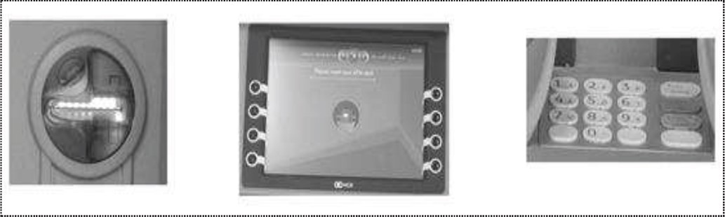

Figure 3. ROI images of the card reader, on-screen button and PIN pad

- Align the targets on a target picture by applying an affine transformation to the base image.

- Extract ROI for card readers, screens and Pins Install the PAD reader to the same location as previously defined.

- Find the image that differs between the two templates.

Step 8: Determine the number of non-zero pixels and decide whether it exceeds the cut-off. In this case, you will get a warning to make
Step 9: Show the result on the GUI screen.

- RESULTS & DISCUSSION

Choosing morphological structural components: A few components were employed throughout the implementation process to reduce picture noise. Selection of Structural elements created using trial and error. Table I demonstrated the process. Finally, a structural component was applied with the highest precision.

TABLE 1. RESULT OF USING STRUCTURING ELEMENT
Shape | Result (Accurate)
'diamond' | 8/10
'arbitrary’ | 7/10
'square' | 10/10
'disk' | 8/10

Change the image size: The ATM image taken is large Due to its large size, it will take a long time to process. Resizing images is necessary to increase efficiency. find out for optimal sizing and avoiding warnings on various platforms Size tested. Table 2 displays the outcomes.

TABLE 2. RESULT OF IMAGE RESIZING AGAINST RESPONSE TIME
Dimension of Image 3555*2000 with (387-612) KB size
Image  Resize  Rate | Processing time in minutes | Observation
100% | 1+ | Warning: displayed at 25% because the image is too big to display on the screen
75% | 1+ | Warning: displayed at 33 percent because the image is too big to display on the screen
50% | 1 | Warning: displayed at 50% because the image is too big to display on the screen
25% | -1 | No errors were displayed.

Threshold: The threshold was determined based on heuristics. The intensity threshold for each region of interest was Tested from 5 to 100. Strength is shown in Table 3. For each ROI, the threshold and the outcome.

Recognize change: This model is structured like this Defines the percentage of the area that deviates Source helps detect subjective anomalies to the recorded image. This was the case for the proposed algorithm Found to be greater than 1% of PIN PAD area Otherwise it will appear in your notification/attention alert App screen, the same sentence for the card reader There is a discrepancy of greater than 5%. To show where it must be put, the backlight, however, emerges from a green plastic case. Additionally, the option of taking the card out of the slot was disregarded. It is set to 0.5 percent on the touch screen. Greater sensitivity to spot anomalies and differences is achieved with a smaller proportion (Figure 4). To reduce noise, he uses morphological inference. After scaling up the ROI, he finds the number of pixels. Check to see whether the value is non-zero and the value exceeds the previously defined threshold.

Thresholding involves the use of morphology. The image turned out to have a lot of broken connections. There are spots, but they are very close to each other. Because of the different intensity for each ROI to focus on, Calculating the threshold using a single threshold causes the following problems: separate patch. carry out a formal final will Combine these patches to form a single contiguous region. Reached.

TABLE 3. RESULT OF TESTING DIFFERENT THRESHOLD

Adjust  Threshold | PIN PAD | Screen & Buttons | Reader
5 | 8/10 false alerts | 10/10 false | 7/10 false alerts
10 | 8/10 false alerts | 10/10 false | 7/10 false alerts
15 | 6/10 false alerts | 10/10 false | 7/10 false alerts
25 | 6/10 false alerts | 10/10 false | 6/10 false alerts
30 | 3/10 false alerts | 10/10 false | 4/10 false alerts
35 | 2/10 false alerts | 10/10 false | As Expected,
40 | 2/10 false alerts | 6/10 false | As Expected,
45 | As Expected, | 5/10 false | As Expected,
50 | As Expected, | 4/10  false | As Expected,
55 | As Expected, | 4/10 false | As Expected,
60 | As Expected, | 2/10 false | As Expected,
65 | I/10 (Normal instead of alert) | I/10 false | 2/10 (Normal instead of alert)
70 | 1/10 (Normal instead of alert) | I/10 false | 2/10 (Normal instead of alert)
75 | 1/10 (Normal instead of alert | As Expected, | 3/10 (Normal instead of alert)
80 | I/10 (Normal instead of alert) | I/10 false alerts  (Normal instead of alert) | 3/10 (Normal instead of alert)
85 | 1/10 (Normal instead of alert) | 2/10 false notifications (Normal instead of alert) | 3/10 (Normal instead of alert)
90 | 1/10 (Normal instead of alert) | 2/10false notifications (Normal instead of alert) | 5/10 (Normal instead of alert)
100 | 2/10 (Normal instead of alert) | 2/10 false notifications (Normal instead of alert) | 10/10  (Normal instead of alert)

- CONCLUSION

We apply a variety of image processing algorithms to identify ATM skimming, which is the objective of our study. See Section III for more information. In conclusion, the proposed algorithm involves segmenting the base image into the target and ROI, applying a morphological closure filter to reduce noise, setting a threshold on the difference image that essentially determines how much the target and base images have changed, and finally, calculating the ROI and determines the number of unchanged pixels in the difference image equal to zero.
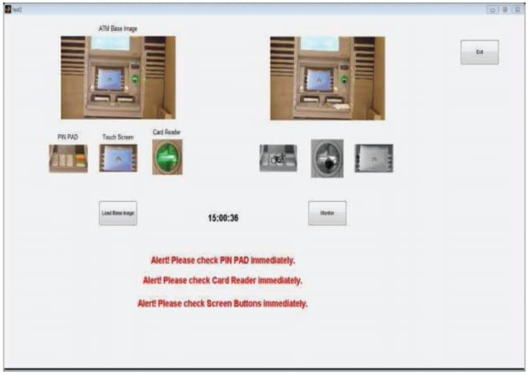
Figure 4. Screenshot of GUI to host the algorithm code
Future expansion and integration of the application with other systems would constitute genuine proactive system activity. Avoid having a duplicate bank card. This is achieved through integration with a central ATM system. It is possible to automate on/off and even link with the police system. Assembled with a CCTV camera is the application Commercial ATM monitoring instruments.

REFERENCES
[I] Cooper, what should I know about card skimming? July 2014[online], available: http://www.engadget.com/2014/07/28/credit-cardskimming-explainerl
[2] Permanent TSB, ATM Security, October 2009, [Online], Available at: https://www.pennanenttsb.ie/about-us/need-elp/securitv/safetvatheatml
[3] As a Hindu, 60 percent of ATMs do not have surveillance cameras. November 2013 [online], available at: http://www.thehindu.com/news/cities!Hyderabad/60-per-cent-atms-donot-have-surveillance-cameras!article5384039.ece
[4] Hawk, R., Hardening ATM Security, 2015, [Online], Available at: http://www.redhawkus.com/blogJenhancing-atm-securitv!
[5] Cluckey, Diebold ActivEdge A TM card readers: with a twist better?, July 2014, [online], available at: http://www.atmmarketplace.com!articles!the-diebold-activeedge-atm-ardreader-a-turn-for-the-better!
[6] Singh, K., Choube, Y., and Goel, "A Proposed Framework for Prevention. “Financial Fraud by Duplicating ATM Cards,” World Conference Engineering, Volume 1, July 2011.
[7] Mandai, Ghosh, Alan, S.S. Chandra “White E-Wallet “Money Enabled by Technology,” International Journal of Advanced Research in Computer Science and Software Engineering, vol. 4, no. 3, March 2014.
[8] Appendar and Rao, E. (2013) “An Overview of Plastic Card Fraud and Solutions to Avoid Fraudulent Transactions,” International Journal of Research in Engineering and Technology, vol. 02, no. August 8, 2013.
[9] Meshram L. and Yenganti P.T., “Credit and ATM Card Fraud “Defending Using Cryptographic Algorithms,” International Journal of Advanced Studies in Computer Science and Software Engineering, vol.3, no. August 8, 2013.
[10] Nixdorf, W., "Anti-skimming II module", Paderborn-Germany, 2014.

