Detection of creatinine through urinalysis for diagnosis of kidney diseases
K Anitha¹, V Hemasri², M Sabitha³
¹Final year Biomedical & Paavai engineering college
²Final year Biomedical & Paavai engineering college
³Final year Biomedical & Paavai engineering college

---------------------------------------------------------------------***---------------------------------------------------------------------
Abstract - The detection level of creatinine in blood as well as in urine and other parameter is diagnostically important as it represents renal, muscular and thyroid functions. Lots of people worldwide suffer from acute and chronic kidney diseases. To overcome it they go under the treatment of hemodialysis, peritoneal dialysis and artificial kidney, and also kidney transplants. It can be easily prevented by knowing the creatinine level in our bodies. Creatinine is a chemical waste product of creatine. Creatine is a chemical made by the body and is used to supply energy mainly to muscles. This test is done to see how well your kidneys work. Creatinine is removed from the body entirely by the kidneys. If kidney function is not normal, the creatinine level in your blood will increase. The proposed work represents a disposable biosensor to measure creatinine in the whole blood. The sensor is developed based on the impedimetric technology. The concentration of creatinine in urine is determined from the impedance data of various urine samples.

Key Words: Biosensor, Creatinine, Kidney function, Urine.

1.INTRODUCTION
Creatinine, a marker of an amino acid pool, is produced from phosphocreatine and creatine. The production of creatinine reveals the gentle breakdown of muscle protein. After production in our body, a moderately fixed amount of creatinine gets filtered from the bloodstream by the kidney. The usual reference ranges of creatinine are: for neonates 0.3-1.2 mg/dl or, 22.9-91.5 mol/L; for infants 0.2-0.4 mg/dl or, 15.3-30.5 mol/L; for children 0.3-0.7 mg/dl or 22.9-53.4 mol/L; for women 0.5-1.0 mg/dl i.e. around 45-90 mol/L and for men 0.7-1.5 mg/dl or 60-110 mol/L. Diagnostically, values beyond 140 µ mole/L imply the urgency of carrying out the creatinine clearance test.
Values beyond 530 µM related to severe renal impairment.0.6-1.5 mg/dl or, 45.8-114.4 µmol/L creatinine level in serum indicates near 50% kidney nephron loss; 1.6 - 4.6 mg/dl or, 77.9-350.8 µmol/L indicates that more than 50% kidney nephron loss that may lead to diminished kidney function; 4.7-9.9 mg/dl or, 358.4-755.0 µmol/L indicates that 75% loss of kidney nephron which extremely impaired renal function. Serum creatinine value of 10 mg/dl or, beyond 762.6 µmol/L indicates that 90% damage of kidney nephron means final-stage of kidney disease .Therefore, consistent monitoring of creatinine in urine and other parameter as well as in blood is clinically essential, mainly for individuals suffering from renal diseases.

2.Methodology
- The operation of the proposed device is quite identical to the normal device.
- The feature that is altered from the normal device is, the result display is eliminated from the conventional device, and instead the user can look into the smartphone for the test readings.
- This is very much cost effective.
- It is help to save the result values which would be useful to both patients as well as the doctors.
- This will help the doctors to monitor the patient’s health condition, and direct them with the appropriate medications.

SAMPLE | Creatinine | Heartrate
2023-04-28 07:03:16 UTC | 0.68 | 51
2023-04-28 07:03:33 UTC | 0.68 | 51
2023-04-28 07:03:50 UTC | 0.68 | 51
2023-04-28 07:04:07 UTC | 1.08 | 65
2023-04-28 07:04:10 UTC | 0.38 | 35
2023-04-28 07:04:14 UTC | 0.30 | 37
2023-04-28 07:04:23 UTC | 0.28 | 33

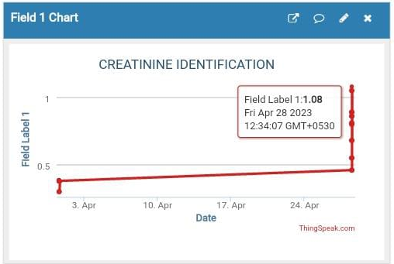
Fig 1 Result

3. CONCLUSIONS

The development of a creatinine biosensor depending on enzymatic hydrolysis of creatinine in the presence of the enzyme creatinine deiminase. It adopts electrochemical impedance spectroscopy (EIS), for the detection of creatinine. The sensor electrodes can be reusable after removing the enzyme immobilized chitosan membrane from the electrode surface. To monitor the performance of the sensor, the suitable calibrating liquid and calibration procedure are discussed. The proposed sensor can successfully measure blood creatinine in the range from 0.1 mg/dl to 4 mg/dl

REFERENCES

- Paper-based device for naked eye urinaryalbumin-creatinine ratio evaluationryuya hiraoka, kento kuwahara, yun-chiao wen, tzunghai yen, yuki hiruta, chao-min cheng, and daniel citterioacs sens.,March 2020.
- Detecting heart rate using pulse sensor as alternative knowing heart conditionyuda irawan,yunior fernando, refine wahyuni , december 2019.
- Internet of things (iot) for next-generationsmart systems: a review of current challenges,future trends and prospects for emerging 5g-iot scenarios kinza shafique , bilal a. khawaja , (senior member, ieee), farah sabir ,sameer qazi , 2019
- Predicting urinary creatinine excretion and its usefulness to identify incomplete 24 hr urine collectionst,Willem de keyzer, Inge huybrenchts, 2011
- World kidney day, “chronic kidney disease”, 2015; retrieved fromhttp://www.Worldkidneyday.Org/faqs/chronickidney-disease

