Date: June 2023

DevOps: A Software Paradigm

Sahiti Putcha, Nagendra Yandapalli, Gollamudi Srivenkat, Sai Susanth Vucha

Abstract- DevOps is as easy and fascinating as its name suggests while, in reality, it takes an effort and cultural shift to achieve it. It is based on two main components, Dev-Developers, and the Ops-Operations team work together to achieve tasks. Although articles and websites throw light on collaboration and communication, automation as its major concepts in DevOps, the cultural shift and adoption of DevOps are often left unnoticed in many papers addressing DevOps and its practices. Investigation into the effectiveness of implementing DevOps revealed that adopting DevOps practices is not easy, but with the suitable techniques and mindset, adopting DevOps will be easily achieved. Researching articles by other authors typically talked about DevOps and its practices and the definition of DevOps. Viewing such articles, this article demonstrates that Adopting DevOps by organizational groups is quite challenging but the suitable tools and understanding of DevOps will help organizations implement it effectively. It also illustrates the statistics of IT professionals who are currently implementing DevOps and how it is useful for them. Furthermore, this article also reasons why DevOps is preferred over Agile.

Keywords- DevOps, automation, CI/CD, integration, microservices, software development, agile.

- Introduction

The modern world cannot function without software. Computer-based systems regulate national infrastructures and utilities, and most electrical items incorporate a computer and controlling software. Industrial manufacture and distribution, as well as the financial system, are entirely computerized. The entertainment sector, which includes the music industry, computer games, cinema, and television, is heavily reliant on software. As a result, software engineering is critical to the operation of national and international societies.
Software systems are intangible and abstract. They are not limited by the qualities of materials, physical laws, or production procedures. This simplifies software engineering because there are no natural boundaries to the software's capability. However, due to a lack of physical restrictions, software systems can rapidly become exceedingly complicated, difficult to understand, and costly to alter. Software systems range in complexity from modest embedded systems to massive global information systems. It is futile to look for universal software engineering notations, methods, or procedures because different types of software necessitate distinct approaches. The demands vary as new software engineering approaches enable us to design larger, more sophisticated systems. Systems must be constructed and supplied more quickly, and systems must have previously thought-to-be-impossible capabilities. Existing software engineering approaches cannot meet these increased expectations, and new software engineering techniques must be developed. Individuals and society are increasingly reliant on complex software systems. We must be able to produce reliable and trustworthy systems in a cost-effective and timely manner. The software business is continuously looking for efficient and adaptable solutions to create high-quality software quickly and at a low cost. Agile techniques strive to consistently deliver excellent products and services to their consumers, ensuring a quick return on investment and the flexibility to adapt to changes in client needs over time and permanent environment changes.
Due to the high level of competitiveness in the software industry, Software Development Companies are currently seeking to increase their productivity, which tends to integrate and institutionalize agile and less complex processes that allow them to adapt to business changes in a timely manner.
Despite advances in the design of solutions, models, or frameworks to support various processes in software development, these alone do not yield the optimum outcomes in highly productive environments that require consumers to be served constantly.
DevOps has recently acquired prominence in the software development process. DevOps as its name suggests is Developers and Operations team who work together to develop software. Trust is an important term used by companies when working with their team and making the software build a successful model. Be it Amazon, Google, or Netflix, everybody looks for trust. Hence to implement DevOps, “Trust” is important. Ever since its inception, several software development trends have been growing, always striving for better practices that ensure the delivery of high-quality products while fulfilling industry standards and customer expectations. Within this evolution, traditional frameworks are continually evolving as a result of the homogeneity of their distinctions, comparison, and integration of best practices. The primary goal of DevOps is to integrate software development and operations into a unified, integrated, and continuous process, to break down boundaries between Dev and Ops. It is intended from a DevOps perspective to leverage the expertise and knowledge of people, processes, and technology to foster collaboration and creativity throughout the software development and launch process. This is accomplished fast, frequently, and consistently, without diminishing the quality and value supplied to clients, which are distinguishing aspects in agile methodologies, while also boosting some of its benefits, such as time to market.
Due to the various perceptions and definitions that can be found in the literature, the goal of this methodical mapping is especially on how companies use DevOps to meet their growing demands and likewise, aims to discover the solutions given by other authors about the conception of DevOps implementation and/or operation. Furthermore. the adoption of DevOps in SDC has been offered along with the studies that identify issues such as the barriers and benefits of practicing DevOps have been conducted. There are, however, no studies with sufficient information to carry out the DevOps adoption process in a clear manner and that specify a set of methods that allow regulating what is linked to DevOps. In this regard, we believe that the systematic mapping performed can be extremely valuable since it synthesizes the present state of knowledge in DevOps and allows us to build the essential attributes to develop a roadmap for the adoption, implementation, and control of DevOps in the SDC.

- Literature Review

The DevOps movement began to take shape between 2007 and 2008 when IT operations and software development communities raised concerns about what they perceived to be a deadly level of dysfunction in the industry. The main concern with traditional software engineering methods was that, it was organisationally and functionally distant from the development and support. That’s when DevOps came into the picture. Nearly all (99%) of DevOps teams are confident about the success of their code that goes into production, in a survey of 500 DevOps practitioners conducted by Atlassian. [1]
DevOps, as the name suggests, means Development and Operations teams come together for a better approach to software engineering. DevOps affects all stages of the development and operations lifecycle. DevOps pulls together the talents, methods, and tools from every aspect of an engineering and IT organization, from planning and building to monitoring and iterating. Ever since its birth, it has been a booming technology that IT professionals consider implementing for better organizational growth and success. DevOps tools help the team reach organizational goals by using CI/CD approach. Continuous integration (CI) and Continuous Delivery (CD) is an important concepts to talk about when working with DevOps. This study suggests that to improve businesses, companies shall practice DevOps instead of Agile. And it also enlightens us that adopting DevOps will deliver the software faster and it is highly reliable.
Research asserts the importance of Agile. Of course agile is a great technique adopted by companies but typically, agile practices are only applied on the development side; however, a software development process does not end with the last acceptance test and handing over the entire deployment to the operations team.

According to reports [3, 4], the “deliver software faster” and the necessity for wider collaboration among IT teams are some of the drivers for the adoption of DevOps.Useful and meaningful cooperation, common ways of working, or shared goals and trust can all lead to improved team collaboration and understanding, as well as the ability to incorporate agility into the maintenance phase of the software development process.
DevOps adoption can help to solve the problems that come with it but the adoption of DevOps is not trivial and can require complex changes in an enterprise process organization and workflows.[4]
But this systematic mapping suggests that DevOps is highly recommended to provide top-notch software products to clients. This study suggests that with the proper implementation of DevOps and CI/CD, companies can easily provide fast and consistent changes to the software and keep up with the growing demands.

3. DevOps Practices

DevOps, short for Development and Operations, refers to a set of practices, methodologies, and cultural philosophies that aim to improve collaboration and efficiency between software development teams and IT operations teams. The primary goal of DevOps is to enable organizations to deliver high-quality software products or services more rapidly, reliably, and frequently.
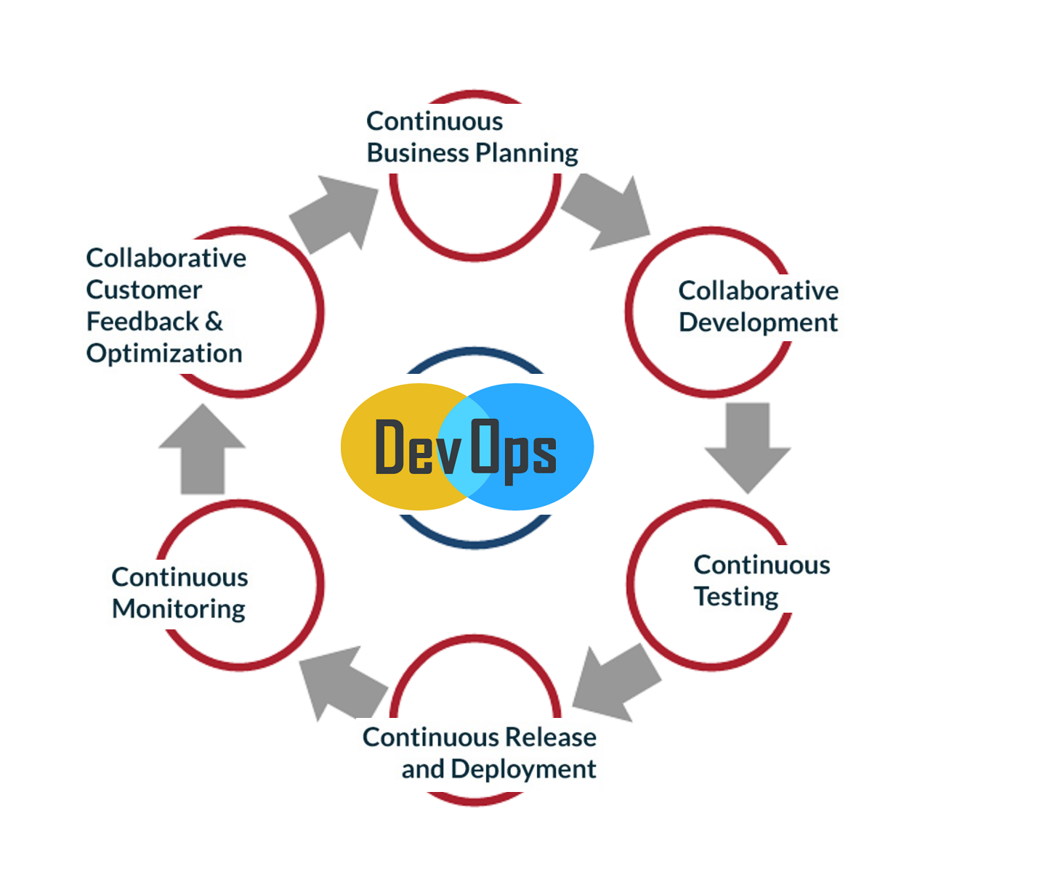
Fig 3.1 DevOps practices
DevOps practices typically involve the following key principles:
- Continuous Integration (CI): Developers frequently integrate their code changes into a central repository, enabling early detection of integration issues. Automated tests and build processes are commonly employed in CI.
- Continuous Delivery (CD): Building upon continuous integration, CD focuses on automating the entire software release process. It ensures that software can be deployed to production environments quickly, reliably, and with minimal manual intervention.
- Infrastructure as Code (IaC): This practice involves defining and managing infrastructure (servers, networks, databases, etc.) using machine-readable configuration files or scripts. IaC enables consistent, reproducible, and automated provisioning of infrastructure resources.
- Continuous Deployment: With continuous deployment, changes that pass through the CI/CD pipeline are automatically deployed to production environments without manual intervention, assuming they pass necessary tests and checks.
- Automated Testing: DevOps emphasizes automated testing to ensure the quality and reliability of software. This includes unit tests, integration tests, functional tests, performance tests, and security tests. Automated tests are typically run as part of the CI/CD pipeline.
- Monitoring and Logging: DevOps promotes the proactive monitoring of applications and infrastructure in production environments. Metrics, logs, and other monitoring data help detect issues, ensure performance, and drive continuous improvement.
- Collaboration and Communication: DevOps encourages close collaboration and effective communication between development, operations, and other teams involved in the software delivery process. Collaboration tools, shared responsibilities, and cross-functional teams help break down silos.
- Agile and Lean Principles: DevOps aligns with Agile and Lean methodologies, promoting iterative development, continuous improvement, and waste reduction. It focuses on delivering value to users more frequently, enabling faster feedback loops.
It's important to note that DevOps is not limited to these practices alone. It also involves a cultural shift towards shared ownership, accountability, and continuous learning. Organizations adopt and tailor DevOps practices to suit their specific needs and challenges, aiming to achieve faster time to market, improved software quality, and enhanced customer satisfaction.
3.1 Microservices
The adoption of the microservices architectural style is rapidly becoming the norm for building systems that require continuous deployment. This style is a specialized form of service-oriented architecture (SOA) with specific restrictions. The primary restrictions are that each service is designed to be small (hence the term "micro"), and all service developers share an understanding that they are contributing to the same overarching system.
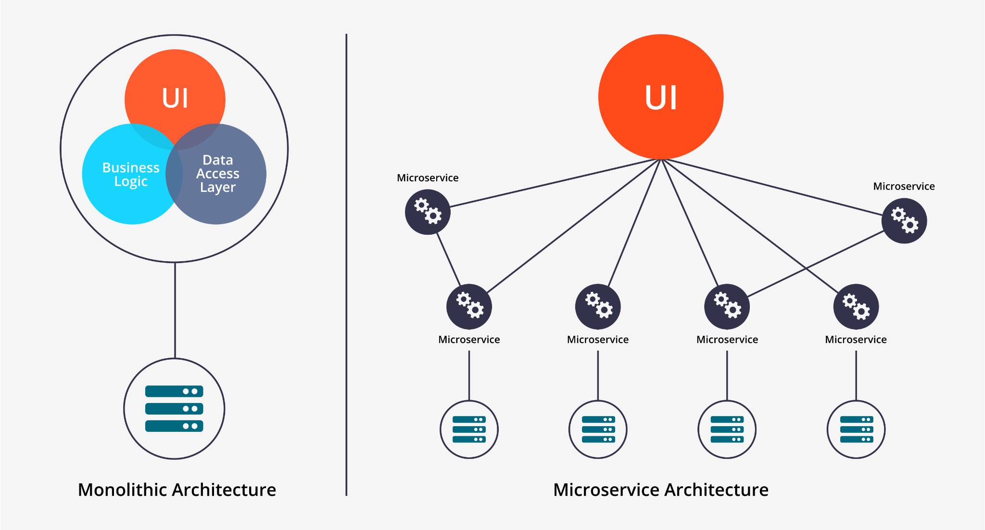
Fig 3.2 Microservice architecture
The emphasis on small services means that large systems are composed of numerous interconnected smaller systems. In a microservices approach, each microservice is developed and maintained by a single dedicated team, reducing the need for extensive coordination among teams. Consequently, a system built with microservices exhibits characteristics akin to a system of systems. This presents challenges in terms of assessing the overall health of the system and attributing changes in health to specific services. Additionally, it poses the task of motivating individual developers to ensure that their services function harmoniously within the larger system, both in terms of reliability and performance reporting. In their article on "Chaos Engineering," Ali Basiri and his colleagues explore these challenges within a broader context[5].
Migrating an existing system to a microservices architecture requires a rearchitecting effort. When the system is currently in production, it is crucial to adopt an incremental approach to changes. Having a concrete example of a step-by-step sequence of changes can provide valuable guidance for the migration process. In the article titled "Microservices Architecture Enables DevOps: Migration to a Cloud-Native Architecture," Armin Balalaie and his colleagues share their experience of migrating a system that provides services for mobile developers to a microservices architecture. They outline the use of open-source tools and incremental changes as they present a collection of migration patterns that offer guidance applicable to various systems, independent of any specific context.
3.2 Adopting DevOps
As mentioned before, the migration to a microservices architecture and the adoption of DevOps practices entail both technical and cultural transformations. Matt Callanan and Alexandra Spillane explore these aspects in their article "DevOps: Making It Easy to Do the Right Thing," focusing on the challenges associated with establishing a continuous-delivery pipeline and addressing both technical and cultural considerations[5].
DevOps is still in its early stages of adoption, and issues related to its implementation are a significant topic of discussion. The theme issue features two articles that specifically tackle adoption issues. Looking into the future, there are several foreseeable questions and challenges for DevOps. One prominent question revolves around determining the best practices for different types of systems and organizations. DevOps practices have primarily evolved within organizations providing internet services, with complex and large systems like those of Amazon, Netflix, and Google. However, applying the same mindset and practices to systems in other domains, such as financial institutions like banks, requires careful consideration and adaptation due to the distinct nature and requirements of these systems.
Another crucial question is identifying which domains can benefit from DevOps practices. One such domain is big data systems. Given the reliance of many big data systems on rapid deployment to support their data pipelines, the adoption of DevOps practices becomes increasingly vital. Big data systems will continue to leverage DevOps methodologies to ensure efficient and seamless data processing.
Overall, these discussions highlight the ongoing evolution of DevOps, its applicability to different types of systems and organizations, and the potential benefits it offers in various domains, including big data systems.
3.3 Adoption of DevOps practices- pros and cons
The adoption of DevOps practices has become increasingly popular in the software development and IT operations communities. DevOps is a set of principles and practices that aim to bridge the gap between development and operations teams, promoting collaboration, automation, and continuous delivery. Here are some pros and cons of adopting DevOps practices:

3.3.1 Pros of DevOps
- Faster time to market: DevOps emphasizes automation and continuous delivery, enabling teams to release software more frequently and with shorter cycle times. This allows organizations to respond to market demands and customer feedback more quickly, gaining a competitive edge.
- Improved collaboration: DevOps breaks down silos between development, operations, and other teams involved in the software delivery process. Collaboration and communication are enhanced, leading to better alignment, shared responsibilities, and a more efficient workflow.
- Increased efficiency and productivity: DevOps promotes automation of repetitive tasks, such as testing, deployment, and infrastructure provisioning. This automation eliminates manual errors, reduces deployment time, and frees up valuable resources, enabling teams to focus on high-value activities.
- Enhanced quality and stability: DevOps practices emphasize continuous integration, testing, and monitoring throughout the software development lifecycle. This leads to earlier detection of issues, improved code quality, and greater overall system stability.
- Scalability and flexibility: DevOps encourages the use of cloud infrastructure and infrastructure-as-code (IaC) approaches, allowing organizations to scale their systems easily and adapt to changing demands. This enables the rapid provisioning of resources and supports the agile delivery of software.

3.3.2 Cons of DevOps
- Cultural challenges: Adopting DevOps requires a cultural shift, which can be challenging for organizations with entrenched departmental silos and resistance to change. It requires a collaborative mindset, open communication, and a willingness to embrace new ways of working.
- Skillset requirements: DevOps practices often require a diverse skillset that combines development, operations, and automation expertise. Organizations may need to invest in upskilling their teams or hiring individuals with the necessary skills, which can be time-consuming and costly.
- Complexity and tooling: The adoption of DevOps practices involves the implementation of various tools and technologies for automation, continuous integration, deployment, and monitoring. Managing and integrating these tools can introduce complexity and require additional effort in terms of setup, maintenance, and training.
- Security considerations: With the increased emphasis on automation and rapid deployments, security can be a concern. It is crucial to ensure that security practices are embedded throughout the DevOps pipeline and that vulnerabilities are identified and addressed early in the process.
- Continuous learning and improvement: DevOps is an ongoing journey that requires continuous learning, experimentation, and improvement. Organizations need to foster a culture of learning from failures, encouraging feedback loops, and continuously refining their processes.
It's important to note that the pros and cons of adopting DevOps practices can vary depending on the organization, its specific context, and the maturity of its software delivery processes. Successful adoption requires careful planning, strong leadership, and a commitment to continuous improvement.

3.4 Why use DevOps instead of the traditional methods
DevOps has emerged as a transformative approach to software development and operations, offering a compelling alternative to traditional methods. The primary reason organizations choose DevOps over traditional approaches is its ability to deliver increased agility. Unlike traditional methods characterized by sequential development and separate operational phases, DevOps promotes an iterative and continuous delivery model. This enables organizations to respond swiftly to changing market demands, adapt to evolving customer needs, and rapidly deliver value to end-users. By fostering collaboration and communication between development and operations teams, DevOps breaks down silos and streamlines the software delivery process, resulting in enhanced efficiency and reduced time to market.
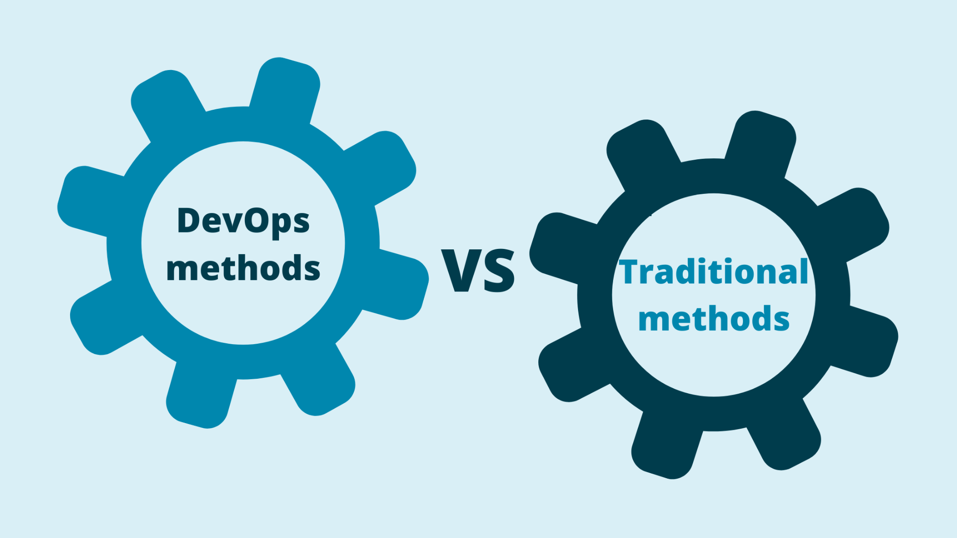
Fig 3.3 Devops methods vs traditional methods

Moreover, DevOps places a strong emphasis on software quality, an aspect often overlooked in traditional methods. Continuous integration, automated testing, and comprehensive monitoring are key tenets of DevOps practices, allowing organizations to identify and rectify issues early in the development cycle. By integrating testing throughout the process, software defects are minimized, resulting in higher-quality deliverables. This commitment to quality not only enhances customer satisfaction but also reduces the cost and effort associated with addressing issues post-deployment. Another significant advantage of DevOps is its scalability and flexibility. Leveraging cloud infrastructure, containerization, and infrastructure-as-code (IaC) techniques, organizations can easily scale their systems and adapt to fluctuating workloads. With automated provisioning and deployment mechanisms, resources can be efficiently allocated, resulting in optimal utilization and cost savings. This agility enables organizations to seize business opportunities quickly, experiment with new ideas, and bring innovative solutions to the market faster than competitors relying on traditional methods.

DevOps further nurtures a culture of continuous feedback and improvement. By soliciting input from users and stakeholders, organizations can gather valuable insights to drive product enhancements and identify areas for optimization. The data-driven decision-making approach of DevOps empowers organizations to iteratively refine their software and processes, ensuring a high degree of customer satisfaction and competitiveness. While traditional methods often entail manual, time-consuming tasks prone to errors, DevOps thrives on automation. By automating routine and repetitive activities, such as building, testing, and deployment, DevOps eliminates human errors and reduces the time and effort required for each release. This not only boosts productivity but also enables teams to focus on higher-value tasks, fostering innovation and creativity.

Ultimately, the decision to adopt DevOps over traditional methods depends on various factors, including organizational culture, project complexity, and existing infrastructure. However, the numerous advantages of DevOps, such as increased agility, collaboration, software quality, scalability, and automation, make it an attractive choice for organizations seeking to deliver software faster, improve customer satisfaction, and gain a competitive edge in the dynamic digital landscape.
3.5 CICD Practices
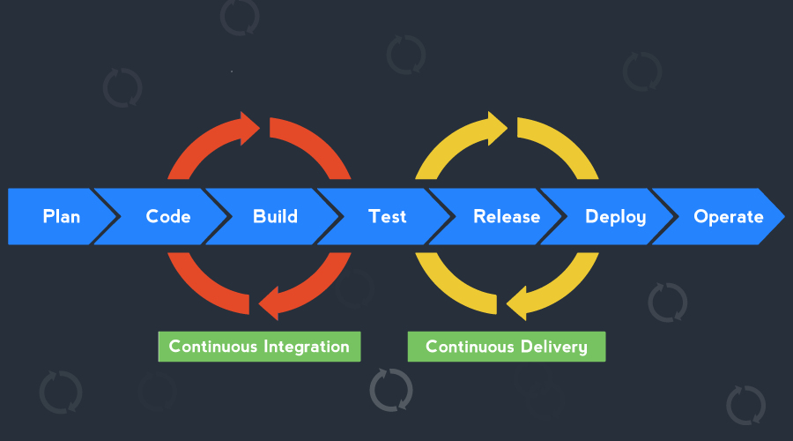
CI/CD, which stands for Continuous Integration and Continuous Delivery (or Continuous Deployment), is a set of practices that automate the software release process. CI/CD enables

Fig 3.4 CICD
development teams to deliver software more frequently, reliably, and with reduced manual effort. Let's explore the key practices involved:
- Continuous Integration (CI): CI focuses on merging code changes from multiple developers into a shared repository frequently and automatically. It involves the following practices:
  - Version Control: Developers use a version control system (e.g., Git) to manage and track changes to the source code.
  - Automated Builds: Whenever changes are pushed to the repository, an automated build process is triggered to compile the code, run tests, and generate build artifacts.
  - Unit Testing: Developers write automated unit tests to verify the functionality and behavior of individual code units (e.g., functions or classes).
  - Code Quality Analysis: Tools like static code analyzers are used to check code quality, enforce coding standards, and identify potential issues.
  - Continuous Integration Server: A CI server (e.g., Jenkins, CircleCI) monitors the version control repository, triggers build-on code changes, and provides feedback on the build status and test results.
- Continuous Delivery (CD) or Continuous Deployment (CDep): CD extends CI by automating the entire software release process, including testing, deployment, and delivery to production. The practices involved are as follows:
  - Automated Testing: A comprehensive suite of automated tests, including unit tests, integration tests, functional tests, performance tests, and security tests, is executed as part of the CI/CD pipeline.
  - Deployment Automation: Infrastructure as Code (IaC) techniques, such as configuration management tools (e.g., Ansible, Puppet) or containerization (e.g., Docker), are used to define and automate the deployment and provisioning of infrastructure resources.
  - Environments Management: Multiple environments (e.g., development, staging, production) are set up to simulate different stages of the software delivery pipeline. Each environment closely resembles the production environment.
  - Release Orchestration: CD tools (e.g., Spinnaker, GitLab CI/CD) automate the release process, managing versioning, and dependencies, and coordinating the deployment of the application across environments.
  - Continuous Deployment (CDep): In continuous deployment, once changes pass through the CI/CD pipeline and meet certain criteria (e.g., successful tests, code review), they are automatically deployed to production without manual intervention. This practice requires a high level of confidence in the automated tests and release process.
  - Continuous Delivery (CD): In continuous delivery, the software is always in a releasable state. However, the decision to deploy to production is made manually, allowing for additional checks or approvals.
CI/CD practices enable faster feedback cycles, reduce integration issues, and provide more reliable and frequent software releases. By automating and streamlining the software delivery process, CI/CD helps organizations deliver value to users quickly and with greater confidence.

4. Methodology
This study used a true experimental design method with a pretest-posttest control group design approach that attempts a type of experimental design where the researcher randomly assigns test units and treatments (DevOps) to the experimental group (system analyst, programmer, developer, system administration, and database administration), intending to systematically describe the facts and characteristics of the object under study precisely, using primary and secondary data from a previous ticketing system and implemented DevOps. In elaboration on the methodology and answering the research questions, the researchers studied the literature (Microsoft, 2021), seven processes are included: boards/backlog, apps source code web.config, repos, test plan, CI/CD pipeline, web apps, & review/insight.
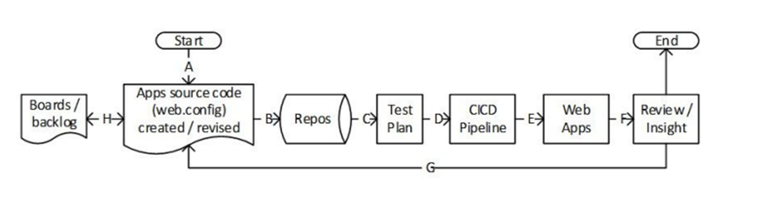
Fig 4.1DevOps Working
- A programmer or developer updates or creates source code.
- The application code is compiled along with the source code in Repos.
- Continuous integration initiates application builds and unit tests using Test Plans.
- With continuous deployment, application objects with environment-specific configuration variables are automatically deployed within pipelines.
- The items are deployed using the App Service.
- A review or perspective based on gathered and examined consumption, effectiveness, and wellness statistics.
- Developers monitor and maintain usage, performance, and health data.
- Backlog data is utilized to prioritize new features and problem solutions using Boards.
DevOps is widely used in the modern world as a set of practices and principles that bridge the gap between software development and operations teams. It focuses on fostering collaboration, automation, and continuous improvement to deliver software faster, with higher quality, and improved customer satisfaction. Here's how DevOps is used in the modern world:
- Collaboration and Communication: DevOps encourages cross-functional collaboration and communication between development, operations, and other stakeholders. By breaking down silos and promoting shared responsibilities, teams can work together more effectively, exchange knowledge, and align their efforts toward common goals.
- Continuous Integration/Continuous Delivery (CI/CD): DevOps promotes the adoption of CI/CD pipelines, where code changes are frequently integrated, tested, and delivered to production. Continuous Integration ensures that code changes are validated and integrated early, reducing integration issues and enabling faster feedback loops. Continuous Delivery automates the release process, allowing teams to deliver software to production rapidly and reliably.
- Infrastructure as Code (IaC): Infrastructure as Code is a core DevOps practice that treats infrastructure provisioning and configuration as software code. IaC tools like Terraform or CloudFormation allow teams to define and manage infrastructure resources in a declarative manner, making infrastructure changes versionable, repeatable, and automated. This approach enables consistency, and scalability, and reduces the risk of configuration drift.
- Automation and Orchestration: DevOps emphasizes automating repetitive, manual tasks and workflows. Automation tools and frameworks are used to streamline build processes, environment provisioning, testing, deployment, monitoring, and incident response. By reducing human error and manual effort, teams can focus on higher-value tasks and achieve faster, more reliable software delivery.
- Monitoring and Observability: DevOps promotes a culture of proactive monitoring and observability. Teams leverage monitoring tools and practices to gain insights into the performance, availability, and reliability of their software systems. By monitoring key metrics and logs, teams can identify and address issues quickly, improve system performance, and enhance the overall user experience.
- Cloud Computing and Containerization: DevOps aligns well with cloud computing and containerization technologies. Cloud platforms, such as AWS, Azure, or Google Cloud, provide scalable infrastructure resources and services that can be provisioned and managed programmatically. Containerization technologies like Docker and Kubernetes enable consistent deployment and management of applications across different environments, improving portability and scalability.
- DevSecOps: DevSecOps integrates security practices into the DevOps process from the beginning. By incorporating security principles and automation tools, teams can identify and address vulnerabilities early in the software development lifecycle. This approach reduces the risk of security breaches, ensures compliance with regulations, and maintains a secure software environment.
DevOps has become a fundamental approach in modern software development and operations, enabling organizations to deliver software faster, respond to market demands more efficiently, and enhance the overall quality of their products and services. It fosters a culture of collaboration, automation, and continuous improvement, empowering teams to innovate and adapt to changing business needs.
3.1 DevOps Stats
DevOps Market size crossed $7 billion in 2021 and is anticipated to increase to a value of over $30 billion between 2022 and 2028 at a CAGR of over 20%.In the USA, DevOps solutions (tools) accounted for 67% of the market's value in 2021, while services accounted for 37% of the total. DevOps services are anticipated to make up around 55% of the market's value by 2028, with tools accounting for the remaining 45%.DevOps is expected to grow at a CAGR of 24.2% from 2021 to 2030, from a market size of $6.78 billion in 2020 to $57.90 billion in 2030.
Between 2021 and 2030, Asia-Pacific would have the highest CAGR, at 26.3%.[6].


Fig 4.2 Global market insights
3.2 Tools Used by the DevOps Team
The DevOps tech stack's most in-demand technical talents globally in 2021. What software and equipment do DevOps engineers and teams utilize most frequently? Linux - 46%,33% for Docker, Bash – 79%, 29% Kubernetes, AWS – 7% [7].
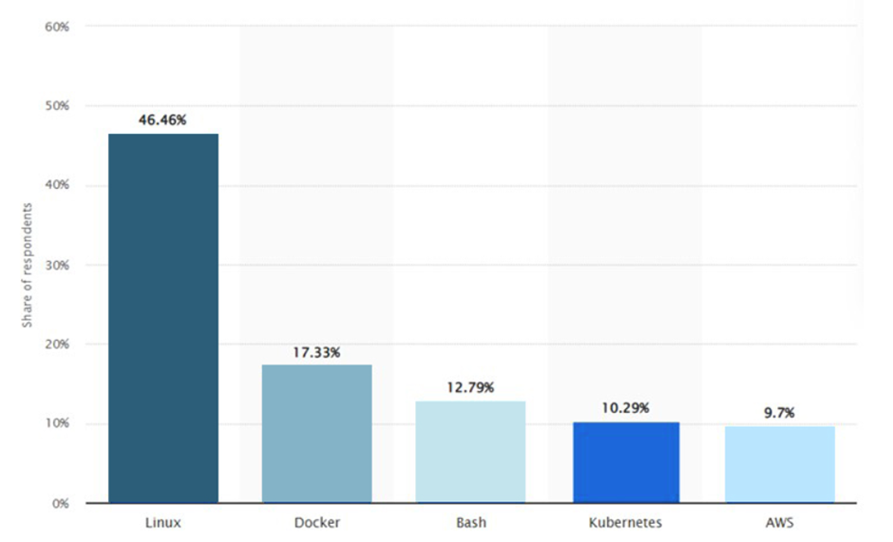
Fig 4.3 DevOps Tech Stats

3.3 Department of Team and DevOps usage
A total of 9% of respondents worked for IT operations or infrastructure teams, 23% were managers, 21% were on DevOps or SRE teams, and 23% were on development or engineering teams. The representation of consultants fell from 4% in 2019 to 2% in 2021, while the representation of C-level executives rose from 4% to 9%.
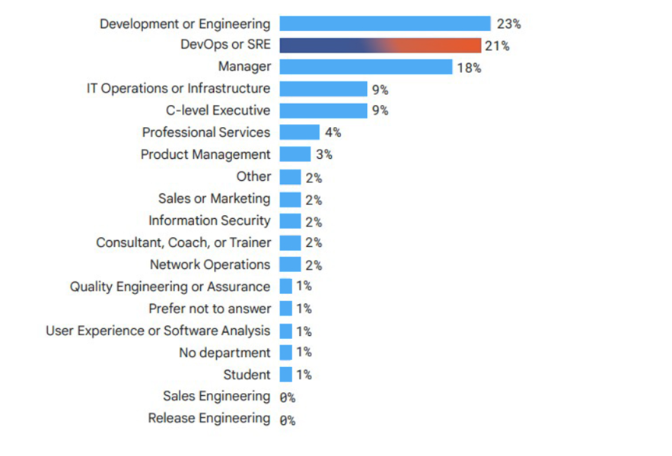
Fig 4.4 State of DevOps[8]

Discussion

The goal of this methodical mapping is to determine the present state of DevOps adoption in SDC.In this regard, it can be determined from the results that, based on the examination of what DevOps represents in the analyzed studies, refers to the cultural shift that an organization must undergo to implement DevOps. Furthermore, DevOps is related to all suggestions at the level of tasks, activities, and roles. DevOps is a practice that combines the phrases 'development' and 'operations'. It is a culture shift that allows developers and operational workers to collaborate.
DevOps refers to a collection of process aspects that promote collaboration and communication, automation, quality assurance and integration, delivery, and continuous deployment. A substantial portion of the DevOps adoption suggestions focuses on the practices of continuous integration, continuous deployment, and process automation. It has been noted that processes to implement DevOps are not properly defined; some are just identified but not extensively explained; even the definitions of the process elements are vague and, in most cases, incomplete. The authors provide activities and/or tasks that entail the adoption of DevOps, but they do not explain how to implement them or who it is responsible for carrying them out. In terms of responsibilities, it is simply stated that an extensive understanding of DevOps is required; however, they do not go into detail regarding their assigned responsibilities, the stage in which they engage, and so on. It was also feasible to see that the authors describe the process aspects based on their own experience rather than a standard or model.
There were significant differences in how the studies defined DevOps. Some did not define DevOps at all, and many definitions were ambiguous. DevOps is a team-practiced principle, according to several definitions. According to some sources, DevOps is practiced by a specialized team. Others consider DevOps as more of a team-oriented profession. According to several papers, DevOps is a container for multiple tools, approaches, and/or practices. We believe that the various viewpoints on DevOps necessitate examining DevOps from several angles. A multi-perspective review of DevOps might assist to clarify the debate.
This article seeks to provide a better understanding of DevOps and the adoption of DevOps by organizations. This article draws information from several previously published sources to offer organizations and developers knowledge of DevOps.

Conclusion
The Agile Manifesto, formulated in 2001, advocated for iterative development, customer collaboration, and adaptive planning. Agile methodologies laid the foundation for the shift towards DevOps.The history of DevOps showcases a progressive shift towards collaboration, automation, and continuous improvement in software development and operations. From its origins in Agile methodologies to the adoption of lean principles and the emergence of automation tools, DevOps has revolutionized the industry. As organizations strive for faster, more reliable software delivery, DevOps will help organizations reach their goals in a faster and more reliable manner. Adopting DevOps is although not easy but with the knowledge and understanding, it can easily be mastered. DevOps drew inspiration from manufacturing principles, focusing on eliminating waste, reducing cycle times, and optimizing processes. Systems thinking encouraged a holistic approach, considering the entire software delivery pipeline and its interactions. Continuous Integration and Continuous Deployment/Delivery (CI/CD) is a crucial components of DevOps practices, enabling organizations to streamline their software development, testing, and deployment processes. This article explores how CI/CD contributes to the DevOps culture, its key benefits, and the role it plays in ensuring efficient and high-quality software delivery.
The authors of the current paper examined the role that DevOps can play in a development process and shared knowledge of adopting DevOps in the development process of companies seeking higher quality results and employing Agile or DevOps software development methodologies.
As DevOps practices become more prevalent in organizations' software development and software maintenance capabilities, we performed a study to better understand DevOps adoption and its effects. We conclude that the effects of DevOps practices on organizational performance are primarily beneficial. Future studies can help to expand and enrich the inventory of practices.

References

- Ian Buchanan.Principal Solutions Engineer, ‘History of DevOps’, Atlassian.
- CA Technologies, White paper: What smart businesses know about DevOps, (2014). http://www3.ca.com/~/media/Files/whitepapers/techinsights-report-what-smartbusinesses-know-about-devops.pdf, last accessed 2017/08/10 4. 3. Gleanster & Delphic, 2015 Annual State of DevOps, (2016).
- https://puppet.com/resources/whitepaper/state-of-devopsreport?pcnav=off&pctiles=off&ls=Campaigns&lsd=Search&cid=7010f000001eViP&utm _medium=paidsearch&utm_campaign=Q2FY18_EMEA_All_CAMPGN_SER_ADWRDS_2016-DOsal-rpt&utm_source=google&utm_content=devops-salaryreport&gclid=Cj0KCQjwn6DMBRC0ARIsAHZtCeO41o1MUzVXRCsTh6SPV2uEyfJT Y3FG4mU2WKyTogAM5ffTw1akJJwaAs-JEALw_wcB, last accessed 2017/08/10
- Bucena, I., & Kirikova, M. (2017, August). Simplifying the DevOps Adoption Process. In BIR Workshops (pp. 1-15).
- Zhu, Liming, Len Bass, and George Champlin-Scharff. "DevOps and its practices." IEEE Software 33.3 (2016): 32-34.
- Preeti Wadhwani, A. P. (2023, May ). GMI Global Market Insights. Retrieved from DevOps Market Size By Component.
- Nicole Forsgren, Jez Humble, and Gene Kim. "Accelerate: The Science of Lean Software and DevOps." DevOps Research and Assessment (DORA), 2021.
- GitLab. "2021 DevOps Trends Report." GitLab, 2021.

