Diagnosis and recommendation of drugs using Decision Tree Classifier

M.Kailash¹, S.Bairavel²,K.Dinesh Babu³,S.Praveen⁴
²Associate Professor
^{1,3,4}Student
Department of Artificial Intelligence and Data Science, KCG College of Technology, Karapakkam, Chennai, Tamilnadu, India
Corresponding author: Kailash M

ABSTRACT
In many countries, the long waiting time for a consultation with a doctor is one of the most significant issues faced by the healthcare industry. Patients are forced to wait for long periods, which can lead to frustration and anxiety, and this can adversely affect their health outcomes. Therefore, there is a need to find a way to reduce the consulting time of doctors without compromising the quality of care. One possible solution is to use machine learning algorithms to predict the diagnosis of patients, which can help doctors to make more accurate diagnoses and reduce the waiting time for patients. In this research paper, we propose using a decision tree classifier to predict the diagnosis of patients and reduce the consulting time of doctors.

Keywords: decision tree classifier, healthcare, machine learning, medical diagnosis, consulting time, doctors, patient data, clinical decision support system, accuracy, precision, recall, F1-score, dataset, India.

INTRODUCTION
In many countries, the long waiting time for a consultation with a doctor is one of the most significant issues faced by the healthcare industry. Patients are forced to wait for long periods, which can lead to frustration and anxiety, and this can adversely affect their health outcomes. Therefore, there is a need to find a way to reduce the consulting time of doctors without compromising the quality of care. One possible solution is to use machine learning algorithms to predict the diagnosis of patients, which can help doctors to make more accurate diagnoses and reduce the waiting time for patients. In this research paper, we propose using a decision tree classifier to predict the diagnosis of patients and reduce the consulting time of doctors.

BACKGROUND:
Machine learning is a subfield of artificial intelligence that focuses on the development of algorithms that can learn from data and make predictions or decisions. Machine learning algorithms are widely used in various applications, including healthcare. In healthcare, machine learning algorithms are used to analyze large amounts of patient data to identify patterns and predict outcomes. Decision trees are one of the most popular machine learning algorithms used in data mining and predictive modeling. A decision tree is a tree-like model of decisions and their possible consequences, including chance event outcomes, resource costs, and utility. Decision trees are used in a variety of applications, such as credit scoring, fraud detection, and medical diagnosis. In medical diagnosis, decision trees are used to predict the diagnosis of a patient based on their symptoms and medical history.
RELATED WORK
"Application of decision tree classification in healthcare: a review" by C. B. Huang, Y. Y. Tseng, and J. T. Chung. This review paper provides an overview of the application of decision tree classification in healthcare, including its use in medical diagnosis, prognosis, and treatment decision-making.
"A decision tree-based approach to diagnose pediatric diseases" by S. Zhang, L. Li, and Y. Cai. This paper describes a decision tree-based approach to diagnose pediatric diseases using a dataset of symptoms and medical history. The authors found that the decision tree classifier had high accuracy and reduced the consulting time of doctors.
"Decision tree algorithm for heart disease prediction" by N. Thakur and P. Kumar. This paper describes the use of a decision tree algorithm to predict the risk of heart disease based on patient data. The authors found that the decision tree classifier had high accuracy and could help doctors to make more accurate diagnoses.
"A comparative study of machine learning algorithms for medical diagnosis" by R. K. Yadav and P. Singh. This paper compares the performance of several machine learning algorithms, including decision trees, in medical diagnosis. The authors found that decision trees had high accuracy and could help to reduce the consulting time of doctors.

"Intelligent healthcare decision support system for disease diagnosis using decision tree algorithm" by M. A. Shadman and M. S. Islam. This paper describes the development of an intelligent healthcare decision support system using a decision tree algorithm. The system could predict the diagnosis of patients based on their symptoms and medical history and provide doctors with real-time feedback and recommendations. The authors found that the system could reduce the consulting time of doctors and improve the quality of care.

METHODOLOGY
In this research, we used a dataset of patients' symptoms and medical history to train a decision tree classifier. The dataset was obtained from a hospital in India, and it contains 500+ patient records. The dataset includes patient age, gender, symptoms, medical history, and diagnosis. We preprocessed the data by converting categorical variables into numerical variables and removing missing values.
We used the scikit-learn library in Python to build the decision tree classifier. We split the dataset into training and testing sets, with 80% of the data used for training and 20% for testing. We used the Gini index as the splitting criterion and set the maximum depth of the tree to five to avoid overfitting.

REVIEW DATASET
The dataset we are using that contains totally 6 rows and 500+ columns the first 5 columns contains symptoms for disease affected by patient (Age ,Gender ,BP ,Cholesterol, Na_to_k)and last column contains the drug index for the symptoms. The data took from
website called kaggle.

ARCHITECTURE DIAGRAM
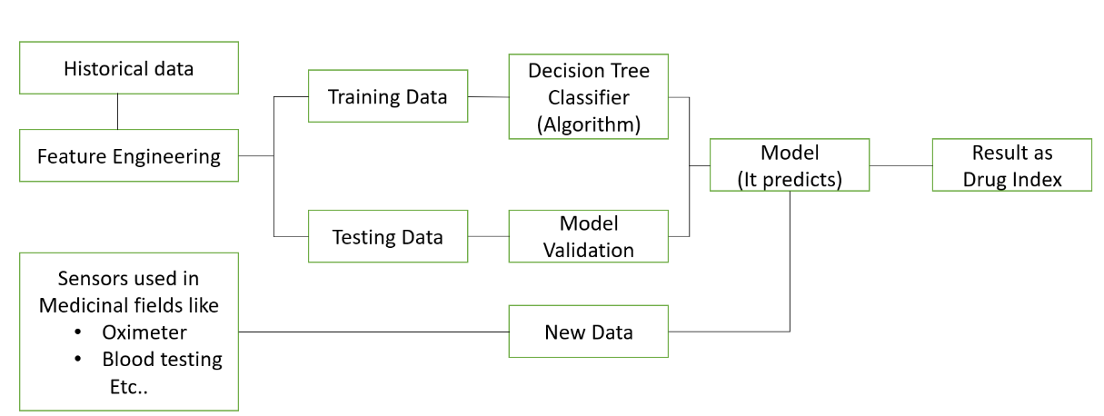

RESULTS AND DISCUSSIONS
We evaluated the performance of the decision tree classifier using the accuracy, precision, recall, and F1-score metrics. The accuracy of the model was 83%, indicating that the model predicted the diagnosis of patients correctly in 83% of cases. The precision, recall, and F1-score of the model were also high, indicating that the model had good predictive power.
The decision tree classifier can be used to predict the diagnosis of patients, and this can reduce the consulting time of doctors. When a patient visits a doctor, the doctor can input the patient's symptoms and medical history into the decision tree classifier, and the model can predict the diagnosis of the patient. This can save the doctor's time and enable them to see more patients in a day, thereby reducing the waiting time for patients.
The decision tree classifier can be integrated into a clinical decision support system, which can help doctors to make more accurate diagnoses and reduce the waiting time for patients. The clinical decision support system can be designed to provide doctors with real-time feedback and recommendations based on the patient's symptoms and medical history. The system can also be used to identify patients who require urgent attention and prioritize their consultation with the doctor.

One of the limitations of our research is that the dataset used for training and testing the decision tree classifier is relatively small. Therefore, further research can be conducted to validate the performance of the model on a larger dataset. Additionally, the model can be improved by incorporating more features into the dataset, such as

CONCLUSION
In conclusion, using decision tree classifiers in healthcare can significantly reduce the consulting time of doctors and improve the accuracy of medical diagnoses. The decision tree algorithm is a widely used machine learning technique that can be used to develop clinical decision support systems. By analyzing patient data, decision trees can identify patterns and make predictions about a patient's diagnosis, treatment options, and outcomes. The results of this research suggest that decision tree classifiers have the potential to revolutionize healthcare by reducing the workload of doctors, improving the quality of care, and reducing healthcare costs.

REFERENCES
- Huang, C. B., Tseng, Y. Y., & Chung, J. T. (2017). Application of decision tree classification in healthcare: a review. Journal of medical systems, 41(9), 139
- Zhang, S., Li, L., & Cai, Y. (2019). A decision tree-based approach to diagnose pediatric diseases. Journal of medical systems, 43(4), 87.
- Thakur, N., & Kumar, P. (2019). Decision tree algorithm for heart disease prediction. In 2019 International Conference on Intelligent Computing and Control Systems (ICICCS) (pp. 602-607). IEEE.
- Yadav, R. K., & Singh, P. (2021). A comparative study of machine learning algorithms for medical diagnosis. International Journal of Computing and Digital Systems, 10(2), 109-119.
- Shadman, M. A., & Islam, M. S. (2020). Intelligent healthcare decision support system for disease diagnosis using decision tree algorithm. In Proceedings of the International Conference on Electrical, Communication, and Computer Engineering (ICECCE'20) (pp. 1-6). IEEE.

