 | DIGITAL DATA THREAD FOR EV COMPONENTS | 

19EEPN6601 - INNOVATIVE AND CREATIVE PROJECT

Submitted by

VISHNU MADHAV 19BME081

In partial fulfilment for the award of the degree
of

BACHELOR OF ENGINEERING
in
MECHANICAL ENGINEERING
Dr.MAHALINGAM COLLEGE OF ENGINEERING AND TECHNOLOGY

POLLACHI - 642003
An Autonomous Institution
Affiliated to Anna University, Chennai - 600 025 JUNE 2022

Dr.Mahalingam College of Engineering and Technology
Pollachi-642 003
An Autonomous Institution Affiliated to Anna University, Chennai-600 025

BONAFIDE CERTIFICATE
Certified that this project report,

“DIGITAL DATA THREAD FOR EV COMPONENTS”
is the bona-fide work of

VISHNU MADHAV 19BME081

who carried out the project work under my supervision

SIGNATURE OF HOD SIGNATURE OF SUPERVISOR Dr.I.RAJENDRAN, M.E., Ph.D., DR.K.HARIHARAN, M.E.,Ph.D.,

HEAD OF THE DEPARTMENT,
Dr. Mahalingam College of Engineering and Technology, NPT-MCET Campus Pollachi-642 003.

ASSOCIATE PROFESSOR

Mechanical Engineering
Dr. Mahalingam College of Engineering and Technology, NPT-MCET Campus Pollachi-642 003.

Submitted for the Autonomous End Semester Examination Innovative and Creative Project Viva-voce held on
ASSOCIATE PROFESSOR,
Electrical and Electronics Engineering

INTERNAL EXAMINER
EXTERNAL EXAMINER

ACKNOWLEDGEMENT

We extend our gratitude to our management for having provided us with all facilities to build our project successfully. We express our sincere gratitude to our honorable Secretary Dr.C.Ramaswamy, M.E., Ph.D., F.I.V., for providing us with required amenities.
We express our profound thanks to our Principal Dr.A.Rathinavelu, B.E., M.Tech., Ph.D.,
who provided us the suitable environment to work.

We express our gratefulness to Dr.I.Rajendran, M.E., Ph.D., Senior Professor and Head of the Department, Mechanical Engineering for providing us kind advice during the development of the project.
Our hearty thanks to our guide, Dr.K.Hariharan, M.E.,Ph.D., Associate Professor, Mechanical Engineering for his constant support and guidance offered to us during the course of our project by being one among us.
We express our thanks to our project co-ordinator Dr.K.Hariharan, M.E.,Ph.D., Associate Professor, Electrical and Electronics Engineering for constant support and guidance offered to us during the course of our project by being one among us.
We are committed to place our heartfelt thanks to all our faculty members, lab technicians and friends, who played the supporting role throughout the project.

TABLE OF CONTENT

CHAPTER | TITLE |  | PAGE NO
 | ABSTRACT |  | (vi)
 | LIST OF TABLES |  | (vii)
 | LIST OF FIGURES |  | (viii)
 | LIST OF ABBREVATIONS |  | (xi)
1 | INTRODUCTION |  | 1
  - THEME
  - BACKGROUND
  - PROBLEM STATEMENTS
  - OBJECTIVES
2 | LITERATURE REVIEW |  | 3
3 | METHODOLOGY  3.1 DIGITAL THREAD
 | 3.2 DIGITAL TWIN |  | 9
4 | DIGITAL DATA THREAD FOR BATTERY |  | 10
 | 4.1 DIGITL THREAD FOR CELL |  | 12
 | 4.2 DIGITAL THREAD FOR BATTERY |  | 13
 | 4.3 DIGITAL THREAD FOR MODULE |  | 14
 | 4.4 DIGITAL THREAD FOR BATTERY PACK |  | 15
5 | DATA CAPTURING METHODOLOGY |  | 16
 | 5.1 DATA STORAGE TO DATABASE |  | 17

6 | FUTURE SCOPE | 24
7 | CONCLUSION | 25
8 | REFERENCE | 26

ABSTRACT

The Electric Vehicle (EV) industry requires efficient and high-quality production processes, which depend on accurate and reliable data collection and storage. Our project aimed to address the issue of data inefficiency on the assembly line by creating a digital thread that collects data at each stage of the production process. This allowed us to identify inefficiencies and improve the production process by ensuring consistency and standardization.

The project also addressed the issue of data storage in the battery test line by connecting it to the company server. Our report discusses the details of our digital thread project, including data collection, analysis, and improvements, as well as the potential benefits for the EV industry and our company. Our project highlights the importance of digital solutions in improving the quality and efficiency of the assembly line.

1. INTRODUCTION

CHAPTER 1

1.1 THEME
"Enhancing EV production with digital thread optimization."

1.2 BACKGROUND
- Inconsistent data collection: The assembly line may collect data in different formats or may miss certain data points, leading to inconsistencies and difficulties in analysing production processes.
- Data storage inefficiencies: Data may not be stored efficiently, leading to data loss or difficulties in accessing and analysing the data.
- Difficulty in identifying inefficiencies: Without accurate and standardized data, it may be difficult to identify inefficiencies or potential issues in the production process.
- Quality control challenges: Inaccurate or incomplete data can make it challenging to monitor the quality of the production line and ensure consistent quality across all products.

1.3 PROBLEM STATEMENTS:
- Problem Statement: Inefficient and unreliable data collection and storage on the assembly line lead to inconsistencies and difficulties in identifying potential issues and improvements.
Solution: Our digital thread project addressed these issues by collecting data at each stage of the production process and improving the standardization and consistency of data collection. This allowed for real-time monitoring of the production line, identification of potential issues, and targeted improvements to enhance efficiency and productivity.

- Problem Statement: Inefficient data storage practices in the battery test line resulted in data loss, making it difficult to analyze the performance of the batteries and ensure consistent quality.
Solution: Our digital thread project addressed this issue by connecting the battery test line to the company server, allowing for automatic and reliable data storage. This enabled accurate analysis of battery performance and ensured consistency and quality across the production line

1.4 OBJECTIVES
- Develop a digital thread for efficient data collection and analysis at each stage of 2-wheeler EV assembly line.
- Identify and rectify inefficiencies in the current data collection and storage processes.
- Automate the collection and storage of battery test data that was previously not stored properly.
- Integrate the digital thread with the company server for easy access to stored data.
- Provide insights to the company to optimize their assembly line processes and improve product quality.

CHAPTER 2

2. LITRATURE REVIEW
2.1 DIGITAL TWIN: ENABLING TECHNOLOGIES, CHALLENGES AND OPEN RESEARCH.
Aidan Fuller, Zhong Fan, Charles Day, and Chris Barlow
This paper presents the topic of Digital Twin technology which is an emerging concept that has become the Centre of attention for industry and, in more recent years, academia. The advancements in industry 4.0 concepts have facilitated its growth, particularly in the manufacturing industry. The Digital Twin is defined extensively but is best described as the effortless integration of data between a physical and virtual machine in either direction. The challenges, applications, and enabling technologies for Artificial Intelligence, Internet of Things (IoT) and Digital Twins are presented. A review of publications relating to Digital Twins is performed, producing a categorical review of recent papers. The review has categorized them by research areas: manufacturing, healthcare, and smart cities, discussing a range of papers that reflect these areas and the current state of research. The paper provides an assessment of the enabling technologies, challenges, and open research for Digital Twins.

2.2 MODULAR BASED FLEXIBLE DIGITAL TWIN FOR FACTORY DESIGN.
Jiapeng Guo, Ning Zhao, Lin Sun, Saipeng Zhang.
This paper presents information on how factory design offers many promising capabilities regarding productivity and floor utilization. To evaluate the design and help the designer to escape design flaws, digital twin is proposed to support factory design. With considering of frequently changing in design phase, a modular approach was proposed to help building flexible digital twin and conducting corresponding changes. By using flexible digital twin, designer can quickly evaluate different designs and find design flaws in an easy way. And consequently, time saving can be benefited. A case study of application on real factory is presented to illustrate the advantage.

2.3 A SIX-LAYER ARCHITECTURE FOR DIGITAL TWINS WITH AGGREGATION.

AJH Redelinghuys, K Kruger, AH Basson
The paper presents the topic Digital twins, the cyberspace counterparts of physical systems, play an important role in cyber-physical production systems (CPPS), within the context of Industry 4.0 and the Internet of Things (IoT). In complex manufacturing systems, with many digital twins, information must be aggregated, which leads to the requirement for digital twins to interact. Reference architectures for digital twins are required when digital twins from different vendors have to interact. This paper extends the Six-Layer Architecture for Digital Twins (SLADT) to a reference architecture with aggregation (SLADTA). The architecture makes maximum use of vendor-neutral off-the-shelf software, as well as secure and open protocols for twin-to-twin communication. SLADTA is illustrated through an application in a manufacturing cell scenario.

2.4 REFERENCE ARCHITECTURE TO INTEGRATE HETEROGENEOUS MANUFACTURING SYSTEMS FOR THE DIGITAL THREAD
Mohammad Lotfi Nejad, Behzad Poorali, Ehsan Adib, Ali Akbar Motie Birjand.
This paper is about how increasing growth of digital technologies in manufacturing has provided industry with opportunities to improve its productivity and operations. One such opportunity is the digital thread, which links product lifecycle systems so that shared data may be used to improve design and manufacturing processes. The development of the digital thread has been challenged by the inherent difficulty of aggregating and applying context to data from heterogeneous systems across the product lifecycle. This paper presents a reference four-tiered architecture designed to manage the data generated by manufacturing systems for the digital thread. The architecture provides segregated access to internal and external clients, which protects intellectual property and other sensitive information, and enables the fusion of manufacturing and other product lifecycle data. We have implemented the architecture with a contract manufacturer and used it to generate knowledge and identify performance improvement opportunities that would otherwise be unobservable to a manufacturing decision maker.

2.5 DEVELOPING A DIGITAL TWIN AND DIGITAL THREAD FRAMEWORK FOR AN ‘INDUSTRY 4.0’ SHIPYARD
Toh Yen Pang, Juan D. Pelaez Restrepo, Chi-Tsun Cheng, Alim Yasin, Hailey Lim, Miro Miletic
This paper provides an overview of the current state-of-the-art digital twin and digital thread technology in industrial operations. Both are transformational technologies that have the advantage of improving the efficiency of current design and manufacturing. Digital twin is an important element of the Industry 4.0 digitalization process; however, the huge amount of data that are generated and collected by a digital twin offer challenges in handling, processing, and storage. The paper aims to report on the development of a new framework that combines the digital twin and digital thread for better data management in order to drive innovation, improve the production process and performance and ensure continuity and traceability of information. The digital twin/thread framework incorporates behavior simulation and physical control components, in which these two components rely on the connectivity between the twin and thread for information flow and exchange to drive innovation. The twin/thread framework encompasses specifications that include organizational architecture layout, security, user access, databases and hardware and software requirements. It is envisaged that the framework will be applicable to enhancing the optimization of operational processes and traceability of information in the physical world, especially in an Industry Shipyard 4.0.

2.6 RESEARCH ON CLOUD DATA STORAGE TECHNOLOGY AND ITS ARCHITECTURE IMPLEMENTATION
Kun Liua, Long-jiang Donga
This paper introduces the concept of cloud computing and cloud storage as well as the architecture of cloud storage firstly. Then we analyze the cloud data storage technology--GFS (Google File System)/HDFS (Hadoop Distributed File System) towards concrete enterprise examples. The concept of cloud computing becomes more and more popular in latest years. So, in this paper, we are learning about its implementation in industry level.

CHAPTER 3

3.1 METHODOLOGY

Flow chart 1

- Problem Identification: Identify the data inefficiencies in the 2-wheeler EV assembly line process.
- Data Collection: Collect data from each stage of the assembly line, such as torque for screw tightening, number of cells placed, polarity checking data, etc.
- Data Analysis: Analyse the collected data to identify inefficiencies and potential areas of improvement.
- Program Development: Develop a program to automatically store the data from the battery test line to the company server.
- Testing and Implementation: Test the program and implement it into the assembly line process.
- Optimization: Continuously monitor and optimize the data collection process to improve efficiency and productivity.
- Documentation: Document the entire process, including the problem identification, data collection, analysis, program development, testing, implementation, and optimization, for future reference.
3.2 DIGITAL THREAD
A digital thread creates a closed loop between digital and physical worlds, transforming how products are engineered, manufactured, and serviced. Digital threads seek to create simple universal access to data. They follow a single set of related data as it weaves in and out of business processes and functions to enable continuity and accessibility.

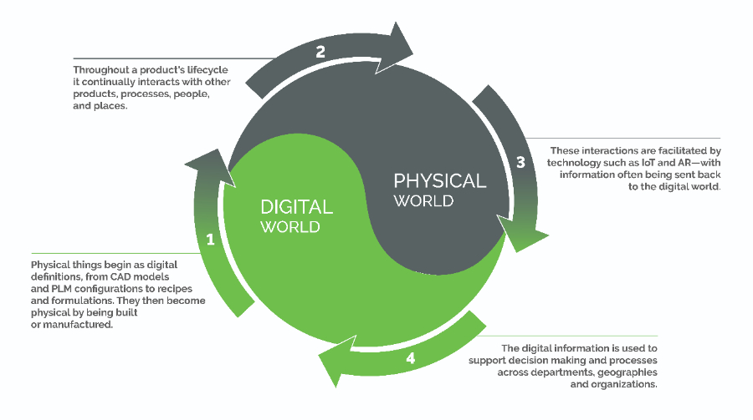
Figure 3.1 Digital thread

For manufacturers, the physical world is sprawling. There are physical products, their components, parts, equipment, and assets that companies create. There are the places where these things are created and live: cities, labs, worksites, factories, and homes. There are the sensors and infrastructure that surround these physical things, and there are the people who interact with all those things. In most cases, these things seem disparate – it is difficult to determine where and how they intersect and relate to one another. That’s where digital – and digital thread – can help.
The digital world also has many layers. Manufacturers operate with a host of enterprise software solutions, which help manage various processes and functions, and produce an incredible amount of data. There’s product design data, manufacturing process data, asset health information, IoT data from products in the field, and all the digital processes that use this and other data to inform decision-making.
In the digital world, the complexity of the physical world can be distilled down to the pertinent information needed to make decisions. With technologies like CAD, PLM, IoT and augmented reality (AR) working together, digital processes are introduced to analyse, manage, and communicate information across departments and functions, allowing decisions to be made faster and more accurately. When the digital tools and processes that are utilized along the lifecycle of a product are connected, the knowledge gleaned from one activity can be shared upstream and downstream to inform others.
A digital thread can be created for many different entities and processes. Most commonly, a thread of a product follows the lifecycle from design inception through engineering and product lifecycle management (PLM), to manufacturing instructions, supply chain management, and through to service histories and customer events. This thread enables enterprises to anticipate and effectively communicate bi-directionally up and down stream of where the product is in its lifecycle, ensuring all participants utilize the most current data and can react quickly to changes or new insights.
Similar threads are emerging for entire operational environments and processes – and even worker tasks and workflows – due to the prevalence of digitization across the value chain driven by technologies like IIoT, AR, MES, and others.

3.2 DIGITAL TWIN
A digital twin is a virtual model designed to accurately reflect a physical object. The object being studied—for example, a wind turbine—is outfitted with various sensors related to vital areas of functionality. These sensors produce data about different aspects of the physical object’s performance, such as energy output, temperature, weather conditions and more. This data is then relayed to a processing system and applied to the digital copy.
Once informed with such data, the virtual model can be used to run simulations, study performance issues, and generate possible improvements, all with the goal of generating valuable insights—which can then be applied back to the original physical object.

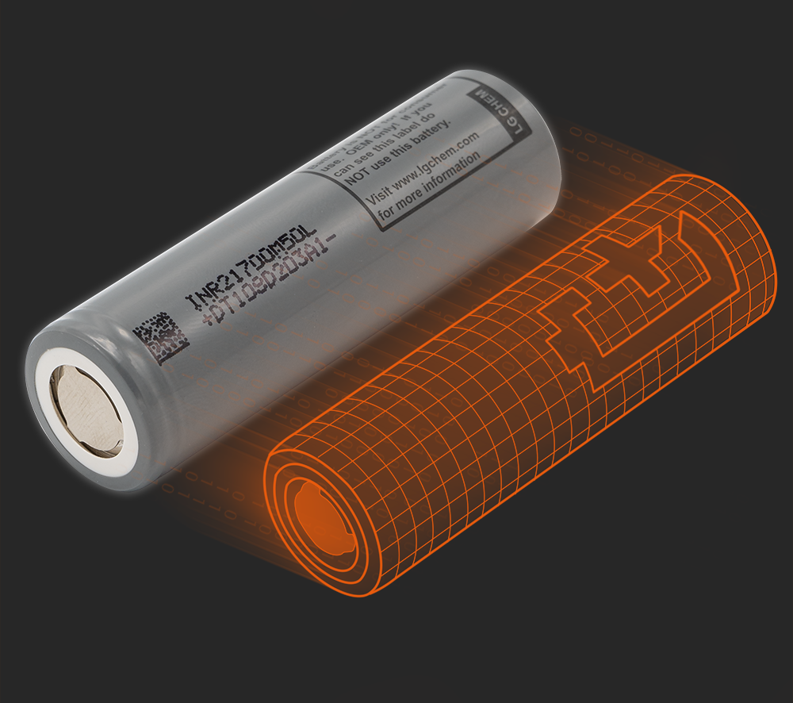
Figure 3.2 Digital twin

3.2.1 Types of digital twins
There are various types of digital twins depending on the level of product magnification. The biggest difference between these twins is the area of application. It is common to have different types of digital twins co-exist within a system or process. Let’s go through the types of digital twins to learn the differences and how they are applied.

Component twins/Parts twins
Component twins are the basic unit of digital twin, the smallest example of a functioning component. Parts twins are roughly the same thing, but pertain to components of slightly less importance.

Asset twins
When two or more components work together, they form what is known as an asset. Asset twins let you study the interaction of those components, creating a wealth of performance data that can be processed and then turned into actionable insights.

System or Unit twins
The next level of magnification involves system or unit twins, which enable you to see how different assets come together to form an entire functioning system. System twins provide visibility regarding the interaction of assets, and may suggest performance enhancements.

Process twins
Process twins, the macro level of magnification, reveal how systems work together to create an entire production facility. Are those systems all synchronized to operate at peak efficiency, or will delays in one system affect others? Process twins can help determine the precise timing schemes that ultimately influence overall effectiveness.

LITHIUM ION BATTERY
This is the most common battery storage system in e-two-wheelers. Lithium-ion batteries have a high power-to-weight ratio, improved high-temperature performance, and a reduced self-rate, among other advantages. A lithium-ion battery is made up of positively charged lithium ions that are moved from the anode to the cathode via a liquid electrolyte, providing the required charge.
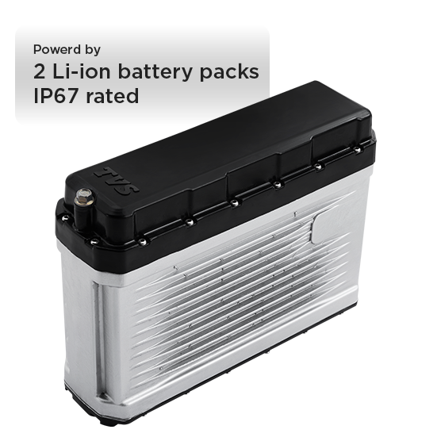

Figure 3.3 Li-ion battery

Lithium-ion batteries have a better capacity to sustain a full charge over time than conventional batteries. Since these battery parts are recyclable, they are an environmentally friendly solution.
Ola S1 Pro, Ather 450X, and TVS iQube are among the electric two-wheelers that use lithium-ion batteries.

CHAPTER 5

PROBLEM STATEMENT
The battery test line data is not stored to server directly thus consuming more time in storage and retrieval of data. This inefficiency causes problems in battery data analysis and retrieval of data related to a specific battery ID. The aim is to automate the process of storing this data to server without repetition of excel file data and display the real time data in the frontend.

5.1 DATA CAPTURING METHODOLOGY
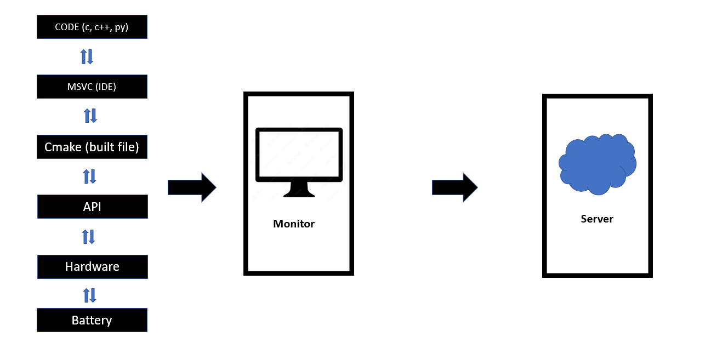

FLOWCHART

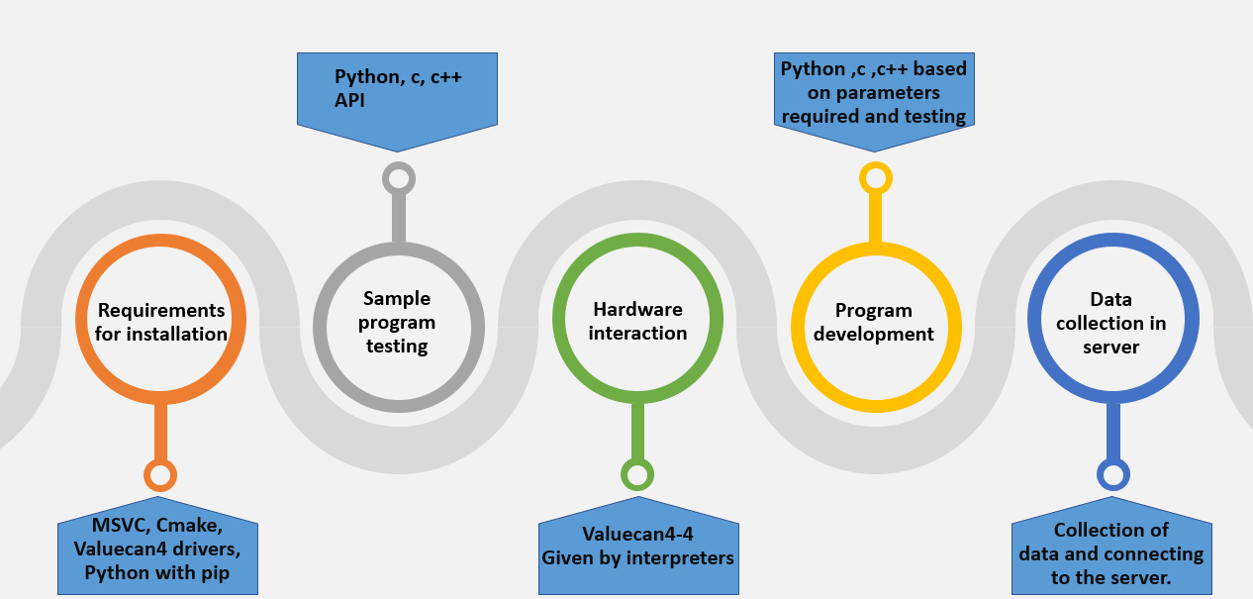
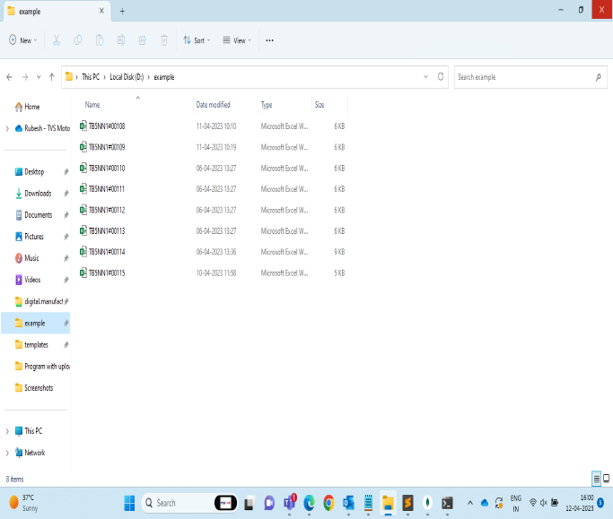

- EXCEL FILE DATA TO BE UPLOADED TO BE DATABASE
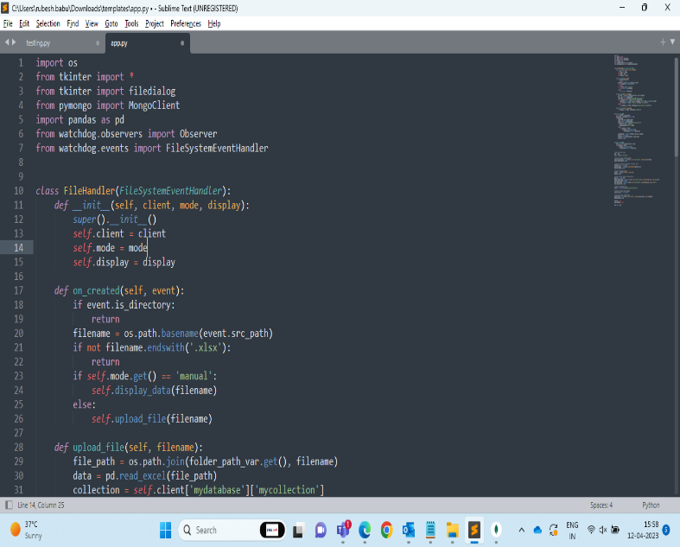
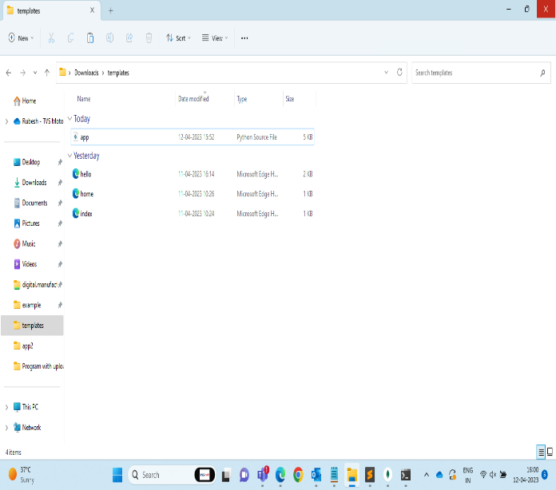
2. BACKEND PYTHON AND FRONTEND HTML FILES
BACKEND PROGRAM USING PYTHON

import os
from tkinter import *
from tkinter import filedialog
from pymongo import MongoClient
import pandas as pd
from watchdog.observers import Observer
from watchdog.events import FileSystemEventHandler

class FileHandler(FileSystemEventHandler):
def __init__(self, client, mode, display):
super().__init__()
self.client = client
self.mode = mode
self.display = display

def on_created(self, event):
if event.is_directory:
return
filename = os.path.basename(event.src_path)
if not filename.endswith('.xlsx'):
return
if self.mode.get() == 'manual':
self.display_data(filename)
else:
self.upload_file(filename)

def upload_file(self, filename):
file_path = os.path.join(folder_path_var.get(), filename)
data = pd.read_excel(file_path)
collection = self.client['mydatabase']['mycollection']
if not collection.find_one({'filename': filename}):
collection.insert_one({'filename': filename, 'data': data.to_dict('records')})
self.display.insert(END, f'Uploaded {filename} to MongoDB\n')
else:
self.display.insert(END, f'{filename} already exists in MongoDB\n')

def display_data(self, filename):
self.display.insert(END, f'{filename} created\n')

def select_folder():
global observer, event_handler
folder_path = filedialog.askdirectory()
if folder_path:
folder_path_var.set(folder_path)
files = os.listdir(folder_path)
num_files_var.set(f'{len(files)} files selected')
if mode_var.get() == 'manual':
upload_button['state'] = NORMAL
else:
for filename in files:
if filename.endswith('.xlsx'):
event_handler.upload_file(filename)

event_handler = FileHandler(client, mode_var, display)
observer = Observer()
observer.schedule(event_handler, folder_path)
observer.start()

def manual_upload():
files = os.listdir(folder_path_var.get())
for filename in files:
if filename.endswith('.xlsx'):
event_handler.upload_file(filename)

# create the main window
root = Tk()
root.title('Excel Uploader')

# create the folder selection button
select_folder_button = Button(root, text='Select Folder', command=select_folder)
select_folder_button.pack()

# create the label for the number of selected files
num_files_var = StringVar()
num_files_label = Label(root, textvariable=num_files_var)
num_files_label.pack()

# create the display widget
display = Text(root, width=50, height=10)
display.pack()

# create the mode selection radio buttons
mode_var = StringVar()
manual_upload_radio = Radiobutton(root, text='Manual Upload', variable=mode_var, value='manual')
manual_upload_radio.pack()
auto_upload_radio = Radiobutton(root, text='Auto Upload', variable=mode_var, value='auto')
auto_upload_radio.pack()

# create the MongoDB client
client = MongoClient('mongodb://localhost:27017')

# create the folder path variable
folder_path_var = StringVar()

# create the manual upload button
upload_button = Button(root, text='Upload', command=manual_upload, state=DISABLED)
upload_button.pack()

observer = None
event_handler = None

root.mainloop()

EXECUTE PROGRAM FROM COMMAND PROMPT (ADD FILE PATH)
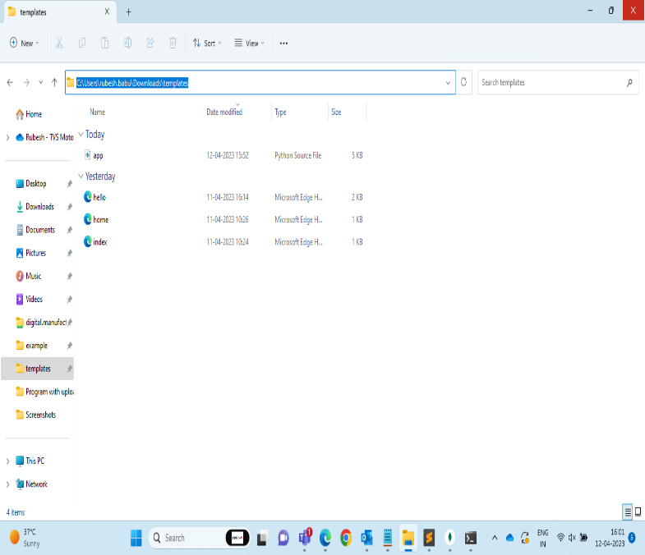
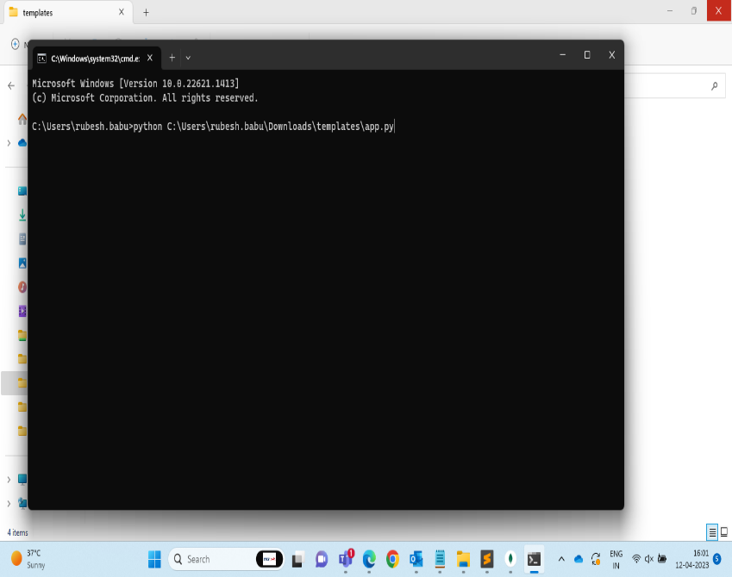

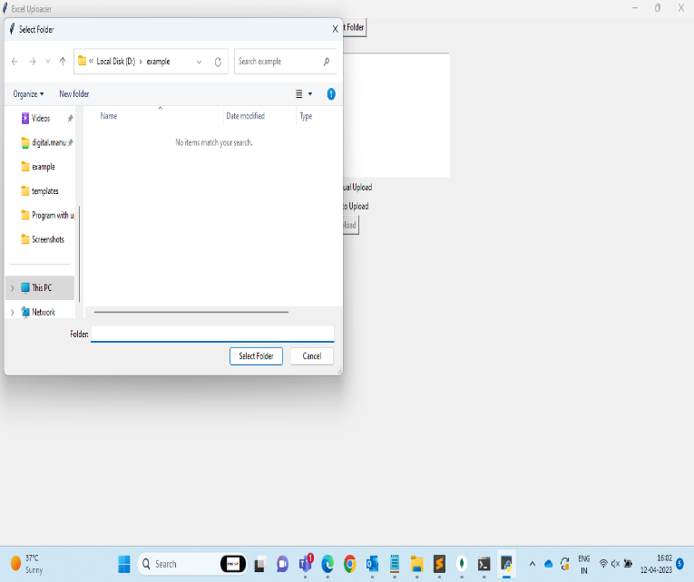
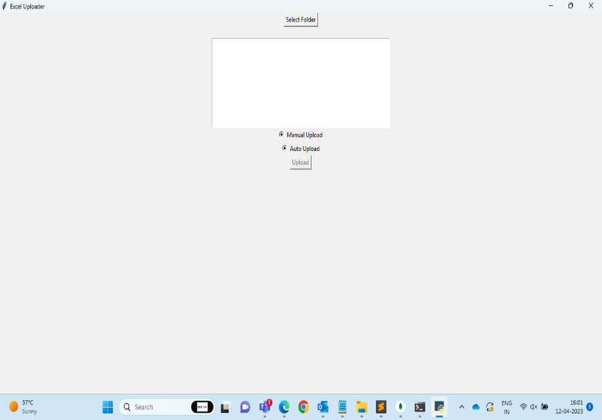
DISPLAY MENU AND UPLOAD WINDOW
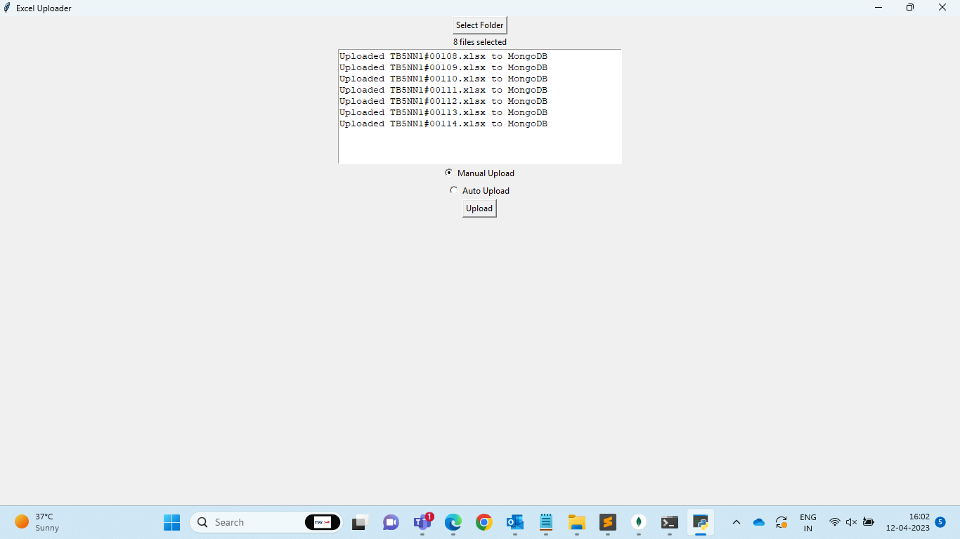
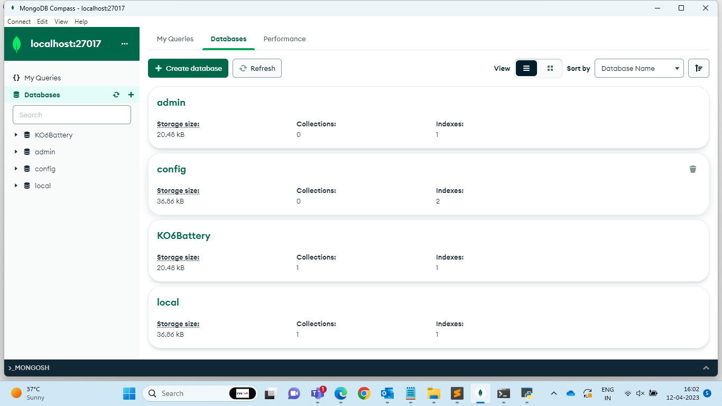
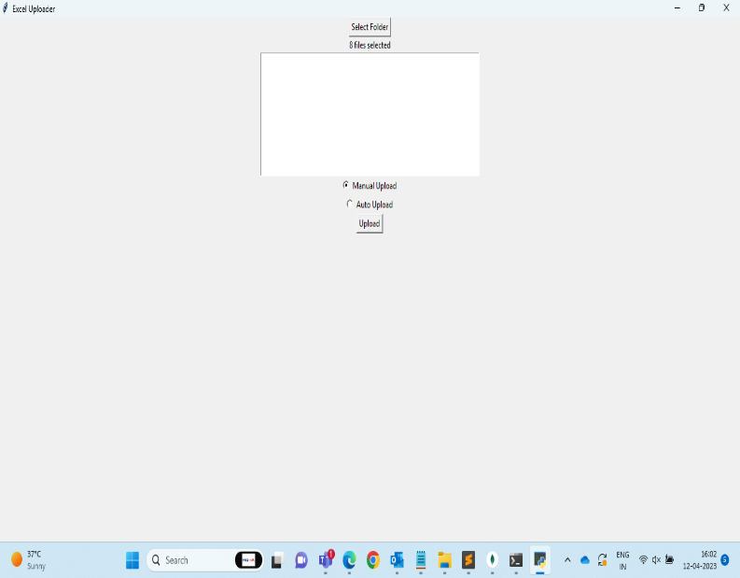
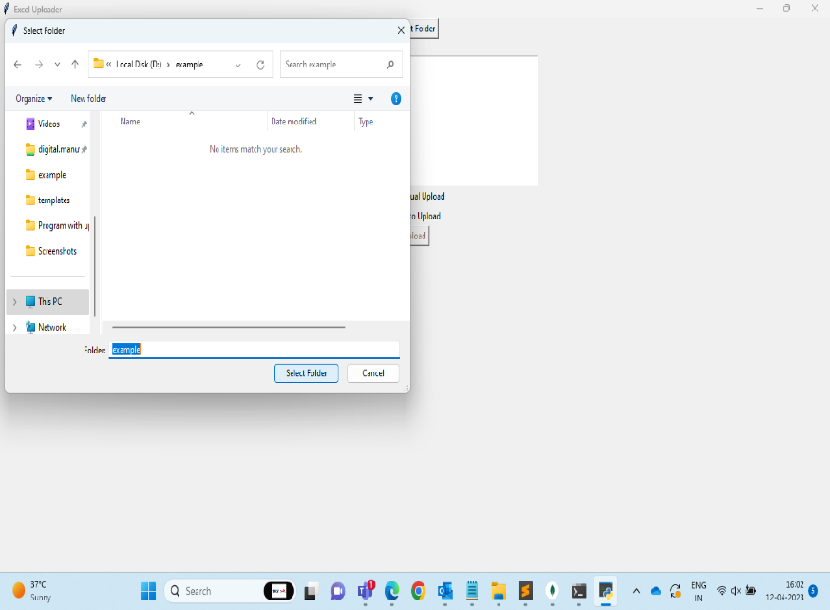
FILE UPLOAD STATUS ON DISPLAY MENU
SELECTION OF FOLDER AND UPLOAD OPTION
EXCEL FILE DATA UPLOADED TO DATABASE
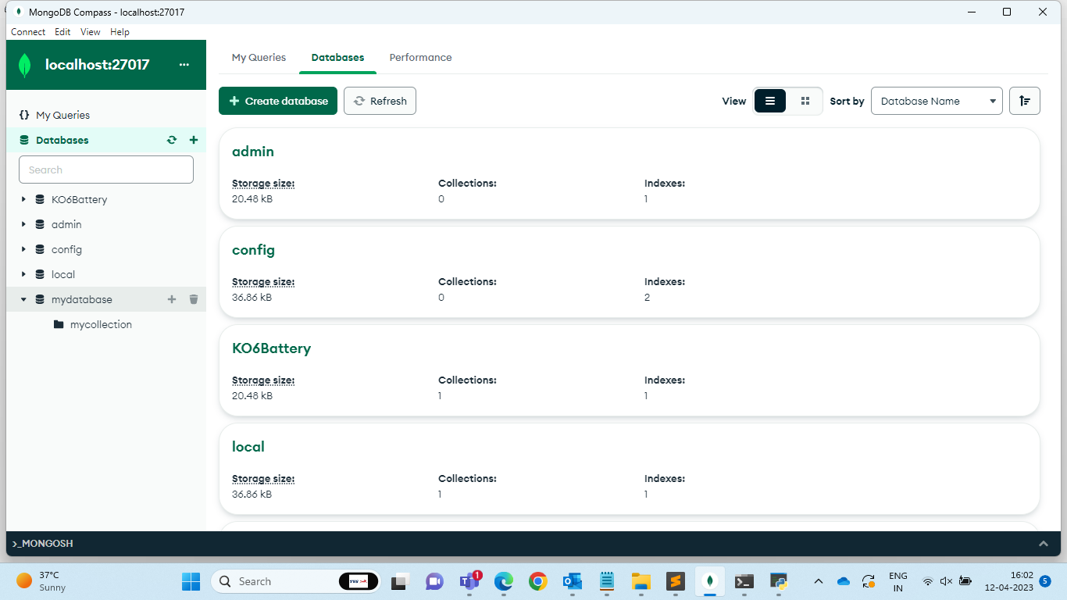

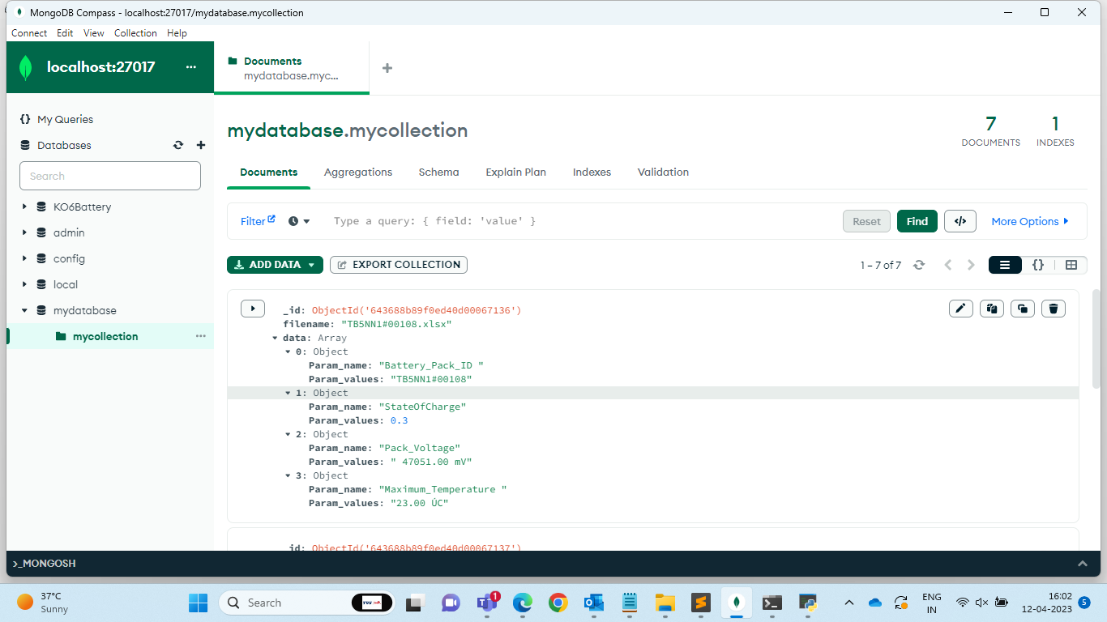

6. FUTURE SCOPE
The completion of the vehicle assembly line data collection process is a significant milestone in achieving a fully integrated digital thread. The availability of real-time data from the assembly line will enable data-driven decision-making and predictive maintenance. The collected data can be used to improve the efficiency of the assembly line and optimize the overall production process. The availability of accurate data will also facilitate the integration of an ERP system, which can help automate various tasks and reduce manual efforts.
In the future, the next step could be the implementation of an advanced analytics system to process the collected data and derive actionable insights. This can help identify bottlenecks in the production process, analyse quality issues, and optimize inventory management. Furthermore, the data can be utilized to develop predictive models to forecast demand and plan production schedules accordingly.
Additionally, the digital thread can be extended beyond the production process to the entire product lifecycle, including sales, customer support, and product end-of-life. By creating a fully connected ecosystem, the company can gain a competitive edge by leveraging the power of data to enhance customer satisfaction, optimize costs, and streamline business operations.

7. CONCLUSION

In conclusion, our project focused on optimizing the data collection process in the battery test line by implementing a digital thread. We identified several practical issues in the current process, including inefficiencies in data management, lack of real-time monitoring, and potential errors in manual data entry. Our solution involved the implementation of a digital thread that improved data visibility and accuracy while reducing the potential for errors.
Through our project, we contributed to the company's overall goal of improving production efficiency and reducing waste. By optimizing the data collection process, we enabled the battery test line to operate more smoothly and provided valuable insights into potential areas for further improvement. Our project also highlighted the importance of incorporating digital technologies into traditional manufacturing processes to improve overall efficiency and productivity.
Overall, we believe that our project has the potential to serve as a model for other manufacturing processes within the company and beyond. By leveraging the power of digital technologies, we can help improve efficiency and reduce waste across a wide range of industries and applications.

