Dual-Hazard Blast and Seismic Risk Assessment on Metro-Station Using Finite Element Modeling

Rusikesh Jadhav¹ and Mr. Sharif Shaikh²

1M. Tech Student in Structural Engineering, G H Raisoni College of Engineering, Maharashtra, India
2Assistant Professor in Structural Engineering, G H Raisoni College of Engineering, Maharashtra, India

Abstract: India, being a developing country, relies on the Metro transit system as a crucial mode of public transportation. This research focuses on the comprehensive analysis of a Metro-station, considering both linear dynamic analysis and blast pressure analysis using the integrated software MIDAS Civil (2020) v2.1. Metro-stations are unique structures that combine the features of a station and a bridge, characterized by their significant dimensions of 140m X 21m. Due to their substantial size and complex nature, it is essential to thoroughly analyze, design, and maintain these heavy and dense structures. In this study, we specifically examine a real-life Metro-station geometry constructed with prestressed concrete materials, subjected to multiple loading scenarios, including blasts, seismic events, and their dual combination. The static and linear dynamic analyses are conducted using the MIDAS Civil (2020) v2.1 software. Additionally, a linear dynamic analysis is performed to assess the behavior of the Metro bridge system, utilizing response spectrum analysis. The results indicate an increased stiffness of the bridge system in the longitudinal direction. Considering the growing frequency of terrorist activities, Metro-stations are prime targets for potential blast attacks, aiming to cause significant damage to both humans and infrastructure. Therefore, we analyze the Metro-station's response to TNT mass blasts ranging from 1 kg to 10 kg. Stress and deformation calculations are performed for each increment of TNT mass, providing valuable insights. Metro-stations are densely populated public areas, emphasizing the importance of this study. For research purposes, we focus on a single span of the Metro-station with a length of 13m. Given the seismic activity in the region, the probability of an earthquake occurring during the structure's lifespan is at least once. Consequently, the structure is designed to be earthquake resistant rather than earthquake proof. To evaluate the structure's response, linear dynamic analysis, specifically response spectrum analysis, is conducted using the Midas Civil software, considering parameters such as displacement, modal behavior, and time period. These analyses encompass single hazard cases, where the structure's failure is dominated by specific loads. Multi-hazard engineering, a relatively novel concept in civil-structural engineering, addresses the failure of structure and infrastructure system portfolios under combined loading conditions. Thus, the objective of this study is to investigate the structure's performance in a multi-hazard scenario, considering the combined effects of multiple load cases.

Keywords: TNT, Midas Civil, Blast Analysis, Dynamic Linear Analysis, Response Spectrum Analysis, Metro-Station, Prestressed Concrete
- INTRODUCTION
T
he public transport system plays a crucial role in reducing air and noise pollution while efficiently utilizing space and energy.
To address the issues of pollution and accommodate the growing population, it is essential to introduce a Metro system in cities. Metro systems offer a fast, safe, economical, and environmentally friendly mode of transportation for the mass movement of passengers, as they operate separately from road traffic. Metro structures can be constructed either elevated or underground and often involve the use of precast, prestressed, and steel members.
Metro structures are more complex compared to bridges, and extensive studies can be conducted to enhance their efficiency in rail transport. With the increasing prevalence of terrorist activities worldwide, it is crucial to analyse and study such events to protect citizens. Properly designing structures to withstand abnormal loads can significantly minimize damage in such cases.
Seismic analysis, which examines a structure's response to earthquakes, is an essential subset of structural analysis. In this study, a single span of 13m, featuring two-floor levels and one-track level, is considered. Seismic loads can cause catastrophic damage to structures, similar to the damage observed in explosions. Metro structures hold great significance in a nation's development, economy, and the safety of human life.
Multi-hazard engineering, while not revolutionary, is a critical aspect of designing structures to withstand multiple hazards. It involves analysing how different design methods employed to protect against various hazards interact and either reinforce or conflict with one another. In this research, seismic, blast, and dual-hazard (seismic + blast) analyses will be conducted using MIDAS Civil (2022) software, which is specifically designed for modelling bridge structures.
Geometric detail
- Station length: 140m
- Station width: 21m
- Total number of spans: 9
- Number of spans considered: 1
- Length of the span: 13m
- Total levels: 3 (1 concourse level, 1 track level, 1 platform level)
- Metro track width: 1.435m
- Segment width: 8.5m
- The structural elements (Pier, Pier Arm, Girders, Box Girder, Deck) are made of M60 grade concrete with a characteristic compressive strength of 60 MPa.
- Cables used have a diameter of 15.7mm and are made of strands with a yield stress of 1860 MPa. The area of each strand is 150 mm².
- Seismic Zone: III
Wind Speed: 39 m/s. Wind load calculations are done according to IRC 6 (2017) and IS 875(2015) standards.

Table 1: Sectional Properties
Section | Area (m²) | I_{xx} (m⁴) | I_{yy} (m⁴) | I_{zz} (m⁴)
Girder | 2.76 | 16.93 | 7.29 | 374.15
Top Cross Beam | 25.45 | 400.50 | 212.31 | 68.34
Bottom Cross Beam | 56.00 | 435.08 | 298.67 | 228.66
Cables | 0.02 | 6.43e-05 | 3.21e-05 | 3.21e-05
Pylon Top | 35 | 163.26 | 72.91 | 142.91
Pylon Bottom | 150 | 2934 | 1250 | 2815
Pier | 12 | 19.43 | 9 | 16

- Design Loads
- Dead Load: The dead load is based on the actual cross-sectional area and unit weights of materials used in the structure. It includes the weight of structural components of the viaduct and other permanent materials.
- Superimposed Dead Load (SIDL): The SIDL is divided into two components - fixed SIDL and variable SIDL. The fixed SIDL remains constant, while the variable SIDL may change depending on specific conditions or loads.
- Live Load: The live load includes the loads imposed by trains and foot traffic.
a. Vertical Train Live Load: The vertical train live load is based on the "Modern Rolling Stock" type, considering the following axle configurations:
  - Maximum number of successive cars: 6
  - Maximum service speed of the train: 80 km/h
  - All axle loads: 16 tons
The maximum number of axles will be loaded on the superstructure to determine the maximum longitudinal force, maximum shear, and maximum bending moment. The superstructure, bearings, and substructure will be checked for both one-track loaded condition and both tracks loaded condition.
b. Horizontal Train Live Load: The horizontal train live load accounts for braking and traction forces. The braking load is taken as 18% of the unfactored vertical loads, while the traction load is taken as 20% of the unfactored vertical loads.
- Centrifugal Force: The centrifugal force is computed for design speeds of up to 80 km/h and curvatures with a radius of up to 500m. Speed restrictions, as per standards, are followed for sharper curves.
- Seismic Design Load: The seismic design load is calculated based on seismic acceleration using the following formula: Ah = (Z/2) * (I/R) * (Sa/g) where Ah is the horizontal seismic coefficient, Z is the zone factor (0.16 for Zone III), I is the importance factor (1.5), R is the response reduction factor as per table 7 of RDSO, Sa is the spectral acceleration, and g is the acceleration due to gravity.
The vertical seismic coefficient is taken as two-thirds of the horizontal seismic coefficient. However, the minimum horizontal and vertical accelerations are set to 0.045g and 0.025g, respectively, as per tender requirements.

Hazardous Loads
Blast Load
A blast load is the load applied to a structure in the form of a blast wave or pressure resulting from an explosion. Explosions, caused by chemical reactions of solid, liquid, or gas explosives, involve a sudden release of energy characterized by large-scale, high-speed, high-energy, high-density, and high-pressure phenomena. The energy release initiates a rapid chemical reaction, generating shock waves that propagate through the surrounding materials.
Blast loads have been a significant concern for structural engineers in the design and analysis of structures. The stresses experienced by structural elements subjected to explosive loading are carefully observed and analyzed. A high blast load can lead to catastrophic damage to a structure, emphasizing the need for accurate blast load calculations in design.
The blast pressure is typically calculated using empirical formulas. The blast pressure is inversely proportional to the distance between the point of interest and the center of the explosion. Initially, when the shock waves are released from the explosion center, they reach maximum pressure and velocity within a very short time, typically in the order of milliseconds. As the shock wave propagates outward, its surface area expands, and the corresponding pressure gradually decreases until reaching equilibrium with the surrounding air. This process is known as the positive phase duration.
During the propagation of the shock wave, the pressure behind the wave falls below the ambient pressure, creating a negative pressure or vacuum effect. This negative pressure formation process is called the negative phase duration. If the blast wave encounters an object in its path, it reflects and delivers a reflected pressure (Pr), which can be two to eight times stronger than the incident pressure. This phenomenon occurs because the particles at the front of the blast wave are stopped by the structure, but they are still forced to move forward by the particles coming from behind.
Understanding blast loads and their effects on structures is crucial for designing structures that can withstand and mitigate the potential damage caused by explosions.

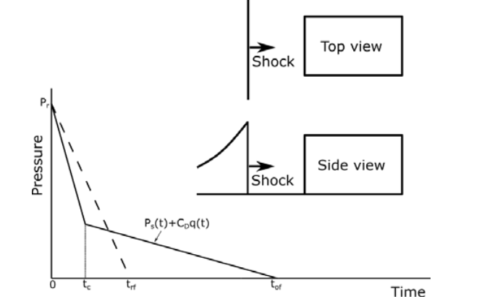
Figure 1 Blast Wave after explosion Figure 2 Pressure exerted on the front face

Fig. 1 shows the pressure diagram of blast wave. The significant factors, on which the response of a structural element subject to blast forces depends, are the pressure versus time diagram acting on the element, the effective time period of the element, the resistance versus deflection diagram of the element, and the maximum permissible deflection.

Blast pressure calculation
Blast calculation can be done with help of empirical formulas
- Brodes
Brodes gives the following values for the peak overpressure(bar) for near and for medium to far.
$Ps=\frac{6.7}{Z^{3}}+1$, bar Ps > 10 bar

$Ps=\frac{0.975}{Z^{1}}+\frac{1.455}{Z^{2}}+\frac{5.85}{Z^{3}}-0.019$, bar 0.1<Ps <10 bar

$Z=\frac{R}{\sqrt[3]{W}}$ , m
Z=Scaled distance, m
R=distance from center of a spherical charge, m
W= TNT Charge mass, kg
- Newmark and Hansen
Newmark and Hansen proposed the following formula for blast pressure calculation
$P=6784.0\frac{W}{R^{3}}+93.0\sqrt{\frac{W}{R^{3}}}$, bar
- Mills
Mills proposed the following formula to calculate the blast pressure.
$Ps=\frac{1772}{Z^{3}}+\frac{114}{Z^{2}}+\frac{108}{Z^{1}}-0.019$, kPa

Section details
While building the geometry of metro-station there are around 20+ sectional properties are used. Following fig. 3 shows a sample sectional property for the end diaphragm of PSC box section, which are based on structural drawings received from MMRCL.
All dimensions in mm.
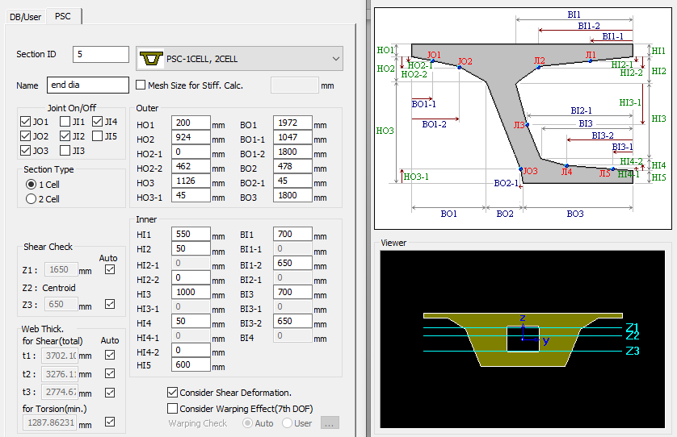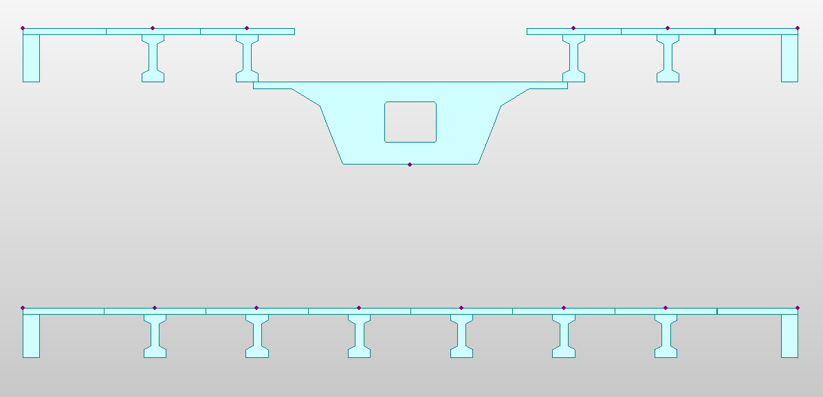
Figure 3 Section properties of PSC box-section of end diaphragm Figure 4 Cross section view of girders
Metro-station structure consists of 6 composite I girder and 2 composite L girder at concourse level and consist of 4 composite I girder and 2 composite L girder at platform level. Track level is setup on PSC box girder, 2 track lane are provided for forward and backward movement of train. Fig. 4 shows the cross-sections of all girder sections.

Cross-section properties
Station Structure includes 20+ sections. Table 2 represents the cross-section properties of some of the important sections.

Table 2. Cross-section Properties
Sr No. | Type | Description | Area | Ixx | Iyy | Izz
1 | Composite I | PPC girder | 0.9113 | 0.0217 | 0.21564 | 0.25064
2 | Composite I | CPC girder | 0.9273 | 0.0217 | 0.18329 | 0.31868
3 | Composite L | PPC edge girder | 0.9675 | 0.0397 | 0.20147 | 0.36493
4 | Composite L | CPC edge girder | 0.9138 | 0.0365 | 0.16332 | 0.33478
5 | Solid | pier | 4.56 | 2.84 | 2.1888 | 1.3718
6 | Solid | pier cap | 3 | 0.4961 | 0.14063 | 4
7 | PSC | mid box | 5.91657 | 8.585 | 3.977175 | 22.46402
8 | PSC | mid to end | 6.49392 | 8.9837 | 4.083778 | 24.08403
9 | PSC | end diaphragm | 9.582 | 11.133 | 4.72488 | 27.704
10 | PSC | PPC arm | 2.6788 | 0.776 | 1.16271 | 0.33707
11 | PSC | CPC arm | 4.32 | 1.6836 | 2.1504 | 1.6

Blast calculations
1 kg tnt
r = 3.75 m
w = 0.001 tonne
Z=37.5 mkg-1
Cd =1
Pa=1 kg/sq.cm
as per table 1 for 1 tonne tnt explosive
Pso = 8 kg/sq.cm = 0.0784532 mpa
Pro = 41.6 kg/sq.cm = 0.40795664 mpa
q = 10.667 kg/sq.cm = 0.104607536 mpa
Newmark and Hansen formula
$Ps=6784.0\frac{W}{R^{3}}+93.0\sqrt{\frac{W}{R^{3}}}$, bar
Ps=0.533627045 bar =0.053362704 mpa
for closed case
$P_{r_{0}}=P_{so}\left[2+\frac{6P_{so}}{P_{so}+7P_{a}}\right]$
Pro=1.323793591 bar
OR
$$P=Ps+Cd*q$$
$P$ = 0.15797024 mpa
Greater of $P_{r_{0}}$ or $P$
S = 10.5 m = 0.0105 mm
R = 0.11538 m =0.00011538 mm
R+1 = 1.11538 m =0.00111538 mm
$i_{s}=6.7*\frac{\sqrt{1+({\frac{Z}{0.23})}^{4}}}{Z^{2}*\sqrt{1+({\frac{Z}{0.23})}^{3}}}*\sqrt[3]{W}$,
$i_{s}=$ 5.23 Pas
$$t_{of}=\frac{i_{s}}{Ps}$$
$t_{of}=$ 0.000196201 s
$$t_{rf}=\frac{i_{s}}{Pro}$$
$t_{rf}$=8.06489E-05 s
$$t_{c}=\frac{4S}{\left(R+1\right)C}$$

$t_{c}=0.000114107$ s

Table 3. Blast pressure for TNT mass in kg
TNT  kg | W  tonne | Z  mkg⁻¹ | Ps  mpa | $$P_{r_{0}}$$  mpa | $$P$$  mpa | $$i_{s}$$  Pas | $$t_{of}$$  s | $$t_{rf}$$  s | $$t_{c}$$  s
1.000 | 0.001 | 37.500 | 0.000 | 0.130 | 0.158 | 5.235 | 0.196 | 0.081 | 0.114
2.000 | 0.002 | 29.764 | 0.083 | 0.220 | 0.188 | 8.310 | 0.200 | 0.076 | 0.114
3.000 | 0.003 | 26.001 | 0.109 | 0.307 | 0.213 | 10.889 | 0.200 | 0.071 | 0.114
4.000 | 0.004 | 23.624 | 0.132 | 0.393 | 0.237 | 13.190 | 0.199 | 0.067 | 0.114
5.000 | 0.005 | 21.930 | 0.155 | 0.481 | 0.259 | 15.306 | 0.198 | 0.064 | 0.114
6.000 | 0.006 | 20.637 | 0.176 | 0.569 | 0.281 | 17.283 | 0.196 | 0.061 | 0.114
7.000 | 0.007 | 19.603 | 0.197 | 0.658 | 0.302 | 19.153 | 0.194 | 0.058 | 0.114
8.000 | 0.008 | 18.750 | 0.217 | 0.749 | 0.322 | 20.936 | 0.193 | 0.056 | 0.114
9.000 | 0.009 | 18.028 | 0.237 | 0.840 | 0.342 | 22.646 | 0.191 | 0.054 | 0.114
10.000 | 0.010 | 17.406 | 0.257 | 0.933 | 0.361 | 24.293 | 0.189 | 0.052 | 0.114

Wind Calculations:
$p_{z}$ = 0.6 x $V_{z}^{2}$ ---- As per clause no. 5.4 of IS 875 Part III
$V_{z}$ = $V_{b}$ x $k_{1}$ x $k_{2}$ x $k_{3}$ x $k_{4}$ ---- As per clause no. 5.3 of IS 875 Part III
Height = 14 m
Where:
$V_{b }$= Basic Wind Speed = 39.0 m/s
$k_{1}$= Probability Factor = 1.06 (cl.6.3.1 IS 875 Part III)
$k_{2}$= Terrain height and structure size factor = 1.00
for terrain category I and structure class B (cl.6.3.2 IS 875 Part III)
$k_{3}$= Topography Factor = 1 (cl.6.3.3 IS 875 Part III)
$k_{4}$= Importance factor for cyclonic region = 1 (cl.6.3.4 IS 875 Part III)
V_{d,H} = Design hourly mean wind speed= (cl. 6.4 IS 875 Part III)
K_{2, i} = Hourly mean wind speed factor = 0.8545 (cl. 6.4 IS 875 part III)
V_{z,H} = Hourly Wind speed = 33.32379 m/s
V_{d,H} = 35.32322 m/s
p_{z} = 0.6 x V ² = 0.749 kN/m²
p_{d} = K_{d} K_{a} K_{c} p_{z} = 748.638 N/m² OK
p_{ds} = 524.046 N/m²
(For construction stages, only 70% wind load is considered)
Where,
K_{d} = wind directionality factor = 1
K_{a} = area averaging factor = 1
K_{c} = combination factor = 1
Gust factor G = 2.30
The average depth of superstructure = 2.4m
Carriageway width = 14.15m
Drag coefficient (b/d = 5.895833) =C_{d} = 1.3
Lift coefficient = 0.75
Transverse wind load = F_{T} = P_{z} x A x G x C_{d} = 3.76 KN/m
Transverse wind load on live load = 524.000*1.2* 2* 3*10⁻³ = 3.77 KN/m
(Consider LL for calculations)
Longitudinal wind load = (0.5*3.80*0+0.25*3.80) = 0.94 KN/m

- RESULTS
- General
It is the most important chapter which shows the result obtained in analysis work on Midas civil. 4 girders were considered for the research work the metro structure. The result obtained were for seismic, blast, multi-hazard.
- Seismic
The linear dynamic analysis was carried on a single span of metro station. In 2 story structure, response of structure at each story is calculated with help of girder deformations. To observe the max. displacement of structure 1 outer girder and 1 inner girder at each story level is considered. So, total 4 girders we considered to studying the response of structure. In each girder the Dx, Dy and Dz deformations were considered at 3 locations i.e., ends and mid-span.

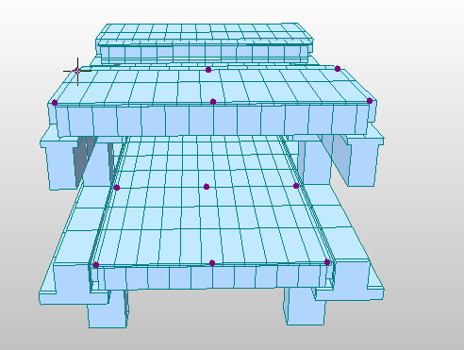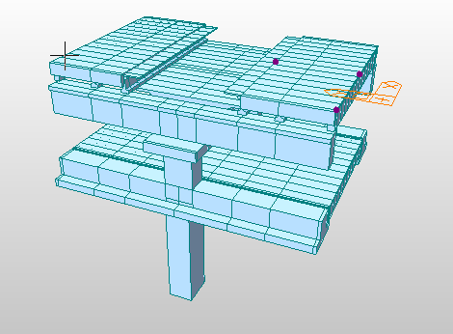
Figure 5 Nodes considered for displacement values Figure 6 Nodes for highest displacement in 3D model

Fig. 5 represents the 3D model showing the nodes giving the max. deformation
Table 4 shows the obtained reaction values under varying load case. In table below the reactions in X, Y direction are nothing but the base shear values in case of earthquake in X, Y direction respectively.

Table 4. Reactions at support
SUMMATION OF REACTION FORCES PRINTOUT
Load | FX (kN) | FY (kN) | FZ (kN)
Self-Weight | 0.000000071 | 0.00000174 | 15037.80
Eqx (RS) | 1333.48 | 0.000010399 | 0.000000528
Eqy (RS) | 0.000011725 | 1254.64 | 0.000005824

Each structure has a time period at which the structure undergoes the mode of vibrations. In the Bridges to obtain the mass participations the no. of modes goes increases. Table 5 shows the time period for 25 modes of vibration. Further table 6 shows the mass participation values for each mode.

Table 5. Time periods for 25 modes of vibration
Mode  No. | Frequency |  | Period  (sec)
Mode  No. | (rad/sec) | (cycle/sec) | Period  (sec)
1 | 8.82414 | 1.40441 | 0.71205
2 | 10.7739 | 1.71472 | 0.58318
3 | 14.5096 | 2.30928 | 0.43304
4 | 14.619 | 2.32669 | 0.4298
5 | 14.8218 | 2.35897 | 0.42391
6 | 20.1866 | 3.2128 | 0.31126
7 | 20.9 | 3.32634 | 0.30063
8 | 20.9036 | 3.32691 | 0.30058
9 | 21.1299 | 3.36292 | 0.29736
10 | 22.4331 | 3.57034 | 0.28009
11 | 25.539 | 4.06465 | 0.24602
12 | 27.5095 | 4.37827 | 0.2284
13 | 27.6369 | 4.39854 | 0.22735
14 | 30.0054 | 4.77551 | 0.2094
15 | 30.714 | 4.88829 | 0.20457
16 | 30.9081 | 4.91918 | 0.20329
17 | 31.7281 | 5.04968 | 0.19803
18 | 40.5164 | 6.44839 | 0.15508
19 | 57.3127 | 9.1216 | 0.10963
20 | 57.6837 | 9.18065 | 0.10893
21 | 77.9636 | 12.4083 | 0.08059
22 | 78.0846 | 12.4276 | 0.08047
23 | 85.4762 | 13.604 | 0.07351
24 | 115.319 | 18.3535 | 0.05449
25 | 138.652 | 22.0672 | 0.04532

Table 6. Modal Participation
MODAL PARTICIPATION MASSES PRINTOUT
Mode  No. | TRAN-X |  | TRAN-Y |  | TRAN-Z |  | ROTN-X |  | ROTN-Y |  | ROTN-Z
Mode  No. | MASS |  | MASS |  | MASS |  | MASS |  | MASS |  | MASS
Mode  No. | % | SUM | % | SUM | % | SUM | % | SUM | % | SUM | % | SUM
1 | 0.0 | 0.0 | 69.5 | 69.5 | 0.0 | 0.0 | 0.0 | 0.0 | 0.0 | 0.0 | 0.0 | 0.0
2 | 56.3 | 56.3 | 0.0 | 69.5 | 0.0 | 0.0 | 0.0 | 0.0 | 0.0 | 0.0 | 0.0 | 0.0
3 | 0.0 | 56.3 | 8.5 | 78.0 | 0.0 | 0.0 | 38.3 | 38.3 | 0.0 | 0.0 | 0.0 | 0.0
4 | 0.0 | 56.3 | 0.0 | 78.0 | 0.0 | 0.0 | 0.0 | 38.3 | 0.0 | 0.0 | 0.0 | 0.0
5 | 17.1 | 73.4 | 0.0 | 78.0 | 0.0 | 0.0 | 0.0 | 38.3 | 41.7 | 41.7 | 0.0 | 0.0
6 | 0.0 | 73.4 | 0.0 | 78.0 | 0.0 | 0.0 | 0.0 | 38.3 | 0.0 | 41.7 | 60.5 | 60.5
7 | 0.0 | 73.4 | 5.2 | 83.2 | 0.0 | 0.0 | 15.7 | 53.9 | 0.0 | 41.7 | 0.0 | 60.5
8 | 0.0 | 73.4 | 0.0 | 83.2 | 0.0 | 0.0 | 0.0 | 54.0 | 0.0 | 41.7 | 0.0 | 60.5
9 | 7.6 | 81.0 | 0.0 | 83.2 | 0.0 | 0.0 | 0.0 | 54.0 | 13.0 | 54.7 | 0.0 | 60.5
10 | 0.0 | 81.0 | 0.0 | 83.2 | 0.0 | 0.0 | 0.0 | 54.0 | 0.0 | 54.8 | 11.0 | 71.6
11 | 0.0 | 81.0 | 0.0 | 83.2 | 0.0 | 0.0 | 0.0 | 54.0 | 0.0 | 54.8 | 0.0 | 71.6
12 | 0.0 | 81.0 | 0.7 | 83.9 | 0.0 | 0.0 | 0.6 | 54.6 | 0.0 | 54.8 | 0.0 | 71.6
13 | 0.0 | 81.0 | 0.0 | 83.9 | 0.0 | 0.0 | 0.0 | 54.6 | 0.0 | 54.8 | 8.2 | 79.8
14 | 4.7 | 85.7 | 0.0 | 83.9 | 0.0 | 0.0 | 0.0 | 54.6 | 1.3 | 56.1 | 0.0 | 79.8
15 | 0.0 | 85.7 | 4.4 | 88.3 | 0.0 | 0.0 | 1.9 | 56.5 | 0.0 | 56.1 | 0.0 | 79.8
16 | 1.0 | 86.7 | 0.0 | 88.3 | 0.0 | 0.0 | 0.0 | 56.5 | 0.4 | 56.5 | 0.0 | 79.8
17 | 0.0 | 86.7 | 0.0 | 88.3 | 0.0 | 0.0 | 0.0 | 56.5 | 0.0 | 56.5 | 1.3 | 81.1
18 | 0.0 | 86.7 | 0.0 | 88.3 | 0.0 | 0.0 | 0.0 | 56.5 | 0.0 | 56.5 | 16.3 | 97.4
19 | 0.0 | 86.7 | 0.0 | 88.3 | 0.0 | 0.0 | 0.0 | 56.5 | 0.0 | 56.5 | 0.0 | 97.4
20 | 0.0 | 86.7 | 0.0 | 88.3 | 0.0 | 0.0 | 0.0 | 56.5 | 0.0 | 56.5 | 0.4 | 97.7
21 | 0.0 | 86.7 | 0.0 | 88.3 | 0.0 | 0.0 | 0.0 | 56.5 | 0.0 | 56.5 | 0.0 | 97.7
22 | 12.0 | 98.7 | 0.0 | 88.3 | 0.0 | 0.0 | 0.0 | 56.5 | 36.8 | 93.2 | 0.0 | 97.7
23 | 0.0 | 98.7 | 11.3 | 99.6 | 0.0 | 0.0 | 41.8 | 98.3 | 0.0 | 93.2 | 0.0 | 97.7
24 | 0.0 | 98.7 | 0.0 | 99.6 | 0.0 | 0.0 | 0.0 | 98.3 | 0.0 | 93.2 | 2.1 | 99.9
25 | 0.0 | 98.7 | 0.0 | 99.6 | 0.0 | 0.0 | 0.0 | 98.3 | 0.0 | 93.2 | 0.0 | 99.9

Blast Load
Blast load is more impactful than the seismic load. Blast pressure acts vertically downward on girders this act as UDL or UVL on the girders. Hence the stresses in girder increases with increase in pressure value. Similar to seismic load analysis, the very same girders ere used to study the stresses in inner and outer girder.
Girder description which are considered are:
- CPC level edge girder
- PPC level edge girder
- CPC level mid girder
- CPC level mid girder
Each girder was divided in 11 parts and stress values were observed at start and end nodes of each node. Hence, 12 values of each girder were obtained. Following table 7 shows the stress values for blast of 1 kg TNT explosive, same is plotted in Fig. 7.

Table 7. Stresses in girder along the length for 1 kg TNT
Division along length | CPC edge girder | PPC edge girder | CPC mid girder | PPC mid girder
1 | 2.54 | 2.04 | -2.27 | -2.53
2 | 2.54 | 2.48 | -2.27 | 0.604
3 | 2.93 | 2.83 | 1.06 | 3.15
4 | 3.24 | 3.1 | 3.65 | 5.11
5 | 3.45 | 3.29 | 5.48 | 6.49
6 | 3.57 | 3.4 | 6.56 | 7.31
7 | 3.59 | 3.42 | 6.9 | 7.56
8 | 3.57 | 3.4 | 6.57 | 7.31
9 | 3.45 | 3.29 | 5.48 | 6.5
10 | 3.24 | 3.1 | 3.65 | 5.12
11 | 2.93 | 2.47 | 1.07 | 0.615
12 | 2.54 | 2.04 | -2.27 | -2.52

Figure 7 Stresses in girder along the length for 1 kg TNT

As per the load combinations table wind load is considered in all the cases. Hence, wind load is considered to see the difference in stress values. In considering the wind 3 cases were used i.e., X-X, Y-Y, inclined (45⁰). Following tables and fig 8, 9 and 10 shows the blast + wind values in X-X, Y-Y, inclined (45⁰) respectively.

Table 8. Stresses in girder along the length for 1 kg TNT and wind X-X
Division along length | CPC edge girder | PPC edge girder | CPC mid girder | PPC mid girder
1 | 2.39 | 1.82 | -3.42 | -4.28
2 | 2.52 | 2.45 | -2.28 | 0.578
3 | 2.89 | 2.78 | 1.02 | 3.08
4 | 3.17 | 3.03 | 3.57 | 5.02
5 | 3.37 | 3.21 | 5.39 | 6.38
6 | 3.48 | 3.3 | 6.46 | 7.19
7 | 3.5 | 3.32 | 6.79 | 7.44
8 | 3.48 | 3.3 | 6.46 | 7.19
9 | 3.37 | 3.2 | 5.39 | 6.39
10 | 3.17 | 3.03 | 3.58 | 5.03
11 | 2.88 | 2.44 | 1.02 | 0.588
12 | 2.52 | 2.05 | -2.28 | -2.51

Figure 8 Stresses in girder along the length for 1 kg TNT and wind X-X

From the above table 8 and fig.8 shows stresses in girder along the length for 1 kg TNT and wind X-X it is observed the stresses increases in girders but this increase is not very much.

Table 9. Stresses in girder along the length for 1 kg TNT and wind Y-Y

Division along length | CPC edge girder | PPC edge girder | CPC mid girder | PPC mid girder
1 | 2.38 | 1.8 | -3.42 | -4.29
2 | 2.51 | 2.45 | -2.28 | 0.574
3 | 2.88 | 2.78 | 1.02 | 3.08
4 | 3.17 | 3.03 | 3.57 | 5.01
5 | 3.37 | 3.21 | 5.38 | 6.38
6 | 3.48 | 3.31 | 6.46 | 7.19
7 | 3.5 | 3.33 | 6.79 | 7.44
8 | 3.48 | 3.31 | 6.46 | 7.19
9 | 3.37 | 3.21 | 5.39 | 6.39
10 | 3.17 | 3.03 | 3.57 | 5.02
11 | 2.88 | 2.44 | 1.02 | 0.584
12 | 2.51 | 2.04 | -2.28 | -2.51

Figure 9 Stresses in girder along the length for 1 kg TNT and wind Y-Y

From the above table 9 and fig.9 shows stresses in girder along the length for 1 kg TNT and wind Y-Y it is observed the stresses increases in girders but this increase is not very much.

Table 10. Stresses in girder along the length for 1 kg TNT and wind 450
Division along length | CPC edge girder | PPC edge girder | CPC mid girder | PPC mid girder
1 | 3.77 | 3.14 | -1.78 | -2.63
2 | 3.9 | 3.79 | -0.638 | 2.24
3 | 4.28 | 4.13 | 2.67 | 4.76
4 | 4.58 | 4.4 | 5.25 | 6.71
5 | 4.81 | 4.59 | 7.09 | 8.1
6 | 4.94 | 4.71 | 8.19 | 8.93
7 | 4.99 | 4.74 | 8.56 | 9.21
8 | 4.94 | 4.7 | 8.19 | 8.93
9 | 4.8 | 4.59 | 7.09 | 8.11
10 | 4.58 | 4.39 | 5.25 | 6.72
11 | 4.27 | 3.78 | 2.67 | 2.25
12 | 3.9 | 3.37 | -0.638 | -0.853

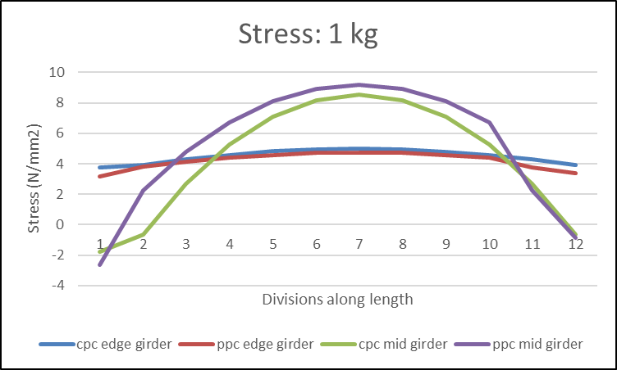
Figure 10 Stresses in girder along the length for 1 kg TNT and wind 450
From the above table 10 and fig 10 shows stresses in girder along the length for 1 kg TNT and wind at 45⁰. It is observed the stresses increases in girders but in this case, increase is very much, it is like 10% increase in stress values. So, we will go with inclined wind load case for further TNT blast analysis.

Figure 11 Deformation range values for various load cases
Above fig 11 shows the deformation values for various loading case considered in study. From the chart it is clear that blast + inclined wind (45⁰) gives the highest values of deformation. So, blast + wind (45⁰) case best to study the stress in girders and structural deformation.
Table 11. Stresses in girder along the length for 2 kg TNT
Division along length | CPC edge girder | PPC edge girder | CPC mid girder | PPC mid girder
1 | 2.61 | 1.22 | -1.44 | -2.04
2 | 3.54 | 5.54 | 0.317 | 5.58
3 | 6.22 | 7.79 | 5.41 | 9.55
4 | 8.31 | 9.54 | 9.38 | 12.6
5 | 9.8 | 10.8 | 12.2 | 14.8
6 | 10.7 | 11.5 | 13.9 | 16.1
7 | 11 | 11.8 | 14.5 | 16.6
8 | 10.7 | 11.5 | 13.9 | 16.1
9 | 9.79 | 10.8 | 12.2 | 14.8
10 | 8.3 | 9.54 | 9.38 | 12.6
11 | 6.21 | 5.53 | 5.41 | 5.59
12 | 3.53 | 2.78 | 0.318 | 0.728

Figure 12 Stresses in girder along the length for 2 kg TNT
From the above table 11 and fig 12 shows stresses in girder along the length for 2 kg TNT. It is observed the stresses increases in girders but in this case, increase is very much, it is like 80% increase in stress values.
Table 12. Stresses in girder along the length for 3 kg TNT
Division along length | CPC edge girder | PPC edge girder | CPC mid girder | PPC mid girder
1 | 3.62 | 1.77 | -1.97 | -2.74
2 | 4.87 | 7.6 | 0.424 | 7.64
3 | 8.5 | 10.6 | 7.38 | 13
4 | 11.3 | 13 | 12.8 | 17.2
5 | 13.4 | 14.7 | 16.7 | 20.2
6 | 14.6 | 15.7 | 19 | 22
7 | 15 | 16 | 19.7 | 22.6
8 | 14.6 | 15.7 | 19 | 22
9 | 13.3 | 14.7 | 16.7 | 20.2
10 | 11.3 | 13 | 12.8 | 17.2
11 | 8.49 | 7.59 | 7.38 | 7.65
12 | 4.87 | 3.88 | 0.424 | 1.03

Figure 13 Stresses in girder along the length for 3 kg TNT
From the above table 12 and fig 13 shows stresses in girder along the length for 3 kg TNT. It is observed the stresses increases in girders but in this case, increase is very much, it is like 35% increase in stress values as in 2 kg case.
Table 13. Stresses in girder along the length for 4 kg TNT
Division along length | CPC edge girder | PPC edge girder | CPC mid girder | PPC mid girder
1 | 4.63 | 2.31 | -2.51 | -3.43
2 | 6.2 | 9.65 | 0.524 | 9.69
3 | 10.8 | 13.5 | 9.34 | 16.5
4 | 14.3 | 16.5 | 16.2 | 21.8
5 | 16.9 | 18.6 | 21.1 | 25.6
6 | 18.4 | 19.9 | 24 | 27.9
7 | 18.9 | 20.3 | 25 | 28.6
8 | 18.4 | 19.9 | 24 | 27.9
9 | 16.9 | 18.6 | 21.1 | 25.6
10 | 14.3 | 16.5 | 16.2 | 21.8
11 | 10.8 | 9.65 | 9.34 | 9.7
12 | 6.19 | 4.97 | 0.524 | 1.34

Figure 14 Stresses in girder along the length for 4 kg TNT
From the above table 13 and fig 14 shows stresses in girder along the length for 4 kg TNT. It is observed the stresses increases in girders but in this case, increase is very much, it is like 30% increase in stress values wrt 3 kg case.

Table 14. Stresses in girder along the length for 5 kg TNT
Division along length | CPC edge girder | PPC edge girder | CPC mid girder | PPC mid girder
1 | 5.63 | 2.86 | -3.05 | -4.12
2 | 7.53 | 11.7 | 0.624 | 11.8
3 | 13.1 | 16.3 | 11.3 | 20
4 | 17.4 | 19.9 | 19.6 | 26.4
5 | 20.5 | 22.5 | 25.6 | 31
6 | 22.3 | 24.1 | 29.1 | 33.8
7 | 22.9 | 24.6 | 30.3 | 34.7
8 | 22.3 | 24.1 | 29.1 | 33.8
9 | 20.4 | 22.5 | 25.6 | 31
10 | 17.4 | 19.9 | 19.6 | 26.4
11 | 13.1 | 11.7 | 11.3 | 11.8
12 | 7.53 | 6.07 | 0.624 | 1.64

Figure 15 Stresses in girder along the length for 5 kg TNT
From the above table 14 and fig 15 shows stresses in girder along the length for 5 kg TNT. It is observed the stresses increases in girders but in this case, increase is very much, it is like 21% increase in stress values wrt 4 kg case.

Table 15. Stresses in girder along the length for 6 kg TNT
Division along length | CPC edge girder | PPC edge girder | CPC mid girder | PPC mid girder
1 | 6.65 | 3.42 | -3.6 | -4.83
2 | 8.88 | 13.8 | 0.725 | 13.8
3 | 15.4 | 19.2 | 13.3 | 23.6
4 | 20.4 | 23.5 | 23.1 | 31.1
5 | 24.1 | 26.5 | 30.1 | 36.5
6 | 26.2 | 28.3 | 34.3 | 39.7
7 | 27 | 28.9 | 35.6 | 40.8
8 | 26.2 | 28.3 | 34.3 | 39.7
9 | 24 | 26.5 | 30.1 | 36.5
10 | 20.4 | 23.5 | 23.1 | 31.1
11 | 15.4 | 13.8 | 13.3 | 13.9
12 | 8.88 | 7.18 | 0.725 | 1.95

Figure 16 Stresses in girder along the length for 6 kg TNT
From the above table 15 and fig 16 shows stresses in girder along the length for 6 kg TNT. It is observed the stresses increases in girders but in this case, increase is very much, it is like 17% increase in stress values wrt 5 kg case.

Table 16. Stresses in girder along the length for 7 kg TNT
Division along length | CPC edge girder | PPC edge girder | CPC mid girder | PPC mid girder
1 | 8.73 | 4.55 | -4.71 | -6.26
2 | 11.6 | 18.1 | 0.931 | 18.1
3 | 20.1 | 25.1 | 17.3 | 30.8
4 | 26.7 | 30.6 | 30.1 | 40.6
5 | 31.4 | 34.5 | 39.2 | 41.2
6 | 34.2 | 36.9 | 44.7 | 46.5
7 | 35.2 | 37.7 | 46.5 | 47.6
8 | 34.2 | 36.9 | 44.7 | 41.2
9 | 31.4 | 34.5 | 39.2 | 47.6
10 | 26.7 | 30.6 | 30.1 | 40.6
11 | 20.1 | 18.1 | 17.3 | 18.1
12 | 11.6 | 9.44 | 0.931 | 2.58

Figure 17 Stresses in girder along the length for 7 kg TNT
From the above table 16 and fig 17 shows stresses in girder along the length for 7 kg TNT. It is observed the stresses increases in girders but in this case, increase is very much, it is like 16% increase in stress values wrt 6 kg case.

Table 17. Stresses in girder along the length for 8 kg TNT
Division along length | CPC edge girder | PPC edge girder | CPC mid girder | PPC mid girder
1 | 8.73 | 4.55 | -4.71 | -6.26
2 | 11.6 | 18.1 | 0.931 | 18.1
3 | 20.1 | 25.1 | 17.3 | 30.8
4 | 26.7 | 30.6 | 30.1 | 40.6
5 | 31.4 | 34.5 | 39.2 | 47.6
6 | 34.2 | 36.9 | 44.7 | 51.8
7 | 35.2 | 37.7 | 46.5 | 54.2
8 | 34.2 | 36.9 | 44.7 | 51.8
9 | 31.4 | 34.5 | 39.2 | 47.6
10 | 26.7 | 30.6 | 30.1 | 40.6
11 | 20.1 | 18.1 | 17.3 | 18.1
12 | 11.6 | 9.44 | 0.931 | 2.58

Figure 18 Stresses in girder along the length for 8 kg TNT
From the above table 17 and fig 18 shows stresses in girder along the length for 8 kg TNT. It is observed the stresses increases in girders but in this case, increase is very much, it is like 14% increase in stress values wrt 7 kg case.

Table 18. Stresses in girder along the length for 9 kg TNT
Division along length | CPC edge girder | PPC edge girder | CPC mid girder | PPC mid girder
1 | 9.79 | 5.13 | -5.28 | -6.99
2 | 13 | 20.2 | 1.04 | 20.3
3 | 22.5 | 28.1 | 19.4 | 34.4
4 | 29.8 | 34.3 | 33.7 | 45.4
5 | 35.1 | 38.7 | 43.9 | 53.3
6 | 38.3 | 41.3 | 50 | 58
7 | 39.3 | 42.2 | 52.1 | 59.6
8 | 38.3 | 41.3 | 50 | 58
9 | 35.1 | 38.6 | 43.9 | 53.3
10 | 29.8 | 34.2 | 33.7 | 45.5
11 | 22.5 | 20.2 | 19.4 | 20.3
12 | 13 | 10.6 | 1.04 | 2.91

Figure 19 Stresses in girder along the length for 9 kg TNT
From the above table 18 and fig 19 shows stresses in girder along the length for 9 kg TNT. It is observed the stresses increases in girders but in this case, increase is very much, it is like 10% increase in stress values wrt 8 kg case.

Table 19. Stresses in girder along the length for 10 kg TNT
Division along length | CPC edge girder | PPC edge girder | CPC mid girder | PPC mid girder
1 | 10.9 | 5.71 | -5.85 | -7.72
2 | 14.4 | 22.4 | 1.14 | 22.4
3 | 24.9 | 31.1 | 21.5 | 38.1
4 | 33 | 37.9 | 37.3 | 50.3
5 | 38.9 | 42.8 | 48.6 | 59
6 | 42.4 | 45.7 | 55.4 | 64.2
7 | 43.6 | 46.7 | 57.7 | 66
8 | 42.4 | 45.7 | 55.4 | 64.2
9 | 38.9 | 42.8 | 48.6 | 59
10 | 33 | 37.9 | 37.3 | 50.3
11 | 24.9 | 22.4 | 21.5 | 22.5
12 | 14.4 | 11.8 | 1.14 | 3.23

Figure 20 Stresses in girder along the length for 10 kg TNT

From the above table 19 and fig 20 shows stresses in girder along the length for 10 kg TNT. It is observed the stresses increases in girders but in this case, increase is very much, it is like 10% increase in stress values wrt 9 kg case.

Multi-Hazard
Following table 20 and fig 21 shows the deformation in Dx, Dy and Dz and the allowed displacement value for various mass load of TNT.As seismic and blast have individual responses on structure the combined effect will be observed.

Figure 21 Deformation for Multi-hazard

Table 20. Maximum displacement for various TNT mass in multi-Hazard
TNT(Kg) | DX (mm) | DY (mm) | DZ (mm)
0 | 9.736104 | 14.92846 | 0
1 | 9.736104 | 15.0113 | -19.6637
2 | 12.98493 | 15.17423 | -37.0389
3 | 16.80996 | 15.49024 | -50.8705
4 | 18.66841 | 15.6261 | -64.7605
5 | 20.54006 | 15.76292 | -78.7492

- GET PEER REVIEWED
The present chapter deals with the conclusion of complete project work which is based on Finite element modelling software outputs i.e., Midas civil results. Based on study conducted on existing project, conclusions are drawn as follows,
1. Response spectrum analysis results represent the fundamental natural time period of structure to be 0.71 seconds.
2. In seismic analysis, the structure requires minimum 23 modes to attain mass participation of more than 90%.
3. It is observed that the first two modes are translational and 3rd mode is torsional, which means the structure is fine and does not belong torsional irregular structure.
4. In seismic analysis, structural deformations are more and stresses generated are less. Hence, it can be concluded that deformation of structure leads to failure of structure in seismic hazard.
5. From the result of 1 kg blast, it was concluded that the structure has 10% more stresses in combined load case of blast and inclined wind load at 450 as compared to only blast case.
6. In progressive cases of blast pressure analysis, the increase in stresses is observed as 80%, 35%, 30%, 21%, 17%, 16%, 14%, 12%, 10%, it can be concluded that stresses are increasing in each blast case but the percentage increase gets reduced in each case.
7. In Blast analysis, structure will failure in observed in both deformation and stresses, but deformation of structure is governing failure than stresses.
8. For multi-hazard case, a combine failure of structure is observed i.e., seismic and last are reaching their ultimate failure action, but blast failure is the governing load case for failure.

- CONCLUSION
The present chapter deals with the conclusion of complete project work which is based on Finite element modelling software outputs i.e., Midas civil results. Based on study conducted on existing project, conclusions are drawn as follows,
- Response spectrum analysis results represent the fundamental natural time period of structure to be 0.71 seconds.
- In seismic analysis, the structure requires minimum 23 modes to attain mass participation of more than 90%.
- It is observed that the first two modes are translational and 3rd mode is torsional, which means the structure is fine and does not belong torsional irregular structure.
- In seismic analysis, structural deformations are more and stresses generated are less. Hence, it can be concluded that deformation of structure leads to failure of structure in seismic hazard.
- From the result of 1 kg blast, it was concluded that the structure has 10% more stresses in combined load case of blast and inclined wind load at 45⁰ as compared to only blast case.
- In progressive cases of blast pressure analysis, the increase in stresses is observed as 80%, 35%, 30%, 21%, 17%, 16%, 14%, 12%, 10%, it can be concluded that stresses are increasing in each blast case but the percentage increase gets reduced in each case.
- In Blast analysis, structure will failure in observed in both deformation and stresses, but deformation of structure is governing failure than stresses.
- For multi-hazard case, a combine failure of structure is observed i.e., seismic and last are reaching their ultimate failure action, but blast failure is the governing load case for failure.
REFERENCES
- Bruneau, M., Fujikura, S., Fouche, P., and Chiarito, V. P., (2015). “Multi-Hazard (Blast and Seismic) Resistance Of Various Types Of Bridge Columns.” 11th International Conference on Shock & Impact Loads on Structures.W.-K. Chen, Linear Networks and Systems (Book style). Belmont, CA: Wadsworth, 1993, pp. 123–135.
- Fouche, P., Bruneau, M., and V. Chiarito. (2017). “Dual-Hazard Blast and Seismic Behavior of Concrete-Filled Double-Skin Steel Tubes Bridge Pier.” Journal of Structural Engineering.B. Smith, “An approach to graphs of linear forms (Unpublished work style),” unpublished.
- Gholamreza, A., Hadi, F. (2017).” Probabilistic two-hazard risk assessment of near-fault and far-fault earthquakes in a structure subjected to earthquake-induced gas explosion.” Journal of Building Engineering 13, pp 298 304.
- Hong, H., and Yun, Z. (2011). “Rigid structure response analysis to seismic and blast induced ground motion.” Elsevier Ltd. The Twelfth East Asia-Pacific Conference on Structural Engineering and Construction.
- Indian Railway Standard (Seismic Code) “Code For Earthquake Resistant Design Of Railway Bridges” Research Designs And Standards Organization Lucknow.
- Nourzadeh, D., Humar, J., and Braimah, A. (2017).” Comparison of Response of Building Structures to Blast Loading and Seismic Excitations.” Elsevier Ltd, 6th International Workshop on Performance, Protection & Strengthening of Structures under Extreme Loading.
- Roy, T., and Matsagar, V. (2021). “Multi-hazard analysis and design guidelines: recommendations for structure and infrastructure systems in the Indian context.” Multi-Hazard Protective Structures (MHPS), Indian Institute of Technology (IIT) Delhi.
- Shahriari, A., Birzhandi, M. S., and Zafarani, M. M., (2021).” Seismic behavior, blast response and progressive collapse of RC structures equipped with viscoelastic dampers.” Elsevier Ltd, Soil Dynamics and Earthquake Engineering.
- Shin, J., Scott, D. W., Stewart, L. K., and Jeon, J. (2020). “Multi-hazard assessment and mitigation for seismically-deficient RC building frames using artificial neural network models.” Elsevier Ltd. Engineering Structures.
- Stephen, J., Cimpoeru, Ritzel, D. V., and Brett. J. M. (2017) “Physics of Explosive Loading of Structures.” Elsevier Ltd.
- Wu, J., Zhou, Y., Zhang, R., Liu, C., Zhang, Z. (2018). “Numerical simulation of reinforced concrete slab subjected to blast loading and the structural damage assessment, Engineering Failure Analysis.
- Zhang, C., Gholipour, G., and Mousavi, A. A. (2020). “Blast loads induced responses of RC structural members: State-of-the-art revie.” Elsevier Ltd. Composites.

