EXPERIMENTAL INVESTIGATION ON WARM MIX ASPHALT AND RECLAIMED ASPHALT PAVEMENT (WMA-RAP) WITH ZYCOTHERM AS ADDITIVE FOR VILLAGE ROADS
Venkatesh A L, Vishwas, Tharun N V, Prema H O, Naveen G.
Department of civil engineering, CIT, Gubbi. Tumkur-572216

ABSTRACT: Roads play a crucial role in ensuring the economic progress of our country. The basic infrastructures required for the development of rural areas are everlasting roads. The construction of roads using reclaimed asphalt pavement (RAP) is generated when asphalt pavements are removed for reconstruction or resurfacing as it consists of high-quality, well-graded aggregates coated by asphalt cement when properly crushed and screened. With increased demand and limited aggregate and binder supply, hot mix asphalt (HMA) producers discovered that RAP can be produced at lower temperatures (130˚C to 150˚C). Using warm mix asphalt (WMA) by mixing chemical additive allows lower consumption of recourses and thus releases less carbon dioxide. RAP is a valuable component in WMA. While several factors drive the use of RAP in asphalt pavements, the two primary factors are economic savings and environmental benefits. A study literature review shows research done in the area of WMA technologies. Reclaimed asphalt pavement is a useful alternative for virgin materials because it reduces the use of virgin aggregates and the amount of virgin asphalt binder required in the production of pavements. The present study involves the comparison of the variation in stability and durability properties of the WMA mixes containing different percentages of RAP material (10%, 20%, and, 30%) and virgin aggregates (90%, 80%, and 70%). The optimum binder content was found using the Marshall Stability test. The WMA is produced with the chemical additive “ZycoTherm” to improve the engineering properties of asphalt mixtures containing high contents of RAP. The adopted mixing temperature for WMA was 130˚C with an additive dosage rate of 0.1% by the weight of the binder. This study makes an effort to evaluate the properties of BC-I mix prepared using RAP material and to compare the Marshall properties of WMA produced with the chemical additive. In this present project work, it can be concluded that more than 10% and less than 30% of RAP can be suitably adopted in making the village roads with the RAP.

INTRODUCTION: Approximately 3.93 million km of national, state, major district, other district, and village roads make up India's extensive road network. The majority of these roads have bituminous pavements, which necessitate ongoing maintenance. All of these operations call for massive amounts of road construction supplies, particularly stone aggregates. In addition, during resurfacing, rehabilitation, or rebuilding activities, substantial amounts of the old bituminous pavement components are often milled or removed. Using a milling machine, which can remove up to 50 mm (2 in) of pavement thickness in a single pass, milling involves removing the pavement surface. With full-depth removal, the pavement is torn and broken with a bulldozer's rhino horn or pneumatic pavement breakers. Typically, a front-end loader picks up the shattered debris, loads it onto haul trucks, and transports it to a processing plant. The RAP is processed at this plant utilizing several procedures, including crushing, screening, conveying, and stacking.

A self-propelled pulverize machine may be used to grind up old asphalt pavements on site and integrate them into granular or stabilized base courses, even though central processing plants recycle the bulk of old asphalt pavements. Reusing materials in a cycle and recycling asphalt pavement maximizes the utilization of natural resources. Because it eliminates the demand for raw aggregate, reclaimed asphalt pavement (RAP) is a good substitute for virgin materials. Additionally, a less expensive new asphalt binder is needed to produce asphalt paving mixes. A high percentage of RAP

combinations may be produced using manufacturing and processing techniques, which saves money and energy. It has been concluded that the

performance of pavements including up to 30% RAP is comparable to that of pavements made from virgin materials with no RAP based on an examination of pavements containing 30% RAP through the Long-Term Pavement Performance (LTPP) program. Engineers, contractors, and anyone engaged in the specification and design of asphalt mixes for flexible pavements, as well as those working to promote the best use of RAP, will find this to be of considerable interest.

A by-product of crude oil is a bitumen. Elements like calcium, iron, sulfur, and oxygen are among the complex hydrocarbons that make up their composition. It is a thermoplastic substance, and temperature affects how stiff it is. It also comes from a natural source. A well-designed bituminous mix should be sufficiently
    - Strong
    - Long-lasting
    - Resistant to fatigue
    - Impervious to irreversible deformation.
    - Economic, and so forth.
It was first utilized to help bind construction materials together due to its inherent adhesive and waterproofing properties.
Warm mix asphalt (WMA), which offers more advantages than traditional hot mix asphalt, has lately gained acceptance in the road business (HMA). In contrast to HMA, WMA is normally manufactured at temperatures between 130 and 150 C. In the late 1990s, the first WMA methods were created. How WMA fits into the complete spectrum of approaches, from cold mix to hot mix, is depicted in Fig. 1.1.


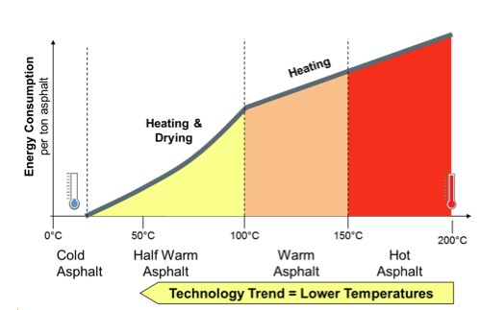
Fig 1.1 Asphalt classification by production temperature

Better field compaction results from WMA's capacity to be more workable at lower temperatures. Lower mixing and compaction temperatures lead to reduced fuel usage as well as lower emissions of carbon dioxide and other pollutants, which lowers health risks for people and demonstrates greater stewardship of the environment. For every 12°C drop in temperature, the amount of smoke released is reduced by almost 50%. Chemical and organic additives such as Revix, Evotherm, ZycoTherm, and others have been developed recently and can be used to create WMA. The sustainability advantages may be improved and enhanced through RAP in WMA.

WARM MIX ASPHALT
One of the biggest issues with the durability of asphalt pavements is the distresses on the surface caused by moisture degradation. The performance of pavements must be enhanced to prevent early failure caused by a weak link between the aggregate and asphalt. By adding organic or chemical additives and creating asphalt-aggregate mixes at lower mixing and compaction temperatures, WMA primarily aims to reduce viscosity. The most often used methods for creating WMA include foaming processes, chemical additions, and organic additives.

Techniques that employ particular organic additives, such as organic waxes or fatty amides with melting points just a little bit higher than the temperatures at which they are used. There has been a 20–30 C temperature drop as a result of these organic additions.
foaming procedures: These techniques employ water to reduce the viscosity of the binder. This is accomplished by turning water into steam, which raises the volume of the binder and lowers its viscosity. Water then evaporation occurs.
Chemical Additives: These methods make use of certain chemical additives that function as surfactants and lessen the pressures that cause the aggregate and binder to rub against one another. There has been a 20–30 C temperature drop as a result of these chemical compounds.

Table 1.1 Chemical additives for WMA
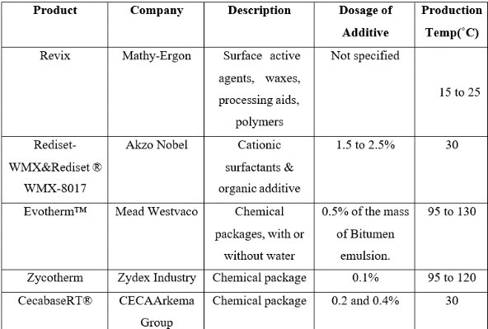

A new generation anti-stripping chemical called ZycoTherm combines with the remaining moisture on aggregate surfaces to improve bitumen saturation and coating. The bitumen and aggregate adhere better as a result of the permanent chemical link it establishes with the aggregate. The adhesive property does not deteriorate over time because of how permanently the connection is created. In comparison to hot mix asphalt, ZycoTherm functions as an ingredient that enables the mixing, laying down, and compaction of asphalt mixtures at substantially lower temperatures. The discussion of pavement kinds, layers, and their purposes is followed by a brief review of warm mix design.


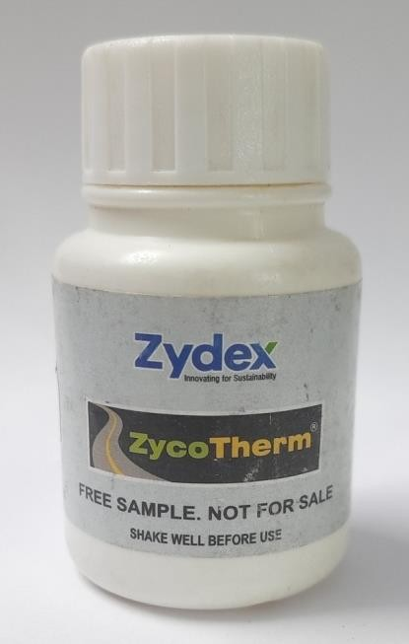

Fig 1.2 ZycoTherm

The WMA additive ZycoTherm was developed by Zydex Industries in Gujarat, India. It is a chemical warm mix additive that is odorless and has been developed to greatly outperform current WMA technologies by allowing for lower production and compaction temperatures while also acting as an anti-strip to increase pavement moisture resistance. ZycoTherm-modified mixes can be made at 120°C to 135°C for production, and they can be compacted at 90°C to 120°C. Overall, ZycoTherm provides temperature decreases based on the mix's characteristics. ZycoTherm features an integrated anti-strip mechanism that enables it to serve as both an anti-strip and addition for heated mixes.

RECLAIMED ASPHALT PAVEMENT
The procedure of incorporating recycled asphalt materials into fresh asphalt mixtures is such that they perform similarly to how they did in their initial use. Recycling lowers project costs while also preserving the environment, reducing pollution and the need to dispose of debris. Reclaimed asphalt pavement is made by recycling old or damaged asphalt pavements and reusing the aggregates and recovered bitumen (RAP).

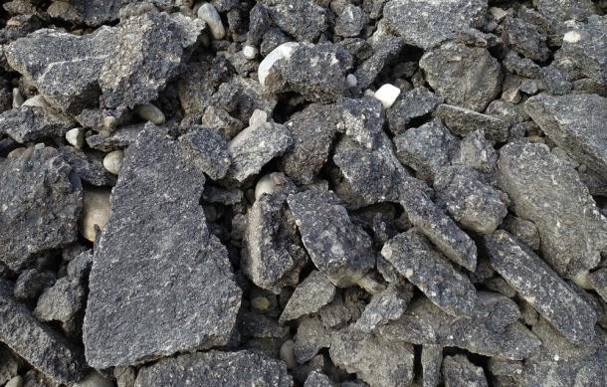

Fig 1.3 RAP material

BENEFITS OF RECYCLING PAVEMENTS

Some of the advantages associated with pavement recycling are:
Lowers the need for costly virgin materials.
Better for the environment.
Minimization of waste disposal/landfills.
Can be recycled multiple times ensuring its value.
Reduced project time.
Improved stiffness.
Conservation of energy.
Increased resistance to rutting.

RECYCLING METHODS

The bituminous mix recycling may be essentially divided into two categories: in-situ recycling and central plant recycling. The procedure is referred to as central plant recycling if the RAP is transformed at a facility that is not a construction site. RAP is transformed in-situ during recycling processes, depending on where it is accessible. To condition the RAP, it might also be heated. Hot mix recycling is the term for the procedure when heat is used. Without the use of heat, recycled materials are processed using a recycling agent (such as a low viscosity emulsion). Figure 1.4 provides a schematic representation of the categorization system.

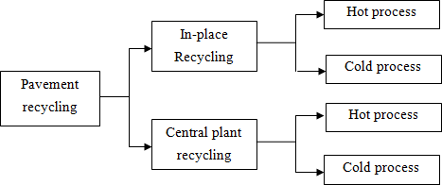

Fig 1.4 Classification of recycling methods

Hot Mix Recycling: RAP is combined with virgin aggregates, bitumen, or a recycling agent to create HMA. The mix is then brought to the location, placed, and compacted.
Hot In-Place Recycling: It is a technique used on-site to restore degraded pavements using the least amount of new materials. To remedy the surface distress, the existing asphalt surface is preheated, milled, and then cut into smaller pieces, material is blended with new aggregates and binder, and then it is laid and compacted.

Cold In-Place Recycling: This method of restoration involves utilizing the components of the current pavement without applying heat. The milled RAP material is combined with aggregate or a recycling agent to create a mix that is then spread out and compacted on the site.

Cold Milling: To collect materials for hot mix recycling, this is done. To achieve a particular slope, grade, and pavement surface devoid of ruts and bumps, specialist equipment with tungsten carbide teeth is needed.

RURAL ROADS
Village roads or rural roads are those that connect local villages or other district roads (ODR). They are built with the aid of local labor and resources. By their by, rural roads are ones with less traffic. As a result, they are often less paved and less broad than highways. In India, there are three types of surfaces that are frequently used for rural roads:
Earth surface.
Compacted gravel surface.
    - Water-bound macadam surface.
Water-bound macadam with bituminous surface
Water-bound macadam with concrete on the surface.
Low volume country roads are split into the following categories for pavement structural design in (IRC: SP72-2007) 1.4.1:
Gravel/Aggregate-surfaced roads (Unpaved Roads)
Flexible Pavements (Paved Roads), and
Rigid Pavements.

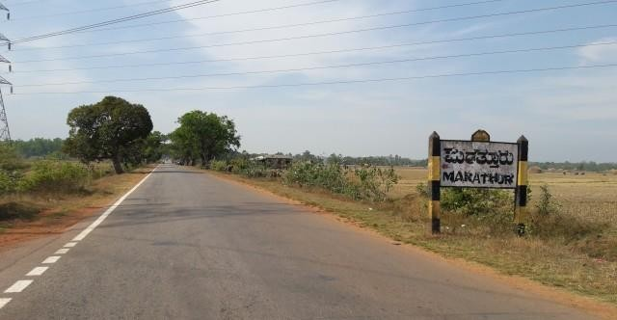

Fig 1.5 Village Road (oorukere, tumkur District)

TYPES OF RURAL ROADS

Types of rural roads constructed under MORD (Ministry of Rural Development) may be differentiated by

Terrain conditions
Surface conditions
About two terrain types there are mainly two conditions to be considered:
Flat areas/Plain area
Hilly areas

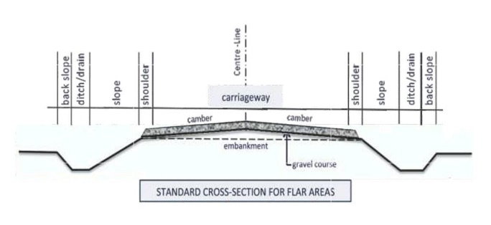

Fig 1.6 Typical features of roads in flat areas


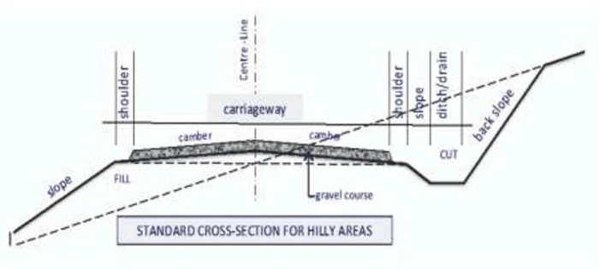

Fig 1.7 Typical features for roads in hilly areas

STANDARD MEASUREMENTS AND DIMENSIONS

According to the following schematic illustration, rural roads in India are typically measured and scaled as follows:

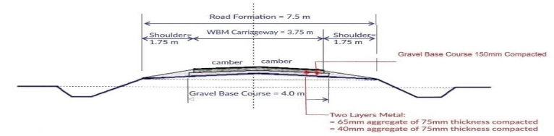

Fig 1.8 Typical measurements for rural roads with WBM pavement, Single lane

NEED FOR THE STUDY
There aren't many resources accessible for building highways, and stone aggregates are one of them. In India, the yearly use of stone aggregates for roads is 175 million cubic meters. Stone quarries should not be overused as a sustainable solution. It would be wise to investigate solutions like soil stabilization for the preservation of soil resources and the use of recycled asphalt products for the preservation of natural aggregates.

High mixing temperatures produce emissions from plants, and high compacting temperatures produce fumes at the paving site, both of which hurt the environment. Attempts are undertaken to reduce the mixing and compacting temperatures without sacrificing the quality of the mixes to avoid these impacts. This paper aims to provide a thorough overview of one such technique, warm mix asphalt technology; recycling has to be used immediately due to its significant benefits over overlaying. It has the potential to reduce greenhouse gas emissions, make building more cost-effective because less fuel is used, and make construction safer for construction workers' health. The WMA criteria were adopted in India under IRC: SP: 101-2014, however, due to a lack of performance evaluation, their use in real road building is limited. Therefore, it is important toinvestigate the effectiveness of WMA technology in the lab and to comprehend the results of employing RAP as a partial aggregate replacement in WMA.

Rural roads are crucial for reducing poverty in rural regions, facilitating the movement of people, materials, and products, promoting agricultural diversification, and enhancing both rural and national economic growth. Rural roads are therefore essential to the development of the nation. In India, where 800 million people still reside in rural regions, the government's numerous programs primarily attempt to improve connectivity by building all-weather roads. Rural roads are a crucial part of rural development in India.

OBJECTIVES
The main objective of the study is to find out the suitability of Reclaimed asphalt pavement (RAP) materials to be used in village roads as well as the construction of flexible pavements.

To optimize and characterize the RAP for Warm Mix Asphalt along with Zycotherm as additive.
Evaluation of the mechanical properties of bituminous mix with various proportions of the RAP.

METHODOLOGY

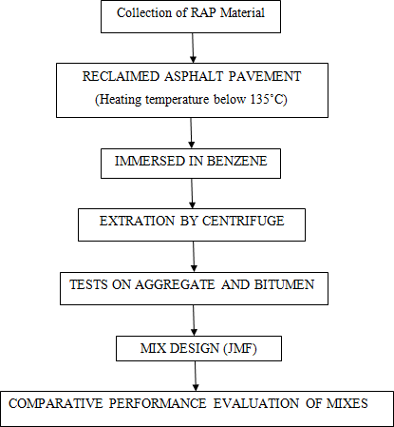


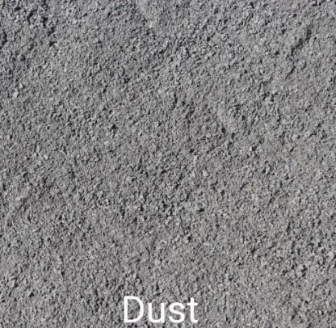

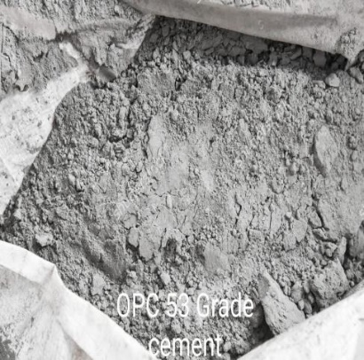

Fig 3.1 Methodology Flowchart

GENERAL

First, samples were prepared using ordinary bitumen of VG10 viscosity grade. Table 4.5 lists the bitumen's fundamental test findings. It was decided to use aggregates with good strength, hardness, toughness, and soundness. The grain size distribution of the aggregates has a significant impact on the characteristics of the bituminous mix. The findings of the tests performed to evaluate the physical characteristics of virgin aggregates are listed in Tables 4.1, 4.2, 4.3, and 4.4. The bitumen content (4.5 percent, 5 percent, 5.5 percent, and 6 percent) and the proportions of the coarse, fine, and filler aggregates were combined according to the JMF to create 12 moulds, which were then tested for Marshall Parameters to determine the OBC for WMA.

Second, a similar process was used to replace some of the virgin aggregates (90
%, 80 %, and 70 %) with RAP material (10 %, 20 %, and 30 % ). The aggregates were heated to 130 °C for warm mix, mixed with bitumen (5.2%) and ZycoTherm (0.1%), valuated for Marshall Parameters, and compared. This is covered in the next chapter.

MATERIAL PROCUREMENT

AGGREGATES

To ascertain the physical characteristics of virgin aggregates, aggregates were obtained from a crusher site close to Uttarahalli, Bangalore, and the fundamental tests on aggregates were carried out in the laboratory following the prescribed test methodologies. 12mm (Downsize), 6mm (Downsize), quarry dust, and cement (OPC 53 Grade) were utilized as aggregates.

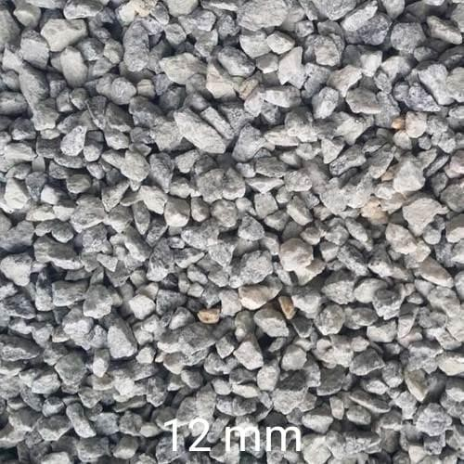

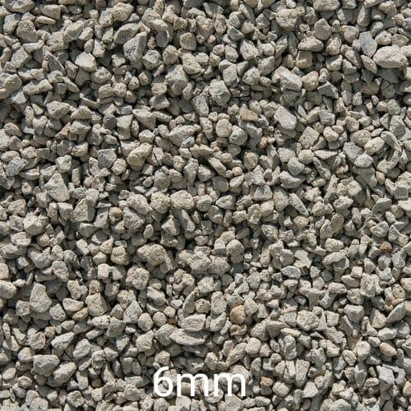

Fig 3.2 Aggregates and Filler material

BINDER
For the investigation, virgin bituminous mixes and RAP mixes, respectively, were presumed to include bitumen of (60/70 Penetration Grade). Its fundamental qualities were evaluated for their suitability in BC Grade - I following IS 73-2013 requirements.

RAP MATERIAL

RAP materials were collected from oorukere for the investigations. In the lab, the recovered bitumen's content, characteristics, and RAP gradation were established.

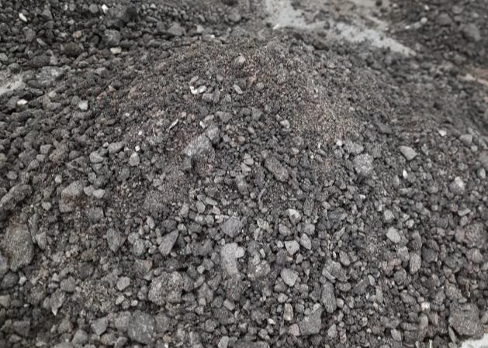

Fig 3.3 RAP Material

ZYCOTHERM


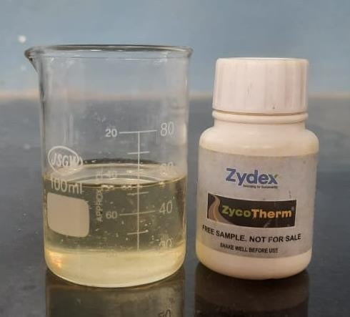
ZYDEX Industries has developed a new generation of warm mix asphalt additive called ZycoTherm. It permits WMA mixing and compaction at temperatures up to 36°C lower than conventional hot mix asphalt.

Fig 3.4 ZycoTherm

PROPERTIES OF ZYCOTHERM

It creates good bonding between aggregate and bitumen or acts as anti stripping agent.

It decreases the mixing temperature and compaction temperature for bituminous mix.

MIXING ZYCOTHERM WITH BITUMEN

The procedure for mixing ZT with bitumen in the laboratory consists of five stages
Quality Check
Apparatus
Mixing of ZT with Bitumen Binder
Determination of ZT dosage for Anti-strip performance
Mixing of Bituminous mixes

QUALITY CHECK

      - Fresh bottles were used for the ZT sample, and previously opened bottles that had been exposed to moisture were avoided.
      - A clear, turbid-free sample produced by diluting 1 ml of ZT with 10 ml of distilled water was used in the experiment to guarantee correct mixing.
      - A fresh sample was collected from an unopened container in place of the solution that was yellowish or turbid after diluting from exposure to ambient moisture.
      - ZT was kept in a dry, shaded environment free from rain, sparks, sunshine, and heat, where it was kept between 4°C and 40°C.
      - ZycoTherm's recommended shelf life was 48 months.

APPARATUS REQUIRED

      - For adding ZT dosage to molten bitumen, a dry graduated pipette containing 0.1 or 10 milliliters is used.
      - A stirrer can create a vortex in molten bitumen that is 2 to 3 cm deep.
      - An oven with a minimum temperature of 135°C for WMA and 165°C for HMA.
      - Containers, handling and mixing equipment, digital thermometer, etc.

MIXING OF ZYCOTHERM WITH BITUMEN BINDER
      - Before adding ZT to the molten bitumen at 150°C to 170°C, the stirrer speed was adjusted to a level high enough to induce the correct shearing in the molten bitumen and achieve a minimum of 1-2cm deep vortex.
      - The ZT's specific gravity was approximately 1.0. As a result, 1g is equal to 1 ml of ZT.
      - ZT was injected drop by drop into the molten bitumen close to the vortex to guarantee good mixing. Ten minutes were spent stirring to properly combine the ZT.


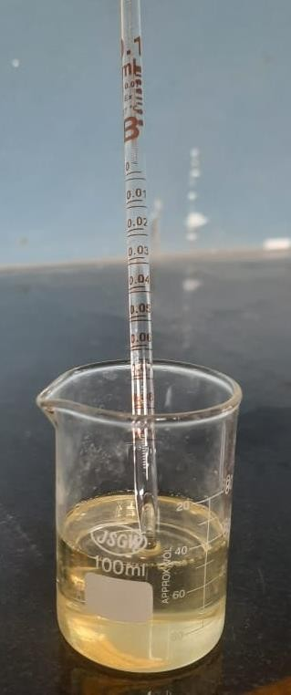

Fig 3.5 Pipetting of 0.06 ml of ZycoTherm

MARSHALL MIX DESIGN
The main objective of the mix design is to produce a bituminous mix by proper proportioning of various components to have –Sufficient bitumen to ensure a durable pavement.
Sufficient strength to resist shear deformation under traffic at a higher temperature.Sufficient air voids in the compacted bitumen to allow for additional compaction by traffic.
Sufficient workability to permit easy placement without segregation.
Sufficient flexibility to avoid premature cracking due to repeated loading by traffic. The bituminous mix for BC-II was designed by the Marshall Method of mix design based on ASTM D 1559-96.

TEST PROCEDURE FOR PREPARING MARSHALL SPECIMENS FOR BC-1
The aggregates were proportioned and mixed as per JMF. The aggregates were heated to a temperature of 125-135°C for a warm mix and the bitumen up to 130°C, also an attempt was made to compare the marshal properties when aggregates (RAP+ virgin) is at 130°C and ZycoTherm Modified Bitumen (ZMB) is also at 130°C which has given a positive results.

Required quantity of bitumen percentages in increments of 0.5%i.e., 4.5%, 5%, 5%, and 6% by total weight of aggregate (1100g) was heated and thoroughly mixed with heated bitumen at a desired mixing temperature of 130°C for the warm mix.

The mix was placed in a pre-heated Marshall mould of 101.6mm diameter and 63.5mmheight with a base plate and collar.

after leveling the top surface, the mix was compacted using a rammer of 4.54kg weight with 457mm height of fall with 75 blows on each face.

Three specimens each were prepared for each bitumen content trial.
The compacted specimens were kept overnight to allow the temperature to fall, later the specimen was extracted using a specimen extractor.
The mean height and weight in air and water were noted for the calculation of bulk density.
The specimens were kept in a thermostatically controlled water bath maintained at 60°Cfor 30-40 minutes
Then the specimens were taken out and placed in Marshall Head and tested to determine the Marshall Stability value, which is the maximum load taken by the specimen before failure, and the flow value, which is the deformation of the specimen in mm at the maximum load. The flow meter used was calibrated with a strain rate of 50mm/minute.
For the determination of OBC, graphs were plotted with bitumen content on the X-axis and following values on the Y-axis.
Marshall Stability
Flow Value
Bulk Density/Unit weight, Gb
Percent of Air Voids in total mix, Vv
Percent Voids filled with bitumen, VFB

The OBC for the mix design was found by taking the average value of the following bitumen contents from the results obtained from the graphs.
Bitumen Content concerning Maximum Stability.Bitumen Content concerning Maximum unit weight.
Bitumen Content concerning 4% Air Voids in the total mix.
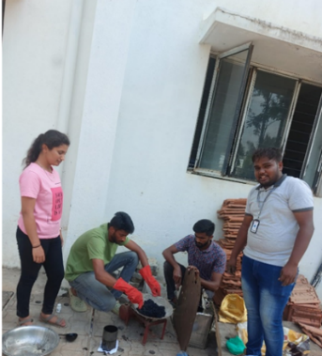
Fig 3.14 Heating of Aggregates
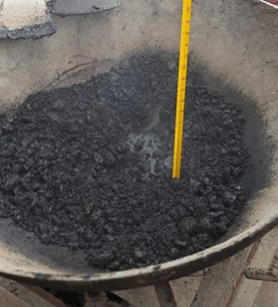

Fig 3.15 Marshall Mix preparation
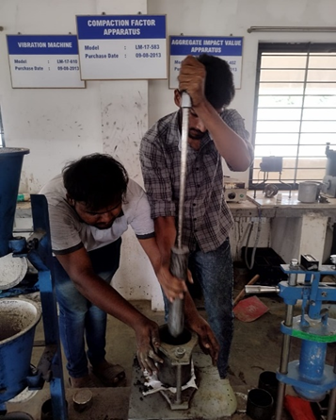
Fig 3.16 Placing the mix & compacting
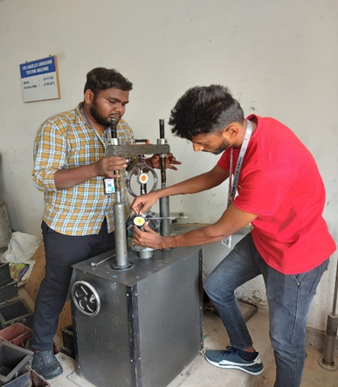

Fig 3.17 Testing of specimen
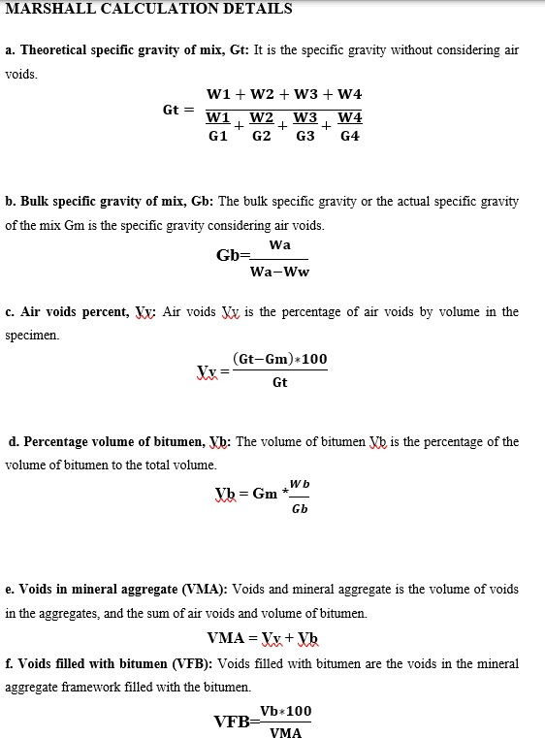

RESULTS AND DISCUSSIONS

EVALUATION OF VIRGIN AGGREGATES AND BITUMEN IN WMA

The physical properties of the virgin aggregates and bitumen were evaluated by various texts.

12MM (DOWNSIZE) AGGREGATES

Table 4.1 Physical Properties of 12mm (Down Size) Aggregates.

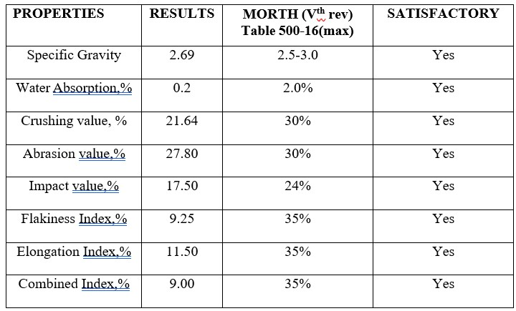

The results obtained after conducting the above-mentioned tests are satisfactory as per MORTH specifications.

6 MM (DOWN SIZE) AGGREGATES

Physical Properties of 6mm (Down Size) Aggregates

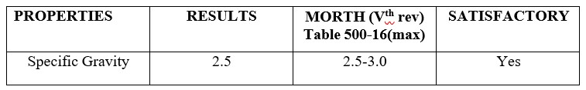
The specific gravity obtained from the above test is used in calculations of the Marshall Stability Test

STONE DUST
Physical Properties of stone Dust Aggregates
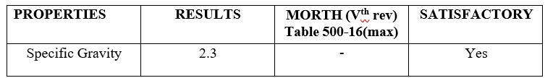
The specific gravity obtained from the above test is used in calculations of the Marshall Stability Test.

CEMENT
The test carried out on OPC 53 Grade cement was a specific gravity test.
Physical Properties of Cement
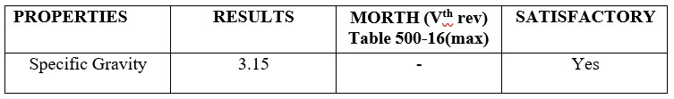
The specific gravity obtained from the above test is used in calculations of the Marshall Stability Test.

BITUMEN
The physical properties of the bitumen were evaluated by various tests. The tests carried out on bitumen are penetration test, ductility test, viscosity test, and softening point test.
Physical Properties of Virgin Bitumen
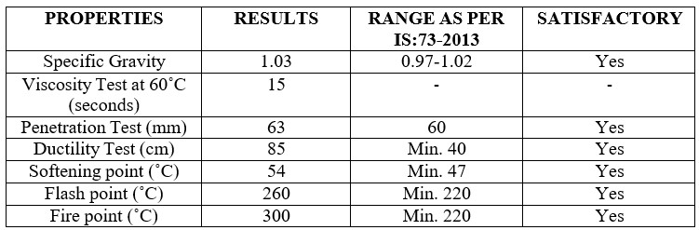
The results obtained after conducting the above-mentioned tests are satisfactory as per MoRT&H specifications.

BLENDING OF VIRGIN AGGREGATES FOR BC-I MIX
Sieve Analysis of various aggregates (12mm down size, 6mm down size, stone dust, and cement as filler) is carried out according to MORT&H specifications. Blending of Virgin Aggregates for Bituminous Concrete Grade-1
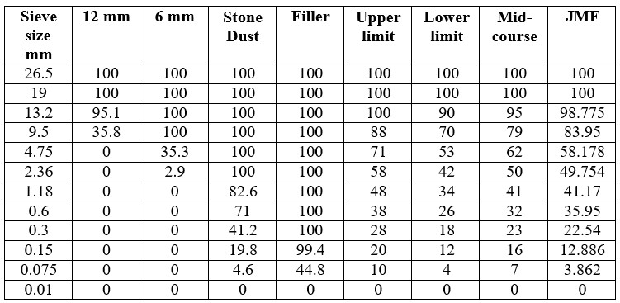
JMF is obtained by the hit and trial method by changing the proportions of the different constituents. JMF obtained in Table 4.6= (12 mm *0.25) + (6 mm *0.26) + (Stone Dust *0.45)+ (Filler * 0.04)

Blending chart of aggregates for bituminous concrete grade 1

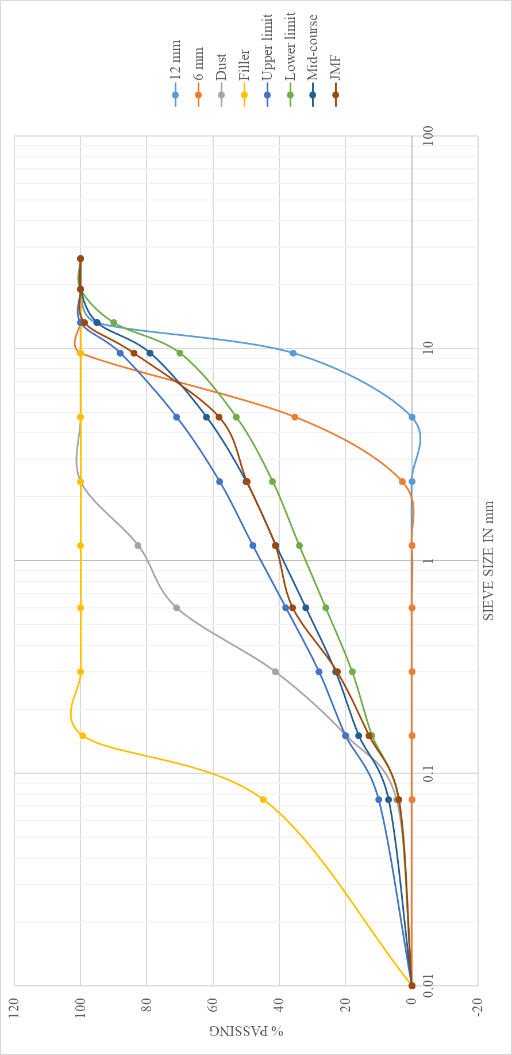

MIXING BITUMEN WITH ZYCOTHERM

ZycoTherm is added to bitumen at 0.1% of the binder weight to produce ZMB (ZycoTherm Modified Bitumen)

Weight of ZT to be added to Virgin Mix

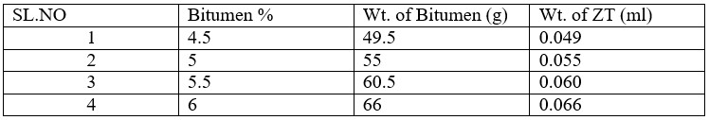

MARSHALL MIX DESIGN FOR VIRGIN AGGREGATES

Marshall Properties of WMA Mix at 130°C of 0.1% ZT Dosage (for virgin aggregate) 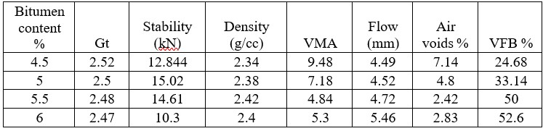

RAPHS SHOWING RELATION BETWEEN MARSHALL PROPERTIES V/S BITUMEN CONTENT OF WMA MIX AT 130°C OF 0.1% ZT DOSAGE (FOR VIRGIN AGGREGATE)

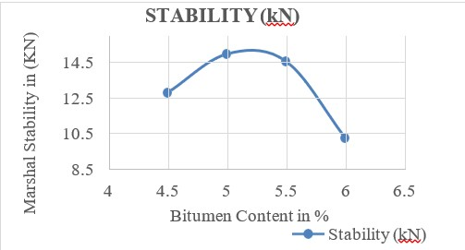 Graph between Bitumen content (%) v/s Marshall Stability (kN)

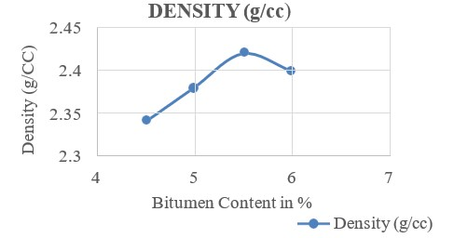 Graph between Bitumen content (%) v/s Density (gm/cc)

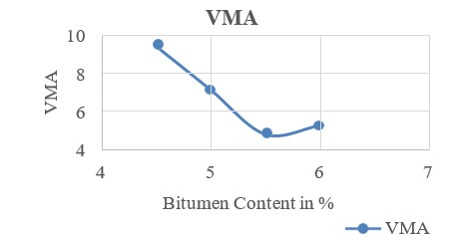

Graph between Bitumen content (%) v/s VMA

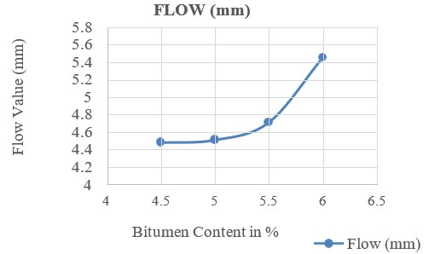

Graph between Bitumen content (%) v/s Flow (mm)

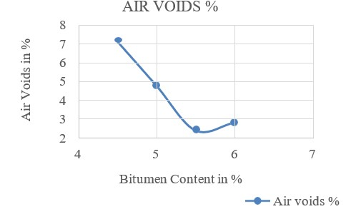

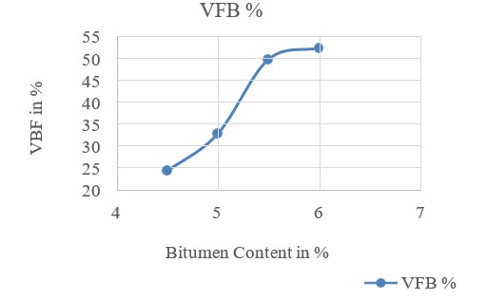
Graph between Bitumen content (%) v/s Air voids (%)

Graph between Bitumen content (%) v/s VFB (%)

RESULT

Bitumen content corresponding to maximum stability (B1) = 5%

Bitumen content corresponding to maximum density (B2) = 5.5%

Bitumen content corresponding to a value of 4% air voids (B3) = 5.15%

OBC = (B1+B2+B3)/3 = 5.2%

Mix design requirements as per MORT&H specification

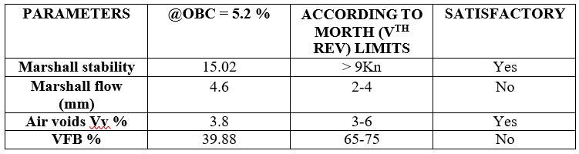

EVALUATION OF RAP MATERIAL

The RAP material is subjected to various tests the determination of its various characteristics such as binder content and specific gravity.

DETERMINATION OF BINDER CONTENT

The determination of binder content is necessary as it would affect the bitumen content during the preparation of moulds for the Marshall Stability test using RAP materials.

Bitumen Extraction by Centrifuge Extraction Test to determine the percentage of bitumen content present in the asphaltic pavement.

Determination of binder content in RAP material.

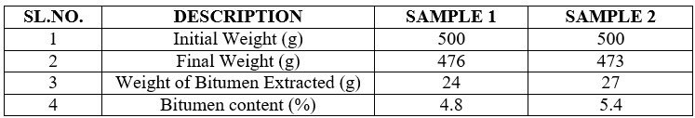Average binder content = 5.1%

SPECIFIC GRAVITY OF RAP MATERIA

The specific gravity of RAP material = 2.56

The specific gravity of RAP material is used in calculations of the Marshall Stability test.

MIX DESIGN

The JMF was obtained from the sieve analysis data, and based on that JMF the aggregates (RAP material 10%, 20% & 30% +virgin aggregates 90%, 80% & 70%) respectively. The binder material present in RAP is also taken into consideration, and hence the ZMB added to the Marshall mix is reduced as the RAP percentage is increased to maintain the OBC for mix. Marshall Mix Design of WMA Mix at 130˚C of 0.1% ZT Dosage (for virgin aggregate and RAP material)

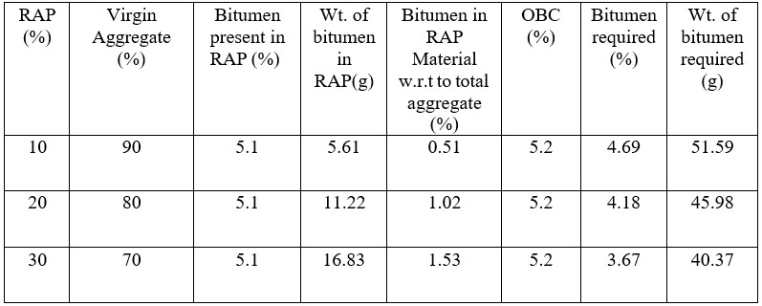

Weight of ZT to be added to Virgin + RAP Mix

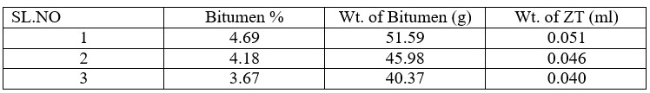

MARSHALL STABILITY TEST (RAP MATERIAL + VIRGIN AGGREGATES)

Marshall Properties of WMA Mix at 130 C of 0.1% ZT Dosage (for virgin aggregate and RAP material)

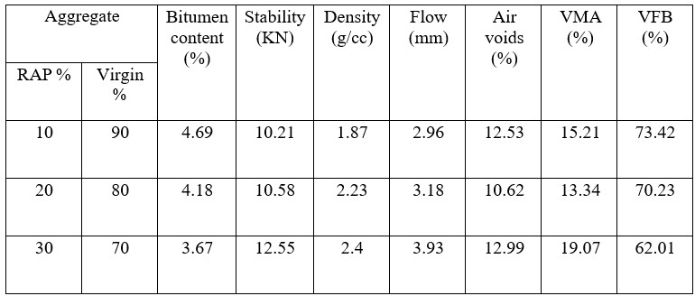

GRAPHS SHOWING RELATION BETWEEN MARSHALL PROPERTIES V/S BITUMEN CONTENT OF WMA MIX AT 130°C OF 0.1% ZT DOSAGE (FOR RAP + VIRGIN AGGREGATE)

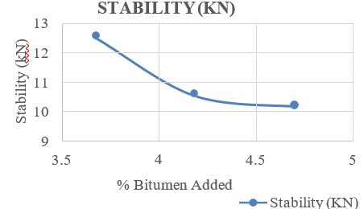

Graph between Bitumen content (%) v/s Marshall Stability

(kN)

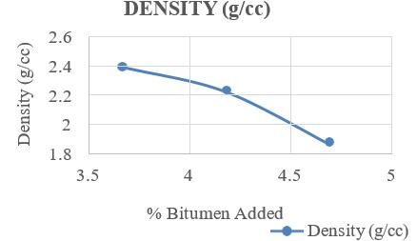

Graph between Bitumen content (%) v/s Density (gm/cc)

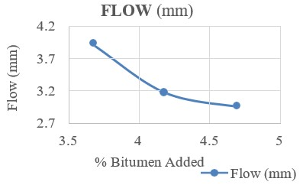

Graph between Bitumen content (%) v/s Flow (mm)

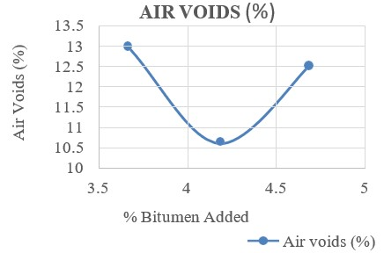

Graph between Bitumen content (%) v/s Air Voids (%)
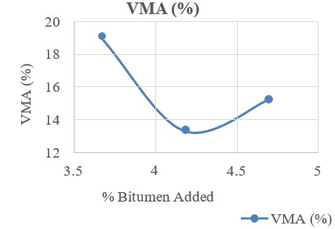

Graph between Bitumen content (%) v/s VMA(%)

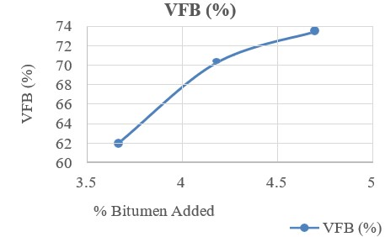

Graph between Bitumen content (%) v/s VFB (%)

RAPHS SHOWING MARSHALL STABILITY AT DIFFERENT PERCENTAGES OF BITUMEN CONTENT FOR BOTH VIRGIN MIX WMA AND VIRGIN + RAP MIX WMA AT 130° C WITH 0.1% ZT DOSAGE

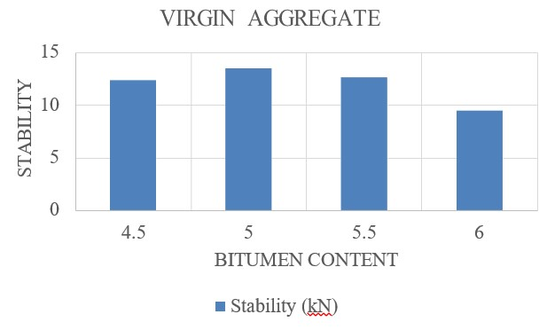

Graph between Bitumen content (%) v/s Stability (KN) for Virgin Aggregates

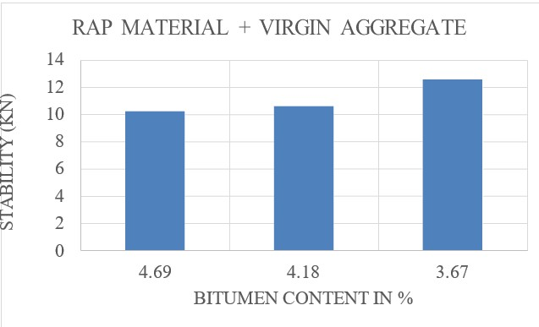

Graph between Bitumen content (%) v/s Stability (KN) for RAP+ Virgin Aggregate

CONCLUSION

1. Based on the JMF, aggregates were proportioned and mixed with ZMB (4.5%, 5%, 5.5%, and 6% by weight) to evaluate the Marshall parameters and the highest stability value was found to be 15.02 for 5% ZMB.

2. OBC of virgin WMA was found to be 5.2% at 130˚C.

3. Tests were conducted on bituminous mixes with virgin aggregate and RAP of 10%,20%, and 30% to evaluate the laboratory performance of the bituminous mix.

4. The Marshall stability at 5% was to be 15.02 KN for 30-70 partial portion stability is

12.55 KN, and for 20-80 it is 10.58 KN and for 10-90, it is found to be 10.21 KN.

5. In this present project work, it can be concluded that more than 10% and less than 30% of RAP can be suitably adopted in making the village roads with the RAP.

6. Using RAP material in the construction of flexible payment reduces the construction cost.

7. Village roads are usually light traffic roads, so it carries low loads compared to other types of road. While its construction RAP materials can be used with virgin materials, they can resist the loads applied on roads.

SCOPE FOR FUTURE STUDY

1. Further investigation can be carried out for more than 40% of RAP materials concerning reducing virgin aggregates and their Marshall properties.

2. ITS behavior can be evaluated.

3. Performance-based on different temperatures and the addition of other additives.

4. Tests on increased % of ZychoTherm by the weight of the binder.

5. Dynamic loading and rutting tests to provide accurate results.

REFERENCES

[1] A. K. Yadava, & Ahmad, S. A. (2019). A critical review of characterization and performance evaluation of reclaimed asphalt pavement (RAP) in road construction. Int J Civ Eng Tech, 10(1), 1379-1389.

[2] Bhanuprasad, K., Raju, S., Sarkar, A. K., Singh, S. K., & Ravindranath, S. (2019, August). Performance of reclaimed asphalt pavement (RAP) material in asphalt mixtures. In AAPA International flexible pavements conference.

[3] Dao, D. V., Nguyen, N. L., Nguyen, M. H., Ly, H. B., & Truong, V. Q. (2022). Evaluation of cracking resistance of warm mix asphalt incorporating high reclaimed asphalt pavement content. Proceedings of the Institution of Mechanical Engineers, Part L: Journal of Materials: Design and Applications, 14644207221100036.

[4] Bhat, F. S., & Mir, M. S. (2022). Study Investigating the Influence of Warm-Mix Asphalt Additives on Rutting and Fatigue Performance of Nano-Modified Asphalt Binders. Transportation Research Record, 2676(4), 719-731.

[5] Khodary, F. THE EFFECTS OF ADDING RECLAIMED ASPHALT PAVEMENT (RAP) AND CEMENT ON THE PROPERTIES OF PAVEMENT BASE COURSE.

[6] Kumar, G. S., & Suresha, S. N. (2018). State of the art review on mix design and mechanical properties of warm mix asphalt, Road Mater. Pavement Des.

[7] Sharanappanavar, M. S. (2016). Study on behavior of warm mix asphalt using zycotherm. Int J Sci Res IJSR, 5, 851-855.

[8] Mir, M. S., Rathore, R., & Singla, D. (2021). A Study on Laboratory Evaluation of Warm Mix Asphalt Incorporated With Reclaimed Asphalt Pavement. International Journal of Innovative Research in Engineering & Management (IJIREM) ISSN, 2350- 0557.

[9] Kumar, R., & Chandra, S. (2016). Warm mix asphalt investigation on public roads-a review. Civil Eng Urban Plan Int J (CiVEJ), 3(2), 75-86.

[10] Varuna M, Bhavani Prasad G, Anjaneyappa Venkateshappa, Amarnath Macheri Srinivasarao, 2021, Studies on Performance Characteristics of Warm Recycled Asphalt Mixes, INTERNATIONAL JOURNAL OF ENGINEERING RESEARCH & TECHNOLOGY (IJERT) Volume 10, Issue 12 (December 2021),

[11] Aravind K and Animesh Das “Bituminous Pavement Recycling”

[12] Ministry of Road Transport and highways (MoRT&H), “Specification for Roads and Bridge Work, Government of India, IRC, 5th revision, New Delhi, India, 2014”.

[13] Zydex Industries, "Laboratory Test Protocol - ZycoTherm - Mixing protocol (Zydex 2012)".

[14] Mix Design Methods for Asphalt Concrete and Other Hot-Mix Types, Asphalt Institute Manual Series No. 2 (MS-2) Sixth Edition.

[15] Indian Standards, "Tests on Aggregates", IS: 2386-1986, Indian Road Congress, New Delhi.

[16] Indian Standards, "Paving Bitumen-Specification, (Fourth Revision)", IS 73: 2013, Indian Road Congress, New Delhi.

[17] Indian Standards. "Methods for Testing Tar and Bituminous Materials", IS: 1201 to 1220 (1978), Indian Road Congress, New Delhi.

[18] IRC, "Interim guidelines For Warm Mix Asphalt", SP: 101-2014, Indian Road Congress, ASTM, "Evaluation of Variability in Resilient Modulus Test Results", D 4123, American Society of Testing and Materials.

[19] S K Khanna, C E G Justo and Veeraragavan, "Highway Material Testing Laboratory Manual", Nemchand and Brothers, Roorkee, 2010.

[20] Guidelines For The Design Of Flexible Pavements For Low Volume Rural Roads IRC:SP;72-2007

