Effect of Influencer Marketing on Purchase Intention a systematic review and Meta-Analysis

A Project Report submitted to
Indian Institute of Information Technology, Allahabad In the partial fulfillment for the

Degree of Master of Business Administration

Under the Supervision of

Dr. Saurabh Mishra

By

Mr. Vishesh Pandey

IMB2021047

[May-2023]



INDIAN INSTITUTE OF INFORMATION TECHNOLOGY, ALLAHABAD
Deoghat, Jhalwa, Allahabad, U.P., India 211012


भारतीय सचना प्रौद्योगिकी संस्थान,इलाहाबाद
Indian Institute of Information Technology, Allahabad
An Institute of National Importance by Act of Parliament Deoghat, Jhalwa, Prayagraj- 211015 (U.P) India
Ph No: 0532-2922025, Fax:0532-2922125, Web:www.iiita.ac.in, E.mail: contact@iiita.ac.in

STUDENT'S DECLARATION

I hereby declare that the Fourth Semester Master Project prepared by Vishesh Pandey titled “Determinants of green purchase intention a systematic review and meta-analysis” is an original piece of work done by me under the supervision of Dr. Saurabh Mishra.
This is a purely fresh work which is done by me and there is no competitive work available in academic domain/providers of items or services of proprietary domain.

I have taken certain information relevant to our study from various journals and books which we have listed in the References section.

I have used certain documents for our reference.

I declare that the submitted work has not been undertaken elsewhere and is free from plagiarism as per the www.plagiarismdetect.com/Turnitin/.Website report.

Place: Prayagraj Mr. Vishesh Pandey
Date: 27/04/2023

CERTIFICATE
Recommended in partial fulfillment of the requirement for the award of Degree of Master of Business Administration (MBA).

Dr. Saurabh Mishra

भारतीय सचना प्रौद्योगिकी संस्थान,इलाहाबाद
Indian Institute of Information Technology, Allahabad
An Institute of National Importance by Act of Parliament
Deoghat, Jhalwa, Prayagraj-211015 (U.P) India
Ph No: 0532-2922025, Fax:0532-2922125, Web:www.iiita.ac.in, E.mail: contact@iiita.ac.in

Checklist for MBA project reports of Six months Duration
- Name of Student(s) with Roll No. Mr. Vishesh Pandey (IMB2021047)

- Title of the Project:

Effect of influencer marketing on purchase intention a systematic review & meta-analysis
- List of Computer resources used in addition to general network connected PC hardware, Please mention below if any Software including operating systems(s), compilers(s) any 4GL(s), S/W tools, libraries were used duly mentioning their type (open source / Free and open source / shareware / proprietary or any other) with version number of the resource.

Windows 10
MS Office 2007
R-Studio
Scopus
Web of science
Comprehensive Meta-Analysis Software

- Category of the Project & your contribution claimed
  - Research Project
  - Study the Determinants of green purchase intention a systematic review and meta-analysis.

- Claims of the work done in light of competitive work & material already available in academic domain / products' / providers of items or services of proprietary domain.

Plagiarism Report

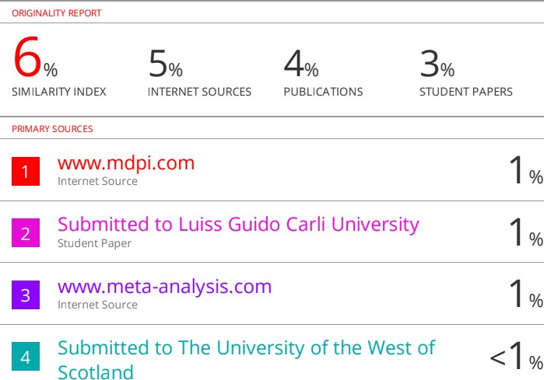

ACKNOWLEDGMENT

I would like to express my sincere gratitude to the following individuals and organizations who have contributed to the completion of this research project.
First and foremost, I would like to thank my research Guide Dr. Saurabh Mishra for his invaluable guidance, support, and encouragement throughout this project. Your insightful feedback and constructive criticism have been instrumental in shaping my research and helping me to reach my goals.
My heartfelt thanks also go to the participants who willingly gave their time and effort to participate in this study. Your cooperation and enthusiasm have been invaluable in providing the necessary data and insights to complete this research.
I am grateful to the Indian Institute of Information Technology for providing me access to their facilities and equipment, which were necessary for the completion of this research.
Finally, I would like to express my gratitude to my family and friends for their unwavering support and encouragement throughout this project. Your belief in me and my work has been a constant source of inspiration and motivation.
Thank you all for your contributions, support, and encouragement in making this research project a success.

Vishesh Pandey
IMB2021047

Table of Contents

- Introduction 8
- Research objective 9
- Literature review 10
- Prisma Model 12
- Research Model 13
- Methodology 14
- Result and Analysis 16
- Conclusion:
  - Conclusion 25
  - Discussion 25
  - Contribution to Theory 26
  - Limitations 26
  - Future scope of study 26
- References 27
- Appendix 29

ABSTRACT

This research aims at providing a meta-analysis of empirical findings of the literature on the impact of influencer marketing on purchase intention. Four factors of influencer marketing were derived like trust, brand attitude, consumer attitude & attractiveness. Results from random effects model showed significant effects of Trust towards influencer marketing on purchase intention (r= 0.541, [LI= 0.387-0.666], Z = 6.008), Consumer Attitude towards influencer marketing on purchase intention (r=0.622, [LI=0.435-0.758], Z= 5.434 Brand Attitude towards influencer marketing on purchase intention (r=0.402, [LI=0.303-0.491] ,Z=7.410), Attractiveness towards influencer marketing on purchase intention (r=0.506, [LI=0.350-0.645], Z=5.680). whereas the effect of Brand Attitude towards influencer marketing on purchase intention is having the lowest correlation value among all the variables and Consumer Attitude towards influencer marketing on purchase intention is having the highest correlation value among the following. Result of the study shows Consumer Attitude towards influencer marketing is going to have the highest impact on purchase intention. Only a small number of studies were accessible for meta-analysis since the study was only confined to Scopus and Web of Science, and several publications were also omitted because they lacked correlation tables. The use of qualitative articles was not relevant to our meta-analysis, hence this study was likewise restricted to quantitative studies. Managers may leverage those variables in their marketing plan to draw customers by concentrating on the influencer marketing aspects that have a significant impact on purchase intention. Marketers may influence consumers' buy intentions, which can impact their choice to make a purchase as well as their loyalty and commitment, by better knowing how to leverage influencer marketing variables. By using meta-analysis, we were able to reconcile earlier findings which enabled us to measure the strength of relationship between various factors (T, CA, BA & AT) on (PI) purchase intention.

Keywords: Influencer marketing, purchase intention, Consumer attitude, Brand attitude, Trust, Attractiveness & Meta-analysis

INTRODUCTION

A meta-analysis on the impact of influencer marketing on purchase intention is a study that compiles, synthesizes, and analyses existing research on the aspects of influencer marketing that influence a person's intention to buy a product. A meta-analysis is a statistical technique used to combine the findings of several researches on a single subject. Data from various studies that have looked into this relationship would be pooled for a meta-analysis of the effect of influencer marketing on purchase intention. The data would then be examined to determine the overall effect size and statistical significance of the effect of influencer marketing on purchase intention. A thorough examination of the most recent literature, including journals, conferences, and other sources, would normally be part of the meta-analysis The articles that satisfy the inclusion requirements were chosen for analysis after the literature has been assessed for quality and relevance.

According to müller, L. (2018), influencer marketing refers to businesses persuading individuals with a substantial social network of followers to promote and share their items and so drive purchase intentions. Purchase intention is the potential or readiness of a customer to make a future purchase of an item or service. Since it may indicate the degree of demand for an item or service and aid businesses in forecasting sales and profits, it is a crucial factor that influences consumer behavior. mattke, J., & maier, C. (2018). Perceptions about the influencer (Babi Rosario et al. 2016; Lafferty and Goldsmith 1999), perceptions about the advertisement (Evans et al. 2017; Wu and Chen 2016), and perceptions about the advertised product (Bosmans and Baumgartner 2005) have all been found to be relevant types of perceptions that affect customers' purchase intentions in the context of influencer marketing.

The meta-analysis would examine a number of influencer marketing factors, such as Trust, Consumer Attitude, Brand Attitude, and Attractiveness have been demonstrated to influence Consumer Intentions to Purchase.

- Trust - Almost all business and social transactions where there is room for uncertainty require some level of trust; most of these exchanges take place in a virtual online environment (Pavlou, 2003). When it comes to relationships with social media influencers, Morgan and Hunt (1994) theorised that trust "exists when one party has confidence in the exchange partner's reliability and integrity."

- Consumer attitude - A good marketing strategy requires understanding customer attitudes, which marketing scholars have expressed interest in (Solomon et al. 2010). “Consumer researches have shown a comparable association between attitude and purchase intention (Ting and de Run 2015; Tarkiainen and Sundqvist 2005). In relation to this, Chen (2007) claimed that customers' purchase intentions may be significantly predicted by their positive

attitudes towards a certain product. Similar to this, a positive attitude towards a product supported by social media influencers can increase the likelihood that the consumer will make a purchase”.

- Brand attitude – “According to Shimp (2010), attitude towards a brand is a predictor of customer behaviour towards that brand and depends on the consumer's individual opinions of that brand. As a result, a "individual's internal evaluation of the brand," according to Mitchell and Olson (1981, p. 318), is defined as attitude towards the brand. In addition, "attitude towards the brand is a relatively enduring, one-dimensional summary evaluation of the brand that presumably energizes behaviour" (Spears & Singh, 2004, p. 55). In other words, brand attitude refers to a consumer's evaluation and/or response to a brand following exposure (Phelps & Hoy, 1996; Wilkie, 1986)”.

- Attractiveness - "Attractiveness is nothing more than a stereotype of positive connotations attached to a person," suggests Erdogan (1999), "and it extends beyond physically attractive attributes to encompass traits like personality and athleticism." Extremely beautiful influencers might affect their followers' intentions to make purchases of products or services, claim Van der Waldt et al. in 2009. Wang and Scheinbaum (2018) agreed and emphasized the importance of appeal in the spread of important messages. SMIs with desirable physical attributes are more likely to attract and keep their followers' interest”.

OBJECTIVES

- To identify and analyse the previous literature on impact of influencer marketing on purchase intention for facilitating a meta-analysis review.
- To identify variables from the existing literature and define the various determinants of influencer marketing affecting purchase intention.
- To test and validate the relationship between the identified variables of influencer marketing with that of purchase intention.

Literature Review & Hypothesis Development

Influencer Marketing
It is a strategy for marketing communications in which brands pay social media and online celebrities to promote the brand's content to all of the influencer's subscribers and target consumers in an effort to raise consumer brand awareness (Agrawal et al., 2016). Companies one of the most important communication technique is influencer marketing, which involves promoting items through well-known figures in online culture. “As a result of technical advancement and digitization, influencer endorsement in product marketing and brand communication has lately expanded”. Mammadli, G. (2000). This type of marketing has been touted as a significant and powerful tool for influencing brand perception and customer purchase intent. Moreira, J. F. D.
S. (2021). Influencer marketing has prompted necessary adjustments. Influencer marketing has altered the creation and use of marketing strategies and made important changes to a number of sectors (Levin, 2019).

Influencer marketing’ factors
Trust
Potential customers anticipate dependable behaviour from suppliers, such as providing things quickly and maintaining their promises, in order to eliminate uncertainty related to e-transactions as a whole . As per Morgan & Hunt (1994), trustability is the "confidence in an exchange partner's reliability and integrity". “Partners can build trust by keeping their promises (Grönroos, 1990)”. “Trust is viewed as a relational quality that develops over time via repeated contacts. In a similar vein, confidence in the influencer gives followers peace of mind that their interactions with the influencer will be beneficial”. We therefore suggest the following hypothesis:
H1: Trust on influencer marketing impacts consumer’s purchase intention.

Consumer Attitude
According to Escalas and Bettman (2003), Sirgy (2005), and Sirgy et al. (2008), consumers use products for expressing themselves or signify its participation in social groupings. “Consumers often have more favourable opinions of things that recall perceptions of themselves, which leads to more favourable attitudes (Graeff, 1996)”. consumers are attracted to engage in a certain behaviour if all of them have liking towards doing so, since attitude expresses personal judgements of engaging in a behaviour as being favourable or unfavourable and is governed by attitudinal beliefs and result evaluations. 2019 (Nguyen). We therefore suggest the following hypothesis:
H2: Consumer attitude towards influencer marketing impacts consumer’s purchase intention.

Brand Attitude
“A brand's attitude is described as a "individual's internal evaluation of the brand" by Mitchell and Olson (1981, p. 318). In addition, "attitude towards the brand is a relatively enduring, unidimensional summary evaluation of the brand that presumably energises behaviour" (Spears & Singh, 2004, p. 55). According to Garvin (1984), brand attitude is connected to a number of characteristics, including robustness, fault occurrence, usability, features, performance, and fit and finish. According to Hu et al. (2019), trust is the desire of a party to be exposed to the acts of the other party in risky situations”. In a nutshell, the brand's mindset describes how a consumer feels about a brand after being exposed to it. Phelps & Hoy(1996). We therefore suggest the following hypothesis:

H3: Brand attitude on influencer marketing influence consumer’s purchase intention.

Attractiveness
According to several studies Baker & Churchill (1977), the level of attraction has grown in importance as a criterion for influencer and celebrity endorsement. According to Giffin (1967), one of the five elements of a speaker's ethos, or source credibility, is personal appeal (or attractiveness). When attempting to influence people, modify their ideas, and improve their buy intentions, the source's physical appeal is crucial Baker & Churchill(1977). “Social media influencers' physical appearance is said to have a strong tendency to impact how well advertisements are received. According to Erdogan (1999), source attractiveness is primarily concerned with an endorser's physical traits or qualities”.Hence, we suggest the following hypothesis:

H4: Attractiveness on influencer marketing impact consumer’s purchase intention.

PRISMA MODEL

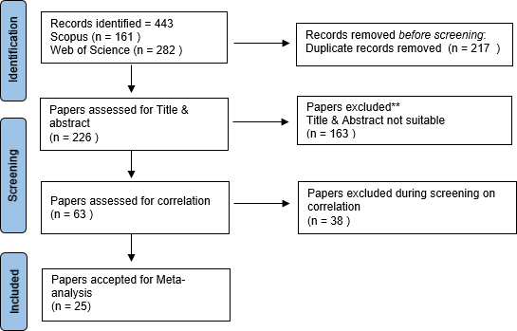

Figure.1
Identification: For this work, “Web of Science and Scopus” were searched to compile previously published publications from various sources. I used the terms "Influencer marketing" or "Social media influencers" and "Purchase intention" to search for these papers.

Following this, duplicate data was eliminated from the publications using R-Studio.
Screening: All titles and abstracts were examined; those papers whose titles and abstracts did not meet the requirements of my paper were rejected.
The remaining papers' hypotheses and influencing factors were taken into account in the following stage of screening, and papers with different variables were removed. Finally, papers with no statistical significance, no correlation value or table were eliminated in the final stage of screening.
Study Included: Then for the final meta-analysis, we were left with 25 papers on which we did our final study.

Conceptual Model


TRUST
CONSUMER
ATTITUDE
PURCHASE
INTENTION
BRAND
ATTITUDE
ATTRACTIVENESS

INDEPENDENT VARIABLES - TRUST, CONSUMER ATTITUDE, BRAND ATTITUDE & ATTRACTIVENESS
DEPENDENT VARIABLE – PURCHASE INTENTION

Search strategies: -

METHODOLOGY

- Screening of literature was done using two databases: Scopus & Web of Science, we use these keywords: "Influencer marketing" OR "social media influencers" AND "Purchase intention"
- Language was limited to English only.
- Only quantitative papers were included.

Phase 1
“We examined the title and abstract of studies to exclude those which did not talk about Purchase intention & influencer marketing, Factors affecting it, off-topic or in other languages, and repeated versions in different databases”.

Phase 2
“Each included study went through an extensive review. For articles without complete descriptions of adopted procedures, or articles which did not use any statistical tool in their paper were removed”.

Data items
Outcomes extracted from each included article were:
- How purchase intention is affected by influencer marketing.
- Sample size
- Correlation between factors
- Correlation Table

Meta-analysis Steps for this Study: -

  - Step 1: Using the keyword search method, phrases like "Influencer marketing" OR "Social media influencers" AND "Purchase intention" have been used to find articles that are relevant to the study's topic.

  - Step 2: Articles have been picked depending on the phenomena that will be examined; for instance, studies explaining correlations between the effects of different factors of Influencer marketing & purchase intention.

  - Step 3: Sorting various types of variables into categories that would be utilised in the selected articles to analyze the connection as well as selecting additional factors of relevance for the study (such as trust, consumer attitude, brand attitude, and attractiveness).

  - Step 4: "To examine relationships between variables, choose the type of effect size (correlation or standardized regression scores)". To balance out the many scales used in other research, correlation values have been used as a measure of an unbiased estimator in order to analyze the relationship between variables in this work.

  - Step 5: Relevant information will be collected from the selected articles in accordance with the hypothesis under investigation. Data such as effect size and sample size were collected.

  - Step 6: Analyzing the dataset to identify the overall effect size and effect range.
  - Step 7:In-depth statistical analysis is performed on the data using subgroup/moderator analysis to discover significant connections between variables and the impacts of various subgroups on them.
.

Results and Discussion

Meta-Analysis Table for Variable.1: (H1: Trust – Purchase intention)

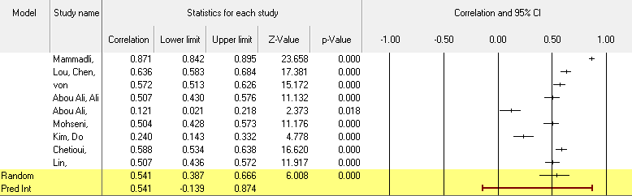

Overview

The analysis is based on nine studies. The effect size index is the correlation.

Statistical model

“For the analysis, the random-effects model was used. The analysis will be used to draw conclusions about a universe of prospective research, with the studies in the analysis being taken as a random sample from that universe”.

What is the mean effect size?

“The 95% confidence interval for the mean effect size is between 0.387 and 0.666, and it is 0.541. The average effect size across all similar trials could lie anywhere within this range. The null hypothesis that the mean impact size is zero is tested using the Z-value. With a p-value of 0.001, the Z-value is 6.008. We reject the null hypothesis and come to the conclusion that the mean effect size is not exactly zero in the universe of populations similar to those in the analysis using a criteria alpha = 0.0541”.

The Q-test for heterogeneity

“The Q-statistic provides a test of the null hypothesis that all studies in the analysis share a common effect size. If all studies shared the same true effect size, the expected value of Q would be equal to the degrees of freedom (the number of studies minus 1). The Q-value is 324.662 with

8 degrees of freedom and p < 0.001. Using a criterion alpha of 0.100, we can reject the null hypothesis that the true effect size is the same in all these studies”.

I-squared calculation

“The I-squared statistic is 98%, which indicates that a portion of the variance in observed effects (up to 98%) actually represents variance in true effects as opposed to sampling error”.

Tau and tau-square

“The variation of real effect sizes, tau-squared, is 0.089 in Fisher's Z units. Tau, the genuine effect size standard deviation, is 0.298 in Fisher's Z units”.

The forecasting window

“We may calculate that the prediction interval is between -0.139 and 0.874 if we assume that the genuine effects are normally distributed (in Fisher's Z units). In 95% of all comparable populations, the genuine effect size falls within this range. Nine studies are included in this analysis. Estimates of heterogeneity based on fewer than ten research are typically not considered to be trustworthy”.

Meta-Analysis Table for Variable.3: (H2: Consumer Attitude – Purchase intention)

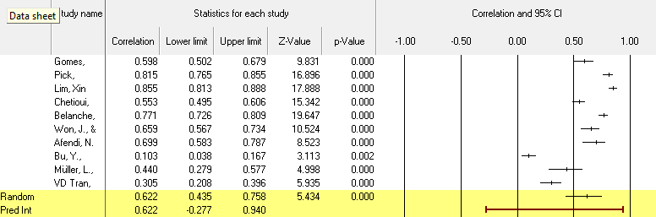

Overview

Ten studies form the basis of the analysis. The correlation is the impact size index.

Statistical framework

“For the analysis, the random-effects model was used. The analysis will be used to draw conclusions about a universe of prospective research, with the studies in the analysis being taken as a random sample from that universe”.

What is the mean effect size?

“The mean effect size is 0.622 with a 95% confidence interval of 0.435 to 0.758. The mean effect size in the universe of comparable studies could fall anywhere in this interval. The Z-value tests the null hypothesis that the mean effect size is zero. The Z-value is 5.434 with p < 0.001. Using a criterion alpha of 0.050, we reject the null hypothesis and conclude that in the universe of populations comparable to those in the analysis, the mean effect size is not precisely zero”.

The heterogeneity Q-test

“The null hypothesis that all studies included in the analysis have the same effect size is tested by the Q-statistic. The expected value of Q would be equal to the degrees of freedom (the number of studies minus 1) if all studies had the same genuine effect size. The Q-value is 488.082, there are 9 possible outcomes, and p 0.001. We can rule out the null hypothesis that the true effect size is the same across all of these trials using a criteria alpha of 0.100”.

I-squared calculation

“The I-squared statistic is 98%, which indicates that a portion of the variance in observed effects (up to 98%) actually represents variance in true effects as opposed to sampling error”.

Tau and tau-square

“The variance of real effect sizes, tau-squared, is 0.175 in Fisher's Z units. Tau, the genuine effect size standard deviation, is 0.418 in Fisher's Z units”.

The forecasting window

“We may calculate that the prediction interval is between -0.277 and 0.940 if we assume that the genuine effects are normally distributed (in Fisher's Z units). In 95% of all comparable populations, the genuine effect size falls within this range”.

Meta-Analysis Table for Variable.2: (H3: Brand Attitude – Purchase intention)

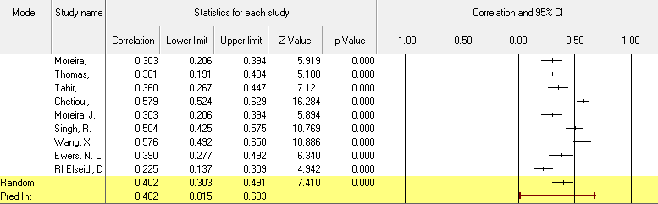

Overview

Nine studies form the basis of the analysis. The correlation is the impact size index.

Statistical framework

“For the analysis, the random-effects model was used. The analysis will be used to draw conclusions about a universe of prospective research, with the studies in the analysis being taken as a random sample from that universe”.

How big is the average effect?

“The 95% confidence interval for the mean effect size ranges from 0.303 to 0.491. The average effect size across all similar trials could lie anywhere within this range”.

The heterogeneity Q-test

“The null hypothesis that all studies included in the analysis have the same effect size is tested by the Q-statistic. The expected value of Q would be equal to the degrees of freedom (the number of studies minus 1) if all studies had the same genuine effect size. With 8 degrees of freedom, the Q- value is 85.960, and the p-value is 0.001. We can rule out the null hypothesis that the true effect size is the same across all of these trials using a criteria alpha of 0.100”.

I-squared calculation

“The I-squared score of 91% indicates that a portion of the reported impact variance actually represents variation in true effects as opposed to sampling error”.

Tau-squared and tau

“Tau-squared, the variance of true effect sizes, is 0.027 in Fisher's Z units. Tau, the standard deviation of true effect sizes, is 0.164 in Fisher's Z units”.

The prediction interval

“If we assume that the true effects are normally distributed (in Fisher's Z units), we can estimate that the prediction interval is 0.015 to 0.683. The true effect size in 95% of all comparable populations falls in this interval. This analysis includes nine studies. As a general rule, estimates of heterogeneity based on less than ten studies are not likely to be reliable”.

Meta-Analysis Table for Variable.4: (H4: Attractiveness – Purchase intention)

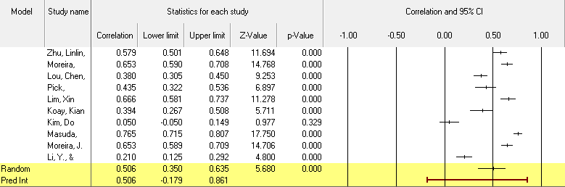

Overview

The analysis is based on ten studies. The effect size index is the correlation.

Statistical model

“The random-effects model was employed for the analysis. The studies in the analysis are assumed to be a random sample from a universe of potential studies, and this analysis will be used to make an inference to that universe”.

What is the mean effect size?

“The mean effect size is 0.506 with a 95% confidence interval of 0.350 to 0.635. The mean effect size in the universe of comparable studies could fall anywhere in this interval. The Z-value tests the null hypothesis that the mean effect size is zero. The Z-value is 5.680 with p < 0.001.
Using a criterion alpha of 0.050, we reject the null hypothesis and conclude that in the universe of populations comparable to those in the analysis, the mean effect size is not precisely zero”.

The heterogeneity Q-test

“The null hypothesis that all studies included in the analysis have the same effect size is tested by the Q-statistic. The expected value of Q would be equal to the degrees of freedom (the number of studies minus 1) if all studies had the same genuine effect size. The Q-value is 286.527, there are 9 possible outcomes, and p 0.001. We can rule out the null hypothesis that the true effect size is the same across all of these trials using a criteria alpha of 0.100”.

I-squared calculation

“The I-squared statistic is 97%, which indicates that a portion (about 97%) of the reported impact variance actually represents variation in true effects as opposed to sampling error”.

The forecasting window
“We may calculate that the prediction interval is between -0.179 and 0.861 if we assume that the genuine effects are normally distributed (in Fisher's Z units). In 95% of all comparable populations, the genuine effect size falls within this range”.

Result and Analysis

For this study 25 publications out of a corpus of 443 papers that we pulled from two databases “Scopus and Web of Science” were taken into consideration. We have collected 161 Scopus papers and 282 from Web of Science. We conducted a systematic literature review (SLR) before choosing 25 empirical studies for meta-analysis, which we then carried out with the use of software for comprehensive meta-analysis.

We established 4 hypotheses for this study, and our research determined that all 4 of them were significant, thus we accepted all 4 of them. Due to the fact that the "r" value computed in our analysis was significant, we conclude that all of those hypotheses were valid and showed a positive correlation.

For proving our hypotheses we have used other values as well like: Mean effect size, The Q test for heterogeneity, the I squared statistic, Tau square and Tau value

So, with the help of all these above values we have proved that all of our hypotheses were significant:

Hypothese.1: Trust - purchase intention

“In this hypothesis we are getting the r value as 0.541 which shows a positive and significant correlation between these two variables. The Q-value is 324.662 with 8 degrees of freedom and p
< 0.001. It shows that there is a significant difference between the observed data and expected values under the null hypothesis. So that is why we have rejected the null hypotheses that there is no relationship between the variable and accepted that the alternate hypotheses that there is a significant relationship. Tau-squared, the variance of true effect sizes, is 0.089 in Fisher's Z units. Tau, the standard deviation of true effect sizes, is 0.298 in Fisher's Z units. It shows that there is a substantial heterogeneity in the true effect size across the study. The value of tau 0.298 shows the standard deviation of the distribution of true effect size”. The value is higher than the typical effect size, which shows that variability of effect sizes across studies are considerable.

Hypotheses.2: Consumer attitude - purchase intention

“In this hypothesis we are getting the r value as 0.622 which shows a positive and significant correlation between these two variables. The Q-value is 488.082 with 9 degrees of freedom and p
< 0.001. It shows that there is a significant difference between the observed data and expected values under the null hypothesis. So that is why we have rejected the null hypotheses that there is no relationship between the variable and accepted that the alternate hypotheses that there is a significant relationship. Tau-squared, the variance of true effect sizes, is 0.175 in Fisher's Z units. Tau, the standard deviation of true effect sizes, is 0.418 in Fisher's Z units. The value of tau 0.418

shows the standard deviation of the distribution of true effect size. The value is higher than the typical effect size, which shows that variability of effect sizes across studies are considerable”.

Hypotheses.3: Brand attitude - purchase intention

“In this hypothesis we are getting the r value as 0.402 which shows a positive and significant correlation between these two variables. The The Q-value is 85.960 with 8 degrees of freedom and p < 0.001. It shows that there is a significant difference between the observed data and expected values under the null hypothesis. So that is why we have rejected the null hypotheses that there is no relationship between the variable and accepted that the alternate hypotheses that there is a significant relationship. The variation of actual effect sizes, tau-squared, is 0.027 in Fisher's Z units. Tau, the genuine effect size standard deviation, has a Fisher's Z value of 0.164.
The value of tau 0.164 shows the standard deviation of the distribution of true effect size. The value is higher than the typical effect size, which shows that variability of effect sizes across studies are considerable”.

Hypotheses.4: Attractiveness - purchase intention

“In this hypothesis we are getting the r value as 0.506 which shows a positive and significant correlation between these two variables. The Q-value is 286.527 with 9 degrees of freedom and p
< 0.001. It shows that there is a significant difference between the observed data and expected values under the null hypothesis. So that is why we have rejected the null hypotheses that there is no relationship between the variable and accepted that the alternate hypotheses that there is a significant relationship. The variation of actual effect sizes, tau-squared, is 0.0093 in Fisher's Z units. Tau, the genuine effect size standard deviation, has a Fisher's Z value of 0.305. The value of tau 0.035 shows the standard deviation of the distribution of true effect size. The value is higher than the typical effect size, which shows that variability of effect sizes across studies are considerable”.

Research Model

TRUST
0.541**
BRAND
ATTITUDE
0.402**
PI
0.622**
CONSUMER
ATTITUDE
0.506**

ATTRACTIVENESS

Meta-Analysis Table

Independent variable | Dependent Variable | Number of studies | Z value | P-  Value | Lower limit | Upper limit | Correlation
Trust | purchase intention | 9 | 6.008 | 0.000 | 0.387 | 0.666 | 0.541
Brand attitude | purchase intention | 9 | 7.410 | 0.000 | 0.303 | 0.491 | 0.402
Consumer attitude | purchase intention | 10 | 5.434 | 0.000 | 0.435 | 0.758 | 0.622
Attractiveness | purchase intention | 10 | 5.680 | 0.000 | 0.350 | 0.635 | 0.506

Figure.3: Meta-Analysis for 4 variables (T, BA, CA, AT)

Figure.3 presents the meta-analysis's findings. The table lists the independent and dependent variables, the number of times a given relationship was examined, the p-value, the standard normal deviation (Z-value), and the 95% lower confidence interval and Upper limit.

The correlations between the constructs are significant, as shown by the p-values across all relationships, and the correlation coefficients are all positive that shows our entire hypothesis is alternate hypothesis and showing higher positive correlation.

The four possibilities put out are all accepted. The correlation values demonstrate that there is a stronger association between Trust, Brand attitude, Consumer attitude & Attractiveness with purchase intention.
The correlation values and likelihood that these values will fall within the specified interval are additionally supported by the 95% confidence interval.

“According to the findings of the meta-analysis (Figure. 3), 4 out of the 4 hypothesized correlations were found to be significant. Particularly strong correlations were found between Consumer Attitude and purchase intention (r = 0.622), followed by Trust and purchase intention (r = 0.541), Attractiveness and purchase intention (r = 0.506) and finally Brand attitude and purchase intention (r = 0.402)”.

Conclusion and Discussion

By utilizing meta-analysis, this study synthesizes information from earlier studies on effect on purchase intention by influencer marketing. This paper focused on how factors of influencer marketing like: Trust, Consumer attitude, Brand attitude and Attractiveness affect purchase intention. All relationships that were suggested carried out satisfactorily in the meta-analysis, which was discovered.

This meta-analysis clarifies these discrepancies in the previously published literature and offers some intriguing insights into the various elements of green purchase intention.

The results addressing the connections between the attributes of influencer marketing over purchase intention (see Figure.3) demonstrate the significance of all connections between the constructs.

These results are consistent with the study's postulated hypotheses. Consumer attitude had the greatest impact on consumers' purchase intention while Brand attitude had the least impact.

“Hypotheses 1 explored the connection between “Trust” and “purchase intention”. The hypotheses and some earlier studies both agree that there is a positive and significant association between Trust” and “purchase intention” Mammadli, Galandar. (2021)”

“Hypotheses 2 proposed the impact of “consumer attitude” towards “purchase intention”. The hypotheses and some earlier studies both agree that there is a higher significant association or positive relation between “consumer attitude” towards “purchase intention” Gomes, Marina Alexandra, Susana Marques, and Álvaro Dias (2022)”

“Hypotheses 3 proposed the impact of Brand attitude on purchase intention. The hypotheses and some earlier studies both agrees that there is a significant association or positive relation between Brand attitude and purchase intention (Moreira, Joana Filipa de Sousa 2021)”

“Hypotheses 4 proposed the impact of Attractiveness on purchase intention. The hypotheses we have developed in this paper and some earlier published research papers or studies both agrees that there is a significant association or positive relation between Attractiveness on Purchase intention (Zhu, Linlin, He Li, Feng-Kwei Wang, Wu He, and Zejin Tian 2021)”

Contribution to theory
The study's findings make several theoretical contributions. This meta-analysis advances our understanding of how different variables of influencer marketing like: T, CA, BA & AT affect purchase intention. The sort of variables to be used for studying the effects of various factors on PI can be inferred from this research by academics. The results can be used as a benchmark for new structures and examined to determine how well they perform. Additionally, the research's findings can be used to depict the points of convergence and divergence, which will help with the development of further inquiries that can be looked into in a broader perspective. The study gave a comprehensive overview of the effects of T, CA, BA & AT as well as how Influencer marketing influences the purchase intention.

Limitations and Future Research Direction
The current research has some restrictions. The meta-analysis solely relies on empirical study. As a result, future researchers can integrate qualitative studies in their reports. Future studies could be boosted even further by using moderators. Influencers' use of social media platforms, the items they recommend, the demographics of the respondents, the sample size, etc. are all potential moderators. In addition, the analysis only took into account four characteristics. It was noted that not enough empirical research has been done on some traits, such as authenticity, credibility, or congruence, in the literature that has already been published. With more study, these qualities will be strengthened, and researchers may use the same ones to meta-analytical studies.

References
Belanche, D., Casaló, L.V., Flavián, M. and Ibáñez-Sánchez, S., 2021. Understanding influencer marketing: The role of congruence between influencers, products and consumers. Journal of Business Research, 132, pp.186- 195.

Won, J. and Kim, B.Y., 2020. The effect of consumer motivations on purchase intention of online fashion-sharing platform. The Journal of Asian Finance, Economics and Business, 7(6), pp.197-207.

Afendi, N.A., Azizan, F.L. and Darami, A.I., 2014. Determinants of halal purchase intention: case in Perlis. International Journal of Business and Social Research, 4(5), pp.118-123.

Singh, R.P. and Banerjee, N., 2018. Exploring the influence of celebrity credibility on brand attitude, advertisement attitude and purchase intention. Global Business Review, 19(6), pp.1622-1639.

Mammadli, G., 2021. The Role Of Brand Trust in The Impact Of Social Media Influencers On Purchase Intention. Available at SSRN 3834011.

Moreira, J.F.D.S., 2021. Influencer marketing: the effect of influencer credibility on attitude towards the influencer- brand collaboration and purchase intention.

Lou, C. and Yuan, S., 2019. Influencer marketing: How message value and credibility affect consumer trust of branded content on social media. Journal of interactive advertising, 19(1), pp.58-73.

Gomes, M.A., Marques, S. and Dias, Á., 2022. The impact of digital influencers’ characteristics on purchase intention of fashion products. Journal of Global Fashion Marketing, 13(3), pp.187-204.

Reinikainen, H., Munnukka, J., Maity, D. and Luoma-Aho, V., 2020. ‘You really are a great big sister’–parasocial relationships, credibility, and the moderating role of audience comments in influencer marketing. Journal of marketing management, 36(3-4), pp.279-298.

Pick, M., 2020. Psychological ownership in social media influencer marketing. European Business Review, 33(1).

Ewers, N.L., 2017. # sponsored–Influencer Marketing on Instagram: An Analysis of the Effects of Sponsorship Disclosure, Product Placement, Type of Influencer and their Interplay on Consumer Responses.

von Mettenheim, W. and Wiedmann, K.P., 2021. The complex triad of congruence issues in influencer marketing. Journal of Consumer Behaviour, 20(5), pp.1277-1296.

Abou Ali, A.A., Ali, A.A. and Mostapha, N., 2021. The role of country of origin, perceived value, trust, and influencer marketing in determining purchase intention in social commerce. BAU Journal-Society, Culture and Human Behavior, 2(2), p.10.

Lim, X.J., Radzol, A.M., Cheah, J. and Wong, M.W., 2017. The impact of social media influencers on purchase intention and the mediation effect of customer attitude. Asian journal of business research, 7(2), pp.19-36.

Kim, D.Y. and Kim, H.Y., 2021. Trust me, trust me not: A nuanced view of influencer marketing on social media. Journal of Business Research, 134, pp.223-232.

Koay, K.Y., Cheung, M.L., Soh, P.C.H. and Teoh, C.W., 2022. Social media influencer marketing: The moderating role of materialism. European Business Review, 34(2), pp.224-243.

Chetioui, Y., Benlafqih, H. and Lebdaoui, H., 2020. How fashion influencers contribute to consumers' purchase intention. Journal of Fashion Marketing and Management: An International Journal, 24(3), pp.361-380.

Bu, Y., Parkinson, J. and Thaichon, P., 2022. Influencer marketing: Homophily, customer value co-creation behaviour and purchase intention. Journal of Retailing and Consumer Services, 66, p.102904.

Masuda, H., Han, S.H. and Lee, J., 2022. Impacts of influencer attributes on purchase intentions in social media influencer marketing: Mediating roles of characterizations. Technological Forecasting and Social Change, 174, p.121246.

Li, Y. and Peng, Y., 2021. Influencer marketing: purchase intention and its antecedents. Marketing Intelligence & Planning.

Müller, L., Mattke, J. and Maier, C., 2018. # Sponsored# ad: exploring the effect of influencer marketing on purchase intention.

Lin, L.Y. and Lu, C.Y., 2010. The influence of corporate image, relationship marketing, and trust on purchase intention: the moderating effects of word‐of‐mouth. Tourism review, 65(3), pp.16-34.

Wang, X.W., Cao, Y.M. and Park, C., 2019. The relationships among community experience, community commitment, brand attitude, and purchase intention in social media. International Journal of Information Management, 49, pp.475-488.

Elseidi, R.I. and El-Baz, D., 2016. Electronic word of mouth effects on consumers' brand attitudes, brand image and purchase intention: an empirical study in Egypt. The Business & Management Review, 7(5), p.268.

Punyatoya, P., 2015. Effect of perceived brand environment-friendliness on Indian consumer attitude and purchase intention: An integrated model. Marketing Intelligence & Planning, 33(3), pp.258-275.

Tran, V.D. and Nguyen, T.D., 2022. The impact of security, individuality, reputation, and consumer attitudes on purchase intention of online shopping: The evidence in Vietnam. Cogent Psychology, 9(1), p.2035530.

Ao, L., Bansal, R., Pruthi, N. and Khaskheli, M.B., 2023. Impact of Social Media Influencers on Customer Engagement and Purchase Intention: A Meta-Analysis. Sustainability, 15(3), p.2744.

Vrontis, D., Makrides, A., Christofi, M. and Thrassou, A., 2021. Social media influencer marketing: A systematic review, integrative framework and future research agenda. International Journal of Consumer Studies, 45(4), pp.617-644.

Chopra, A., Avhad, V. and Jaju, A.S., 2021. Influencer marketing: An exploratory study to identify antecedents of consumer behavior of millennial. Business Perspectives and Research, 9(1), pp.77-91.

