 | TEXT EMOTION DETECTION USING MACHINE LEARNING AND NLP | 
A PROJECT REPORT
Submitted by

BHARATHIPRIYAN
DINESH M
JEEVABALAN S B
MOHONLAL P
(723719104015)
(723719104022)
(723719104030)
(723719104047)

in partial fulfillment for the award of the degree
of
BACHELOR OF ENGINEERING
IN
COMPUTER SCIENCE AND ENGINEERING

VSB COLLEGE OF ENGINEERING TECHNICAL CAMPUS
COIMBATORE-642109

ANNA UNIVERSITY: CHENNAI 600 025

MAY 2023
ANNA UNIVERSITY: CHENNAI 600 025
BONAFIDE CERTIFICATE
Certified that this project report “TEXT EMOTION DETECTION USING MACHINE LEARNING AND NLP” is the Bonafide work of “BHARATHIPRIYAN B, DINESH M, JEEVABALAN S B, MOHANLAL P”. who carried out the project work under my supervision.

SIGNATURE

Mr. P. DINESH KUMAR

HEAD OF THE DEPARTMENT

Deparment of Computer Science and and Engineering
V.S.B College of Engineering
Technical Campus
Coimbatore-642109

SIGNATURE

Mr. BHARATHIRAJA

SUPERVISOR
Assistant professor
Department of Computer Science and Engineering
V.S.B College of Engineering Technical Campus
Coimbatore-642109

Submitted for the university project viva voce held on ..................................at V.S.B. College of Engineering Technical Campus in Coimbatore.

INTERNAL EXAMINER EXTERNAL EXAMINER
ACKNOWLEDGEMENT

First of all we extend our heartfelt gratitude to the management of V.S.B College of Engineering Technical Campus institutions, Chairman Mr.V.S.Balsamy, B.Sc., L.L.B.,for providing us with all sort of support in the completion of this project.

We record our indebtedness to our principal Dr.V.VELMURUGAN, Ph.D for his/her guidance and sustained encouragement for the successful of the project.

We are highly gratitude to Mr. P. DINESHKUMAR Head of the department, Department of Computer Science and Engineering for his/her valuable suggestions throughout the course of this project.

We owe our gratitude to our project coordinator Dr.T. KALAILUMARAN professor, Department of Computer Science and Engineering for his/her unlisted encouragement and moreover for his timely support and guidance till the completion of the project work.
We also extend our sincere thanks to Mr.M.BHARATHIRAJA assistant professor project guide for his/her kind support and timely assistance rendered which lead us in successful completion of our project.
We extend our heartfelt salutation to our beloved parents and friends who have always been an integral part in helping us through tough times and all teaching and non-teaching staff for providing their moral support making herculean success of our project.

ABSTRACT
In today’s technological world, a majority of users across the world have access to Internet for communication via text, image, audio, and video. People from diverse backgrounds exchange information on current scenarios and project their own views on them over social media. There is a need to understand and recognize the behavior of such large text information on people by analyzing their emotions. The paper focuses on data obtained from one of the most popular social media - Twitter by analyzing live as well as past feeds and getting emotions from them. The twitter data required in English language is converted into a vector of eight emotions and supervised learning techniques such as K-means, Naive Bayes and SVM and NLP is used to determine label identifying one of the basic emotion family. At the end, a comparative study of the performance of different classifiers is discussed

TABLE OF CONTENTS
CHAPTER | TITLE | PAGE.NO
 | ABSTRACT | VII
1 | INTRODUCTION  1.1 INTRODUCTION  1.2 MODULES  1.3 MODULE DESCRIPTION | 1  2  2
2 | LITERATURE SURVEY | 4
3 | SYSTEM SPECIFICATION  3.1 HARDWARE SPECIFICATION  3.2 SOFTWARE REQUIREMENTS  3.3 MACHINE LEARNING  3.3.1 Algorithm implementation  3.4. USES OF MACHINE LEARNING  3.4.1 Clustering algorithm  3.4.2 Application of clustering in different fields  3.5 APPLICATION OF MACHINE LEARNING  3.5.1 Machine learning in healthcare  3.5.1.2 Machine learning examples  Healthcare for drug discovery  3.6 MACHINE LEARNING APPLICATIONS IN  FINANCE  3.6.1 machine learning applications in retail  3.7 MACHINE LEARNING EXAMPLES IN RETAIL FOR PRODUC RECOMENDATIONS  3.8 MACHINE LEARNING APPLICATIONS IN TRAVEL  3.9 MACHINE LEARNING APPLICATIONS IN  SOCIAL MEDIA  3.10 PRINCIPAL COMPONENT ANALYSIS  3.11. MACHINE LEARNING APPLICATIONS IN  SOCIAL MEDIA  3.12 PRINCIPAL COMPONENT ANALYSIS | 8  8  8  8  10  14  14  15  16  17  18  19  20  21  22  23  24  25
4 | ADOPTION ALGORITHM  4.1 RANDOM FOREST ALGORITHM  4.2 WORKING OF RANDOM FOREST ALGORITHM  4.3 BAGGING  4.4 BOOSTING  4.4.1 Steps involved in random forest algorithm  4.4.2 Important features of random Forest  4.5 DIFFERENCE BETWEEN DECISION TREE AND  RANDOM FOREST  4.5.1 Important hyperparameters in Random forest algorithm | 27  27  27  28  30  30  31  32  33
5 | SYSTEM STUDY  5.1 EXISTING SYSTEM  5.2 DISADVANTAGES  5.3 PROPOSED SYSTEM  5.4 ADVANTAGES | 35  35  35  36
6 | SYSTEM DESIGN  6.1 INPUT DESIGN  6.2 OUTPUT DESIGN | 37  37  38
7  8 | SYSTEM IMPLEMENTATION  7.1 SYSTEM IMPLEMENTATION  7.2 DATA COLLECTION AND PREPROCESSING  7.3 FEATURE EXTRACTION  7.4 MODEL SELECTION  7.5 TRAINING  7.6 MODEL EVALUATION  7.7 HYPERPARAMETER TUNNING  7.8 TESTING  7.9 DEPLOYMENT  7.10 CONTINUOUS IMPRPVEMENT  SOFTWARE DESCRIPTION  8.1 PYTHON  8.2 MODULES  8.2.1 numpy  8.2.2 pandas  8.2.3 sklearn  8.3 FLASK  8.4 ROUTING  8.5 ER DIAGRAM | 39  39  39  39  39  39  40  40  40  40  40  42  47  47  48  49  50  51  51
9  10  Apendix-1  Appendix-2 | CONCLUSION  FUTURE ENHANCEMENT  REFERENCE  SOURCE CODE  CODE FOR INDEX  CODE IN CSS  SAMPLE OUTPUT | 53  54  56  58  64  64  67

CHAPTER-1
INTRODUCTION
1.1 INTRODUCTION
Social media has become an integral part of the people in 21st century. Due to rapid progress in Information & Technology sector, people have access to any kind of information at the click of a button. Moreover, with the invent of smart-phones and 4G networks, even people from the remote areas are getting connected to Tier 1 and Tier 2 cities. With the growing population in countries like India, it has led to tremendous growth in the number of people using social networks. Social networks like Facebook, WhatsApp, Twitter, etc. has eliminated the gap between lives of people. One of the reasons to use these social networks to know the current happenings around them and to express their views and suggestions in the form of likes, share, tweets, polls, email, etc. This has created a new category of people called netizens. Communication via social media is done in the form of text, image, audio and video which contains information and consumes space, memory and Internet bandwidth. All these activities done on social media has resulted into vast amount of information being generated on a daily basis. Social media analysis has become a interesting field of research to understand the behavior and thoughts of people in response to social, economic, cultural, educational and all others activities happening around the world. Social media data is in the form of unstructured data since people are from diverse backgrounds with different race, culture, language and standard of living project their ideas, views, opinions, expressions and so on the Internet. So, it has become a challenge in recent years to extract valuable information from these ever-growing data in the form of posts, emails, blogs, micro-blogs, tweets, reviews, comments, polls and surveys on the Web about an individual, an organization or government in the process of decision-making. These opinionated data not only exist on the Web but also within the large organizations like Google, Microsoft, Hewlett-Packard, SAP and SAS to know the opinions of their employees spread across the continents in the form of customer feedback collected from emails and call centers or results from surveys conducted by organizations. This has created strong interest for research in sentiment analysis.
1.2 MODULES
- Data collection
- Data Pre-Processing
- Training data and Test data
- Model Creation
- Model Prediction
  - MODULE DESCRIPTION
- Data collection
To generate training data set, a total of 100 words from each of the bags is used. These words are first converted into hashtags and then fed into the Tweet Retrieval System (TRS). The TRS keeps on listening to the live tweet stream and captures any tweets with the hashtag that is passed to it. Labelling of training dataset is automated when a tweet is retrieved it is assigned a label which is one of the basic emotion family to which the hashtag word belongs.
- Data Pre-Processing
Pre-processing refers to the transformations applied to our data before providing the data to the algorithm. Data Preprocessing technique is used to convert the raw data into an understandable data set. In other words, whenever the information is gathered from various sources it is collected in raw format that isn’t possible for the analysis.
- Training data and Test data
- For choosing a model we split our dataset into train and test
- Here data are split into 3:1 ratio that means.
- Training data having 70 percent and testing data having 30 percent.
- In this split process preforming based on train_test_split model
- After splitting we get xtrain xtest and ytrain ytest
- Model Creation
  - Contextualize machine learning in your organization.
  - Explore the data and choose the type of algorithm.
  - Prepare and clean the dataset.
  - Split the prepared dataset and perform cross validation.
  - Perform machine learning optimization.
  - Deploy the model.
- Model Prediction
Predictive modeling is a statistical technique using machine learning and data mining to predict and forecast likely future outcomes with the aid of historical and existing data. It works by analyzing current and historical data and projecting what it learns on a model generated to forecast likely outcomes. In this project our final prediction is to predict the emotion based on the given text

CHAPTER 2
LITERATURE SURVEY
Title: Text-based emotion detection: Advances, challenges, and opportunities
Author: FranciscaAdoma Acheampong, Chen Wenyu, Henry Nunoo-Mensah
Emotion detection (ED) is a branch of sentiment analysis that deals with the extraction and analysis of emotions. The evolution of Web 2.0 has put text mining and analysis at the frontiers of organizational success. It helps service providers provide tailor-made services to their customers. Numerous studies are being carried out in the area of text mining and analysis due to the ease in sourcing for data and the vast benefits its deliverable offers. This article surveys the concept of ED from texts and highlights the main approaches adopted by researchers in the design of text-based ED systems. The article further discusses some recent state-of-the-art proposals in the field. The proposals are discussed in relation to their major contributions, approaches employed, datasets used, results obtained, strengths, and their weaknesses. Also, emotion-labeled data sources are presented to provide neophytes with eligible text datasets for ED. Finally, the article presents some open issues and future research direction for text-based ED.
Title: AI Based Emotion Detection for Textual Big Data: Techniques and Contribution
Online social media (OSM) like Facebook and Twitter has emerged as a powerful tool to express via text people’s opinions and feelings about the current surrounding events. Understanding the emotions at the fine-grained level of these expressed thoughts is important for system improvement. Such crucial insights cannot be completely obtained by doing AI-based big data sentiment analysis; hence, text-based emotion detection using AI in social media big data has become an upcoming area of Natural Language Processing research. It can be used in various fields such as understanding expressed emotions, human–computer interaction, data mining, online education, recommendation systems, and psychology. Even though the research work is ongoing in this domain, it still lacks a formal study that can give a qualitative (techniques used) and quantitative (contributions) literature overview. This study has considered 827 Scopus and 83 Web of Science research papers from the years 2005–2020 for the analysis. The qualitative review represents different emotion models, datasets, algorithms, and application domains of text-based emotion detection. The quantitative bibliometric review of contributions presents research details such as publications, volume, co-authorship networks, citation analysis, and demographic research distribution. In the end, challenges and probable solutions are showcased, which can provide future research directions in this area.
Title: Deep learning approach to text analysis for human emotion detection from big data
Author: Jia Guo
Emotional recognition has arisen as an essential field of study that can expose a variety of valuable inputs. Emotion can be articulated in several means that can be seen, like speech and facial expressions, written text, and gestures. Emotion recognition in a text document is fundamentally a content-based classification issue, including notions from natural language processing (NLP) and deep learning fields. Hence, in this study, deep learning assisted semantic text analysis (DLSTA) has been proposed for human emotion detection using big data. Emotion detection from textual sources can be done utilizing notions of Natural Language Processing. Word embeddings are extensively utilized for several NLP tasks, like machine translation, sentiment analysis, and question answering. NLP techniques improve the performance of learning-based methods by incorporating the semantic and syntactic features of the text. The numerical outcomes demonstrate that the suggested method achieves an expressively superior quality of human emotion detection rate of 97.22% and the classification accuracy rate of 98.02% with different state-of-the-art methods and can be enhanced by other emotional word embeddings.

Title: A Survey of Textual Emotion Detection
Author: Samar Al-Saqqa; Heba Abdel-Nabi; Arafat Awajan
Emotion detection in text is a research field that gained an extensive interest recently. The advancement in communication networks and the spread usage of social web is the reason of massive amount of emotions that can be extracted frequently. The extraction and analysis of such emotions provides a powerful tool in detecting and recognizing the feelings, and this provides many advantages in diverse areas. In this survey, we focused on the textual emotion detection as a task of sentiment analysis. This survey explored the latest state of art approaches for emotion detection in text, and discussed their classification according to the used techniques, the used emotional model and the different used datasets. The outcome of this paper tends to highlight the limitation and gaps of these recent works and direct the possible future research to fulfill these gaps in this increasingly developed field.
Title: Towards Text-based Emotion Detection A Survey and Possible Improvements
Author: Edward Chao-Chun Kao; Chun-Chieh Liu; Ting-Hao Yang; Chang-Tai Hsieh; Von-Wun Soo.
This paper presents an overview of the emerging field of emotion detection from text and describes the current generation of detection methods that are usually divided into the following three main categories: keyword-based, learning-based, and hybrid recommendation approaches. Limitations of current detection methods are examined, and possible solutions are suggested to improve emotion detection capabilities in practical systems, which emphasize on human-computer interactions. These solutions include extracting keywords with semantic analysis, and ontology design with emotion theory of appraisal. Furthermore, a case-based reasoning architecture is proposed to combine these solutions.

Title: Text-based Emotion Recognition using Sentiment Analysis
Author: Chris Jonathan D; Sujitha Juliet
The reason for sentiment analysis is to distinguish the fundamental mentalities of individuals locally. The Internet is where clients of the world put their perspectives to various things. They talk about regular issues, whine about what they use, and offer positive or negative viewpoints about the item. This makes the Internet a significant source of data for opinion mining and sentiment analysis. In Software engineering, sentiment analysis has many purposes such as, recognizing thoughts that will further develop customers message conveyance and distinguishing their thoughts on a composed email. Furthermore, phenomenal, composed data must be utilized for few articulations, accordingly, lessening the possibilities of accurate analysis. The authors have gathered data on the utilization of instant messages that can be utilized to determine such issues. The fundamental reason for the task is to offer a concise composed expression, which is just enthusiastic. The proposed model aims to utilize two strategies and to realize what works best. The hardest part in sentiment analysis is figuring out the text(s) as per the thoughts. So, this model analysis data from corpora text and recognizes emotion out of it. In addition to customer satisfaction assessment and brand belief analysis, sentiment analysis through text is widely used currently

CHAPTER-3
SYSTEM SPECIFICATION
3.1 HARDWARE SPECIFICATION
- Processor: I3 OR I5
- Hard Disk: 500 GB.
- Monitor: 15’’ LED Monitor
- Input Devices: Keyboard, Mouse
- Ram: 4 GB.
3.2 SOFTWARE REQUIREMENTS:
  - Operating system: Windows 10
  - Coding Language: Python
  - Front End: Visual Studio
  - Database: Scikit.learn.org
3.3 MACHINE LEARNING
3.3.1 Algorithm Implementation
- Implementing a machine learning algorithm will give you a deep and practical appreciation for how the algorithm works. This knowledge can also help you to internalize the mathematical description of the algorithm by thinking of the vectors and matrices as arrays and the computational intuitions for the transformations on those structures.
- There are numerous micro-decisions required when implementing a machine learning algorithm and these decisions are often missing from the formal algorithm descriptions. Learning and parameter zing these decisions can quickly catapult you to intermediate and advanced level of understanding of a given method, as relatively few people make the time to implement some of the more complex algorithms as a learning exercise.
Uses of machine learning
- To better understand the uses of machine learning, consider some of the instances where machine learning is applied: the self-driving Google car, cyber fraud detection, online recommendation engines like friend suggestions on Facebook, Netflix showcasing the movies and shows you might like, and “more items to consider” and “get yourself a little something” on Amazon—are all examples of applied machine learning.
- All these examples echo the vital role machine learning has begun to take in today’s data-rich world. Machines can aid in filtering useful pieces of information that help in major advancements, and we are already seeing how this technology is being implemented in a wide variety of industries. The process flow depicted here represents how machine learning works.
- With the constant evolution of the field, there has been a subsequent rise in the uses, demands, and importance of machine learning. Big data has become quite a buzzword in the last few years; that’s in part due to increased sophistication of machine learning, which helps analyze those big chunks of big data. Machine learning has also changed the way data extraction, and interpretation is done by involving automatic sets of generic methods that have replaced traditional statistical techniques.
- 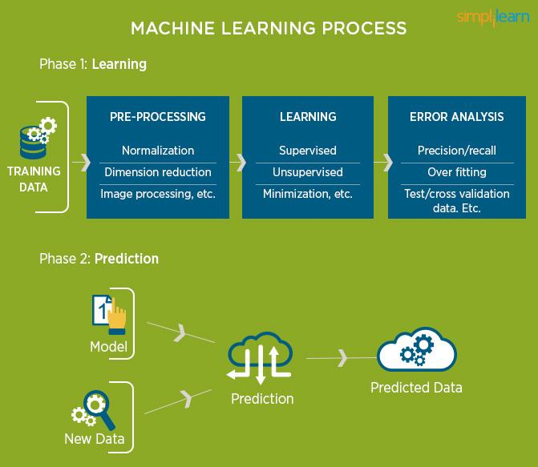
Figure 3.3.1.1 Machine learning process

3.4. Uses of Machine Learning
Earlier in this article, we mentioned some applications of machine learning. To understand the concept of machine learning better, let’s consider some more examples: web search results, real-time ads on web pages and mobile devices, email spam filtering, network intrusion detection, and pattern and image recognition. All these are by-products of applying machine learning to analyze huge volumes of data. Traditionally, data analysis was always being characterized by trial and error, an approach that becomes impossible when data sets are large and heterogeneous. Machine learning comes as the solution to all this chaos by proposing clever alternatives to analyzing huge volumes of data. By developing fast and efficient algorithms and data-driven models for real-time processing of data, machine learning is able to produce accurate results and analysis.
Machine learning tasks are classified into several broad categories. In supervised learning, the algorithm builds a mathematical model of a set of data that contains both the inputs and the desired outputs. For example, if the task were determining whether an image contained a certain object, the training data for a supervised learning algorithm would include images with and without that object (the input), and each image would have a label (the output) designating whether it contained the object. In special cases, the input may be only partially available, or restricted to special feedback. Semi-supervised learning algorithms develop mathematical models from incomplete training data, where a portion of the sample inputs are missing the desired output. Classification algorithms and regression algorithms are types of supervised learning. Classification algorithms are used when the outputs are restricted to a limited set of values. For a classification algorithm that filters emails, the input would be an incoming email, and the output would be the name of the folder in which to file the email. For an algorithm that identifies spam emails, the output would be the prediction of either "spam" or "not spam", represented by the Boolean values true and false. Regression algorithms are named for their continuous outputs, meaning they may have any value within a range.
Examples of a continuous value are the temperature, length, or price of an object.
Supervised Machine Learning: The majority of practical machine learning uses supervised learning. Supervised learning is where you have input variables (x) and an output variable (Y) and you use an algorithm to learn the mapping function from the input to the output Y = f(X) . The goal is to approximate the mapping function so well that when you have new input data (x) that you can predict the output variables (Y) for that data.
Techniques of Supervised Machine Learning algorithms include linear and
logistic regression, multi-class classification, Decision Trees, and support vector machines. Supervised learning requires that the data used to train the algorithm is already labeled with correct answers. For example, a classification algorithm will learn to identify animals after being trained on a dataset of images that are properly labeled with the species of the animal and some identifying characteristics.
Supervised learning problems can be further grouped into Regression and Classification problems. Both problems have as goal the construction of a succinct model that can predict the value of the dependent attribute from the attribute variables. The difference between the two tasks is the fact that the dependent attribute is numerical for regression and categorical for classification.
A regression problem is when the output variable is a real or continuous value, such as “salary” or “weight”. Many different models can be used, the simplest is the linear regression. It tries to fit data with the best hyper-plane which goes through the points.
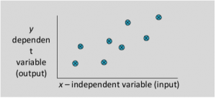
Figure 3.4.1
Types of Regression Models:
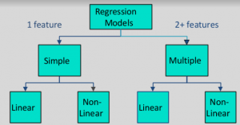
Figure
In unsupervised learning, the algorithm builds a mathematical model of a set of data which contains only inputs and no desired outputs. Unsupervised learning algorithms are used to find structure in the data, like grouping or clustering of data points. Unsupervised learning can discover patterns in the data, and can group the inputs into categories, as in feature learning. Dimensionality reduction is the process of reducing the number of “features”, or inputs, in a set of data.
An unsupervised learning method is a method in which we draw references from datasets consisting of input data without labeled responses. Generally, it is used as a process to find meaningful structure, explanatory underlying processes, generative features, and groupings inherent in a set of examples.
Clustering is the task of dividing the population or data points into a number of groups such that data points in the same groups are more similar to other data points in the same group and dissimilar to the data points in other groups. It is basically a collection of objects on the basis of similarity and dissimilarity between them.
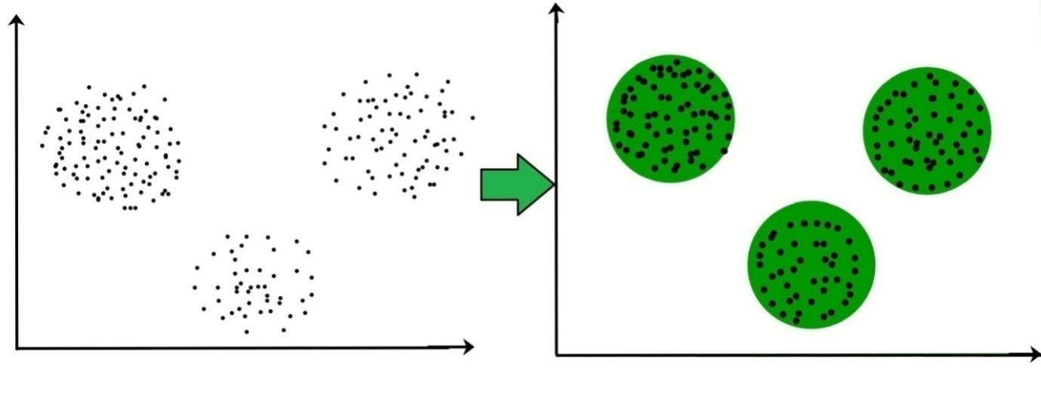

These data points are clustered by using the basic concept that the data point lies within the given constraint from the cluster center. Various distance methods and techniques are used for calculation of the outliers.
Clustering is very much important as it determines the intrinsic grouping among the unlabeled data present. There are no criteria for a good clustering. It depends on the user, what is the criteria they may use which satisfy their need.
For instance, we could be interested in finding representatives for homogeneous. groups (data reduction), in finding “natural clusters” and describe their unknown properties (“natural” data types), in finding useful and suitable groupings (“useful” data classes) or in finding unusual data objects (outlier detection). This algorithm must make some assumptions which constitute the similarity of points and each assumption make different and equally valid clusters.
3.4.1 Clustering Algorithms:
K-means clustering algorithm – It is the simplest unsupervised learning algorithm that solves clustering problem.K-means algorithm partition n observations into k clusters where each observation belongs to the cluster with the nearest mean serving as a prototype of the cluster
3.4.2 Applications of Clustering in different fields
1. Marketing : It can be used to characterize and discover customer segments for marketing.
2. Biology : It can be used for classification among different species of plants and animals.
3. Libraries : It is used in clustering different books on the basis of topics and information.
4. Insurance : It is used to acknowledge the customers, their policies and identifying frauds.
5. City Planning : It is used to make groups of houses and to study their values based on their geographical locations and other factors present.
6. Earthquake studies : By learning the earthquake affected areas we can determine the dangerous zones.
Active learning algorithms access the desired outputs (training labels) for a limited set of inputs based on a budget, and optimize the choice of inputs for which it will acquire training labels. When used interactively, these can be presented to a human user for labeling. Reinforcement learning algorithms are given feedback in the form of positive or negative reinforcement in a dynamic environment, and are used in autonomous vehicles or in learning to play a game against a human opponent. Other specialized algorithms in machine learning include topic modeling, where the computer program is given a set of natural language documents and finds other documents that cover similar topics. Machine learning algorithms can be used to find the unobservable probability density function in density estimation problems. Machine learning seems to be the most straightforward case of all. It is for the most part associated with terms referring to different scientific methods for knowledge discovery or prediction (labelled as machine or statistical learning methods). Towards Data Science provides a platform for thousands of people to exchange ideas and to expand our understanding of data science. Data science is an interdisciplinary field that uses scientific methods, processes, algorithms and systems to extract knowledge and insights from data in various forms, both structured and unstructured similar to data mining.
3.5 APPLICATION OF MACHINE LEARNING
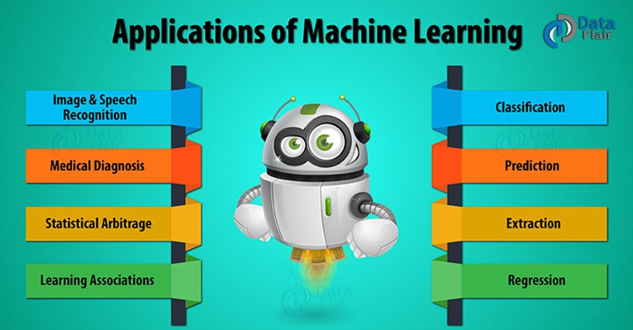

- Machine Learning Applications in Healthcare
- Machine Learning Applications in Finance
- Machine Learning Applications in Retail
- Machine Learning Applications in Travel
- Machine Learning Applications in Media

3.5.1 MACHINE LEARNING IN HEALTHCARE
Doctors and medical practitioners will soon be able to predict with accuracy on how long patients with fatal diseases will live. Medical systems will learn from data and help patients save money by skipping unnecessary tests. Radiologists will be replaced by machine learning algorithms
McKinsey Global Institute estimates that applying machine learning techniques to better inform decision making could generate up to $100 billion in value based on optimized innovation, enhanced efficiency of clinical trials and the creation of various novel tools for physicians, insurers and consumers. Computers and Robots cannot replace doctors or nurses, however the use of life-saving technology (machine learning) can definitely transform healthcare domain. When we talk about efficiency of machine learning, more data produces effective results – and the healthcare industry is residing on a data goldmine.
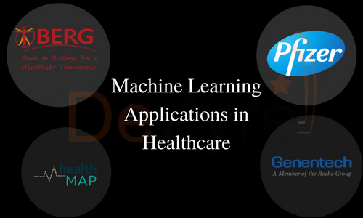

i) Drug Discovery/Manufacturing
Manufacturing or discovering a new drug is expensive and lengthy process as thousands of compounds need to be subjected to a series of tests, and only a single one might result in a usable drug. Machine learning can speed up one or more of these steps in this lengthy multi-step process.

3.5.1.2Machine Learning Examples in Healthcare for Drug Discovery

- Pfizer is using IBM Watson on its immuno-oncology (a technique that uses body’s immune system to help fight cancer) research. This is one of the most
significant uses of IBM Watson for drug discovery. Pfizer has been using machine learning for years to sieve through the data to facilitate research in the areas of drug discovery (particularly the combination of multiple drugs) and determine the best participant for a clinical trial.

ii) Personalized Treatment/Medication
Imagine when you walk in to visit your doctor with some kind of an ache in your stomach. After snooping into your symptoms, the doctor inputs them into the computer that extracts the latest research that the doctor might need to know about how to treat your ache. You have an MRI and a computer helps the radiologist detect problems that possibly could be too small for the human eye to see. In the end, a computer scans all your health records and family medical history and compares it to the latest research to advice a treatment protocol that is particularly tailored to your problem. Machine learning is all set to make a mark in personalized care.
Personalized treatment has great potential for growth in future, and machine learning could play a vital role in finding what kind of genetic makers and genes respond to a particular treatment or medication. Personalized medication or treatment based on individual health records paired with analytics is a hot research area as it provides better disease assessment. In future, increased usage of sensor integrated devices and mobile apps with sophisticated remote monitoring and health-measurement capabilities, there would be another data deluge that could be used for treatment efficacy. Personalized treatment facilitates health optimization and also reduces overall healthcare costs.

Machine Learning Examples in Healthcare for Personalized Treatment
- A major problem that drug manufacturers often have is that a potential drug sometimes work only on a small group in clinical trial or it could be considered unsafe because a small percentage of people developed serious side effects. Genentech, a member of the Roche Group collaborated with GNS Healthcare to innovate solutions and treatments using biomedical data. Genentech will make use of GNS Reverse Engineering and Forward Simulation to look for patient response markers based on genes which could lead to providing targeted therapies for patients.

3.6 MACHINE LEARNING APPLICATIONS IN FINANCE
More than 90% of the top 50 financial institutions around the world are using machine learning and advanced analytics. The application of machine learning in Finance domain helps banks offer personalized services to customers at lower cost, better compliance and generate greater revenue.
Machine Learning Examples in Finance for Fraud Detection
One of the core machine learning use cases in banking/finance domain is to combat fraud. Machine learning is best suited for this use case as it can scan through huge amounts of transactional data and identify if there is any unusual behavior


. Every transaction a customer makes is analyzed in real-time and given a fraud-score that represents the likelihood of the transaction being fraudulent. If the fraud score is above a particular threshold, a rejection will be triggered automatically which would otherwise be difficult without the application of machine learning techniques as humans cannot reviews 1000’s of data points in seconds and make a decision.
- Citibank has collaborated with Portugal based fraud detection company Feedzai that works in real-time to identify and eliminate fraud in online and in-person banking by alerting the customer.
- PayPal is using machine learning to fight money laundering. PayPal has several machine learning tools that compare billions of transactions and can accurately
- differentiate between what is a legitimate and fraudulent transaction amongst the buyers and sellers.

3.6.1 MACHINE LEARNING APPLICATIONS IN RETAIL
Machine learning in retail is more than just a latest trend, retailers are implementing big data technologies like Hadoop and Spark to build big data solutions and quickly realizing the fact that it’s only the start.
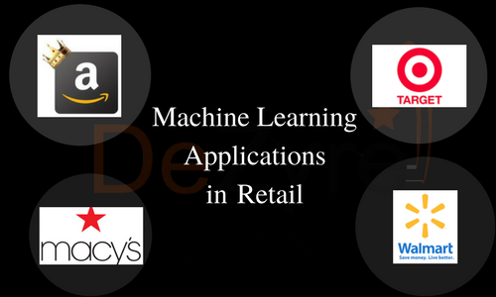
(FIG)
They need a solution which can analyse the data in real-time and provide valuable insights that can translate into tangible outcomes like repeat purchasing. Machine learning algorithms process this data intelligently and automate the analysis to make this supercilious goal possible for retail giants like Amazon, Target, Alibaba and Walmart.

3.7 Machine Learning Examples in Retail for Product Recommendations
According to The Realities of Online Personalisation Report, 42% of retailers are using personalized product recommendations using machine learning technology. It is no secret that customers always look for personalized shopping experiences, and these recommendations increase the conversion rates for the retailers resulting in fantastic revenue.
- The moment you start browsing for items on Amazon, you see recommendations for products you are interested in as “Customers Who Bought this Product Also Bought” and “Customers who viewed this product also viewed”, as well specific tailored product recommendation on the home page, and through email. Amazon uses Artificial Neural Networks machine learning algorithm to generate these recommendations for you.
- To make smart personalized recommendations, Alibaba has developed “E-commerce Brain” that makes use of real-time online data to build machine learning models for predicting what customers want and recommending the relevant products based on their recent order history, bookmarking, commenting, browsing history, and other actions.

3.8 MACHINE LEARNING APPLICATIONS IN TRAVEL
One of Uber’s biggest uses of machine learning comes in the form of surge pricing, a machine learning model nicknamed as “Geosurge” at Uber. If you are getting late for a meeting and you need to book an Uber in crowded area, get ready to pay twice the normal fare. In 2011, during New Year’s Eve in New York, Uber charged $37 to $135 for one mile journey

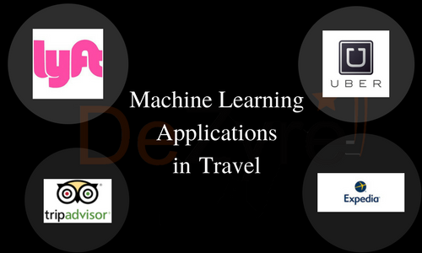

. Uber leverages predictive modelling in real-time based on traffic patterns, supply and demand. Uber has acquired a patent on surge pricing. However, customer backlash on surge-pricing is strong, so Uber is using machine learning to predict where demand will be high so that drivers can prepare in advance to meet the demand, and surge pricing can be reduced to a greater extent.

3.9 MACHINE LEARNING APPLICATIONS IN SOCIAL MEDIA
Machine learning offers the most efficient means of engaging billions of social media users. From personalizing news feed to rendering targeted ads, machine learning is the heart of all social media platforms for their own and user benefits. Social media and chat applications have advanced to a great extent that users do not pick up the phone or use email to communicate with brands – they leave a comment on Facebook or Instagram expecting a speedy reply than the traditional channels
Here are some machine learning examples that you must be using and loving in your social media accounts without knowing the fact that there interesting features are machine learning applications -

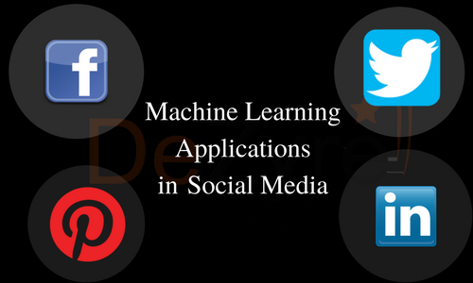

- Earlier Facebook used to prompt users to tag your friends but nowadays the social networks artificial neural networks machine learning algorithm identifies familiar faces from contact list. The ANN algorithm mimics the structure of human brain to power facial recognition.
- The professional network LinkedIn knows where you should apply for your next job, whom you should connect with and how your skills stack up against your peers as you search for new job.

3.10 PRINCIPAL COMPONENT ANALYSIS
The main idea of principal component analysis (PCA) is to reduce the dimensionality of a data set consisting of many variables correlated with each
other, either heavily or lightly, while retaining the variation present in the dataset, up to the maximum extent. The same is done by transforming the variables to a new set of variables, which are known as the principal components (or simply, the PCs) and are orthogonal, ordered such that the retention of variation present in the original variables decreases as we move down in the order. So, in this way, the 1st principal component retains maximum variation that was present in the original components. The principal components are the eigenvectors of a covariance matrix, and hence they are orthogonal.
Importantly, the dataset on which PCA technique is to be used must be scaled. The results are also sensitive to the relative scaling. As a layman, it is a method of summarizing data. Imagine some wine bottles on a dining table. Each wine is described by its attributes like colour, strength, age, etc. But redundancy will arise because many of them will measure related properties. So what PCA will do in this case is summarize each wine in the stock with less characteristics.
Intuitively, Principal Component Analysis can supply the user with a lower-dimensional picture, a projection or "shadow" of this object when viewed from its most informative viewpoint.
Data science is a "concept to unify statistics, data analysis, machine learning and their related methods" in order to "understand and analyze actual phenomena" with data It employs techniques and theories drawn from many fields within the context of mathematics, statistics, information science, and computer science. Data analysis is a process of inspecting, cleansing, transforming, and modeling data with the goal of discovering useful information, informing conclusions, and supporting decision-making. Data analysis has multiple facets and approaches, encompassing diverse techniques under a variety of names, while being used in different business, science, and social science domains. In today's business, data analysis is playing a role in making decisions more scientific and helping the business achieve effective operation.

3.11. MACHINE LEARNING APPLICATIONS IN SOCIAL MEDIA
Machine learning offers the most efficient means of engaging billions of social media users. From personalizing news feed to rendering targeted ads, machine learning is the heart of all social media platforms for their own and user benefits. Social media and chat applications have advanced to a great extent that users do not pick up the phone or use email. to communicate with brands – they leave a comment on Facebook or Instagram expecting a speedy reply than the traditional channels.
Here are some machine learning examples that you must be using and loving in your social media accounts without knowing the fact that there interesting features are machine learning applications -
- Earlier Facebook used to prompt users to tag your friends but nowadays the social networks artificial neural networks machine learning algorithm identifies familiar faces from contact list. The ANN algorithm mimics the structure of human brain to power facial recognition.
- The professional network LinkedIn knows where you should apply for your next job, whom you should connect with and how your skills stack up against your peers as you search for new job.

3.12 PRINCIPAL COMPONENT ANALYSIS
The main idea of principal component analysis (PCA) is to reduce the dimensionality of a data set consisting of many variables correlated with each other, either heavily or lightly, while retaining the variation present in the dataset, up to the maximum extent. The same is done by transforming the variables to a new set of variables, which are known as the principal components (or simply, the PCs) and are orthogonal, ordered such that the retention of variation present in the original variables decreases as we move down in the order. So, in this way, the 1st principal component retains maximum variation that was present in the original components. The principal components are the eigenvectors of a covariance matrix, and hence they are orthogonal.
Importantly, the dataset on which PCA technique is to be used must be scaled. The results are also sensitive to the relative scaling. As a layman, it is a method of summarizing data. Imagine some wine bottles on a dining table. Each wine is described by its attributes like colour, strength, age, etc. But redundancy will arise because many of them will measure related properties. So what PCA will do in this case is summarize each wine in the stock with less characteristics. Intuitively, Principal Component Analysis can supply the user with a lower-dimensional picture, a projection or "shadow" of this object when viewed from its most informative viewpoint.
Data science is a "concept to unify statistics, data analysis, machine learning and their related methods" in order to "understand and analyze actual phenomena" with data It employs techniques and theories drawn from many fields within the context of mathematics, statistics, information science, and computer science. Data analysis is a process of inspecting cleansing, transforming, and modeling data with the goal of discovering useful information, informing conclusions, and supporting decision-making. Data analysis has multiple facets and approaches, encompassing diverse techniques under a variety of names, while being used in different business, science, and social science domains. In today's business, data analysis is playing a role in making decisions more scientific and helping the business achieve effective operation.

CHAPTER-4
ADOPTION ALGORITHM
4.1 RANDOM FOREST ALGORITHM
Random Forest is one of the most popular and commonly used algorithms by Data Scientists. Random forest is a Supervised Machine Learning Algorithm that is used widely in Classification and Regression problems. It builds decision trees on different samples and takes their majority vote for classification and average in case of regression.
One of the most important features of the Random Forest Algorithm is that it can handle the data set containing continuous variables, as in the case of regression, and categorical variables, as in the case of classification. It performs better for classification and regression tasks. In this tutorial, we will understand the working of random forest and implement random forest on a classification task.
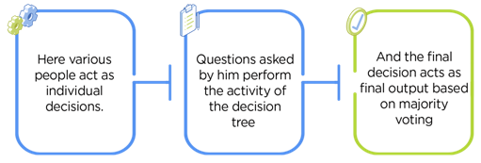

4.2 WORKING OF RANDOM FOREST ALGORITHM
Before understanding the working of the random forest algorithm in machine learning, we must look into the ensemble learning technique. Ensemble simply means combining multiple models. Thus, a collection of models is used to make predictions rather than an individual model.
Ensemble uses two types of methods:
1. Bagging– It creates a different training subset from sample training data with replacement & the final output is based on majority voting. For example, Random Forest.
2. Boosting– It combines weak learners into strong learners by creating sequential models such that the final model has the highest accuracy. For example, ADA BOOST, XG BOOST.
4.3 BAGGING
As mentioned earlier, Random Forest works on the Bagging principle. Now let’s dive in and understand bagging in detail.
Bagging, also known as Bootstrap Aggregation, is the ensemble technique used by random forest. Bagging chooses a random sample/random subset from the entire data set.
Hence each model is generated from the samples (Bootstrap Samples) provided by the Original Data with replacement known as row sampling. This step of row sampling with replacement is called bootstrap. Now each model is trained independently, which generates results.
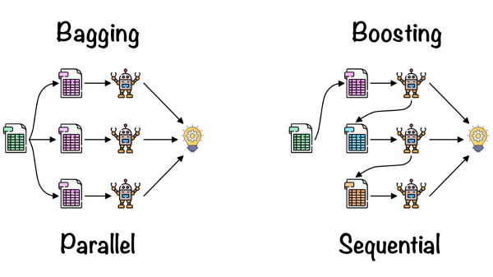

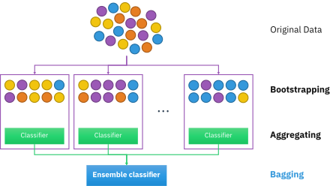

Now let’s look at an example by breaking it down with the help of the following figure. Here the bootstrap sample is taken from actual data (Bootstrap sample 01, Bootstrap sample 02, and Bootstrap sample 03) with a replacement which means there is a high possibility that each sample won’t contain unique data. The model (Model 01, Model 02, and Model 03) obtained from this bootstrap sample is trained independently. Each model generates results as shown. Now the Happy emoji has a majority when compared to the Sad emoji. Thus based on majority voting final output is obtained as Happy emoji.
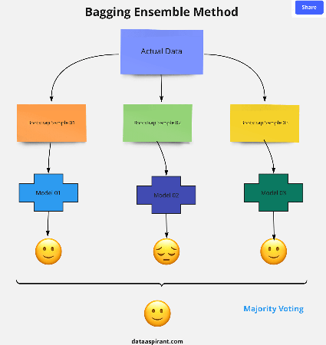

4.4 Boosting
Boosting is one of the techniques that use the concept of ensemble learning. A boosting algorithm combines multiple simple models (also known as weak learners or base estimators) to generate the final output. It is done by building a model by using weak models in series.
There are several boosting algorithms; AdaBoost was the first really successful boosting algorithm that was developed for the purpose of binary classification. AdaBoost is an abbreviation for Adaptive Boosting and is a prevalent boosting technique that combines multiple “weak classifiers” into a single “strong classifier.” There are Other Boosting techniques. For more, you can visit
4.4.1 STEPS INVOLVED IN RANDOM FOREST ALGORITHM
Step 1: In the Random Forest model, a subset of data points and a subset of features is selected for constructing each decision tree. Simply put, n random records and m features are taken from the data set having k number of records.
Step 2: Individual decision trees are constructed for each sample.
Step 3: Each decision tree will generate an output.
Step 4: Final output is considered based on Majority Voting or Averaging for Classification and regression, respectively.
For example: consider the fruit basket as the data as shown in the figure below. Now n number of samples are taken from the fruit basket, and an individual decision tree is constructed for each sample. Each decision tree will generate an output, as shown in the figure.
The final output is considered based on majority voting. In the below figure, you can see that the majority decision tree gives output as an apple when compared to a banana, so the final output is taken as an apple.

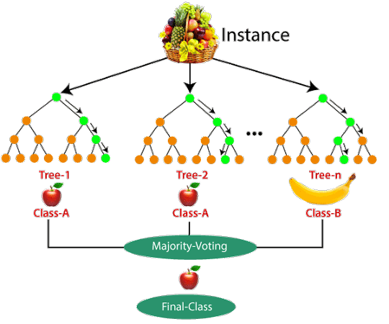

4.4.2 IMPORTANT FEATURE OF RANDOM FOREST
Diversity: Not all attributes/variables/features are considered while making an individual tree; each tree is different.
Immune to the curse of dimensionality: Since each tree does not consider all the
features, the feature space is reduced.
Parallelization: Each tree is created independently out of different data and attributes. This means we can fully use the CPU to build random forests.
Train-Test split: In a random forest, we don’t have to segregate the data for train and test as there will always be 30% of the data which is not seen by the decision tree.
Stability: Stability arises because the result is based on majority voting/ averaging.

4.5 DIFFERENCE BETWEEN DECISION TREE AND RANDOM FOREST

Random forest is a collection of decision trees; still, there are a lot of differences in their behavior.
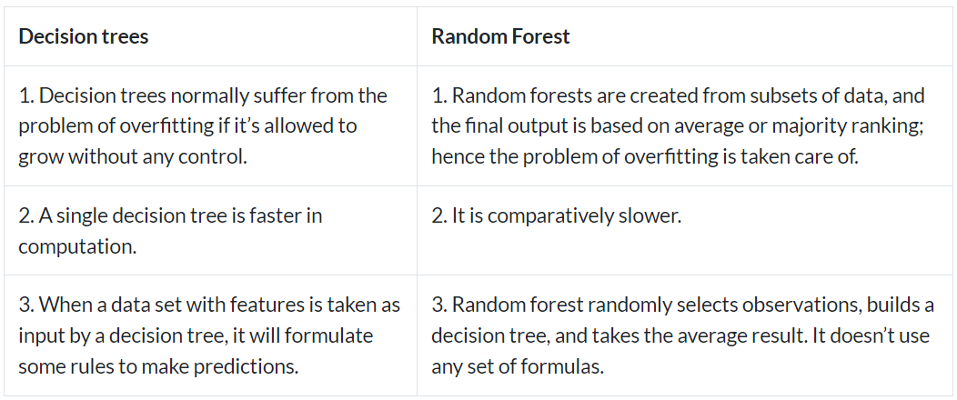

Thus random forests are much more successful than decision trees only if the trees are diverse and acceptable.
4.5.1 IMPORTANT HYPERPARAMETERS RANDOM FOREST

Hyperparameters are used in random forests to either enhance the performance and predictive power of models or to make the model faster.
Hyperparameters to Increase the Predictive Power
min_estimators: Number of trees the algorithm builds before averaging the predictions.
max_features: Maximum number of features random forest considers splitting a node.
mini_sample_leaf: Determines the minimum number of leaves required to split an internal node.
criterion: How to split the node in each tree? (Entropy/Gini impurity/Log Loss)
max_leaf_nodes: Maximum leaf nodes in each tree
Hyperparameters to Increase the Speed
n_jobs: it tells the engine how many processors it is allowed to use. If the value is 1, it can use only one processor, but if the value is -1, there is no limit.
random state: controls randomness of the sample. The model will always produce the same results if it has a definite value of random state and has been given the same hyperparameters and training data.
oob_score: OOB means out of the bag. It is a random forest cross-validation method. In this, one-third of the sample is not used to train the data; instead used to evaluate its performance. These samples are called out-of-bag samples.
Random forest is a great choice if anyone wants to build the model fast and efficiently, as one of the best things about the random forest is it can handle missing values. It is one of the best techniques with high performance, widely used in various industries for its efficiency. It can handle binary, continuous, and categorical data. Overall, random forest is a fast, simple, flexible, and robust model with some limitations.

CHAPTER 5
SYSTEM STUDY
5.1 EXISTING SYSTEM
In previous Emotion classification can be divided into two different categories: coarse-grained and fine-grained classification. Classifying emotions on a coarse-grained level (positive or negative) can be accurately perceived from text. Hancock et al. [8] used content analysis Linguistic Inquiry and Word Count (LIWC) to classify emotions as positive or negative. They found that positive emotions are expressed in text by using more exclamation marks and words, while negative emotions are expressed using more affective words. However, this method is limited to positive/negative emotions (happy vs. sad). On the other hand, classifying emotions on a fine grained level (for example, the six Ekman emotions) requires semantic and syntactic analysis of the sentence and can be done using three methods: (1) Keyword-based detection, (2) Learning-based detection, and (3) Hybrid detection. We discuss each family of methods separately.
5.2 DISADVANTAGES
- The existing work will be done without using NLP.
- Have complexities in text classification.

- It not only provides a measure of how appropriate a predictor (coefficient size)is, but also its direction of association (positive or negative).
5.3 PROPOSED SYSTEM
Text emotion prediction is a popular application of natural language processing (NLP) that involves determining the sentiment or emotion expressed in a given text. This task can be challenging due to the complexity and variability of human language, as well as the diverse ways in which emotions can be expressed. However, with the advent of machine learning and NLP techniques, it is now possible to build models that can accurately predict emotions from text. One effective approach for text emotion prediction is to use a Random Forest classifier with DictVectorizer. DictVectorizer is a tool that can convert a collection of text documents into a matrix of token occurrences, which can then be used as input to a machine learning algorithm.
The Random Forest algorithm is a decision tree-based ensemble method that can handle complex interactions between features, making it well-suited for NLP tasks such as text emotion prediction.
5.4 ADVANTAGES
- Robust predictions: Random Forest models are less prone to overfitting compared to other models, making them a good choice for text emotion prediction. This is because each tree in the forest is trained on a random subset of the data, which reduces the variance in the predictions.
- Feature importance: Random Forest can provide information on the importance of each feature in the model. This can be useful for understanding which words or features are most important in predicting emotions and can help guide further analysis.
- Handles high-dimensional data: NLP tasks often involve high-
- dimensional data, where each document may contain hundreds or thousands of features. Random Forest can handle this type of data efficiently, making it a scalable and effective method for text emotion prediction.

CHAPTER-6
SYSTEM DESIGN
6.1 INPUT DESIGN
Input design is the process of converting user-originated inputs to a computer-based format. Input design is one of the most expensive phases of the operation of computerized system and is often the major problem of a system.
Input design is a part of overall design, which requires careful attribute. Inaccurate input data are the most common cause of errors in data processing. The goa l of designing input data is to make data entry as easy, logical and free from errors. In the system design phase input data are collected and organized into groups of similar data

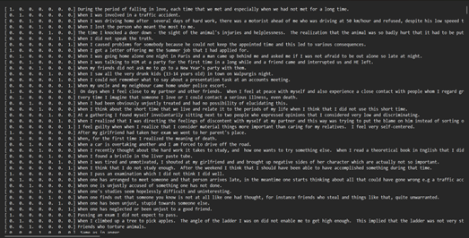

6.2 OUTPUT DESIGN

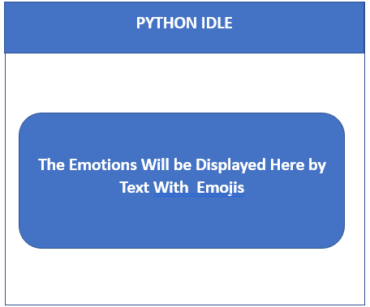

CHAPTER-7
SYSTEM IMPLEMENTATION
7.1 SYSTEM IMPLEMENTATION
System testing in text emotion detection using machine learning and NLP involves evaluating the performance and effectiveness of the emotion detection model. Here are some steps and considerations for conducting system testing:
7.2 DATA COLLECTION AND PREPROCESSING
Gather a dataset of text samples with corresponding emotion labels. Clean and preprocess the text data by removing noise, special characters, and irrelevant information. Perform tasks such as tokenization, stemming or lemmatization, removing stopwords, and normalizing the text. This step helps standardize the input data for training the emotion detection model.
7.3 FEATURE EXTRACTION
Extract relevant features from the preprocessed text data. Common techniques include bag-of-words (BoW), term frequency-inverse document frequency (TF-IDF), or word embeddings such as Word2Vec or GloVe. These features represent the textual information that the model will use for emotion detection.
7.4 MODEL SELECTION
Choose an appropriate machine learning algorithm or model for text emotion detection. Popular choices include Support Vector Machines (SVM), Naive Bayes, Random Forests, or deep learning models such as Recurrent Neural Networks (RNNs) or Transformer-based models like BERT.
7.5 TRAINING
Split the dataset into training and validation sets. Train the selected model using the training data, feeding it the extracted features and corresponding emotion labels. The model learns to map the input text features to the correct emotion categories during this process.
7.6 MODEL EVALUATION
Evaluate the trained model's performance using the validation set. Calculate metrics such as accuracy, precision, recall, and F1 score to assess its effectiveness in detecting emotions. Adjust the model's hyperparameters, such as learning rate or regularization strength, to improve its performance if necessary.
7.7 HYPERPARAMETER TUNNING
Fine-tune the model's hyperparameters using techniques like grid search or random search. This process involves systematically varying hyperparameter values and evaluating their impact on the model's performance. Choose the set of hyperparameters that yield the best results.
7.8 TESTING
Once you have a trained and optimized model, test its performance on a separate test dataset that was not used during training or validation. This step provides an unbiased assessment of the model's ability to generalize to new, unseen text samples.
7.9 DEPLOYME
Integrate the trained model into your desired application or system. Provide an interface or API through which users can input text, and the model can predict the associated emotions. Ensure that the deployment environment has the necessary dependencies and resources to support the model's execution.
7.10 CONTINUOUS IMPROVEMENT
Monitor the model's performance in the real-world environment, gather user feedback, and collect additional data if needed. Continuously evaluate and update the model to enhance its accuracy and adapt to evolving language patterns or user requirements.
Remember that these steps provide a general framework, and the specific implementation details may vary based on the chosen algorithms, frameworks, and programming languages.

CHAPTER-8

SOFTWARE DESCRIPTION
8.1 PYTHON
Python is an open source programming language. Python was made to be easy-to-read and powerful. A Dutch programmer named Guido van Rossum made Python in 1991. He named it after the television show Monty Python's Flying Circus. Many Python examples and tutorials include jokes from the show.
Python is an interpreted language. Interpreted languages do not need to be compiled to run. A program called an interpreter runs Python code on almost any kind of computer. This means that a programmer can change the code and quickly see the results. This also means Python is slower than a compiled language like C, because it is not running machine code directly.
Python is a good programming language for beginners. It is a high-level language, which means a programmer can focus on what to do instead of how to do it. Writing programs in Python takes less time than in some other languages.Python drew inspiration from other programming languages like C, C++, Java, Perl, and Lisp.
Python has a very easy-to-read syntax. Some of Python's syntax comes from C, because that is the language that Python was written in. But Python uses whitespace to delimit code: spaces or tabs are used to organize code into groups. This is different from C. In C, there is a semicolon at the end of each line and curly braces ({}) are used to group code. Using whitespace to delimit code makes
Python a very easy-to-read language.
Python is used by hundreds of thousands of programmers and is used in many places. Sometimes only Python code is used for a program, but most of the time it is used to do simple jobs while another programming language is used to do more complicated tasks.
Its standard library is made up of many functions that come with Python when it is installed. On the Internet there are many other libraries available that make it possible for the Python language to do more things. These libraries make it a powerful language; it can do many different things.
Some things that Python is often used for are:
- Web development
- Game programming
- Desktop GUIs
- Scientific programming
- Network programming.
Version 1
Python reached version 1.0 in January 1994. The major new features included in this release were the functional programming tools lambda, map, filter and reduce. Van Rossum stated that "Python acquired lambda, reduce(), filter() and map(), courtesy of a Lisp hacker who missed them and submitted working patches’’
The last version released while Van Rossum was at CWI was Python 1.2. In 1995, Van Rossum continued his work on Python at the Corporation for National Research Initiatives (CNRI) in Reston, Virginia whence he released several versions.
By version 1.4, Python had acquired several new features. Notable among these are the Modula-3 inspired keyword arguments (which are also similar to Common Lisp's keyword arguments) and built-in support for complex numbers. Also included is a basic form of data hiding by name mangling, though this is easily bypassed.
During Van Rossum's stay at CNRI, he launched the Computer Programming for Everybody (CP4E) initiative, intending to make programming more accessible to more people, with a basic "literacy" in programming languages, similar to the basic English literacy and mathematics skills required by most employers. Python served a central role in this: because of its focus on clean syntax, it was already suitable, and CP4E's goals bore similarities to its predecessor, ABC. The project was funded by DARPA.[13] As of 2007, the CP4E project is inactive, and while Python attempts to be easily learnable and not too arcane in its syntax and semantics, reaching out to non-programmers is not an active concern.
In 2000, the Python core development team moved to BeOpen.com to form the BeOpen Python Labs team. CNRI requested that a version 1.6 be released, summarizing Python’s development up to the point at which the development team left CNRI. Consequently, the release schedules for 1.6 and 2.0 had a significant amount of overlap.Python 2.0 was the only release from BeOpen.com.
After Python 2.0 was released by BeOpen.com, Guido van Rossum and the other PythonLabs developers joined Digital Creations.
The Python 1.6 release included a new CNRI license that was substantially longer than the CWI license that had been used for earlier releases. The new license included a clause stating that the license was governed by the laws of the State of Virginia. The Free Software Foundation argued that the choice-of-law clause was incompatible with the GNU General Public License. BeOpen, CNRI and the FSF negotiated a change to Python's free software license that would make it GPL-compatible. Python 1.6.1 is essentially the same as Python 1.6, with a few minor bug fixes, and with the new GPL-compatible license.
Version 2
Python 2.0 introduced list comprehensions, a feature borrowed from the functional programming languages SETL and Haskell. Python's syntax for this construct is very similar to Haskell's, apart from Haskell's preference for punctuation characters and Python's preference for alphabetic keywords. Python 2.0 also introduced a garbage collection system capable of collecting reference cycles.[7]
Python 2.1 was close to Python 1.6.1, as well as Python 2.0. Its license was renamed Python Software Foundation License. All code, documentation and specifications added, from the time of Python 2.1's alpha release on, is owned by the Python Software Foundation (PSF), a non-profit organization formed in 2001,
modeled after the Apache Software Foundation.[15] The release included a change to the language specification to support nested scopes, like other statically scoped languages.[16] (The feature was turned off by default, and not required, until Python 2.2.)
A major innovation in Python 2.2 was the unification of Python's types (types written in C) and classes (types written in Python) into one hierarchy. This single unification made Python's object model purely and consistently object oriented. Also added were generators which were inspired by Icon.
Python 2.5 was released on September 2006 and introduced the with statement, which encloses a code block within a context manager (for example, acquiring a lock before the block of code is run and releasing the lock afterwards, or opening a file and then closing it), allowing Resource Acquisition Is Initialization (RAII)-like behavior and replacing a common try/finally idiom.
Python 2.6 was released to coincide with Python 3.0, and included some features from that release, as well as a "warnings" mode that highlighted the use of features that were removed in Python 3.0.Similarly, Python 2.7 coincided with and included features from Python 3.1,which was released on June 26, 2009.
Parallel 2.x and 3.x releases then ceased, and Python 2.7 was the last release in the 2.x series. In November 2014, it was announced that Python 2.7 would be supported until 2020, but users were encouraged to move to Python 3 as soon as possible.
Version 3
Python 3.0 (also called "Python 3000" or "Py3K") was released on December 3, 2008 It was designed to rectify fundamental design flaws in the language—the changes required could not be implemented while retaining full backwards compatibility with the 2.x series, which necessitated a new major version number. The guiding principle of Python 3 was: "reduce feature duplication by removing old ways of doing things".
Python 3.0 was developed with the same philosophy as in prior versions. However, as Python had accumulated new and redundant ways to program the same task, Python 3.0 had an emphasis on removing duplicative constructs and modules, in keeping with "There should be one— and preferably only one —obvious way to do it".
Nonetheless, Python 3.0 remained a multi-paradigm language. Coders still had options among object-orientation, structured programming, functional programming and other paradigms, but within such broad choices, the details were intended to be more obvious in Python 3.0 than they were in Python 2.x.
Python 2.7.0
Note: A bugfix release, 2.7.13, is currently available. Its use is recommended.
Python 2.7.0 was released on July 3rd, 2010.
Python 2.7 is scheduled to be the last major version in the 2.x series before it moves into an extended maintenance period. This release contains many of the features that were first released in Python 3.1. Improvements in this release include:
- An ordered dictionary type
- New unit test features including test skipping, new assert methods, and test discovery
- A much faster io module
- Automatic numbering of fields in the St. Format() method
- Float repr improvements backported from 3.x
- Tile support for Tkinter
- A backport of the memoryview object from 3.x
- Set literals.
- Set and dictionary comprehensions.
- Dictionary views
- New syntax for nested with statements

8.2 MODULES
1.NUMPY
2.PANDAS
3.SKLEARN
8.2.1 NUMPY
NumPy is a Python package. It stands for &#39; Numerical Python&#39; It is a library consisting of multidimensional array objects and a collection of routines.
For processing of array.
Numeric, the ancestor of NumPy, was developed by Jim Hugunin. Another
package Numarray was also developed, having some additional functionalities. In
2005, Travis Oliphant created NumPy package by incorporating the features of
Numarray into Numeric package. There are many contributors to this open source
project.
Operations using NumPy
Using NumPy, a developer can perform the following operations −
• Mathematical and logical operations on arrays.
• Fourier transforms and routines for shape manipulation.
• Operations related to linear algebra. NumPy has in-built functions for linear
algebra and random number generation.
NumPy – A Replacement for MatLab
NumPy is often used along with packages like SciPy (Scientific Python)
and Mat−plotlib (plotting library). This combination is widely used as a
replacement for MatLab, a popular platform for technical computing. However,
Python alternative to MatLab is now seen as a more modern and complete
programming language.
It is open source, which is an added advantage of NumPy.
INSTALLATION
pip install &quot;numpy”
8.2.2 PANDAS
Pandas is an open-source, BSD-licensed Python library providing high-
performance, easy-to-use data structures and data analysis tools for the Python
programming language. Python with Pandas is used in a wide range of fields
including academic and commercial domains including finance, economics,
Statistics, analytics, etc. In this tutorial, we will learn the various features of
Python Pandas and how to use them in practice.
Pandas deals with the following three data structures −
- Series
- DataFrame
- Panel
These data structures are built on top of Numpy array, which means they are fast.
INSTALLATION
Pip install pandas
8.2.3 SKLEARN
Scikit-learn is a machine learning library for Python. It features several regression,
classification and clustering algorithms including SVMs, gradient boosting, k-
means, random forests and DBSCAN. It is designed to work with
Python Numpy and SciPy .
The scikit-learn project kicked off as a Google Summer of Code (also known as
GSoC) project by David Cournapeau as scikits.learn. It gets its name from
“Scikit”, a separate third-party extension to SciPy.
Python Scikit-learn
Scikit is written in Python (most of it) and some of its core algorithms are written
in Cython for even better performance.
Scikit-learn is used to build models and it is not recommended to use it for reading,
manipulating and summarizing data as there are better frameworks available for
the purpose.
It is open source and released under BSD license.
Install Scikit Learn
Scikit assumes you have a running Python 2.7 or above platform with NumPY
(1.8.2 and above) and SciPY (0.13.3 and above) packages on your device. Once we
have these packages installed we can proceed with the installation.
pip install scikit-learn
8.3 FLASK
What is Flask?
Flask is an API of Python that allows us to build up web-applications. It was
developed by Armin Ronacher. Flask’s framework is more explicit than Django’s
framework and is also easier to learn because it has less base code to implement a simple web-Application. A Web-Application Framework or Web Framework is the collection of modules and libraries that helps the developer to write
applications without writing the low-level codes such as protocols, thread
management, etc. Flask is based on WSGI(Web Server Gateway Interface) toolkit
and Jinja2 template engine.
8.4 ROUTING
Nowadays, the web frameworks provide routing technique so that user can
remember the URLs. It is useful to access the web page directly without
navigating from the Home page. It is done through the
following route() decorator, to bind the URL to a function.
Building URL in FLask:
Dynamic Building of the URL for a specific function is done
using url_for() function. The function accepts the name of the function as first
argument, and one or more keyword arguments. See this example.

8.5 E-R DIAGRAM
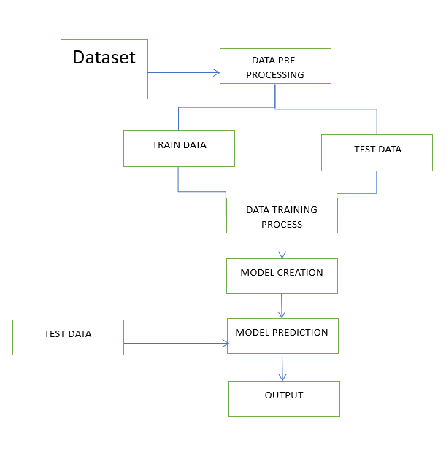

CHAPTER-9
CONCLUSION
9.1 Conclusion
The most important part is getting good quality of data. Often tweets retrieved consists of only URLs and hence pre-processing data still remains one of the most crucial steps which needs to be improved. Secondly, only explicit emotions are explored in the tweet so detecting implicit emotions in objective sentences can in included in future work. At present, each sentence is treated as individual unit. Further the association between the sentences can be included. The proposed system works at the syntactic level only, semantic level parsing can be implemented further. Finally, the Bag of words needs to be more exhaustive and hence more words describing emotions can be added to these bags In conclusion, using a Random Forest classifier with DictVectorizer for text emotion prediction can be a highly effective approach. DictVectorizer is useful for
converting text data into a format that can be used by the classifier, while the Random Forest algorithm can handle complex interactions between features and can provide robust predictions. Additionally, Random Forest models are less prone to overfitting compared to other models, making them a good choice for this task. Overall, the accuracy of the model will depend on the quality and quantity of the data used for training and testing.
It is also important to consider other factors such as feature selection and preprocessing techniques, as well as the specific requirements of the problem at hand.
Nonetheless, the combination of DictVectorizer and Random Forest can be a powerful tool for text emotion prediction, with potential applications in sentiment analysis, customer feedback analysis, and social media monitoring, among others.

CHAPTER-10
FUTURE ENHANCEMENT
In the future, there are several potential enhancements for text emotion detection using machine learning and natural language processing (NLP). Some of these advancements could include:
Contextual Understanding: Future models may improve their ability to understand the contextual nuances of emotions in text. This could involve considering not only the words used but also the surrounding sentences, the speaker's intent, and the overall context of the conversation.
Multimodal Analysis: Emotion detection can be enhanced by incorporating multimodal analysis, which combines textual information with other modalities such as images, audio, and video. By integrating multiple data sources, models can capture a richer representation of emotions, leading to more accurate predictions.
Transfer Learning: Transfer learning, where a model trained on a large dataset is fine-tuned for a specific task, can be utilized to improve emotion detection. Pretrained models on general language understanding can be adapted to emotion detection tasks, allowing for better performance with limited data.
Fine-grained Emotion Recognition: Emotions are complex and can have subtle variations. Future models may aim to recognize and classify emotions at a more
fine-grained level, moving beyond the basic categories (e.g., happy, sad, angry) to capture more nuanced emotions like sarcasm, irony, or ambivalence.
User-specific Adaptation: Emotion detection models could be personalized to individual users, considering their unique linguistic patterns, cultural backgrounds, and emotional expressions. Personalized models can better understand and interpret emotions based on an individual's writing style and history, leading to more accurate predictions.
Handling Sarcasm and Irony: Detecting sarcasm and irony in text is a challenging task. Future models could focus on improving their ability to recognize these forms of expression by incorporating semantic and contextual understanding. This could involve training models on datasets specifically curated to capture sarcasm and irony.
Domain-specific Emotion Detection: Emotion detection models can be enhanced by training them on domain-specific data. By specializing in certain domains (e.g., social media, customer support, healthcare), models can better understand the unique emotional expressions and language used in those contexts.
Real-time Emotion Detection: As technology advances, real-time emotion detection in live conversations or streams of text can become more feasible. This would allow for immediate analysis of emotions, enabling applications such as sentiment analysis in customer service or real-time emotional monitoring in social media.
Ethical Considerations: Future advancements should also prioritize ethical considerations. Researchers and developers should address biases and ensure
fairness in emotion detection models, avoiding the amplification of stereotypes or discriminatory practices.
These are just a few potential enhancements for text emotion detection using machine learning and NLP. As research progresses and technology advances, we can expect further improvements in this field.

Reference

1] Bing Liu (2009) Sentiment Analysis and Subjectivity, Handbook
- YasminaDouiji and HazarMousanifI-CARE - Intelligent Context Aware system for Recognizing Emotions from text
- Agarwal A 2012 Unsupervised Emotion Detection from Text using Semantic and Syntactic Relations IEEE/WIC/ACM International Conference on Web Intelligence and intelligent Agent Technology pp 346-353
- Haxby J V, Hoffman and Gobbini M I 2002 Human neural system for face recognition and social communication. Pyschiatry51pp 59-67
- Nilesh 2014 Approaches of Emotion Detection from Text International Journal of Computer Science and Information Technology Research2pp 123-128\
- Ekman P 2015 An Argument for Basic Emotion International Journal of Cognition and Emotion 6
- Chatterjee A, Gupta U, Chinnakotla MK, Srikanth R, Galley M, Agrawal P. Understanding emotions in text using deep learning and big data. Comput Hum Behav. 2019;93:309–17.
- Rodríguez AOR, Riaño MA, García PAG, Marín CEM, Crespo RG, Wu X. Emotional characterization of children through a learning environment
- using learning analytics and AR-Sandbox. J Ambient Intell Human Comput. 2020;11:1–15.
- Hossain MS, Muhammad G. Emotion recognition using deep learning approach from audio–visual emotional big data. Inf Fusion. 2019;49:69–78.
- Zhang H, Jolfaei A, Alazab M. A face emotion recognition method using convolutional neural network and image edge computing. IEEE Access. 2019;7:159081–9.
- Kanjo E, Younis EM, Ang CS. Deep learning analysis of mobile physiological, environmental and location sensor data for emotion detection. Inf Fusion. 2019;49:46–56.
- Chen T, Ju S, Yuan X, Elhoseny M, Ren F, Fan M, et al. Emotion recognition using empirical mode decomposition and approximation entropy. Comput Electr Eng. 2018;72:383–92.
- Shrivastava K, Kumar S, Jain DK. An effective approach for emotion
- detection in multimedia text data using sequence based convolutional neural network. Multimed Tools Appl. 2019;78(20):29607–39.
- Asghar MZ, Subhan F, Ahmad H, Khan WZ, Hakak S, Gadekallu TR, et al. Senti-eSystem: a sentiment-based eSystem-using hybridized fuzzy and
- deep neural network for measuring customer satisfaction. Software Pract Exper. 2021;51(3):571–94.
- Hasan M, Rundensteiner E, Agu E. Automatic emotion detection in text
- streams by analyzing twitter data. Int J Data Sci Analytics. 2019;7(1):35–51.
- Alazab R. 0038 children below 5 years of employed mothers are less
exposed to acute poisoning in Alexandria, Egypt. Occup Environ Med. 2014;71(Suppl 1):A63.
- Dash S, Luhach AK, Chilamkurti N, Baek S, Nam Y. A Neuro-fuzzy
- approach for user behaviour classification and prediction. J Cloud Comput. 2019;8(1):17.
- Awad A, Obayan A, Salhab S, Roufayel R, Kadry S. Effect of smoking on appetite, concentration and stress level. Glob J Health Sci. 2020;12(1):139–9.

APPENDIX-1
SOURCE CODE

import re
from collections import Counter
from sklearn.model_selection import train_test_split
from sklearn.metrics import accuracy_score
from sklearn.ensemble import RandomForestClassifier
import warnings
from flask import Flask, render_template, request
import warnings
warnings.filterwarnings('ignore')
app = Flask(__name__)
# Rest of the code...
def read_data(file):
data = []
with open(file, 'r')as f:
for line in f:
line = line.strip()
label = ' '.join(line[1:line.find("]")].strip().split())
text = line[line.find("]")+1:].strip()
data.append([label, text])
return data

file = 'C:/Users/BHARATHIPRIYAN B/Pictures/Text_Emotion/hey/text.txt'
data = read_data(file)
print("Number of instances: {}".format(len(data)))

def ngram(token, n):
output = []
for i in range(n-1, len(token)):
ngram = ' '.join(token[i-n+1:i+1])
output.append(ngram)
return output

def create_feature(text, nrange=(1, 1)):
text_features = []
text = text.lower()
text_alphanum = re.sub('[^a-z0-9#]', ' ', text)
for n in range(nrange[0], nrange[1]+1):
text_features += ngram(text_alphanum.split(), n)
text_punc = re.sub('[a-z0-9]', ' ', text)
text_features += ngram(text_punc.split(), 1)
return Counter(text_features)
def convert_label(item, name):
items = list(map(float, item.split()))
label = ""
for idx in range(len(items)):
if items[idx] == 1:
label += name[idx] + " "

return label.strip()

emotions = ["joy", 'fear', "anger", "sadness", "disgust", "shame", "guilt"]

X_all = []
y_all = []
for label, text in data:
y_all.append(convert_label(label, emotions))
X_all.append(create_feature(text, nrange=(1, 4)))

X_train, X_test, y_train, y_test = train_test_split(X_all, y_all, test_size = 0.2, random_state = 123)

def train_test(clf, X_train, X_test, y_train, y_test):
clf.fit(X_train, y_train)
train_acc = accuracy_score(y_train, clf.predict(X_train))
test_acc = accuracy_score(y_test, clf.predict(X_test))
return train_acc, test_acc

from sklearn.feature_extraction import DictVectorizer
vectorizer = DictVectorizer(sparse = True)
X_train = vectorizer.fit_transform(X_train)
X_test = vectorizer.transform(X_test)

##svc = SVC()
##lsvc = LinearSVC(random_state=123)
clf = RandomForestClassifier(random_state=123)
##dtree = DecisionTreeClassifier()

##clifs = [svc, lsvc, rforest, dtree]

# train and test them
print("| {:25} | {} | ".format("Classifier", "Accuracy"))
print("| {} | {} |".format("-"*25, "-"*17))
##for clf in clifs:
clf_name = clf.__class__.__name__
train_acc, test_acc = train_test(clf, X_train, X_test, y_train, y_test)
print("| {:25} | {:17.7f} |".format(clf_name, train_acc))

l = ["joy", 'fear', "anger", "sadness", "disgust", "shame", "guilt"]
l.sort()
label_freq = {}
for label, _ in data:
label_freq[label] = label_freq.get(label, 0) + 1

# print the labels and their counts in sorted order
for l in sorted(label_freq, key=label_freq.get, reverse=True):
print("{:10}({}) {}".format(convert_label(l, emotions), l, label_freq[l]))

emoji_dict = {"joy":"😂", "fear":"😱", "anger":"😠", "sadness":"😢", "disgust":"😒", "shame":"😳", "guilt":"😳"}
t1 = "This looks so impressive"
t2 = "I have a fear of dogs"
t3 = "My dog died yesterday"
t4 = "I don't love you anymore..!"

texts = [t1, t2, t3, t4]
for text in texts:
features = create_feature(text, nrange=(1, 4))
features = vectorizer.transform(features)
prediction = clf.predict(features)[0]
print( text,emoji_dict[prediction])

# Route to handle the prediction request
@app.route('/')
def home():
return render_template('index.html')

@app.route('/predict', methods=['POST'])
def predict():
# Get the text input from the form
text = request.form['text']

# Use the text to make predictions
features = create_feature(text, nrange=(1, 4))
features = vectorizer.transform(features)
prediction = clf.predict(features)[0]
emoji = emoji_dict[prediction]

# Render the result template with the prediction
return render_template('result.html', prediction=prediction, emoji=emoji)

if __name__ == '__main__':
app.run()

# Rest of the code..

INDEX CODE
<html>
<body>
<h2>Enter Text:</h2>
<form action="/predict" method="post">
<textarea name="text" rows="4" cols="50"></textarea><br><br>
<input type="submit" value="Predict">
</form>
</body>
</html>

CODE IN CSS
.container {
max-width: 600px;
margin: 0 auto;
padding: 20px;
}

h1 {
text-align: center;
}

.input-section ul {
padding: 0;
list-style-type: none;
}

.input-section ul li {
margin-bottom: 10px;
}
.container {
max-width: 600px;
margin: 0 auto;
padding: 20px;
}

h1 {
text-align: center;
}

.input-section ul {
padding: 0;
list-style-type: none;
}

.input-section ul li {
margin-bottom: 10px;
}

APPENDIX-2
SAMPLE OUTPUT
