Face Recognition based Attendance

Management System
Somrup Roy, Subhajeet Mondal, Mamon Sahid, Kusal Thakur Dept. of Computer Science and Engineering
JIS UNIVERSITY
Kolkata, India

Abstract— In this digital era, face recognition system plays a vital role in almost every sector. Face recognition is one of the mostly used biometrics. It can used for security, authentication, identification, and has got many more advantages. Despite of having low accuracy when compared to iris recognition and fingerprint recognition, it is being widely used due to its contactless and non-invasive process. Furthermore, face recognition system can also be used for attendance marking in schools, colleges, offices, etc. This system aims to build a class attendance system which uses the concept of face recognition as existing manual attendance system is time consuming and cumbersome to maintain. And there may be chances of proxy attendance. Thus, the need for this system increases. This system consists of four phases- database creation, face detection, face recognition, attendance updation. This device is installed in the classroom, where and student's information, such as name, roll number,class, sec, and photographs, is trained. The images are extracted using Open CV. Before the start of the corresponding class, the student can approach the machine, which will begin taking pictures and comparing them to the qualified dataset. The image is processed as follows: first, faces are identified using a ML classifier, then faces are recognized using the Algorithm, histogram data is checked against an established dataset, and the device automatically labels attendance. An Excel sheet is developed, and it is updated every hour with the information from the respective class instructor.
KEYWORDS - Face Recognition; Face Detection; ML classifier; attendance system;

- INTRODUCTION
Traditional method of attendance marking is a tedious task in many schools and colleges. It is also an extra burden to the
to the faculties who should mark attendance by manually calling the names of students which might take about 5 minutes of entire session. This is time consuming. There are some chances of proxy attendance. Therefore, many institutes started deploying many other techniques for recording attendance like use of Radio Frequency Identification (RFID) [3], iris recognition [4], fingerprint recognition, and so on. However, these systems are queue based which might consume more time and are intrusive in nature. Face recognition has set an important biometric feature, which can be easily acquirable and is non-intrusive. Face recognition based systems are relatively oblivious to various facial expression. Face recognition system consists of two categories: verification and face identification. Face verification is an 1:1 matching process, it compares face image against the template face images and whereas is an 1:N problems that compares a query face images [1]. The purpose of this system is to build a attendance system which is based on face recognition techniques. Here face of an individual will be considered for marking attendance. Nowadays, face recognition is gaining more popularity and fame . This new system will consume less time than compared to traditional methods.
- LITERATURE SURVEY
Authors in [3] proposed a model of an automated attendance system. The model focuses on how face recognition incorporated with Radio Frequency Identification (RFID) detect the authorized students and counts as they get in and get out form the classroom. The system keeps the authentic record of every registered student. The system also keeps the data of every student registered for a particular course in the

attendance log and provides necessary information according to the need. In this paper [4], authors have designed and implemented an attendance system which uses iris biometrics. Initially, the attendees were asked to register their details along with their unique iris template. At the time of attendance, the system automatically took class attendance by capturing the eye image of each attendee, recognizing their iris, and searching for a match in the created database. The prototype was web based. In [5], authors proposed an attendance system based on facial recognition. The algorithms like Viola-Jones and Histogram of Oriented Gradients (HOG) features along with Support Vector Machine (SVM) classifier were used to implement the system. Various real time scenarios such as scaling, illumination, occlusions and pose was considered by the authors. Quantitative analysis was done on the basis of Peak Signal to Noise Ratio (PSNR) values and was implemented in MATLAB GUI. Authors in [6] researches to get best facial recognition algorithm (Eigenface and Fisherface) provided by the Open CV 2.4.8 by comparing the Receiver Operating Characteristics (ROC) curve and then implemented it in the attendance system. Based on the experiments carried out in this paper, the ROC curve proved that, Eigenface achieves better result than Fisherface. System implemented using Eigenface algorithm achieved an accuracy rate of 70% to 90%. In [7], authors proposed a method for student attendance system in classroom using face recognition technique by combining Discrete Wavelet Transforms (DWT) and Discrete Cosine Transform (DCT). These algorithms were used to extract the features of student’s face followed by applying Radial Basis Function (RBF) for classifying the facial objects. This system achieved an accuracy rate of 82%.

- PROPOSED SYSTEM
All the students of the class must register themselves by entering the required details and then their images will be captured and stored in the dataset. The faces detected will be compared with images present in the dataset. If match found, attendance will be marked for the respective student.
Steps in Digital Image Processing:

Digital image processing involves the following basic tasks:
- Image Acquisition - An imaging sensor and the capability to digitize the signal produced by the sensor.
- Preprocessing – Enhances the image quality, filtering, contrast enhancement etc.

  - Segmentation – Partitions an input image into constituent parts of objects.
  - Description/feature Selection – extracts the description of image objects suitable for further computer processing.
  - Recognition and Interpretation – Assigning a label to the object based on the information provided by its descriptor.
Interpretation assigns meaning to a set of labelled objects.
  - Knowledge Base – This helps for efficient processing as well as inter module cooperation
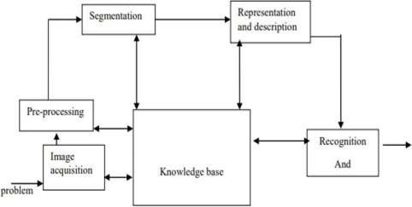
FIG 1
FLOWCHART OF THE PROPOSED SYSTEM
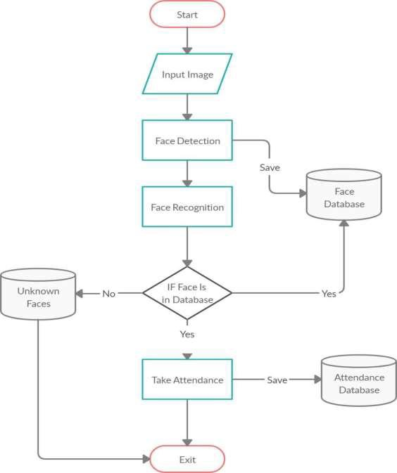

FIG 2

- Dataset Creation
Images of students are captured using a web cam. Multiple images of single student will be acquired with varied gestures and angles. These images undergo pre- processing. The images are cropped to obtain the Region of Interest (ROI) which will be further used in recognition process. Next step is to resize the cropped images to particular pixel position. Then these images will be converted from RGB to gray scale images. And then these images will be saved as the names of respective student in a folder.
- Face Detection
Face detection here is performed using Haar-Cascade Classifier with OpenCV. Haar Cascade algorithm needs to be trained to detect human faces before it can be used for face detection. This is called feature extraction. The haar cascade training data used is an xml filehaarcascade_frontalface_default. The haar features shown in Fig.3. will be used for feature extraction.
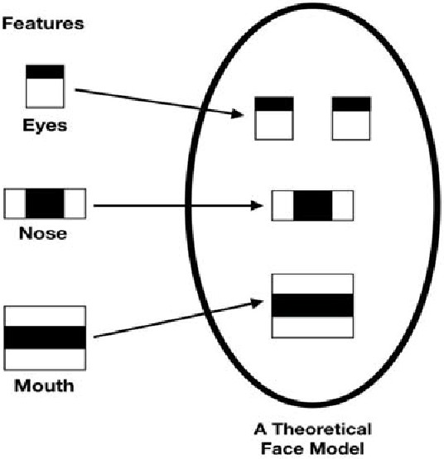
FIG 3
Here we are using detectMultiScale module from OpenCV. This is required to create a rectangle around the faces in an image. It has got three parameters to consider- scaleFactor, minNeighbors, minSize. scaleFactor is used to indicate how much an image must be reduced in each image scale. minNeighbors specifies how many neighbors each candidate rectangle must have. Higher values usually detects less faces but detects high quality in image. minSize specifies the minimum object size. By default it is (30,30) [8]. The parameters used in this system is scaleFactor and minNeighbors with the values 1.3 and 5 respectively.
- Face Recognition
Face recognition process can be divided into three stepsprepare training data, train face recognizer, prediction. Here training data will be the images present in the dataset. They will be assigned with a integer label of the student it belongs to. These images are then used for face recognition. Face recognizer used in this system is Local Binary Pattern Histogram. Initially, the list of local binary patterns (LBP) of entire face is obtained. These LBPs are converted into decimal number and then histograms of all those decimal values are made. At the end, one histogram will be formed for each images in the training data. Later, during recognition process histogram of the face to be recognized is calculated and then compared with the already computed histograms and returns the best matched label associated with the student it belongs to [9].
- Attendance Updation
After face recognition process, the recognized faces will be marked as present in the excel sheet.


FIG 4


FIG 5

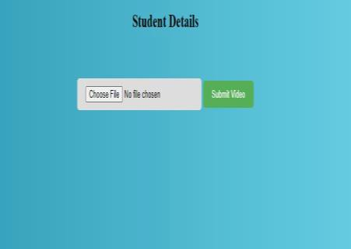In every session, respective faculty must enter their course code. Then after submitting the course code, the camera will start automatically. The Fig 8 , 9 shows the face recognition window where two registered students are recognized and if in case they were not registered it would have shown ‘unknown’. By pressing CTRL+Q, the window will be closed and attendance will be updated in the excel sheet

FIG 6 FIG 7


FIG 8

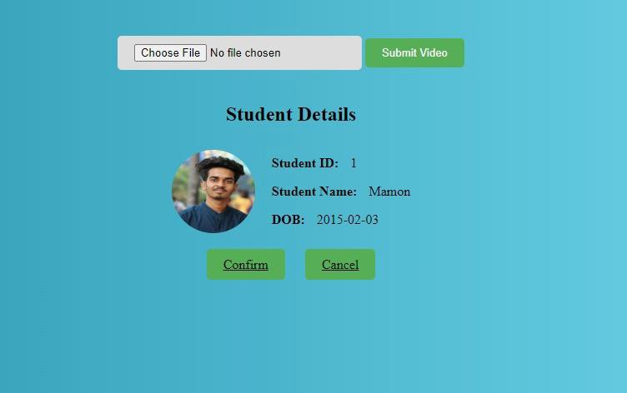
FIG 9
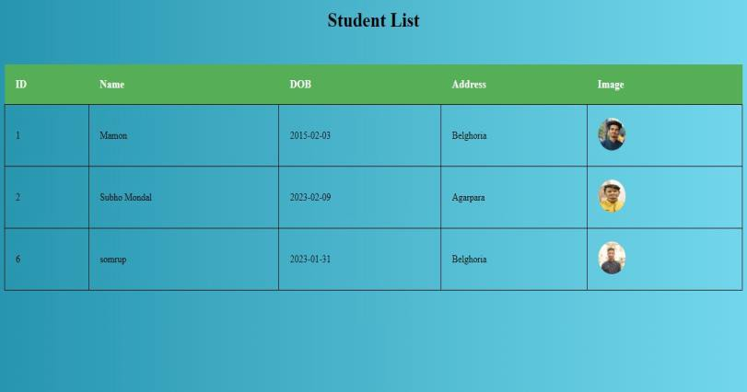
FIG 10
V. CONCLUSION
Face recognition systems are part of facial image processing applications and their significance as a research area are increasing recently. Implementations of system are crime prevention, video surveillance, person verification, and similar security activities. The face recognition system implementation can be part of universities. Face Recognition Based Attendance System has been envisioned for the purpose of reducing the errors that occur . in the traditional (manual) attendance taking system. The aim is to automate and make a system that is useful to the organization such as an institute. The efficient and accurate method of attendance in the office environment that can replace the old manual methods. This method is secure enough, reliable and available for use. Proposed algorithm is capable of detect multiple faces, and performance of system has acceptable good results.

REFERENCES
[1]. A brief history of Facial Recognition, NEC, New Zealand,26 May 2020.[Online]. Available:
https://www.nec.co.nz/market-leadership/publications-media/a-brief- history-of-facialrecognition/
[2]. Face detection,TechTarget Network, Corinne Bernstein, Feb, 2020.[Online]. Available:
https://searchenterpriseai.techtarget.com/definition/face-detection [3]. Paul Viola and Michael Jones, Rapid Object Detection using a Boosted Cascade of Simple Features. Accepted Conference on Computer Vision and Pattern Re cognition, 2001.
[4]. Face Detection with Haar Cascade,Towards Data Science- 727f68dafd08,Girija Shankar
Behera, India, Dec 24, 2020.[Online]. Available:https://towardsdatascience.com/face-detectionwith-
haar-cascade-727f68dafd08
[5]. Face Recognition: Understanding LBPH Algorithm,Towards Data Science-
90ec258c3d6b,Kelvin Salton do Prado, Nov 11, 2017.[Online]. Available https://towardsdatascience.com/face-recognition-how- lbph-works-90ec258c3d6b
[6]. What is Facial Recognition and how sinister is it, Theguardian, IanSample, July, 2019.
[Online]. Available:
https://www.theguardian.com/technology/2019/jul/29/what-is- facialrecognition-
and-how-sinister-is-it
[7].Kushsairy Kadir , Mohd Khairi Kamaruddin, Haidawati Nasir, Sairul I Safie, Zulkifli Abdul
Kadir Bakti,"A comparative study between LBP and Haar-like features for Face Detection using OpenCV", 4th International Conference on Engineering Technology and Technopreneuship (ICE2T), DOI:10.1109/ICE2T.2014.7006273, 12 January 2015.
[8].Senthamizh Selvi.R,D.Sivakumar, Sandhya.J.S , Siva Sowmiya.S, Ramya.S , Kanaga Suba
Raja.S,"Face Recognition Using Haar - Cascade Classifier for Criminal Identification",International Journal of Recent Technology and Engineering(IJRTE), vol.7, issn:2277-3878, ,
issue-6S5, April 2019.

