IDENTIFICATION OF COUNTERFEIT PRODUCTS USING BLOCKCHAIN

Ms.Malini R
Dept of Information Science & Engineering
Atria Institute of Technology, Bangalore, India
malini@atria.edu
S Rahul
Dept of Information Science & Engineering
Atria Institute of Technology, sBangalore, India srahul.sr0502@gamil.com

Vishal Misra
Dept of Information Science & Engineering
Atria Institute of Technology, Bangalore, India vishalrockmisra@gmail.com
Keerthana V
Dept of Information Science & Engineering
Atria Institute of Technology, Bangalore, India
keerthanav@ieee.org

transactional data. Therefore, any application using Blockchain technology as the base architecture ensures that the contents of its data are tamper-proof. This study makes use of decentralized Blockchain technology to ensure that customers do not just depend on retailers to decide whether or not things are authentic. We outline a decentralized Blockchain system with product anti-counterfeiting so that producers may utilize it to supply authentic goods without having to oversee directly owned outlets, which can greatly lower the cost of product quality assurance.

Abstract - With the blockchain technology garnering more and more attention in recent years, several apps have been created using it. Data integrity will therefore be preserved thanks to blockchain-based software solutions that use technology as their core component. When making decisions about a product's authenticity, the dispersed ensures through technology that consumers are completely free from the influence of businesspeople. Information is stored in blocks, each of which has a unique identity, in a system called blockchain. It links to other blocks that have a hash address, a link to the block after it, and a link to the hash address of the block before it. blockchain's security is mostly due to this feature. Blockchain technology is often described using the terms distributed, decentralized, and digital ledger. Because of blockchain technology, customers are no longer forced to rely on a third party to confirm the legitimacy of items. The objective of this project is to develop a web application that will help people figure out whether a product they want to buy is real or phoney. Block hashes of the product data will be kept in the programme, and a scanner made accessible by user login may be used to get the data about a product. Blockchain, a decentralized digital ledger, uses hash functions to create blocks that are linked together by the hash function of a previous block, creating a database that is impenetrable to manipulation.

Keywords- Blockchain, Quick Response (QR), Counterfeit, Decentralized, Smart contracts, Ethereum, MetaMask

INTRODUCTION

As the blockchain technology has gained popularity, many new applications have been found for it. Applications that use blockchain technology as the foundation of their design will thereby maintain the integrity of data. Customers will be able to decide for themselves whether a product is legitimate without any interference from sellers thanks to decentralised technology. Blockchain is a network where data is kept in units called blocks. Each block has a unique hash address and is linked to other blocks by blocks with links to blocks that came after it and blocks with blocks that had the hash addresses of blocks that came before it. The hash function is mostly used to establish blockchain security.

The terms distributed, decentralised, and digital ledger are frequently used to describe blockchain technology. Customers are no longer required to rely on a third party to verify the authenticity of products thanks to blockchain technology. The goal of this project is to create a web application that will assist users in determining whether a product they wish to purchase is legitimate or phoney. Block hashes of the product information will be stored in the programme, and a scanner that is made available through user login can be used to get the data about a product. Because hash functions are used in blocks that are connected by a previous block's hash function, blockchain, a decentralised digital ledger, uses a database that is impossible to alter.

LITERATURE SURVEY

In [1 Numerous applications have been developed using blockchain, which has recently attracted increasing attention. The digital currency Bitcoin is a well-known example of a Blockchain application since it not only solves the issue of double spending in an efficient manner but also has the ability to independently verify the veracity of
In [2], Social characteristics including user intimacy, influence, and interaction patterns are sometimes overlooked as essential components of social network analysis despite being fundamental to the process of identifying communities. Multi-classification algorithms that can detect overlapping groups are still in their infancy; the bulk of methods now in use are single classification algorithms. In past studies, we divided users into social communities and computed closeness based on the relationships between users. The links between other users can be discovered, as can their interests, and a malevolent user may even impersonate another user to deceive others. As a result, the transfer of user data must take place in a manner that respects their privacy. In order to protect the privacy of information in social networks, we provide an effective privacy-preserving algorithm in this research. First, we verify users' identities after they send a request in order to shield others from malicious users during the expansion of communities built on the foundation of mining seeds. We exploit the block chain's ability to recognise transactions and prevent tampering to store the user's public key and link it to the block address, which is subsequently used for authentication. The attributes are hashed using mixed hash encryption rather than being sent in plaintext after authentication to ensure that users can only determine the degree of matching rather than knowing specific information about other users. This is done to prevent the honest but inquisitive users from gaining unauthorised access to the information of other users. Our protocol would defend effectively against a variety of threats, according to analysis.

In [3], People start to pay greater attention to product quality and food safety as their standard of life rises. As a result, creating a trustworthy system that can track a product's origin is essential for consumers. However, the majority of traceability systems currently in use have a tendency to be opaque, data is typically stored within the enterprise, and data manipulation is extremely inexpensive. The advancement of blockchain technology gives us fresh perspectives on how to implement product traceability in supply chain scenarios. Blockchain technology can be utilised to solve the aforementioned issues thanks to its decentralisation, transparency, and immutability features. In this research, we present a blockchain-based system for product traceability, where all product transferring histories are continuously recorded in a distributed ledger using smart contracts, forming a chain that can be used to identify the origin of the products. In order to guarantee the transaction's authenticity, we construct an event response mechanism to confirm the parties' identities. The cornerstone for addressing disputes and locating accountable parties is the permanent storage of all occurrences in the form of logs. Additionally, using the Truffle testing framework, a system prototype is built. An implementation of a decentralised web page interface based on the prototype is made using the contract code deployed on a test network TestRpc that runs in local memory.
In [4], In the contemporary world, supply chains are becoming a significant source of potential advantages as they develop into automated, highly complex networks. At the same time, people are becoming more concerned with the quality of food products. Tracing the origin of data and maintaining its traceability throughout the supply chain network, however, is difficult. Traditional supply networks rely on a third party for transactions and are centralised. Transparency, accountability, and auditability are all lacking in these centralised systems. We have provided a comprehensive solution for a blockchain-based agriculture and food (Agri-Food) supply chain in our suggested solution. It makes use of smart contracts and other essential blockchain technologies that are implemented via the Ethereum blockchain networkWhile the blockchain guarantees that data and records in the network cannot be changed, it is still unable to address some of the most pressing issues in supply chain management, such as the dependability of the parties involved, the transparency of the trading process, and product tracing. In order to assure traceability, trust, and delivery mechanisms in the agri-food supply chain, a trustworthy system is required. All transactions in the proposed system are recorded on a blockchain, which ultimately uploads the data to IPFS. The storage system provides an efficient, safe, and trustworthy solution by returning a hash of the data that is saved on blockchain. Smart contracts are provided by our system together with their corresponding algorithms to demonstrate how system elements interact. Additionally, this work includes analyses of security and vulnerability as well as simulations and evaluations of smart contracts..
However, centralised data centres like cloud storage cannot afford an efficient way to manage these enormous data stores. Due to the rapid increase in the variety and number of devices connected to the internet, traditional network architecture faces many challenges because it was not created to provide high availability, real-time data delivery, scalability, security, resilience, and low latency. This study suggests a unique distributed cloud architecture built on a blockchain to handle these problems, together with controller fog nodes at the network's edge that support Software Defined Networking (SDN) in order to adhere to the necessary design principles. A distributed cloud architecture based on blockchain technology is the suggested paradigm, and it offers low-cost, secure, and on-demand access to the most competitive computing infrastructures in an IoT network. The suggested concept makes high-performance computing affordable by building a distributed cloud infrastructure. Furthermore, we offer a secure distributed fog node architecture that makes use of SDN and blockchain technologies in order to bring computing resources to the edge of the IoT network and enable low latency access to vast amounts of data in a secure manner. Multiple computing resources at the edge of the IoT network come together to form fog nodes, distributed fog computing entities that enable the deployment of fog services. Using a variety of performance metrics, we assessed the performance of our suggested design and contrasted it with the current models. The outcomes of our assessment demonstrate that performance is enhanced by lowering the induced delay, lowering the reaction time, boosting throughput, and having the capacity to quickly identify assaults in the IoT network.

In [5], One of the newest blockchain uses, focusing on increasing quality control and anti-counterfeiting, is food traceability. Existing systems for tracking food do not provide a high degree of system dependability, scalability, or data accuracy. In addition, traceability procedures in contemporary supply chain networks are laborious and complex. Blockchain technology holds forth the possibility of developing a new ontology for supply chain traceability, allapping these worries. However, the majority of blockchain's consensus mechanisms and data flow were created for cryptocurrencies rather than supply chain traceability; as a result, it is impractical to simply apply blockchain technology to food traceability. The new deployment of blockchain, IoT technology, and fuzzy logic into a comprehensive traceability shelf-life management system for controlling perishable food is presented in this study as the blockchain-IoT-based food traceability system (BIFTS). Lightweight and vaporised qualities are implemented in the blockchain to fulfil the requirements for food traceability, and an integrated consensus mechanism that takes into account shipment transit time, stakeholder evaluation, and shipment volume is built. The adoption of IoT technology is then coordinated with the blockchain data flow based on the quantity of traceable resource units. The decision support may then be developed in the food supply chain by employing accurate and trustworthy data for adjusting the shelf life and fuzzy logic for assessing quality decline.

In [6], The supply chain has been using RFID (Radio Frequency Identification) technology for anti-counterfeiting measures for more than a decade. The authenticity of RFID tags, however, cannot be ensured throughout the post-supply chain since they are very simple to copy in public. In this article, we suggest a brand-new POMS (Product Ownership Management System) for post-supply chain anti-counterfeiting items with RFID attachments. We use the blockchain concept of Bitcoin for this, where anybody can verify the balance evidence of ownership. If the seller does not have ownership of the counterfeit goods, the customer can refuse to buy them even if the RFID tag information is authentic, according to the proposed POMS. Utilising Ethereum, a decentralised application platform built on the blockchain, we implemented a proof-of-concept experimental system and assessed its cost performance. According to the findings, it usually costs less than $1 to manage a product's ownership with up to six transfers.

In [7], Data has been outsourced to authorised data centres as a result of the Internet of Things' (IoT) rapid growth and the ensuing explosion in the amount of data created by smart devices.

In [8], Intrusion detection systems (IDSs) are commonly used in a variety of computer networks with the aim of spotting cyber threats and potential incidents. Collaborative intrusion detection networks (also known as collaborative IDSs), which enable IDS nodes to communicate data with one another, have been created to improve the detection capacity of a single IDS. However, current detection architectures continue to face challenges with data and trust management, which could reduce the efficacy of such detection systems. Blockchain technology has recently shown its flexibility in a variety of industries, including supply chain management, global payments, interbanking, and more. Blockchain technology has the potential to be used in the intrusion detection field since it can assure process transparency and secure the integrity of data storage. This paper offers an overview of the points at which IDSs and blockchains interact. We describe the history of intrusion detection and blockchain, how it might be used to intrusion detection, and unresolved issues in this area.

In [9], Mutually distrusting parties may conduct secure transactions without the involvement of a third party thanks to emerging smart contract systems over decentralised cryptocurrencies. The decentralised blockchain makes sure that honest parties get fair recompense in the case of contract violations or terminations. Transactional privacy, however, is absent from current systems. On the blockchain, every transaction is visible, including the flow of money between pseudonyms and the total amount transacted. We introduce Hawk, a decentralised smart contract solution that maintains transactional privacy from public view by not storing financial transactions on the blockchain in plain text. Hawk programmers can create private smart contracts intuitively without having to implement cryptography, and our compiler creates an effective cryptographic protocol where contractual parties communicate with the blockchain using cryptographic primitives like zero-knowledge proofs. We are the first to properly define the blockchain model of cryptography and reason about its security. Independent interest may be seen in the formal modelling. In order to create apps that run on decentralised blockchains, we encourage the community to use this formal paradigm.

In [10], One of the major problems facing the online retail sector is the prevalence of phoney goods in the market. These goods are copies of the original branded goods even though they have the appearance of being real. Nearly 20% of the goods sold on online stores' websites are counterfeit. Block chain has gained greater attention recently, and a variety of uses for this technology are emerging. In this study, we use the decentralised Block chain technology method to ensure that customers do not have to rely on distributors to know if their items are real or not. We present a decentralised Block chain network with anti-counterfeiting components that enables manufacturers to supply goods without operating clear outlets, significantly reducing the expenses associated with product quality assurancex
- METHODOLOGY

Consumers, distributors, retailers, and manufacturers have indeed experienced significant losses because of the current challenge of differentiating between original and replica products due to the development of technology and markets. Hence, a blockchain-based application called the fake product detector is suggested to tackle this. This chapter provides a concise overview of the system's design, along with a detailed explanation of its features and user interface. The objective is to employ blockchain functionality to deliver a practical, precise, and affordable product anti-counterfeiting solution. The system is an Android application built on the blockchain that is used every day to find counterfeit GOODS.
The system comprises of consumer and manufacturer parts.

- Manufacture end: The business following the verification of the mail ID for the purposes of registration and authentication. Users can log in to the system, add new products or items, and submit the product information using a system generated QR code that contains all the product information. It's also suggested to serialize the QR code for further security and to maintain track of the product. The product information will be saved in a database, and a secure graphic technique was used to make the QR code copy sensitive, meaning that when copied, information is lost, and printing is irreversible.

- Customer end: With their email address and password, customers must register or log in. After user verification is complete, the product starts up with a scan button to scan the QR code of the product. The user in this case is a customer looking to verify the legitimacy of the goods. The block-produced code from the producer will be contrasted with the distinctive scanned code from the client. The user will then be informed of the product's validity. Customers can view product information such as name, manufacturing year, price, overall quality, product quality, and manufacturer information.

- Working: Using QR (Quick response) codes that are linked to smart contracts and tied to specific products, the system can identify counterfeit goods by scanning them with smartphones or other scanning devices. This will show if the products are real or fake. After verifying a company's mail ID and registration procedure, we will grant them access to submit the product data via a system-generated QR code. The product information includes the name of the brand of the product, the year it was manufactured, its price, its total quantity, its quality, and the manufacturer's information. The QR code will be saved in a decentralized block utilizing Blockchain technology, and this will be maintained in a database (Firebase). A distinct QR code that cannot be used by the manufacturer for multiple products will be included in each block transaction. Manufacturers can employ serialized QR codes to convey product information, engage customers, and boost sales, improving the security and dependability of the tracing and identification process. Before scanning the QR or barcode of the product, the customer must first log in or register with the system. The customer's unique scanned code will be compared to the manufacturer's code, which is kept in blocks of smart contracts, after user verification is complete. The user will be informed that the product is original with all of its details and an authentic certificate from the database if the code matches. If the codes do not match, the user will be informed that the product is fake, helping to avoid purchases of counterfeit goods that could cause serious harm to one's health or substantial financial losses. If the product is false, the location of the user will be accessed with permission, and a notification will be issued to the manufacturer. The manufacturer can then take additional legal action against the distributor, retailer, and black-market manufacturer. This builds user pleasure and customer confidence in retailers, and it can also save manufacturers time and money battling false advertising and sales caused by counterfeit goods.

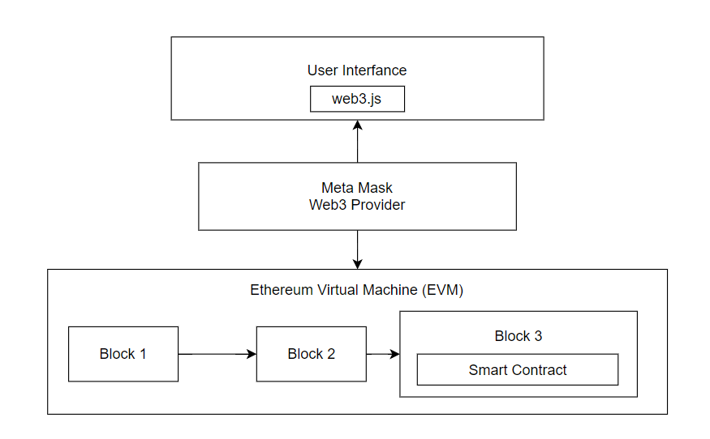
Fig. 1 System Architecture

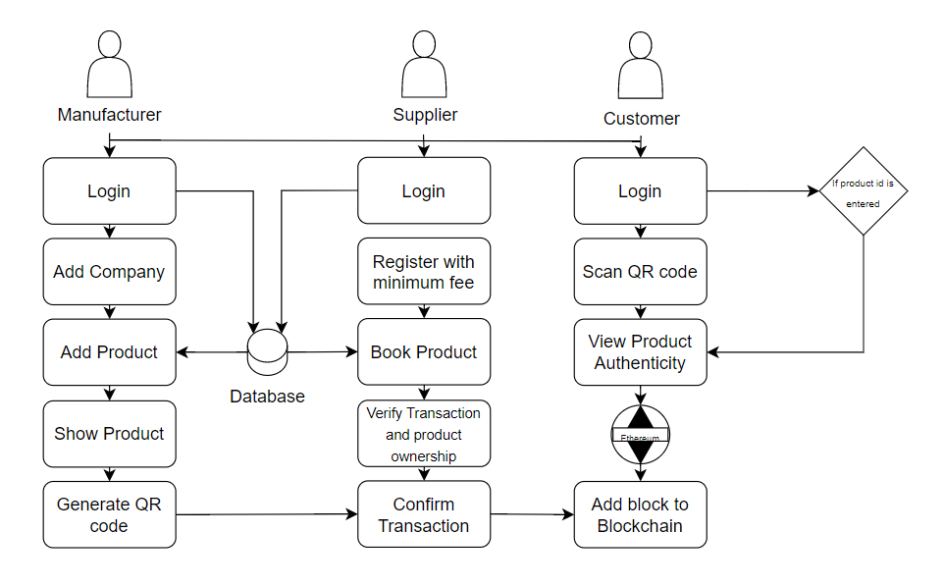
Fig. 2 System Flow
Algorithm

      - Fake product detection using blockchain technology involves assigning a unique identifier to each product and recording its transaction history on a blockchain. The SHA-256 algorithm can be used to generate these unique identifiers and ensure their integrity.

- The SHA-256 algorithm is a widely used cryptographic hash function that takes an input message of arbitrary length and produces a fixed-size output, called a hash value or message digest. The output is a 256-bit value that is unique to the input message, meaning that any change in the input message will result in a different hash value. This property makes the SHA-256 algorithm ideal for generating unique identifiers for products.

- To implement fake product detection using blockchain, each product is assigned a unique identifier that is generated by applying the SHA-256 algorithm to a combination of the product's attributes, such as its serial number, manufacturer, and production date. This unique identifier is then recorded on the blockchain, along with the product's transaction history, including its origin, ownership, and any transfers.

  - Whenever a product is transferred from one party to another, the transaction is recorded on the blockchain, along with the unique identifier of the product. Any attempt to tamper with the product or its unique identifier will result in a different hash value, which will be immediately detected by the blockchain network. This ensures that the authenticity and integrity of the product can be verified at any time by anyone with access to the blockchain.
- In summary, the SHA-256 algorithm is a key component of fake product detection using blockchain technology, as it allows for the generation of unique identifiers that can be used to track the transaction history of products and ensure their authenticity and integrity.
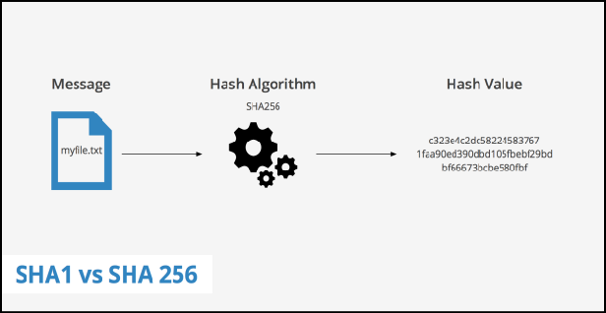

Fig. 3: SHA256 Algorithm

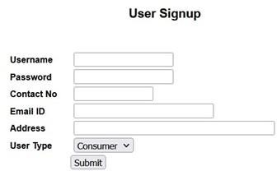
RESULTS

Fig 4: User Signup

The clients/users use this webpage to create an account on the website as well as to check product details and their authenticity. This is done using the provided details and their respective digital signatures.

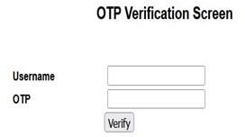

Fig 5: OTP Verification Screen

This webpage sends an OTP (One Time Password) to the registered user to verify their identity. This is a crucial step as it aids in securing the customer transactions through the blockchain mechanism.

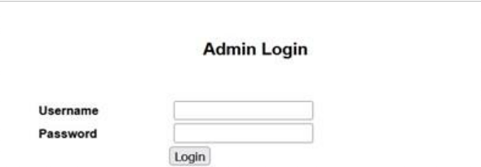

Fig. 6: Admin Login

This webpage is accessed solely by the admin and no one else. It requires admin credentials to control the entire blockchain system and conduct transactions. In case an error occurs at any point in the blockchain, it can be easily rectified by the admin.
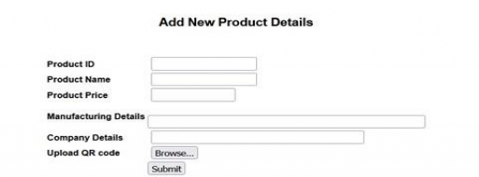

Fig 7: Add New Product Details

This webpage is accessed by the manufacturer and is used to add the details of any product that is ready to be sold. All the necessary details of the product are acquired, following which, the QR code of that specific product is uploaded to maintain its secrecy and uniqueness.

Fig 8: Scanning to get Product Details

This webpage is used by the manufacturer, suppliers, and retailers to view product details. The shared QR code of the product is uploaded, and site is redirected to the page containing the product details. The authentication process is discreet and third-party members have no access to it.

Fig 12: Final Scan Output

This page is displayed after the authentication is done. It displays an “Authentication Success” message along with the product details.

CONCLUSION

The use of blockchain technology for the identification of counterfeit products has the potential to revolutionize the way we combat counterfeiting. By creating a tamper-proof record of the origin, ownership, and movement of products, we can ensure that consumers are protected from the risks associated with counterfeit products. However, the implementation of this technology will require collaboration between manufacturers, retailers, and regulatory bodies to ensure its effectiveness.

Future enhancements of this technology could include the use of artificial intelligence and machine learning to analyze data from the blockchain and identify patterns that indicate the presence of counterfeit products. Additionally, the integration of blockchain technology with other emerging technologies such as the Internet of Things (IoT) could further enhance the effectiveness of the system.

Overall, the use of blockchain technology for the identification of counterfeit products is a promising solution to a persistent problem. With continued development and collaboration, we can create a safer and more secure market for consumers
Fig 9: Product Details

This page is displayed to the user after the OTP is entered and the product id. It contains a detailed description of the product that the user has ordered or purchased.

Fig 10: Digital Signature Generation

This webpage is used to generate a digital signature for the product. This helps secure the product firmly using blockchain as it is unique for every product.

REFERENCES

[1] Authentication With Block-Chain Algorithm and Text Encryption Protocol in Calculation of Social Network by Jinhua Ma1 , Shih-Ya Lin2 , Xin Chen3 , Hung-Min Sun4 , Yeh-Cheng Chen5 , And Huaxiong Wang6

[2] Authentication With Block-Chain Algorithm and Text Encryption Protocol in Calculation of Social Network by Ruiguo Yu1,2, Jianrong Wang1,3, Tianyi Xu1,3, Jie Gao1,3, Yongli An1,3, Gong Zhang1,3, and Mei Yu1,3

[3] Smart Contract-Based Product Traceability System in the Supply Chain Scenario by Shangping Wang, Dongyi Li1, Yaling Zhang2, and Juanjuan Chen1

[4] Blockchain-Based Agri-Food Supply Chain: A Complete Solution by Affaf Shahid1, Ahmad Almogren 2, (Senior Member, IEEE), Nadeem Javaid 1, (Senior Member, IEEE), Fahad Ahmad Al-Zahrani 3, Mansour Zuair 4, And Masoom Alam1

Fig 11: Authentication Scan for users

In this webpage, the facility to view the details of a particular product is provided to the user. The user uploads the QR code of the required product to access the complete transactional details of that product.

[5] Blockchain-driven IoT for Food Traceability with an Integrated Consensus Mechanism by Yung Po Tsang1, King Lun, Chun Ho Wu2, Member, IEEE, George To Sum Ho2, Member, IEEE, Hoi Yan Lam2

[6] A Novel Blockchain-Based Product Ownership Management System (POMS) for Anti-Counterfeits in The Post Supply Chain by Kentaroh Toyoda, Member, IEEE, P. Takis Mathiopoulos, Senior Member, IEEE, Iwao Sasase, Senior Member, IEEE, and Tomoaki Ohtsuki, Senior Member, IEEE

[7] A Software Defined Fog Node based Distributed Blockchain Cloud Architecture for IoT by Pradip Kumar Sharma1, Mu- Yen Chen2, Jong Hyuk Park1

[8] When Intrusion Detection Meets Blockchain Technology: A Review by Weizhi Meng, Elmar Tischhauser, Qingju Wang, Yu Wang, and Jinguang Han

[9] Hawk: The Blockchain Model of Cryptography and Privacy- Preserving Smart Contracts by Ahmed Kosba∗, Andrew Miller∗, Elaine Shi†, Zikai Wen†, Charalampos Papamanthou

[10] Fake Product Detection using Blockchain by P.M. Lavanya, N. Ananthi; K. Kumaran; M. Abinaya; B. Kalaivani; V. Krithika; S. Shanjai Rahul

