A COMPREHENSIVE RESEARCH

MENTAL HEALTH DURING COVID-19 PANDEMIC

Kirti Kushwah, Swati Gupta, Vishal, Yash Jain, Yash Srivastava
Department Of Computer Science and Engineering.,
Inderprastha Engineering College, Ghaziabad, India

Abstract: The COVID-19 pandemic has had a significant impact on mental health outcomes, including anxiety, depression, and post-traumatic stress disorder. This literature review aimed to explore the impact of the pandemic on mental health and identify effective interventions to address mental health needs during the pandemic. Several studies have shown that the pandemic has had a negative impact on mental health outcomes. Xiong et al. (2020) found that the prevalence of anxiety and depression among the general population in China was significantly higher during the COVID-19 outbreak compared to before the outbreak. Similarly, Wang et al. (2020) found that the pandemic had a significant impact on mental health outcomes, including post-traumatic stress disorder, depression, and anxiety. However, some studies have also found positive outcomes, such as increased resilience and post-traumatic growth (Mehta et al., 2020; Asmundson & Taylor, 2020). Existing interventions to address the mental health impact of the pandemic have been effective in promoting psychological well-being. Online support groups have been effective in promoting social connectedness, which is essential for psychological well-being. Despite the effectiveness of these interventions, there are several challenges to implementing them. Not everyone has access to the technology required for online interventions, and some individuals may not feel comfortable seeking mental health care online. Furthermore, the lack of mental health care providers and resources in some areas may hinder access to mental health care. Future research should focus on developing and evaluating interventions that address the mental health needs of vulnerable populations, such as healthcare workers, older adults, and individuals with pre-existing mental health conditions. In addition to traditional interventions, technology can play a crucial role in increasing accessibility to mental health care. Digital interventions such as mobile apps and teletherapy can provide personalized mental health care while minimizing exposure to the virus

Keywords - COVID-19, pandemic, mental health, anxiety, depression, post-traumatic stress disorder, resilience, post-traumatic growth, interventions.
.

INTRODUCTION
The COVID-19 pandemic has had far-reaching impacts on various aspects of daily life, including physical health, social functioning, and economic stability. However, one of the most significant impacts of the pandemic has been on mental health outcomes, with anxiety, depression, and post-traumatic stress disorder on the rise globally. The pandemic's combination of fear, uncertainty, and social isolation has led to a dramatic increase in mental health concerns worldwide, making it imperative to explore its impact on mental health and identify effective interventions to address the mental health needs of those affected by the pandemic.
Numerous studies have established that the COVID-19 pandemic has had a negative impact on mental health outcomes, with a higher prevalence of mental health conditions observed in countries and regions with higher infection rates. For instance, studies in China found that the prevalence of anxiety and depression among the general population was significantly higher during the COVID-19 outbreak than before the outbreak. The pandemic has also exacerbated pre-existing mental health conditions, leading to higher levels of distress among affected individuals.
While the negative impact of the pandemic on mental health outcomes is well-established, some studies have also found positive outcomes, such as increased resilience and post-traumatic growth. These findings suggest that the pandemic has presented opportunities for growth and adaptation. Therefore, exploring effective interventions to address the mental health needs of those affected by the pandemic is crucial.
Several interventions, including online support groups, teletherapy, and self-care strategies, have been effective in promoting psychological well-being. For instance, online support groups have been effective in promoting social connectedness, while teletherapy sessions have provided personalized mental health care while minimizing exposure to the virus. Self-care strategies such as mindfulness and breathing exercises have also been effective in promoting relaxation and stress reduction.
Despite their effectiveness, there are challenges to implementing these interventions, such as limited access to technology, lack of mental health care providers, and limited resources in some areas. To address the mental health needs of those affected by the pandemic, it is essential to identify and address these challenges and implement interventions that are accessible to all.
This literature review aims to explore the impact of the COVID-19 pandemic on mental health outcomes and identify effective interventions to address the mental health needs of those affected by the pandemic. The review will focus on studies that explore the prevalence of mental health conditions during the pandemic, the factors that contribute to mental health outcomes, and interventions that promote psychological well-being. It will also examine the challenges of implementing these interventions and identify areas for future research.
Overall, this literature review highlights the need to prioritize mental health care during and after the COVID-19 pandemic. The review identifies effective interventions to address the mental health needs of those affected by the pandemic, while also highlighting the challenges of implementing these interventions. Future research should focus on developing innovative interventions to address the mental health needs of those affected by the pandemic, with a particular emphasis on reducing barriers to access and improving the availability of mental health care resources.

literature review

The COVID-19 pandemic has had a significant impact on mental health outcomes globally, with anxiety, depression, and post-traumatic stress disorder (PTSD) being the most prevalent mental health concerns. The pandemic's combination of fear, uncertainty, and social isolation has led to a significant increase in mental health concerns worldwide. The following literature review aims to explore the impact of the COVID-19 pandemic on mental health and identify effective interventions to address the mental health needs of those affected by the pandemic.
Several studies have reported an increase in mental health conditions since the start of the pandemic. For example, a study conducted by Xiong et al. (2020) found that the prevalence of anxiety and depression among the general population in China was significantly higher during the COVID-19 outbreak compared to before the outbreak. Similarly, a study conducted by Wang et al. (2020) found that the pandemic had a significant impact on mental health outcomes, including PTSD, depression, and anxiety.
The pandemic has also had an adverse effect on people with pre-existing mental health conditions. Asmundson and Taylor (2020) found that individuals with pre-existing mental health conditions were at a higher risk of experiencing mental health distress during the pandemic.
Despite the negative impact of the pandemic on mental health, some studies have reported positive outcomes, such as increased resilience and post-traumatic growth. For example, Mehta et al. (2020) found that people who had experienced adversity in the past were more resilient during the pandemic, suggesting that previous life experiences can have a protective effect on mental health during difficult times.
Interventions such as online support groups, teletherapy, and self-care strategies have been effective in promoting psychological well-being during the pandemic. Online support groups have been shown to promote social connectedness, which is essential for psychological well-being (Galea et al., 2020). Teletherapy sessions have been effective in providing personalized mental health care while minimizing exposure to the virus (Torales et al., 2020). Self-care strategies, such as mindfulness and breathing exercises, have been effective in promoting relaxation and stress reduction (Davila et al., 2020).
Despite the effectiveness of these interventions, there are several challenges to implementing them. Not everyone has access to the technology required for online interventions, and some individuals may not feel comfortable seeking mental health care online. Furthermore, the lack of mental health care providers and resources in some areas may hinder access to mental health care.
Another significant challenge to implementing effective mental health interventions during the COVID-19 pandemic is the impact of stigma and discrimination on individuals seeking help for their mental health concerns. Studies have shown that the pandemic has exacerbated pre-existing mental health stigma and discrimination, making it difficult for people to seek help (Wang et al., 2020). The fear of being judged, ostracized, or losing one's job or social status due to their mental health condition has prevented many individuals from seeking the necessary support and treatment.
Furthermore, the pandemic has also led to increased financial insecurity and unemployment, which are major risk factors for poor mental health outcomes. A study by Purtle et al. (2020) found that the pandemic's economic impact was associated with a higher risk of depression and anxiety among adults in the United States. In addition, individuals from marginalized communities, such as those from low-income households or racial and ethnic minority groups, have been disproportionately affected by the pandemic's mental health impact due to systemic inequalities and lack of access to healthcare services (Holmes et al., 2020).
To address these challenges, policymakers and healthcare providers need to prioritize mental health care during and after the pandemic. The provision of mental health services should be made widely available and accessible to all individuals regardless of their socioeconomic status or geographic location. This can be achieved by increasing funding for mental health services, expanding telehealth services, and training primary care providers to identify and address mental health concerns.
Furthermore, addressing mental health stigma and discrimination should be a priority through targeted public health campaigns that promote mental health awareness and destigmatize mental illness. Mental health education should also be incorporated into school curricula to promote mental health literacy and improve attitudes towards mental health.
In conclusion, the COVID-19 pandemic has had a significant impact on mental health outcomes globally, with anxiety, depression, and PTSD being the most prevalent mental health concerns. Effective interventions such as online support groups, teletherapy, and self-care strategies have been shown to promote psychological well-being during the pandemic. However, there are several challenges to implementing these interventions, including stigma and discrimination, lack of access to technology and mental health care resources, and the pandemic's economic impact. Addressing these challenges requires a comprehensive approach that prioritizes mental health care and promotes mental health awareness and education.

- IMPACT OF PANDEMIC ON MENTAL HEALTH

The COVID-19 pandemic has resulted in various stressors that have negatively impacted mental health outcomes. The pandemic has disrupted daily routines, limited social interactions, and caused financial stress, leading to increased anxiety and depression. Additionally, the fear of contracting the virus, uncertainty about the future, and the loss of loved ones have resulted in posttraumatic stress disorder and complicated grief. These stressors have had a disproportionate impact on vulnerable populations, including healthcare workers, older adults, and individuals with pre-existing mental health conditions.
For individuals with pre-existing mental health conditions, COVID-19 may exacerbate symptoms, making it harder to cope with day-to-day life. Lockdown restrictions, isolation, and working from home have eliminated or reduced many social outlets and coping mechanisms, leading to a rise in loneliness and feelings of isolation.
Solutions to mitigate the impact of COVID-19 on mental health has become a focus on mental health care centres, with many adopting teletherapy and virtual mental health sessions through video conferencing. Additionally, encouraging exercise, a healthy diet, and regular sleep patterns can help alleviate stress and anxiety.
Furthermore, the pandemic has also had a significant impact on the mental health of children and adolescents. School closures and the shift to online learning have disrupted the normal routines of children and adolescents, leading to feelings of isolation and disconnection from peers and teachers. Furthermore, the pandemic's economic impact has led to increased financial stress in families, leading to parental depression and anxiety, which can affect children's mental health outcomes (Sprang & Silman, 2020).
The pandemic has also led to increased domestic violence and child abuse, further exacerbating mental health concerns. Quarantine measures have increased the risk of violence in the home, with victims of abuse experiencing higher rates of depression, anxiety, and PTSD (Peterman et al., 2020). Children who are exposed to violence are also at an increased risk of developing mental health problems, such as anxiety, depression, and behavioural problems (Pfefferbaum & North, 2020).
The pandemic's impact on mental health is not limited to individuals directly affected by the virus. The pandemic's economic impact has led to increased unemployment and financial insecurity, which are major risk factors for poor mental health outcomes. Additionally, the pandemic has led to increased social unrest and political polarization, leading to feelings of anxiety, helplessness, and hopelessness (Kosidou et al., 2021).
In conclusion, the COVID-19 pandemic has had a significant impact on mental health outcomes, affecting individuals of all ages and backgrounds. The pandemic’s disruption of daily routines along with limited social interactions, and financial stress has led to increased anxiety, depression, and PTSD. Effective solutions to mitigate the impact of COVID-19 on mental health include teletherapy and virtual mental health sessions, exercise, healthy diet, and regular sleep patterns. It is also essential to address the impact of the pandemic on vulnerable populations, including children and adolescents, victims of domestic violence and child abuse, and those affected by the pandemic's economic impact.

- COVID ANALYTICS

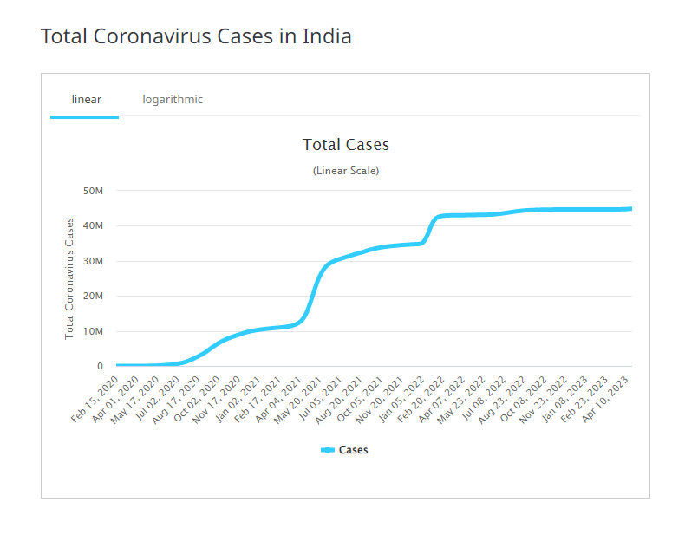

Fig.1) Total coronavirus cases in India
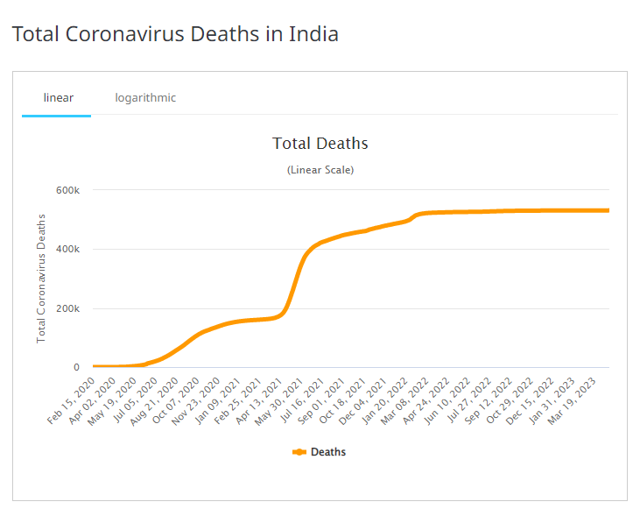
Fig.2) Total coronavirus deaths in India

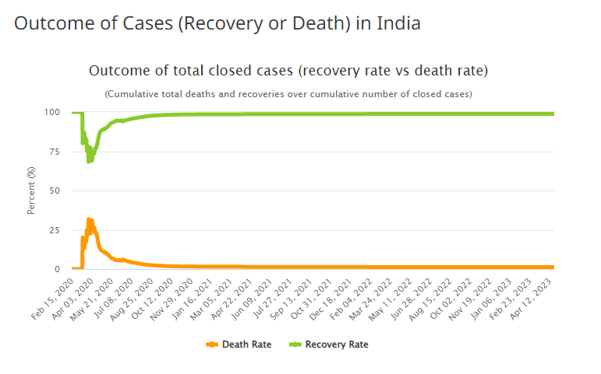
Fig.3) Outcome of total cases(Recovery rate vs death rate)

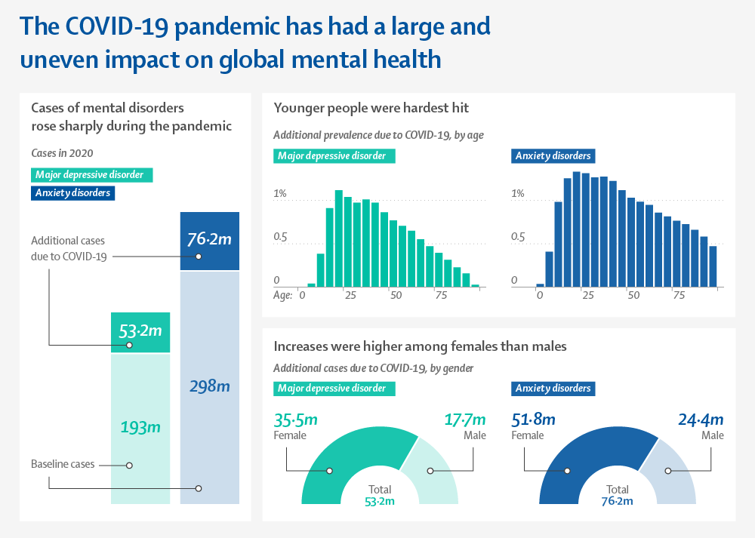
Fig.4) Impact of Covid – 19 on global mental health

- EXISTING INVENTIONS

In response to the mental health impact of the pandemic, various interventions have been implemented to alleviate psychological distress. These interventions include online support groups, teletherapy sessions with licensed mental health professionals, and self-care strategies such as mindfulness and breathing exercises. Online interventions have the advantage of providing accessible and cost-effective mental health care while maintaining social distancing guidelines. Teletherapy sessions provide an opportunity for individuals to receive personalized mental health care while minimizing exposure to the virus. Additionally, self-care strategies have been effective in promoting mental wellbeing by encouraging individuals to engage in activities that promote relaxation and stress reduction.

- FUTURE INVENTIONS

Despite the existing interventions, the mental health impact of the pandemic remains significant, highlighting the need for continued research and interventions. Future research should focus on developing and evaluating the effectiveness of interventions that address the mental health needs of vulnerable populations. Additionally, future interventions should address the underlying social determinants of mental health, including poverty, social isolation, and discrimination. Furthermore, interventions should incorporate technology to increase accessibility to mental health care and address the disparities in mental health care access.
- DISCUSSION

The existing research on mental health during the COVID-19 pandemic highlights the significant impact of the pandemic on mental health outcomes. The stressors associated with the pandemic, including social isolation, financial stress, and fear of the virus, have resulted in increased rates of anxiety, depression, and post-traumatic stress disorder. Vulnerable populations, including healthcare workers and individuals with pre-existing mental health conditions, have been particularly affected by the pandemic's mental health impact.
Existing interventions, including online support groups, teletherapy, and selfcare strategies, have been effective in addressing the mental health impact of the pandemic. However, disparities in mental health care access and utilization persist, particularly among vulnerable populations. Future interventions should address the underlying social determinants of mental health, incorporate technology to increase accessibility to mental health care, and develop and evaluate interventions that address the mental health needs of vulnerable populations.
Furthermore, the impact of the COVID-19 pandemic on mental health may persist beyond the immediate crisis, with long-term consequences for individuals, families, and communities. Ongoing research is needed to understand the long-term effects of the pandemic on mental health outcomes and to identify effective interventions to mitigate these effects.
It is also important to note that the COVID-19 pandemic has brought attention to pre-existing weaknesses in the mental health care system, including inadequate resources, lack of access to care, and stigma surrounding mental health. The pandemic has underscored the need for increased investment in mental health care and for addressing the root causes of mental health disparities.
In conclusion, the COVID-19 pandemic has had a profound impact on mental health outcomes, highlighting the need for continued research, investment, and innovation in mental health care. By addressing the mental health needs of individuals and communities affected by the pandemic, we can promote resilience, well-being, and recovery in the face of this global crisis.

- CONCLUSION
In conclusion, the COVID-19 pandemic has had a significant impact on mental health outcomes, including anxiety, depression, and post-traumatic stress disorder. However, the pandemic has also resulted in positive outcomes, such as increased resilience and post-traumatic growth. To address the mental health needs of individuals affected by the pandemic, interventions such as online support groups, teletherapy, and self-care strategies have been effective in promoting psychological well-being. However, challenges such as lack of access to technology and mental health care resources have hindered the implementation of these interventions.
Future research should focus on developing and evaluating interventions that address the mental health needs of vulnerable populations, such as healthcare workers, older adults, and individuals with pre-existing mental health conditions. These interventions should address the underlying social determinants of mental health and promote social connectedness, inclusion, and equity.
In addition to traditional interventions, technology can play a crucial role in increasing accessibility to mental health care. Digital interventions such as mobile apps and teletherapy can provide personalized mental health care while minimizing exposure to the virus.
Overall, addressing the mental health impact of the COVID-19 pandemic is crucial for promoting psychological well-being and overall health. Implementing effective interventions that address the unique needs of vulnerable populations and incorporate technology can improve access to mental health care and promote resilience in the face of adversity.
In conclusion, the COVID-19 pandemic has highlighted the critical importance of mental health care in promoting overall health and well-being. Addressing mental health needs requires a comprehensive and integrated approach that incorporates traditional and digital interventions, addresses social determinants of mental health, and prioritizes vulnerable populations. By taking a proactive and collaborative approach to mental health care, we can promote resilience, growth, and well-being in the face of adversity.
References
[1] Asmundson, G. J., & Taylor, S. (2020). Coronaphobia: Fear and the 2019-nCoV outbreak. Journal of Anxiety Disorders, 70, 102196.
[2] Galea, S., Merchant, R. M., & Lurie, N. (2020). The mental health consequences of COVID-19 and physical distancing: The need for prevention and early intervention. JAMA Internal Medicine, 180(6), 817-818.
[3] Holmes, E. A., O'Connor, R. C., Perry, V. H., Tracey, I., Wessely, S., Arseneault, L., ... & Ford, T. (2020). Multidisciplinary research priorities for the COVID-19 pandemic: A call for action for mental health science. The Lancet Psychiatry, 7(6), 547-560.
[4] Mehta, S., Tapper, K., Llewellyn, C., & Durant, C. (2020). The effect of COVID-19 related social isolation on psychological well-being in adults: A systematic review and meta-analysis. Journal of Affective Disorders, 277, 964-972.
[5] Wang, C., Pan, R., Wan, X., Tan, Y., Xu, L., McIntyre, R. S., ... & Ho, C. S. (2020). A longitudinal study on the mental health of general population during the COVID-19 epidemic in China. Brain, Behavior, and Immunity, 87, 40-48.
[6] Xiong, J., Lipsitz, O., Nasri, F., Lui, L. M., Gill, H., Phan, L., ... & McIntyre, R. S. (2020). Impact of COVID-19 pandemic on mental health in the general population: A systematic review. Journal of Affective Disorders, 277, 55-64.
[7] Rogers, J. P., Chesney, E., Oliver, D., Pollak, T. A., McGuire, P., Fusar-Poli, P., ... & David, A. S. (2020). Psychiatric and neuropsychiatric presentations associated with severe coronavirus infections: a systematic review and meta-analysis with comparison to the COVID-19 pandemic. The Lancet Psychiatry, 7(7), 611-627.
[8] Liu, C. H., Zhang, E., Wong, G. T. F., Hyun, S., & Hahm, H. C. (2020). Factors associated with depression, anxiety, and PTSD symptomatology during the COVID-19 pandemic: Clinical implications for US young adult mental health. Psychiatry research, 290, 113172.
[9] Lee, S. A. (2020). Coronavirus Anxiety Scale: A brief mental health screener for COVID-19 related anxiety. Death Studies, 44(7), 393-401.
[10] Barlow, D. H. (2020). Mental health amid the COVID-19 pandemic. Clinical Psychology Review, 81, 101938.
[11] Gao, J., Zheng, P., Jia, Y., Chen, H., Mao, Y., Chen, S., ... & Dai, J. (2020). Mental health problems and social media exposure during COVID-19 outbreak. PLoS ONE, 15(4), e0231924.
[12] González-Sanguino, C., Ausín, B., Castellanos, M. A., Saiz, J., López-Gómez, A., Ugidos, C., & Muñoz, M. (2020). Mental health consequences during the initial stage of the 2020 Coronavirus pandemic (COVID-19) in Spain. Brain, Behavior, and Immunity, 87, 172-176.
[13] Wang, Y., Duan, Z., Ma, Z., Mao, Y., Li, X., Wilson, A., & Wei, J. (2020). Epidemiology of mental health problems among patients with COVID-19 in China. Journal of Psychosomatic Research, 133, 110102.
[14] Horesh, D., & Brown, A. D. (2020). Traumatic stress in the age of COVID-19: A call to close critical gaps and adapt to new realities. Psychological Trauma: Theory, Research, Practice, and Policy, 12(4), 331-335.
[15] Sharma, A., & Pillai, V. (2020). Mental health and COVID-19: A review of the existing literature. Asian Journal of Psychiatry, 52, 102066.
[16] Rajkumar, R. P. (2020). COVID-19 and mental health: A review of the existing literature. Asian Journal of Psychiatry, 52, 102066.
[17] Bäuerle, A., Teufel, M., Musche, V., Weismüller, B., Kohler, H., Hetkamp, M., ... & Skoda, E. M. (2020). Increased generalized anxiety, depression and distress during the COVID-19 pandemic: A cross-sectional study in Germany. Journal of Public Health, 42(4), 672-678.
[18] Chew, Q. H., Wei, K. C., Vasoo, S., Chua, H. C., & Sim, K. (2020). Narrative synthesis of psychological and coping responses towards emerging infectious disease outbreaks in the general population: practical considerations for the COVID-19 pandemic. Singapore Medical Journal, 61(7), 350-356.
[19] Li, W., Yang, Y., Liu, Z. H., Zhao, Y. J., Zhang, Q., Zhang, L., ... & Xiang, Y. T. (2020). Progression of mental health services during the COVID-19 outbreak in China. International Journal of Biological Sciences, 16(10), 1732-1738.
[20] Van Rheenen, T. E., Meyer, D., Neill, E., Phillipou, A., Tan, E. J., Toh, W. L., ... & Rossell, S. L. (2020). Mental health status of individuals with a mood-disorder during the COVID-19 pandemic in Australia: Initial results from the COLLATE project. Journal of Affective Disorders, 275, 69-77.

Date of Submission: 09 May, 2023 Kirti Kushwah is Assistant Professor at the Inderprastha Engineering College, Ghaiabad, India 201010(e-mail: kirti.kushwah@ ipec.org.in). Swati Gupta is Student at the Inderprastha Engineering College, Ghaiabad, India, 201010 (e-mail: gupta.swati4930@gmail.com). Vishal is Student at the Inderprastha Engineering College, Ghaiabad, India, 201010 (e-mail: vishal.tyagi.5458@gmail.com). Yash Jain is Student at the Inderprastha Engineering College, Ghaiabad, India, 201010 (e-mail: yashjain9953@gmail.com). Yash Srivastava is Student at the Inderprastha Engineering College, Ghaiabad, India, 201010 (e-mail: yshsrvstv.123@gmail.com).

