Online Food Ordering System for Food Court Based On Scrum Approach

Tanishka Ranjit Singh pardeshi¹, Vaishnavi Rajendra dhone²,
Prem Anil bargal³, Mayur babasaheb Gavhane ^{4,} ^{1,2,3,4,}
Diploma student, Dept. of Computer Engineering,
Chhatrapati Shivaji Maharaj College of Engineering

Abstract - inside this era, the know-how have be ceaselessly step up its roles in human’s life. In this rapidly changes of the technology, we have to step forward and must not get caught left behind, counting in the simplest situation such as food ordering. It is no hesitation that online food ordering is at its peak now as more and more people feel easing to do with. Generally, nation do online food order what time they just fancy to casually eat at home.
It’s rare to see an onsite food ordering done online, therefore our goal is to extend a system for online ordering for an onsite food court big business. We realize that there are several flaws in traditional food ordering system which we would like to improve, especially during the bug outbreak; we hope that the new classification could provide the best knowledge for the population involved.
This paper presents the introduction of our idea, the issues behind, the elaboration of the solution, the purpose and benefits of our system, and how our team implement scrum methodology to our projects.

Keywords—scrum approach, sprint, ordering food, online, burn down chart
- INTRODUCTION
Over the centuries, the world witnesses a lot of changes in hope for a better solution to the world’s problems we are facing every day. Advanced technologies are being developed as of time to time and every innovation will never cease to amaze us. Until today, we know that the development of science and technology is inevitable. As the classic old era shifts into today’s complicated era, people’s lifestyles undergo those changes too. Technologies we have today help us a lot in everything we do. Something that would literally take to do in the old times does not nervousness us anymore today [1]. It is gradually replaced by the innovation of equipment, including drinking activities. The idea of an online food ordering application are very trendy now in particular for youngsters, who are either too lazy or too busy to prepare meals for themselves, and they are becoming extremely loyal to a exact food delivery platform. At the beginning we acknowledge the ease of using an online food ordering system from house, but how about designed for the onsite food ordering?
All that being said, the authors realize that onsite food ordering system, especially for groceries courts, is not efficient enough for our lives today. The problem we discuss will be dense in the following paragraphs.

First, in a common food court, we will see a lot of people nomadic here and lot of them stay around the food court just to check on the available vendors and menu. furthermore, walking from one edge of the food court to another as is awfully tiring and point in time consuming.
Secondly is the queuing difficulty. Some group just do not like the idea of queuing because it will waste time. Pretty sure all and sundry in the world agree that they do not like queueing and waiting. The unorganized and busy vendors will have a hard time to sort out their tasks as the circumstances get more chaotic.
Thirdly, the seating issues. Generally, people will take turn in looking after the table they sit at. While the others wandering the area to look for what they want to eat, it would be at least someone who is responsible for the table. This idea is in fact fine for a group of people. Yet, if it happened that someone to be alone, there is obviously no one who is going to look for the table for him. It is going to set hurdles him if there is no complimentary space after he orders his meals.
Lastly, during the pandemic state of affairs, people are very aware of the surroundings around them. To minimize bodily contacts with others, they have to be more cautious with their behavior. People are wandering the area of the food courts, queue, and swap over of cash, could trigger the spread of viruses.
- The business problems
- How do we do away with the need of queuing when ordering food in food court?
- What kind of sum is considered more effective in today’s world?
- How are we able to help sellers to comfortably handle their businesses?
- Solution
To reply all those harms and issue stated above, the authors come into an conformity they take, for a answer to this food order surrender in the food court trade systems. Our answer is to develop a system for purchaser and seller with the best experience for both party while still gears the social antagonism. In order to do that, the bargain will allow client to liberally access our online ordering scheme for onsite drinking activities. also, the

new system would be nice to be added with the payment feature directly. Electronic payment has become popular means today for paying to online purchases made by purchasers [2][3]. The payment could be done using some popular payment systems which are using an electronic wallet (e-wallet) and virtual account banking as well. Meanwhile, the seller could easily accept and view orders made by customer. Using this feature, the system could help seller by simplifying their business work. Even after the pandemic is over, we believe the system will still be useful, handy, and long-lasting due to its convenience.
- Purpose of new system
- No Queuing is necessary
The availability of the new system allows customer to order their desired dishes from their own seat. There will be no more walking to specific vendor and queuing, which will be very convenient for people who are too lazy, busy, or too tired to stand.
- Allows Order from Multiple Vendors
The system also allows customer to create several orders from multiple sellers all at once. No more strolling aimlessly from one vendor to another. Every transaction made will be automatically calculated in which customer could easily complete the order after the payment has been received. The purpose of the electronic payment features is to reduce extra work for cash payment and avoid payment error by human.
- Automatic Order scheduled
If we compare to the traditional ways where sellers have to manually accept orders and learn by heart or write them down, the new-system will cover those jobs for seller. There will be no direct interaction required between a customer and seller.

- Benefits
The emergence of the online ordering and payment system will surely affect to the buy-and-sell activities in a food court. The customer will be facilitated with an online ordering and payment applications with no difficulties, and the seller will manage its business and job much more simply.
- METHODOLOGY
choose the right methodology for software development is crucial. Taking the wrong choices can lead to delayed deliveries, dissatisfied employees and clients, and ultimately create a disaster.
The most current and popular move toward is agile progress methodology. This Agile methodology is a technique used in software development used by the team, in order to administer a project by dividing it into various stages and with continuous collaboration with clients. It employs continual planning, learning, improvement, team association, and early delivery to encourages flexible responses of changes. There are several types of agile methodology, such as Scrum, Extreme Programming (XP), Crystal, Kanban, etc. The word Agile means to be fast, trivial, free-moving, and alert. Agile is a word used to describe a process model concept which is assorted from the existing process model concepts [4][5][6]. Agile software development concepts is first introduced by Kent Beck and his 16 colleagues by stating that the Agile Software
Development is a way to build software by doing it and helping others to build it all at once [7]. Additionally, iterative processes are used to help enable upgrading in communication, exploit cooperation, as well as protect the team from disruptions and impediments. In overall, the goal of this method is to deliver a more suitable product more quickly than with traditional methods [8].

- Scrum Methodology
Scrum is a subset of agile framework. As the report depicted above, scrum is the most popular agile framework used in companies today [9]. Founded by Jeff Sutherland and Ken Schwaber, scrum comprise of five values: promise, courage, focus, openness, and respect. It aims to develop, deliver, and sustain the complex products through partnership, accountability, and iterative progress [10][11]. Scrum is an iterative, incremental framework for projects and product or application increase [12]. It structures the development in cycles of work called sprints [13].
- The Process of Scrum
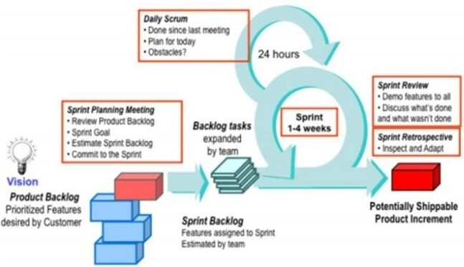
Fig 1. Working Flow of Scrum [14]
- Scrum Implementation to Our Project
From what authors understood, here are some main things how to apply Scrum frameworks to this software project maturity (can be seen in Fig 1).
- Define the Role
Each human being in the team has its own role and the decision is made based on the personalities and role’s needs such as scrum master, product owner, and development team.
- Define User Story
In this stage, the team has busily defined the intended users which are customers and sellers of the food courts. Besides, we have also analyzed the features and functionalities of users’ perspectives.
- Define Product Backlog
In this stage, we defined all the required features and functionalities and defined its main concern level along with its time estimation.
- Define Sprint Backlog
In this stage, we decisive on the duration of each sprint, which is 4 weeks. From the recognized product backlog, we picked several features as our sprint backlog. The features selected for each sprint is based on the priority. We try to complete the task from high to low priorities
- Sprint Meeting
During the meeting, we examine the project’s progress and discuss about no matter which needed in order to achieve the best we can for each sprint.

- RESULT AND DISCUSSION
The result of this paper will be a web request that will be used by customer to order food from a food court and also from a mobile application used by the sellers to manage their restaurant menu and orders. To get this result, the team will use the Scrum framework. The Scrum team consists of 3 persons, in which the team will follow the Scrum framework steps including making the item for using up backlog, doing daily sprint meetings, etc.
- Product Backlog
Product backlog will include the application features, where the product owner has the responsibility for making and deciding what features to be added on the list [15].
Table I. Product Backlog

23 | Seller: Update Group Option | Medium | 5
24 | Seller: Delete Group Option | Medium | 3
25 | Seller: View Group Option | Medium | 5
26 | Seller: View Order History Detail | Medium | 7
27 | Seller: View Profile | Medium | 5
28 | Seller: Edit Profile | Medium | 7
29 | Customer: Dashboard | Low | 4
30 | Seller: Set Restaurant Status | Low | 2
31 | Seller: Change PIN | Low | 3
32 | Seller: Input PIN | Low | 3
33 | Seller: Input Verification Code | Low | 3
34 | Seller: Set Notification | Low | 4
35 | Seller: Logout | Low | 2

Table I is all the product backlog items that the team has to complete during the sprint.
- Sprint
The team decided to take 4 sprints in total, in which every sprint has a fixed-length event of 1-2 weeks. During each sprint, a daily sprint will be held to discuss any progress that has been made from the product backlog that have been defined before.

Table II. Sprint 1
No | Backlog | Priority | ET (hours)
1 | Customer: Add to Cart | High | 7
2 | Customer: Order | High | 7
3 | Customer: View & Choose Payment Method | High | 4
4 | Customer: Payment | High | 14
5 | Seller: Login | High | 8
6 | Seller: Register | High | 8
7 | Seller: Finish Order | High | 4
8 | Seller: View Pending Order | High | 7
9 | Seller: View Pending Order Detail | High | 7
11 | Customer: View & Select Shops | Medium | 5
13 | Customer: View & Select Menu | Medium | 5
15 | Seller: View List Menu | Medium | 5
16 | Seller: Insert Menu | Medium | 7
17 | Seller: Update Menu | Medium | 7
18 | Seller: Delete Menu | Medium | 3
19 | Seller: View Order History | Medium | 6
20 | Customer: Edit Cart | Medium | 7
21 | Customer: View Cart | Medium | 6
22 | Seller: Insert Group Option | Medium | 5

No | Sprint | Activity (hours)
1 | Seller-Login | - Create login form and validation (5)  - Connect database (3)
2 | Seller-Register | - Create registration form and validation (5)  - Connect database (3)
3 | Seller-Input Verification Code | - Create the input code number form (2)  - Validation (1)
4 | Seller-Insert Menu | - Create the insert menu form and validation (4)  - Connect database (3)
5 | Seller-Update Menu | - Create the update menu form and validation (4)  - Connect database (3)
6 | Seller-Delete Menu | - Create the delete confirmation message (1)  - Connect database (2)
7 | Seller-View List Menu | - Connect database (2)  - Create the user interface of the list (3)
8 | Seller-View Pending Order | - Connect database (2)  - Create the user interface to show the list (5)
9 | Seller-Finish Order | - Connect database (2)  - Create the finish confirmation message (2)
10 | Seller-View Pending Order Detail | - Connect database (2)  - Create the user interface to show the detail (5)

70

60

50

40
Hours

30

20

10

0
1 2 3 4 5 6 7 8 9 10 11 12 13 14 15
Days

Estimated Effort Remaining Effort

Fig 2. Sprint 1 Burndown Chart

According to the product backlog estimation time, sprint 1 which consists of above product backlog will take 59 or 14 estimation days (can be seen in Table II).

Figure 2 shows the estimation time to complete sprint 1 (shown in blue line), and the lasting effort or the time that took us to finish the sprint (shown in red line). By comparing the red line against the blue line, the run has been complete with no backlog left.
3 | Seller-Set Restaurant Status | - Connect database (1)  - Create the on/off toggle (1)
4 | Seller-Set Notification | - Connect database (1)  - Create the on/off toggle (1)  - Show the notification sound list (2)
5 | Seller- Logout | - Connect database (1)  - Create the logout confirmation message (1)
6 | Customer- Dashboard | - Create the dashboard and input form number (4)
7 | Customer- View & Select Restaurant | - Connect database (2)  - Create the user interface to show the restaurant list (3)
8 | Customer- View & Select Menu | - Create the user interface to show the menu list (3)

Table III. Sprint 2
No | Sprint | Activity (hours)
1 | Seller-Login | - Create login form and validation (5)  - Connect database (3)
2 | Seller-Insert Group Option | - Create the insert form and validation (3)  - Connect database (2)
3 | Seller-Update Group Option | - Create the update form and validation (3)  - Connect database (2)
4 | Seller-Delete Group Option | - Create the delete confirmation message (1)  - Connect database (2)
5 | Seller-View Group Option | - Connect database (2)  - Create the user interface of the list (3)
6 | Seller-View Order History | - Connect database (2)  - Create the user interface to show the list (4)
7 | Seller-View Order History Detail | - Connect database (2)  - Create the user interface to show the detail (5)
8 | Seller-Edit Profile | - Connect database (2)  - Create the user interface to show the profile detail and button to edit the profile detail including validation (5)

According to the product backlog estimation time, sprint 2 which consists of above product backlog will take 43 or 10 days of estimation (can be seen Table III).
Fig. 3 shows the estimation time to complete sprint 2
According to the product backlog estimation time, sprint 3 which consists above product backlog will take 28 or 7 days of estimation.

30
25
20
Hours
15
10
5
0
1 2 3 4 5 6 7 8
Days

(shown in blue line), and the remaining effort or the time that Estimated Effort Remaining Effort
took us to finish the sprint (shown in red line). By comparing
the red line against the blue line, the sprint has been
Fig 4. Sprint 3 Burndown Chart

completed with no backlog left.
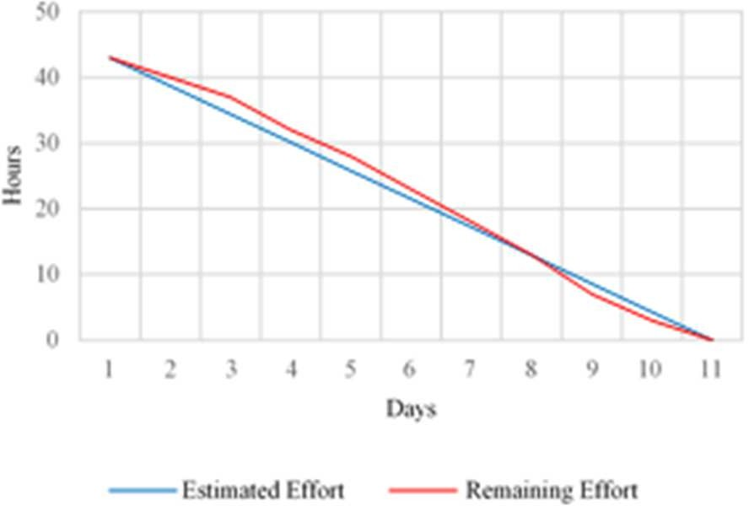
Fig 3. Sprint 2 Burndown Chart

Table IV. Sprint 3
Fig. 4 shows the estimation time to complete sprint 3 (shown in blue line), and the remaining effort or the time that took us to finish the sprint (shown in red line). By comparing the red line against the blue line, the sprint has been completed with no backlog left.
Table V. Sprint 4
No | Sprint | Activity (hours)
1 | Customer-Add to Cart | - Connect database (2)  - Create the food detail option (5)
2 | Customer-View Cart | - Connect database (2)  - Create the user interface to show the cart list (4)
3 | Customer-Edit Cart | - Connect database (2)  - Create the food detail option (5)
4 | Customer-Order | - Connect database (2)  - Create the user interface to show the order summary (4)  - Create the option to re-input the table number (1)
5 | Customer-View & Choose Payment Method | - Connect database (1)  - Create the user interface to show the payment method list (3)

No | Sprint | Activity (hours)
1 | Seller- Change PIN | - Connect database (1)  - Create the input PIN form and the confirmation (2))
2 | Seller-Input PIN | - Connect database (1)  - Create the input PIN form and validation (2)

6 | Customer- Payment | - Connect database (2)  - Create the user interface to show the payment detail based on the chosen payment method (9)  - Create the menu to change the payment method (2)  - Show the successful payment notification (1)

According to the product backlog estimation time, sprint
- which consists above product backlog will take 45 or 12 days of estimation (can be seen in Table V).

50

40

30
Hours

20

10

0
in mind such that it can be implement within other web application frameworks. The proposed class diagram does not depict third-party payment details considering the large number of varieties available in the current market. However, the proposed design provides a comprehensive payment system that can be added complete depending on which payment system that the current system requires.

  - CUSTOMER WEB MOBILE

Table VI. The User Interface List for Customer (Mobile Application)

1 2 3 4 5 6 7 8 9 10 11 12 13
No | Screen Contents
1 | This is the first screen the customer will see when the customer scans the barcode on the table. Customer will have to input their table number before proceeds to the  next page.
2 | Customer can search, choose food category, and view list  of available restaurants.
3 | Shows all the categories in the food court if user clicks on ‘Lihat Semua’ on Dashboard page
4 | Shows all the related restaurants with the selected  category
5 | Customer will be taken to this page if customer is searching on Dashboard page. Customer can search the menu they want and the system will show the  Corresponding restaurant.
6 | Shows the available menus on the specific restaurant.  Customer can add to cart the dish they would like to eat.
7 | Customer can add or remove quantity, customize the food options, and input special notes to restaurant.
8 | Message when customer hasn’t added any dishes to cart
9 | Shows information about dishes added by customer. Customer can further update their added dish here.
10 | Customer can edit the menu detail from the selected  added-to-cart dish.
11 | Shows summary of dishes customer want to order with total price they have to pay. Customer can also update quantity, edit table number, and choose their desired  payment method.
12 | Customer can continue to do payment, change the  payment method or back to cart.
13 | Customer can select another payment method
14 | By using ShopeePay, customer will be taken to ‘Shopee’ app to continue the payment based on the selected  payment method or cancel the transaction.
15 | By using GoPay, customer can proceed to ‘Gojek’ app by clicking the button or view QR Code for scanning.
16 | By using OVO, customer has to input his/her phone  number with an OVO account
17 | Shows successful payment message after customer  completes the payment.

Days

Estimated Effort Remaining Effort

Fig 5. Sprint 4 Burndown Chart
Fig 5 shows the estimation time to complete sprint 4 (shown in blue line), and the remaining effort or the time that took us to finish the sprint (shown in red line). By comparing the red line against the blue line, the sprint has been completed with no backlog left.

- Interfaces
In this section, we will include some of our prototype designs for our project application.
User interface design is an important part in designing an application; the author will portray the front end of the author's application in detail below. Online Food is equipped with a home page that aims to be the main display when the application is opened. So that users can directly use the application without having to register or login. There are 2 types of home pages in the application, namely the customer's home page which is the main display for customers, while the seller's home page is to be used by restaurant owners. The main page display of the customer is designed as a mobile application. The main view is insights from restaurant customers. As a restaurant customer, he or she can choose a table, then view the food menu. And if fascinated, he/she can carry on with ordering and payment. While the main page display for sellers, is designed for all platform including desktop, laptop, and mobile. in addition, the design of seller interface, includes restaurant sales business functions they need. Considering the large number of interface designs, in this paper, the author does not present the designs in the image forms. However, a detailed list of interface designs, both for customers and for sellers, are shown thoroughly in Table VI and Table VII.
A class diagram for our project application design is described in appendix A. The proposed design portrays the core essentials required for the system as illustrated in the scrum backlog. The design is also organized with extensibility

  - SELLER APPLICATION

Table VII. The User Interface List for Seller Application (Desk Top and Mobile Application)

No | Screen Contents
24 | Screen that appears when user or seller opens the  application
25 | To log in, seller has to fill in the required fields as shown on the picture on the left. Seller can also click on ‘Daftar’  to register.
26 | To log in, user needs to input PIN to verify their account
27 | To sign up, seller has to fill in required fields and upload a  picture.
28 | Seller need to input verification code received by the  corresponding phone number to continue the registration
29 | Shows pending orders lists of transaction made by  customers on related restaurants. On top corner right, seller can see the transaction history.
30 | Shows current orders details with Order-ID, payment type,  transaction-made time, and dishes ordered by customer.
31 | Shows the history orders of the seller restaurant based on each day and total revenue made on that day.
32 | Show the details from the selected history list order on  each day, such as: transaction-made time, table number, and transaction price.
33 | Shows the details from the selected order, such as:  OrderID, payment type, transaction-made time, transaction-done time, and dishes ordered.
34 | Shows all the list of menus group by categories
35 | Seller can choose to edit menu or categories, add menu  and add category
36 | To add new dish, seller needs to input the required field  about the menu and click the button to add
37 | Seller need to input the category name and add the category
38 | Seller can choose to edit category, dish, the group option,  and also delete a menu from category
39 | Seller can change the name of the category.
40 | Seller can change the selected menu information
41 | Seller can remove the connected group option or connect  to another available group option.
42 | Seller can choose to edit or add the group option.
43 | Seller can input the group option information details and  click the button to add.
44 | Seller can add an option to the group option by providing  its name and additional price (≥ 0).
45 | Seller can edit the group option detail or delete connection of a dish to a group option
46 | Seller can change the detail of the selected group option.
47 | Seller can change an option of the group option.
48 | Seller can view the connected group option and also can connect or remove the connection of the group option
49 | Shows brief profile and additional settings.
50 | Seller can change the profile’s details of the restaurant.
51 | To change password, seller needs to input the old password and the new password to change the password.
52 | Seller can set the notification to on or off and also change  the sound of the notification.
53 | To change the IN, seller has to provide the old PIN before  giving the new PIN.

View publication stats

- CONCLUSION
54 | Confirmation message if the user wants to log out
55 | Shows menu and category list.
56 | Shows option groups list and the connected dishes.

base on the outcome and dialogue we had done, the application both for customer and supplier could be done more effectively and efficiently using scrum framework. Overall, the development and sprints done are all well-distributed and well-managed resulting in no additional backlog for the next run and therefore no latency in project delivery. To achieve the perfect request development using scrum approach, choosing the best-suited product owner, scrum master, as well as recruiting skillful yet adaptable and open-minded development team are indeed crucial. In the process in application development, the team also held daily scrum meetings to make sure the lot is under control and to maintain open announcement within the scrum team.

REFERENCES

- J. Sutherland. (2021). “The Scrum Papers: Nut, Bolts, And Origins Of An Agile Framework”, pp. 16

- J. Kosakowski, “The Benefits of Information Technology,” Eric Digest, August 1998.

- M. Mahalakshmi and M. Sundararajan, “Traditional SDLC vs Scrum Methodology-A Comparative Study”.

- Ming‐Yen Teoh, W., Choy Chong, S., Lin, B. and Wei Chua, J. (2013), "Factors affecting consumers’ perception of electronic payment: an empirical analysis", Internet Research, Vol. 23 No. 4, pp. 465-485.
- Visual Paradigm, “What Are The Three Scrum Roles?”, [Online]. Available from: https://www.visual-paradigm.com/scrum/what-are- t he-three-scrum-roles/ [Accessed 26th June 2021]
- Scrum.org, “What is a Sprint Review?”, [Online]. Available from: https://www.scrum.org/resources/what-is-a-sprint-review [Accessed 26th June 2021]
- Frank Cervone, (2011),"Understanding agile project management methods using Scrum", OCLC Systems & Services: International digital library perspectives, Vol. 27 Iss 1 pp. 18 – 22.
- Pressman, Roger S, “Software engineering: a practitioner’s approach,” 7th ed. 2010

- K. S. Rubin, “Essential Scrum: A Practical Guide to the Most Popular Agile Process”, Upper Saddle River, New Jersey: Addison-Wesley, 2013, pp 14-27.
- S. N. Kumar, C. Padmaja, C. B. R. Krishna and K. Mahender. (2020), ”Scrum: An Effective Software Development Agile Tool”

