GENERATION OF ELECTRICITY BY SOLID WASTE

Mrs.Kalpana S
Department of Electrical and
Electronics engineering
PES Institute of Technology and
Management
Shivamogga, India
Kalpana@pestrust.edu.in
Varun H N
Department of Electrical and
Electronics engineering
PES Institute of Technology and
Management
Shivamogga, India varunhnhovale01@gmail.com Ganesh gowda P
Department of Electrical and
Electronics engineering
PES Institute of Technology and
Management
Shivamogga, India ganeshgowdap@gmail.com

Bhavana C
Department of Electrical and
Electronics engineering
PES Institute of Technology and
Management
Shivamogga, India bhavanac990024@gmail.com Karthik S
Department of Electrical and
Electronics engineering
PES Institute of Technology and
Management
Shivamogga, India karthikbelli8@gmail.com

Abstract-Generation of electricity by using waste materials.The waste materials like plastics ,papers etc. ,Burn in zara box.heating in the panel and it convert heat into electricity.It stored electricity in battery.Connecting the LED bulb start glowing. electrical energy is produced utilising trash, including plastic, rubber, garbage, and other undesirable items. As soon as the solid waste begins to burn, heat is produced, and then the heating system begins turning that heat energy into electricity.The carbon emission is managed using pollution control filters.Catalytic converters can reduce the air pollution that is produced as a result of power generation.

Keywords—MUNCIPLE SOLID WASTE,WASTE TO ENERGY.

I. INTRODUCTION
With 3.4% of the world's energy consumption by more than 17% of the population, India is the sixth-largest energy consumer in the world. In India, thermal power plants produce about 65.34 percent of the country's electricity, followed by hydroelectric power plants (21.53%), nuclear power plants (2.70%), and renewable energy sources (10.42%). India's enormous coal deposits provide more than 50% of the country's commercial energy needs. The energy strategy of India is influenced by four main economic and social factors: a quickly expanding economy, rising household incomes, limited domestic fossil fuel reserves, and the unfavourable environmental effects of rapid expansion in urban and rural areas. Knowing and estimating the resources that are accessible, applying their relationship to the population, and managing the changing situations effectively are of the utmost importance. With the aid of spatial approaches, such information is extracted in the waste material. This paper, plastic, and rubber bagasse focuses on estimating how much solid waste a waste material generates. An effort to alternately minimise pollutants while meeting the standards for solid waste management. One of the most effective and beneficial ways to decrease trash would be to generate power from waste. According to earlier studies, there are a number of thermochemical and biochemical ways for generating gases and direct power from trash.

II. SCOPE OF PROJECT
- We can create high-quality heating penals for producing large amounts of power.
- We can also create large level burning boxes with heating penal linking systems that are simple to use.
- Energy used for recycling partially offsets the decrease in energy used to process virgin raw materials.

III. PROBLEM STATEMENT
- The use of waste materials in the production of power is an alternate, economical method.
- In many nations, being able to meet the demand for energy has recently become a major issue.
- Burring waste materials can be controlled when carbon emissions are produced by employing carbon plates.

IV. OBJECTIVE OF THE PROJECT
- To research the viability of reclaiming energy from solid waste.
- To restore energy to the solid west using various ways.
- To use recycled plastic to create electricity.
- To provide enough electricity for city people while limiting the need for additional landfill space.

V. ADVANTAGE OF IMPLEMENTING
THE SYSTEM The majority of waste that ends up in landfills may be decreased, natural resources are conserved, and raw materials are inexpensively obtained.

VI. MEHODOLOGY
Reviewing the project scope and research field came first before the project was put into action. The next challenge was to design the conveyor belt's mechanical and electrical systems before it could be built.When the hardware and circuits implementations were complete, the design work was complete. Reaching the pinnacle of the project, the programming segment was dedicated to the output of the heating penal system, the sensing of the heating sensor, and the output to the LED bulb glow. Last but not least, changes were made to the software and circuitry to improve the system's ability to conduct precise movements. Thus, while the system was operating, troubleshooting was also done to correct some flawed procedures.

VII. BLOCK DIAGRAM
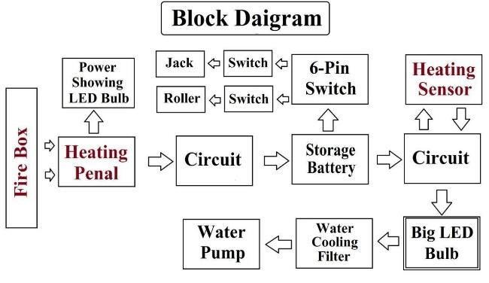
Figure 1. Block diagram

Working principle.
Heat is produced when waste is burned in the fire box, which then causes the heating panel to begin converting it into electricity. Once that electricity has been transferred into a circuit, it then directly causes an LED bulb to glow. Once this electricity has been stored in a battery, the heating sensor then turns on the output power supply, causing the LED bulb to glow and emit smoke, which is then carried away by the water trough.

VIII. COMPONENTS


Figure 2. Heating panel
Convection heaters are another name for heating panels.because they only generate convectional heat As the air moves around the room, hot metal elements inside the heater's body heat it. The heated air then radiates heat to the occupants of the space. Fast and efficient space heating is provided by convection heat.


Figure 3. Heating sensor
Temperature sensors function by sending electrical signals that contain readings. By detecting the voltage across the diode terminals, sensors are made of two metals that produce an electrical voltage or resistance whenever there is a change in temperature. The temperature rises in tandem with an increase in voltage.



Figure 4. DC Motor
1SA motor's rated RPM is 3000 rpm at 12 volts.In this project, the rotating cooling fan is powered by a DC motor for cooling purposes.
IX. CONCLUSION
Poorly managed garbage causes diseases and contributes to climate change, which has an impact on public health, safety, and the environment.
The solid waste management will lessen pollution and global warming, among other things.

X. REFERENCES

[1] M. K. Shukla, J SAMRIDDHI A Journal of Physical
Sciences Engineering and Technology “Waste to Energy”: A Review on Generating Electricity in India, 2020.
[2]Energy saving trust, Blog post Generating energy from waste: how it works - Energy Saving Trust “Generating energy from waste”,2019.
[3]Jennifer Chu Study finds topological materials could boost the efficiency of thermoelectric devices. Turning heat into electricity 2018.
- T. Gumbo, Scaling up sustainable renewable energy generation from municipal solid waste in the African continent: lessons from eThekwini, South Africa.
Consilience, J Sustain. Dev. 12 (2014) 46–63.
- L. Makarichi, R. Kan, W. Jutidamrongphan, K.-A. Techato, Suitability of municipal solid waste in African cities for thermochemical waste-to-energyconversion: the case of Harare metropolitan city, Zimbabwe. Water Manag.
Res.37(1)(2019)83–94,
- E. Mwangomo, Potential of waste to energy in African urban areas, Adv.Recycling Waste Manag. 3 (2018) 1000162 [7] B. Güneralp, S. Lwasa, H. Masundire, S. Parnell, K.C. Seto, Urbanization in Africa: challenges and opportunities for conservation, Environ. Res. Lett. 13 (1)(2017) 015002, [8] J. Nyika, E. Onyari, M. Dinka, S. Bhardwwaj, A review on methods of assessingpollution levels from landfills in South Africa, Int. J. Environ. Waste Manag. 28(2021) 436– 455.
[9] D. Moya, C. Aldas, D. Jaramillo, E. Jativa, P. Kaparaju, Waste-to-energy technologies: an opportunity of energy recovery from municipal solid waste,using Quito-Ecuador as case study, Energy Procedia 134 (2017) 327–336,

