Design Crossword Puzzle
using Graph Theory

ManishKumar Vishwakarma
Department of Computer Engineering
Thakur college of Engineering & Technology
Mumbai, India
manish.kumar.vishwakarma999@gmail.com

Pallavi Vishwakarma
Department of Computer Engineering
Thakur college of Engineering & Technology
Mumbai, India
pallavivishwakarma999@gmail.com

Aakash Yadav
Department of Computer Engineering
Thakur college of Engineering & Technology
Mumbai, India
ay111176980@gmail.com

Ms. Niki Modi
Department of Computer Engineering, Thakur college of Engineering & Technology
Mumbai, India

niki.modi@thakureducation.org

Abstract— This project involves the development of an app for generating and solving crossword puzzles using graph theory and backtracking algorithms. The app provides users with a user-friendly interface to create their own puzzles or solve the ones generated by the app. The project demonstrates the application of graph theory and backtracking algorithms in game design and showcases the potential of technology in creating interactive and engaging puzzles. Additionally, the project highlights the importance of user experience design in developing mobile applications that are intuitive and easy to use.

Keywords— Graph Theory, Backtracking Algorithm, Android studio, Java, XML, Firebase.

Introduction
Crossword puzzles have been a popular form of word game for many years, challenging players to fill a grid with words based on given clues. Designing a crossword puzzle that is both challenging and aesthetically pleasing requires careful consideration of the structure of the puzzle and the placement of the words. Graph theory provides a powerful tool for analyzing and optimizing the layout of the puzzle, with nodes representing individual cells and edges representing the constraints between cells.

In this project, we have developed an app that uses graph theory and backtracking algorithms to generate and solve crossword puzzles. The app provides users with a user-friendly interface to create their own puzzles or solve the ones generated by the app. Graph theory is used to model the structure of the puzzle, and backtracking algorithms are used to generate and solve the puzzle by exploring all possible solutions in a systematic way.

The project showcases the potential of technology in creating interactive and engaging puzzles, and demonstrates the application of graph theory and backtracking algorithms in game design.

Additionally, the project highlights the importance of user experience design in developing mobile applications that are intuitive and easy to use. With the increasing popularity of mobile apps and games, this project provides a valuable insight into the integration of mathematical concepts and technology in creating engaging and challenging puzzles for users to enjoy.

Literature Survey

Title of the paper | Proposed Solution | Gap identified
An optimization approach for crossword puzzle design | Proposes an optimization approach for generating crossword puzzles using a modified version of the max flow algorithm to model the problem as a network flow problem. | The approach requires many computational resources, which limits the size of the puzzles that can be generated. The approach also does not consider the aesthetic qualities of the puzzle, such as the symmetry of the grid and the layout of the words.
A graph-theoretic approach to the design of crossword puzzles | Proposes a graph-theoretic approach to designing crossword puzzles, in which the puzzle is modeled as a graph and the layout of the words is optimized using a depth-first search algorithm. The approach also incorporates heuristics to ensure that the puzzle is aesthetically pleasing. | The approach only considers one type of constraint between words, i.e., the intersection of words. It does not consider other types of constraints, such as the adjacency of words, which may limit the variety of puzzles that can be generated.
Solving and generating crossword puzzles using constraint programming | Proposes a constraint programming approach to generating and solving crossword puzzles, in which the puzzle is modeled as a set of constraints on the variables representing the words in the puzzle. The approach also incorporates heuristics to improve the efficiency of the search algorithm. | The approach does not consider the aesthetic qualities of the puzzle, such as the symmetry of the grid and the layout of the words. Additionally, the approach may not be suitable for generating large puzzles due to its high computational complexity.
Generating and solving crossword puzzles with a genetic algorithm | Proposes a genetic algorithm approach to generating and solving crossword puzzles, in which the puzzle is modelled as a set of chromosomes and the fitness function is used to evaluate the quality of the solutions. The approach also incorporates mutation and crossover operators to improve the diversity of the population. | The approach does not consider the aesthetic qualities of the puzzle, such as the symmetry of the grid and the layout of the words. Additionally, the approach may not be suitable for generating large puzzles due to its high computational complexity.
Table 1: Literature review
Survey results:

We conducted a survey to identify insight into the relationship between crossword puzzles and graph theory, as well as the extent to which people are aware of and utilize this relationship.

- Have you ever used graph theory to solve a crossword puzzle?
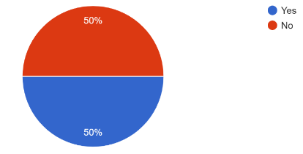

Fig 1: Question 1

- Do you think can help improve the quality of crossword puzzle solving software?
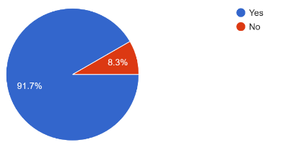

Fig 2: Question 2

- Would you be more likely to use a crossword puzzle solving app that utilizes graph theory concepts?

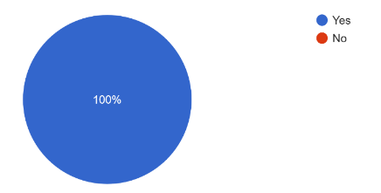

Fig 3: Question 3

- Do you think understanding graph theory can help you solve crossword puzzles more efficiently?
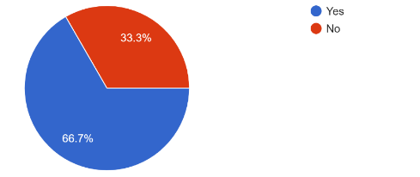
Fig 4: Question 4

- When solving a crossword puzzle, do you visualize the puzzle as a graph?
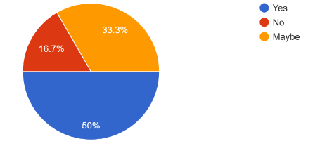
Fig 5: Question 5

- Have you ever created a crossword puzzle that utilizes graph theory concepts?

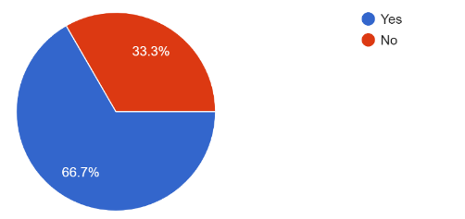
Fig 6: Question 6

This survey provided insights into the potential impact of graph theory on crossword puzzle solving software, as well as the appreciation of crossword puzzles as a structured and designed object.

Methodology
The problem we aim to solve with this project is the need for an efficient algorithm for generating and solving crossword puzzles. Traditional methods of crossword puzzle generation and solving can be time-consuming and often require manual intervention. Therefore, we propose to design an app that uses graph theory and backtracking algorithm to generate and solve crossword puzzles efficiently.
A crossword puzzle can be represented as a graph where the nodes are the blank squares and the vertices are the intersections of the horizontal and vertical words. Each node can be assigned a label that corresponds to the clue for the corresponding word. The edges of the graph represent the connections between the nodes, indicating which squares are connected to each other.Key issues
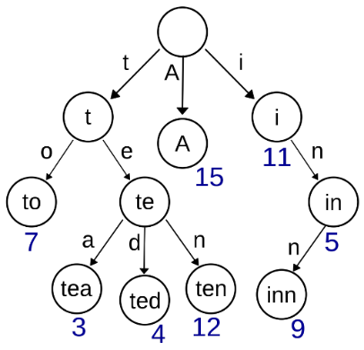
Fig 7: Crossword puzzle graph

In this graph, the words in the puzzle can be represented as paths or cycles, starting at one node and ending at another, while passing through other nodes and edges in between. The connections between nodes and edges help to constrain which words can fit into a given space, as any word that fits into one part of the puzzle must also be compatible with the intersecting words that are crossing through it.

Backtracking algorithm is used to design crossword puzzle. This algorithm is used to color the nodes of the graph with different letters from the alphabet, while ensuring that no adjacent nodes have the same letter. The algorithm works by trying out different color assignments for each node and backtracking if it finds that a particular color assignment leads to a conflict. This process continues until a valid coloring of the graph is found, or until it is determined that no valid coloring exists. The backtracking algorithm is computationally efficient and can handle large, complex graphs, making it well-suited for crossword puzzles.

The time complexity of a backtracking algorithm can range from O(1) in the best case scenario to O(n!) in the worst case scenario, where n is the size of the problem space.

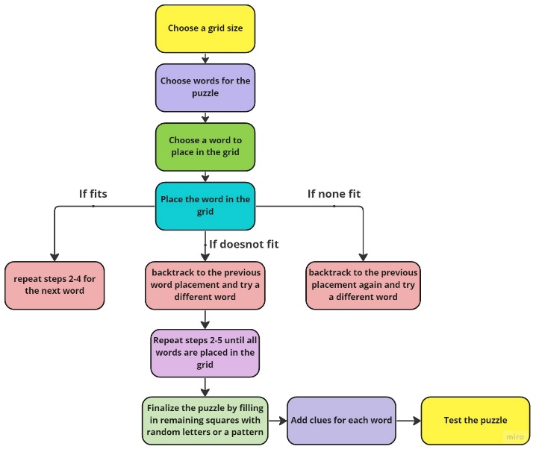

Fig 8. Mathematical Model

Implementation

We have implemented this backtracking algorithm by developing
an mobile application using Android studio, java, xml and firebase as our database.

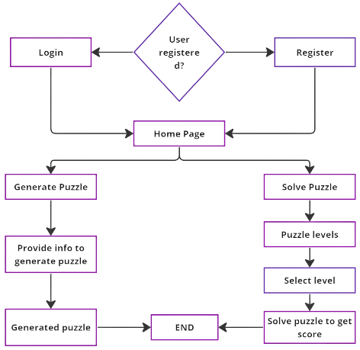
Fig 9: System Architecture

Actual results:

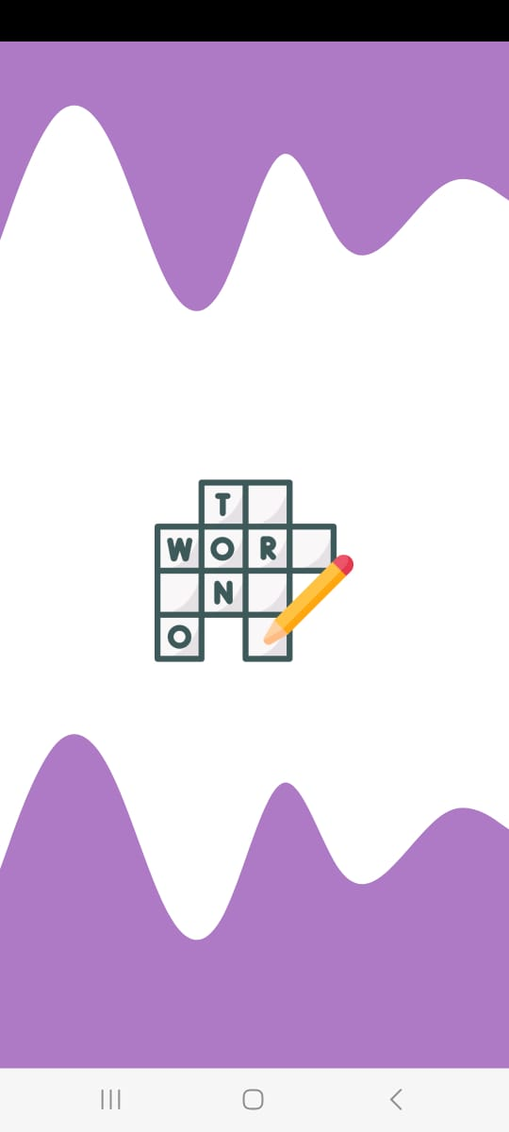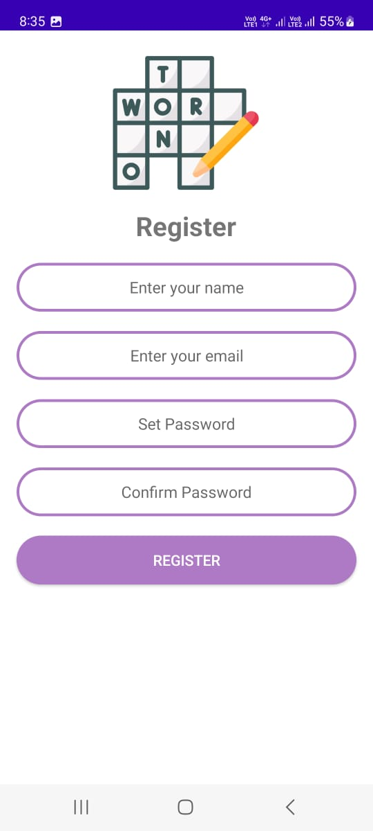
Fig 10: Splash Screen Fig 11: Register page

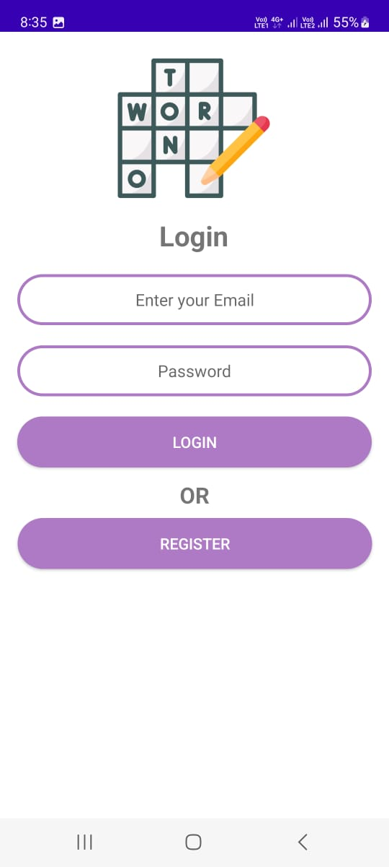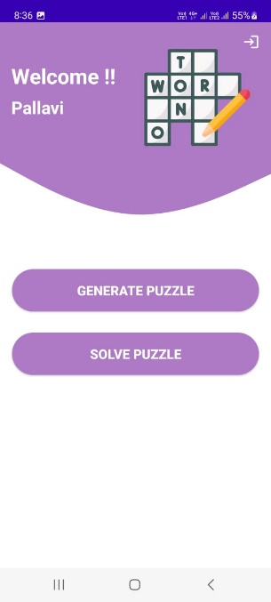
Fig 12: Login page Fig 13: Home screen
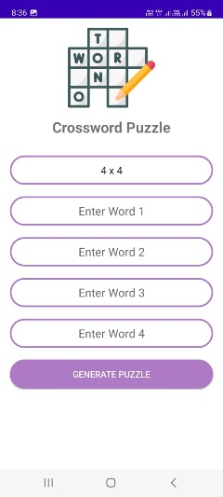 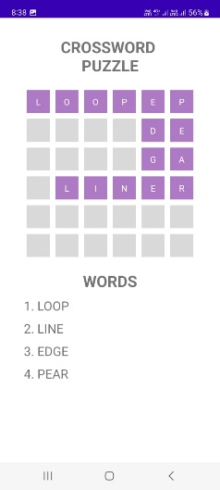 Fig 14: Info to create puzzle Fig 15: Generated puzzle

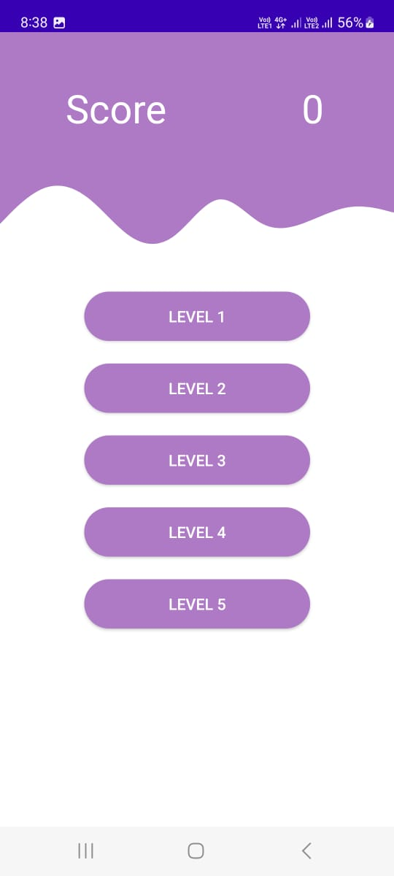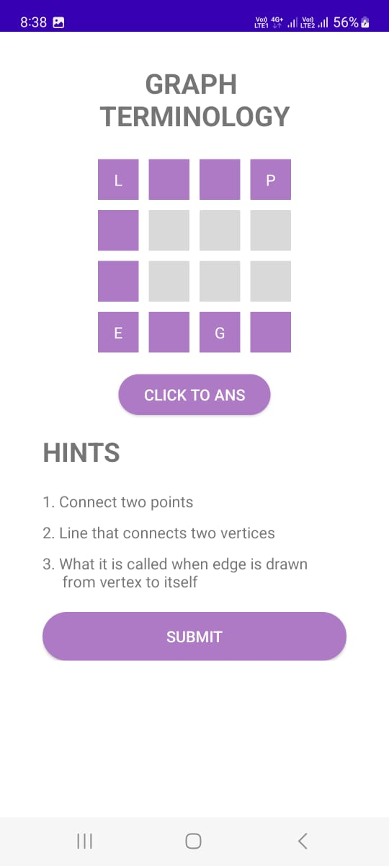
Fig 16: Puzzle levels Fig 17: Puzzle level 1

This project highlights the potential of graph theory and backtracking algorithms in creating engaging and challenging puzzles, and provides a valuable insight into the application of mathematical concepts in game design. The app we have developed provides users with a fun and interactive way to test
their knowledge and challenge their skills in a way that is both enjoyable and educational. We hope that this project will inspire others to explore the possibilities of graph theory and backtracking algorithms in game design, and to create innovative and engaging puzzles for users to enjoy.

Conclusion
In conclusion, this project has demonstrated the effectiveness of using graph theory and backtracking algorithm in generating and solving crossword puzzles. The app we have developed, using Android Studio, Java, XML, and Firebase database, provides users with a seamless experience to generate custom puzzles or solve pre-existing ones.

The app utilizes graph theory to generate crossword puzzles by breaking down the puzzle into a graph, with each letter represented as a node. This approach has allowed us to efficiently generate complex puzzles while ensuring the validity of the puzzle structure. The backtracking algorithm has been utilized to ensure that each word in the puzzle intersects with other words at the appropriate letter positions.

Overall, the success of this project demonstrates the potential for further research and development in the field of generating and solving crossword puzzles using graph theory and backtracking algorithm. This app provides a proof of concept for the effectiveness of these algorithms and the potential for more efficient and effective puzzle generation in the future.

Future scope
There are several areas where this project can be expanded in the future:
- Improved user interface:
While the current interface is user-friendly, there is always room for improvement. A more intuitive interface with more customization options would enhance the user experience.

- Collaborative puzzle solving:
The app could be expanded to allow for multiple users to collaborate on solving a puzzle, adding a social element to the puzzle solving experience.

- Puzzle difficulty levels:
The app could be further improved by allowing users to select a difficulty level for the puzzles they generate or solve. This would cater to both novice and expert puzzle solvers.

Overall, the project of designing crossword puzzles using graph theory and backtracking algorithm has great potential for further development and improvement. The app we have developed provides a solid foundation for future research and innovation in the field of crossword puzzle generation and solving.

- ACKNOWLEDGEMENT

We gratefully acknowledge the support, guidance, and encouragement of my Dissertation Guide Assistant Professor Ms. Niki Modi ma’am for this novel work.

- REFERENCE

[1] "An optimization approach for crossword puzzle design" by M. R. Garey, D. S. Johnson, and L. Stockmeyer.

[2] "A graph-theoretic approach to the design of crossword puzzles" by M. R. Garey and D. S. Johnson.

[3] "Solving and generating crossword puzzles using constraint programming" by A. B. Petersen and H. V. Hansen.

[4] "Generating and solving crossword puzzles with a genetic algorithm" by S. H. Lee and S. B. Kim.

[5] https://developer.android.com/docs

[6] https://docs.oracle.com/en/java/

[7] https://firebase.google.com/docs

[8] https://www.w3schools.com/xml/el_documentation.asp
[9] https://www.geeksforgeeks.org/backtracking-algorithms/
[10] https://www.crosswordsolver.org/guides/what-is-a-crossword-puzzle
[11] https://www.geeksforgeeks.org/solve-crossword-puzzle/

