Philosophical and theoretical aspects of development of embryo based on Susrutha Samhita-
literature and comparative study with modern aspects w.s.r to Garbhavakranthi Sharir

AUTHORS
☆ Dr. Amal Hameed. MD(Ayu)
H.O.D, Dept. of Rachana Sharir, Krishna Ayurved Medical College , Vadodara
&
PhD scholar (final year) PIAR, Parul university

☆ Dr. Akashdeep Meshram MD(Ayu) Professor & Phd Guide
PIAR Parul University

☆ Dr. Malhari Srideshpande MD(Ayu)
Principal, Krishna Ayurved Medical College, Vadodara

☆ Happy Savaliya
First year BAMS,
Krishna Ayurved Medical College , Vadodara

INTRODUCTION
Garbhavakranti comprises of two words, i.e., the "Garbha" and "Avakranti“, which literally gives an idea about descent of soul into the womb. In ancient literature of Ayurveda "Garbhavkranti Shariram" is the science which deals with all these phenomenon. Veda, Purana, vrihatrayi, Laghutrayi, Commentators of samhitas specially Dalhan, chakrapani, Arundatta etc also has illustrated garbhavkranti-Shariram.

In Sharirsthana Acharya Sushrut has elaborated process of Garbha utpatti. He has explained characteristics of Shuddha i.e. normal Shukra (semen) and Artav (menstrual flow). Garbhavkranti is the word which literally means descent of the soul into the womb. the union of shukra (spermatozoa), shonita (ovum) and Atma (soul) inside the uterus is known as garbha (embryo). The fertilization between Shukra and Shonita

produces zygote which further develops into fetus. The Ritu, Kshetra and Ambu etc plays vital role in the proper development of foetus. Different components originating from five elements(panchamahabhoot) takes part in the formation, development of the garbha. The whole process of development of the foetus from two cells to mature foetus is called Garbhavakranti.

Need for the study:-
To create a common idea and cover the knowledge gap by comparing and connecting Garbhavakranti information with modern embryology. The study's overall findings emphasize the value of traditional Ayurvedic knowledge in supporting maternal and fetal health and indicate that fusing it with Western medical practices may result in more successful therapies for congenital abnormalities.

Specific objectives;
▪︎Examine the effects of Garbhavakranti, an Ayurvedic concept, on the wellbeing of pregnant women and their unborn children.

▪︎To assess the efficiency of Ayurvedic treatments for controlling pregnancy- related issues like premature labor etc.

▪︎To look into the safety and possible adverse effects of using Ayurvedic treatments during pregnancy and after delivery.

▪︎To assess possible areas for integration between the Ayurvedic approach to maternal and fetal health and contemporary obstetrical practices.

▪︎In order to promote maternal and fetal health in Ayurveda, it is necessary to make suggestions for incorporating.

STUDY DETAILS & DESCRIPTION

सौम्यं शुक्रमार्तवमाग्नेयमितरेषामप्यत्र भूतानां सान्निध्यमस्त्यणुना विशेषेण, परस्परोपकारात् (परस्परानुग्रहात् ) परस्परानुप्रवेशाच्च ||३|
तत्र स्त्रीपुंसयोः संयोगे तेजः शरीराद्वायुरुदीरयति,
ततस्तेजोनिलसन्निपाताच्छुक्रं च्युतं योनिमभिप्रतिपद्यते संसृज्यते चार्तवेन, ततोऽग्रीषोमसंयोगात् संसृज्यमानो गर्भाशयमनुप्रतिपद्यते क्षेत्रज्ञो वेदयिता स्प्रष्टा प्राता द्रष्टा श्रोता रसयिता पुरुषः स्रष्टा गन्ता साक्षी धाता वक्ता यः कोऽसावित्येवमादिभिः पर्यायवाचकैर्नामभिरभिधीयते दैवसंयोगादक्षयोऽव्ययोऽचिन्त्यो भूतात्मना सहान्वक्षं सत्त्वरजस्तमोभिर्देवासुरैरपरैश्च भावेर्वायुनाऽभिप्रेर्यमाणो
गर्भाशयमनुप्रविश्यावतिष्ठते ||४||
तत्र शुक्रवाहुल्यात् पुमान्, आर्तवबाहुल्यात् स्त्री, साम्यादुभयोर्नपुंसकमिति ||५||

The course of fertilization i.e. the whole incidence of fertilization is explained based upon the philosophical aspect.
There are two physical components:-
1. The male component (sperm)
2. The female component (ovum)
Sperm and ovum both have meiotic divisions and have haploid number of chromosomes.
ACCORDING TO AYURVEDA, sperm is termed as Agneya(very active or hyperactive) and ovum is termed as saumya(which gives structure).

The genetic contribution of male and female (The chromosomes) X and Y differentiate the sex. Along with that the components of the DNA combines together to produce the PHENOTYPE and this combination itself is categorized as Agneya and Saumya.

GENOTYPE is represented by the two haploid genes. In the genotypic presentation there

are two the dominant and the recessive characters. Certain characters dominate the female character and certain characters dominates the male character.
ACCORDING TO AYURVEDA, the contribution is characterized in a different manner not as dominant and recessive instead it is characterized based on the one which gives energy and which gives the structure.
Thus according to current modern scenario it is dominant and recessive characters and according to ayurveda it is the energy giving and structure giving component.

HOW LIFE IS GENERATED?

ACCORDING TO MODERN,
It is not discussed as a different entity that how life is developed all it says is how zygote is formed and how zygote is divided further forming a life.

ACCORDING TO AYURVEDA,
When the ovum and the sperm merges together i.e fertilization, the atma enters and due to which one gets personality, capacity to sense, capacity for intellectual activities, capability to recieve the sensations

HOW ATMA ENTERS AND WHAT KIND OF ATMA ENTERS?

ACCORDING TO MODERN, this process is not discussed but it depends upon the genotypes, phenotypes, dominant & recessive characters.

ACCORDING TO AYURVEDA,There is a eternal life force in the universe and a component of this eternal force enters this structure i.e the Zygote formed, and this is decided by something which is beyond human capacities and once it's done than it's result depends on the qualities Sattva, Rajas and Tamas.

The sex of the zygote is determined at the time of fertilization itself by the dominance of male and female components (XX= female, XY=male).

ऋतुस्तु द्वादशरात्रं भवति दृष्टार्तवः; अदृष्टार्तवाऽप्यस्तीत्येके भाषन्ते ||६||
The period for fertilization,
According to sushruta=12 days
According to others= even without the rutuchakra fertility can occur.

CHARACTERS OF A FERTILE WOMEN:-

भवन्ति चात्र-
पीनप्रसन्नवदनां प्रक्लिन्नात्ममुखद्विजाम् | नरकामां प्रियकथां स्रस्तकुक्ष्यक्षिमूर्धजाम् ||७|| स्फुरद्भुजकुचश्रोणिनाभ्यरुजघनस्फिचाम् । हर्षोत्सुक्यपरां चापि विद्यादृतुमतीमिति [१] ।।८।।

According to Sushruta,
Face looks attractive, she is comfortable,

desiree to have a male component, felling of emptiness in abdomen, legs, eyes and head, felling of vibrations all over the body, more anxiety.
All this are the signs of rutu mati, the one who is fertile or capable for reproducing.

नियतं दिवसेऽतीते सङ्कुचत्यम्बुजं यथा | ऋतौ व्यतीते नार्यास्तु योनिः संव्रियते तथा ||९||
According to sushruta, during the fertile window period fertility is possible and the fertilization is possible, beyond that period the YONI becomes constricted, hence the changes in the endometrium and the endometrium gets destructed and therefore at that time fertilization is not possible.

मासेनोपचितं काले धमनीभ्यां तदार्तवम् |
ईषत्कृष्णं विवर्णं च वायुर्योनिमुखं नयेत् ||१०||
तद्वर्षाद्द्वादशात् काले वर्तमानमसृक् पुनः | जरापक्वशरीराणां याति पञ्चाशतः क्षयम् ||११||
The menstrual flow is a regular cycle which occurs once in a month, the artava is brought to uterus by dhamni and is gets discarded out if the fertilization has not occur.
According to sushruta,
the period of menarche= 12 years
Menopause= 50 years

CHANGES DURING MENSTRUATION
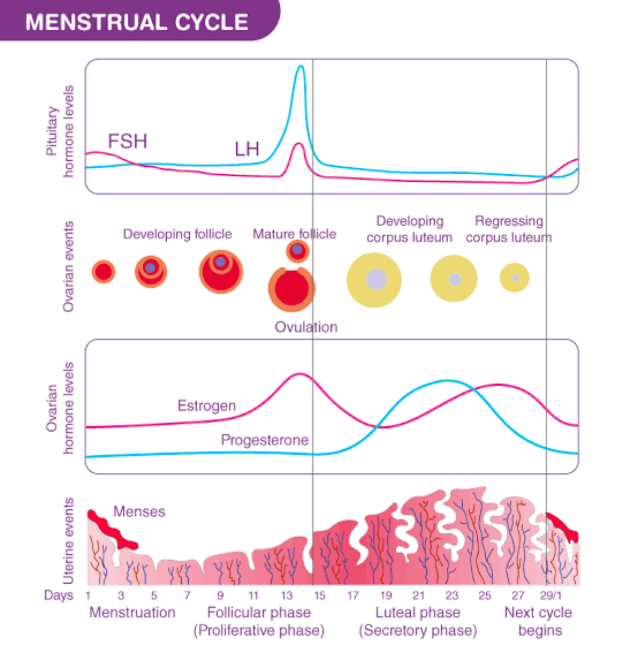

युग्मेषु तु पुमान् प्रोक्तो दिवसेष्वन्यथाऽबला |
पुष्पकाले शुचिस्तस्मादपत्यार्थो स्त्रियं व्रजेत् ||१२||
In the even days= possibility of male
In the odd days= possibility of female
Therefore the time of conception should be taken into consideration and it should be more preferable in auspicious occasions.
This point is yet not considered true that is the time of conception is really important or not.

तत्र सद्योगृहीतगर्भाया लिङ्गानि - श्रमो ग्लानिः पिपासा सक्थिसदनं शुक्रशोणितयोरवबन्धः स्फुरणं च योनेः ||१३||
ACCORDING TO AYURVEDA,
signs of fertilization can be seen immediately after the conception, the feeling of tiredness, thirst, vibratory sensations in the vagina etc.
ACCORDING TO MODERN,
This kind of description is not mentioned yet.
Orgasm is the felling of satisfaction at the end of sexual indulgence and orgasm would also be present with this similar symptoms

but orgasm is not a sign of fertilization. Menstruation is absent after fertilization.

LATER SYMPTOMS AFTER FERTILIZATION
स्तनयोः कृष्णमुखता रोमराज्युद्गमस्तथा ।
अक्षिपक्ष्माणि चाप्यस्याः सम्मील्यन्ते विशेषतः || १४ ||
अकामतश्छर्दयति गन्धादुद्विजते शुभात् |
प्रसेकः सदनं चापि गर्भिण्या लिङ्गमुच्यते ||१५||

The sperm does not unite with ovum immediately after fertilization, sperm enters through the vagina and ovum enters through the fimbria so there is a need of migration and fertilization occurs if both are viable and it is a chance factor. The question that does the fertilization occurs immediately is very variable becaus it can occur from 15 minutes to 3-4 days also. After fertilization the zygote travels in the uterus and finally gets implanted in the endometrium that is called IMPLANTATION. And from this time one would have the typical signs of pregnancy
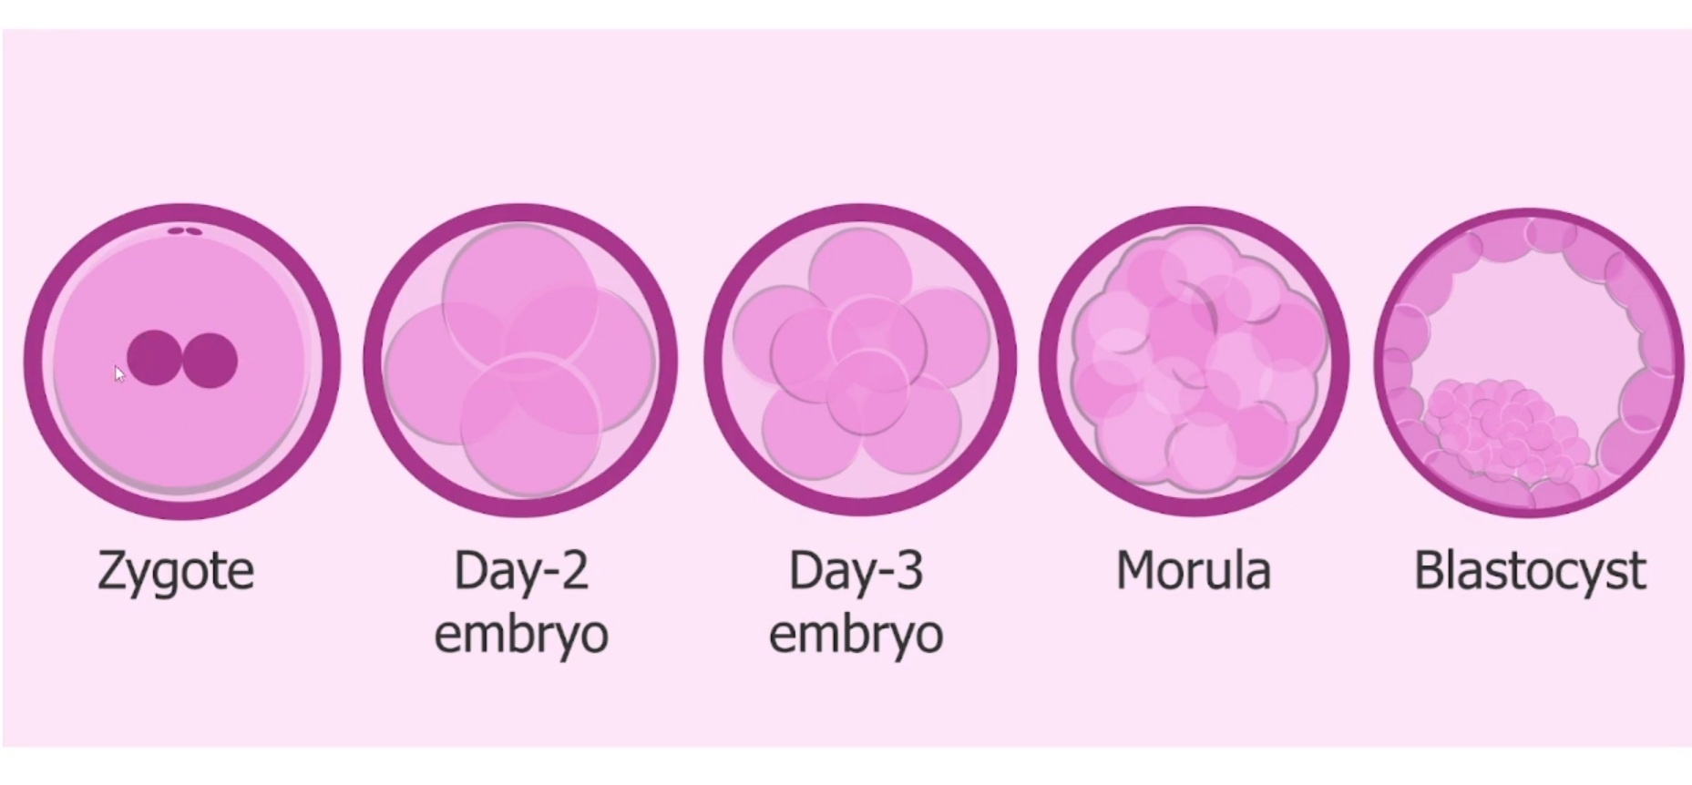
like congestion in breast, sense of vomiting and feeling of having that pregnancy and it would be seen after 2 weeks of the sexual indulgence and not immediately, these are the clinical symptoms which occurs only after the implantation and not during the period of fertilization or while the zygote is moving in the uterus. The usual time taken for embedding is 1-2 weeks and only after the embedding the hormonal changes occurs significantly which causes the sense of vomiting, discomfort, emotional disturbances and emotional unstability.

The stage when the embryo gets embedded in the endometrium is the stage of BLASTOCYST (minimum of 60 divisions).

तदा प्रभृति व्यवायं व्यायाममतितर्पणमतिकर्शनं दिवास्वप्नं रात्रिजागरणं शोकं यानारोहणं भयमुत्कुटुकासनं चैकान्ततः स्नेहादिक्रियां शोणितमोक्षणं चाकाले वेगविधारणं च न सेवेत ||१६||
दोषाभिघातैर्गर्भिण्या यो यो भागः प्रपीड्यते । स स भागः शिशोस्तस्य गर्भस्थस्य प्रपीड्यते ।।१७।।
The pregnant women should avoid all the vigorous activities like exercises, weight loss or weight gain, too much of sleep, traveling on vehicles, sitting on squating position, raktamokshan, sodhan chikitsa etc should be avoided during pregnancy because any injury to the pregnant women can lead to same injury in the fetus and hence one should take care of the mother.

MASANUMASIK VRIDDHI
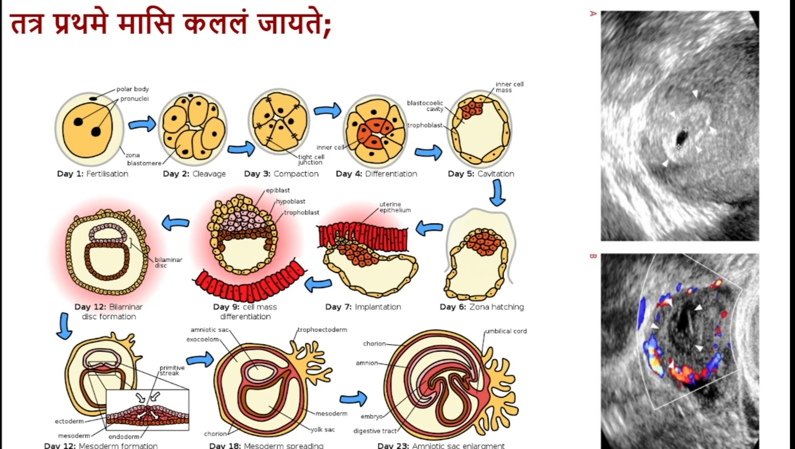
1st month:-
ACCORDING TO AYURVEDA,
In 1st month it appears like semi-solid mass of tissue which does not have any shape of human body.
ACCORDING TO MODERN,
it is also considered and around 25th day the BLASTOCYST is found along with a mass of 4mm. Only after this the fertilization can be confirmed by USG (ultrasound or sonogram or ultrasonogram) at the end of 1st month. So at this stage one can only find the embedded embryo with a hollow cavity
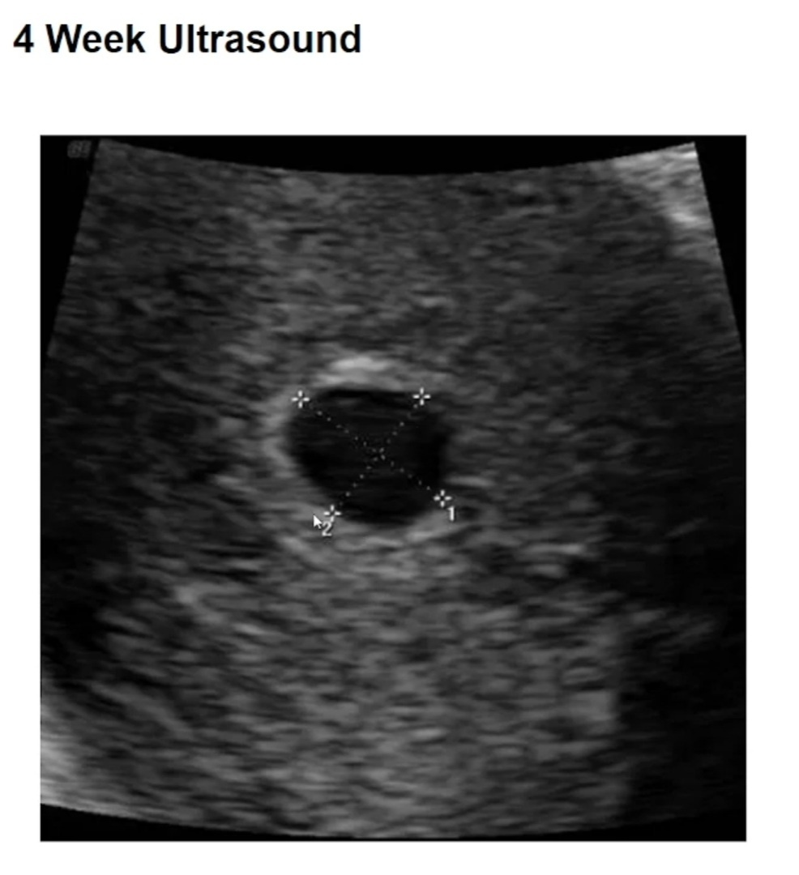
without any differentiation. Due to the presence of vascularity by DOPPLER USG, the blood flow and the blood vessels around the area can be seen.
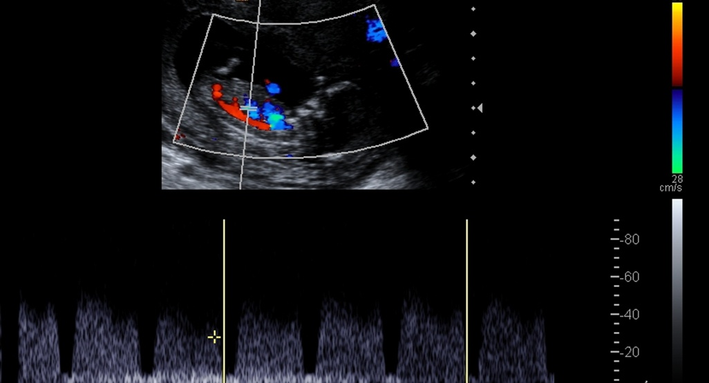

2nd month:-
द्वितीये शीतोष्मानिलैरभिप्रपच्यमानानां महाभूतानां सङ्घातो घनः सज्जायते, यदि पिण्डः पुमान्, स्त्री चेत् पेशी, नपुंसकं चेंदर्बुदमिति;
ACCORDING TO AYURVEDA,
the 2nd month the garbha becomes a ધન or pinda like form. If this solid mass is oval shaped, it is a male, if it is elongated peshi in shape, it is a female & if the mass is rounded (arbuda like) then it is a hermaphrodite At this stage, the mahabhuta acted upon by shita (kapha), and by ushma(pitta) and Anila (vayu) start the process of differentiation and form

the solid mass called ધન.
ACCORDING TO MODERN,
The USG is done at the interval of month's or trimester but for academical purposes it is done at week intervals. Ultrasonogram done before the 4th week is not very much confirmatory and according to current knowledge one can not differentiate the shape in first 3 months of pregnancy, thus sex determination can be only done around the 4th month where the sex buds develops in th fetus with the help of ultrasonogram not only the size and structure(dimensions)but also the weight can be studied by assisting the placental blood flow.
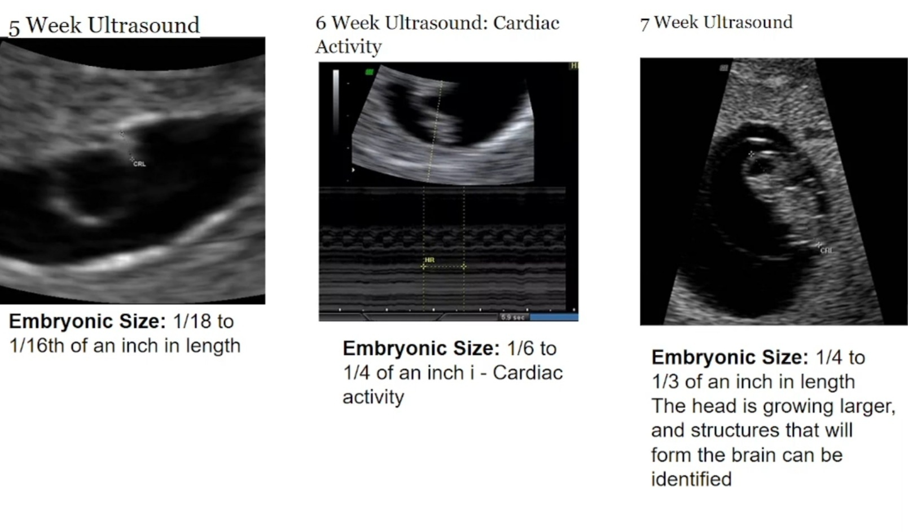
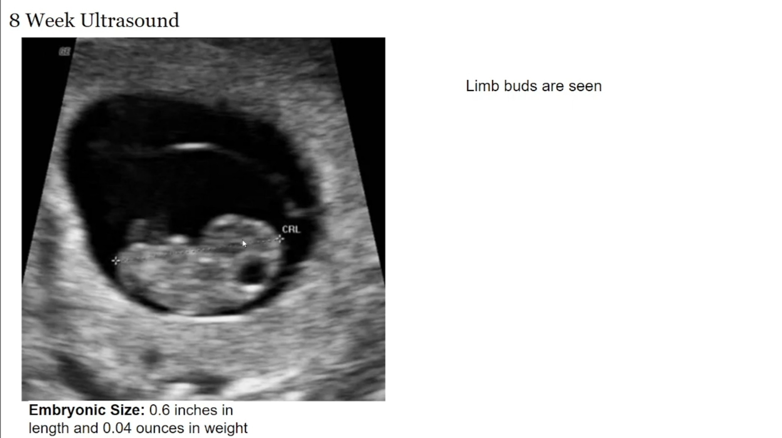

5th week :-
The embryonic size is 1/18th to 1/16th of an inch in length, the shape would be same as a membrane and a blastocyst.

6th week:-
The embryonic size is 1/16th to 1/4th of an inch in length, cardiac activity is (vascular concentration) is seen.

7th week:-
The embryonic size is 1/4th to 1/3rd of an inch in length, the head grows larger and the structures that will form the brain can be seen.

8th week:-
The embryonic size is 0.6 inches in length and 0.04 ounces in weight. Limb buds can be seen as points or projections from where the limbs are developed and the direction of head can also be identified.

3rd month:-
तृतीये हस्तपादशिरसां पञ्चपिण्डका निर्वर्तन्तेऽङ्गप्रत्यङ्गविभागश्च सूक्ष्मो भवति;
ACCORDING TO AYURVEDA,
In the 3rd month there is formation of 5 pindikas that develops into hands, feets and the head. At this the anga pratyanga vibhaga commences and proceeds further. The 5 pindikas are present in the form of bud like structure at this stage.
The fetus grows and develops into 5 buds of 2 arms, 2 legs and head. All the organs (pratyangs) are in minute and non visible form. Features of featus start to see here.
ACCORDING TO MODERN,
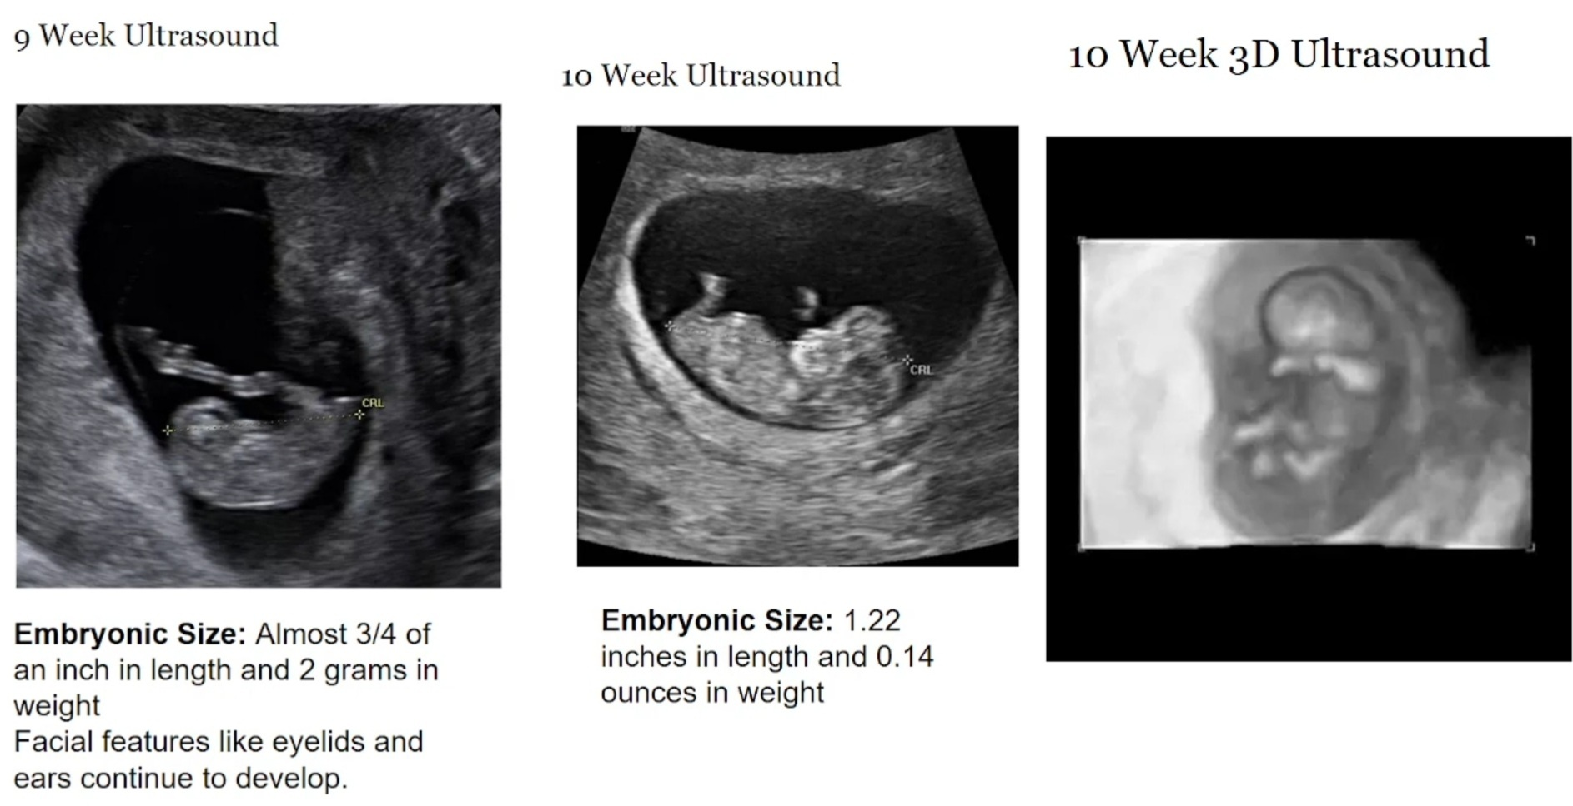
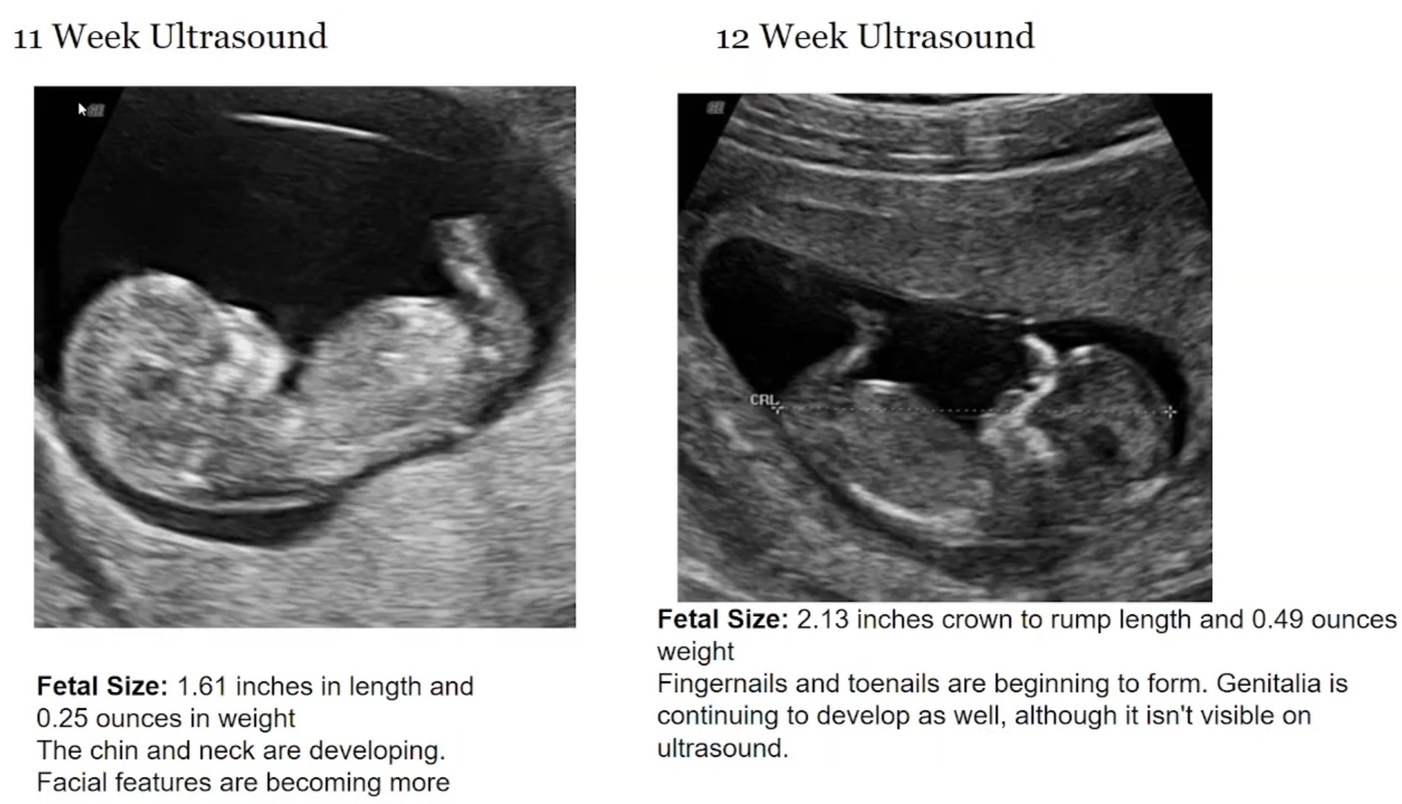

9th week:-
The embryonic size is almost 3/4th of an inch in length and 2 grams in weight, facial features like eyelids and ears continue to develop.

10th week:-
The embryonic size is 1.22 inches in length and 0.14 ounces in weight.

11th week:-
The fetal size is 1.61 inches and 0.25 ounces in weight, the chin and neck are developing and the facial features are becoming more prominent.

12th week:-
The fetal size is 2.13 inches crown to rump length and 0.49 ounces weight, fingernails and toenails begin to form, genitalia continue to develop as well, although it isn't visible on ultrasound.

●At the end of 1st trimester(3 months) some guidelines like the landmarks for gestation is done.
One of the important criteria for Assessing the growth of the fetus in the first 2 months would be be assessing the size of the gestational sac(bag like structure).
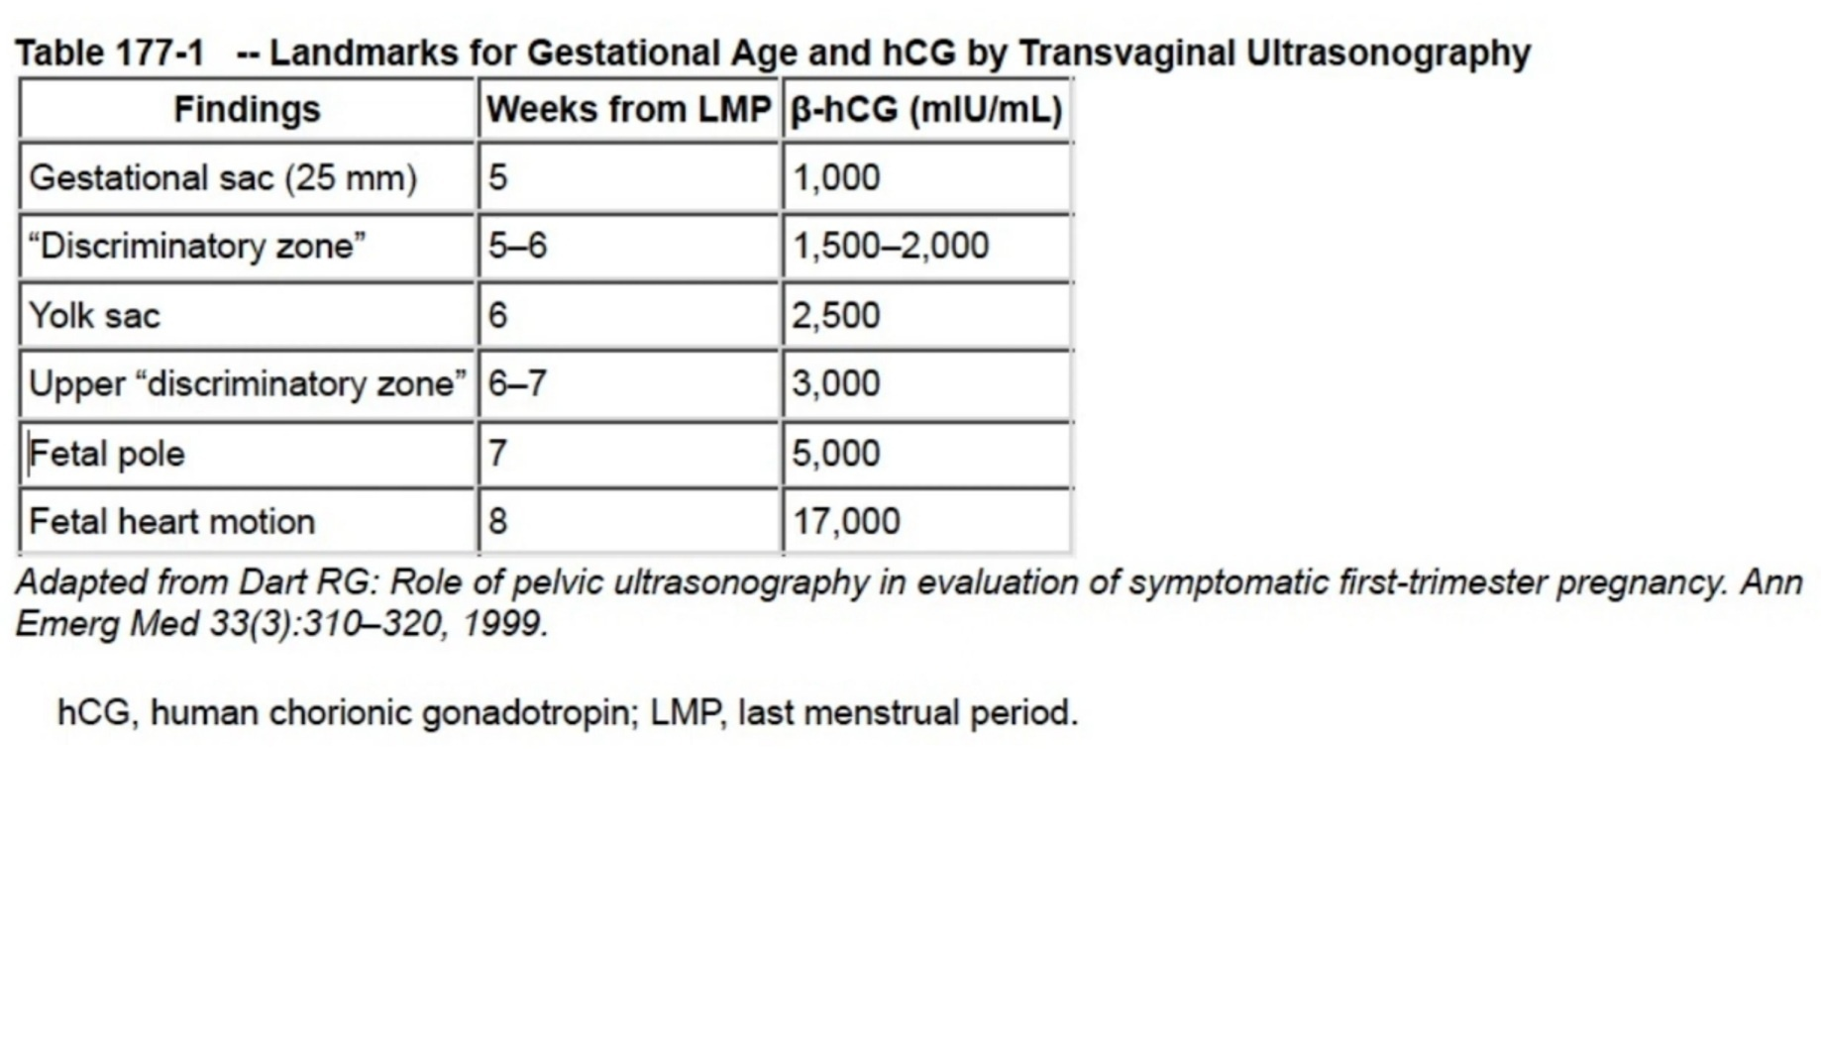

● The viability of the pregnancy cant be made out before the first trimester so there are possibilities of ECTOPIC PREGNANCY or EXTRAUTERINE PREGNANCY (A pregnancy in which the fertilised egg implants outside the uterus) Or any vaginal bleeding. So basically at the end of first trimester, with the help of USG it can be known that whether the pregnancy is viable or there are any deformities present.

FIRST TRIMESTER ULTRASOUND: Guidelines are used for,

•Confirmation of the presence of an intrauterine pregnancy

•Evaluation of a suspected ectopic pregnancy

•Defining the cause of vaginal bleeding

•Evaluation of pelvic pain

•Estimation of gestational (menstrual) age

•Diagnosis or evaluation of multiple gestations

•Confirmation of cardiac activity

•Imaging as an adjunct to chorionic villus sampling, embryo transfer, and localization and removal of an intrauterine device

•Assessing for certain fetal anomalies, such as anencephaly, in high-risk patients

•Evaluation of maternal pelvic masses and/or uterine abnormalities

•Measuring the nuchal translucency (NT) when part of a screening program for fetal

aneuploidy

•Evaluation of a suspected hydatidiform mole

4th month:-
चतुर्थे सर्वाङ्गप्रत्यङ्गविभागः प्रव्यक्तो भवति, गर्भहृदयप्रव्यक्तिभावाच्चेतनाधातुरभिव्यक्तो भवति, कस्मात्? तत्स्थानत्वा
तस्माद्गर्भश्चतुर्थे मास्यभिप्रायमिन्द्रियार्थेषु करोति, द्विहृदयां चनारींदौहृदिनीमाचक्षते |
दौहृदविमाननात् कुब्जं कुणिं खञ्जं जडं वामनं विकृताक्षमनक्षं वा नारी सु जनयति, तस्मात् सा यद्यदिच्छेत्तत्तस्यै दापयेत्, लब्धदौहृदा हि वीर्यवन्तं चिरायुषं च पुत्रं जनयति ||१८||
ACCORDING TO AYURVEDA,
The parts of the body become more distinct As the hridaya, the seat of consciousness. (चेतनास्थानम् ) also becomes well developed at this stage. the foetus becomes conscious during the 4th month & express it's desire and feeling through it's mother. At this stage the

lady is called Dauhridani as she bears the fetus whose hridaya is active. The pregnant women express the feelings of fetus as her own desires and longings & must be fulfilled.
All the organs (anga pratyangas) and their subdivision becomes observable and more visible. The chetna dhatu also gets manifested because the fetal heart becomes obvious, the seat of chetna is the heart therefore in the 4th month the fetus desire things to taste, to smell etc through the mother.
The mother now possess two heart therefore called as dauhridini. Non-fulfillment of desires may lead to the birth of the child who would have hump back or deformed arm or would be an idiot or be with defective eyes or without eyes. Therefore whatever mother desires should be given to her. One who gets fulfillment of all the belongings would deliver a strong and long lived child. Pregnant women
desires should be given to her by the

physicians in order to avoid harm.

ACCORDING TO MODERN,
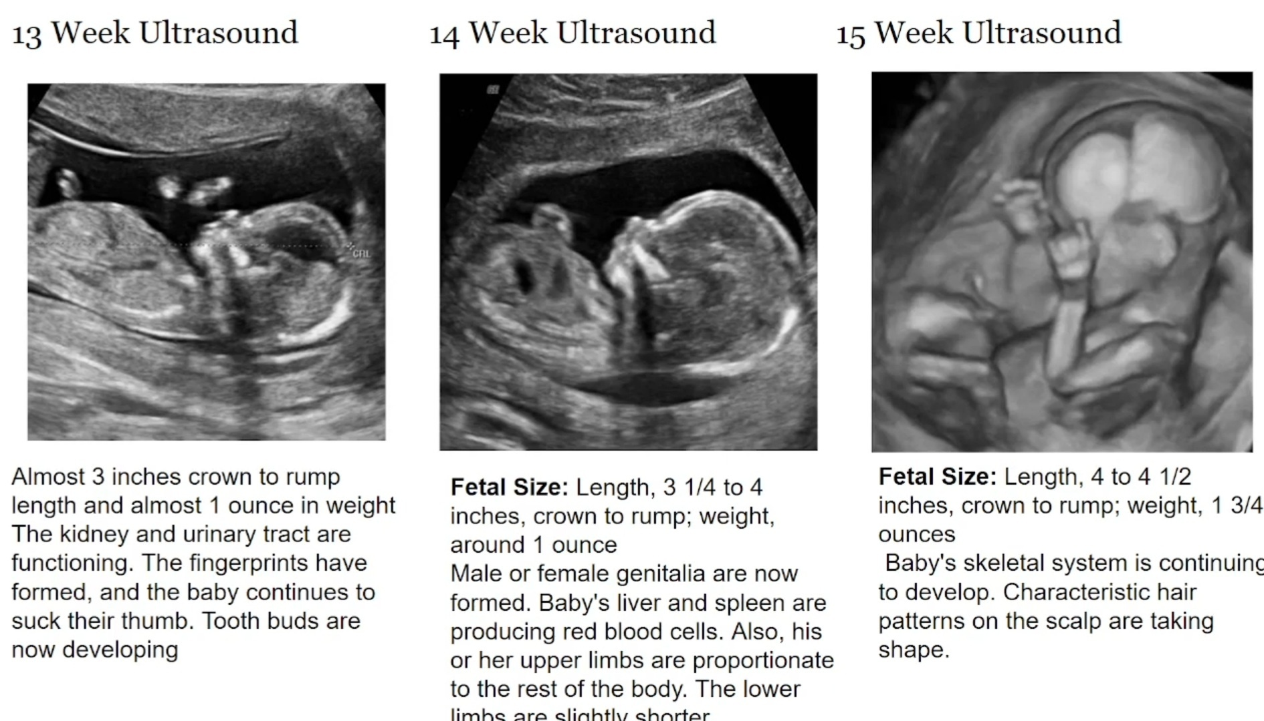
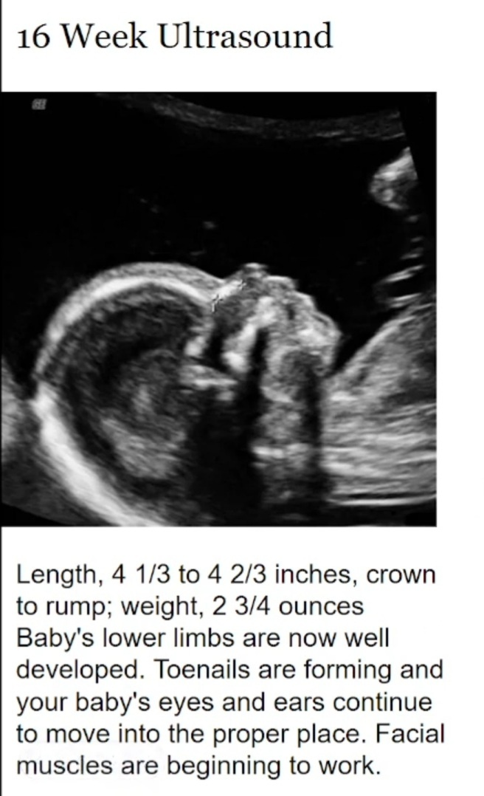

13th week:-
Almost 3 inches crown to rump length and almost 1 ounce in weight, the kidney and urinary tract are functioning, the fingerprints have formed, baby continue to suck their thumb. Tooth buds are now developing.

14th week:-
The length, 3 1/4 to 4 inches crown to rump, and weight around 1 ounce, male or female genitalia are now formed, baby's liver and spleen produces RBC(red blood cells), his/her upper limbs are proportionate to the rest of the body, the lower limbs are slightly shorter.

15th week:-
The length 4 to 4 1/2 inches crown to rump, weight 1 3/4 ounces, baby's skeletal system is continuing to develop, characteristics hair pattern on the scalp are taking shape.

16th week:-
The length 4 1/3 to 4 2/3 inches crown to rump, weight 2 3/4 ounces, baby's lower limb are now well developed. Toenails are developing and baby's ears and eyes continue to move into proper place. Facial muscles are beginning to work.

5th month:-
पञ्चमे मनः प्रतिबुद्धतरं भवति,
ACCORDING TO AYURVEDA,
In the 5th month, the mana or mind of the fetus begins to function, thus the fetus becomes livelier, waking from the subconscious state, the mind and wisdom becomes more noticeable and perception.

ACCORDING TO MODERN,
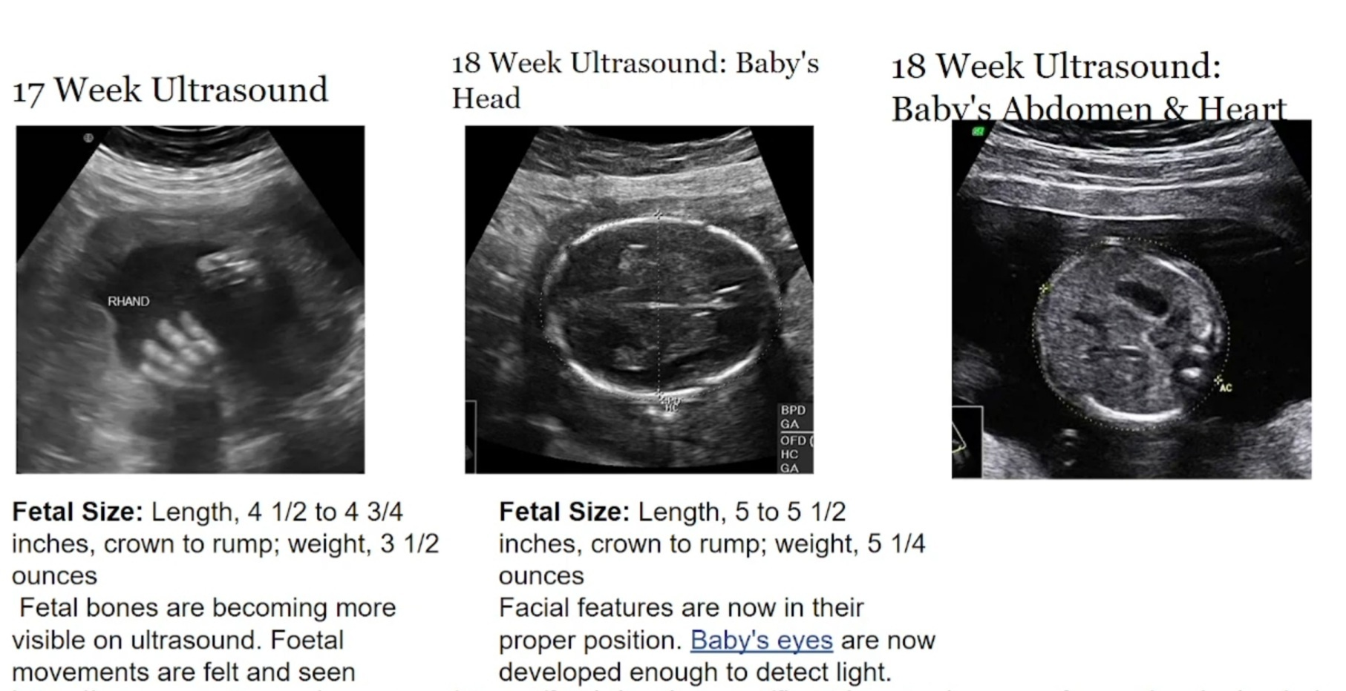
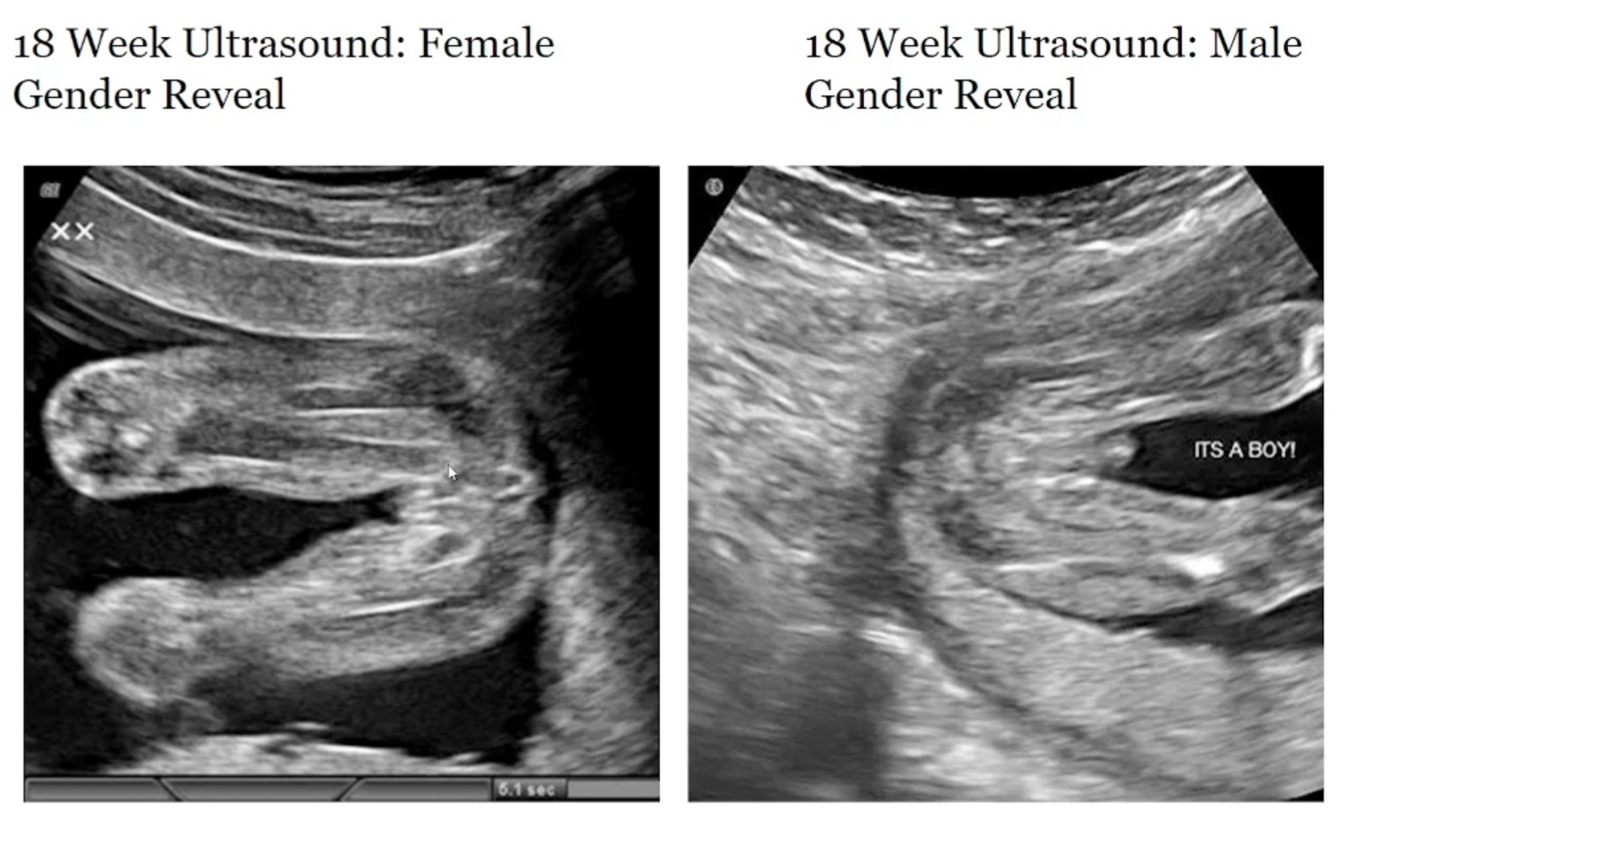
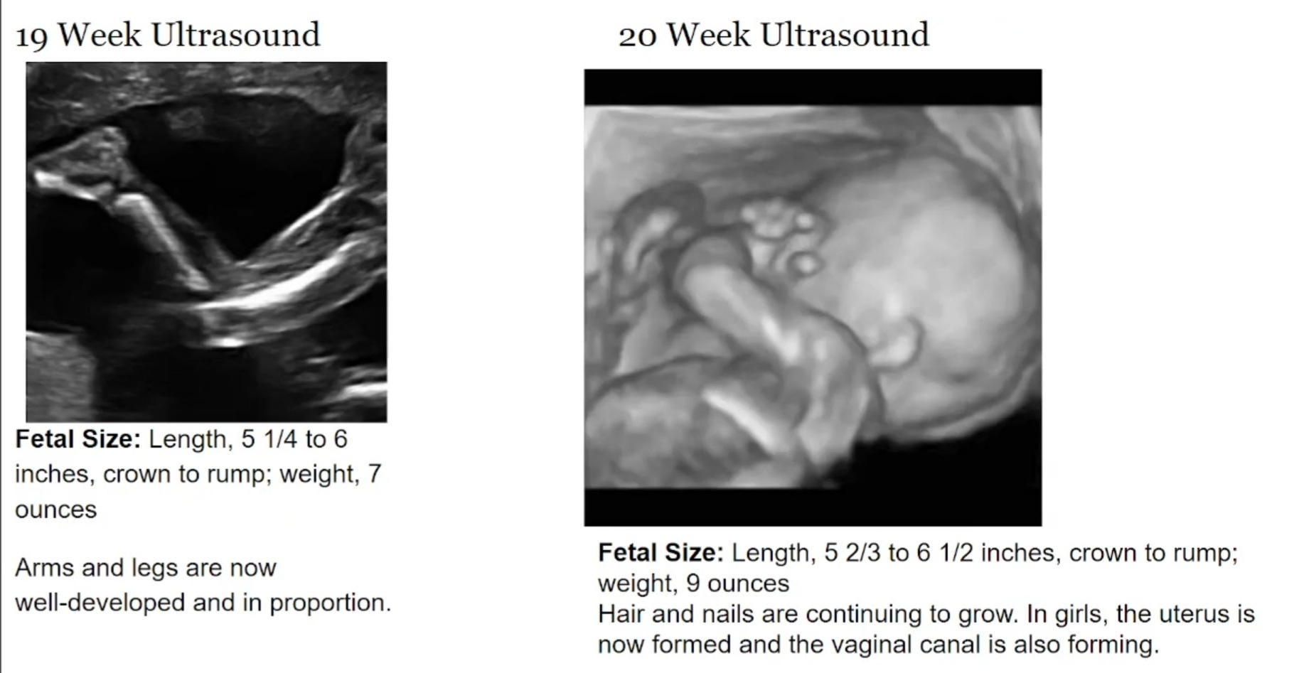

17th week:-
Fetal Size: Length, 4 1/2 to 4 3/4 inches, crown to rump; weight, 3 1/2 ounces, Fetal bones are becoming more visible on ultrasound. Foetal movements are felt and seen.

18th week:-
Fetal Size: Length, 5 to 5 1/2 inches, crown to rump; weight, 5 1/4 ounces, Facial features are now in their proper position. Baby's eyes are now developed enough to detect light.
18th week ultrasound reveals gender, by looking at the shape of genital buds sex determination is possible.
1.Female gender reveal:- a depression is seen at the genital pore.
2. Male gender reveal:- a projection is seen at the genital pore.
☆sex determination and revealing the gender is illegal now a days, here it is only explained for academic purpose☆

19th week:-
Fetal Size: Length, 5 1/4 to 6 inches, crown to rump; weight, 7 ounces, Arms and legs are now well-developed and in proportion.

20th week:-
Fetal Size: Length, 5 2/3 to 6 1/2 inches, crown to rump;weight, 9 ounces, Hair and nails are continuing to grow. In girls, the uterus is now formed and the vaginal canal is also forming.

6th month:-
षष्ठे बुद्धिः
ACCORDING TO AYURVEDA,
Buddhi manifests in the 6th month of development (CHARAK opines that the fetus becomes endowed with more energy and complexion at this stage).
ACCORDING TO MODERN,
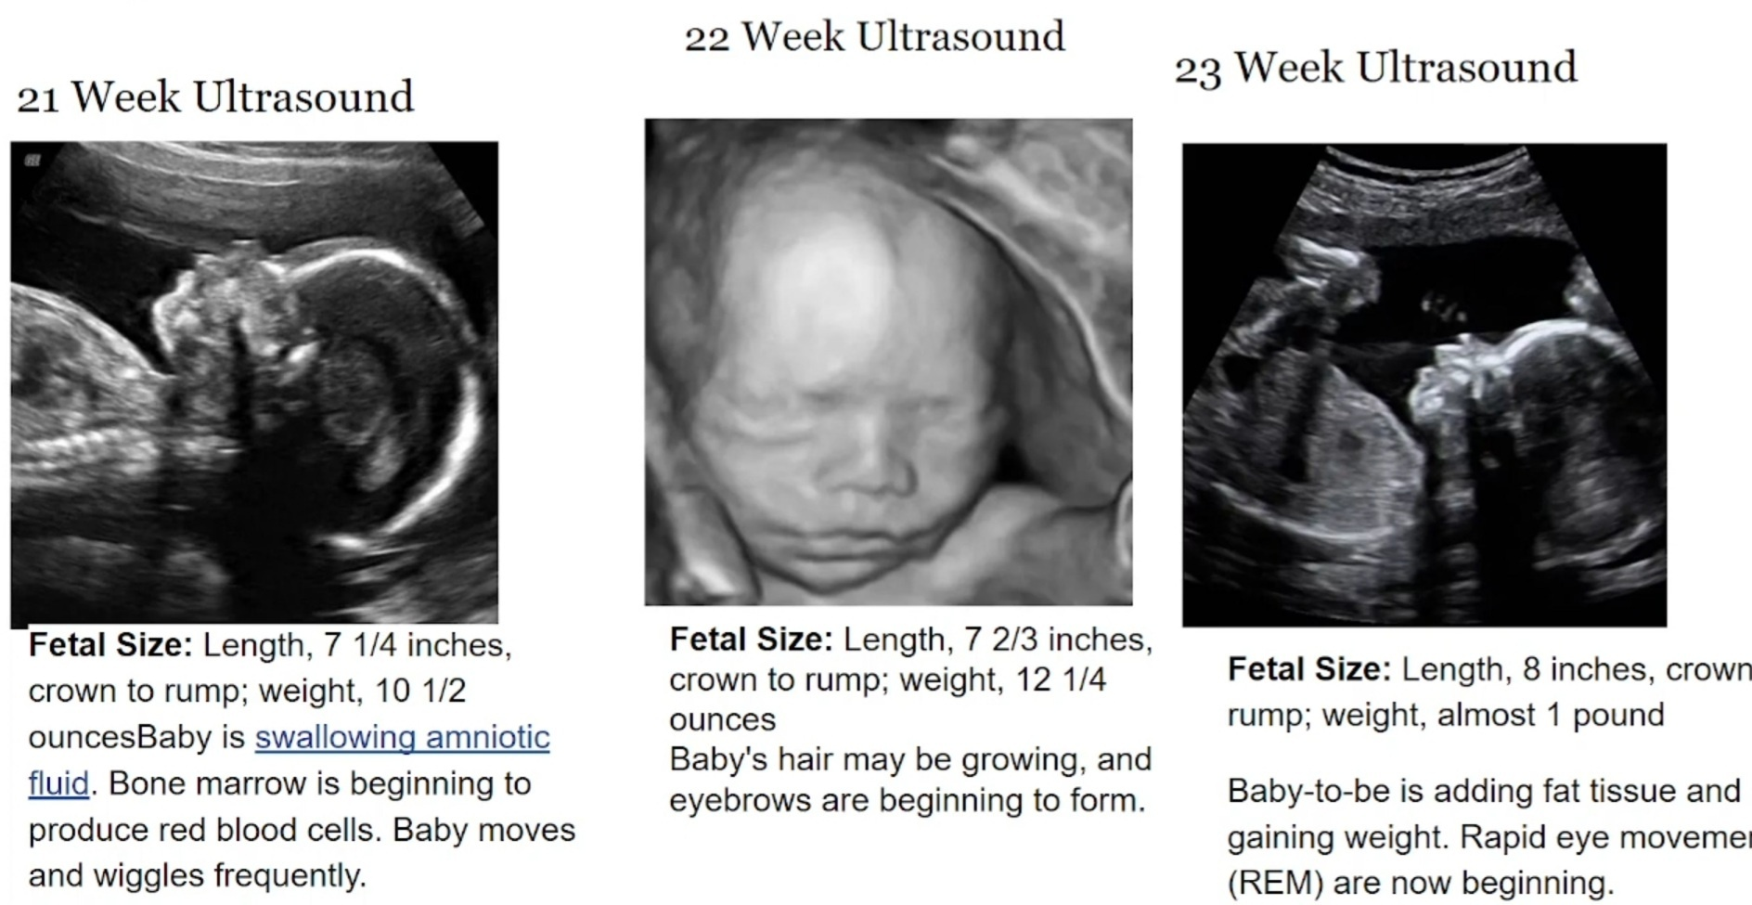
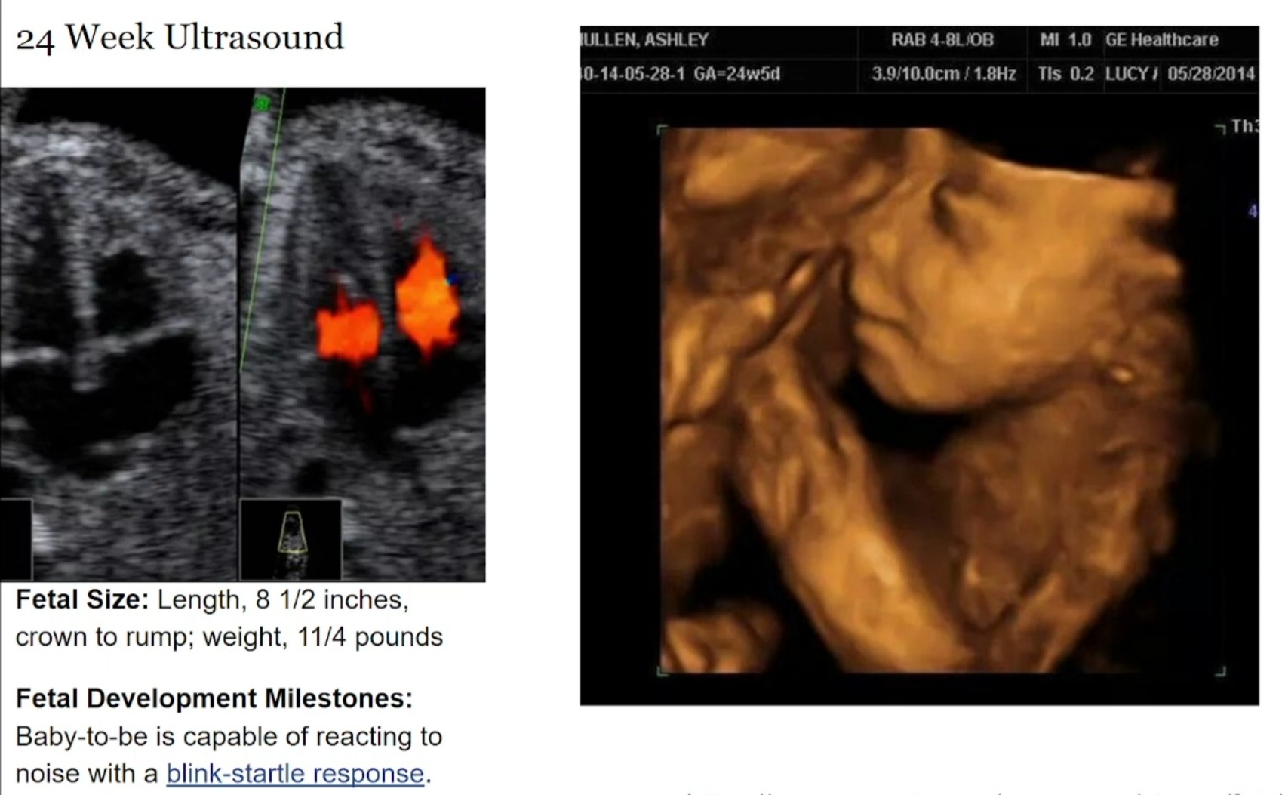

21st week:-
Fetal Size: Length, 7 1/4 inches, crown to rump; weight, 10 1/2 ounces, Baby is swallowing amniotic fluid. Bone marrow is beginning to produce red blood cells. Baby moves and wiggles frequently.

22nd week:-
Fetal Size: Length, 7 2/3 inches, crown to rump; weight, 12 1/4 ounces, Baby's hair may be growing, and eyebrows are beginning to form.

23rd week:-
Fetal Size: Length, 8 inches, crown rump; weight, almost 1 pound, Baby-to-be is adding fat tissue and gaining weight. Rapid eye movement (REM) are now beginning.

24th week:-
Fetal Size: Length, 8 1/2 inches, crown to rump; weight, 1 1/4 pounds.

Fetal Development Milestones:
Baby-to-be is capable of reacting to noise with a blink-startle response, lungs are also developing.

7th month:-
सप्तमे सर्वाङ्गप्रत्यङ्गविभागः प्रव्यक्ततरः;
ACCORDING TO AYURVEDA,
In the 7th month the body parts gets differentiated rapidly and becomes even more conspicuous and all the other dhatus grow and develop rapidly, all the anga pratyangas are becoming more obvious, one can make out all the body parts, both internal and external organs are noticeable during this month.
ACCORDING TO MODERN,
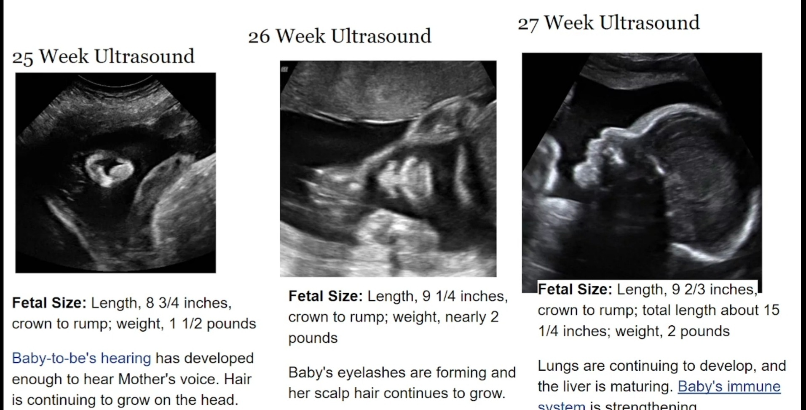
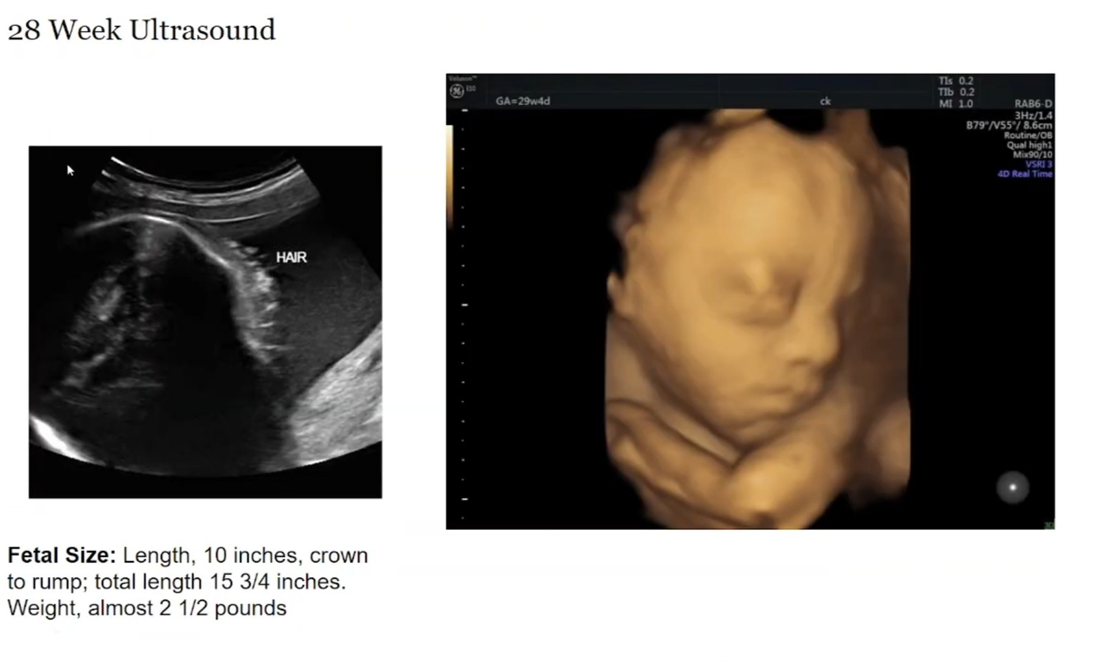

25th week:-
Fetal Size: Length, 8 3/4 inches, crown to rump; weight, 1 1/2 pounds, Baby-to-be's hearing has developed enough to hear Mother's voice. Hair is continuing to grow on the head.

26th week:-
Fetal Size: Length, 9 1/4 inches, crown to rump; weight, nearly 2 pounds, Baby's eyelashes are forming and her scalp hair continues to grow.

27th week:-
Fetal Size: Length, 9 2/3 inches, crown to rump; total length about 15 1/4 inches; weight, 2 pounds,Lungs are continuing to develop, and the liver is maturing. Baby's immune system is strengthening.

28th week:-
Fetal Size: Length, 10 inches, crown to rump; total length 15 3/4 inches. Weight, almost 2 1/2 pounds.

8th month:-
अष्टमेऽस्थिरीभवत्योजः , तत्र जातश्चेन्न जीवेन्निरोजस्त्वान्नैर्ऋतभागत्वाच्च , ततो बलिंमांसौदनमस्मै दापयेत्;
ACCORDING TO AYURVEDA,
In the 8th month, the ojas becomes unstable shifting from the mother's side to the fetus and vise versa. Hence a child born in the 8th month does not survive after birth due to the absence of ojas. Hence, to avoid premature birth of the child special offerings aremade during the 8th month of the pregnancy. The ojas becomes unsteady, suppose the featus born in this month does not survive firstly, because of the absence of ojas and secondly, because of demeans therefore sacrificial offerings of flesh and cooked rice should be

offered to them.
ACCORDING TO MODERN,
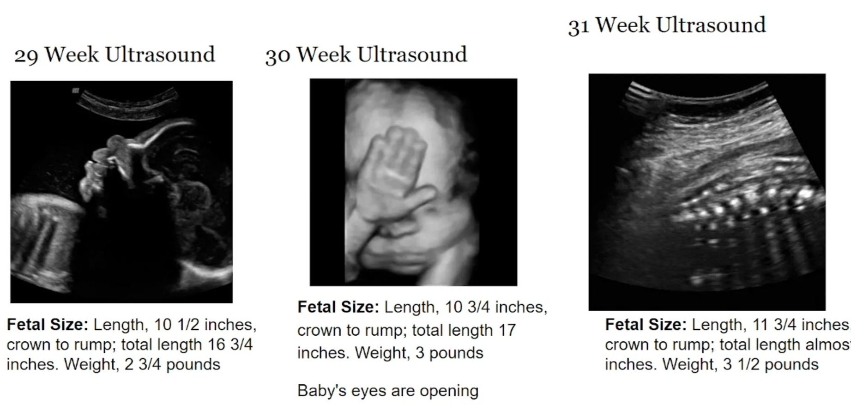
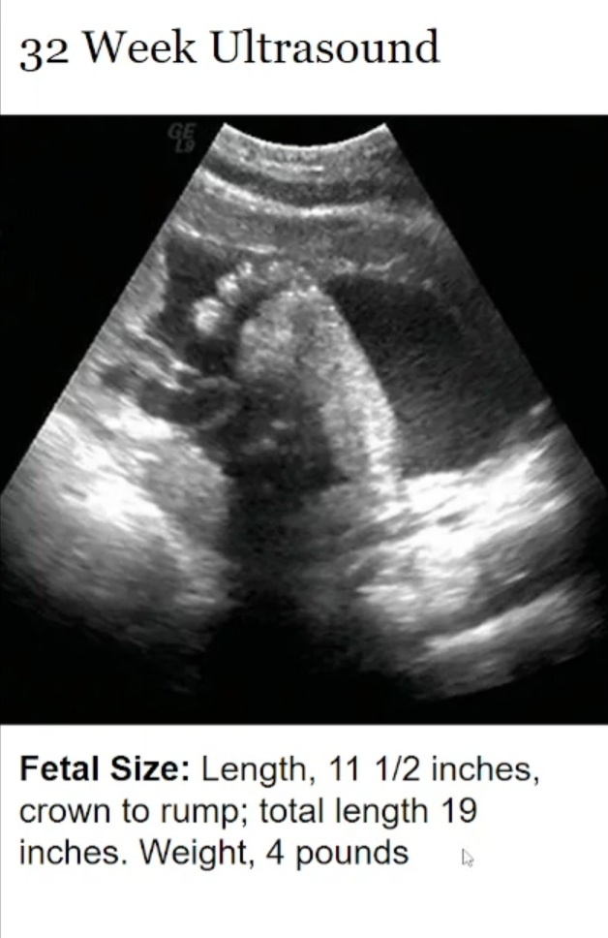

29th week:-
Fetal Size: Length, 10 1/2 inches, crown to rump; total length 16 3/4 inches. Weight, 2 3/4 pounds.

30th week:-
Fetal Size: Length, 10 3/4 inches, crown to rump; total length 17 inches. Weight, 3 pounds, Baby's eyes are opening.

31st week:-
Fetal Size: Length, 11 3/4 inches. crown to rump; Weight, 3 1/2 pounds.

32nd week:-
Fetal Size: Length, 11 1/2 inches, crown to rump; total length 19 inches. Weight, 4 pounds.

9th month:-
नवमदशमैकादशद्वादशानामन्यतमस्मिज्जायते, अतोऽन्यथा

विकारी भवति ।।३०।।
ACCORDING TO AYURVEDA,
After this parturition should take place within the 9th to 12th month of conception. If it is prolonged it is understood that the fetus have some kind of vikar or abnormalities and immediate treatment should be given to remove the fetus out of the uterus. Usually, in the 9th month delivery takes place, the delivery may also take place in any time of the 9th, 10th, 11th or else in the 12th month, otherwise pregnancy should be regarded as abnormal.
ACCORDING TO MODERN,
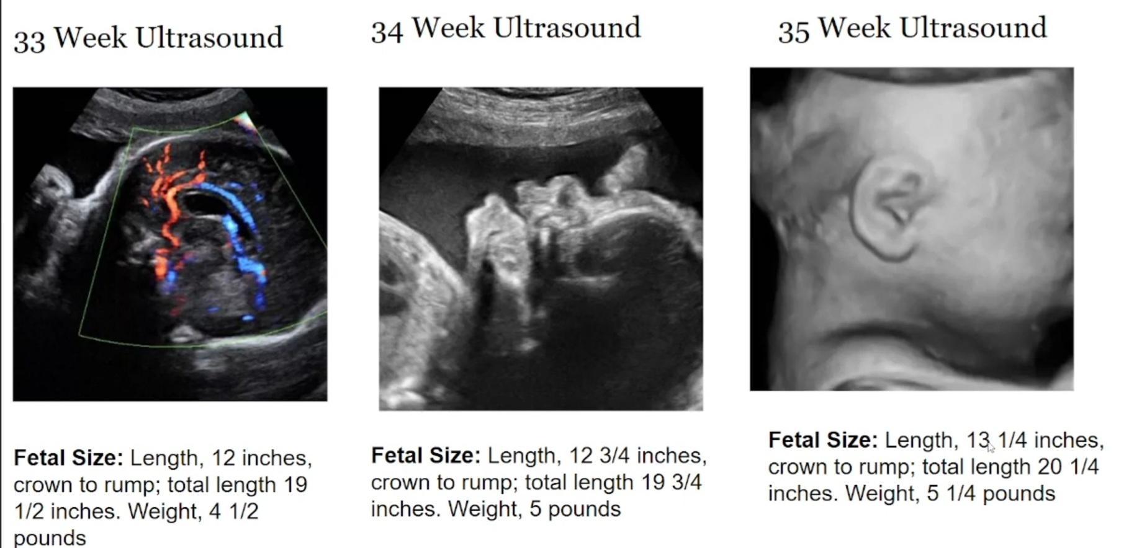
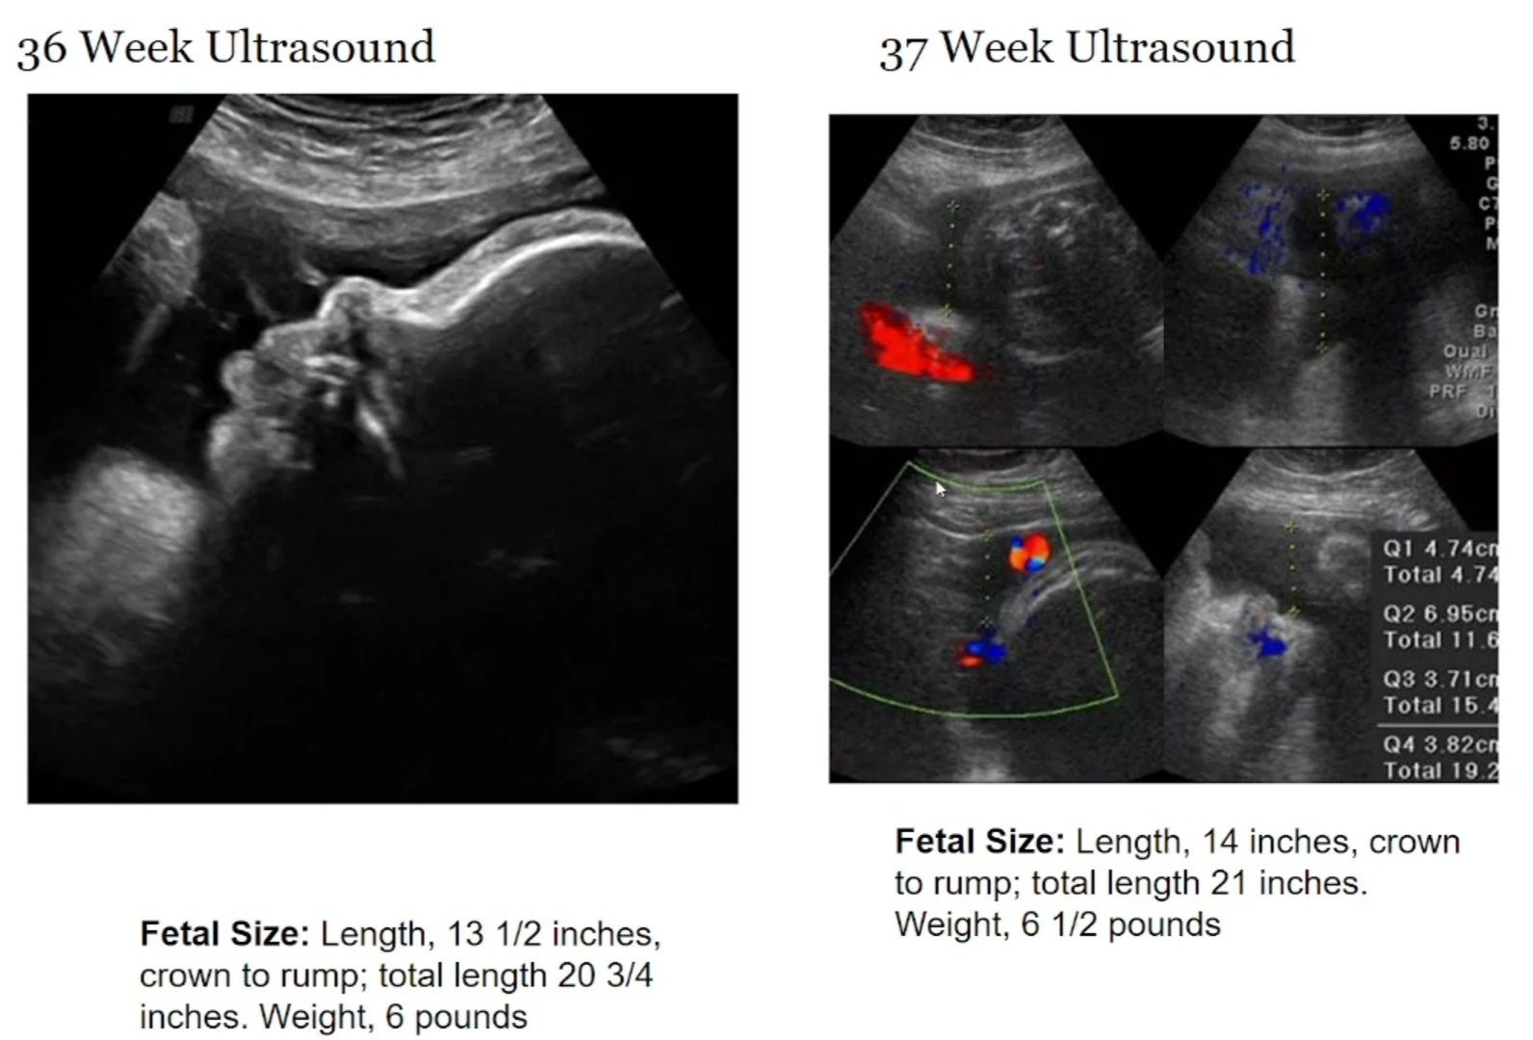

33rd week:-
Fetal Size: Length, 12 inches, crown to rump; total length 19 1/2 inches. Weight, 4 1/2 pounds.

34th week:-
Fetal Size: Length, 12 3/4 inches, crown to rump; total length 19 3/4 inches. Weight, 5 pounds.

35th week:-
Fetal Size: Length, 13 1/4 inches, crown to rump; total length 20 1/4 inches. Weight, 5 1/4 pounds.

36th week:-
Fetal Size: Length, 13 1/2 inches, crown to rump; total length 20 3/4 inches. Weight, 6 pounds.

37th week:-
Fetal Size: Length, 14 inches, crown to rump;

total length 21 inches. Weight, 6 1/2 pounds, placental blood flow can be very easily made out.

THE CRITERIA FOR SEEING THAT THE FETUS IS GROWING PROPERLY(VIABLE) OR NOT;
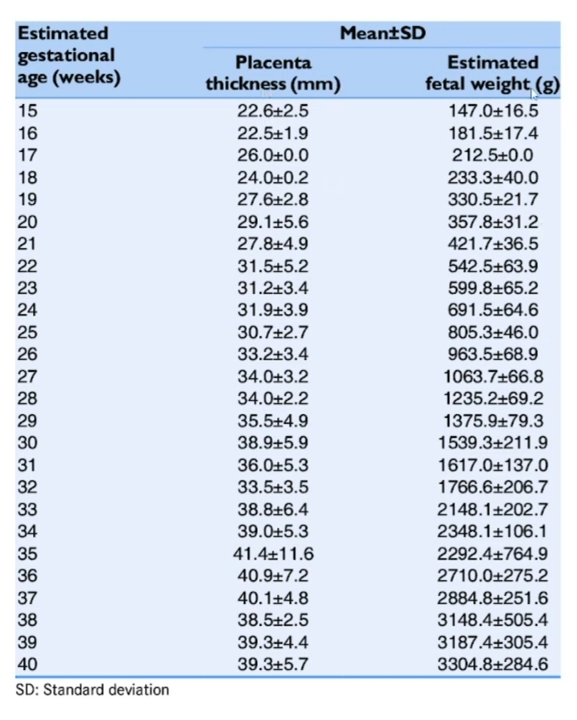

DEFINITION OF TERMS OF PREGNANCY;
(based upon the guidelines given by the American College of Obstetricians(ACOG) and Maternal Fetal Medicine (SMFM) 2013 )
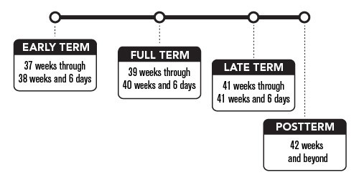

•Early term: 37 weeks, 0 days, through 38 weeks, 6 days, of gestation.

•Full term: 39 weeks, 0 days, through 40 weeks, 6 days, of gestation.

•Late term: 41 weeks, 0 days, through 41 weeks, 6 days, of gestation.

•Postterm: At least 42 weeks, 0 days, of gestation.

CHANCES OF SURVIVAL OF FETUS;
•50% chances if delivery is around 5th or 6th month (18th -24th week ).
•after 2nd week if proper facilities are provided and their is absence of abnormalities then average child birth can occur.

DESCRIPTION OF PLACENTA:-

ACCORDING TO AYURVEDA,
मातुस्तु खलु रसवहायां नाड्यां गर्भनाभिनाडीप्रतिबद्धा, साऽस्य मातुराहाररसवीर्यमभिवहति । तेनोपस्नेहेनास्याभिवृद्धिर्भवति । असञ्जाताङ्गप्रत्यङ्गप्रविभागमानिषेकात् प्रभृति सर्वशरीरावयवानुसारिणीनां रसवहानां तिर्यग्गतानां धमनीनामुपस्नेहो जीवयति ||३१||
The exchange of the nourishment in the form of rasa,from the mother to fetus occur through garbha naadi.The garbha is completely dependent on its mother for sustenance. The apara is connected to the mother's hridaya which is rasasthana. The ahara rasa reaches the fetus body and it is digested by the own agni of fetus (swakayagani). And the sara part is utilized for the further development of dhatus and for the proper nourishment of the fetus.
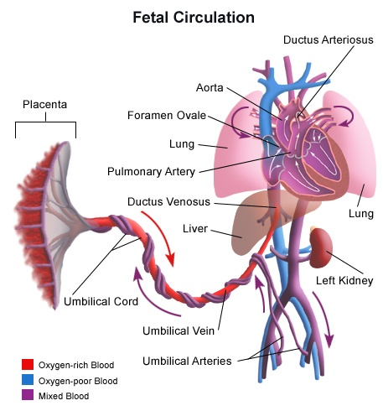

ACCORDING TO MODERN,

▪︎Blood rich in nutrients & oxygen supplied via the placenta flows through the umbilical vein to the Ductus Venosus.

▪︎(IVC) - upto the Right atrium.

▪︎This blood mixes with the blood returning to the heart from the upper body via (SVC) & from lower body by (IVC).

▪︎Once in the RA, some of the blood flows to the RV & some of the blood flows through the foramen ovale to LA & into the LV where it is

then pumped out into the aorta of the body.

▪︎Point of clarification: The flow of blood from the foramen ovale (from RA to LA) enables oxygenated blood from the placenta to reach coronary artery in cerebral circulation the two most metabolic, active organs in the developing fetus.

▪︎blood that flows into the RV is then pumped into the pulmonary artery, because the lungs are fluid filled instead of air filled, the vessels in the lungs are narrow, creating higher resistance to blood flow, creating higher resistance to blood flow into the lungs.

▪︎due to this ↑ resistance to blood flow in pulmonary circulation & ↓ resistance to blood flow in systemic circulation, blood pumped into the pulmonary artery by the RV is more likely to flow into Ductus arterious & then into the aorta.

▪︎due to high flow of blood from SVC & IVC upto the RA, pressure in RA is higher than in LA, this promotes blood flow from foramen ovale at the atrial level.

▪︎only 8% of RV output flows into the lungs.

▪︎providing nutrients for the developing lung tissues.

▪︎most of blood passes through ductus arteriosus into the aorta & out to body.

▪︎The umbilical arteries allow blood flow of blood from the body back to placenta to be enriched with oxygen & nutrients.

▪︎once baby is born & takes breath the umbilical cord is clamped & the placenta is removed from the Systemic circulation.

▪︎Immediately the transition from fetal to postnatal circulation begins with the elimination of the placenta from the circulation, systemic vascular resistance begins to rise.

▪︎with each breath, more alveoli in the lungs expand, & the vessel surrounding them dialate in response to presence of oxygen, Pulmonary pressure begins to decrease.

▪︎In postnatal circulation, blood no longer flows thorough the foramen ovale or the ductus arteriosus.

▪︎The ↑ in LA pressure after birth forces the septum primum against septum secundum functionally closing the foramen ovale permanently. closes as fibrin deposits fuse the layers of septal wall together.

▪︎The ductus arteriosus begins to close

shortly after birth, once the infant begins to breathe.

▪︎The ductus venosus is open at the time of birth making central venous access possible through umbilical vein, as fibrin infiltrates the ductus venosus it usually closes within 3-7 days, after closing the remnant is called Ligamentum Venosum.
▪︎within a week after birth, the umbilical vein & the umbilical artery are infiltrated within fibrin & also becomes ligament.

DEVELOPMENT OF DIFFERENT COMPONENTS IN FETUS:-

ACCORDING TO AYURVEDA,
गर्भस्य खलु सम्भवतः पूर्वं शिरः सम्भवतीत्याह शौनकः, शिरोमूलत्वात् प्रधानेन्द्रियाणां ; हृदय कृतवीर्यो, बुद्धेर्मनसश्च स्थानत्वात्; नाभिरिति पाराशर्यः, ततो हि वर्धते देहो देहिनः; पाणिपादमिति मार्कण्डेयः, तन्मूलत्वाच्चेष्टाया गर्भस्य; मध्यशरीरमिति सुभूतिर्गौतमः, तन्निबद्धत्वात् सर्वगात्रसम्भव

तत्तु न सम्यक्, सर्वाण्यङ्गप्रत्यङ्गानि युगपत् सम्भवन्तीत्याह धन्वन्तरिः, गर्भस्य सूक्ष्मत्वान्नोपलभ्यन्ते वंशाङ्कुरवच्चूतफलवच्च; तद्यथा चूतफले परिपक्के केशरमांसास्थिमज्जानः पृथक् पृथग्दृश्यन्ते कालप्रकर्षात्, तान्येव तरुणे नोपलभ्यन्ते सूक्ष्मत्वात्; तेषां सूक्ष्माणां केशरादीनां कालः प्रव्यक्ततां क एतेनैव वंशाङ्करोऽपि व्याख्यातः ।
एवं गर्भस्य तारुण्ये सर्वेष्वङ्गप्रत्यङ्गेषु सत्स्वपि सौक्ष्म्यादनुपलब्धिः, तान्येव कालप्रकर्षात् प्रव्यक्तानि भवन्ति ||३२||
There was a difference of opinion for which part of fetus is developed first and which develops next, But according to sushruta, every organ in th body would be represented at the moment of fertilization and later on it gets developed and differentiated due to the time factor. Sushruta gives an example of seeds and fruits as firstly different components are not seen and later on it develops into a mature form differentiating different components.
ACCORDING TO MODERN,
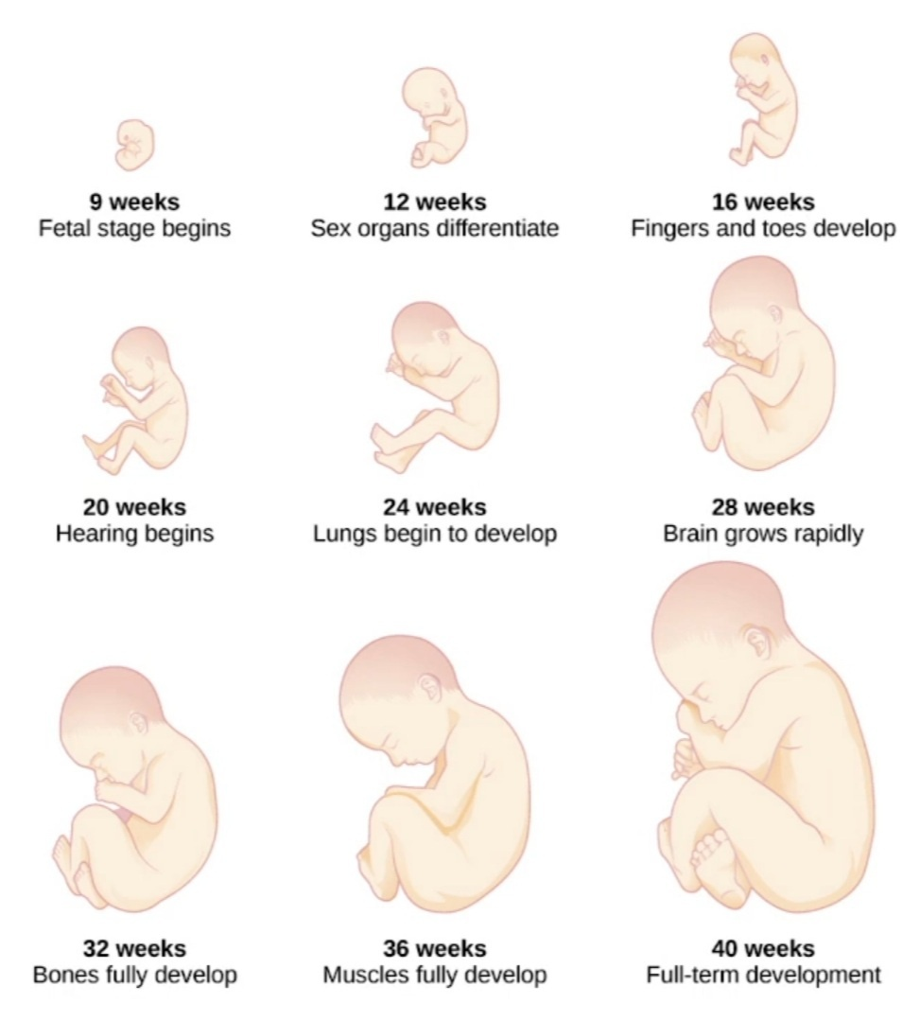

COMPONENTS WHICH PLAY ROLE IN FORMATION OF DIFFERENT STRUCTURES OF THE BODY:-
तत्र गर्भस्य पितृजमातृजरसजात्मजसत्त्वजसात्म्यजानि शरीरलक्षणानि व्याख्यास्यामः ।
गर्भस्य केशश्मश्रुलोमास्थिनखदन्तसिरास्नायुधमनीरेतः प्रभृतीनि स्थिराणि पितृजानि, मांसशोणितमेदोमज्जहृन्नाभियकृत्प्लीहान्त्रगुदप्रभृतीनि मनि मातृजानि, शरीरोपचयो बलं वर्णः स्थितिर्होनिश्च रसजानि, इन्द्रियाणि ज्ञानं विज्ञानमायुः सुखदुःखादिकं चात्मजानि, सत्त्वजान्युत्तरत्र वक्ष्यामः, वीर्यमारोग्यं बलवर्णौ मेधा च सात्म्यजानि ||३३||
ACCORDING TO AYURVEDA,
•All the hard tissues and structures are

formed from= Paternal component.
•All the soft tissues and structures are formed from= Maternal component.
•All the psychological components are got from=Atma.
•Thes sex of the fetus can be predicted by certain signs in the mother, like formation of the milk.
If milk is formed first in right breast and if the mother have more vibrations on right side then the fetus is MALE.
If milk is formed first in left breast and if the mother have more vibrations on left side then the fetus is FEMALE.

ACCORDING TO MODERN,
This theory is not validated.

HOW PERSONALITY OF THE FETUS IS KNOWN;
भवन्ति चात्र-
देवताब्राह्मणपराः शौचाचारहिते रताः । महागुणान् प्रसूयन्ते

विपरीतास्तु निर्गुणान् ||३५||
अङ्गप्रत्यङ्गनिर्वृत्तिः स्वभावादेव जायते अङ्गप्रत्यङ्ग निर्वृत्तौ ये भवन्ति गुणागुणाः । ते ते गर्भस्य विज्ञेया धर्माधर्मनिमित्तजाः ||३६||
ACCORDING TO AYURVEDA,
Ultimately the personality of the child and whether there would be a successful fertilization or not is decided by the DHARMA & ADHARMA.
ACCORDING TO MODERN,
This theory is not validated.

PROBLEMS FACED IN STUDY:
ancient science retained its connections with the humanity in a holistic approach while modern science emphasized the differences between scientific pursuit and other disciplines, so it is difficult to understand both simultaneously and co-relate it.

CONCLUSION as per different Acharyas;

There is a common explanation of Garbhavakranthi in different Acharya, and some of them had unique topics to discuss. Garbha was formed on a very logical foundation. That which remains constant across all three time kala the past, the present, and the future can be recognized as a universal idea. When this idea was examined from a contemporary scientific perspective, it became clear that the Ayurvedic explanation, which is defined at the molecular and genetic level, is far beyond western comprehension.

इति सुश्रुतसंहितायां शारीरस्थाने गर्भावक्रान्तिशारीरं नाम तृतीयोऽध्यायः
THE END

REFERENCES:-

1.susrutha samhita shareera sthan 3rd chapter; Varanasi Chaukhambha Orientalia.
2.dalhana commentary on susrutha samhita.
3.Inderbir Singh, Human embryology, Tenth edition, Jaypee Brothers Medical Publishers (P) Ltd, New Delhi, 2015
4.Published scholarly articles.

