GESTURE SUPPORTED GLOVES WITH SMART GLASS FOR PEOPLE WITH SPEECH DISORDER
Jayien Mathew¹, Henna Maria², Anuja Anilkumar³, Meera C Haridas⁴
¹Jayien Mathew Computer Science Engineering & Kottayam Institute of Technology and Science
²Henna Maria Computer Science Engineering & Kottayam Institute of Technology and Science
³Anuja Anilkumar Computer Science Engineering & Kottayam Institute of Technology and Science
⁴Meera C Haridas Computer Science Engineering & Kottayam Institute of Technology and Science
⁵Akhija Lakshmi R Computer Science Engineering & Kottayam Institute of Technology and Science
---------------------------------------------------------------------***---------------------------------------------------------------------
Abstract - A person's capacity to make the sounds that form words are impacted by speech problems. In order to facilitate easier communication between speech-impaired persons and non-impaired people utilising synthesised speech, our approach describes a smart speaking glove. Flex sensors built into a smart glove have resistance values that alter based on the gesture the user specifies. This gesture data is analysed by a microcontroller, and a coupled Android device provides the accompanying vocal output. Also, a smart glass is provided which is connected with the hand gloves which will show the important text messages on the glass and also an accelerometer is provided within the glass for doing head movement detection, which can be also utilized for controls. We use MQTT protocol for transmission in this system. Disabled people utilise sign language as a means of communication. Here we are converting sign language into text and then to speech, utilizing data gloves communication barrier between two different communities is eliminated. By using data gloves, people with disabilities may advance in their careers and help the country as a whole as there are millions of them.

Key Words: Artificial Neural Network (ANN), Analog Digital Converter (ADC), Message Quaking Telemetry Transport (MQTT), Micro-Controller Unit (MCU), Organic-Light Emitting Diode (OLED).

1.INTRODUCTION

A person's capacity to make the sounds that form words is impacted by speech problems. We are presenting a glove and smart glass for speech challenged individuals to improve communication with others. Speech disabled people interact with others through their body language, particularly their hand gestures, but normal people cannot comprehend them properly. A person with a speech issue has difficulty producing or forming the spoken sounds necessary for interpersonal communication. Speech difficulties can have a variety of reasons, such as hearing loss, degenerative illnesses, autism, hearing loss, and muscular weakness. Speech difficulties can have an impact on a person's quality of life generally and sense of self.
A person's capacity to make the sounds that form words is impacted by speech problems. In order to facilitate easier communication between speech-impaired persons and non-impaired people utilizing synthesized speech, our approach describes a smart speaking glove. Flex sensors built into a smart glove have resistance values that alter based on the gesture the user specifies. This gesture data is analyzed by a microcontroller, and a coupled Android device provides the accompanying vocal output. Additionally, a smart glass is available that connects to the hand gloves and displays important text messages. The smart glass also has an accelerometer that detects head movement and can be used for controls. Using data gloves, we are able to break down the communication barrier between two disparate communities by translating sign language into text and then speech.

2. LITERATURE SURVEY
Ganesh Choudhary B, Chethan Ram B V [1] In this study, they put forth a method for completely implementing human computer interfaces electronically, without the use of mechanical sensors. The goal is to replace outdated methods of manipulating robotic arms using joysticks and buttons with more logical ones. Here, they provide a method for achieving the previously described goal by using an image processing methodology with a web camera. By using computational geometry calculations, they were able to engage with a robot in real time by recognising the key hand characteristics, such as the fingers.
Malav Atul Doshi, Sagar Jignish Parekh, Dr. Mita Bhowmick [2] Unprecedented range is offered by wireless RF (Radio Frequency) modules in a budget-friendly wireless data solution. Due to the complexity of constructing radio circuits, RF modules are frequently employed in electrical design. Astonishing developments in the healthcare system have resulted from the contemporary surgical age. Even the greatest standard operations, however, result in significant scarring and prolonged healing times. A robotic arm is made up of numerous pieces that are linked together.
Mrs.NeelaHarish, Dr.S. Poonguzhali [3] The Indian sign language symbols used in this essay are universal to all deaf and dumb persons in India. With the assistance of the flex sensors and accelerometer, the gestures represented by the Indian sign language symbols will be controlled. Rotation, angle tilt, and direction shifts are movements that are incorporated into gesture representation. To learn about their dynamics, the accelerometer and flex sensor are put over the data glove's fingers and wrists, respectively. The micro-controller will then process these voltage signals before sending them to the voice module. Deaf individuals who are speech and hearing challenged have particular difficulties as a result of these barriers.
Ms. Puja Dhepekar [4] They have created a wirelessly controlled robotic hand that uses a flex sensor to do pick-and-place operations in this study. Three flex sensors were employed in this instance to regulate the position of the robotic system. To regulate the opening and closing of the gripper that selects and puts the instrument, one flex sensor is employed. The robotic system is moved up and down using a second flex sensor. The robotic system's circular movement is controlled by a third flex sensor. All of this wireless Zigbee positioning control of the robotic system through the flex sensor is accomplished.

3. METHODOLOGY
The three components of the proposed system are the glove, raspberry pi, and smart glass parts. Wi-Fi is being used to link the gadgets here. The gloves part is visible on the left side of the building. The sensors are an accelerometer and a gyroscope, and the programming is done on an MCU node. The ESP8266-based open-source platform Node MCU allows for the connection of devices and the transmission of data via the Wi-Fi protocol. Additionally, by including some of the most crucial micro-controller features like GPIO, PWM, ADC, and others, it can address many of the project's needs on its own.
- Architecture of the Proposed System
An accelerometer measures static or dynamic acceleration using an electromechanical sensor. Static acceleration refers to the constant force acting on a body, such as friction or gravity. These factors are mostly predictable and consistent. Here, the hand's movement to the left, right, up, and backward are detected by the gyro. The ADC connects the five-flex sensor to the node MCU. An analogue signal, such as voltage, is converted to a digital form by an ADC (analog-to-digital converter) so that a microcontroller can read and interpret it. The Node MCU only has one analogue port, which is utilised to reconnect the problematic flex sensor through the ADC.
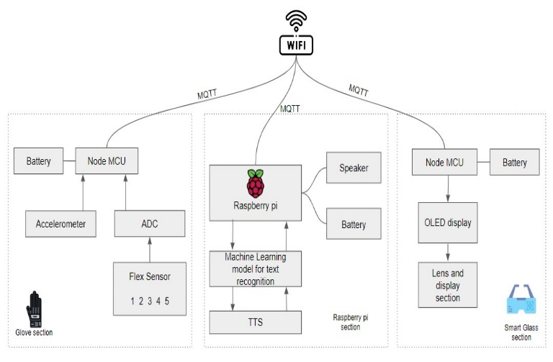
Fig -1: Architecture of proposed system

According to the motions of the hands, signals are delivered to the Raspberry Pi. The machine learning methods are then used to decipher these signals. When using this ADC, we get five or six ADC ports. The ADC transforms analogue signals into digital signals, which are then transmitted via serial protocol to the node MCU. The MQTT protocol is then used to send this signal to Wi-Fi. A messaging protocol called MQTT (Message Queuing Telemetry Transport) is designed for Internet of Things (IoT) devices with exceptionally high latency and little bandwidth. The Message Queuing Telemetry Transport protocol is the best one for machine-to-machine (M2M) communication since it is tailored for low-bandwidth, high-latency settings. The MQTT server, speaker, battery, text-to-speech model, and character recognition system are all included in the Raspberry Pi portion. This part contains the code for the character recognition and text-to-speech models. Machine learning mode and text to voice libraries for Python are loaded in the last part to convert text to speech. The signal responds promptly to each finger movement and is transferred to pi. Then, each signal is chosen and obtained at a specific character. Finally, when we instruct a speaker to talk, a word will be created and delivered in audio format. Text is shown in the lens using the OLED display.
An organic compound film serves as the emissive electroluminescent layer in an organic light-emitting diode (OLED or organic LED), often referred to as an organic electroluminescent (organic EL) diode. This organic compound film produces light in response to an electric current. This organic layer is sandwiched between two electrodes, with at least one transparent electrode. OLEDs are utilised to make digital displays for portable systems and other devices. The text is finally visible through the lens and is now audible.
  - Use Case Diagram of the Proposed System
The scope and high-level functions of a system are described in use case diagrams. The interactions between the system and its actors are also depicted in these diagrams. utilise-case diagrams show what the system does and how the actors utilise it, but they do not show how the system works within. The sensor in this figure gathers values for the user's hand gestures. The sensor reads its value when the code is run and sends it to the Raspberry Pi section. The raspberry system creates the term with the use of an active machine learning model. To confirm the word, this word is also sent to the user. The text is transformed to voice when the user confirms it. Finally, the user and receiver will hear the audio through a speaker.
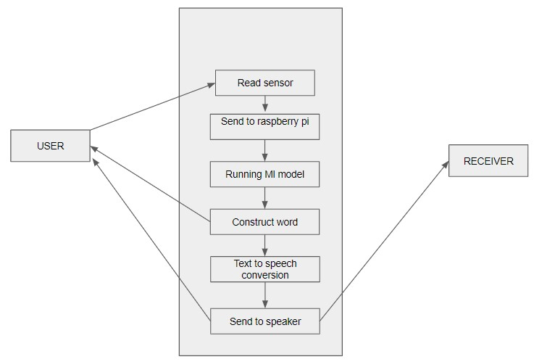
Fig -2: Use Case Diagram of the Proposed System

  - Activity diagram of the proposed System

Similar to a flowchart or data flow diagram, an activity diagram visually displays a series of actions or the flow of control in a system. In business process modelling, activity diagrams are frequently employed. Additionally, they can outline the procedures in a use case diagram. Read the sensor first in this diagram. Once the hand is in a resting position, no further data must be sent. The value will move to the direction that indicates no and displays the real status in glass if the actual value is less than the threshold value. If a voice signal is about to appear, enter a loop that indicates completion. goes into the yes position on the right side after entering the loop. Text is converted to speech, which is subsequently transmitted through speakers.

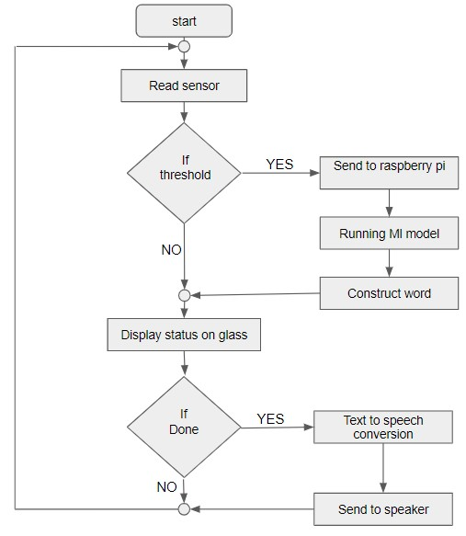
Fig -3: Activity Diagram of the Proposed System
4. IMPLEMENTATION

Our project is divided into six modules: setting up smart gloves with flex sensors, programming smart gloves, creating machine learning models, and smart glasses and their display configuration. main python code and interface for connecting smart glasses, gloves, and main python code. A pair of glasses with a display unit that gives the user a visual interface for manipulating electronics make up the smart glass module. By establishing a Wi-Fi connection with a suitable device, the display unit may be configured. It's possible for the display unit to stand alone. The display device may be used to show the texts after it has been set up.
A person's capacity to make the sounds that form words is impacted by speech problems. In order to facilitate easier communication between speech-impaired persons and non-impaired people utilising synthesised speech, our approach describes a smart speaking glove. Flex sensors built into a smart glove have resistance values that alter based on the gesture the user specifies. This gesture data is analysed by a microcontroller, and a coupled Android device provides the accompanying vocal output.
Setting up the microcontroller to interpret the data from the flex sensors and transfer it to the main device is a necessary step in programming the smart gloves. The microcontroller's programming language is Arduino C programming. The programming must be built to instantly process and send data from the flex sensors to the main device.
The machine learning module entails the development of a machine learning model that can identify and decipher user-made hand gestures. A dataset of hand gestures and the accompanying activities is used to train the model. The dataset needs to be varied and inclusive of a variety of hand movements, including intricate actions involving many fingers. Python may be used to build the machine learning model, together with well-liked tools like Jupyter Notebook or Google Collab.
The primary Python code module acts as an interface between the machine learning and the smart glass and glove components. To show the necessary data on the smart glass after receiving data from the smart gloves, the code must be created. Using the machine learning model, it ought to be able to recognise hand gestures and carry out the corresponding actions on the gadget.
The core Python code may be interfaced with the smart glass and smart glove modules utilising Wi-Fi. To show the necessary data on the smart glass after receiving data from the smart gloves, the code must be created. Using the machine learning model, the code need to be able to recognise hand motions and carry out the relevant operations on the gadget.
In a wireless sensor network, a wormhole attack can interfere with routing and eventually worsen network performance. We have discussed many wormhole attack types and their methods of detection in this study. An active study field is wormhole identification in a dynamic WSN environment. Integration of trust-based systems and time- or distance-bounding wormhole detection methods is a promising research area for wormhole detection. A hands-free and simple user interface is offered by the implementation capabilities for controlling electrical equipment.
5. RESULT

Using the K-Nearest Neighbours (KNN) technique, our project was trained. The model learnt from the input data during the training process and was able to generate precise predictions using the data.

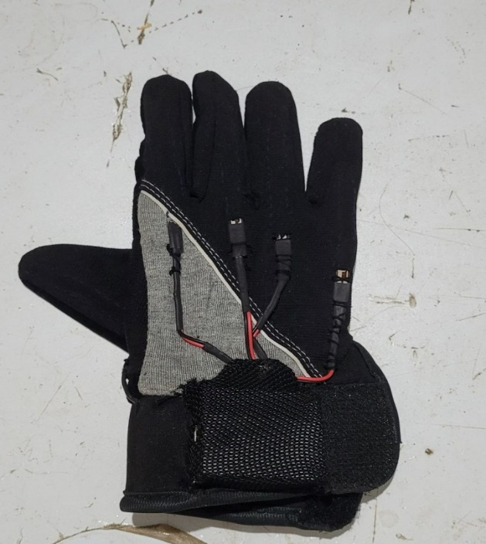
Fig -4: Smart Glove
During the testing phase, the trained model was assessed using a test dataset, and it was discovered that the model used the KNN technique to obtain an accuracy of 99.9%. The model is trustworthy and may be utilised in real-world applications due to its high degree of accuracy.
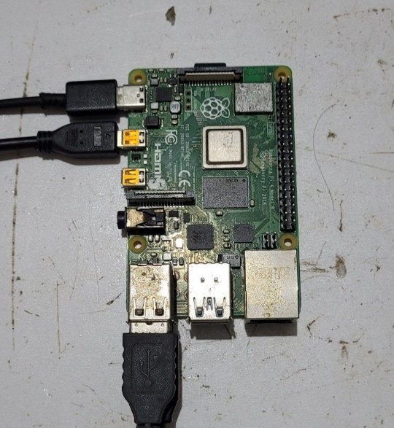
Fig -5: Raspberry pi
Overall, the Gesture assisted glove with smart glass for speech handicapped people performed well, giving those who can't talk an effective way to communicate. The tool enables speech-impaired people to engage with others and communicate their thoughts and ideas in a natural and intuitive way by deciphering hand signals. The accomplishment of this research demonstrates the power of machine learning and artificial intelligence to improve people's lives, especially those who deal with particular difficulties because of a handicap or other circumstances.
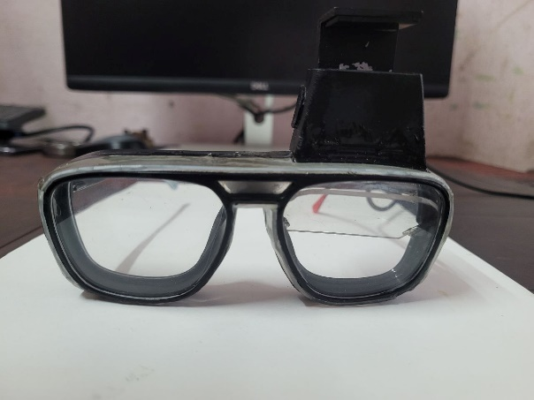
Fig -6: Smart Glass
6. CONCLUSION

Disabled people utilise sign language as a means of communication. Using data gloves, we are able to break down the communication barrier between two disparate communities by translating sign language into text and then speech. By using data gloves, people with disabilities may advance in their careers and help the country as a whole as there are millions of them. improving the nation and improving their future. Including smart glasses will make it easier to manage and see the controls and important messages. In order to facilitate easier communication between speech-impaired persons and non-impaired people utilising synthesised speech, this research presents a smart speaking glove. Including smart glasses will make it easier to manage and see the controls and important messages. In order to facilitate easier communication between speech-impaired persons and non-impaired people utilising synthesised speech, this research presents a smart speaking glove. Flex sensors built into a smart glove have resistance values that alter based on the gesture the user specifies. This gesture data is analysed by a microcontroller, and a coupled Android device provides the accompanying vocal output. Additionally, a smart glass is available that connects to the hand gloves and displays important text messages. The smart glass also has an accelerometer that detects head movement and can be used for controls. Implement home automation approaches limitations in the future, and make an effort to enhance the current algorithm by adjusting the model and its associated constraints. For persons who are deaf, everyday speech is transformed into text.

ACKNOWLEDGEMENT

We would like to use this occasion to extend our heartfelt gratitude and appreciation to everyone who assisted us in successfully completing this task. W635e sincerely appreciate Dr. P Arun Bose, Department Head of Computer Science Engineering, for providing us with all the facilities and assistance we need. For the assistance and cooperation, we would like to sincerely thank Ms. Akhija Lakshmi R, project coordinator department of Computer Science Engineering.
We would like to officially express our thanks to Ms. Akhija Lakshmi R, Assistant Professor, Computer Science Engineering, for serving as our project advisor and providing mentorship during this endeavour.
Finally, we would like to express our gratitude to our family, friends, and all those who helped make this project work a success.
REFERENCES

1. Wang Ke, Wang Li, Li Ruifeng and Zhao Lijun “Real-time Hand Gesture Recognition for Service Robot”2010 International Conference on Intelligent Computation Technology and Automation.
2. Mrinalini Pramod Tarvekar “Hand Gesture Recognition System for Touch-less Car Interface Using Multiclass Support Vector Machine” ISBN:978-1-5386-2842-3.
3. Chi-Min Oh, Md. Zahidul Islam , Jae-Wan Park and Chil-Woo Lee” A Gesture Recognition Interface with Upper Body Model-based Pose Tracking”2010 2nd International Conference on Computer Engineering and Technology.
4. Ariyanto, Mochammad, Wahyu Caesarendra, Khusnul A. Mustaqim, Mohamad Irfan, Jonny A. Pakpahan, Joga D. Setiawan, and Andri R. Winoto. ”Finger movement pattern recogni-tion method using artificial neural network based on electromyography (EMG) sensor.” In 2015 International Conference on Automation, Cognitive Science, Optics, Micro Electro-Mechanical System, and Information Technology(ICACOMIT), pp. 12-17. IEEE, 2015.
5. Dixit, Dr Shantanu K., and Mr Nitin S. Shin-gi. ” Implementation of flex sensor and electronic compass for hand gesture based wireless automation of material handling robot.” International Journal of Scientific and Re-search Publications 2, no. 12 (2012): 1-3.
6. Mascaro, S. and Asada, H. Photoplethysmograph Fingernail Sensors for Measuring Finger Forces Without Haptic Obstruction, IEEE Transactions on Robotics and Automation.
7. Ganesh Choudhary, Chetan Ram B V "Real Time Robotic Arm Control Using Hand Gestures"2014 IEEE 978-1-4799-5958-7114.

