Web based application for Hate Speech recognition
using NLP

Manan Soam Swadha Dwivedi
B.Tech. CSE, Amity University, Noida B.Tech. CSE, Amity University, Noida
manansoam@gmail.com dswadha@gmail.com

Dr. Shuchi Mala
Assistant Professor, Amity University, Noida
smala@amity.edu

Abstract— "Hate speech" is commonly understood as offensive language that targets a person or a group based on their inherent characteristics such as race, religion, or gender and may threaten social harmony. However, under International Human Rights Law, there is no universal definition of hate speech as the concept is still widely debated regarding its relation to freedom of opinion and expression, non-discrimination, and equality. Hate speech can take any form of expression, including images, cartoons, memes, objects, gestures, and symbols, and can be disseminated offline or online. It is discriminatory, biased, bigoted, intolerant, or demeaning towards an individual or a group. All people have the right to freedom of expression and opinion, but all too frequently, this right is abused, leading to hate speech and further stereotyping and discrimination against already vulnerable communities. This has led to a rise in hate speech in our country across several platforms, which has led to the subsequent rise in discrimination and hate crimes against minorities.
Curbing this widespread hate is the need of the hour. Our project will try to make the internet a safer and harmonious place.

Keywords— Hate Speech, NLP, Web Scraping,
Tensorflow.
- Introduction

Hate speech targets the real identity factors of an individual or a group, including but not limited to religion, ethnicity, nationality, race, color, descent, and gender. It may also target other characteristics that convey identity, such as language, economic or social status, disability, health condition, or sexual orientation, among others.

Our project has a primary objective of mitigating the impact of hate speech within the realm of the open internet. We will design a web scraper that will identify and censor hate speech on the websites. Later we will make a google extension The Internet is a misleading space for many, especially for younger generations and kids. Children and young people are exposed to the internet where they consume a lot of unsolicited content. Our project will help prevent this. We aim to develop a web application that, when enabled, will detect the use of textual hate speech on the internet in various dialects.

In recent years, several studies have utilized different feature engineering techniques and machine learning algorithms to automatically detect hate speech messages on various datasets in an attempt to tackle this growing problem on social media platforms. However, no research has been conducted to compare and contrast the effectiveness of various feature engineering methodologies and machine learning algorithms on a common dataset that is publicly available.

The Hate Speech Censor offers an effective approach to filtering out offensive language and unfavorable content, utilizing machine learning and particularly Natural Language Processing with Sentiment Analysis. Through brainstorming, we developed a preliminary concept for a multi-browser extension that examines the content of a webpage and replaces or censors any explicitly negative material. This project is a multi-browser extension that allows users to censor negative sentences using a pre-trained natural language processing (NLP) model. The extension is written in HTML, CSS, and JavaScript, and it uses the Chrome Extension API.

The extension's main features include censoring words and sentences using a spoiler container, replacing sensitive words with funny and gentle ones, saving URLs and detected sentences for further analysis, and managing different local users for analyses.

To ensure the model is accurate, the project includes a testing component, which checks the spoiler container on different levels of negative sentences based on the sensitivity option and tests the funny/synonym replacement feature.

The project uses several different languages and technologies to function. The text content that is crawled from web pages is preprocessed using NodeJS JavaScript, which formats the data for the model. The core of the project is written in Python, and it uses TensorFlow with Keras to create the NLP model for analyzing sentences with sentiment analysis.

Overall, the project aims to provide a helpful tool for users to filter out negative or sensitive content online, making their browsing experience more positive and enjoyable.

- Problem Statement

This project aims to create a web scraper that can utilize natural language processing and machine learning techniques to identify and filter out hate speech on social media platforms in real-time. The web scraper will collect data from different social media sites and analyze the content to detect any instances of hate speech. When hate speech is detected, the system will implement a censorship mechanism that will either hide or replace the offensive content with a more positive message.

Cutting-edge machine learning algorithms and natural language processing techniques will be employed in order to accomplish the project's goal. The system will be integrated into a Google Chrome extension, which can be quickly installed and utilized by individuals who desire a safer experience while online.

The end result of this project will provide a trustworthy and effective solution to combat hate speech and encourage a more welcoming and inclusive atmosphere on the internet.

- Literature Review

Paper [1] presents a study that investigates the effectiveness of different feature engineering techniques and machine learning algorithms in identifying hate speech in publicly available datasets. While social media has revolutionized information sharing, it has also led to the spread of hate speech. The experimental results indicate that the support vector machine method performs best when combined with bigram features, achieving an overall accuracy rate of 79%. This research has real-world applications and can serve as a benchmark for automatically identifying hate speech texts. The study also has scientific significance as it displays experimental findings in more than one form of scientific methods for automatically classifying texts. However, the model has limitations, including the lack of precision in real-time predictions of the information and the inability to distinguish the seriousness of the hate speech message.

Paper [2] This study suggests a machine learning approach for detecting hate speech in social media text that is a mix of Hindi and English. The researchers utilize Facebook's pre-trained fastText word embedding library to differentiate between hate and non-hate in a dataset of 10,000 samples. The fastText features provide a more effective feature representation when combined with a Support Vector Machine (SVM) and Radial Basis Function (RBF) classifier in comparison to word2vec and doc2vec features. The article also highlights that character level features are the most successful for code-mixed data, which is significant for researchers studying this type of data.

Paper [3] This article addresses the challenge of identifying offensive content on social media platforms, which has been a topic of much discussion in recent years. The study conducts extensive experiments using various machine learning, deep learning, and transfer learning models to detect hate speech in code mixed or script mixed/switched forms in non-English speaking countries. The experimental results demonstrate that TF-IDF features with 1 to 6 gramme characters are the most effective for the given task. While more complex deep learning and transfer learning models are commonly used, the most successful models for the Tamil code-mix, Malayalam code-mix, and Malayalam script-mix datasets were naive bayes, logistic regression, and vanilla neural networks.

Paper [4] This research compares different methods of creating features and machine learning algorithms to recognize hate speech in a publicly accessible dataset. The most successful combination was the bigram feature set with the support vector machine technique, achieving an accuracy of 79 percent. The study establishes a benchmark for future research on automated text classification systems, and the results can aid in the detection of hate speech automatically.

Paper [5] This article addresses the issue of fairness assessment in document classification methods, which typically rely on artificial monolingual data without actual author demographic information. The authors of this study created a multilingual Twitter corpus to detect hate speech using inferred values for age, country, gender, and race/ethnicity for author demographic characteristics. They evaluated the fairness and bias of baseline classifiers on the author-level demographic attributes and the performance of four popular document classifiers. The English corpus was used to analyze potential bias-inducing factors. The study highlights the significance of considering author demographic information and potential biases in document classification methods.

paper [6] The paper discusses the significance of manual feature creation and statistical algorithms in detecting hate speech using machine learning techniques. The authors emphasize the need to extract text-based features to distinguish between hate speech and non-hate speech. The paper highlights different types of features, including surface features, negative sentiment, linguistic features, lexical resources, meta-information, and multi-modal information, that can be utilized to detect hate speech. The study concludes that several machine learning models, such as Naive Bayes, Bayesian Logistic Regression, Random Forest Decision Tree, and Support Vector Machine, are commonly used for hate speech detection, and that incorporating non-textual features can enhance the performance of these models.

Paper [7] addresses the challenges of hate speech detection in multilingual societies and proposes the use of pre-trained BERT models to construct hate speech detection models in both monolingual and multilingual settings. The paper finds that multilingual hate speech identification performs comparably or better than baseline monolingual hate speech detection models. The study also expands the literature on detecting hate speech to include the Malay language.

[8] The practice of web scraping has become increasingly important in recent years, but the task has become more challenging due to website updates and advancements. Websites now commonly use robots.txt and anti scraping techniques to reduce traffic from scrapers, and dynamically loaded content can pose an issue. This essay explores common problems encountered when scraping social media and suggests solutions, including using automation to interact with dynamic elements and adding an artificial random delay to bypass some antiscraping techniques. The study also touches on the morality and legality of scraping, as well as potential fixes for other issues. While the study is limited in scope, the interactions observed are typical of those found in comment sections across various social media environments.

[9] This paper discusses the development of a web scraper based on Python that gathers data from the scheduling tool TimeEdit and saves it in a structured format. The resulting data can then be uploaded to a dynamic website for easy analysis. The study follows an agile workflow, using techniques such as pre-study, user stories, and development modification based on results. Although Python is not commonly used in the relevant Master's program, the language was easy to learn and use. The study achieves its goals of creating a web scraper, a scalable website for uploading scraped data, and tools for organizing and viewing data, ultimately resulting in a system that is more effective than the previous one.

[10] The paper is about web scraping and how it can be used for personalized information retrieval. It provides an overview of the history and applications of web scraping and discusses the benefits of using web scrapers to gather tailored information. It explores different types of web scrapers and their effectiveness. The paper is divided into several sections that address different aspects of the topic, including the significance of personalized information retrieval and the evolution of web scraping. The overall aim is to demonstrate the usefulness of web scraping for gathering specific information for personal use.

[11] This article explains the concept of web scraping, which is a technique used to extract structured data from unstructured web pages. It discusses various methods of web scraping, including traditional copy-and-paste, regular expression matching, HTTP programming, HTML parsing, DOM parsing, web scraping software, vertical aggregation platforms, semantic annotation recognizing, and computer vision web-page analyzers. The article emphasizes that while web scraping software is the easiest method, other methods require some level of technical knowledge. Additionally, it points out that numerous online scraping programs are available, and many of them are built using Java, Python, and Ruby. The goal of the article is to provide a comparative analysis of the most popular web scraping tools and techniques.

[12] As the amount and variety of data available online continue to increase, it is important to have methods for efficiently extracting valuable information. Data crawlers are software programs that can be used to automatically navigate websites and extract specific types of data, which can be very useful for research and analysis. However, traditional crawlers can be slow and inefficient, particularly when working with large amounts of data. This study proposes a new approach for optimizing the crawler system to increase speed and efficiency using the Scrapy framework and techniques such as using random user-agents and dynamically changing IP addresses. The results show that this approach can significantly improve the performance of the crawler system.

The paper [13] surveys hate speech detection using natural language processing techniques. It emphasizes the need for automated methods to address the increasing prevalence of hate speech in online platforms. The challenges of hate speech recognition, including domain, context, media objects, timing, author identity, and targeted recipients, are discussed. The paper provides a comprehensive overview of automatic hate speech detection, with a focus on feature extraction methods. Supervised learning and character-level approaches are found effective, and the inclusion of lexical resources improves classification. The paper suggests the establishment of a benchmark dataset and highlights the importance of considering meta-information and multi-modal data for hate speech identification.

[14] The internet's widespread use has generated a concern: toxic comments, which can lead to personal attacks and harassment. This paper explores the development of models for predicting toxic comments online. Advancements in hardware and big data management have made deep learning approaches feasible. The authors employed convolutional neural networks (CNNs) to identify toxic comments, showing their superiority over traditional methods. The study utilized a large dataset from a Kaggle competition and reinforces the research interest in using CNNs for toxic comment classification.

[15] Detecting hate speech on social media is challenging due to its complexity and similarity to other offensive language. Previous methods, such as lexical detection and supervised learning, have shown limitations. This study employed a crowd-sourced hate speech lexicon to collect tweets and trained a multi-class classifier to differentiate between hate speech, offensive language, and neutral content. The findings revealed patterns in classification, with racist and homophobic tweets more likely classified as hate speech. The study recommends considering context and diverse usage to improve hate-speech detection accuracy.

- Methodology

Web scraping is a technique that enables the transformation of unstructured web data into structured data. This conversion allows for convenient storage and analysis in a central local database or spreadsheet. Several approaches to web scraping are available, including traditional copy-and-paste, text extraction, regular expression matching, HTTP programming, HTML parsing, and DOM parsing.
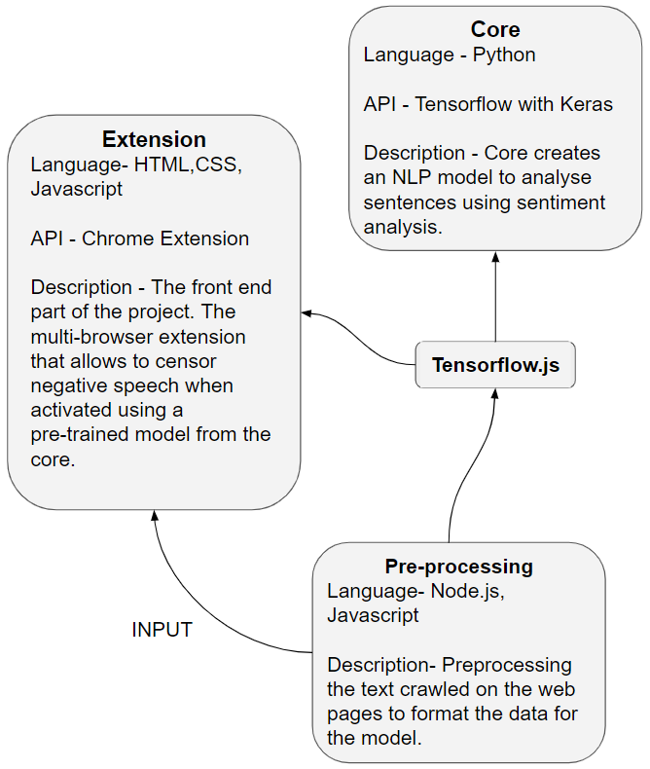

Fig.1: Project Overview

Web scraping tools, platforms for vertical data aggregation, semantic annotation recognition, and computer vision-based web page analyzers are some of the techniques used in web scraping. Among these, web scraping software is one of the simplest methods, apart from manual copy and paste. All other methods involve some level of technological know-how. Hundreds of online scraping programmes are available now, the most of which were created using Java, Python, and Ruby. Along with commercial software, there are some open source web scraping programmes. The finest web scraping tools for novices are programmes like Yahoo Pipes, Google Web Scrapers, and Outwit Firefox extensions. This study concentrated on providing comparative clarity on popular web scraping tools and web scraping approaches.

Next, we aimed to focus on machine learning. A better understanding of all the ML concepts,algorithms. We also focused on implementing these algorithms using some basic datasets.
We focused on developing knowledge about deep learning, which is a type of supervised learning. This includes our study on the following basic ML algorithms and models:

● Naive Bayes classifier
● Support Vector Machine (SVM)
● Random Forest Decision tree
● Logistic Regression using Bayesian inference

An extensive list of characteristics for the hate speech detection categorization challenge includes
- Basic surface features, such as bag-of-words and n-grams;
- Word generalizations that assign generalized features to groups of words with similar meanings;
- Identification of negative sentiments, specifically targeting hate speech through sentiment analysis;
- Utilization of lexical resources, including word lists associated with different forms of hate speech;
- Linguistic features that involve relationships between words based on their types;
- Incorporation of knowledge-based features, particularly contextual data;
- "Meta-information" encompassing user details like gender, level of activity, or number of followers;
- Integration of multi-modal information, which includes data from diverse modes such as visual or auditory content.

- Proposed Algorithm

Section 1: Training the Neural Network Model
1. Data Collection and Preprocessing:
- We gathered a dataset of text data containing instances of hate speech and non-hate speech.
- We cleaned the text data by removing noise, special characters, and irrelevant information.
- We tokenized the text into individual words or subword units.
- We performed text normalization techniques such as lowercasing and stemming or lemmatization.
- We applied techniques like stop-word removal and spell checking to improve data quality.

2. Feature Extraction:
- We utilized word embeddings to represent words as dense vectors capturing semantic meaning.
- We employed pre-trained language models for contextualized word representations.
- We explored techniques like TF-IDF or Bag-of-Words to create numerical representations of text.

3. Model Architecture Design:
- We chose the appropriate neural network architecture for our task, such as recurrent neural networks (RNNs).
- We incorporated layers like bidirectional GRU (Gated Recurrent Unit) layers, an embedding layer, and dense layers with sigmoid activation.
- We considered the use of attention mechanisms to focus on relevant parts of the text.
- We defined appropriate activation functions and regularization techniques to prevent overfitting.

4. Model Training:
- We split the preprocessed dataset into training and validation sets.
- We used the training set to train the neural network model, optimizing the parameters using the Adam optimizer through backpropagation and gradient descent.
- We monitored the model's performance during training using evaluation metrics like accuracy, precision, recall, and F1-score.

Section 2: Model Evaluation and Testing
1. Model Evaluation:
- We evaluated the trained model using the validation set to assess its performance.
- We measured metrics such as accuracy, precision, recall, and F1-score to gauge its effectiveness in detecting hate speech.
- We performed cross-validation or used techniques like k-fold validation to validate the model's generalization capability.
- We analyzed the model's performance on different metrics to understand its strengths and limitations.

2. Model Testing:
- We obtained a separate test dataset containing unseen text instances.
- We used the trained model to predict whether the text instances in the test dataset were hate speech or non-hate speech.
- We evaluated the model's performance on the test dataset using metrics like accuracy, precision, recall, and F1-score.
- We analyzed the results and gathered insights into the model's performance in real-world scenarios.

Section 3: Engine
1. Building the Extension:
- We used HTML, CSS, and JavaScript to develop the Chrome extension.
- We designed a user-friendly interface that integrated seamlessly with the Chrome browser.
- We implemented features like a spoiler container that censored negative words and sentences, replacing them with gentle alternatives.
- We included functionalities for saving URLs and detected sentences for further analysis and reference.

2. Integration with NLP Model:
- We integrated the pre-trained NLP model into the Chrome extension.
- We ensured the model could accurately detect and classify hate speech within the text content.
- We leveraged appropriate web development technologies to enable the interaction between the extension and the model.

3. Testing and Refinement:
- We implemented a testing component to evaluate the functionality of the extension.
- We tested the spoiler container and the funny/synonym replacement feature on sentences with varying degrees of harshness.
- We fine-tuned the extension based on the test results

- Testing

Unit Testing
Unit testing is a testing technique in software development that tests individual functions or methods in isolation from the rest of the system. It is an essential practice in ensuring the quality and reliability of software.
To perform unit testing in this code, we created individual test cases for each function or method in the code. We used the Python built-in unittest module, which provides a framework for creating and running unit tests.
In this particular case, we focused on testing the "detect" function. We created sample input sentences that covered a range of scenarios and expected output for each label, such as toxic, severe_toxic, obscene, threat, insult, and identity_hate. Then, we wrote test cases to check if the function returned the expected output for each input sentence. This allowed us to ensure that the function worked as expected and that it could accurately detect if a given text contained toxic, severe_toxic, obscene, threat, insult, or identity_hate content.
Overall, unit testing is an important practice in software development that helps ensure that each individual part of the code works correctly before integrating it with other parts of the system. It helps catch bugs and errors early on in the development process, reducing the overall cost and effort required to fix them later.

Integration Testing
During integration testing, we verified that the different components of the system were interacting correctly with each other. We specifically focused on the data processing, model training, and prediction components of the system.
To ensure that the data processing and model training were functioning properly, we designed test cases that included different scenarios and edge cases. We also verified that the training process was yielding the expected accuracy levels.
For the prediction component, we tested the model's ability to accurately predict whether a text contained insulting, toxic, obscene, threatening, insulting, or identity-hate content. We used sample test cases to verify that the predictions were accurate and consistent with the expected results.
Overall, integration testing allowed us to ensure that the system as a whole was working as intended and that the individual components were interacting correctly with each other.

- Module Description

The framework of the project is kept basic. The modules or libraries used in this project are highlighted underneath:
- HTML: We use HTML to structure and create the web pages that our web scraper analyzes. We extract the HTML content from the web pages and pass it on to the natural language processing model for analysis.
- CSS: Although CSS is not directly used in our web scraper, it plays a role in the appearance and layout of the social media platforms that we analyze. The styling of the social media platforms affects the formatting and organization of the HTML content that our scraper analyzes.

- JavaScript: JavaScript is used on social media platforms to enable real-time interactions and updates. We may encounter JavaScript-generated content that requires additional handling. However, our focus is on analyzing the text content of the social media posts and comments, rather than interacting with the page elements directly.

- Python: Python is the primary programming language we use in the development of our web scraper and the natural language processing model. We develop the scraper using Python libraries such as Scrapy and BeautifulSoup to extract the HTML content from social media platforms. We also develop the natural language processing model using Python's machine learning libraries, including Keras and NumPy.

  - OS: The Python "os" library is utilized to carry out various file system operations, including the creation and deletion of files and directories. Additionally, it allows interaction with the operating system to execute system commands.

  - re: We utilize the "re" library to manipulate text and perform pattern matching to identify instances of hate speech in the social media content. We define patterns using regular expressions to identify hate speech.

  - sys: The "sys" library allows us to interact with the Python interpreter and access command-line arguments.

  - NumPy: We extensively use NumPy in the development of our natural language processing model to perform numerical operations on arrays of text data.

  - Pandas: We rely on the "pandas" library to manipulate and analyze data extracted from social media platforms. This library provides functions for grouping, filtering, merging, and aggregating data, which helps us identify patterns of hate speech in the social media content.

  - Matplotlib: We use Matplotlib to visualize the data analyzed by our web scraper and the natural language processing model. The library offers functions for creating various types of charts and plots, enabling us to identify trends and patterns in the social media content.

- Keras: In our project, we make use of Keras, a Python-based high-level neural networks API, to develop our text classification model. Keras provides a user-friendly interface for building and training neural networks for a wide range of tasks, including sentiment analysis and hate speech detection. It provides a user-friendly interface and abstracts away the complexities of low-level neural network programming, allowing us to focus on designing and fine-tuning our model architecture.

- TensorFlow: TensorFlow serves as the backend for Keras and provides the underlying computational framework for our text classification model. We leverage TensorFlow's powerful capabilities for creating, training, and deploying machine learning models. TensorFlow offers efficient GPU acceleration, automatic differentiation, and distributed computing support, enabling us to process large volumes of social media data and train complex neural network architectures.

- VS Code: We employed Visual Studio Code (VS Code) as a local development environment in our hate speech detection project. With its user-friendly interface, extensive extensions, and plugins, VS Code provided a versatile environment for writing, testing, and debugging code. Its integrated terminal and version control capabilities aided code management and collaboration. VS Code's flexibility and ecosystem enhanced our productivity and workflow customization, contributing to the success of our hate speech detection project.

- Google Colab: In our hate speech detection project, we utilized Google Colab as our primary development environment. Colab's browser-based interface and free GPU resources allowed us to write and execute Python code efficiently, speeding up the training of our deep learning models. The integration with Google Drive facilitated easy access to datasets and model checkpoints. Additionally, Colab's pre-installed libraries like Keras and TensorFlow enabled seamless implementation of NLP and deep learning techniques. Collaborative features further supported teamwork and sharing of code and notebooks.

- Results

The project is an effective Google Chrome extension that utilizes a pre-trained natural language processing (NLP) model to censor negative statements. The extension leverages the Chrome Extension API and is developed using HTML, CSS, and JavaScript.
The main features of the extension include censoring words and sentences using a spoiler container, replacing harsh and hateful words with amusing and gentle ones and saving URLs and detected sentences for future analysis.
The project provides a testing component that evaluates the funny/synonym replacement functionality as well as the spoiler container on various degrees of harsh sentences based on the sensitivity setting. We studied various learning curves and ways to adjust the parameters in order to achieve better performance.
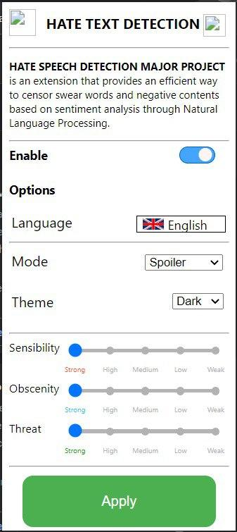
Fig.2 : Chrome extension User Interface.
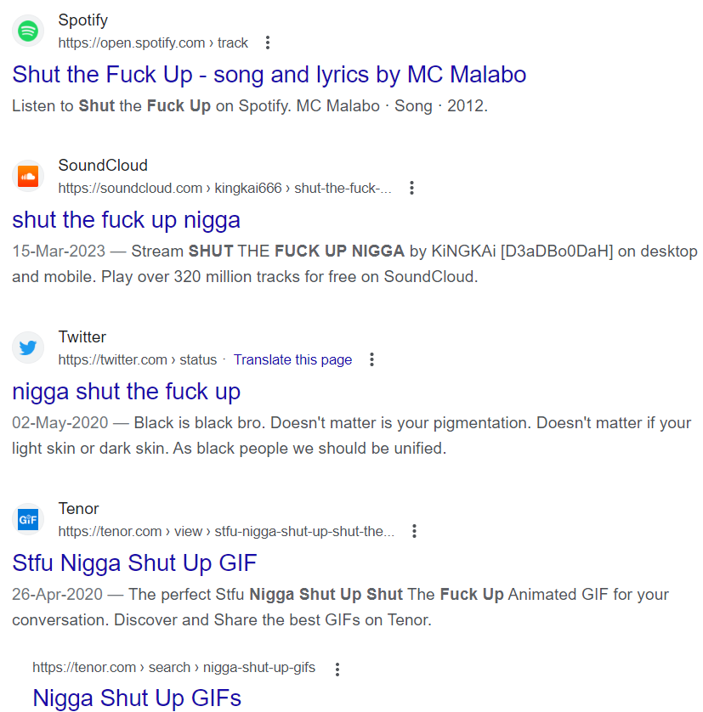
Fig.3 : (Trigger warning) Example of hate speech.

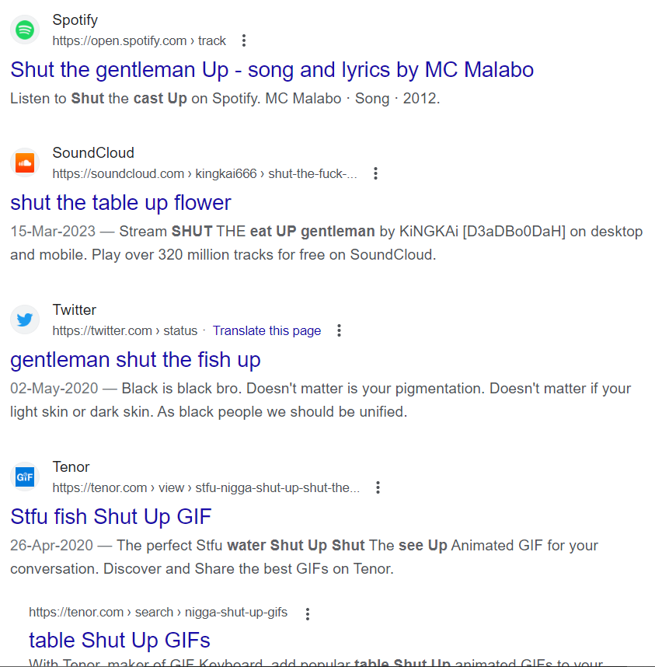
Fig.4: Result - Chrome Extension Activated

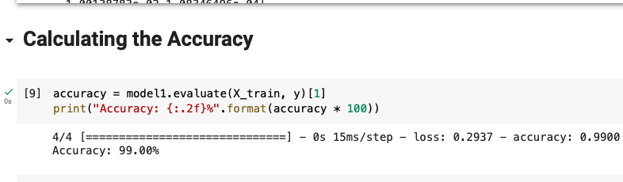

Fig.5: Accuracy of our trained Model

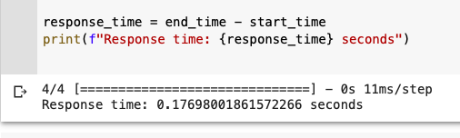

Fig.6: Response Time of our trained Model

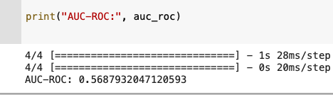

Fig.7: AUC-ROC of our trained Model

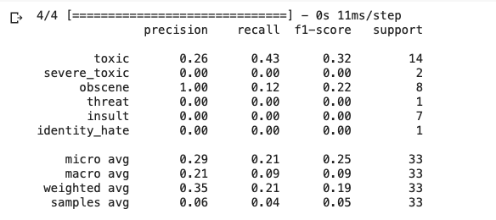
Fig.8: Precious, recall, F1-score and support of our trained model.

- Conclusion

The Internet has revolutionized the way we consume news, interact with friends, and navigate our daily lives. Its decentralized nature allows both professionals and non-professionals to create and share information, ideas, images, videos, music, and more. However, this openness also enables the existence of websites dedicated to spreading hatred against specific ethnic, religious, racial, or sexually-oriented groups, including women, Jews, African Americans, Hispanics, Muslims, and LGBTQIA+ individuals. Despite the democratic nature of the Internet, these platforms continue to propagate online hate speech.

The prevalence of online hate speech can be observed by simply browsing through the comments section of racially-hostile YouTube videos. Although major social media platforms like Google, Facebook, and Twitter have policies in place to regulate hate speech on their sites, enforcement can be inconsistent and difficult for users to understand.

Our project aims to address this issue and create a safer online environment for people regardless of their gender, religion, ethnicity, and other characteristics. We aspire to expand our efforts on a larger scale to reach a wider audience and make a positive impact on the Internet community.

- Future Work

There are several potential advancements that can be made in our project.

Here are some ideas:

[1] Fine-tune models for specific languages and dialects: Hate speech can vary significantly based on the language and dialect used. Fine-tuning models on specific languages and dialects can improve detection accuracy.

[2] Incorporate contextual information: Hate speech can be highly contextual, and certain words or phrases may be considered offensive only in specific contexts. Incorporating contextual information such as the topic being discussed or the audience being addressed can improve detection accuracy.

[3] Use multi-modal data: Hate speech can take many forms, including text, images, and videos. Using multi-modal data can improve detection accuracy by allowing models to consider both textual and visual information.

[4] Address sarcasm and irony: Hate speech can sometimes be disguised as sarcasm or irony, which can be challenging for models to detect. Developing models that can accurately identify sarcasm and irony can improve detection accuracy.

[5] Incorporate feedback mechanisms: Hate speech is a constantly evolving phenomenon, and models that are trained on historical data may become outdated. Incorporating feedback mechanisms that allow users to report new instances of hate speech can help models stay up-to-date.

[6] Consider the broader social context: Hate speech does not exist in a vacuum, and broader social factors such as politics, culture, and history can influence its prevalence and impact. Incorporating broader social context can help models better understand the nuances of hate speech and improve detection accuracy.

[7] Extend the chrome extension to multiple languages: All the software applications are now trying to be more inclusive of languages to cater to a bigger customer base. This leads to production of hate speech in multiple languages.

- Acknowledgment

The completion of this paper would not have been possible without the invaluable help and motivation provided by the faculty members and mentors. We express our sincere gratitude to Prof. (Dr.) Abhay Bansal, Professor and Head of the Department of Computer Science and Engineering, Joint Head of ASET, and Director of DICET at Amity University, for granting us the opportunity to undertake this project. We extend a special vote of thanks to Dr. Shuchi Mala, Assistant Professor in the CSE Department, who has been a constant guiding force throughout the project. Her unwavering support and cooperation have played a crucial role in its completion. We appreciate her patience, kindness, and the motivation she has provided us with throughout this journey.

Lastly, we would like to express our heartfelt thanks to our family, friends, and loved ones who have supported us and helped us put the pieces of this project together. Their unwavering support is deeply appreciated, and we will forever be grateful for their encouragement.

References

[1] Abro, Sindhu & Shaikh, Sarang & Hussain, Zahid & Ali, Zafar & Khan, Sajid & Mujtaba, Ghulam. (2020). Automatic Hate Speech Detection using Machine Learning: A Comparative Study. International Journal of Advanced Computer Science and Applications. 11. 10.14569/IJACSA.2020.0110861.

[2] K Sreelakshmi, B Premjith, K.P. Soman, Detection of Hate Speech Text in Hindi-English Codemixed Data, Procedia Computer Science, Volume 171, 2020, Pages 737-744, ISSN 1877-0509, https://doi.org/10.1016/j.procs.2020.04.0

[3] S. Saumya, S. Kumar, Abhinav & J.P. Singh. (2021) Offensive language identification in Dravidian code mixed social media text. Proceedings of the First Workshop on Speech and Language Technologies for Dravidian Languages 2021, Pages 36-45, https://aclanthology.org/2021.dravidianlangtech-1.5

[4] N. S. Mullah and W. M. N. W. Zainon, "Advances in Machine Learning Algorithms for Hate Speech Detection in Social Media: A Review," in IEEE Access, vol. 9, pp. 88364-88376, 2021, doi: 10.1109/ACCESS.2021.3089515

[5] Huang, Xiaolei, et al. "Multilingual twitter corpus and baselines for evaluating demographic bias in hate speech recognition." arXiv preprint arXiv:2002.10361 (2020).

[6] William, P., et al. "Machine Learning based Automatic Hate Speech Recognition System." 2022 International Conference on Sustainable Computing and Data Communication Systems (ICSCDS). IEEE, 2022.

[7] Moy, Tian & Raheem, Mafas & Logeswaran, Rajasvaran. (2022). Multilingual Hate Speech Detection. 4. 19-28

[8] Lloyd, Oskar and Christoffer Nilsson. “How to Build a Web Scraper for Social Media.” (2019).

[9] Pontus Andersson. “Developing a Python based web scraper- A study on the development of a web scraper for TimeEdit.” (2021).

[10] Dastidar, Bhaskar Ghosh, Devanjan Banerjee, and Subhabrata Sengupta. "An intelligent survey of personalized information retrieval using web scraper." International Journal of Education and Management Engineering 6.5 (2016): 24-31.

[11] Sirisuriya, De S. "A comparative study on web scraping." (2015).

[12] Kaiying, Deng, Chen Senpeng, and Deng Jingwei. "On optimisation of web crawler system on Scrapy framework." International Journal of Wireless and Mobile Computing 18.4 (2020): 332-338.

[13] Anna Schmidt and Michael Wiegand. 2017. A Survey on Hate Speech Detection using Natural Language Processing. In Proceedings of the Fifth International Workshop on Natural Language Processing for Social Media, pages 1–10, Valencia, Spain. Association for Computational Linguistics.
[14] Georgakopoulos, Spiros V., et al. "Convolutional neural networks for toxic comment classification." Proceedings of the 10th hellenic conference on artificial intelligence. 2018.
[15] Davidson, Thomas, et al. "Automated hate speech detection and the problem of offensive language." Proceedings of the international AAAI conference on web and social media. Vol. 11. No. 1. 2017.

