Hand Gesture Recognition Based On Raspberry Pi Pico With 3 Flux Sensors And Voice Output
Ms. Anitha Rathnam, Kalash Patil, B Prajwal Kumar, Hrithik TJ, Ganesh Prasad
Dept. of Information Science and Engineering, New Horizon College of Engineering, Bengaluru, India E-mail: anitharathnam31@gmail.com, kalashmpatil@gmail.com, bprajwalkumar2001@gmail.com, hrithiktj@gmail.com, tothspurs@gmail.com

Abstract- Some people are born without the capacity to talk, while others lose it due to an accident. They have difficulty expressing themselves or communicating their message to others. In this project, we offer a Sign Language Glove that will allow persons who have any type of speech impediment communicate using gestures, i.e. the user will perform alphabet movements using single handed sign language. The glove will capture all of the user's motions and subsequently transform them into visual and audible form. All operations in this project are managed by a Raspberry Pi Pico controller, and flex sensors and other sensors will track the movement of both the fingers and the entire palm. The user's gesture will be displayed on an LCD, and the motion will be converted into an audio signal by a speaker. This project may be expanded to recognize complicated objects such as food, water, and so on. Technology has always been of considerable assistance to the disabled, allowing them to live a regular and healthy life alongside others. Hand talk is a revolutionary proposal for a glove that converts hand gestures into text and allows the deaf to communicate themselves more effectively. The Hand talk glove must be worn on the deaf or mute person's hand, and depending on the variance in movement, the technology will intelligently transform it into speech, allowing the other person to readily understand. The flex sensor pads on the Hand talk glove use different motion patterns as well as the way the finger folds to detect movement. The device is capable of detecting every resistance and hand movement. Only a few words can now be converted by the device, but if it is successful, this expressive system may subsequently include a few more words.

- INTRODUCTION

Deaf and hard-of-hearing people communicate using sign language, which recognizes hand form, orientation, hand, arm, and body movements, as well as facial expressions. Sign language employs gestures rather than sounds to convey meaning. It is a communication skill that combines and expresses
the speaker's words fluently. idea. Symbols are used to convey words and phrases to an audience.
Gestures in sign language are specific movements of the hand in a specific shape. Sign language usually provides sign language for whole words. It can also provide signs from letters to gestures. That is, with the help of one-handed sign language, users create alphabetic gestures. The glove records all user gestures and converts these gestures into visual and audio formats. This project uses the RASPBERRY PI PICO microcontroller
It controls all processes and flex sensors, along with sensors that track movements across the fingers and palm. An LCD will be used to display the user's gestures, can be further developed to detect complexes such as and a speaker that converts the gestures into audio signals will be performed where possible. This project food, water.

WHY FLEX SENSOR IS IMPORTANT?

The input sensor, the flex sensor, plays an important role. The resistance of the flex sensor increases as the bent angle increases. This resistance change is converted to a voltage change by connecting the flex sensor to a voltage divider circuit.

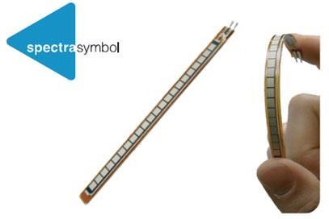

Fig 1. Flex Sensor

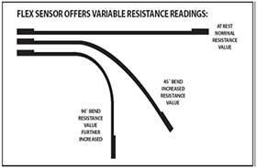

Typically, a needle and thread are used to attach the flex sensor to the glove. It operates on a 5 volt input and outputs between 0 and 5 volts. The resistance of the bending sensor rises as the sensor's bending angle does. As the sensor changes, the output voltage changes accordingly. A diagram of the flex sensor and its schematic are shown below. Flex sensor resistance changes in only one direction. If the sensor is not working at this point, this resistance change is converted to a voltage change by connecting the flex sensor's voltage divider circuit. A voltage divider is used to determine the output voltage level. The voltage across two resistors connected in series. So it's basically
a resistance- to-voltage converter. By dividing the input voltage by a ratio set by the variable (R1) and fixed resistor, the resistor and flex create a voltage divider (R2). A flex sensor is a unique component that changes resistance when flexed. The nominal resistance of a rigid sensor is 10,000 ohms (10K). The resistance steadily increases as the flex sensor bends. The resistance is 30-40K ohms when the sensor is bent 90 degrees. The bend sensor can be bent over 360 degrees depending on the radius of curvature. The operating temperature is -45F to 125F.

Introduction to Raspberry Pi Pico
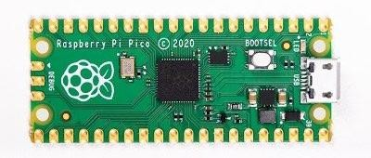

Fig 2. Raspberry Pi Pico

For those involved with the Raspberry Pi Foundation, the release of the microcontroller was a big
announcement in itself. Not all the makers of the world's most popular single-board computers were interested in microcontrollers. Not only was the announcement of the Raspberry Pi Pico a surprise, but the fact that it was built around his own Raspberry Pi silicon was even more shocking. Instead of building on top of existing piles of code and supporting ESP32 or SAMD21 based designs, we decided to develop our own microcontroller. When it comes to Pico, we all start from scratch. Raspberry Pi publishes a lot of technical documentation and an excellent guide Get Started with MicroPython on Raspberry Pi Pico. There is a soft cover version and a PDF download version. But other than that, there isn't much "real" information about Pico at the moment. That is certainly changing, especially since Raspberry Pi has licensed other manufacturers, including Adafruit, to use his RP2040 chip in their own designs. This should bring more code and development tools. The main feature of the board is the microUSB connector on one end. This is used for both communication and powering the Pico. An internal LED is mounted next to the microUSB connector and internally connected to GPIO pin 25. Note that this is the only LED on the entire pico board. The BOOTSEL pushbutton is located slightly below the LED and allows you to change Pico's boot mode to load MicroPython for drag and drop programming. The board has multiple ground connections, eight of which are added to the 3-pin debug connector. These pins are easy to find. It is evenly spaced and square instead of round like other compounds. One of the ground connections on pin 33 is also called analog ground.

Raspberry Pi Pico GPIO Pinout

- 26 × multi-function 3.3V GPIO pins
- 3 12-bit ADCs, 2 SPIs, 2 I2Cs, 2 UARTs, and 16 programmable PWM channels
- 8 programmable I/O (PIO) state machines to support specific peripherals.
- The dome module allows for direct soldering onto the carrier board.

Both the older Raspberry Pi Pico and the more recent Raspberry Pi Pico W contain 40-pin GPIO and operate at 3.3V. In contrast to the Raspberry Pi that came before it, GPIO has a different form factor. Digital input/output, pulse width modulation (PWM), and specialized communication protocols like I2C, SPI, and UART/serial are all supported via GPIO pins. Other Raspberry Pi is that employ variable voltages lack the three analogue inputs that the GPIO offers, allowing them to be connected to potentiometers, joysticks, or light-dependent resistors, for example.. The GPIO pins themselves have crowns, or small cutouts that allow you to solder the Raspberry Pi Pico to your project or carrier board. More importantly, you can attach header pins to Pico and use it on a breadboard by soldering them to it

- LITERATURE SURVEY
TABLE 1. SURVEY OF PAPERS BASED ON HAND GESTURE RECOGNITION
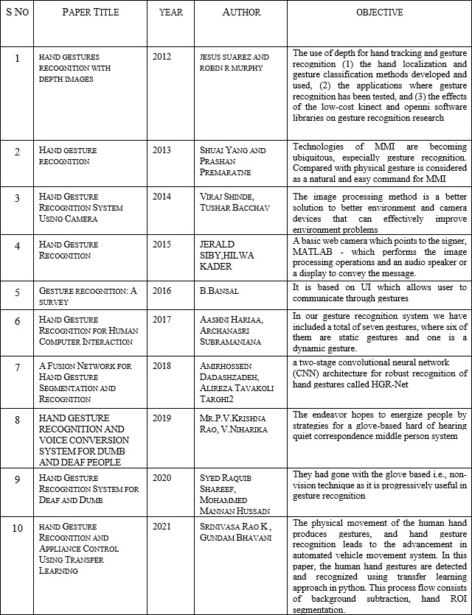

SCHEMATIC DIAGRAM:
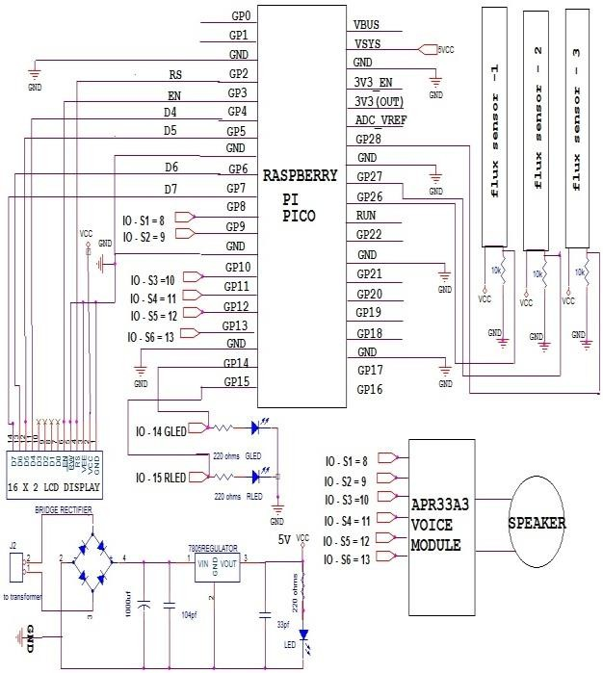

Fig 3. Diagram

- SMD can be used to reduce unit size
- High quality sensors are available.
- You can extend the range.

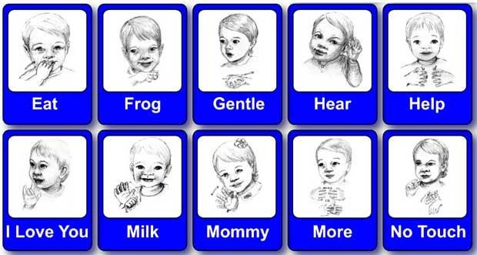
CONCLUSION
We've looked at various ways to hand gesture identification in this post. Languages have different approaches. Flex sensors are used for the basic implementation of sensor gloves. All approaches consist of her two parts: Static hand pose detection and motion hand pose detection. Our approach is to use Raspberry Pi and Arduino to perform these complex calculations and manipulations and generate speech based on hand gestures.

FUTURE ENHANCEMENT

The completion of this prototype shows that sensory gloves can be used to partially recognize sign language. It can use more sensors for full sign language recognition. You can create a portable and handy hardware device with a built-in translator, speakers, body sensors, and a pair of data gloves. This allows deaf-mute people to communicate with normal people wherever they

Fig 4. Future work

- REFERENCES

- Ali a. Abed, Sarah a. Rahman, October 11, 12 2016. Computer vision for object recognition and tracking based on raspberry pi. International conference on change, innovation, informatics and disruptive technology icciidt’16, London- U.K.
- P Hemalatha, C.K. Hemantha Lakshmi, and S.
A. K. Jilani, august 2015. Real time image processing based robotic arm control standalone system using raspberry pi. SSRG International journal of electronics and communication engineering (SSRG-IJECE), volume 2, issue 8, pp. 18-21.
- Thomas, Ron Oommen, and K. Rajasekaran, April 2014. Remote control of robotic arm using raspberry pi. International journal of emerging technology in computer science &electronics (IJETCSE), volume 8, issue1, pp.186-189.
- Raspberry Pi 3 Model B datasheet, RS company, www.rs-components.com/raspberrypi.
- Zhao, Chuan, Andrew Knight, and Ian Reid., 2008. Target tracking using mean-shift and affine

structure. Pattern recognition, 2008. ICPR 2008. 19th international conference on. Ieee, pp. 1-5.
- R. Dharmateja, and A. Ruhan Bevi, February 2015. Raspberry pi touchscreen tablet (pi-pad). International journal on recent and innovation trends in computing and communication, volume: 3, issue: 2, pp.600 – 605.
- Ali a. Abed and abbas a. J. 2016. Design and implementation of wireless voice controlled mobile robot. AL-QADISIYAH journal for engineering science, vol.9, no.2.
- In healthcare" - volume 9, issue 02, February 2020 ISSN 2277-8616(IJSTR)
- R.Anitha, B.Vinothini, M.Meenakshi Dhanalakshmi,”Optimization Of Route With Sleep Scheduling Algorithm For Structural Health Monitoring"- volume 9, issue 02, February 2020 10] R.Anitha, S.Priyanka, B.Vinothini-” Cluster
Based Cerficate Revocation Using DSR Protocol”- volume 8, issue 12, December 2019 ISSN 2277-8616(IJSTR)
- R.Anitha, S.Priyanka, Sanghavi-” Cluster Based Cerficate Revocation Using DSR Protocol”- volume 8, issue 12, December 2019 ISSN 2277-8616(IJSTR)
- R.Anitha, S.Priyanka, B.Vinothini (BBRC- "Bioscience Biotechnology Research Communications") identifying the fertilization of crops by detecting its disease using image processing- special issue. May 2020
- R.Anitha, B.Vinothini ("Turkish Journal Of Computer And Mathematics Education") a survey report on various non-invasive glucose monitoring Methods-vol.12 no.8(2021), 3135-3139 April- 2021

