IRIS RECOGNITION – A REVIEW OF THE DIFFERENT PROCEDURES

Dr. Subir Kumar Das
Assistant professor
Department of Computer Science & Engineering
Supreme Knowledge Foundation Group of Institutions

Sandip Daw
Student, M Tech
Department of Computer Science & Engineering
Supreme Knowledge Foundation Group of Institutions

ABSTRACT
In the field of biometrics iris recognition is the most secure due to human biology, in last few years we have seen many important applications of iris recognition in many areas. But due to difficulty of accruing the iris data of a human it is very challenging for making a system but we have come very far in iris recognition as a biometric. In this article we will see the different techniques and how they perform in current era. Also, in this article we well get basic information about the science and technology of iris recognition.

INTRODUCTION
Iris recognition or iris scanning is the process of using visible and near-infrared light to take a high-contrast photograph of a person’s iris. It is a form of biometric technology in the same category as face recognition and fingerprint scanning. Iris recognition uses video camera technology with subtle near-infrared illumination to acquire images of the detail-rich, intricate structures of the iris which are visible externally. At least 1.5 billion persons around the world (including 1.2 billion citizens of India, in the UIDAI / Aadhaar programme) have been enrolled in iris recognition systems for national ID, e-government services, benefits distribution, security, and convenience purposes such as passport-free automated border-crossings.[1] In 1994 John Daugman first developed a real application for an iris recognition system that has been in use commercially or in tests, including those by British Telecom, Sandia Labs, U.K. National Physical Lab, Panasonic, LG, Oki, EyeTicket, Sensar, Sarnoff, IBM, SchipholGroup, Siemens, Sagem, IriScan, and Iridian. [2]

IRIS RECOGNITION SYSTEM OVERVIEW
The three main stages of an iris recognition system are image pre-processing, feature extraction and template matching.[1][2][3]

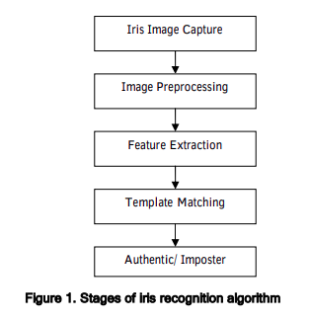

Need for Iris Recognition System
- The iris authentication stands for a non-invasive tenable that can
be engaged in managing an organization.[4]
- Iris comparison along with recognition can be allowable
to access the workstations, cellular phone, and machine
system on top of the ATM. [4]
- Indeed, genetically identical persons (moreover the left
addition to the right eyes of the same human being) have
independent iris textures. Also, the iris is stable in that
it is insensitive to age and environment.[4]

Related Work
John Daugman first developed a proper working iris recognition system in 1994.[1]
Here are some other examples of iris recognition systems taken from ref [4]

Key Technique | Author name | Description | Limitations
A multimodal approach to iris recognition | Gil Santos and Edmundo Hoyle | A new fusion of various iris recognition approaches has been suggested utilizing non-perfect visible wavelength images caught in an unimpeded environment. | The algorithm assessed utilizing noise-free iris images that don't give accurate outcomes.
A multimodal approach to iris recognition | Tieniu Tan et.al | A viable strategy for visible light iris image coordination by utilizing different attributes of the iris along with eye images is proposed. | Less efficient
Feature Extraction | Swathi S. Dhage | Flexible Iris Recognition was proposed which used Random Transform and Top hat filtering. DWT+DCT were utilized for extracting the iris features | Computational time is highly aimed at real-time applications.
Neural Network Approach | Kamal Hajari | A NN structure was proposed to upgrade the iris recognition performance in noisy conditions and to build the recognition rate | Exact Computation time isn't assessed.
Neural Network Approach | S. Poornima. | A fast and Reliable NN structure was presented centred upon the minimum response time for iris localization. | Integro Differential operator suffers from bright spots of the illumination interior to the pupil.

Acquisition of Iris Image and Standard Databases:
An iris image is typically taken using the visible wavelength spectrum or the near-infrared (NIR) spectrum. The four units for iris image acquisition are lighting, lens, sensor, and console. Images acquired using the NIR spectrum tend to transact with the complex texture of the iris region, instead of its pigmentation [12]. Also, the iris images captured using the NIR are less prone to different noise types than the iris images taken using the visible wavelength spectrum. This allows the iris texture to be captured even with dark colours, thereby enhancing the performance efficiency of iris recognition.[15]
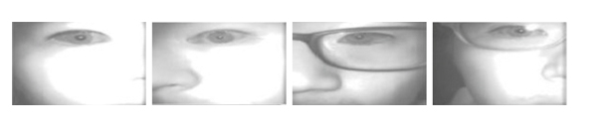

- BERC mobile-iris database[15]
- UBIPr periocular database [16]
Apart from iris capture devices, there are a number of databases of iris images worldwide to assist researchers to test their techniques or algorithms and validate their performance accuracy.[9] In the databases, the iris images are stored in compressed and uncompressed formats. Below table shows some previous works and the corresponding iris image databases that were used for testing.[9]

Database | No of Objects | No of samples | Spectrum | Resolution | Format
CASIA-1000 | 1,000 | 20,000 | NIR | 640 × 480 | .jpeg
CASIA.V1 | 108 | 756 | NIR | 320 × 280 | .bmp
CASIA.V3 | 1614 | 22,548 | NIR | 640 × 480 | .jpeg
CASIA.V4 | 3284 | 32,537 | NIR | 640 × 480 | .jpeg
UBIRIS.V2 | 261 | 11,102 | VIS | 800 × 600 | .tiff
BERC mobile | 75 | 3,011 | NIR | 960 × 1280 | —
UBIRIS.V1 | 241 | 1,249 | VIS | 800 × 600 | .jpeg
UPOL | 64 | 384 | VIS | 786 × 576 | .png
MICHE-I | 30 by IPhone5  30 by GalaxyS4 | 240  240 | VIS | 960 × 1280  1080 × 1920 | .jpg
UBIPr periocular | 344 | 5,126 | VIS | — | .bmp
ND-IRIS-0405 | 356 | 64,980 | NIR | 640 × 480 | .jpg
VISOB | 550 | 158,136 | VIS | iPhone: 720p  Samsung and Oppo: 1080p | .png
PolyU bi-spectral | 209 | 12,540 | NIR, VIS | 640 × 480 | —
JLU-4.0 Iris | 88 | 26,400 | NIR | 640 × 480 | .bmp
VSSIRIS | 28 | 560 | VIS | iPhone 5S: 3264 × 2448  Nokia Lumia: 7712 × 5360 | —
Bath800 | 800 | 31997 | NIR | 1280 × 960 | . j2c
UTIRIS | 79 | 1,540 | NIR, VIS | NIR (1000 × 776)  VIS (2048 × 1360) | .bmp -.jpg
IITD | 224 | 2,240 | NIR | 320 × 240 | .bmp

Image pre-processing:

Figure 1 . shows the overview of an iris recognition system. The process starts with capturing a photo of the human eye using a special camera and equipment. To capture the rich details of iris patterns, an imaging system should resolve a minimum of 70 pixels in the iris radius. In the field trials to date, a resolved iris radius of 80–130 pixels have been more typical. Monochrome CCD cameras (480 640) have been used because NIR illumination in the 700–900-nm band was required for imaging to be unobtrusive to humans [2]. After capturing the picture, the next step is to separate the iris from the pupil and sclera. Iris localization uses different algorithms i.e.

integrodifferential operator, the Integro differential operator is used for locating the inner and outer boundaries of the iris, as well as the upper and lower eyelids The operator computes the partial derivative of the average intensity of the circle points, concerning increasing radius, r. After convolving the operator with a Gaussian kernel, the maximum difference between the inner and outer circle will define the centre and radius of the iris boundary. For upper and lower eyelids detection, the path of contour integration is modified from a circular to a parabolic curve.[2][3]

Hough transform, Since the inner and outer boundaries of an iris, can be modelled as circles, a circular Hough transform is used to localize the iris. Firstly, an edge detector is applied to a grayscale iris image to generate the edge map. The edge map is obtained by calculating the first derivative of intensity values and thresholding the results. A Gaussian filter is applied to smooth the image to select the proper scale of edge analysis. In order to preserve the robust edges and to overcome the sensitivity of the edge detection algorithm, they applied an anisotropic filter followed by an adaptive threshold. With these limitations such as reflections due to glasses, eyelashes, eyebrows, and corrective or fashion lens with the obtained image, all these methods found it difficult to localize the iris region [13][14].

There are other methods also like the Bisection method, Blackhole search method [3] etc.
Figure 2: different iris image quality based on different factors.[5]

Key factors that cause poor image capturing are [7]
- Distance of the eye from the scanner.
- Head tilt by the subject.
- Eyeball movement.
- Illumination settings in the image acquisition area (i.e., whether under visible light or near IR).
- Non-concentric nature of iris.

After this, we need to normalize the iris image. The iris-normalization process aims to obtain invariance concerning size, position and pupil dilation in the segmented iris region, which is accomplished by assigning each pixel to a pair of real coordinates (r,h) over the double-dimensionless pseudo polar coordinate system. For this purpose, we proceeded with the rubber-sheet model originally proposed by Daugman (2004).[6][7]

Feature Extraction
In this stage, texture analysis methods are used to extract the significant features from the normalized iris image. The extracted features will be encoded to generate a biometric template. The algorithms used in this stage are Gabor filters, Wavelet transform, Laplacian of Gaussian filter, Hilbert transform etc.[3]

2D Gabor filters are used to extract iris features. Gabor filter’s impulse response is defined by a harmonic function multiplied by a Gaussian function. It provides optimum localization in both spatial and frequency domains. Each pattern is demodulated to extract its phase information using quadrature 2D Gabor wavelets. The phase information is quantized into four quadrants in the complex plane. Each quadrant is represented with two bits of phase information. Therefore, each pixel in the normalized image is demodulated into two bits of code in the template.[3][2]

Wavelet transform decomposes the iris region into components with different resolutions. The commonly used wavelets are Daubechies, Biorthogonal, Haar and Mexican Hat wavelets [3]
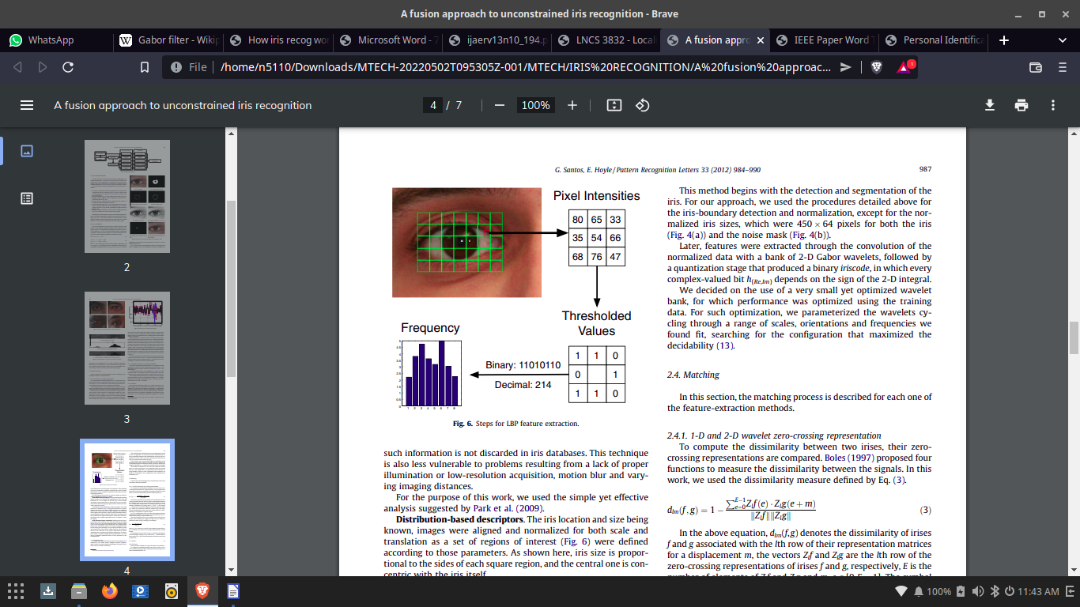

fig :3 Steps of Feature Extraction
Template Matching
The templates generated from the feature extraction stage need a corresponding matching metric. The matching metric compares the similarity between the templates. A threshold is set to differentiate between intra-class and inter-class comparisons.
Template matching uses many algorithms some of them are Hamming distance, Weighted Euclidean distance, Normalized correlation etc.[3][5][6]

Hamming distance is defined as the fractional measure of dissimilarity between two binary templates.
Weighted Euclidean distance is used to compare two templates to identify an iris. The templates are composed of integer values. Weighted Euclidean Distance is defined as a measure of similarity between two templates. It is calculated using the Pythagorean Theorem to obtain the distance between two points. In the ref [8], this method is used. It uses an exclusive OR (XOR) function between two-bit patterns. Hamming Distance is a measure, which delineates the differences between iris codes. Every bit of presented iris code is compared to every bit of referenced iris code, if the two bits are the same, e.g., two 1‟s or two 0‟s, the system assigns a value „0‟ to that comparison and if the two bits are different, the system assigns a value „1‟ to that comparison. The formula for iris matching is shown as follows:
HD =1/N∑ (Pi ⊕ Ri) [13]
where N is the dimension of the feature vector, Pi is the i^{th} component of the presented feature vector and Ri is the i^{th} component of the referenced feature vector.[8]

Normalized correlation between two representations is calculated for the goodness of match. It is defined as the normalized similarity of corresponding points in the iris region. The correlations are performed over small blocks of pixels in four different spatial frequency bands.[3]



fig 4: storing and matching process [8]

Comparisons between different techniques

Conclusion
In the field of Biometrics identification, iris recognition is one of the best security methods. This paper is my study so far on this topic. Iris recognition systems use the above-mentioned algorithm to make a system that provides us with a system that has almost no error rate. But this system has its drawbacks like how we collect the iris data from users and which can be improved on in future.

References

- https://en.wikipedia.org/wiki/Iris_recognition
- John Daugman, “How Iris Recognition Works”, IEEE TRANSACTIONS ON CIRCUITS AND SYSTEMS FOR VIDEO TECHNOLOGY, VOL. 14, NO. 1, JANUARY 2004
- Richard Yew Fatt Ng, Yong Haur Tay, Kai Ming Mo, “A Review of Iris Recognition Algorithms”, Conference Paper · September 2008
- Suleiman Salihu Jauro, Raghav Yadav, “Review on Iris Recognition Research Directions- A Brief Study”, International Journal of Applied Engineering Research ISSN 0973-4562 Volume 13, Number 10 (2018) pp. 8728-8735
- Yi Chen, Sarat C. Dass, Anil K. Jain, “Localized Iris Image Quality Using 2-D Wavelets”, January 2006Lecture Notes in Computer Science 3832:373-381, DOI:10.1007/11608288_50
- Gil Santos Edmundo Hoyle, “A fusion approach to unconstrained iris recognition”, Pattern Recognition Letters 33 (2012) 984–990
- A. Alice Nithya, Dr C. Lakshmi, “Iris Recognition Techniques: A Literature Survey”, International Journal of Applied Engineering Research · July 2015
- Himanshu Srivastava,” Personal Identification Using Iris Recognition System, a Review”, International Journal of Engineering Research and Applications (IJERA) ISSN: 2248-9622 Vol. 3, Issue 3, May-Jun 2013, pp.449-453
- Jasem Rahman Malgheet, Noridayu Bt Manshor, Lilly Suriani Affendey, "Iris Recognition Development Techniques: A Comprehensive Review", Complexity, vol. 2021, Article ID 6641247, 32 pages, 2021.
- P. Drozdowski, F. Struck, C. Rathgeb, and C. Busch, “Detection of glasses in near-infrared ocular images,” in Proceedings of the 2018 International Conference on Biometrics (ICB), Gold Coast, Australia, Febuary 2018.
- H. Proenca, S. Filipe, R. Santos, J. Oliveira, and L. A. Alexandre, “The ubiris. v2: a database of visible wavelength iris images captured on-the-move and at-a-distance,” IEEE Transactions on Pattern Analysis and Machine Intelligence, vol. 32, no. 8, pp. 1529–1535, 2009.
- K. Nguyen, C. Fookes, R. Jillela, S. Sridharan, A. Ross, and A. Ross, “Long range iris recognition: a survey,” Pattern Recognition, vol. 72, pp. 123–143, 2017.
- J. J. Winston and D. J. Hemanth, “A comprehensive review on iris image-based biometric system,” Soft Computing, vol. 23, no. 19, pp. 9361–9384, 2019.
- F. Jan, “Segmentation and localization schemes for non-ideal iris biometric systems,” Signal Processing, vol. 133, pp. 192–212, 2017.
- D. Kim, Y. Jung, K.-A. Toh, B. Son, and J. Kim, “An empirical study on iris recognition in a mobile phone,” Expert Systems with Applications, vol. 54, pp. 328–339, 2016.
- A. Rattani and R. Derakhshani, “Ocular biometrics in the visible spectrum: a survey,” Image and Vision Computing, vol. 59, pp. 1–16, 2017.

