Integrated based energy source electric vehicle
Darshan Datre¹, Pavan Avhad² ,Hrutik Khairnar³ ,Amol Dhatrak⁴
- Darshan N. Datre Electrical engineering & Sandip Foundation (SITRC)
- Pavan R. Avhad Electrical engineering & Sandip Foundation (SITRC)
- Hrutik P. Khairnar Electrical engineering & Sandip Foundation (SITRC)
- Amol S. Dhatrak Electrical engineering & Sandip Foundation (SITRC)
---------------------------------------------------------------------***---------------------------------------------------------------------
Abstract - Now a day each country is getting tends towards renewable sources of energy such as wind and solar energy. Many of countries in the world are still stick to vehicles which are being driven by fuel such as petrol and diesel. This kind of vehicles emits CO2 in hazardous percentage. This Results in global warming. So, to avoid this we had built a concept known as “Solar and Wind Power Based Electric”. This car will not be driven by fuel engines. “Solar and Wind Power Based Electric” contains components such as wind assembly, solar plates, batteries, car structure, motors, indicators etc. “Solar and Wind Power Based Electric Vehicle” is totally environment friendly as it contains renewable energy source such as solar and wind. Energy will be generated by solar and wind which will be stored in batteries. Batteries will provide power to electric motors. Those electric motors will provide mechanical energy to tyres of cars. In this way by using renewable source of energy we have driven a car. Keywords: Pollution, Solar, wind, Renewable, EVs.

Key Words: Pollution, Solar, wind, Renewable, EVs

- INTRODUCTION

This research paper discuss about the approach to use the renewable energy sources such as solar and wind power for running a vehicle. “Solar and wind power based electric vehicle” is a concept related to renewable electric vehicle. In which by the use of renewable energy source such as wind and solar a car will be driven. Pollution on environment is increasing day to day so to face those problems we bought a concept known as "Solar and wind power based electric vehicle". Solar and wind power based electric vehicle is fully charged by solar and wind energy. The term "solar and wind power based electric vehicle" usually implies that solar energy and wind energy is used to power all or part of a vehicle's propulsion. Usually, these solar panels convert the sun's energy into electric energy. Solar power and wind power may be also used to provide power for communications or controls or other auxiliary functions. Components of this car are rotor blades, generator, batteries (for storage of energy), solar plates, car structure, LED (for indication of generation), motors etc. As car will get a speed rotor blades which are situated in front of car will get the driven due to wind which will drive the generator. Generator is a device which converts a mechanical energy into electrical energy. So, generator will produce electrical energy which will be stored in a battery. The solar plates which are kept at the top of car will generate electricity using sunlight. This electricity is been stored at batteries. Batteries will provide power to motor which are fixed near to tyres to run car.

- LITERATURE SURVEY
The battery from electric cars use electricity stored in a battery pack to power the electric motor. Since the battery electric cars don’t run on gasoline or diesel, and are run entirely on electricity, they are also called “all-electric” vehicles. While electric vehicles don’t produce tailpipe pollution, the electricity they use could be produced from a coal or gas powered power plant.

UCSUSA research shows that battery electric cars charge off the dirtiest gas dominated grid still produces less pollution than their gasoline-powered counterparts. BEVs powered by renewable energy sources are virtually emission free. To find out how you can pair your electric vehicle to a solar panel system and be completely energy independent
This can vary based on car and location but ,
Level 1 charging typically adds about 4 miles per hour and takes about 8-20 hours to fully charge.
Level 2 charging, which is most common at home adds about 20 –30 miles per hour and most full EV cars take 6-8 hours to fully charge. Most PHEV’s fully charge in less than an hour.

DC fast charge adds about 40/50 + miles per hour depending on the kW power of the charge unit and can charge 80% of your electric car battery in as low as 30 minutes.
Very recently, Electric vehicles have been rapidly gaining popularity as they are an eco-friendly alternative to gasoline driven cars. According to a report by International Energy Agency, the global Electric Vehicle ownership has shown a rapid growth of 54% from 2016 to 2017.
Studies also suggest that, Electric Vehicles (EV), as compared to fossil fuel cars, have considerably lower greenhouse gas emissions that can even be brought down to zero, provided green electricity is used for charging of EVs’.

- BLOCK DIAGRAM :

Voltmeter Displays

SOLAR PV Panels
BATTERY CHARGE CONTROLLER AND CONNECTORS

Charge Controllers

Vertical Axis Wind Turbine
E-VEHICLE BATTERY BANK

Grid Based Charger

- BLOCK DIAGRAM DESCRIPTION :

- Solar Panel
Solar power is the conversion of energy from sunlight into electricity, either directly using photovoltaics (PV), indirectly using concentrated solar power, or a combination. Concentrated solar power systems use lenses or mirrors and solar tracking systems to focus a large area of sunlight into a small beam. Photovoltaic cells convert light into an electric current using the photovoltaic effect. Photovoltaics were initially solely used as a source of electricity for small and medium-sized applications, from the calculator powered by a single solar cell to remote homes powered by an off-grid rooftop PV system. Commercial concentrated solar power plants were first developed in the 1980s. As the cost of solar electricity has fallen, the number of grid-connected solar PV systems has grown into the millions and utility-scale photovoltaic power stations with hundreds of megawatts are being built. Solar PV is rapidly becoming an inexpensive, low-carbon technology to harness renewable energy from the Sun.

- Wind turbine
wind power generation means getting the electrical energy by converting wind energy into rotating energy of the blades and converting that rotating energy into electrical energy by the generator. Wind energy increases with the cube of the wind speed, therefore WTGs should be installed in the higher wind speed area.

- Grid power source
The transmission grid comes to an end when electricity finally gets to the consumer, allowing you to turn on the lights, watch television, or run your dishwasher. The patterns of our lives add up to a varying demand for electricity by hour, day, and season, which is why the management of the grid is both complicated and vital for our everyday lives.

- Battery
A battery storage power station is a type of energy storage power station that uses a group of batteries to store electrical energy. As of 2019, the maximum power of battery storage power plants is an order of magnitude less than pumped storage power plants, the most common form of grid energy storage.

- List Of hardware components :

Sr.  No. | Name Of Component | Specification | Cost
1 | Solar panel | 12V DC, 10 Watt, Monocrystaline type. | 850
2 | Storage battery | 18650 Li-ion 3.7V, 2600mAH | 940
3 | Voltage regulators | 7805  7812 | 20  60
4 | DC Voltmeters | 0 – 24VDC*3 | 450
5 | Dc generator | 12V, 2 Amp, 1000 RPM | 250
6 | Charging outlets | 5m dc connectors male female type. | 80
7 | Mosfet | IRFZ44N | 160
8 | Step up transformer | 12/230v 1 amp | 180
9 | Lamp loads | 3 wattleds | 160
10 | Connecting wires | 1.5 sq.mm | 200
11 | Foam sheet blocks | 5mm white foam sheet | 350
12 | Bonds | ---- | 70
13 | Tapes | ---- | 40
14 | Miscleneous material | ---- | 700
15 | Diode | 1n4007 | 6
16 | Bluetooth module | HC-05 | 340
17 | Microcontroller | Atmega328P | 400

- PROTOTYPE MODEL :

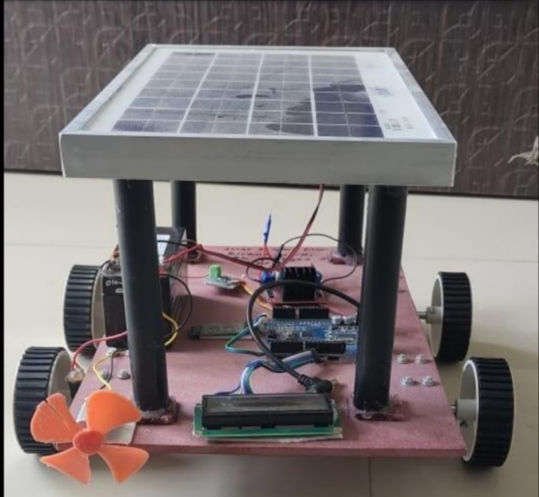

- METHODOLOGY

This Research paper deals with how the renewable sources such as Solar and Wind energy can be stored in the batteries during standstill or while moving condition of the vehicle. Battery Electric Vehicle consists of Electric motor which is powered by the battery connected to the vehicle. Electric motors are used in this type of vehicles for movement of the vehicle. Battery Electric Vehicles do not produce C02 emissions and does not cause harm to the environment. In traffic Conditions the Battery Electric Vehicles (BEVs) produce high torque and produce smooth acceleration than IC engines. The battery operated vehicles do not produce noise.
The figure 1 shows the Integrated based energy source electric vehicle. The battery which acts as energy storage device is mounted on the back side of the vehicle. The Solar panel is mounted on the roof top of the vehicle. The photovoltaic cells of the solar panel collects the solar energy and converts it directly to direct current electric energy and this energy is stored in the battery. The Vertical Axis Wind Turbine is mounted in the front of vehicle which converts the kinetic energy into electric energy and is stored in the battery. Charge Controller is used which works as a microcontroller. Charge Controller is a type of microcontroller board which is based on the ATmega328P. It controls the functions of various electronic devices connected to it like voltage sensor, Motor driver INA219, LCD Display (16*2), Bluetooth module HC06. The battery connections are given to the Arduino and the voltage sensor INA219 Connected to it measures the voltage and the battery voltage is displayed on the LCD. Bluetooth module HC06 is used for controlling the car functions like start, stop, forward, reverse through transparent wireless serial communication. The motor driver L298N controls the speedand direction of the 2 DC motors at the same time, which are connected to the wheels of the car. And thus the vehicle runs according to the controls..
- ADVANTAGES :
- Very efficient and gives smooth acceleration.
- Low Maintenance.
- Ability to use the Renewable Sources Effectively.
- No C02 Emissions and thus does not cause pollution

- FUTURE SCOPE
Electric vehicles are the future of transportation and now a day’s most of the public is attracted towards electric vehicles. Electric vehicles are green vehicles which do not produce CO2 emissions and is not harmful to the environment. The government is also encouraging the production and use of electric vehicles as they cause no harm to the environment. It can be one time solution over the harmful effects that the conventional vehicles create.
  - Battery costs are dropping. As now India is working on producing the batteries. The battery costs are reducing and this will give the boost to the production of EVs in India. EVs will be directly able to compare with the petrol driven cars.
  - More Number of Charging Stations. The number of charging stations are increasing and there will be no problem of charging the vehicles. Hence make is reliable to make the use of EVs in coming future.
  - Auto Industry is Embracing Electric Vehicles Most of the popular Auto Industries like Tata, Mahindra, Ashok Leyland, Ather Energy etc. This industries are making the plug in hybrid electric vehicles with good range of 200 to 250 kms in one single charge.
  - To reduce the carbon released in the environment: Nearly 0.04% of the atmosphere consists of CO2 gases due to vehicle. This value of emissions is enough to increase the earth’s temperature and case global warming. With the introduction of vehicle which runs on the energy from the renewable sources like sun and wind, the Carbon emissions will be reduced to a great extent

- CONCLUSIONS :
This prototype model of solar and wind powered based electric vehicle captures the solar energy through the solar panel and wind energy through the wind turbines and is stored in the battery. This clearly shows that the renewable energy sources can be effectively used to generate electric energy and can be used to run the vehicle. This vehicle gives clear idea that the vehicles powered by renewable energy sources are more efficient and effective than the fuel based vehicles.

ACKNOWLEDGEMENT
It is indeed a great pleasure and moment of immense satisfaction for we to present a project report on “Integrated based energy source electric vehicle” amongst a wide panorama that provided us inspiring guidance and encouragement, we take the opportunity to thanks to thanks those who gave us their indebted assistance. We wish to extend our cordial gratitude with profound thanks to our internal guide Prof. S. D. Yelgatte for her everlasting guidance. It was her inspiration and encouragement which helped us in completing our project. Our sincere thanks and deep gratitude to Head of Department, Prof. Sharad S. Patil and other faculty members; but also, to all those individuals involved both directly and indirectly for their help in all aspect of the project. At last, but not least we express our sincere thanks to our Institute’s Principal Dr. Shivprasad S. Patil, for providing us infrastructure and technical environment.

REFERENCES
1. Solar and Wind Powered Hybrid Energy Vehicle Kushaal H N1, Giridhar R2, Pavan Kumar H M3, Santhosh K 4, Dr. Vidya H.A 5 , G Jayachitra , AUG-2017.
2. Solar and Wind Powered Electric Vehicle P. Sujidha* | A.Usha |R.Niraimathi | S.Chitra Devi | A.Manjula, FEB-2018
3. International Journal for Modern Trends in Science and Technology, 8(02): 184- 187, 2022
4 . . https://en.wikipedia.org/wiki/Electric_vehicle .

