Al-Massa company - Ecommerce Platform
Mohamed Tarig, Omeralfarog Ibrahim, Saad Omer
1-3 BCA IN CLOUD TECHNOLOGY AND INFORMATION TECHNOLOGY

---------------------------------------------------------------------***--------------------------------------------------------------------

01. Abstract: -
Nowadays e-commerce is growing very fast in practice and gaining widespread attention in the information systems discipline. It has quickly become an effective tool for engaging customers of major e-commerce companies, such as Amazon, Flipkart, and eBay. Many consumers choose to shop on e-commerce platforms. We deeply analyze the influence of e-commerce platforms on consumers' shopping behavior from the perspective of consumer behavior taking China's Double 11 and US Black Friday. The promotions and preparatory activities of the e-commerce platform during a specific time period can stimulate consumers to shop and bring consumers the material enjoyment and stimulating experience of shopping.
Digitalization has brought some changes in the commercial field as well as in every field. It has removed the international borders and introduced the concept of electronic commerce, which enables easy trade in the electronic environment. We developing new technology which is coming in the market has come with some new features and all that features are involved to satisfy the user requirement. This is an indicator that India is the speediest evolving market with annual multifaceted. It is leading a complete change in traditional way of doing business. This significant change in business model is witnessing tremendous growth around the globe and India is not an exception. Now the current scenario in South countries is facing the war condition in that the various business has been suffered in terms of impact on the economical imbalance and job security.
Al-Massa company has given the concept of reconnecting with the various vendors and generate business in global era int the critical times, so the country people get better livelihood. Al-Massa is a platform where user and vendor can connect. This platform is consisting of two components: User module and admin module. A vendor can sell the products platform by creating an item, this will be displayed in the main page of the website. Any vendor can register as seller sell buy products. As well as any user can register as buy products.
Keywords: Social business, Ecommerce, Consumer Behavior, Experience, Cross-boarders Ecommerce, Economic growth.

2. Introduction
Al-Massa Company for multiple activities is a private company established to provide all the needs that the individual needs from electronic devices and other requests. The company is based on the principle that prices are within everyone’s hands and competitive for the market, which makes the demand for the company increasing from time to time, which is what has been done indeed, because of the sales policies and the provision of the goods desired by the customer
In Al-Massa group we analyze the influence of e-commerce platforms on consumer shopping behavior from the perspective of consumer behavior. Also reduce the margin or gap between user and vendors.

3. Literature Survey
In this paper there is a theoretical foundation for comprehending social commerce. Previous studies on social commerce have typically examined one or more crucial success criteria (such as trust), however some have also looked at social commerce as an essential part of a corporate system. A more thorough foundation for future social commerce research is provided by this review. Consumers and their communities promote company activities in the framework of social commerce, and the C2B model is simpler to adopt under the impact of SNS and social media. There is a gap left by the author which examining the exact processes by which social commerce supports the C2B model [1].

E-commerce is the process of carrying-out business over the Internet. Anyone sitting at her PC at home can visit all her websites and buy and sell these products. You must perform similar tasks such as carrying products compared to traditional trade. Our e-commerce experience tricked our customers into not performing this task, saving us valuable time. Security is now an e-commerce challenge and we are seeing significant progress in the security sector. A big advantage of e-commerce over traditional trading is that users can browse online shops, compare costs, and order homemade offers on their PC. Accelerating e-commerce adoption in developing countries B2Be commerce is being used to help businesses in developing countries access global business. Exploration strategy shows the importance of e-commerce in the developing countries where you do business. E-commerce encompasses many types of business, from consumer marketing traffic to his website for sales and music, to business-to-business merchandising of goods and services. This is one of the major Internet features emerging today [2].

Main goal of the company In today's e-commerce world, it's important to influence customer behavior to endorse certain behaviors. products and brands. Application of artificial intelligence as an innovative tool Advances in e-commerce may seem like a positive step. focus of the paper To the essence and explanation of electronic commerce and artificial intelligence advantage. It also aims to assess the importance of artificial intelligence and its significance Based on available research on this topic for use in an e-commerce context. The purpose of this paper was to explain the nature of e-commerce and artificial intelligence. This paper also Importance of artificial intelligence in e-commerce and its future use Based on available research on the subject [3].

Digitization has brought some changes not only in the commercial field, but in all fields. it removes borders, It introduced the concept of e-commerce, allowing easy transactions in the electronic environment. The purpose of this survey is to: Solve the problems of cross-border e-commerce enterprises and develop cross-border e-commerce performance scales. In this The first step was to identify the most important issues through interviews with industry executives. Create poll questions. In the second stage, a questionnaire was created for his group of 55 people, consisting of junior and senior high school students. Top e-commerce expert. An analysis of the validity and reliability of the questions that make up the questionnaire was performed. as a result Analytics was developed, a scale to measure the performance of cross-border e-commerce companies. This scale is The world's first cross-border e-commerce. The study looks at cross-border e-commerce in general and as a focus. Sector problem. Issues arising from Marketing, Logistics, Taxes & Duties, Payments, Support, and Incentives resolved identified. We have made an in-depth study of the problems that have arisen in the field of cross-border e-commerce, and have provided solutions and suggestions. It was developed to solve these problems and serve the sector. Payment issues, such as using payment methods in different countries or currencies It causes problems with payments. Many factors drive marketing, such as the cost of marketing efforts problem. tax or customs issues that may cause additional costs or inconvenience to you forced company. everything is taken into consideration. This is a new development study that can be considered a limitation. the study [4].

This article reveals the importance of e-commerce and its impact on the Indian economy. The work also highlights the contribution of electronic commerce to the economy India Development, Opportunities, Challenges in India. E-commerce has changed the way business is done in India. E-commerce has made it easier to reduce physical labor and save time. Today, e-commerce has become a part of everyday life Nowadays, e-commerce is a great platform for the social and economic development of the Indian economy. This will cause a complete change in the traditional way of doing business. This major change in the business model is evidenced by a tremendous growth worldwide and India is no exception. The massive spread of the internet fueled the growth of e-commerce and much more startups have increasingly used this opportunity as a distinctive business model. In addition, e-commerce also has a significant impact surroundings Although the model is widely used in the current business scenario, this option has not been fully explored. Current research was done to describe the e-commerce scenario, to analyze e-commerce trends. The study continues to examine key variables essential to the success of e-commerce business models.[5]

This paper investigated the analysis of customer reviews using the Amazon data and tested four known moderators’ classifiers Critical grammar parts were also evaluated and studied. It was established that of all the possible combinations of different parts of speech, the most effective combination is the verb, adverb and adjective. Evaluation of the quality of online products is based on positive or negative evaluation about remarks. As is known, a sentence consists of several separate speech elements, many types offer different degrees of accuracy. Table 1 illustrates the performance of different models, which compares many text classifiers and presents the validation accuracy of different models. Among all for models, a multi-channel CNN model with a fast text classifier (Fast text) gives about 80% confirmation accuracy rate, followed by the LSTM (BERT), RMDL (BERT) and RMDL (ELMo) models, which provide 78 percent confirmation. degree of accuracy. This article develops a fair and efficient technique that also integrates neutrality of ratings to improve analysis.[9]

According to the findings of this study, the quality of social business websites is users’ mutual altruism and affects the creation behavior of the user and affects the value of the experience, creating behavior with a significantly positive effect on the experiential value. This means that the user himself behavior is very important for a social commerce platform. As users and as a social entrepreneur. The main interactive environment, the quality of the website is good or bad, directly affects the user purpose, i.e., the impact of users on the creation of participation and advertising value Website quality mainly includes usability, content, security and the interaction of these four considerations [8].

The background is database marketing and the big data revolution soil, marketing theory as a basis, Internet as a medium, and statistical methods became one of them development paths of large companies and electrical stores. Database marketing continues in Finland and abroad database marketing based on explosion and machine learning the algorithm is an important part. (This is why this article explores for database marketing of an e-commerce company machine learning algorithm and main jobs and conclusions are summarized [7]

With the rise of the Internet industry and other technologies based on the rapid expansion of e-commerce, there is coordination little by little the problem of electronic commerce appeared which affects organizational environment. Currently the study is related E-commerce and supply chain collaboration are increasing and more attention As a new impetus for economic growth e-commerce has brought new impetus to the supply chain. In process supply chain coordination using electronic commerce make the required information easier and more accurate, the company expanded further, strengthening the confidence of supply chain companies both internally and externally, and bringing financial benefits. In this article, different types of e-commerce highlight the different characteristics of big data due to the different applications of virtual e-commerce in the industrial campus. Therefore, this paper analyses industrial birds and electronics through literature comparison and data research. Through the business relationship and the survey, we can see that with the expansion of e-commerce and big data, the investment of the industrial estate has continuously expanded, which also proves that the expansion of e-commerce in the future is promising.[6]

It Every new technology that comes into the market has some innovative features and everything else Features are added to meet user requirements. Many technologies come and go on the market but some of them influence the market and bring huge change and are at the top. In this report we are explained an online used book store. It is a service through which customers can buy or sell used books with this service, a seller can sell a book by creating a profile for the book filling in the necessary information and the customer can search for the required book. we studied A recommendation system that provides user-relevant recommendations for users to benefit from ideas to buy other books related to the subject to improve users' knowledge. In this report, we explore it all about e-commerce sites that sell or buy used books. The report briefly explains history, introduction, popularity, assumptions, survey, features and much more, which is a big part of it innovation [10].
This research paper provides an overview of the development of electronic commerce and knowledge of the latest trends and technology that attracts customers and offers management and useful information about electronic trading Even though you understand parts of it we also tried to fully understand e-commerce system design and flow basics information on the operation of electronic commerce.[11]

3.2 RELATED WORK:

3.2.1 PROBLEMS IN CROSS-BORDER E-COMMERCE AND DEVELOPMENT OF CROSS-BORDER
With cross-border e-commerce, businesses market their products or services to consumers or other companies in international markets. They catch important opportunities by using network technologies, especially when selling internationally. In classical export, businesses primarily aim to find business partners or distributors with whom they can work in target markets.
With problems related to marketing that develop the processing that lead to practice all the world through the network.
Features of cross border:
1. Scale Development Process Faster Execution.
2. Construct Validity and Reliability
Boundaries or Limitations of cross border:
1. Problems Related to Support and Incentive
2. Problems Related to Taxation and Customs
3. Problems Related to Marketing

3.2.2 Amazon E-Commerce Website
E-commerce stores become a part of our diurnal lives. Advances in technology have made it possible for people to measure during a comfortable terrain in their homes and shop online without having to travel to any store
Features of Amazon E-Commerce Website:
1. A seller can sell the products platform by creating an item Source code generation.
2. Anyone can register as seller or user and sell or buy products.
Boundaries or Limitations of Window Builder

3.2.3 E-Commerce Database Marketing Based on Machine Learning Algorithm
machine learning algorithm, and data mining technology based on this development provide the technical foundation for customer insight for electric stores, which can be applied in almost every link of marketing activities. consumers focus their time and energy on discovering and reaching many commodities, they fail to include all of them. At the same time, businesses should also look for more effective strategies to accurately target consumers in the face of increasing commercial competition
Features of Commerce Database Marketing Based on Machine Learning Algorithm:
1. this paper focuses on the construction of a multidimensional index system affecting
the sales of e-commerce products
2. Analyze the current situation of an e-commerce company.
Boundaries or Limitations of Commerce Database Marketing Based on Machine Learning
Algorithm:
1. Need to expand machine learning prediction algorithms. As the e-commerce data
2. factory has not been established for a long time
3. It is necessary to improve feature construction from multiple perspectives based on
4. e-commerce practical experience.
5. Need to in-depth understanding of e-commerce database marketing status
3.2.4 Electronic commerce
electronic commerce (ecommerce) refers to companies and individuals that buy and sell goods and services over the Internet. Ecommerce operates in different types of market segments and can be conducted over computers, tablets, smartphones, and other smart devices. Ecommerce is the buying and selling of goods and services over the Internet. It is conducted over computers, tablets, smartphones, and other smart devices. Almost anything can be purchased through ecommerce today; for this reason. ecommerce is often highly competitive. It can be a substitute for brick-and-mortar stores, though some businesses choose to maintain both. Ecommerce operates in several market segments including business-to-business, business-to-consumer, consumer-to-consumer, and consumer-to-business.
What Visual Basic allows to do?
1. Greater earning potential due to no limitations on physical location
2. Reduced costs assuming digital presence costs less than building, insurance, taxes, and repairs.
Boundaries or Limitations of Visual Basic:
1. Products can't be seen or handled until delivered (can't try before they
buy)
2. Risk of a down website causing lost revenue or income.
3. Lacks instant gratification as customers must believe in a product before
seeing it in person

4 Taxonomy chart
Taxonomy Charts are nothing more than research gaps, which are essentially unanswered questions or problems in a topic that are indicative of a dearth of prior research in that area. A research gap can also exist when there is a sizable body of prior research, but the results of the studies point in several directions, making it challenging to draw conclusive conclusions.
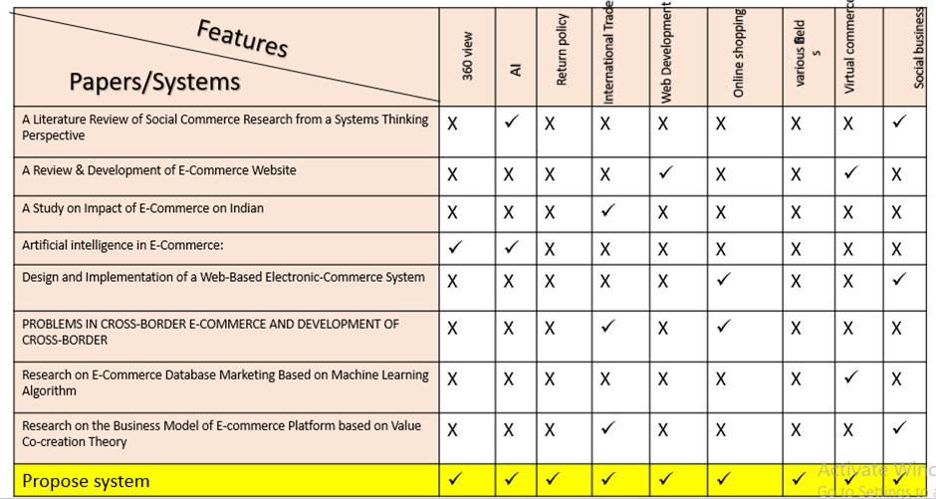

5. EXISTING SYSTEM:
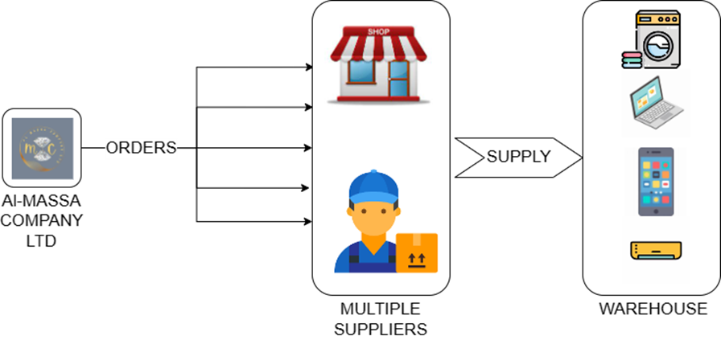
FIG.2. EXISTING SYSTEM ARCHIECTURE
In Al-Massa Company the customer initiates the purchasing process, which then moves through the pertinent divisions of the business. The personnel sort the purchases before delivering them to the delivery department.
This technique wastes a lot of time and requires excessive daily or irregular financial outlays. Another problem with this is that there are no records of sales or of the products that were supplied to the supplier and how many of those things were sold by that supplier. They lack a tracking system that would allow them to monitor the status of orders that are supplied to various providers. They are deficient in terms of both finding records and creating bills.

6. PROPOSED SYSTEM:
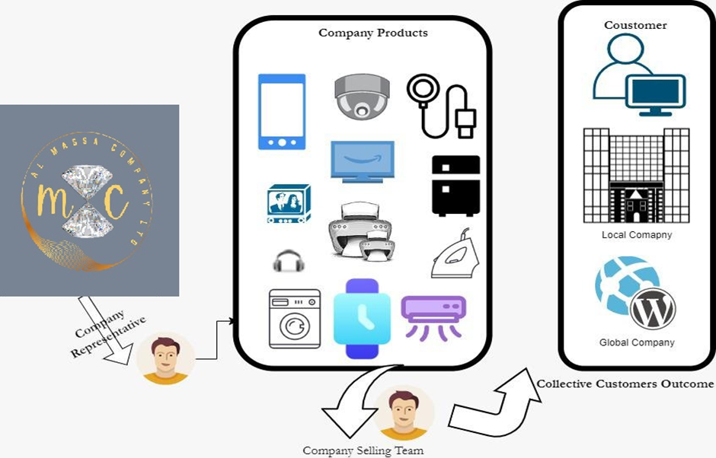

FIG.3. PROPOSED SYSTEM

Our proposed system is to overcome existing system problems and deliver a great solution which helps Al-Massa Company Ltd. Store by touching all the corners of the customers’ needs aspects. We are providing an e-commerce website which connect customers or users directly to the store (Al-Massa Company Ltd.) and they can directly contact, visit the store using the proposed system. There are 2 modules present in the Proposed System: -
1) Admin Module: - The business owner has full access to the website through this panel (admin) and can conduct CRUD operations on it. It has the power to limit users' access. Prior to adding the individual products, the admin can first establish the categories for the products that will appear in the user panel. The product data include the name, category, price, description, and promotion, among other information. Administrators can check sales reports for the products they offer on a daily, monthly, or annual basis.
2) Users Module: - The user of this module can access all the product categories and the products included in each category. Customers and users can see product descriptions, compare prices, and choose the best products for their needs. Once the chosen item is visible in the shopping cart, the buyer can place an order and receive information about it once the payment has been made. Through e-commerce, clients can select any good or service they desire from any vendor, anywhere in the globe. Customers can use it to research products, contrast features and costs, and determine whether a purchase is worthwhile. One of the main advantages of this technique is time savings. Customers can shop whenever they want and get anything they need online.

Conclusion & Future Scope
In the modern era, websites are regarded as one of the most powerful marketing tools utilized by marketers and major corporations around. Additionally, the website offers a wider reach both within and outside of the area and more marketing possibilities. due to the fact that it is not limited to a certain region. The target audience will find you no matter where you go as long as you offer your services well.
The following points will show you the importance of designing a website for your company
• More imaginative and less expensive than reality
• Promoting your goods and guaranteeing their widespread use
• Constant presence; • The ability to present in multiple languages;
• A far larger target audience segment, or group of customers, than is possible.
Ecommerce web development is a tool that you can use to increase the success of your company. It can assist you in building a website that produces leads, boosts traffic, and boosts sales and money for your company. Al-Masa Company aims to create a website that meets the needs of every individual user so that the customer's objective is perfectly and easily attained.

References
1. Xintian Wang, Hai Wang and Caiming Zhang: “A Literature Review of Social Commerce Research from a Systems Thinking Perspective” MDPI. 24 April 2022.
2. Sachin Saurabh: “Amazon E-Commerce Website” International Journal for Research in Applied Science & Engineering Technology (IJRASET). June 2022.
3. Richard Fedorko: “Artificial Intelligence in E-commerce.” ResearchGate. July 2022
4. Safiye Gizem SAYDAM, Mustafa Emre CİVELEK: “PROBLEMS IN CROSS-BORDER E-COMMERCE AND DEVELOPMENT OF CROSS-BORDER E-COMMERCE PERFORMANCE SCALE” Journal of International Trade, Logistics and Law, 1, 2022.
5. 1Dr. Rajeshwari. R.R, 2Dr. Leela M. H: “A Study on Impact of E-Commerce on Indian Economy – Government Initiatives, Opportunities and Challenges”
6. Hongqi Ang Yue*: “Research on E-Commerce Data Standard System in the Era of Digital Economy from the Perspective of Organizational Psychology”: Frontiers in Psychology
7. Nie Chen: “Research on E-Commerce Database Marketing Based on Machine Learning Algorithm”: Hindawi, 29 June 2022
8. Hou Yan: “Research on the Business Model of E-commerce Platform based on Value Co-creation Theory”, ResearchGate, March 2016
9. Upendra Singh1,4, Anant Saraswat1,4,: “Towards improving e‐commerce customer review analysis for sentiment detection”, scientific reports, 2022
10. Mrunal Munot, Bhavna Khivsara: “A REVIEW PAPER ON E-COMMERCE WEBSITE FOR SECOND-HAND BOOKS” International Research Journal of Modernization in Engineering Technology and Science, 03-March-2022
11. Amandeep1, Ashwini Verma2: “A Review & Development of E-Commerce Website”, International Research Journal of Engineering and Technology (IRJET),

