Design and Development of Deep Learning Based Technique for Image Denoising

Ms. Pranita S. Jadhav¹, Dr. Mrs. M. M. Pawar², Dr. Mrs. S. P. Pawar³
¹ Mtech Student, SVERI’s College of Engineering, Pandharpur
² Professor, SVERI’s College of Engineering, Pandharpur
³ Professor, SVERI’s College of Engineering, Pandharpur
---------------------------------------------------------------------***---------------------------------------------------------------------
Abstract - The effectiveness of generative adversarial networks (GANs) and deep convolutional neural networks (DCNNs) in image denoising, but they face serious trade-offs not only between noise and artifact removal, but also in preserving details of the problem. In this study, to address these serious image denoising problems, a Hierarchical Generative Adversarial Network that we suggest (HI-GAN) with a.Three generators are present in the proposed HI-GAN. The issue of losing high-frequency elements like edges and texturing is addressed by the first generator. The generator is skilled at retaining crucial information. The second generator focuses on retrieving low-frequency characteristics from noisy images and mitigating the consequences of instabilities brought on by the discriminator. Both of the two generators perform equally well when it comes to denoising, although using different evaluation criteria. The performance of the rebuild is then enhanced by the addition of a third generator to assist them cooperate more successfully.

Key Words: Convolutional and deconvolutional neural networks, deep learning, generative adversarial networks, image denoising.

1.INTRODUCTION

Digital images play a very important role in many aspects of our daily life, such as satellite TV, intelligent traffic monitoring, signature verification, handwriting recognition on checks, and other scientific and technological fields, such as geographic information channels and other information on images Factors are inevitably affected by noise in the process of acquisition, compression and transmission, resulting in distortion and loss of image data[4]. Image denoising has affected almost all technical fields, and plays an important role in many fields such as transmission and coding, microscopic imaging, forensics, image restoration, visual tracking, image registration, image segmentation, and image classification. For robust performance it is essential to preserve the content of the original image[3]. Image denoising is a classic technique that aims to remove as much noise as possible from the original image and restore image details. It is difficult to distinguish noise, edge, and texture during image denoising, because they are high-frequency components, and some details in the denoised image may be lost. The main purpose of image denoising is to estimate the original image from a noise-contaminated version of the image by removing or suppressing the noise[21]. Image denoising is a representative low-level vision task that recovers clear images from noisy ones. Many types of noise can be generated in an image, but it can be assumed that the noise caused by low light or high temperature problems encountered during the image acquisition step follows a Gaussian distribution noisy image to recover the real image. In general, recovering meaningful information from noisy images to obtain high-quality images during noise removal is an important problem nowadays[16]. Compared with traditional DCNNs, GAN-based methods can capture more texture details, but they also produce more edge and texture artifacts in some local regions of the image, and have relatively low PSNR. Overcoming the shortcomings of GAN-based methods is extremely important in practical applications, especially in medical imaging and fluorescence microscopy images, where PSNR is the most important criterion for evaluating reconstruction performance. In this study, we hope to develop a denoising method that can simultaneously achieve high-accuracy and high-quality perception. We propose three strategies to address these issues. Our first strategy is to develop an efficient adversarial loss function to improve discriminator stability, since unstable discriminators often lead to mode collapse. The method demonstrate that traditional discriminators completely ignore the prior knowledge that half of the training samples are fake. Therefore, while the discriminator can easily achieve perfect classification between real and fake training samples, it classifies most samples (including real and fake samples) as real. This is because the generator tricks the discriminator into believing that fake samples are real samples. Therefore, although the generator outputs fake images containing ghost artifacts, these images still belong to the category of real images. These images have high perceptual quality, but cannot achieve low MSE due to unrealistic artifacts. To stabilize the discriminator, we also propose a second strategy aimed at developing a new augmentation algorithm for training multiple generators. This is inspired by the fact that multi-generator based GANs avoid the mode collapse problem better than single generator based GANs. We propose Hierarchical Generative Adversarial Networks, HI-GAN. Empirically, the proposed HI-GAN can be efficiently trained by combining all the advantages of its generator while avoiding their disadvantages. In our third strategy to improve the effectiveness of HI-GAN generators, we propose a novel deep learning-based architecture, the Enhanced Residual Dense UNet (B-DenseUNet) developed for ensembles of HIGAN generators with Advantages of: Residual Dense Blocks (RDB) and UNets this allows maximum information flow through all convolutional layers in the network[22].The main objectives of this study are as follows:
- Examine existing methods and find out the limitations of image denoising.
- Design and develop a novel neural convolutional network for image noise reduction.
- Test various performance indicators of the proposed system, such as accuracy, precision, PSNR (peak signal-to-noise ratio) and so on.
- Calculate the original image by erasing noise from a version of the image that has noise in it.

2. RELATED WORK

- Deep Neural Networks for Image Denoising
There have been several attempts to tackle the denoising problem with deep neural networks. In Jain and Seung proposed the use of convolutional neural networks (CNNs) for image denoising and claimed that CNNs have similar or even better rendering performance than MRF models. In a multi-layer perceptron (MLP) was successfully used for image denoising. In a stacked sparse denoising autoencoder approach is employed to handle Gaussian noise removal and yields comparable results to K-SVD. In a trainable nonlinear reaction-diffusion model (TNRD) is proposed, which can be represented as a feed-forward deep network by unrolling a fixed number of gradient descent inference steps. Among the above deep neural network based methods, MLP and TNRD can achieve promising performance and compete with BM3D[16].

- Residual Learning
Residual learning for CNNs was originally proposed to address the problem of performance degradation, i.e. even training accuracy starts to drop as the depth of the network increases. Residual networks explicitly learn residual maps for some stacked layers, assuming that residual maps are easier to learn than the original unreferenced maps. With this residual learning strategy, extremely deep CNNs can be easily trained and the accuracy of image classification and object recognition can be improved [16].

- GAN
With the generative and adversarial network (GAN) proposed by Goodfellow et al. A lot of related work was carried out in 2016. Some researchers have performed image style transfer studies, such as the one by B. Bair et al. Proposed CycleGAN. They think it is an image-to-image translation problem. Orest Kupyn et al. DeblurGAN was proposed to remove blind motion [8]. Among them, the author designed a GAN-based deep residual network and proposed a loss function for network training. In their training results, due to the well-designed loss function, not only the resolution of the image is improved, but also the content and color of the original image are improved, and many details are preserved[23].

3. LITERATURE SURVEY

Songhyun Yu et al. [1] proposed For image denoising, a deep iterative down-up convolutional neural network (DIDN) is used, which iteratively lowers and raises the resolution of feature maps. Here, they suggest a deep learning frame denoising algorithm. U-Net was updated for picture denoising and utilised as the fundamental module. They create a network topology that repeatedly down- and up-samples deep feature maps by arranging the modules. They successfully created a single model to address multi-level and real-world noise. capable of handling 5 to 50 levels of Gaussian noise.
Zhang Xin et al. [2] proposed a deep image denoising and enhancement framework using optical folding networks. The network consists of three layers for picture reconstruction, missing data completeness, and high-dimensional projection. It is a lightweight two-unit CNN-based network made up of a convolutional layer, a max-pooling layer, and a ReLU layer, with the convolutional layer acting as the final unit. Training data preprocessing and enrichment effectively improves performance.
Liu Zhe et al. [3] Image denoising using CNN model in deep learning. In this study, they develop and apply a linear CNN-based denoising technique. According to their experimental findings, the suggested CNN model can greatly enhance the efficiency of conventional image filtering techniques by effectively removing Gaussian noise. They briefly introduce linear CNN-based picture denoising techniques. Conventional image filters can perform much better when using linear CNN models. In this piece, salt and pepper noise and Gaussian noise are discussed.
Shreyasi Ghose et al. [4] Deep learning currently uses convolutional neural network (CNN) models for picture denoising. They injected 1% to 10% white Gaussian noise to the image in order to denoise it, and then they used a CNN model to do it. Additionally, run a qualitative analysis on photos with no noise. Taking into account edge characteristics, texture, uniform and non-uniform regions, smoothness, and object structure, image quality declines under qualitative examination. The outcomes of CNN-based methods were compared with conventional or standard methods for picture denoising using three metrics: PSNR (Peak Signal-to-Noise Ratio), SSIM (Structural Similarity Index Measure), and MSE (Mean Squared Error).
Admola E. et al. [5] conducted a thorough investigation into the different CNN methods for picture denoising. Different CNN image denoising techniques are categorised and examined. examined well-known datasets to assess CNN image denoising techniques. They introduced datasets including the Berkeley Segmentation Dataset (BSD), the Waterloo Exploration Database, the EMNIST, the COCO dataset, the MIT-Adobe fvek, the ImageNet, the BSD68, the Set 14, the Renoir, the NC12, the NAM, the SIDD, the SUN397, the Set5, the CAVE, etc. LIVE1, Chelsea, the DIV2K dataset, and the Harvard database are some examples.
Wuttipong Kumwilaisak et al. [6] developed a novel technique for picture denoising based on multi-directional long short-term memory networks and deep convolutional neural networks to get rid of Poisson noise. Convolutional neural network (CNN) layers in several directions and multi-directional long short-term memory (LSTM) layers make up the architecture of the suggested network. According to our tests, the suggested picture denoising algorithm performs better than other algorithms in terms of both subjective quality and objective quality. Under various hyperparameter settings, the denoising outcomes of DCNN in the Poisson noise environment produce results that are almost ideal, such as: B. A number of CNN layers.
Gu Shuhang and others. [7]self-guided neural network (SGN) was suggested for quick picture denoising. Images are denoised from top to bottom by SGN using a self-routing technique. The process of extracting finer-scale features is then driven by SGN, which first extracts low-resolution spatial features. To help with the estimation of the output image, multi-scale contextual information is gradually brought back to the full-resolution branch. The suggested SGN is evaluated using industry-recognized benchmarks for grayscale and colour picture denoising.
Li Huiming et al. [8] suggested an algorithm for the image denoising task specified by this model, and shown that we are able to outperform the most recent state-of-the-art image denoising techniques by training on a large image database. They have demonstrated that they can outperform the most cutting-edge picture denoising techniques by training on massive image databases.
Harold C. Burger et al. [9] attempted to directly learn the mapping using an easy-to-use multi-layer perceptron (MLP) on image patches. Despite having done this before, they will demonstrate that by practising on big image databases, they are capable of competing with the most cutting-edge image denoising techniques right now.
Dingsha Babu and others. [10] offered a variety of techniques to reduce noise in damaged photos and restore clear, high-quality images. Numerous CNN- and non-CNN-related denoising techniques can deliver high-quality results quickly. But when compared to the currently prominent non-CNN methods, several CNN-related denoising techniques produce exceptional results. CNN Network's strong modelling skills enable it to effectively denoise photos. Some of the methods utilised in CNN networks to enhance noise reduction performance include BN, ReLU, and residual learning. These methods aid in accelerating the network's training phase and the overall procedure.
Forest Agostinelli et al. [11] introduced adaptive multi-column SSDA, a novel technique for combining multiple SSDA by adaptively predicting optimal column weights. They show that AMC-SSDA can perform robust denoising on images corrupted by several different types of noise without knowing the type of noise at test time.
Tian Chunwei et al. [12] For picture denoising, compare and analyse deep networks. They begin by displaying a fundamental deep learning framework for picture denoising. The authors go on to discuss deep learning methods for noisy tasks, such as additive white noise images, blind denoising, genuine noisy photos, and mixed noisy images.
Xie Junyuan et al. [13] a novel method for blind inpainting and picture denoising that combines sparse coding with deep neural networks that have already been trained with denoising autoencoders. They suggest a brand-new DA training programme that enables image colorization and denoising inside a unified framework.
Alexander Krull et al. [14] NOISE2VOID, a cutting-edge training method that trains a denoising CNN with just one noise acquisition, has been suggested. Through the use of imaging techniques like photography, fluorescence microscopy, and cryo-transmission electron microscopy, they have shown how N2V may be applied to a variety of imaging modalities.
Triumph Weir et al. [15] To address the challenge of denoising in very low light, a physics-based noise generation model and a noise parameter calibration approach were presented. They demonstrate that convolutional neural networks can compete with and occasionally exceed networks trained on matched actual data by solely using their synthetic data for training.
Zhang Kai as well as others. [16] applied residual learning to distinguish noise from noisy observations and presented a deep convolutional neural network for picture denoising. To speed up training and enhance denoising performance, batch normalisation and residual learning are combined.
Fan Linwei et al. [17] highlighted new developments in several picture denoising techniques and examined the benefits and drawbacks of each. Recent developments in image denoising techniques, such as sparse representations, low-rank, and CNN-based (more particularly, deep learning) denoising approaches, have been made possible by the replacement of conventional local denoising models with NLMs.
Yue Wensun et al. [18] To reduce statistical noise in digital radiological images, the DNGAN end-to-end deep learning algorithm has been developed. A perceptual function made up of MSE loss, adversarial loss, nonsense loss, and total variation loss serves as the foundation for DNGAN. One of these involves learning an adversarial loss from an adversarial generative network, which makes the resulting images more perceptually appealing. On a training dataset collected from an actual X-ray imaging equipment, they trained and assessed the suggested approach.
Iza Sazanita Isa et al. [19] examined the effectiveness of three distinct filtering techniques while using MRI pictures with varying amounts of noise. The median filter is the most effective technique when compared to other filters that are mostly employed for Gaussian noise reduction. The findings of this study demonstrate that for denoising MRI pictures, the median filter offers favourable outcomes with better PSNR values. Previous related research that used various imaging modalities to test the results have likewise validated this finding.
Zhang Kai and others. [20] FFD-Net, a new CNN model, was presented for quick, effective, and adaptable discriminative denoising. This is accomplished using a variety of methods, including input denoising in space using downscaled sub-images and input denoising utilising noise maps in network design and training.

4. PROPOSED METHOD

The proposed HI-GAN is made up of the Gb;Ga, Da discriminator, and Gc gain network. Gb and Ga are both image denoising DCNN generators. Additionally, Ga and Da received training together to enhance Ga's capacity for denoise and detail preservation in distorted images. Ga's advantage comes from its capacity to address the issue of missing high-frequency features like edges and textures by persistently engaging in recurrent zero-sum games with Da. Gb, on the other hand, is trained independently and is not in competition with any network. Gb's technique is to ignore the discriminator's influence on instability and concentrate solely on denoising.
In general, Gb and Ga use distinct methods and criteria to assess the effectiveness of rebuilding, and neither is superior to the other.The modified RDB contains an additional RELU layer. In the RDB block, we added a RELU layer followed by a convolution to obtain an improved output. A major benefit is the reduced chance of vanishing gradients. The constant gradient of ReLU leads to faster learning. The ReLU activation function is differentiable at all points except zero. For values ​​greater than zero we only consider the maximum value of the function. This can be written as:
f(x) = maximum {0,z​​}

Fig-1: Block Diagram of Model
1. Input image:
In this project, we first take a noisy image as an input image. These input images contain noise. It passes these images to a deep learning model.
2. CNN/GAN:
All images specified by the input will be retrieved. It is then processed to obtain a denoised image of the corresponding input image. It is nothing more than a deep learning model.
The first stage in building a GAN is to decide what the end output of the noisy image should be, and then to gather an initial training dataset based on these parameters. This data is then randomised and fed into the generator until it achieves a fundamental level of precision for output.
3. Output image:
After being processed by the deep learning architecture, the processed image is then passed to the output section. This image is provided as a denoised version of the corresponding noisy image.

5. MODEL ARCHITECTURE
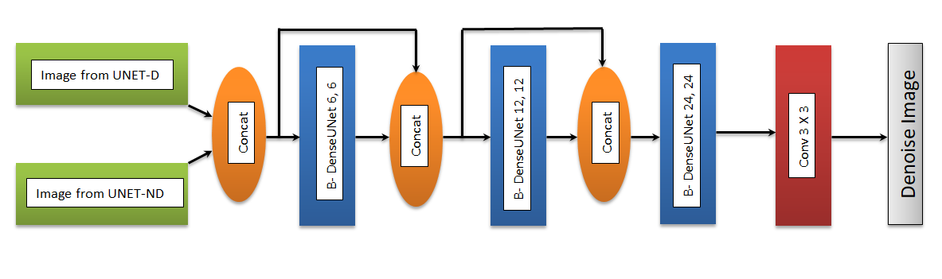
Fig-2: Block Diagram of G_{c}
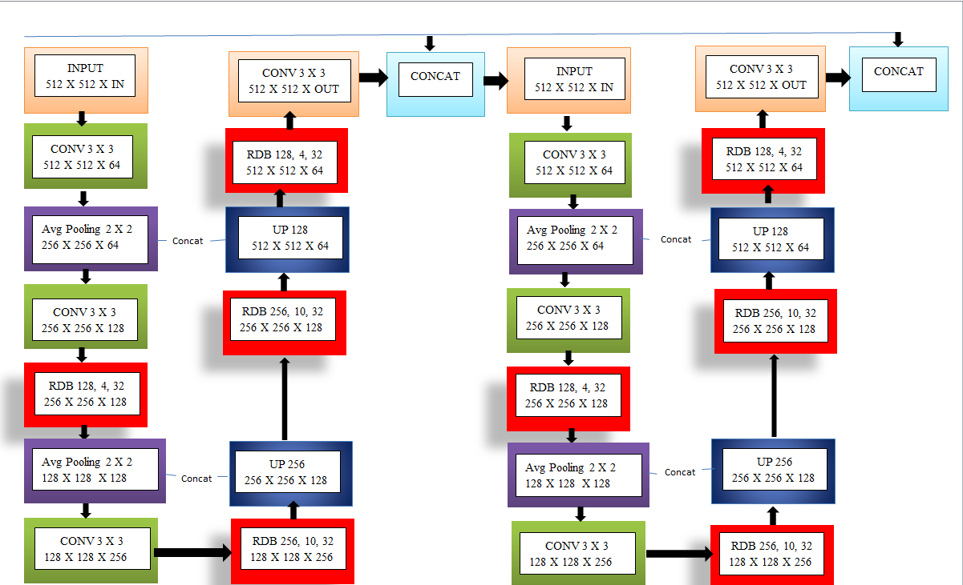
Fig-3: Block diagram of B-DenseUNet used in the generators including Ga ; Gb and Gc
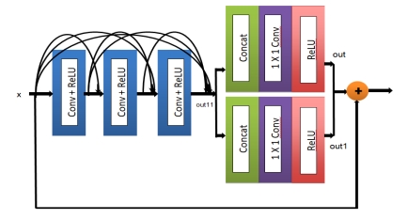
Fig-4: Residual Dense Block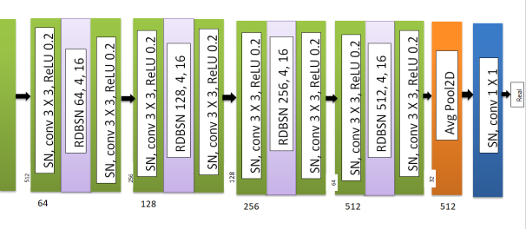Fig-5: Block Diagram
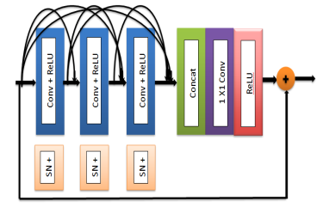 Fig- 6: Residual Dense Block with Spectral Normalization

6. EVALUATES

We will introduce the implementation procedure and the specifics of the experiments in this section, including the specifics of the datasets and the assessment measures.

Dataset
We use SIDD [1] and FFHQ datasets in this study. The SIDD dataset contains 320 natural images. The FFHQ dataset consists of 52,000 high-quality PNG images with a resolution of 512×512, showing significant variance in age, race, and image background. Randomly cropped training patches of size 512 × 512 are obtained from randomly selected images in these datasets. Noise and ground truth patch pairs are generated by the noise model in for synthesizing real noise. The free source Pytorch machine learning library is used to train our model [34]. We use an Nvidia GTX 1080 Ti graphics card to test our methodology.

Evaluation metrics

Peak signal to noise ratio (PSNR)
This metric calculates the inaccuracy between comparable pixels to assess the visual quality of images, and it has been demonstrated to be connected with mean the opinion resultant scores average provided opinion by score human experts. It is nothing more than an MSE feature. The distortion value of an image after steganography is affected by the size of the values value.
Structural similarity index (SSIM)
This metric evaluates the brightness, contrast, and structural quality of steganographic images. The degree of similarity between the image before and after steganography increases with increasing SSIM values.

Testing Datasets

We employed the DND[25], SIDD[24], and NAM[26] databases to compare the suggested method's accuracy to that of its rivals. The primary purpose of the DND dataset is to assess PSNR and SSIM on real-world photos. Based on an online submission mechanism, competing approaches' performance is evaluated. 50 pairs of real noise images and ground truth images make up the dataset. PSNR and SSIM of natural images taken by smartphone cameras are evaluated using SIDD. This dataset comprises of numerous pairs of photos that were taken in related scenes with various lighting setups. The performance ratings for the SIDD dataset are based on an online submission method, just like the DND dataset. 11 test images from the NAM dataset are used by us to assess and contrast the reconstruction capabilities.

7. RESULTS

SIDD
Noisy Image | HI-GAN Denoised Image | Denoised Image by Our Method | Clean Image
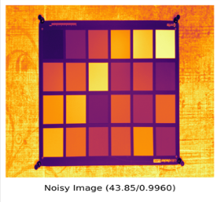 | 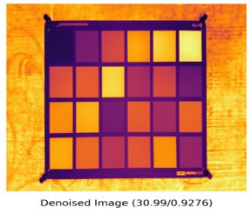 | 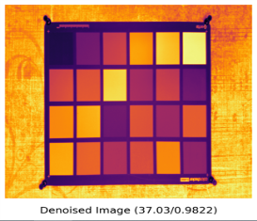 | 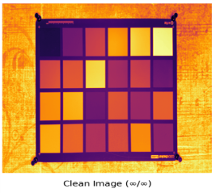
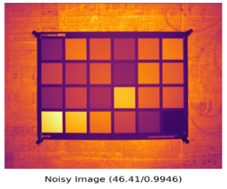 | 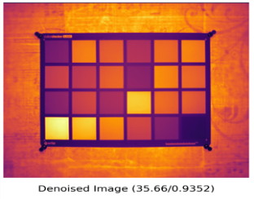 | 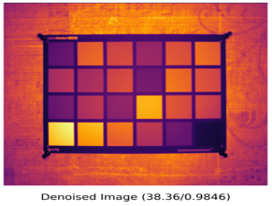 | 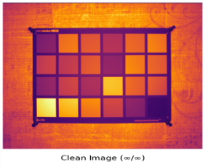
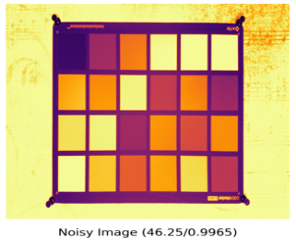 | 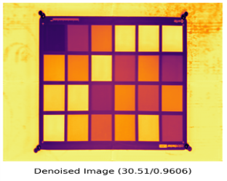 | 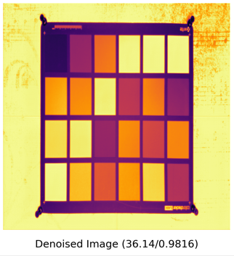 | 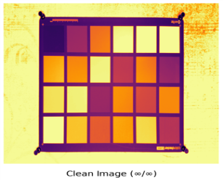
Fig-7: Residual Dense Block with Spectral Normalization

DND
Noisy Image | HI-GAN Denoised Image | Denoised Image by Our Method | Clean Image
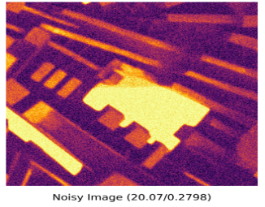 | 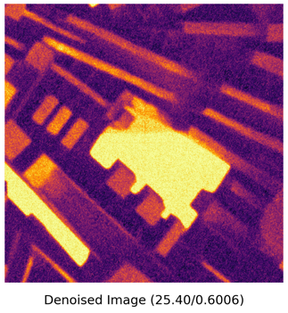 | 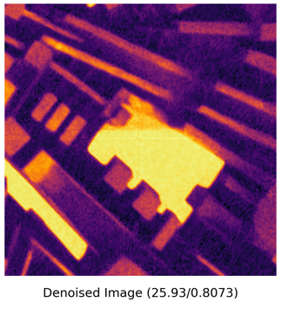 | 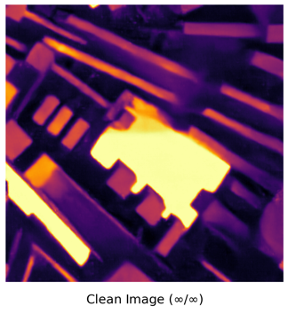
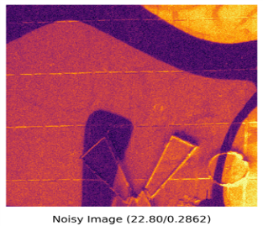 | 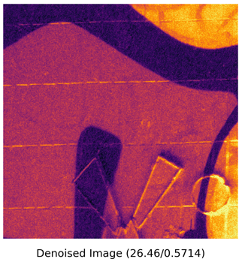 | 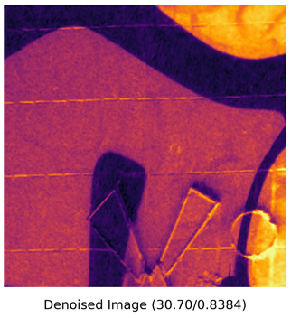 | 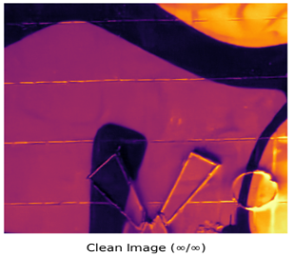
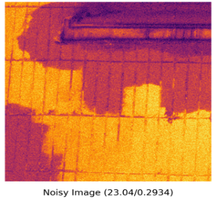 | 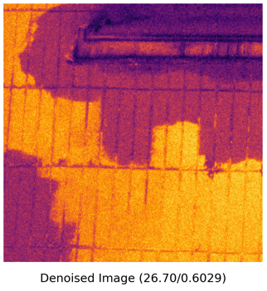 | 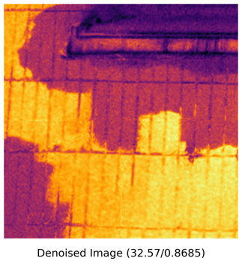 | 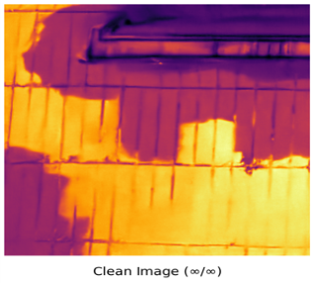
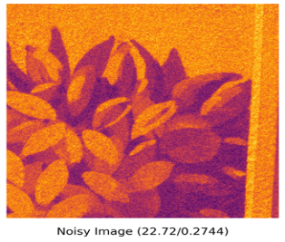 | 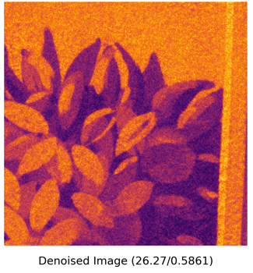 | 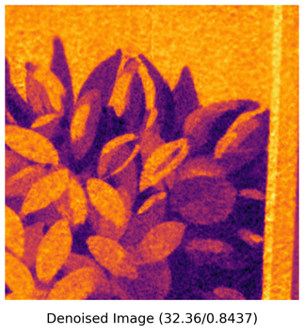 | 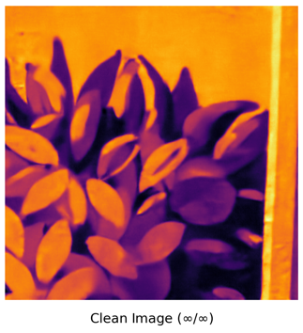
Fig-8: Residual Dense Block with Spectral Normalization

FFHQ
Noisy Image | HI-GAN Denoised Image | Denoised Image by Our Method | Clean Image
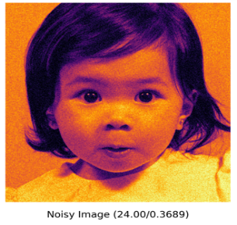 | 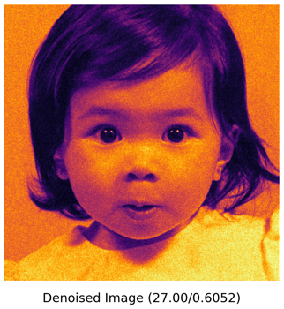 | 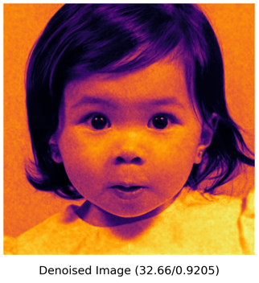 | 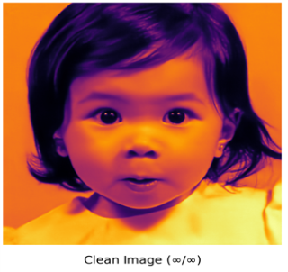
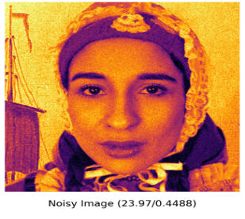 | 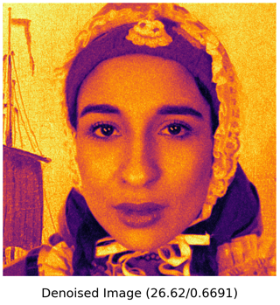 | 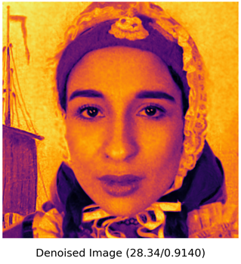 | 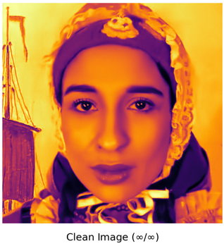
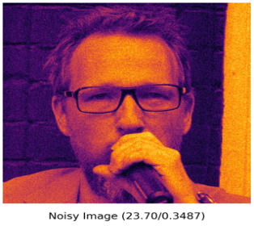 | 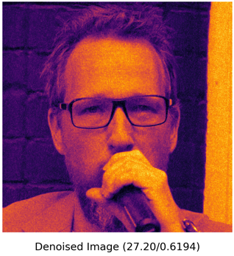 | 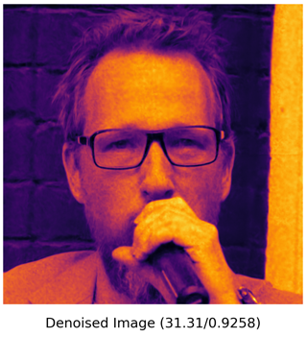 | 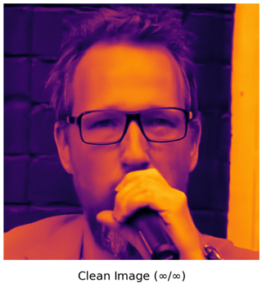
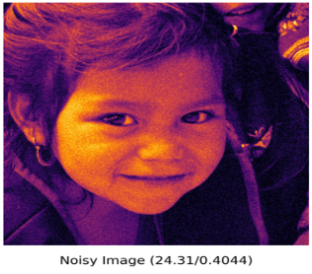 | 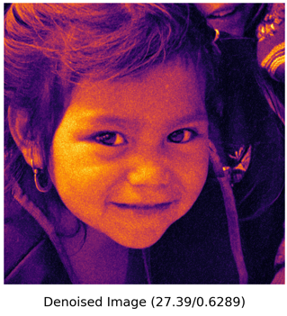 | 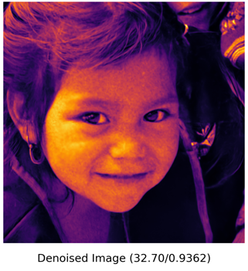 | 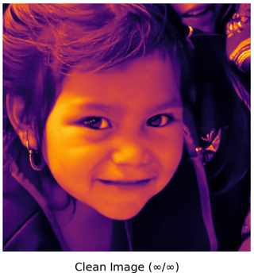
Fig-9: Residual Dense Block with Spectral Normalization

NAM
Noisy Image | HI-GAN Denoised Image | Denoised Image by Our Method | Clean Image
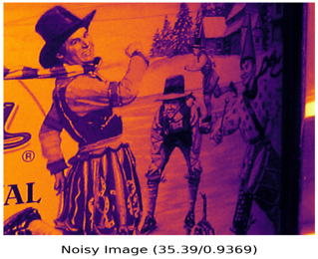 | 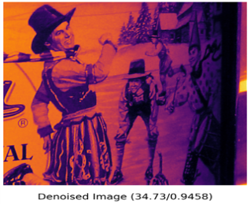 | 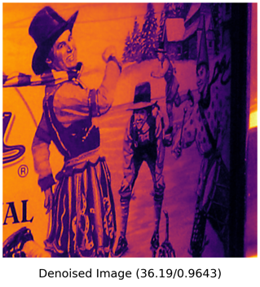 | 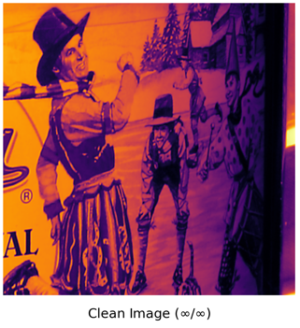
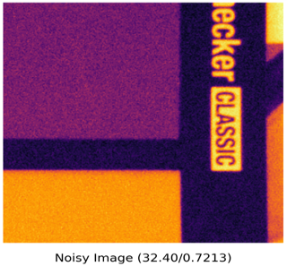 | 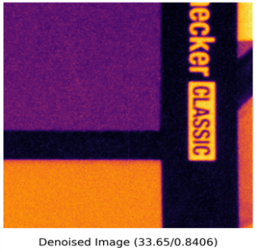 | 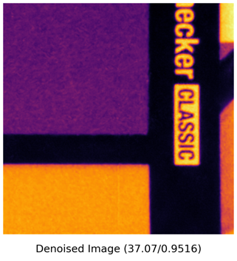 | 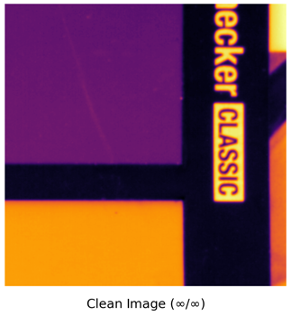
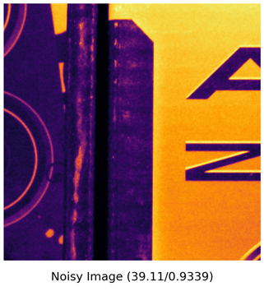 | 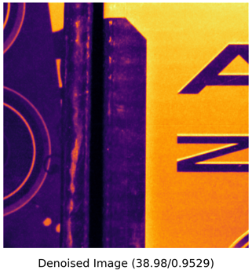 | 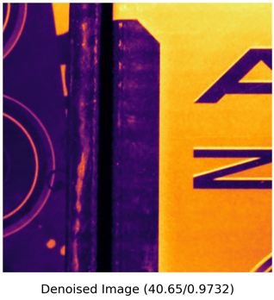 | 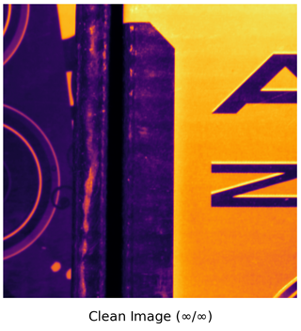
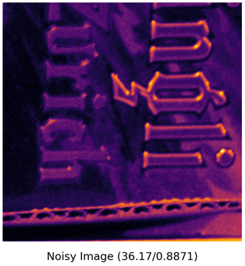 | 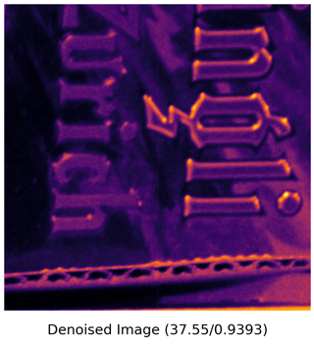 | 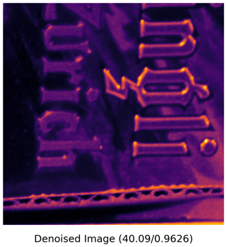 | 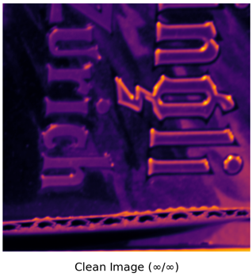
Fig-10: Residual Dense Block with Spectral Normalization

The results of HIGAN and our model is shown in tabular form –
Table-1:Result of HIGAN and Our Model
Dataset | HIGAN | Our Model
SIDD | 32.756/0.936 | 37.418/0.9824
FFHQ | 27.06/0.6377 | 31.158/0.925
DND | 26.1/0.5707 | 31.286/0.8452
NAM | 36.528/0.9244 | 38.522/0.9654

8. CONCLUSIONS

An enhanced HIGAN model for picture denoising is put forth in this research, and it achieves good perceptual quality in terms of both general content and specific features. When it comes to single frame denoising, the trained model performs amazingly. The model can maintain key features without losing perceptible details thanks to the modified loss function. Our model can handle photos with stronger texture and brightness, according to tests on the datasets SIDD, FFHQ, DND, and NAM.
ACKNOWLEDGEMENT

Instead of computing efficiency, this effort focuses on the perceptual quality of super-resolution photographs. We also want to lengthen the model's runtime so that real-time computer vision applications can use it. Additionally, our work only covers the suggested models for image SR and denoising individually at this time. However, we frequently have to cope with noisy low-resolution photos for practical purposes. The two picture processing techniques of traditional interpolation and noise reduction clash. Further investigation on the impact of combined SR and denoising on damaged photos may therefore be highly motivating.

REFERENCES

[1] Yu, Songhyun, Bumjun Park, Jechang Jeong. “Deep iterative down-up cnn image bdenoising.” Proceedings of the IEEE/CVF Conference on Computer Vision and Pattern Recognition Workshops. 2019.
[2] Zhang, Xin, Ruiyuan Wu. “Fast depth image denoising and enhacement using a deep convolutional network.” IEEE International Conference on Acoustics Speech and Signal Processing(ICASSP). 2016.
[3] Liu, Zhe, Wei Qi Yan, Mee Loong Yang. “Image denoising based on a CNN model.” 4th International Conference on Control Automation and Robotics(ICCAR). 2018.
[4] Ghose, Shreyasi, Nishi Singh, Prabhishek Singh. “Image denoising using deep learning: Convolutional neural network.” 10th International Conference on Cloud Computing, Data Science & Engineering (Confluence). 2020.
[5] Ilesanmi, Ademola E., Taiwo O. Ilesanmi. “Methods for image denoising using convolutional neural network: a review.” Complex & Intelligent Systems. 2021.
[6] Kumwilaisak, Wuttipong. “Image denoising with deep convolutional neural and multi-directional long short-term memory networks under Poisson noise environments.” IEEE Access 8. 2020.
[7] Gu, Shuhang, et al. “Self-guided network for fast image denoising.” Proceedings of the IEEE/CVF International Conference on Computer Vision. 2019.
[8] Li, HuiMing. "Deep learning for image denoising." International Journal of Signal Processing, Image Processing and Pattern Recognition. 2014.
[9] Burger, Harold C., Christian J. Schuler, Stefan Harmeling. "Image denoising: Can plain neural networks compete with BM3D?." IEEE conference on computer vision and pattern recognition. 2012.
[10] Babu, Dinsha, Sajeev K Jose. "Review on CNN Based Image Denoising." Review on CNN Based Image Denoising. 2020.
[11] Agostinelli, Forest, Michael R. Anderson, Honglak Lee. "Adaptive multi-column deep neural networks with application to robust image denoising." Advances in neural information processing systems. 2013.
[12] Tian, Chunwei. "Deep learning on image denoising: An overview." Neural Networks. 2020.
[13] Xie, Junyuan, Linli Xu, Enhong Chen. "Image denoising and inpainting with deep neural networks." Advances in neural information processing systems. 2012.
[14] Krull, Alexander, Tim-Oliver Buchholz, Florian Jug. "Noise2void-learning denoising from single noisy images." Proceedings of the IEEE/CVF Conference on Computer Vision and Pattern Recognition. 2019.
[15] Wei, Kaixuan. "A physics-based noise formation model for extreme low-light raw denoising." Proceedings of the IEEE/CVF Conference on Computer Vision and Pattern Recognition. 2020.
[16] Zhang, Kai. "Beyond a gaussian denoiser: Residual learning of deep cnn for image denoising." IEEE transactions on image processing. 2017.
[17] Fan, Linwei. "Brief review of image denoising techniques." Visual Computing for Industry, Biomedicine, and Art. 2019.
[18] Sun, Yuewen. "Digital radiography image denoising using a generative adversarial network." Journal of X-ray Science and Technology. 2018.
[19] Isa, Iza Sazanita. "Evaluating denoising performances of fundamental filters for T2-weighted MRI images." Procedia Computer Science 60. 2015.
[20] Zhang, Kai, Wangmeng Zuo, and Lei Zhang. "FFDNet: Toward a fast and flexible solution for CNN-based image denoising." IEEE Transactions on Image Processing. 2018.
[21] Chunwei Tian, et al. "Image denoising using deep CNN with batch renormalization." Proceedings of the IEEE/CVF Conference on Computer Vision and Pattern Recognition. 2019.
[22] Duc My Vo, Duc Manh Nguyen, Thao Phuong Le, Sang-Woong Lee. " HI-GAN: A hierarchical generative adversarial network for blind denoising of real photographs." Proceedings of the IEEE/CVF Conference on Computer Vision and Pattern Recognition Workshops. 2021.
[23] Peizhu Gong, Jin Liu, Shiqi Lv. "Image Denoising with GAN Based Model." Journal of Information Hiding and Privacy Protection. 2020.
[24] A.Abdelhamed S. Lin, M. S. Brown. " A high-quality denoising dataset for smart phone cameras." IEEE Computer Vision and Pattern Recognition(CVPR). 2018.
[25] T. Plotz, S. Roth. "Benchmarking denoising algorithms with real photographs." IEEE Computer Vision and Pattern Recognition(CVPR). 2017.
[26] S. Nam, Y. Hwang, Y. Matsushita, S. J. Kim. "A holistic approach to cross-channel image modelling and its application to image denoising." IEEE Computer Vision and Pattern Recognition(CVPR). 2016.

