DIGITAL WEATHER MONITORING AND FORECASTING WITH DATA STORAGE
Pranita Bhamare¹, Ankit Anand², Varun Sharma³, Prof. S.G. Madhikar⁴
¹Student, Dept. of ENTC Engineering, Sinhgad College of Engineering, Pune
²Student, Dept. of ENTC Engineering, Sinhgad College of Engineering, Pune
³ Student, Dept. of ENTC Engineering, Sinhgad College of Engineering, Pune
⁴ Assistant Professor, Dept. of ENTC Engineering, Sinhgad College of Engineering, Pune

---------------------------------------------------------------------***---------------------------------------------------------------------
Abstract – “Digital Weather Forecasting on LCD display with Data Storage Capabilities" presents the design of weather monitoring and forecasting system. In recent years, the need for accurate weather monitoring systems has become paramount due to the increasing frequency and intensity of climate-related events. The system is designed to provide real-time weather data collection, analysis, and forecasting, while also enabling seamless integration with ThingSpeak, a cloud-based IoT analytics platform. By harnessing the power of these components and the connectivity offered by the integrated Wi-Fi module, the system establishes a robust data transmission channel to the ThingSpeak server, opening up a wide range of applications in weather forecasting and beyond.

Key Words: Weather monitoring, forecasting, rain sensor, Temperature sensor, Humidity sensor, gas sensor, ThingSpeak server, Data storage.

- INTRODUCTION

Farmers and gardeners are well aware of the vital role that weather monitoring plays in ensuring successful crop yields. Weather monitoring systems offer valuable insights into environmental conditions, enabling informed decision-making. This research aims to develop an innovative weather monitoring system that integrates key components, including the DHT11 temperature and humidity sensor, MQ135 gas sensor, rain sensors, and Arduino Nano microcontroller. The primary objective of this system is to wirelessly collect and transmit accurate weather data to the ThingSpeak server, serving as a centralized platform for data storage, analysis, and diverse applications.
The availability of precise data empowers farmers by facilitating optimized irrigation schedules, determining appropriate soil amendments, and identifying optimal planting periods. Additionally, the system enables the measurement of soil temperature, rainfall levels, pH, and UV intensity, providing comprehensive environmental insights. While local weather forecasts offer general predictions, the real-time data provided by this weather station system ensures enhanced accuracy and immediate information for effective decision-making. This becomes particularly crucial for individuals residing in coastal areas, where timely alerts about impending storms and environmental events can prevent loss of life and property. Moreover, considering the potential risks associated with excessive UV exposure, the weather station system serves as a valuable tool by alerting users to heat waves and other weather-related emergencies. By monitoring weather conditions, including heavy rainfall, the system contributes to the prevention of injuries, infections, and fatalities caused by flooding and associated hazards.

  - METHODS AND TOOLS USED

The weather monitoring and forecasting system project incorporates a diverse range of methods and tools to efficiently collect and analyze weather data. Leveraging the Node MCU ESP01 family Wi-Fi module, the system establishes a seamless wireless connection, enabling the secure transmission of gathered weather data to the ThingSpeak server for further analysis and storage. Ensuring consistent and reliable operation, a robust transformer power supply is implemented to provide the necessary electrical power to all system components. Within the system, various sensors play crucial roles, such as the MQ135 gas sensor, which adeptly detects and precisely measures air quality variations, and the rain sensor, effectively capturing real-time rainfall data. Additionally, the DHT11 sensor meticulously measures ambient temperature and humidity levels, offering valuable insights into weather-related conditions. To guarantee a steady power supply for all components, the 7805 IC diligently acts as a voltage regulator, maintaining stability throughout the system. The integration of an LCD display allows users to visualize real-time weather data in an easily understandable format. Acting as the system's central processing unit, the Arduino Nano microcontroller proficiently collects data from the sensors, facilitates communication with the Node MCU ESP01 Wi-Fi module, and seamlessly integrates with the ThingSpeak server for comprehensive data storage, thorough analysis, and compelling visualization. By leveraging the capabilities of the ThingSpeak server, the collected weather data is efficiently transmitted and meticulously represented graphically, empowering meteorologists and researchers to conduct comprehensive analysis and derive accurate weather forecasts.
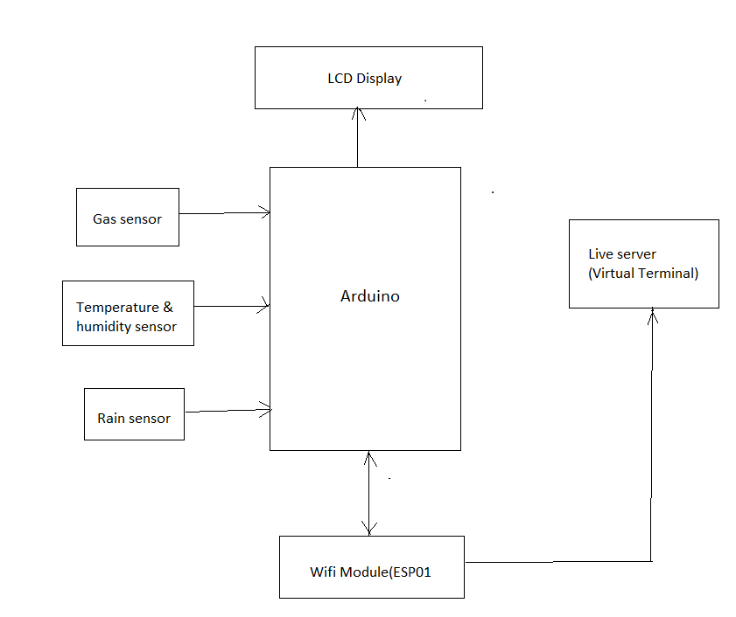

Fig -1: Block Diagram
  - ESP01 Node MCU –

- The ESP8266 (ESP-01) is a Wi-Fi module operating at 3.3V, requiring a 3.3V TTL USB to Serial port adapter for serial connection with a PC.
- The ESP8266 can function as a serial proxy or serial passthrough, enabling the seamless transmission of USB traffic from the PC to the ESP8266 and vice versa.
- The module features several essential pins with specific functions:
  - GND: Ground pin for ensuring electrical stability (0V).
  - GPIO2: General-purpose input/output pin No. 2.
  - GPIO0: General-purpose input/output pin No. 0.
  - RX: Receive data in and GPIO3.
  - VCC: Voltage pin operating at +3.3V (capable of handling up to 3.6V).
  - RST: Reset pin for system reset.
  - CH_PD: Chip power-down control.
  - TX: Transmit data out and GPIO1.

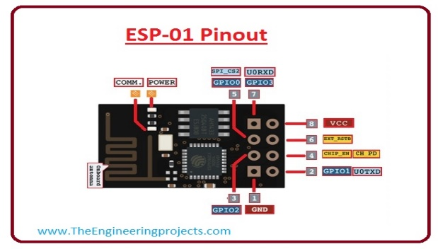

Fig -2: ESP8266 Node MCU

  - Arduino Nano –

The Arduino Nano is a compact and versatile microcontroller board featuring the Atmel ATmega328P microcontroller, and it operates at 16 MHz .
It offers 14 digital I/O pins, including 6 PWM pins, and 6 analog input pins for reading sensor values. The board supports UART, I2C, and SPI communication interfaces. With 32KB of flash memory and 2KB of SRAM, it provides ample storage for program code and data. Operating at 5V, it can be powered via USB or an external source. Its compact size and compatibility with the Arduino IDE make it a popular choice for various electronic projects.
Our system works on 5V through Arduino nano.

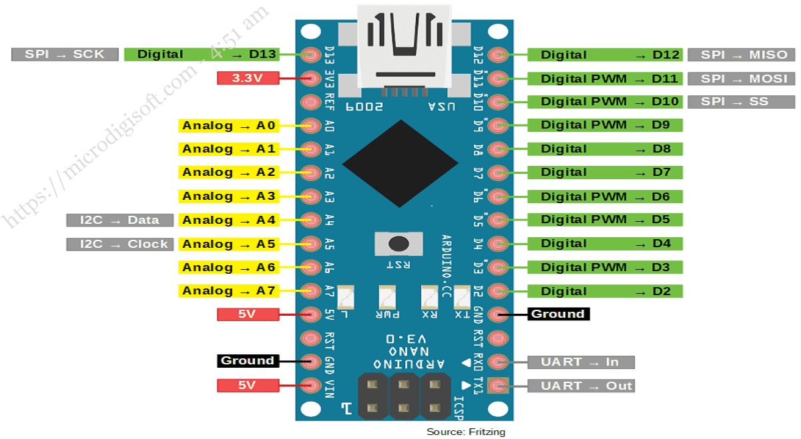

Fig -3: Arduino Nano
  - LCD Display –

- Ground Pin (Pin 1): The Ground pin is connected to the Ground terminal of the microcontroller unit or power source, providing the reference voltage for the display.
- VCC Pin (Pin 2): The VCC pin is used to connect the voltage supply pin of the display to the power source, ensuring proper power delivery.
- V0/VEE Pin (Pin 3): This pin regulates the contrast of the display. It is connected to a changeable potentiometer (POT) that can supply a variable voltage ranging from 0 to 5V, allowing for control over the display contrast.
- Register Select Pin (Pin 4): The Register Select pin toggles between the command and data register of the display. It is connected to a pin of the microcontroller unit, enabling the selection of either 0 or 1 to switch between command and data modes.
- Read/Write Pin (Pin 5): The Read/Write pin determines whether the display is in read or write mode. It is connected to a pin of the microcontroller unit, allowing for the selection of either 0 or 1 to perform the respective operation.
- Enable Pin (Pin 6): The Enable pin is used to initiate the read or write process. It needs to be held high (1) to execute the desired operation. It is connected to a pin of the microcontroller unit and is typically kept constantly high.
- Data Pins (Pins 7-14): These pins are responsible for sending data to the display. The number of data pins varies depending on the mode used, either 4-wire or 8-wire. In 4-wire mode, four pins (0 to 3) are connected to the microcontroller unit, while in 8-wire mode, eight pins (0 to 7) are used for data transmission.
- +VE LED Pin (Pin 15): This pin is connected to the positive terminal of the LED backlight, ensuring proper power supply for the backlight.
- -VE LED Pin (Pin 16): This pin is connected to the negative terminal of the LED backlight, completing the circuit and enabling the illumination of the backlight.

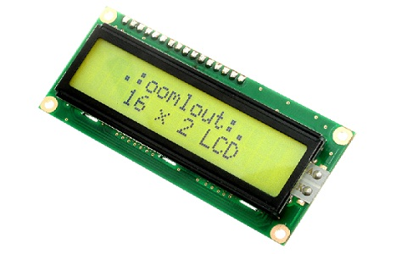
Fig -4: LCD Display
  - Temperature and Humidity Sensor –

The DHT11 module is an advanced digital temperature and humidity sensor that provides accurate and reliable measurements. It utilizes a calibrated digital signal output, ensuring precise temperature and humidity readings. By combining the digital module collection technology and temperature & humidity sensing technology, this module offers exceptional reliability and stability. The sensor consists of capacitive sensor components and high-precision temperature measurement devices, seamlessly connected to a high-performance 8-bit microcontroller.
This integration results in a product of outstanding quality, rapid response time, and optimal performance at a reasonable cost. Its standard single-bus interface allows for quick and easy system integration, making it suitable for a wide range of applications. With its compact size, low power consumption, and a signal transmission distance of up to 20 meters, the DHT11 module proves to be the ideal choice for various demanding applications that require precise temperature as well as humidity measurements.

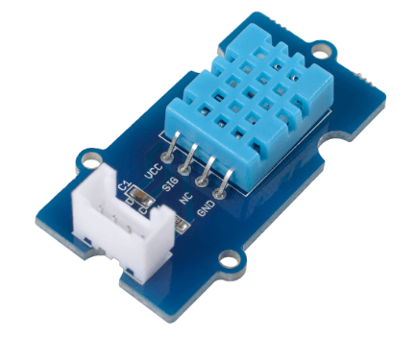
Fig -5: DHT11 Temperature and Humidity Sensor

  - Gas Sensor –

The MQ-135 gas sensor is a highly versatile component capable of detecting a wide range of gases, including Ammonia (NH3), Sulfur (S), Benzene (C6H6), CO2, and other harmful gases, as well as smoke. This sensor features both digital and analog output pins, allowing for flexible data retrieval. When the gas levels exceed a predefined threshold in the air, the digital pin is triggered and goes high, indicating the presence of hazardous gases. The threshold value can be conveniently adjusted using the on-board potentiometer. Additionally, the sensor offers an analog output pin that provides an analog voltage representing the approximate concentration of these gases in the atmosphere. This enables accurate measurement and monitoring of gas levels for various applications, including air quality assessment, safety systems, and environmental monitoring.

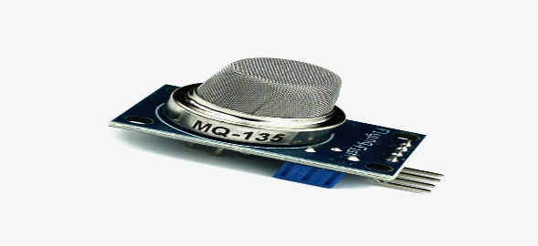

Fig -6: MQ-135AirQuality Sensor
  - Rain Sensor –

The rain sensor module is equipped with specially designed nickel-coated lines that operate on the principle of resistance. These lines effectively gauge the moisture levels in the surrounding environment and provide analog output through dedicated pins. Additionally, when the moisture threshold is exceeded, the sensor module generates a digital output signal, indicating the presence of rain. This module incorporates an integrated circuit (IC) similar to LM393, which combines the electronic components and the printed circuit board (PCB). The PCB plays a crucial role in collecting raindrops and facilitating their measurement. As raindrops land on the PCB, they create a parallel resistance path, allowing for precise calculations through an operational amplifier.

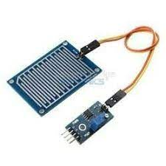
Fig -7: Rain Sensor

- SIMULATION DESIGNS

The simulation focused on the integration of the ESP01 Wi-Fi module, Arduino microcontroller, and various sensors including the temperature, humidity, gas, and rain sensors. These sensors were designed to detect and measure specific parameters in the atmosphere.

The code implementation for the simulation utilized the Adafruit-GFX and Adafruit-SSD1306 libraries for the MQ135 gas sensor, as well as the SSD1306 library for the OLED display in the Arduino IDE environment.

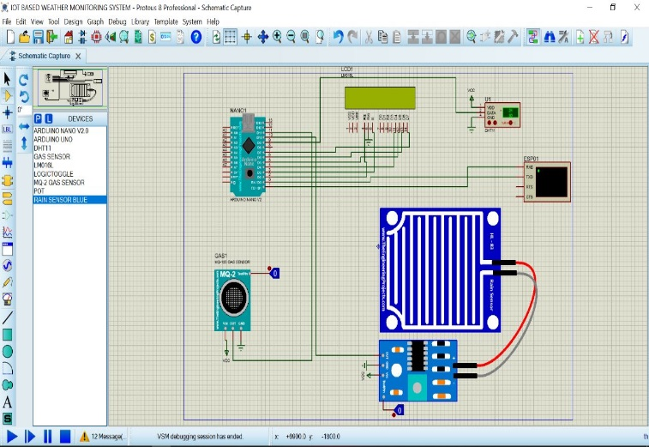

Fig -8: Simulation design before power supply

During the simulation, when the temperature and humidity sensor, gas sensor, and rain sensor provided their respective readings to the Arduino, the Arduino processed this data and displayed it digitally on the LCD. The ESP01 Wi-Fi module then received the readings from the Arduino and transmitted them to a live server hosted on a virtual terminal. This server stored the real-time readings, enabling the system to continuously update and analyze the data.

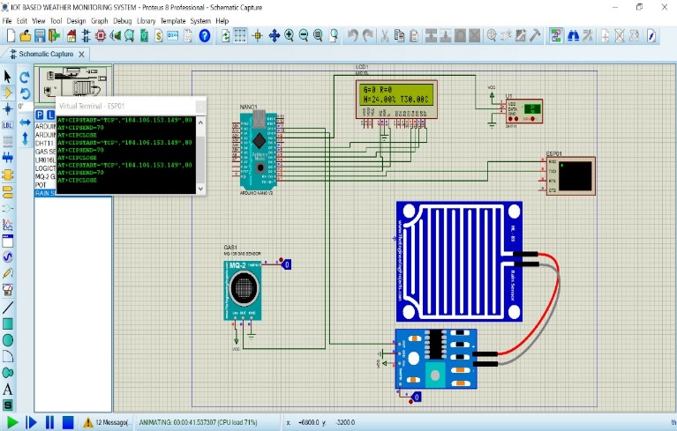

Fig -9: Simulation Working snapshot after providing power

Particular attention was given to the rain sensor, which initially displayed a digital output of 0 in the absence of rain. Once rain was detected, the sensor generated a digital output of 1, which was visually displayed on the LCD. Similarly, the MQ135 gas sensor provided an assessment of air quality and purity. When the Air Quality Index (AQI) level exceeded certain predefined values, the sensor indicated that the atmosphere was polluted by displaying a digital output of 1 on the LCD.

- SCHEMATIC DIAGRAM

The schematic diagram for the weather monitoring and forecasting system presents a visual representation of the electrical connections and components used in the project. It serves as a blueprint for understanding the system's overall architecture and functionality. The diagram showcases the intricate network of wires, nodes, and components that work together seamlessly to collect and analyze weather data.

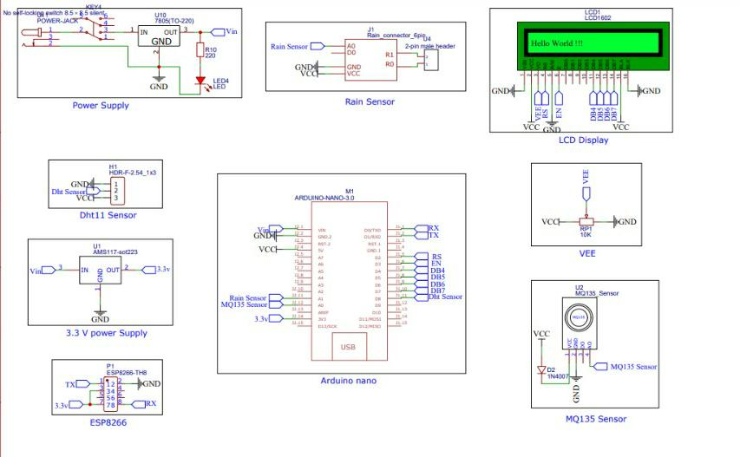
Fig -9: Schematic diagram
With meticulous attention to detail, the schematic diagram reveals the interconnections between the microcontroller unit, sensors, display module, and Wi-Fi module. Each component is strategically placed, depicting their specific roles in the system.

- HARDWARE DESIGN

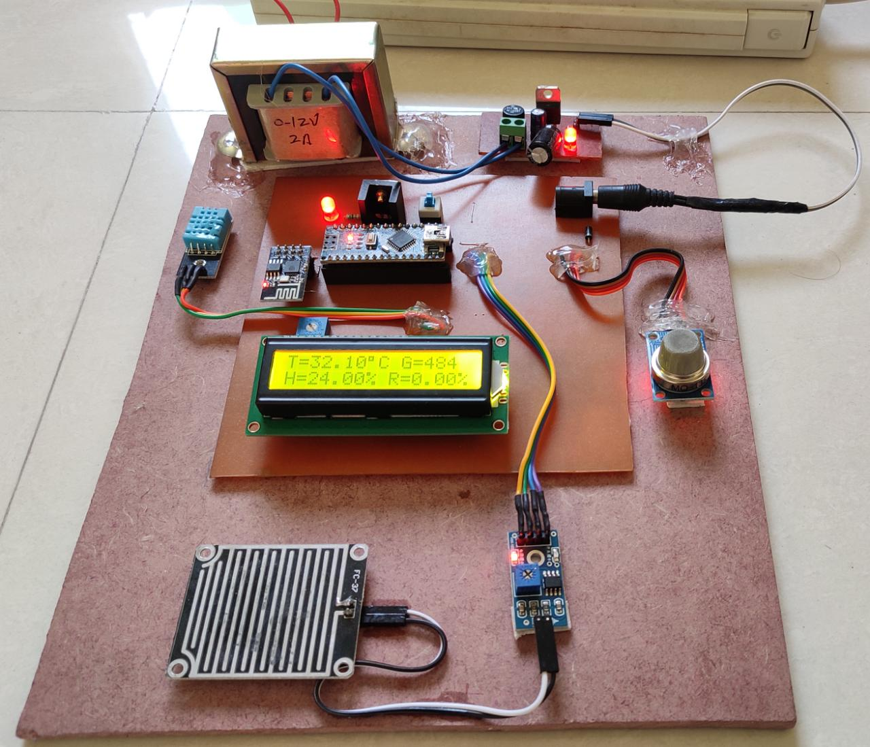

Fig -10: Hardware Design

- REPRESENTATION OF DATA ON SERVER

The ThingSpeak server provides a user-friendly platform for representing weather data in a visually appealing and informative manner. It allows users to gain insights, detect patterns, and make informed decisions based on the collected data and to customize their data representations by selecting the appropriate visualization tools and configuring display settings.

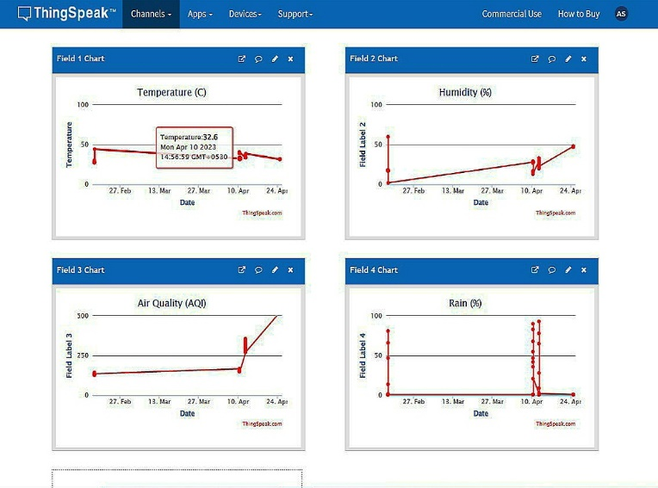
Fig -10: Graphical Representation of Data

- Channel ID: 2036072
- Author: mwa0000029201980

For weather monitoring system that collects temperature, humidity, and rainfall data. The system is equipped with sensors and an Arduino board, which transmits the data wirelessly to the ThingSpeak server for storage and analysis.
On the ThingSpeak server, the collected data can be visualized in different formats, such as graphs, charts, or gauges. For temperature data, a line graph can be created to show the variations in temperature over time.

- CONCLUSIONS

In conclusion, this research paper presents the design and implementation of a cost-effective weather monitoring system utilizing Arduino Uno as a central component. The prototype system demonstrates the feasibility of collecting and analyzing three key weather parameters: rain state, air density, and dust density, in addition to temperature and humidity readings.
The results obtained from the proposed weather station exhibit a high level of accuracy when compared to established weather sources such as "www.weather.com". This comparison serves as evidence of the reliable performance and accuracy of the proposed model, making it a viable solution for weather monitoring without the need for an internet connection, particularly in various regions of India.
Furthermore, the smart weather forecasting capabilities of the system offer additional advantages. With the ability to store data on a web server database, the system provides long-term data storage and analysis. Moreover, the possibility of solar power integration enhances the system's versatility, allowing it to operate in remote or inaccessible locations where conventional power sources may be limited.
Overall, the proposed weather monitoring system presents a low-cost and effective solution that empowers users with real-time weather data and reliable forecasting. Its potential applications extend to agricultural practices, urban planning, and disaster management, among others. With its proven performance and flexibility, this system opens up new avenues for accurate weather monitoring and analysis, contributing to informed decision-making and improved environmental resilience.

- ACKNOWLEDGEMENT

This project and the research that accompanies it would not have been possible without the exceptional support of our instructor, Prof. Mrs. S. G. Madhikar. She was always there to push us a little bit to get the job done on time and on time. She always gave us the freedom to do our thesis and the opportunity to work under her guidance.
We greatly appreciate the help of Dr. M. B. Mali, HOD, Faculty of Electronics and Telecommunications, and all staff have allowed us to continue our project work in the required university laboratories and use the necessary tools for the project. judgment. We would like to express our sincere gratitude to the Principal, Dr. S. D. Lokhande for his invaluable support and trust in us.

- REFERENCES

- Ashenafi Lambebo, Sasan Haghani, 2014, A Wireless Sensor Network for Environmental Monitoring of Greenhouse Gases, ASEE 2014 Zone I Conference, University of Bridgeport, Bridgpeort, CT, USA. International Journal of Engineering Research in Electrical and Electronic Engineering (IJEREEE), vol. 2, no. 2, pp. 69–72, February 2015.
- Arduino Based Weather Monitoring System Yash J Joysher1, Jeba Shiny J2, Sathiya Narayanan S3, Pradeepan K4 Department of Computer Science and Engineering, SRM Institute of Science and Technology.
- Study of Recent Literature on Weather Monitoring Systems Madhuri P. Patil Dept. of ETC, Godavari COE, Jalgaon, MS, India S. R. Pachpande Dept. of ETC, J T Mahajan COE Faizpur, MS, India J. P. Chaudhari, PhD CHARUSAT Space Research and Technology Center, Changa, Gujarat, India K. P. Rane, PhD ETC Department Godavari COE Jalgaon, MS, India. Weather Visibility Prediction Based on Multimodal Fusion CHUANG ZHANG 1 , (Member, IEEE), MING WU 1 , JINYU CHEN1, KAIYAN CHEN1 , CHI ZHANG2 , CHAO XIE3 , BIN HUANG3 , AND ZICHEN HE4.
- H. Saini, A. Thakur, S. Ahuja, N. Sabharwal, N. Kumar, “Arduino based automatic wireless weather station with remote graphical application and alerts,” 2016 3 rd International Conference on Signal Processing and Integrated Networks (SPIN), Noida, pp. 605-609, 2016.
- M. Beniston, Turbulence to climate: numerical investigations of the atmosphere with a hierarchy of models. Berlin: Springer, 1998.
- K. Sikder, G.Petracca, H. Aksu, T. Jaeger and A. S. Uluagac, “A Survey on Sensorbased Threats to Internet-of-Things (IoT) Devices and Applications” - https://arxiv.org/pdf/1802.02041.pdf. Accessed: 08.08.2018.
- S. Mallikarjun, S. Chandra Shekar Reddy, G. Nagalaxmi, R. Gayathri, “IOT Based Remote Monitoring of Weather Parameters for Solar, Wind Applications”, International Journal of Engineering Research in Electrical and Electronic Engineering (IJEREEE), vol. 2, no. 2, pp. 69–72, February 2018.
- Srinivas Rao, K. Srinivasa Rao and N. Ome,” Internet of Things (IOT) Based Weather Monitor system”, International Journal of Advanced Research in Computer and Communication Engineering, vol. 5, no. 9, pp. 312–319, September 2016.
- Akash and A. Birwal, “IoT-based Temperature and Humidity Monitoring System for Agriculture”, International Journal Of Innovative Research in Science, Engineering and Technology, vol. 6, no. 7, pp. 12756–12761, July 2017.
- S. D. Shewale and S. N. Gaikwad, “An IoT Based Real-Time Weather Monitoring System Using Raspberry Pi”, International Journal of Advanced Research in Electrical, Electronics and Instrumentation Engineering, vol. 6, no. 6, pp. 4242–4249, June 2017.

