Eye Controlled Mouse Cursor and Virtual Keyboard for DIVYANG
Mr.Ramdas Bagawade¹, Shakyadita Sonawane², ³Spandan Pagar³, Aishwarya Chemate⁴
Department of Computer Engineering,
Government College of Engineering and Research Avasari Khurd, Pune, India

---------------------------------------------------------------------***---------------------------------------------------------------------
Abstract - This paper represents an implementation of developing an algorithm for controlling the movement of computer screen using the Iris movement. By accurately detecting the position of the iris in eye and mapping that to a specific position on the computer screen. These techniques were implemented by analyzing the coordinates of face and the eyes. An OpenCV based model that analyzes the movement of the Iris, with the aid of a camera and positions the cursor in accordance to the movement of Iris is being designed. Also, we are going to represent the development of a virtual keyboard which works by detecting eye gaze and eye blinking. For this, a system has been built that captures video directly from PC camera and detects human face and eye. It also detects eye gaze as left or right to select keyboard section and eye blinking to select the desired key from the virtual keyboard. This system will prove to be a boon for differently abled person to control the screen by simply using eye gaze. It will also help them to type without using finger or hands. Such types of application are important and blessings for those people who completely lost the control of their limbs.

Key Words: OpenCV: HCI; GUI; iris

1.INTRODUCTION
Communication is an indispensable need for human beings. The invention of computer-mediated communication (CMC) has provided the ability to communicate across great distances, communicate to an unlimited number of people at a low cost, and the ease of creating documents and other material to share. Ever since the invention of computers, there has been a very high amelioration of computer’s power and potentiality. Nevertheless, we still use keyboards and mouse to communicate and work with the computer. However, for people who suffer from severe physical disabilities, paralysis, and amputation, it is almost impossible to use this computer communication boon in today’s world. Around 19% population in the world is physically disabled. It is a difficult task for them to interface and access the computer along with its accessories.[1] Sometimes it becomes difficult for them to control basic screen widgets. Communication barriers are experienced by people that affect reading, writing, and or understanding, and who use different ways to communicate than people who do not have these disabilities.
To tackle this, we have developed a system which enables them to control the screen widgets using iris movements. In this we have employed techniques to monitor iris movement which helps to control several tabs available on the screen. Also, they we’ll be able to access the virtual keyboard using their eye gaze and eye blinking. It will be helpful for them to control entire screen and perform all sorts of tasks just into looking into the screen! But there was a need to develop such systems for the people who can’t work spontaneously, who are only able to perform any involuntary action. Many disabled people have only the action that they can perform of their own free will is the blinking of their eyes. As a result, various eye-gaze-based human interaction technologies are being developed.
A modern piece of technology is an eye gaze driven virtual keyboard. The idea behind the virtual keyboard is to display the keys in a rectangle form like a keyboard and continuously light up the keys one by one at a time. Whenever the desired key light up, we would just need to close our eyes and the key will be pressed automatically. The face is known as the index of one’s mind while eyes are called windows to the soul of the human. An enhanced window into a person's intention and desire is provided by the amount of eye movement and blinking. Here, the eye-tracking system refers to the technique of measuring the movement/activity of eyes. To track the movement of eyes we have to detect eye and eyeball first. Again, face detection is the early step of eye detection. One of the most significant stages in the eye detection process is the exact detection of landmarks within the face.Tasks such as facial identification, expression analysis, age estimation, and gender classification are often built upon a facial land-marking component in their methods [2,3,4]. The application designed by this study approaches the subject with a cheaper and convenient alternative which can be operated using a simple laptop and a webcam.

2. Body of Paper
  - Video Capture
First, video is captured from the webcam, which has the actual resolution. From the captured video, we grab frames. The captured frame is passed for the grayscale conversion to reduce the computation power for further processing.
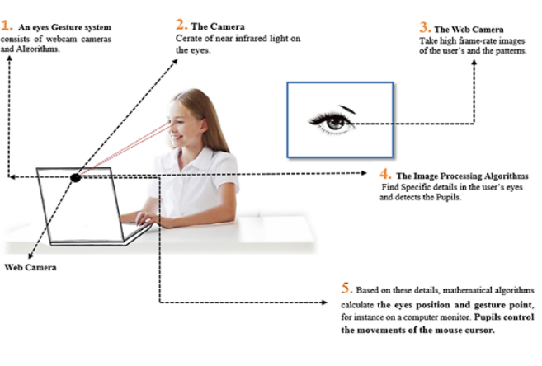

Fig.1.Architecture Diagram of Eye Mouse and Eye Key

  - Grayscale Conversion
The grayscale conversion has many ways of converting colorful images into gray form. The luminosity method is used to convert the color image into gray. It can be carried out by following steps:
1) Read the color image.
2) For any pixel read the intensity values of red, blue and green channels as R, G and B respectively.
3) Calculate the gray value Gr=0.299*R+0.587*G+0.114*B
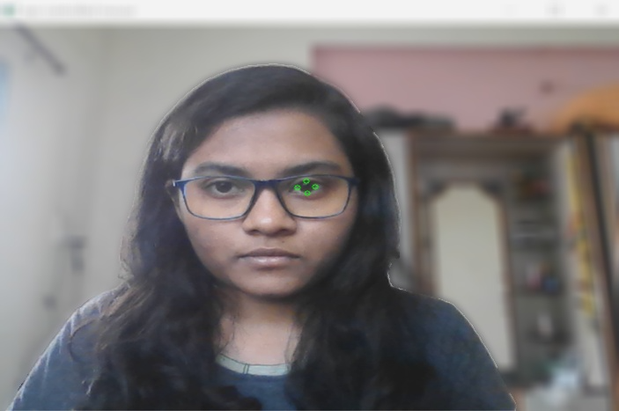
4) Set, Gr as intensity.
5) Repeat steps from 2 to 4 until all pixels are scanned.

  - Facial Landmarks Detection
Facial landmarks are used to localize and represent salient regions of the face. There are two steps while detecting the facial landmarks: • Localize the face in the image • Detect the key facial structures on the face. There are various landmark detection algorithms available, but for this application, we use Dlib. Dlib is a cross-platform library written in C++, which uses histogram-oriented gradient (HOG) and support vector machine to detect the face and dlib pre-trained model for detecting 68 landmarks points of the face.
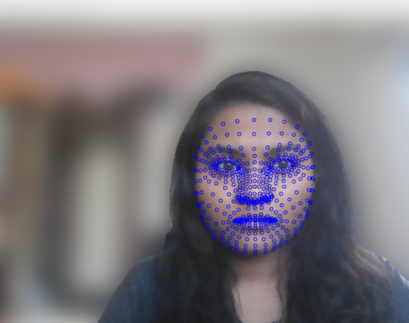

Fig.2. Landmarks on face

D. Eye cropping and resizing
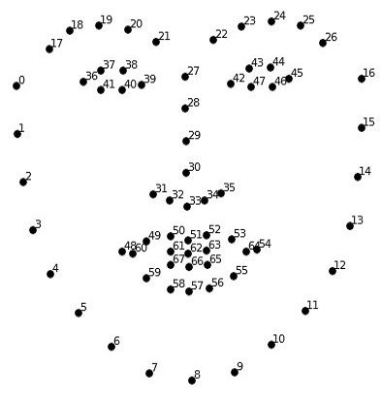
The left eye is cropped from the face using the landmarks points: 37,38,39,40, 41, and 42 and the right eye is cropped from the face using the landmarks points: 43,44,45,46,47 and 48 as shown in Fig. 3. Now obtained cropped left and right eyes are resized into size 64x56 and 34x26 to feed gaze detection network and blink detection network, respectively.
Fig.3. 68 landmark points on face 1

E. Eye Gaze and Movement Detection
In this section, we detect the eye gaze point based on the movement of eyes. Ours eyes have two colors; the eyeballs are normally black or brown and the remaining part is white. So, we can detect the movement of the eyeball. Here we only detect eye gaze as right, left, or center point. For this, we apply a threshold on the eyes image and point the eyeball to detect movement.

Fig.4. Eye Gaze and Movement Detection

F. Eye Blinking Detection
Eye blinking is a reflex that closes and opens the eyes rapidly. Eye blinking is a natural process and it happens very quickly. Here, we have to find out what occurs when we blink our eyes. It is easy to point out that an eye is blinking when:
♣ The eyeball cannot be seen.
♣ Eyelid is closed.
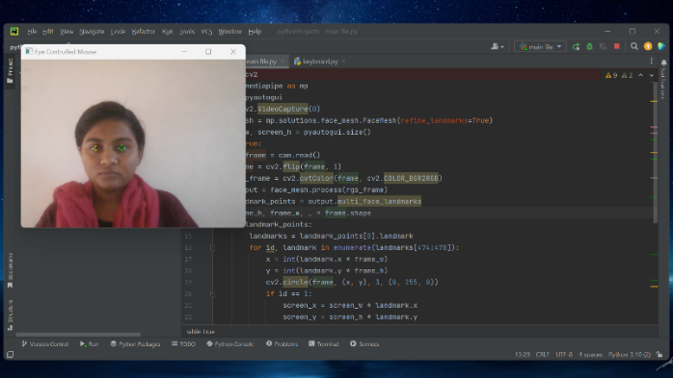
♣ Upper and bottom eyelashes connect.

Fig.5. Blink detection
G. Virtual Keyboard on Screen
For the system, we create a virtual keyboard and divide it into two parts. The basic idea behind the keyboard is as same as the old QWERTY keyboard. In the left part we put 1, 2, 3, 4, 5, Q, W, E, R, T, A, S, D, F, G, Z, X, C, V, SPACE, DELETE, and some sign. The right parts keys are-6, 7, 8, 9, 0, Y, U, I, O, P, H, J, K, L, B, N, M, SPACE, DELETE and some sign. We can now choose a key from the keyboard by eyes to type.

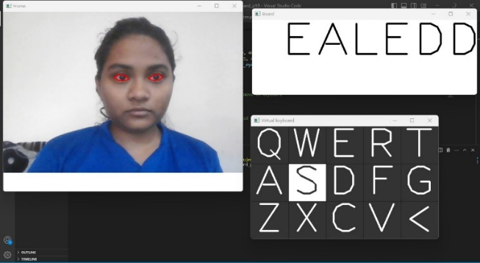
Fig.6.Overall keyboard working

- Working of cursor movement (mouse clicking function)
- Click Activity
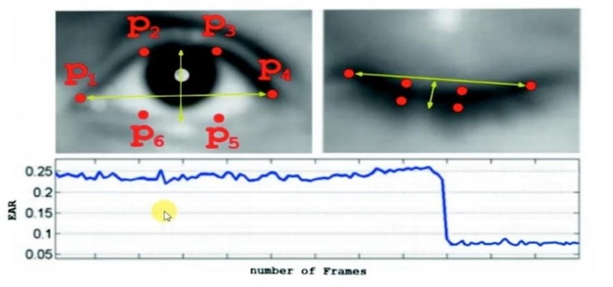
It used to read the input from the video and starts detecting the face features like. Clicking by Blink motion. If we are using mouse, we can perform any clicking action on the screen. It is very useful for persons who does not have upper limbs can easily perform clicking actions with the help of mouse and can type with the help of Keyboard in our system.
Fig.7. Setting up the threshold

- Steps for cursor movement and click

- cam = cv2.VideoCapture(0)
This line creates a VideoCapture object that captures frames from the default camera (specified by 0).

- screen_w, screen_h = pyautogui.size()
This line gets the size of the screen in pixels using the pyautogui.size() function.

- through the detected landmarks for the first face in the frame and draw circles around the landmarks corresponding to the eyes. The pyautogui.moveTo() function is used to move the mouse cursor to the position of the second landmark, which is around the outer corner of the left eye.

- extract the landmarks corresponding to the left eye and draw circles around them. The distance between the two landmarks is checked, and if it is less than a certain threshold, a mouse click is simulated using the pyautogui.click() function.

- Working of virtual keyboard

- Face and Eye detection
The first step of the system is face detection. So, face detection in real-time implemented using Haar based HoG feature descriptor and to detect eye we use facial landmarks
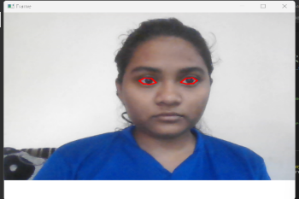
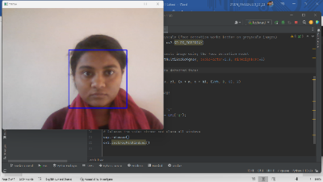
method with dlib.
Fig.8.Face detection Fig.9.Eyedetection

- Eye Gaze Detection
To detect eye gaze, we calculate eye gaze ratio from both left and right eye. We detect the screening point at which eyeball is looking.
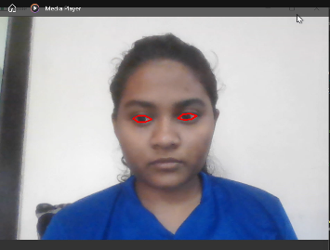
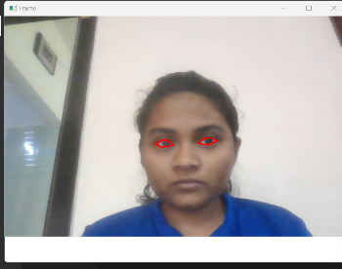
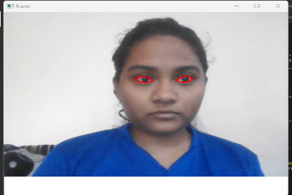
Fig. 10. (a) Gaze on left side (b) Gaze in center (c) Gaze on right side

- Eye Blinking Detection

Here the eye area is taken from the video stream and then we apply a threshold to detect eye-ball more accurately. We calculate the eye blinking ratio to differentiate between the normal eye blinking and the desired blinking type. We set a value as 4 and compare it with the blinking ratio. Whenever the blinking ratio is more than 4, key from the keyboard is printed on the whiteboard.
          - (b)
Fig. 11. Eye ball detection (a) Left eye (b) After applying threshold

- Keyboard Selection
To select the left or right side of the keyboard we calculate gaze ratio. If the gaze ratio is more than 0.9 (constant value) left side of the keyboard will be opened otherwise right side will open.
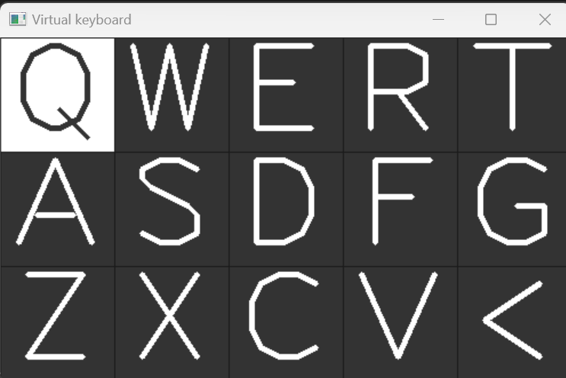
Fig.12.Keyboard partition
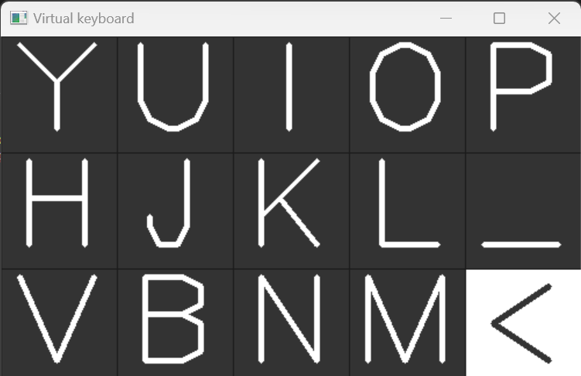
Fig.13(a). Left part of keyboard Fig.13(b). Right part of keyboard

width = 100, height = 100, th = 1 # thickness
keyboard = np.zeros((300, 500, 3),np.uint8)
Each key of the keyboard is lighted up. Mainly we are lighting up each key for 8 frames and then the next one.
Thus, when our desired key is lighted up we just have to close our eyes for around seconds and the key will appear on the board shown in Fig. 14.

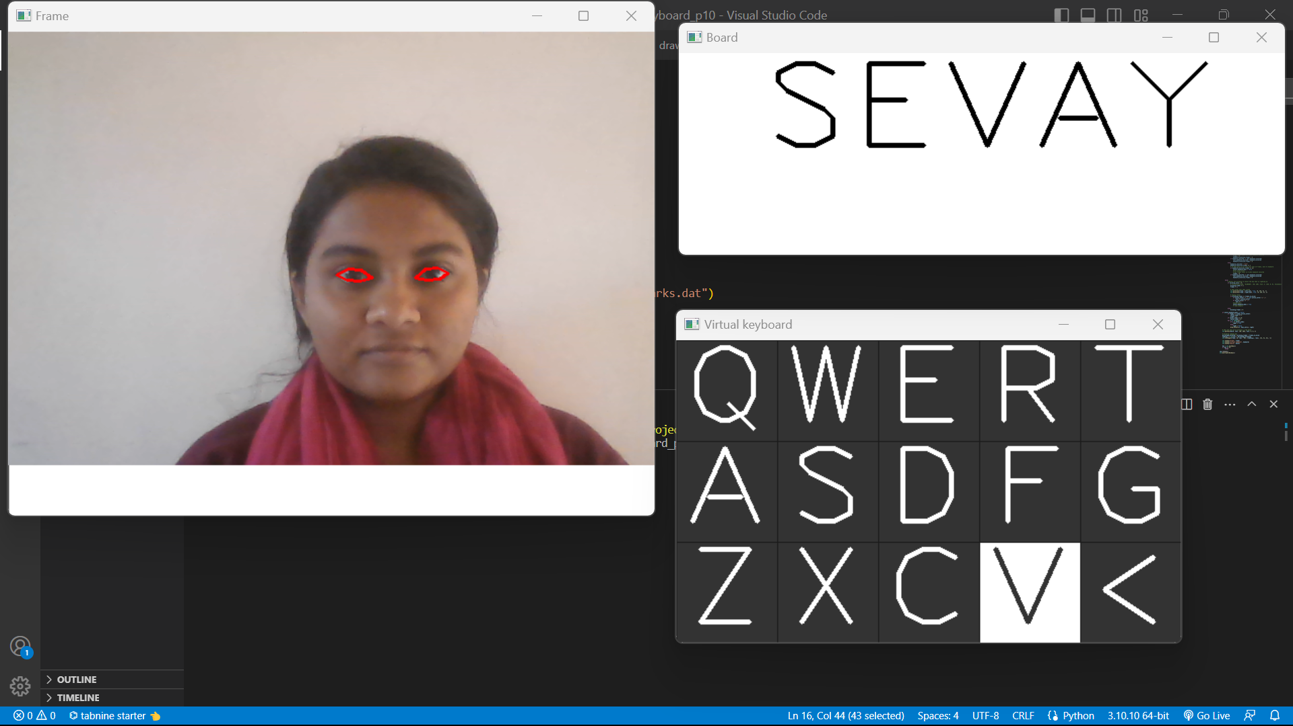

Fig. 14. Typing the letters correctly

3. CONCLUSIONS

A system that enables a disabled person to interact with the computer is successfully developed and tested. People with physical disabilities have limited capabilities in moving, performing manual tasks and taking participation in some life activities. Since that physical impairments can significantly make tedious using of information technology, it is required to make adaptations that will be enabling the full communication with computers by persons with this kind of disabilities. As information education is fundamental education in modern society, the special accent should be given to the communication problems between physically handicapped persons and computers. This study addresses deficiencies and reduces disparities to a certain extent by providing a ’Eye controlled virtual keyboard’ for physically-challenged people. Though the proposed system will provide a robust and a sort of blessings technique to write for physically damaged people, it is not a quick way of writing for normal people.
The method can be further enhanced to be used in many other applications. The system can be modified to make it easier for people with disabilities to control home appliances like TVs, lights, doors, and so on. The framework can likewise be adjusted to be utilized by people experiencing total loss of motion, to work and control a wheelchair. Additionally, the eye mouse can be used to identify drivers who are drowsy in order to avoid collisions. The eye movement detection and tracking have also potential use in gaming and virtual reality.

ACKNOWLEDGEMENT

It is a great honor to convey special thanks to all those helping hands without whom it would be hard for us to do this research. This research has been possible with patience, support and, encouragement that we have received from many personalities of our institution. First, we would like to acknowledge our college Government College of Engineering and Research, Awasari Khurd, Pune for providing the opportunity to carry out this study.

.

REFERENCES

1] Nanda kumar.M, G. Hruday, K. Lohith Raj, N. Satwik “Eye-Controlled Mouse Cursor for Physically Disabled”, International Research Journal of Engineering and Technology (IRJET) Volume: 07 Issue: 06 [June 2020]
2] Partha Chakraborty, Dipa Roy, Md. Zahidur Rahman, Saifur Rahman “Eye Gaze Controlled Virtual Keyboard” International Journal of Recent Technology and Engineering (IJRTE) ISSN: 2277-3878, Volume-8 Issue-4 [November 2019]
3] Mohamad Nasor, Mujeeb Rahman K k, Maryam Mohamad, Farida Mohamad “Eye-Controlled Mouse Cursor for Physically Disabled Individual”, Department of Biomedical Engineering, Ajman University, Ajman, UAE [17 February 2019]
4] Grauman, K.; Betke, M.; Gips, J.; Bradski, G.R., “Communication via eye blinks‐Detection and duration analysis in real-time”, IEEE CONFERENCE PUBLICATIONS, 2009
5] Craig Hennessey, Jacob Fiset, “Long Range Eye Tracking: Bringing Eye Tracking into the Living Room”, IEEE, 2012
6] Toshiyuki Masui, Koji Tsukada, and Itiro Siio, “Mouse Field: A Simple and Versatile Input Device for Ubiquitous Computing”, Vol. 3205, Springer (2011), p.319-328.
7] Ms. S. A. Chhabria, Dr. R. V. Dharaskar, Dr. R. V. Dharaskar, “Eye Recognition and Hand Gesture Identification Fusion System” February 2013
8] D. Li, J. Babcock, and D. J. Parkhurst, “Open Eyes: a low-cost head-mounted eye-tracking solution,” Journal of Sensors 17the 2006 Symposium on Eye Tracking Research and Applications, pp. 95–100, San Diego, California, USA, 27-29 March 2006.
9] E. Cáceres, M. Carrasco, and S. Ríos, “Evaluation of an eye pointer interaction device for human-computer interaction”, Heliyon, vol. 4, no. 3, p. e00574, 2018.
10] Academic Editor: Carlos Ruiz, “Optical Mouse Sensor for Eye Blink Detection and Pupil Tracking Application in a Low-Cost Eye-Controlled Pointing Device” Hindawi Journal of Sensors Volume 2019, Article ID 3931713, 19 pages.

