FUTURE FORECATING USING SUPERVISED MACHINE LEARNING MODELS COVID 19
A.BHARATHI¹, S.LAKSHMANRAM² ,T.SUBASH³, S.SURESHKUMAR^{4,} P.PRASAD⁵,
¹Associate Processor in Information Technology, Nandha Engineering College, Perundurai -638052, Erode District, TamilNadu, India.
^{2,3,4,5}Students of Information Technology, Nandha Engineering College, Perundurai -638052, Erode District, TamilNadu, India.

ABSTRACT :The global proliferation of COVID-19 has placed mankind in danger. Because of the disease's high infectivity and transmissibility, the resources of some of the world's most powerful economies are being taxed. The capacity of machine learning algorithms can anticipate the number of forthcoming patients impacted by COVID-19, which is now regarded as a possible threat to humanity. In this work, four conventional forecasting models, least absolute shrinkage and selection operator (LR), were utilized to anticipate the COVID-19 hazardous elements. Each model makes three sorts of predictions: the number of newly infected cases, the number of fatalities, and the number of recoveries. However, in the cannot predict an exact outcome for the patients.To address the problem, the suggested technique employing LR predicts the number of COVID-19 cases in the following 30 days as well as the influence of preventative measures such as social isolation and lockout on the spread of COVID-19.

1. INTRODUCTION
1.1 COVID-19
COVID-19, the global pandemic, has exposed human society's vulnerability to severe infectious illnesses as well as the challenge of treating this problem in a globally integrated complex system. COVID-19 impacted almost 100 nations in a few of weeks. As a result, the entire human species should not only work together to defeat the pandemic, but also make reasonable plans to return to work and production based on the real circumstances in each location, as well as conduct geographical risk assessments. Many attempts have been made to develop an appropriate and rapid method of detecting infected people at an early stage. Guan et colleagues discovered bilateral pulmonary parenchymal ground-glass and consolidative pulmonary opacities, occasionally with a rounded shape and a peripheral lung distribution, after performing chest CT scans on 21 COVID19 infected individuals in China. As a result, COVID-19 diagnosis may be portrayed as an image segmentation issue to extract the disease's major characteristics. Coronavirus Disease 2019 (COVID-19), caused by a new coronavirus, is rapidly spreading over the world. As of April 9, 2020, it had infected over 1,436,000 persons in over 200 nations and territories.Forecasting is the practice of creating future predictions based on past and present data, most typically using trend analysis.
1.2 FUTURE FORECASTING
Forecasting is the practice of creating future predictions based on past and present data, most typically using trend analysis. A common example would be the estimate of some variable of interest at some future date. Prediction is a similar but broader phrase. Both terms can relate to formal statistical approaches that use time series, cross-sectional, or longitudinal data, as well as less formal judgmental procedures. In hydrology, for example, the phrases "forecast" and "forecasting" are frequently reserved for estimates of values at specific future periods, but the term "prediction" is used for more general predictions, such as the number of times floods will occur over a lengthy period. Forecasting and prediction rely heavily on risk and uncertainty; it is usually regarded good practice to highlight the degree of uncertainty attached to projections. In any event, the data must be current if the forecast is to be as precise as feasible. In certain circumstances, the data needed to forecast the variable of interest is predicted itself.

2. LITERATURE REVIEW
2.1 USING EXISTING CELLULAR WIRELESS NETWORK FUNCTIONALITIES TO DETECT REGIONS AT RISK FOR COVID-19 SPREAD.
Alsaeedy, A.,[1] suggest a novel technique for identifying places with high population density and mobility that are at risk of spreading COVID-19. Crowded areas with actively moving individuals (referred to as at-risk areas) are more likely to transmit the disease, especially if they contain asymptomatic infected persons alongside healthy ones. Methods: Our system detects at-risk areas by leveraging current cellular network features such as handover and cell (re)selection, which are utilized to provide smooth coverage for mobile end-user equipment (UE). We leverage pre-existing cellular-network functions to control end-user movement and assure smooth coverage. Because almost everyone owns a cellular mobile device (known as user equipment (UE)), these function as always-on human trackers. More particular, as the number and mobility of UEs increases, so does the number and mobility of individuals. According to a recent study, SARS-CoV-2 can survive in the air for up to three hours (as aerosols) after being exhaled by infected patients while speaking, coughing, or even breathing, whether symptomatic or not. We are especially concerned about the situation in which infectious persons are present in regions with a high density of continually moving people.

2.2 USING MACHINE LEARNING TO QUANTIFY COVID-19 CONTENT IN THE ONLINE HEALTH OPINION WAR

R. F. Sear, [2] A large quantity of possibly deadly COVID-19 disinformation is surfacing online, according to Richard f. Sear, Nicolas Velásquez et al. We apply machine learning to assess COVID-19 material among online opponents of conventional health advice, namely vaccines ("anti-vax"). We discovered that the anti-vax group is having a less concentrated argument about COVID-19 than the pro-vaccination ("pro-vax") community. The anti-vax community, on the other hand, demonstrates a greater range of "flavours" of COVID-19 issues, and so can appeal to a broader cross-section of those seeking COVID-19 counsel online, such as those skeptical of a mandated fast-tracked COVID-19 vaccination or those seeking alternative cures. As a result, the anti-vax movement appears to be in a better position to gain new supporters in the future than the pro-vax community. This is important because if a COVID-19 vaccine is not widely adopted, the globe will fall short of providing herd immunity, leaving countries vulnerable to future COVID-19 outbreaks. We present a mechanistic model that explains these findings and may aid in determining the potential success of intervention techniques. Our technique is scalable, addressing the pressing issue that social media platforms have in analyzing massive amounts of online health misinformation and deception.

3. EXISTING SYSTEM
COVID 19 is now seen as a possible hazard to mankind. In this work, four conventional prediction models were utilized to predict COVID-19 hazardous elements, including linear regression (left to right), at least complete summary, and choose operator, Support Vector Machine (SVM). Predictions are produced based on each of the models, such as the number of new infections, fatalities, and recurrences during the following 10 days. The study's findings provide a promising mechanism for using these approaches in the current setting of COVID 19 infection. Predictions are produced based on each of the models, such as the number of new infections, fatalities, and recurrences during the following 10 days. The study's findings provide a promising mechanism for using these approaches in the current setting of COVID 19 infection.COVID-19 does not appear to have a serious impact on children; several paediatric wards have been focused on the urgency of COVID-19-related concerns. As a result, many other acute and chronic disorders, particularly those that are infrequent, may receive insufficient care. This lack of interest can lead to serious complications or even death, especially in children.
4. PROPOSED SYSTEM
Machine learning approaches were effective for prediction because they automatically extracted important characteristics from training samples, used activation from the previous time step as input for the current time step, and used network self-connections. According to the results of the model analysis, we believe that the early stage emergency intervention actions, such as blocking, restricting the flow of people, and enhancing assistance, had a critical restraining influence on the original expansion of the epidemic.Continued investment in diverse medical resources to guarantee that suspected patients may be identified and treated in a timely way is a very successful preventative and treatment technique. The AI calculation LR every one of these calculation are utilized and the best calculation are arranged in the r-squared blunder and the changed r-squared mistake.

4.1 DATA
The data contains the total number of confirmed cases, total number of fatalities, total number of newly confirmed cases, and total number of healed patients per province. We also utilized data on recent diagnoses in South Korea, Iran, and Italy, which contains data from official announcements from various nations. All data is from the daily case report, and the data is updated once every day.

4.2 ESTIMATION PROCESS
The Basic reproduction number varies substantially between control stages and has a direct impact on control intensity. Furthermore, the virus's incubation time has a direct impact on the virus's transmission pace. These two parameters must be calculated. According to current research, unrestrained Basic reproduction. As a result, we selected the valuation range in the appropriate range. The value range for the regulated Basic reproduction number was chosen to be [0, 1.5].

4.3 DATA-DRIVEN METHODS TO PREDICT COVID-19
The data was used (when the first incidence of COVID-19 was reported in India), with 80% of the data used for training and the remaining 20% for predicting and validation. The resultant figure depicts the total number of confirmed cases, the observed data is the data used for training, the official data (green line) is the official data available, and the predicted data represents the total number of confirmed cases forecast. According to this graph, the predicted number of total verified positive cases roughly matches the existing official data.

4.4 DATA PRE PROCESSING
Data preprocessing is a technique for converting raw data into a clean data collection. The dataset is frequently inadequate, inconsistent, and/or deficient in specific behaviors or patterns, and it is rife with mistakes. Data preparation is a tried-and-true way for dealing with such problems.

4.5 PREDICTION OF ACCURACY
This approach is appropriate for use with predicting neural networks or characteristic data such as infection event or non-event binomial effects. The forecast accuracy of different metrics may be utilized for a variety of applications. They include the rate at which normal (unpredicted forecast accurately predicts sensitivity (non-infectious disease), accuracy (expected percentage of predicted trend), positive predictive value, negative predictive value (correctly predicted infection rate is), and the ratio. Expected forecasts are a measure of the chance that the growth in the whole process surpasses the individual's accuracy).

ARCHITECTURE DIAGRAM

Fig.1 ARCHITECTURE DIAGRAM
Above Figure 1, Shows the Block Diagram of the Future Forecasting using Supervised Machine Learning Models COVID-19

- RESULT ANALYSIS
To develop a structure for the future deciding of the amount of cases impacted by COVID-19 using AI procedures. The dataset used for the assessment contains information about the step by step reports of the amount of as of late tainted cases, the amount of recoveries, and the amount of passings in light of COVID-19 all throughout the planet. As the death rate and avowed cases are extending bit by bit which is an upsetting situation for the world. The amount of people who can be affected by the COVID-19 pandemic in different countries of the world isn't prominent. This assessment is an undertaking to calculate the amount of people that can be affected similarly as new sullied cases and passing's including the amount of expected recoveries for the impending 10 days. Four AI models LR, LASSO, SVM, ES and LSTM have been used to predict the amount of as of late debased cases, the amount of passings, and the amount of recuperations. The plots of asserted cases, passing's, and recoveries on the underlying four sheets followed by the plot of certifiable situation amassed from the genuine data reports of the analyzing season of the assessment in the fifth sheet. The results in the charts show that the ML models used in this assessment befit the assessing task making the course towards the comfort of the examination and future investigation of the near nature.

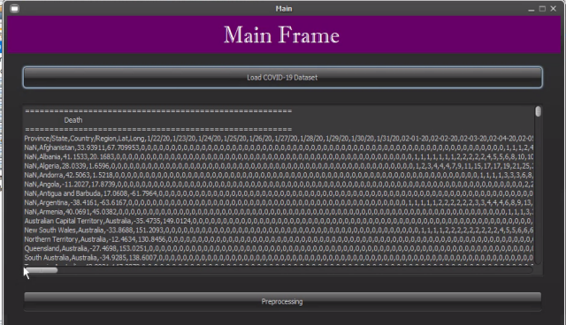

Fig.2 MAIN FRAME

Above Figure 2, Shows the options available in this Module. Load Covid-19 Data set the data are preprocessing to the main frame.

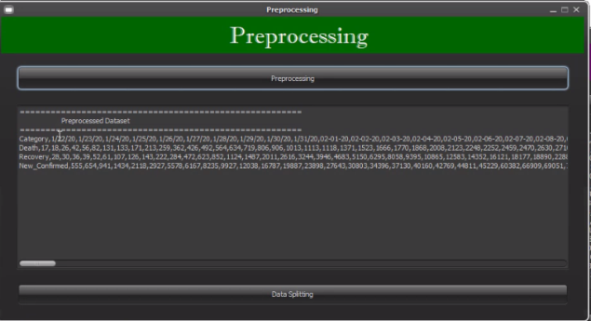

Fig.3 PREPROCESSING

Above Figure 3, Shows the options available in this module. To load the data and preprocessing the
Data set after the preprocessing to load the data splitting of this module

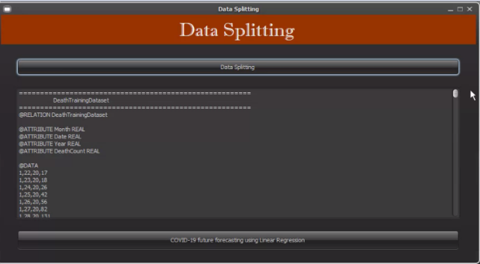

Fig.4 DATA SPLITTING

Above Figure 4, In this Module Death Training Dateset predict to the data splitting Module.

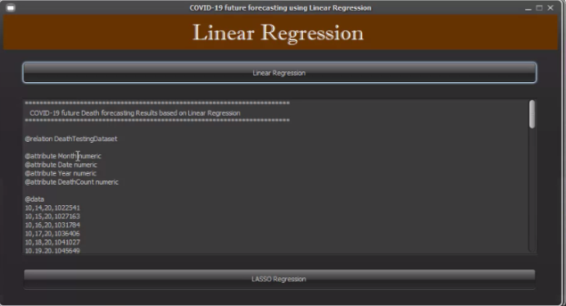
Fig.5 LINEAR REGRESSION

Above Figure 5, In this Module Predicit the final output for COVID-19 Future Death Forecasting result based on Linear Regression.

RESULT AND DISCUSSION
Above Figure 6 Prediction intervals using Linear Regrssion in all three cases (death rate, new confirmed cases, recovery rate)
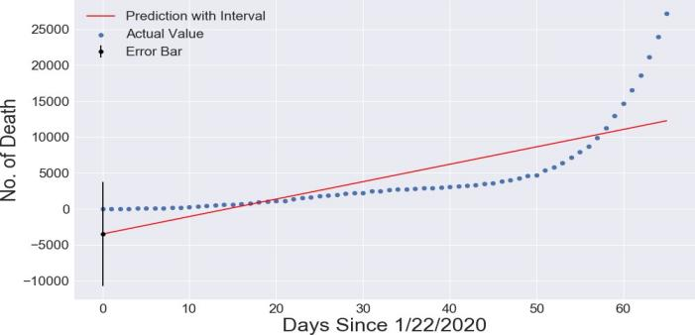

Fig.6.1 NO OF DEATH CASES USING LINEAR REGRESSION

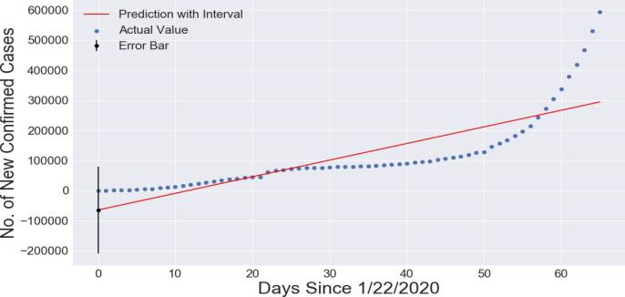

Fig.6.2 NO OF CONFIRMED CASES USING LINEAR REGRESSION

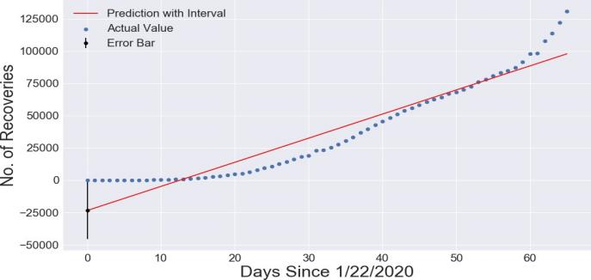
Fig.6.3 NO OF RECOVERIES USING LINEAR REGRESSION

5. CONCLUSION
Data-driven forecasting/estimation strategy was utilized to anticipate the likely number of COVID-19 positive cases in India during the following 30 days. Using and curve fitting, the number of recovered cases LRLASSO, SVM, ES, LSTMdaily positive cases, and died cases was also estimated. The effect of preventative measures such as social isolation and lockdown has also been demonstrated, indicating that these preventive measures can considerably minimize the transmission of the infection. Although this method frequently requires sufficient data to support it, in the early stages of epidemic transmission, this method can still be used to more accurately predict the indicators of epidemic transmission in the short term, so that intervention control can be provided at all levels of departments and policy implementation can provide short-term emergency prevention programmes. For various factors and in different places, the forecast results of three distinct mathematical models differ. In general, the Logistic model may have the best fitting effect among the three models.

6. REFERENCES

- Alsaeedy, A. A. R., & Chong, E. (2020). Detecting Regions at Risk for Spreading COVID-19 Using Existing Cellular Wireless Network Functionalities. IEEE Open Journal of Engineering in Medicine and Biology, 1–1.
- Sear, R. F., Velasquez, N., Leahy, R., Restrepo, N. J., El Oud, S., Gabriel, N., … Johnson, N. F. (2020). Quantifying COVID-19 content in the online health opinion war using machine learning. IEEE Access, 1–1.
- Hu, S., Gao, Y., Niu, Z., Jiang, Y., Li, L., Xiao, X. … Yang, G. (2020). Weakly Supervised Deep Learning for COVID-19 Infection Detection and Classification from CT Images. IEEE Access, 1–1.
- Zhang, Y., Li, Y., Yang, B., Zheng, X., & Chen, M. (2020). Risk Assessment of COVID-19 Based On Multisource Data from a Geographical View. IEEE Access, 1–1.
- Abdel-Basset, M., Mohamed, R., Elhoseny, M., Chakrabortty, R. K., & Ryan, M. (2020). A hybrid COVID-19 detection model using an improved marine predator’s algorithm and a ranking-based diversity reduction strategy. IEEE Access, 1–1.
- F. Petropoulos and S. Makridakis, “Forecasting the novel coronavirus covid-19,” Plos one, vol. 15, no. 3, p. e0231236, 2020.
- G. Grasselli, A. Pesenti, and M. Cecconi, “Critical care utilization for the covid-19 outbreak in lombardy, italy: early experience and forecast during an emergency response,” Jama, 2020.
- C. P. E. R. E. Novel et al., “The epidemiological characteristics of an outbreak of 2019 novel coronavirus diseases (covid-19) in china,” Zhonghualiuxingbingxuezazhi vol. 41, no. 2, p. 145, 2020.
- Y. Grushka-Cockayne and V. R. R. Jose, “Combining prediction intervals in the m4 competition,” International Journal of Forecasting, vol. 36, no. 1, pp. 178–185, 2020.
- N. C. Mediaite. Harvard professor sounds alarm on ‘likely’ coronavirus pandemic: 40% to 70% of world could be infected this year. Accessed on 2020.02.18.
- J.-H. Han and S.-Y. Chi, ‘‘Consideration of manufacturing data to apply machine learning methods for predictive manufacturing,’’ in Proc. 8th Int. Conf. Ubiquitous Future Netw. (ICUFN), Jul. 2016, pp. 109–113.
- C. Willmott and K. Matsuura, ‘‘Advantages of the mean absolute error (MAE) over the root mean square error (RMSE) in assessing average model performance,’’ Climate Res., vol. 30, no. 1, pp. 79–82, 2005.
- R. Kaundal, A. S. Kapoor, and G. P. Raghava, ‘‘Machine learning techniques in disease forecasting: A case study on rice blast prediction,’’ BMC Bioinf., vol. 7, no. 1, p. 485, 2006.
- S. Baran and D. Nemoda, ‘‘Censored and shifted gamma distribution based EMOS model for probabilistic quantitative precipitation forecasting,’’ Environmetrics, vol. 27, no. 5, pp. 280–292, Aug. 2016.
- Y. Grushka-Cockayne and V. R. R. Jose, ‘‘Combining prediction intervals in the m4 competition,’’ Int. J. Forecasting, vol. 36, no. 1, pp. 178–185, Jan. 2020.
- N. C. Mediaite. Harvard Professor Sounds Alarm on ‘Likely’ Coronavirus Pandemic: 40% to 70% of World Could be Infected This Year. Accessed: Feb. 18, 2020.
- [1] S. Makridakis, E. Spiliotis, and V. Assimakopoulos, ‘‘Statistical and machine learning forecasting methods: Concerns and ways forward,’’ PLoS ONE, vol. 13, no. 3, Mar. 2018, Art. no. e0194889.
- G. Bontempi, S. B. Taieb, and Y.-A. Le Borgne, ‘‘Machine learning strategies for time series forecasting,’’ in Proc. Eur. Bus. Intell. Summer School. Berlin, Germany: Springer, 2012, pp. 62–77.
- F. E. Harrell Jr, K. L. Lee, D. B. Matchar, and T. A. Reichert, ‘‘Regression models for prognostic prediction: Advantages, problems, and suggested solutions,’’ Cancer Treat. Rep., vol. 69, no. 10, pp. 1071–1077, 1985.
- P. Lapuerta, S. P. Azen, and L. Labree, ‘‘Use of neural networks in predicting the risk of coronary artery disease,’’ Comput. Biomed. Res., vol. 28, no. 1, pp. 38–52, Feb. 1995.
- K. M. Anderson, P. M. Odell, P. W. Wilson, and W. B. Kannel, ‘‘Cardiovascular disease risk profiles,’’ Amer. heart J., vol. 121, no. 1, pp. 293–298, 1991.
- H. Asri, H. Mousannif, H. A. Moatassime, and T. Noel, ‘‘Using machine learning algorithms for breast cancer risk prediction and diagnosis,’’ Procedia Comput. Sci., vol. 83, pp. 1064–1069, Jan. 2016.
- F. Petropoulos and S. Makridakis, ‘‘Forecasting the novel coronavirus COVID-19,’’ PLoS ONE, vol. 15, no. 3, Mar. 2020, Art. no. e0231236.
- G. Grasselli, A. Pesenti, and M. Cecconi, ‘‘Critical care utilization for the COVID-19 outbreak in lombardy, italy: Early experience and forecast during an emergency response,’’ JAMA, vol. 323, no. 16, p. 1545, Apr. 2020.
- C. P. E. R. E. Novel, ‘‘The epidemiological characteristics of an outbreak of 2019 novel coronavirus diseases (Covid-19) in China,’’ Zhonghua Liu Xing Bing Xue Za Zhi= Zhonghua Liuxingbingxue Zazhi, vol. 41, no. 2, p. 145, 2020.

