FABRICATION OF PAPER BY AGRO-WASTE.
Mr. Kiran M R ^{[1]}  Assistant Professor | Manoj Kumar Ballikatti$B S ^{[2]}$ | Shreenitha N Raj$^{[3]}$ | Srinivasa N$^{[4]}$
Dept. of EEE,  PESITM,  Shivamogga. | Dept. of EEE,  PESITM,  Shivamogga. | Dept. of EEE,  PESITM, Shivamogga. | Dept. of EEE, PESITM, Shivamogga.

Abstract: Non-wood fibre is one of the main sources for the pulp and paper industry in developing nations because of its quantity and affordability. In several paper grades, especially writing and printing papers, these non-wood materials have a great deal of potential to be employed as substitute options. The utilisation of agricultural fibres for this purpose is briefly discussed in this work. There is discussion of non-wood materials as fibrous materials.

Key words: fibrous materials, grass, non-wood, pulp, and areca waste.
Introduction
There has been an increase in paper and board production and consumption in recent decades. Due to the strong growth in demand in recent years, it is predicted that the forecasted demand for wood materials may exceed the potential supply. Production of pulp from non-wood resources has several advantages compared with wood, such as easy pulping capability, excellent fibres for special types of paper and high-quality bleached pulp. Based on the foregoing, we undertook a project aimed at comparing the effectiveness of non-wood raw materials such as agro-wastes. Grass fibres are mainly obtained from the vascular bundles in monocotyledonous stems and leaves. They can also be obtained from separate fibre strands situated on the outer sides of the vascular bundles. Grass fibres for pulping Rice straw (Oryza sativa L.) is a major resource in countries of southern and eastern Asia. The main challenges in the application of rice straw are the high cost of collection and storage. to According to Atchison, bagasse is utilised in the creation of all paper grades. Bamboo pulp is typically created from trimmed stem, as opposed to bagasse pulp, which is obtained from sugarcane waste. Many regions of the world's natural vegetation prominently feature bamboo. It grows from sea level to the snow line and is particularly preferred in warm, tropical areas. It has two different growth types, either single-stemmed or tightly clumped. According to studies, bamboo is the fastest-growing plant accessible for pulp, growing 20–100 cm per day and reaching its full height of 15–30 m in 2-4 months. When the culm is about 3–4 years old, it reaches its maturity stage. old. Its fibres range in length from 2.7 to 4.0 mm and have an average diameter of 0.015 mm. It has a wide range of uses, including the fabrication of Bristol board, duplex and triplex paper, wrapping paper, bag paper, multiwall, and newspaper substitutes. Although frequently discarded as agricultural waste in many nations, banana pseudo-stem has been recognised as a potential source of cellulose. The prudent use of forest and agricultural leftovers as well as the protection of forests have become increasingly important over time. The key driving force behind this fact was the rise in popularity of panel, paper, and board goods made from wood fibres. Increasing volumes of recycled fibres are presently being used to meet this need. In certain paper grades, secondary fibres make up more than 50% of the raw ingredients.
Literature Review:
Production of pulp from non-wood resources has many advantages such as easy pulping capability, excellent fibres for the special types of paper or high-quality bleached pulps they can be used perpetually as an effective substitute where forest wood resources are being decreased ^{[1]}. The use of non-woody biomasses as alternative raw materials, which are accessible and convertible into pulp and paper of the same quality as those obtained from wood. They have similar characteristics to those obtained from paper woods ^{[2]}. Valorization of paper from as paper consumption increases, waste generation is bond to increase as well, indicating that the P&P industry faces a series of obstacle ranging from availability of raw materials to the generation of large amounts of side streams. The overall conclusion was to overcome these challenges attempting a multipronged intervention that includes conversion of the existing paper and pulp industries to biorefineries could be a worthwhile step ^{[3]}. The use of bagasse has a further advantage of having lower collection costs since it is obtained from sugar mills, which take care of collection. Therefore, in countries where the replacement fuel cost for bagasse in sugar mills is low, the use of bagasse as paper making raw material is an attractive prospect. Here it is concluded that use of non-wood plant fibres for pulp and paper industry will continue to grow at a fast rate and also grow as a percentage of total papermaking raw material ^{[4]}.

Experimental:
Raw Materials:
Areca trash, banana stems, and grass were the primary raw materials used for this project. While these two materials were not being used, areca waste was collected from a farm and grass was collected from a nearby lawn. The grass and stem are then prepared for boiling after being trimmed and sliced into small bits.
When we started the pulping process, we boiled the chopped areca and grass in separate containers at a set temperature until the hard fibre became softer. The pulpy material is collected from each sample individually after it has been partially cooked before being taken further for grinding.
Drying
After being ground, the pulp in this procedure is removed and spread out into a thin sheet to serve as the structure. It is then allowed to dry outside in the sun.
Testing
The dry pulp is made into a thin sheet and then sliced into various sizes. When the thickness of the pulp used to make paper, which we evaluated from the literature review, and the texture of these slurries were comparable. Then, chemicals like sodium hydroxide are added and left for a while for observation in order to improve its texture. The mechanical and visual attributes of the conditioned pulp were evaluated in accordance with the required standards. 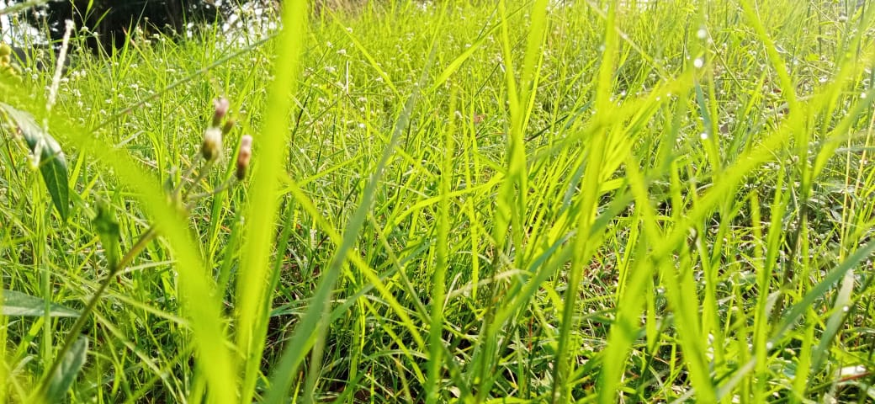
Fig 1: Grass
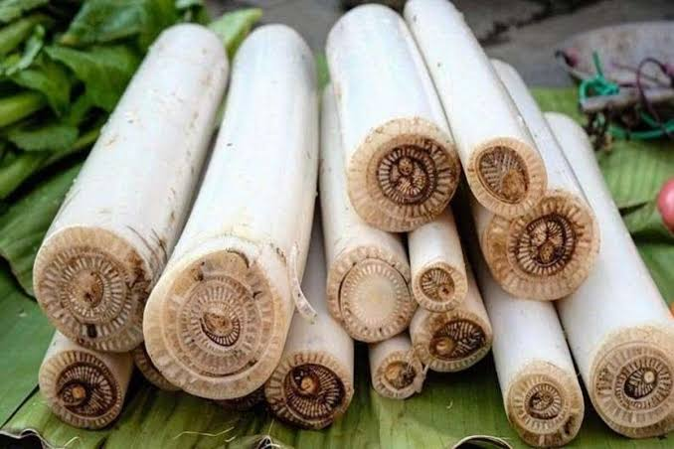
Fig 2: Banana Stem
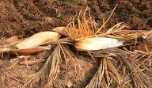
Fig 3: Areca waste

Results and Discussion
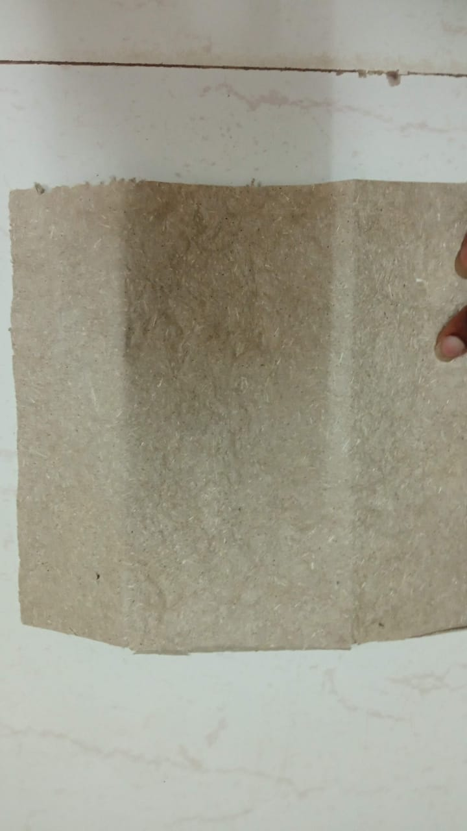
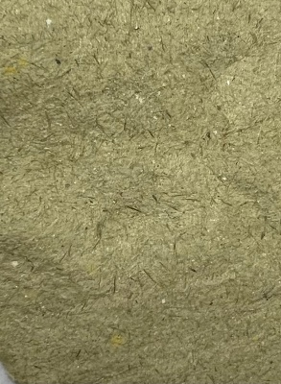
Fig.4 depicts paper made from grass and Areca waste. The first observation relates to the significant amount of ash (about 16%), which is typical for annual plants. Ash content is high for processing in industries. The second observation is the low level of lignin, at 15%, when compared to other annual plants. This raw material is pulpable despite having a high ash percentage, largely due to its low lignin level. The grasses may be swiftly and readily pulped. When examined, it was discovered that the characteristics of grass paper and areca paper were similar to those of the before mentioned agricultural products. This proves that pulp made from these grasses can partially replace hardwood pulp. moderate extent.
Fig. 4: Fabricated Paper from Agro-waste

Conclusion
This study's main goal was to determine if grass and banana stem fibre were suitable as prospective sources of lignocellulosic fibres for manufacturing paper. Banana fiber's low strength and high grass content make it ideal for creating paper. The texture necessary for pulp production was highly grass-like after going through the boiling procedure. In comparison to other raw materials, banana fibre had relatively low permeability; yet, grass fibre had high optical characteristics. Banana stem fibre is not suited for the production of fine paper due to the poor quality of its pulp. Future research is needed, though, to fully characterise the banana and grass fibre and enable its proper use in paper or board sector.
References
- Moghadase Akabri., Hussein Resalti., 2012. Use of agriculture waste in pulp and paper industry. The $1^{th}$ International and the $4^{th}$ National Congress on Recycling of Organic Waste in Agriculture 26 – 27 April 2012 in Isfahan, Iran.
- M. Z. H. Khan, M. A. R. Sarkar, Forhad ibne al imam, M. Zahid h. Khan, and Raimo o. Malinen., 2014. Paper Making from Banana Pseudo-Stem: Characterization and Comparison Journal of Natural Fibres, 11:199–211, 2014 Copyright © Taylor & Francis Group, LLC.
- Mayowa Akeem Azeez., 2018. Pulping of Non-woodyBiomass http://dx.doi.org/10.5772/intechopen.79749.
- Debkumar Chakraborty., Shikha Dahiya., Amulya Kotmraju., S Venkata Mohan., 2019. Valorization of paper and pulp waste Industrial and Municipal Sludge: Emerging Concerns and Scope for Resource Recovery. https://doi.org/10.1016/B978-0-12-815907-1. 00027-1.
- Essam Saber Abd El-Sayed., Mohamad Sakhawy., Mohamed El-Sakhawy., 2020. Non-wood fibres as raw material for pulp and paper industry.
- Mohd Aripin A. Potential of Non-Wood Fibres for Pulp and Paper-Based Industries. Universitiy Tun Hussein Onn Malaysia; 2019

