Determination Of Water Quality by Using Artificial Intelligent
Manjunatha M Katti, Gowtham S, Kirankumar, Raju, Usha M R.
Department of civil engineering CIT. Gubbi, Tumkur-572216

Abstract: Water quality assessment plays a crucial role in ensuring public health and the sustainability of aquatic ecosystems. Traditional water quality analysis methods are often time-consuming, labor-intensive, and require expensive equipment. To overcome these limitations, this project aims to develop a using artificial intelligence (AI) and machine learning (ML) techniques. The proposed methodology involves the collection of water samples from various sources, including rivers, and the subsequent analysis of multiple physicochemical parameters. These parameters may include pH, solids, sulfate, turbidity and conductivity. The collected data will be used to train and validate AI and ML models. Initially, feature engineering techniques will be applied to extract relevant features from the acquired water quality dataset. These features will serve as input variables for the AI and ML models. Multiple algorithms, such as decision trees, random forests, support vector machines, K-nearest neighbor, and XGBoost will be employed to develop predictive models for water quality assessment. The developed AI and ML models will be implemented into a user-friendly software interface, allowing users to input water quality parameters and obtain instant assessments.

INTRODUCTION
As India grows and urbanizes, its water bodies are getting toxic. Every day, almost 40 million liters of wastewater enter rivers and other water bodies, around 80% of India’s water is severely polluted because of people dump raw sewage, silt, and garbage into the country’s rivers and lakes. This has led to water being undrinkable and the population having to rely on illegal and expensive sources. Each year, more than 1.5 million Indian children die from diarrhea. Out of the entire Indian population, experts predict that 40% of people may not have a connection to a clean water source by 2030. Rapid industrial development has prompted the decay of water quality at a disturbing rate. Furthermore, infrastructures, with the absence of public awareness, and less hygienic qualities, significantly affect the quality of drinking water. In fact, the consequences of polluted drinking water are so dangerous and can badly affect health, the environment, and infrastructures.
Therefore, it is very important to analyse and if possible, predict the water quality (WQ).The water quality index (WQI) is a metric that assesses the water quality of a particular location or source by evaluating various physical, chemical, and biological parameters. AI and ML techniques can be used to automate the process of water quality index determination, which can provide a quick and accurate assessment of water quality. There are various methodologies proposed for the prediction and modelling of water quality (WQ). These methodologies include ANN as a prediction analysis, machine learning algorithms for modelling, statical approaches, image recognition, Internet of Things (IoT), etc.
As a powerful data analysis approach, machine learning is widely used to identify patterns or make predictions based on big data generated from different scenarios. Machine learning algorithms can be trained on large datasets of water quality parameters, such as pH, Hardness, solids, turbidity, and various physical and chemical parameters, to identify patterns and relationships among them. These algorithms can then use these patterns to predict the water quality index of a given location or source based on its water quality parameters. Before machine learning is applied in practice, data acquisition, appropriate algorithm selection, model training, and model validation need to be conducted. Among these processes, the choice of algorithm is crucial. Supervised and unsupervised learning are two main classes of machine learning technologies. The main difference between these two classes is the presence of labels in the datasets. Supervised learning deduces predictive functions from the labelled training datasets. Each training instance includes input values and expected output values. Supervised learning algorithms try to identify the relationships between the input and output values and generate a predictive model to predict the result based on the corresponding input data. Supervised learning can be used for data classification and regression, and a variety of algorithms, including, support vector machine (SVM), Decision Tree (DT), Random Forest classifier, k-nearest neighbour (K-NN), and XGBoost, etc. have been developed.
In contrast, unsupervised learning is usually used to handle data without labels, solving various problems in pattern recognition based on unlabelled training datasets. Unsupervised learning classifies the training data into different categories according to their different characteristics, mainly based on dimensionality reduction and clustering. However, the number of categories is uncertain and is the meaning of each category clear. Therefore, unsupervised learning is usually used for classification and association mining. Principal component analysis (PCA), K-means, etc. are the commonly used unsupervised machine learning algorithms.

MATERIAL AND METHODOLOGY
PARAMETERS
Parameters are the basic and most important component of a model. Based on the parameter model prediction and it shows the skill of the model over the data. Similarly, machine learning algorithms also have some parameters to predict water quality. We take 6 parameters to predict the water quality. Those parameters are:
- PH
- Hardness
- Sulfate
- Solids
- Turbidity
- Conductivity

To predict whether the water is drinkable or not, IS 10500-2012 provides some standard values as mentioned below,
Table: - IS 10500-2012 standard water parameters
Parameter | IS limit
pH | 6.5 to 8.5
Hardness | 200 to 600mg/l
Solids | 500mg/l
Sulfate | 200 to 400mg/l
Turbidity | 1 to 5NTU
Conductivity | 50 to 1500 µS/cm

Water quality index calculation
Water Quality Index Calculation. To measure water quality, WQI is used to be calculated using various parameters that significantly affect WQ. In this study, a published dataset is considered to test the proposed model, and seven significant water quality parameters are included. The WQI has been calculated using the following formula:
WQI = ∑N i=1qi × wi
∑N i=1wi

where q is the boundary of that parameter, w factor is the weight of that parameter.
On the basis of WQI value it is determined that the quality of the water is drinkable or not.

Working
Experimental Setup.
The experiment have been conducted in a specific environment (Visual Studio code 2017 and python)

- Data Extraction: - In this, we extract the data from the internet to train our data and predict the water quality. It contained 3277 samples from different Indian states during the period from 2014 to 2020, but in this dataset, we have taken only 500 samples to analyze the water quality. The data set has six significant parameters, namely, pH, Hardness, solids, sulfate, turbidity, and conductivity. Data was collected by the Indian government to ensure the quality of the supplied drinking water. This dataset was obtained from Kaggle https://www.kaggle.com/datasets/adityakadiwal/water-potability.
- Data Exploration: - In this step, we analyze the data visually by comparing some parameters of water with the IS standards of water (IS 10500-2012). It gives a slight overview of the data.
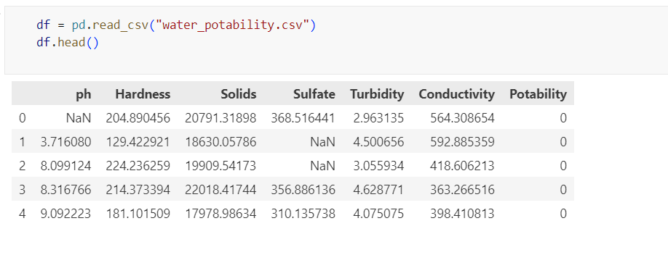
- Data pre-processing: Clean the dataset by handling missing values, outliers, and inconsistencies. This step may involve data normalization, transformation, or feature engineering to enhance the performance of the machine learning algorithms.
- Counting Rows and Columns in the dataset
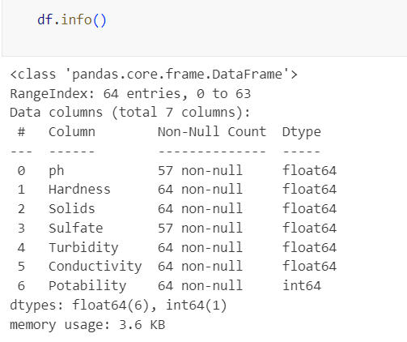

- Statistical Analysis
From the above table, we can see that the count of each feature is not the same. so there must be some null values. Feature Solids has a high mean and standard deviation compared to other feature. so the distribution must be high
.
- Checking For Missing Values
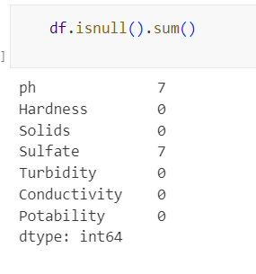
Data Cleaning: - In this step,as we can see that ph and solids has the missing we replace them with mean and remove noise from the data.

Graphical representation of missing null values:
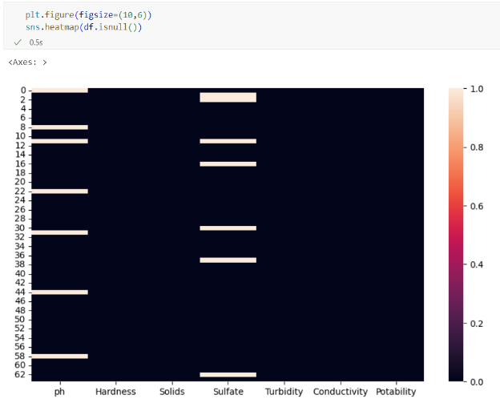
- graphical representation of heat map
This graph indicates there is no null values
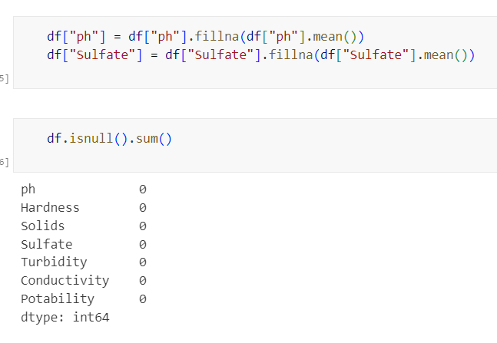

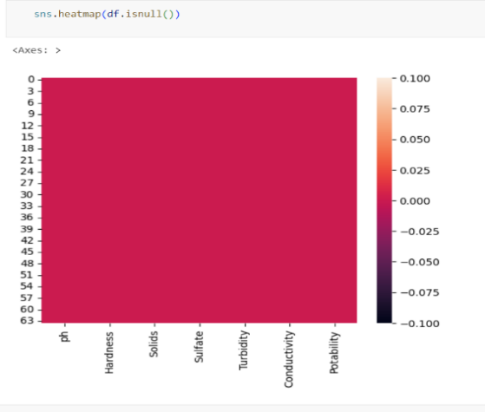

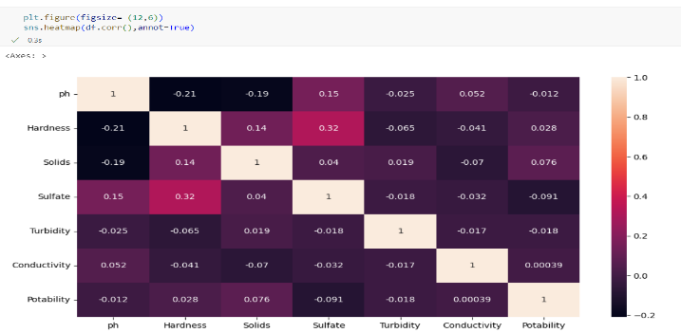
Exploratory Data Analysis

- Plotting bar chart between potability and count
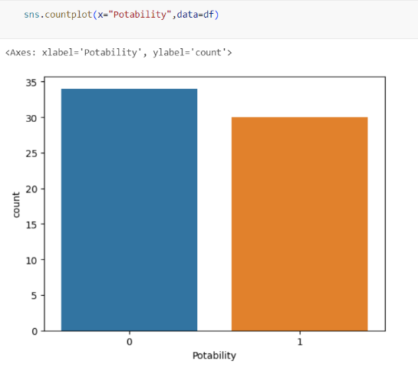

- Plotting pie chart of potable water and unpotable water
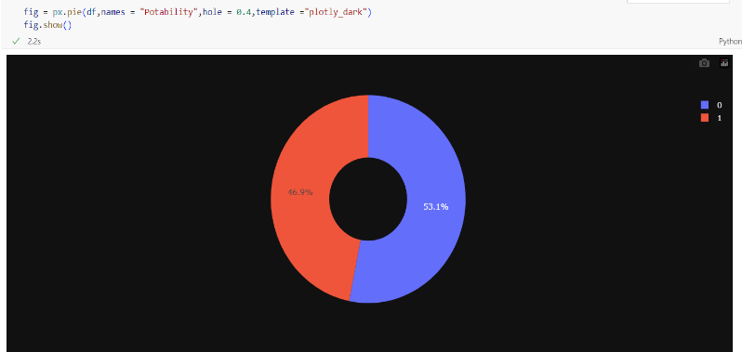

- Predicting water sample as potable or unpotable
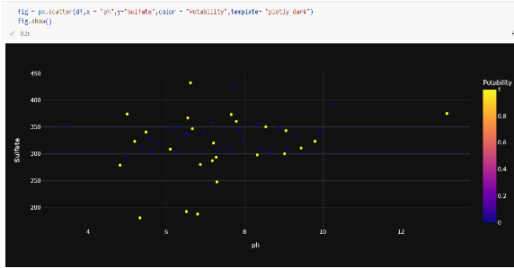
Depending on the Sulphate and P^{H}

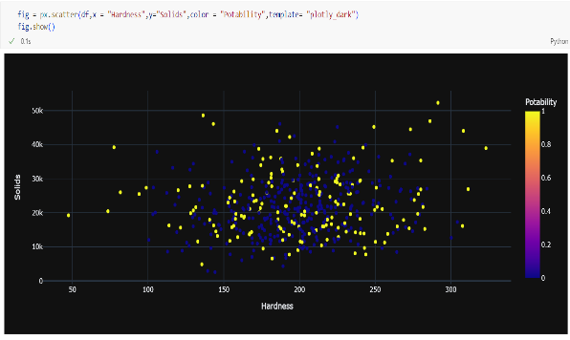
Depending on the Hardness and Solids

- Graphical representation of missing null values
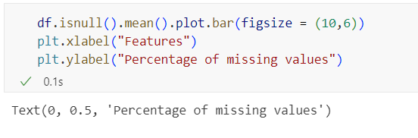

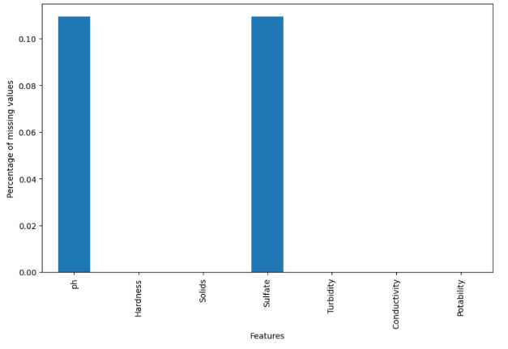

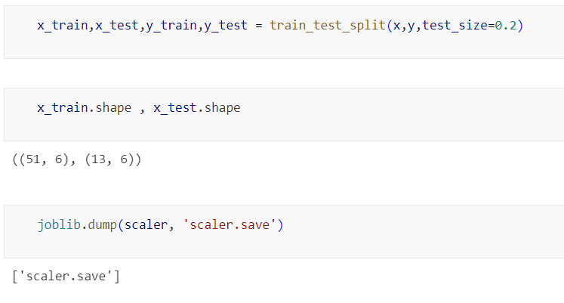
Data Splitting: - In this step, we divide the dataset into 80-20 %. Normally, with a two-section split, 80% of data is utilized for analysis or testing purposes and the other 20% is used to prepare the model.

Machine learning algorithm classifiers
- Decision tree classifier:
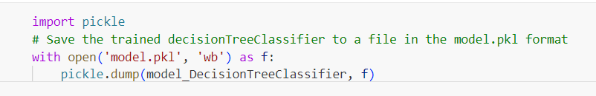
A decision tree is a type of supervised machine learning algorithm that is commonly used for classification and regression tasks. It works by recursively splitting the data into smaller subsets based on the values of the fatures (or input variables) until a certain stopping criterion is met.
Here's a step-by-step explanation of how a decision tree works:
The algorithm starts by selecting a feature that best splits the data into two groups based on the values of that feature. The goal is to find a feature that maximizes the "purity" of the subsets - that is, to split the data in a way that minimizes the amount of "mixing" between different classes or values.
The data is then split into two subsets based on the chosen feature. Each subset contains data points that have similar values for the chosen feature.
The algorithm repeats the process for each subset, selecting another feature that best splits the data and creating more subsets. This process continues until a stopping criterion is met, such as reaching a maximum depth, reaching a minimum number of samples in a node, or achieving a minimum level of purity.
Once the tree is built, it can be used to make predictions on new data. When a new data point is presented, the algorithm traverses the tree from the root node to a leaf node, making decisions based on the values of the features at each node. The leaf node reached by the algorithm represents the predicted class or value for the new data point.
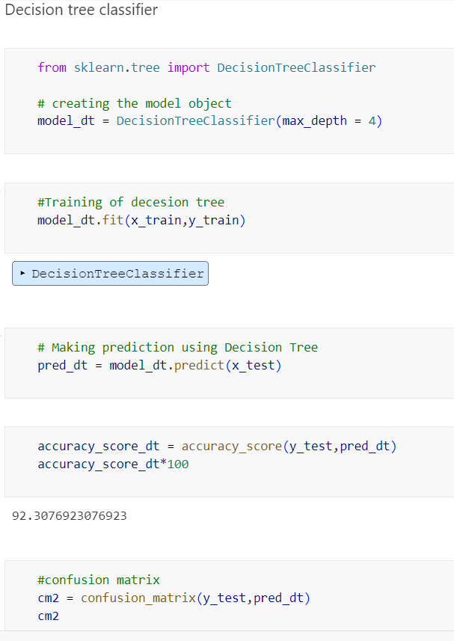
Decision trees have many advantages, including their interpretability and ability to handle both categorical and continuous data. However, they can also be prone to overfitting and may not always generalize well to new data.
- Random Forest Classifier:
Random Sampling: A random forest is built on multiple decision trees, and each tree is trained on a random subset of the training data. This is known as random sampling with replacement, or bootstrapping.
Feature Selection: At each node of the decision tree, a random subset of the features is selected as candidates for splitting the data. This helps to reduce overfitting by ensuring that each tree is trained on different features.
Decision Tree Construction: Each decision tree is constructed by recursively splitting the data into smaller subsets based on the selected features until the subsets contain only one class or a pre-defined stopping criterion is met.
Majority Voting: Once all the trees have been constructed, they are used to predict the class of new data by majority voting. Each tree in the random forest classifier makes a prediction, and the class that receives the most votes is selected as the final prediction.
Evaluation: The performance of the random forest classifier is evaluated using metrics such as accuracy, precision, recall, and F1-score.
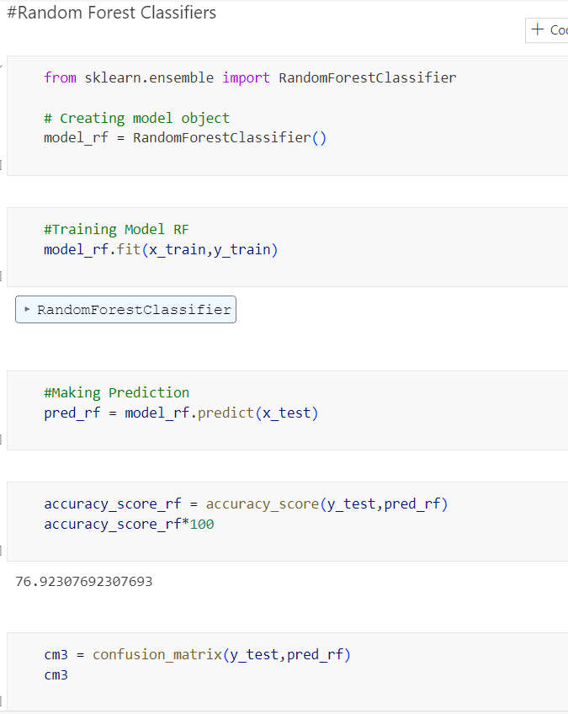
Overall, a random forest classifier works by building multiple decision trees on random subsets of the training data and features, and combining the predictions of these trees using majority voting to produce a final prediction. This helps to reduce overfitting and improve the accuracy of the classifier.
- K-Nearest neighbour:
K-nearest neighbour (KNN) is a type of supervised learning algorithm in machine learning that can be used for both classification and regression tasks. It is a non-parametric algorithm, which means it does not make any assumptions about the underlying distribution of the data.

In KNN, the "k" refers to the number of nearest neighbours that are considered for making predictions. For example, if k=3, then the algorithm will consider the 3 nearest neighbours of a test instance in the training data and make a prediction based on the majority class (for classification) or the average value (for regression) of those 3 neighbours.

KNN works by calculating the distance between the test instance and all the instances in the training data, and then selecting the k nearest neighbours based on this distance measure (usually Euclidean distance or Manhattan distance). The algorithm then uses the majority class or the average value of these k neighbours to make a prediction for the test instance.

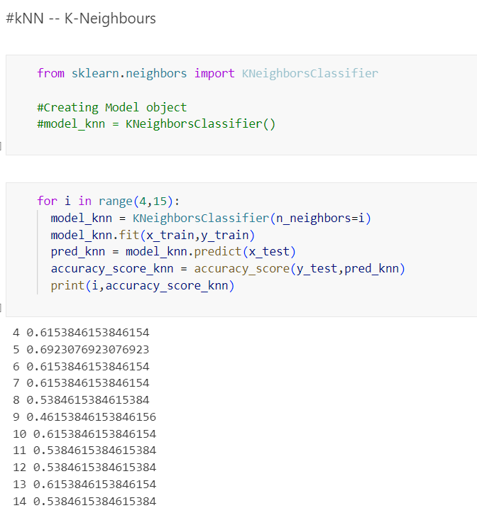
KNN is a simple yet effective algorithm that can be used for a variety of machine learning tasks, especially when the dataset is small or the underlying relationship between the features and the target variable is complex. However, it can be computationally expensive and may not perform well with high-dimensional data or imbalanced datasets.
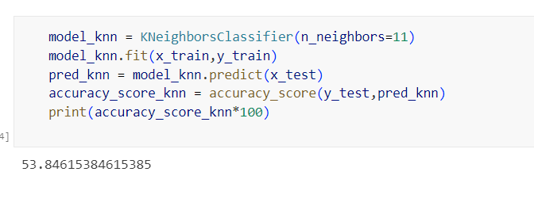
- Support vector machine (SVM):
Data pre-processing: The first step in using SVM is to pre-process the data by cleaning, transforming, and normalizing it. This includes removing any missing or irrelevant data, scaling the features to have zero mean and unit variance, and transforming the features to a higher-dimensional space if necessary.
Selecting the kernel function: The next step is to select a kernel function that will be used to map the data into a higher-dimensional space. The most commonly used kernel functions are the linear, polynomial, and radial basis function (RBF) kernels.
Choosing the hyperparameters: Once the kernel function is selected, the next step is to choose the hyperparameters that govern the behaviour of the SVM algorithm. These include the regularization parameter C, which controls the trade-off between the margin and the classification error, and the kernel parameters (e.g., the degree of the polynomial kernel, or the gamma parameter of the RBF kernel).
Training the SVM model: After selecting the kernel function and the hyperparameters, the SVM model is trained by finding the hyperplane that separates the data points of different classes with the maximum margin. This is done by solving a constrained optimization problem that maximizes the margin subject to some constraints.
Predicting new data: Once the SVM model is trained, it can be used to predict the class labels of new, unseen data points by evaluating the sign of the decision function, which is defined as the dot product between the test point and the support vectors in the kernel space.
Evaluating the performance: Finally, the performance of the SVM model is evaluated using various metrics such as accuracy, precision, recall, and F1 score. These metrics are calculated by comparing the predicted class labels with the true class labels of the test data.
Overall, SVM is a powerful machine learning algorithm that can be used for both classification and regression tasks. Its ability to handle non-linear data and its robustness to noise and outliers make it a popular choice for many real-world applications.
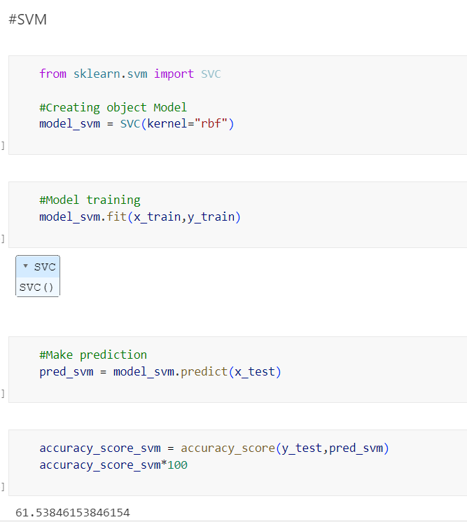

- XGBoost:
XGBoost works by constructing an ensemble of decision trees iteratively, where each subsequent tree is built to correct the errors of the previous one. The general idea behind XGBoost is to optimize a loss function that measures the difference between the predicted and actual values of a target variable.
Here is a brief overview of how XGBoost works:
The algorithm starts with a single decision tree, which makes a prediction based on a set of input features.
The prediction of the first tree is compared to the actual value of the target variable, and the difference between the two is used to compute a loss function.
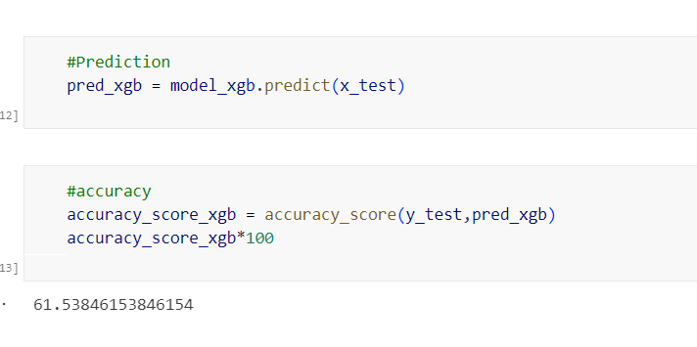
The second tree is then built to correct the errors of the first tree. This is done by training the second tree on the same set of input features, but with weights assigned to the training samples based on their error from the first tree.
The process is repeated for multiple iterations, with each

subsequent tree being built to correct the errors of the previous trees. The final prediction is obtained by taking the weighted average of the predictions of all the trees in the ensemble.
In addition to the basic gradient boosting algorithm, XGBoost includes a number of optimizations and regularization techniques that improve its performance and generalization ability. These include:
Shrinkage: reducing the contribution of each tree to the final prediction to avoid overfitting.
Column sampling: randomly selecting a subset of features at each iteration to reduce the correlation between the trees and improve generalization.
Row sampling: randomly selecting a subset of training samples at each iteration to reduce the risk of overfitting.
L1 and L2 regularization: adding penalties to the loss function to encourage simpler and more robust models.
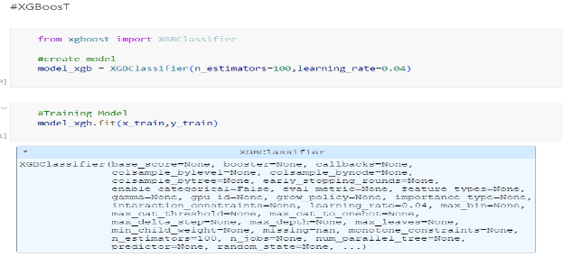
Overall, XGBoost is a powerful and flexible algorithm that can be used for a wide range of machine learning tasks. Its ability to handle missing values, support multiple objective functions, and work with different types of data makes it a popular choice among data scientists and machine learning practitioners

Comparison with different models:
By checking the accuracy score of each models we need to select model which having high accuracy score, by using that model we have created web page we can use this web page for testing purpose.
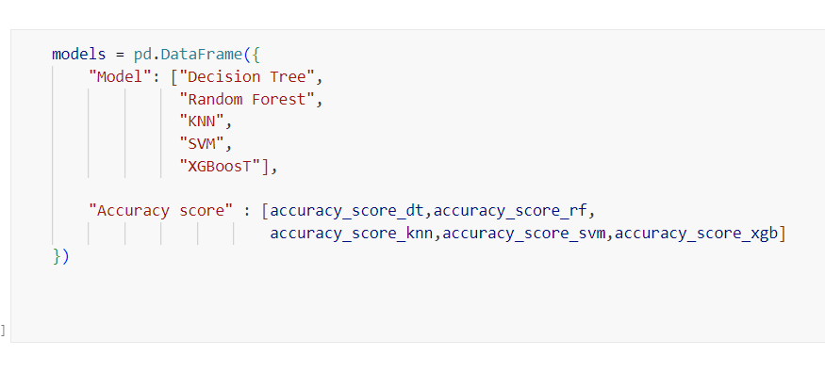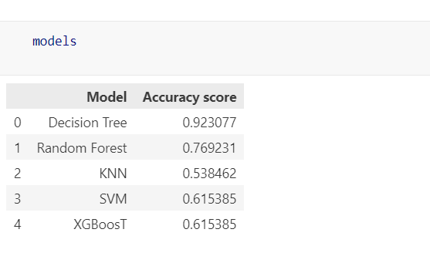
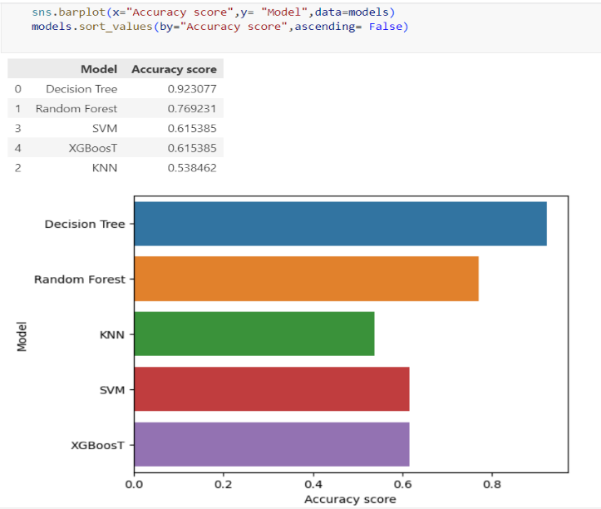
Graphical representation by comparing the different models to get high accuracy of prediction:

To create an web for classification of water sample as potable or unpotable based on its parameter:

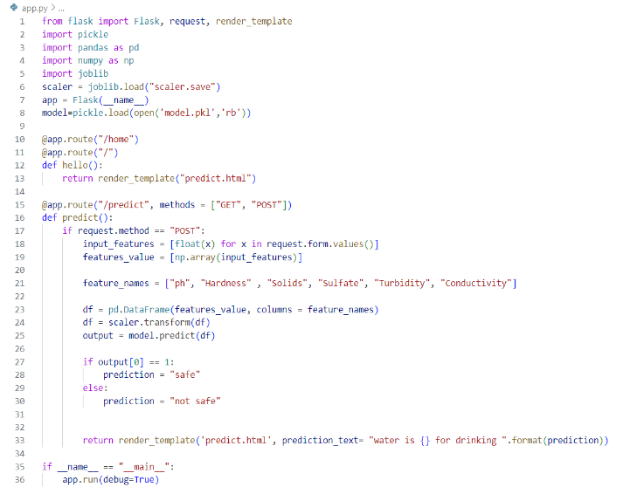
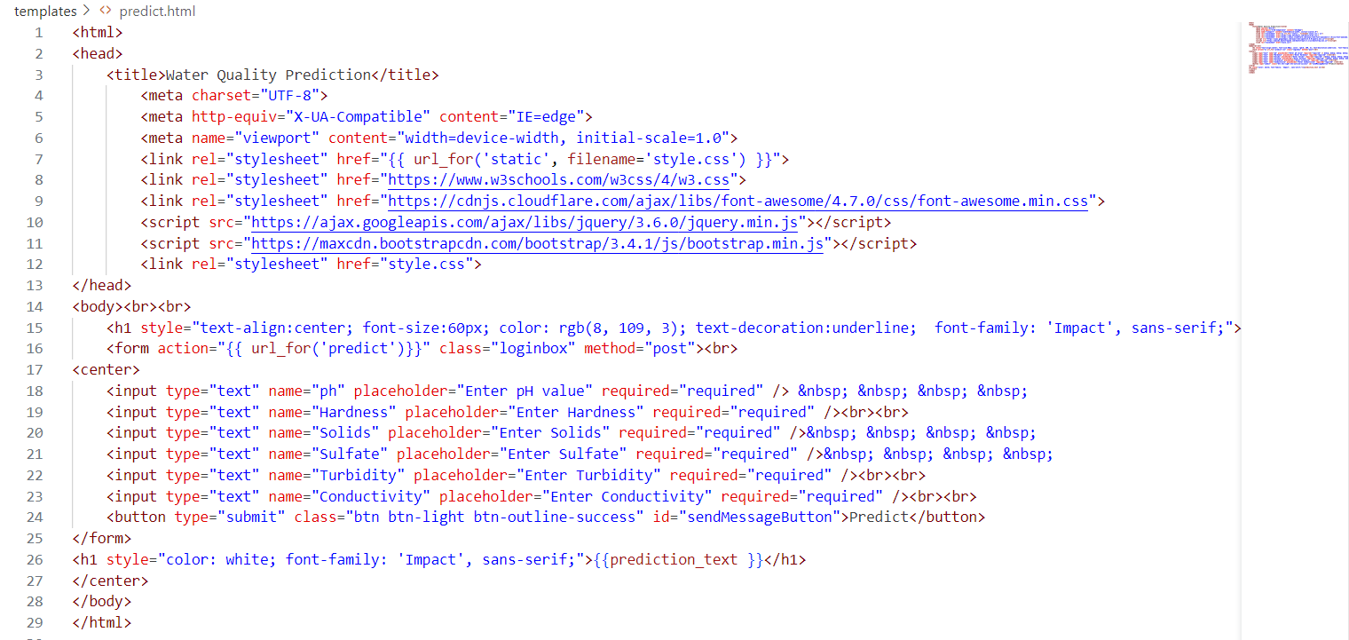
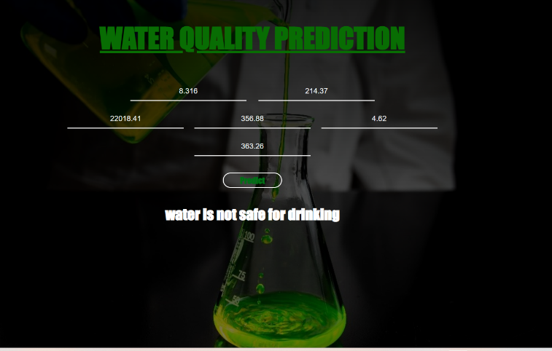
SAMPLE PREDICTION

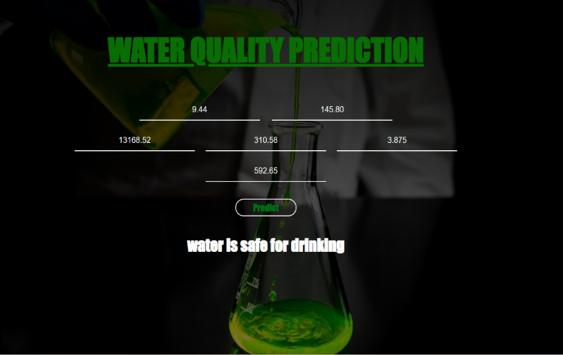
Sl.no 5: SHIMSHA AT D/S OF BRIDGE, HALAGUR
Sl.no 11: KABBANI AT SARAGUR VILLAGE D/S

CONCLUSION
k-nearest neighbour, decision tree classifier, random forest, support vector machine, and XGBoost are the 5 machine learning classifiers that we employed. We found that the decision tree classifier provided the highest performance in these cases (92% accuracy), thus we utilised it to forecast the water quality. We developed a website in Chapter 4 for analysing or forecasting a water sample. Below is a list of this website's results.
Sample no from data set | Sample location | Prediction result
5 | SHIMSHA AT D/S OF BRIDGE, HALAGUR | unsafe
11 | KABBANI AT SARAGUR VILLAGE D/S | safe
25 | GHATPRABHA AT D/S OF MUDHOL RD. CROSS BDG, KARNATAKA | unsafe
36 | GHATPRABHA AT D/S OF MUDHOL RD. CROSS BDG, KARNATAKA | safe

The above predicted results is based on potability of water, if potability value is 0 which means the water is unsafe for human consumption and if potability value is 1 which means the water is safe for human consumption as looking to the predicted result it gave the correct result as per the trained data so we can use this web for future classification for any projects.

REFFRENCE:
[1]. Roman Trach, Yuliia Trach, Agnieszka Kiersnowska, Anna
Markiewicz, Marzena Lendo-Siwicka and Konstantin Rusakov:
In their paper entitled “A STUDY OF ASSESSMENT AND PREDICTION OF WATER QUALITY INDEX USING FUZZY LOGIC AND ANN MODELS”.

[2]. Theyazn H. H Aldhyani, 1 Mohammed Al-Yaari , 2 Hasan Alkahtani,3 and Mashael Maashi
In their paper entitled “WATER QUALITY PREDICTION USING ARTIFICIAL INTELLIGENCE ALGORITHMS”.
[3] Sai Sreeja Kurra, Sambangi Geethika Naidu, Sravani Chowdala, Sree Chithra Yellanki, Dr. B. Esther Sunanda.
In their paper entitled “WATER QUALITY PREDICTION USING MACHINE LEARNING”.
[4] Nishant Rawat1 , Mangani Daudi Kazembe2 , Pradeep Kumar Mishra:
In their paper entitled “WATER QUALITY PREDICTION USING MACHINE LEARNING”.

