

Resaerch Paper
Title- Perception of Consumer Towards Digital Marketing.

FOR THE PARTIAL FULFILLMENT OF THE REQUIREMENT
FOR THE AWARD OF
BACHELORE IN BUSINESS ADMINISTRATION
(MARKETING AND AUTOMOBILE MANAGEMENT)



Submitted By;
JEETESH PACHAURI
20GSOB1060033

DECLARATION

On the basis of the project report submitted by Jeetesh Pachauri, a student of Bachelor of Business Administration, I hereby certify that the project report "Perception of Consumer Towards Digital Marketing," which is submitted to the Department of Management, School of Business (MAM), Galgotias University for the partial fulfilment of the requirement for the award of the degree of Marketing and Automobile Management, is an original contribution with existing knowledge and a faithful record of work carried out by him under my guidance and supervision.

Galgotias University, Greater Noida
Date:05.04.2023

Signature of Guide (Internal) Signature of Student
Jeetesh Pachauri
Dr. Rejhi John
Assistant Professor

Content

Title page
Declaration
Preface
Abstract
Introduction
Literature review
Objectives
Research Methodology
Survey
Introduction on the topic
Components of digital marketing
Findings
Reference

Preface
This research article is entirely original, meaning that no information has been taken from another source. This research paper was written with the intention of expanding and gaining expertise in the marketing industry. This study report provides extensive information on the subject of digital marketing. Secondary data is the foundation for both the survey and this research study. This research paper's primary goal is to provide in-depth understanding about the field of marketing, specifically regarding the subject. The topic is "perception of consumers towards digital marketing," which refers to how customers view digital marketing based on the mental impressions made on them. The effects of various digital marketing strategies on consumers' minds vary.

Perception of consumer Towards Digital Marketing

Abstract:

Digital marketing is the practise of marketing a product using the internet. Social media marketing, email marketing, search engine optimisation, search engine marketing, What's App marketing, and so on are all examples. As the issue is titled "Consumer Perception of Digital Marketing," how customers view digital marketing is determined by their attitude. It has both a positive and bad impact on the thoughts of consumers. It benefits marketers and many businesses in a variety of ways, as digital marketing enables organisations and businesses to scale their operations. Pay-per-click, content marketing, affiliate marketing, mobile marketing, and marketing are all components of digital marketing. Search engine optimisation, search engine marketing, and Google Analytics are all examples of online marketing.
Key word – Digital Marketing
Introduction
When it comes to vocabulary, internet marketing and digital marketing are frequently muddled. The practise of publicising commodities and a firm that delivers products and services on an online platform is known as digital marketing. In simple terms, digital marketing differs from traditional marketing because it involves the use of online techniques and processes that allow businesses and organisations to keep an eye on the improvement of their marketing campaign on a regular basis to determine whether it will work or not. Almost every company's web presence has already advanced in the twenty-first century. Email was the most generally utilised method, and modern technology now allows individuals to handle it easily. Customer Relationship Management systems had been used to manage records in a specific sector for several years. Few corporations had already placed advertisements on their websites with the same intention of favoured marketing. Companies with positive thinking generally focused on their search engine strategy, and some of them collaborate with their affiliates. This is internet marketing, thus online marketing members or experts have already begun to emerge. Digital marketing is the most often used, and its most typical form is the organization's website or the main hub of all its online services. Savvy marketers use a combination of content marketing, affiliate marketing, mobile marketing, and email marketing to generate capable visitors to a website and incentivize the same client.

Literature Review
Gangeshwer's (2013) study article focuses on valuable information available for online purchase and factors impacting e-commerce conditions. With the rapid growth of internet usage in the twenty-first century, an online platform is poised to play a critical role in providing new opportunities to both large and small businesses. As a result, the online platform is doomed to evolve in terms of producing revenue through sales or geographic reach in India. According to Todar (2016), the usage of traditional marketing is diminishing year after year due to the excessive use of the internet by the new generation of customers who prefer to shop on online platforms.However, research tells that the utilization of traditional marketing still exists among the developed class of customers. Hence the research suggests that one of the perfect ways for a company is to create a mixture of both techniques which is a mixing of both the procedures of traditional and digital marketing which will fulfill the requirement of both the class which developed a class of customers as well the customers of the new generation. Sathya (2016) researched the consequences of Digital marketing and said that digital marketing is the best way for publicizing goods and services by utilizing digital techniques and the most commonly used is the internet, which also indulges the utilization of mobile phones, display advertisements or the utilization of any other digital platform. Nadaraja and Yazdanifard (2016) conducted research to determine the benefits and drawbacks of social media marketing as the primary tool for marketers seeking to connect with their target customers. This platform has many advantages and disadvantages, and businesses are still figuring out how to deal with it.
Objectives
The goal of this research paper is to thoroughly understand the themes. To have a thorough understanding of the components of digital marketing. To fully comprehend the digital marketing study and to learn how customers perceive digital marketing.
Research Methodology
Secondary data is used in this study report. Secondary data is used in the survey. To comprehend the subject, information from numerous websites was gathered. PDFs from various websites were used to study more about the issues in depth.
Survey on digital marketing
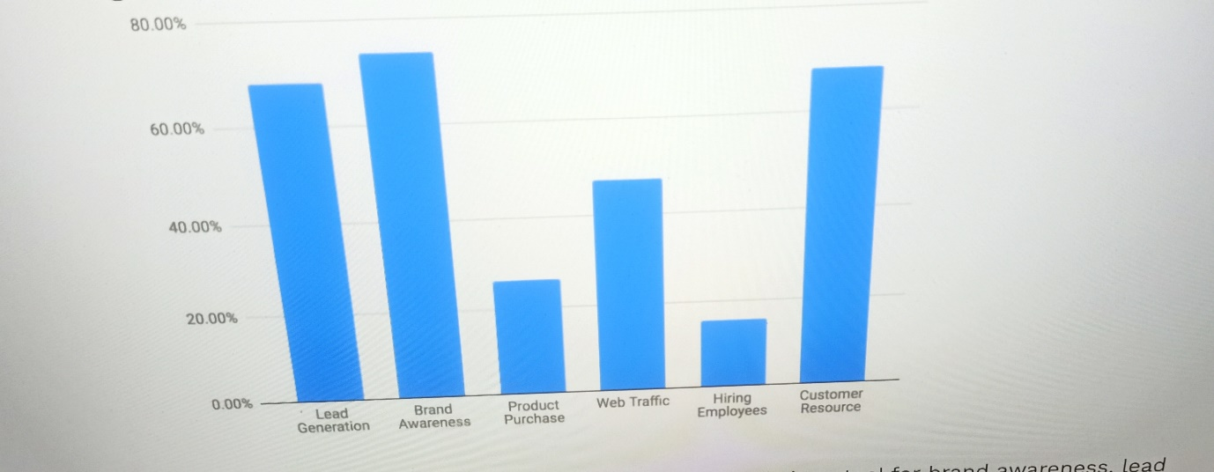
Source- Powder keg webdesign.com

These bar charts show what the main goals of digital marketing were. In this bar chart, the main goals of digital marketing are
1. lead generation,
2. brand awareness,
3. product awareness, and
4. Web traffic
5. Employee hiring
6. Customer resources etc.
Speaking of percentages, the lead generation percentage is 80%-60% and the brand awareness percentage is 80%-60%, but the brand awareness bar chart Slightly higher compared to the generated bar chart. The product purchase rate is less than 40%, but the product purchase bar chart is between 40% and 20%. The percentage of web traffic is less than 60% but between 60% and 40% and its bar chart is higher than the bar chart for product purchases. Adoption is very low, less than 20%, and the bar chart is between 20% and 0%.
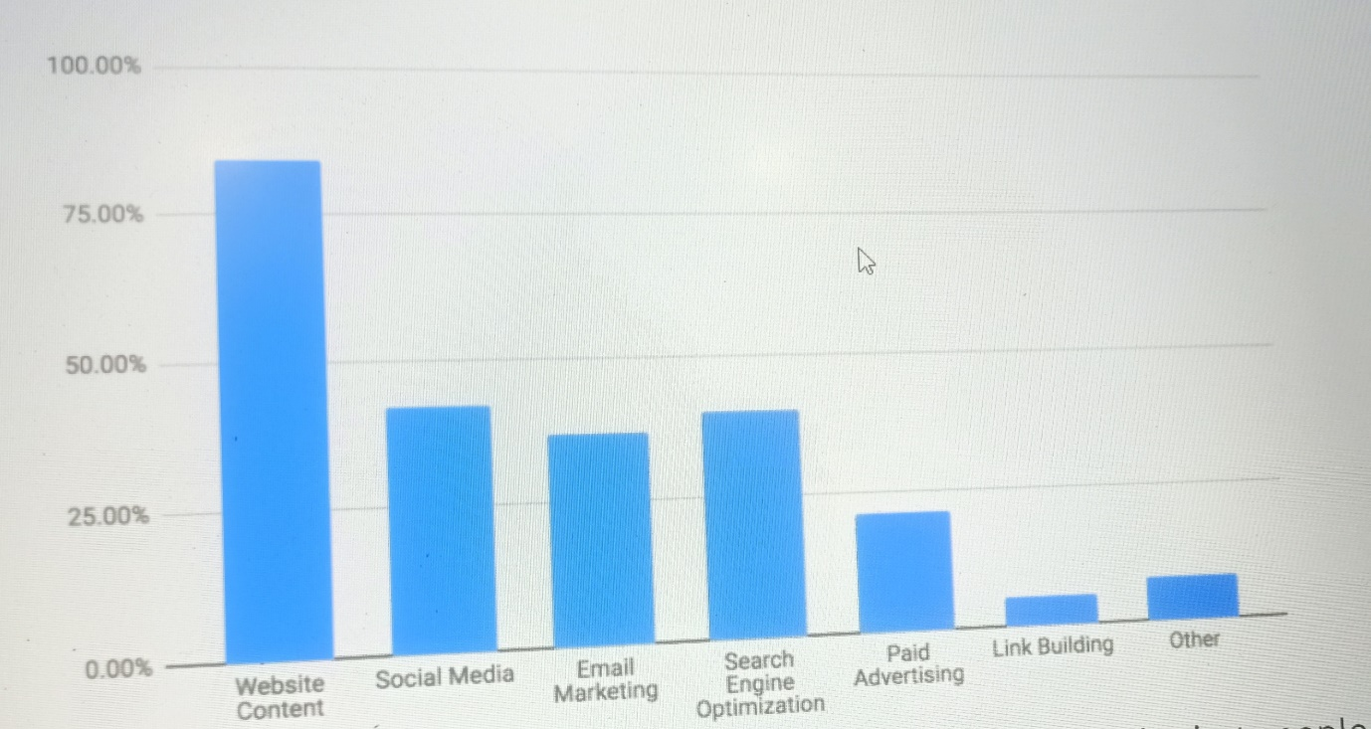
Source- Powder keg web design

This second bar graph explains what digital methods were most effective for your organization So, in this, we can see that website content social media, email marketing, Search Engine Optimization, paid advertising, link Building, and others were effective digital methods for an organization. But if we talk about percentage then the percentage of website content is much higher as compared to any other digital method so the percentage of website content falls between 100% to 75%. If we talk about the percentage of social media then it is much lesser as compared to the percentage of website content. The Percentage of social media falls between 50% to 25 % and the bar graph of website content is also higher as compared to the bar graph of social media. The Percentage of email marketing falls between 50% to 25% and its bar graph is also lower as compared to the bar graph of social media. The Percentage of search engine optimization falls between 50% to 25% and the bar graph of search engine optimization is higher as compared to the bar graph of email marketing. The Percentage of paid advertising is lesser as compared to any other digital method. The Percentage of paid advertising falls between the percentage of 25% to 0%. The Percentage of link building is very much lesser and also its bar is very lower as compared to any other bar graphs of digital methods. Its percentages fall between 25% to 0 %. The Bar graph of other is higher as compared to the bar graph of link building and its percentages fall between 25% to 0%.
Now we can able to tell from these bar graphs that it will create a different impact on the mind of the consumer towards perception on digital marketing. In both the bar graphs we can able to see bar graphs keep on fluctuating and hence either it will create a positive impact or the negative impact on the minds of the consumer.

How does consumer perceive towards digital marketing?

It depends upon the mind of the consumer and how the consumer perceives digital marketing. Now it depends on the marketers, company, and business organization as well as the organization how they do digital marketing of their products. So before doing digital marketing of their product they have to keep a lot of things in their mind when they have to choose the segmentation whether they will go for demographic segmentation, psychographic segmentation, or they will go for geographic segmentation. So, if they go for clothing then they will have to choose geographic segmentation because they will have to choose that first of all which state or city they have to cover because cloth is the type of product that gets the maximum no. of purchases in the state or in a city which is densely populated and the transportation network should be good also so clothes can able to reach the city on time otherwise in digital marketing if it is shown in google ad that the product will reach to the town or state by 13th October 2022 and if the product reaches its destination by 20th October 2022 then digital marketing will create a negative impact on the mind of the consumer because product can’t able to reaches its destination on time because of poor transportation network or due to some any other factors also. If they go for a mobile phone then they have to do the digital marketing of this product in a very careful way and for this product but a mobile phone is that type of thing without which we can’t able to spend a single day without it and hence they have to carefully do the digital marketing of a product so they have to go for psychographic segmentation.
Components of Digital Marketing

- Search Engine Optimization
Search engine optimization is a procedure of search engine marketing. It utilizes google and different search engines to run traffic to your website which you want to utilising it. It works in this way by presenting your website upper in google findings for key searches which is useful for your asset’s products and services. Search engine optimization is the technique to produce and make creativity in a website and because of this search engines rank at the top as compared to other pages. It must be aimed at keyword marketing and pay-per-click advertising. The advancement in the technology permits advertiser’s agency to aim at particular key words and sentences and make sure that the advertisement displays the consequences of search engines. With the improvement in management, the amount is increasing when it comes to higher stages of rivalry. Different types of advertisement agencies want to increase their working capacity. Which indulges in expanding search engines or indulging huge keywords. A greater number of advertisers are wanted to go with the pay-for-click. If the ranking of the advertisement is higher so due to this it results in the generation of higher traffics.

Reason for selecting Search Engine Marketing techniques

- Building a Sem account is much easier and can create traffic faster depending on the level of rivalry.

- The marketer utilizes search engines to search the relevant data which results in building trustful relationships aiming at the references which show many platforms, especially in result platforms.

Benefits of using Search Engine Optimisation

- It provides you with a rival benefit
- It provides support in increasing PPC campaigns
- It assists in content marketing
- It will not cost you anyhow
- It creates an impact on the credibility
- It provides support in connecting with a large number of audiences
- It helps to keep you on the top of the rank in local findings
- It helps in the betterment for the utilization of the website
- Utilisers can able to get relevant and better results
- It helps in the improvement of the utiliser’s engagement rates

Disadvantages of using Seo

- It utilizes a lot of time and effort
- It creates penalties when not done in a proper way
- It needs consistency in the maintenance
- It does not give benefits at the starting
- It does not confirm whether we can able to get results or not
- You have to compete with the rest of the internet otherwise it will create difficulty for you
- The services provided by Seo its cost is much higher

Examples of Seo
- Making lists
- Creating platforms

Content Marketing

Content marketing is a terminology that means improvement or to give useful information, blog, letters, newspapers, whitepapers, social media posts, emails, videos, etc., or just like the present and current potential consumers. When it is done in a proper way this content indicates professionals and it makes sure that the company must respect its customer to which they sell their goods and services. The regular utilization of content marketing creates and builds relationships through consistent and regular customers. When your customer thought about your company as a friend and wants to know about their success and useful material of suggestion and guidance or advice then the chances of getting selected increase when it times to purchasing goods and services available in the market.
Content Promotion
The word "content marketing" refers to enhancing or providing helpful information through blogs, letters, newspapers, whitepapers, social media posts, emails, videos, etc., or by simply acting like current and potential customers. When properly executed, this material demonstrates professionalism and ensures that the business must respect the customers to whom it sells its goods and services. Through consistent and regular consumers, the regular use of content marketing fosters and builds relationships. When a consumer views your business as a friend and inquires about their achievements and helpful information, counsel, or advice, their chances of being chosen when making purchases of goods and services on the market grow.

How does content marketing work?

Your business utilizes content marketing so that they can able to generate a greater number of clients in case goods and services that customers want and they that what to buy and what not to buy before the sales get closed. To utilize it in a proper way you will require to provide the best information at every level of the sale cycle starting from the awareness and then coming to consideration and then comes to purchasing goods and services available in the market. If this looks like a complicated method then we don’t need to worry about it. Reaching content in this process helps to simplify the method. Now let’s see how the company utilizes content marketing at every level of the sales cycle to involve and sell.

Awareness Stage

In the initial level of sales method, your list should aim at awareness which can be on the top for your customers. Customers can able to write in such a way that they know about the pain points, challenges, and questions which provides you with the best opportunity for involvement with them. Content at the conscious level needs to be educated, on how to give advice to their customer we need to save our selling for accepting or ending phases. The Best list for this level includes articles, blog posts, e-books, videos, newsletters, etc.
For instance, a restaurant creates a blog and then they posted it on a different platform so that they can able to think that how to plan a list for a graduation party in the spring season. A bike touring company can able to create a small clip on the subject matter with three methods to select the correct bike ride. An architecture company can able to make an e-book which is known as the query to put before recruiting an architect.

Consideration Stage
At the deliberation level, the list should be able to give flexible and useful content in marketing. It can able to teach the learner which types of characteristics and methods they have to look at and how different techniques represent their requirements. And definitely, our list should be bent forward in the direction of what our business gives. For instance, in a mobile phone which is based on a cloud system these types of specifications, and characteristics can help to improve customer service as much as possible. A prospective company can able to make a case study regarding the huge blunder that many people can create when they recruit a landscape person. A serving company represents a case study of the victorious program which aims at the advantages they provide for instance how to occupy food problems at another program and how to make sure that your services utilize a sustainable approach.

Closing Stage

Content marketing is that type of strategy which generally plays a vital part when possibilities are nearer to purchase. At this level one can aim on selling till the time you can able to maintain consistency for driving to your house when you have the better option instead of how perfect your products and services are.
Our central message should be their expertise, information, and distinguishing advantages of what you are selling. For instance, an organization that gives advice generates an investigating result which shows that businesses that involve in strategic planning, predictions by the outlander and different assistance, predicted by which type of assistance they will provide understanding the highest evolution. A manufacturer manager generates smaller clips focusing on the range in which they perform tasks in varieties of working areas to show a variety of professions. A doctor who practices his professionalism motivates his/her outpatient to make contributions in testimonials regarding their state of perfection material or top-class assistance.

How do I get started with content marketing?

Doing content marketing makes you feel good, but that's not all. The perfect content marketing event should be progressive and sustainable. A number of measures should be taken first.
1. Customer Choices - Building a platform for a specific audience requires a good understanding of customer choices, issues they face, preferences, etc. Second, you must have adequate knowledge or detailed information about the various departments. You can choose 1 or 2 to write on behalf of those departments. If you don't do this, you need to know your customers and their preferences before you start.
2. Determine the right content – ​​The right content is related to the stage of the sales pattern you are building your listings for. Another important question is how can we better demonstrate importance? Sometimes it's a clip, sometimes it's a checklist.
social media marketing
Social media marketing is the use of social media platforms and sites to promote products. This may take the form of advertising, influencer marketing, or posters to promote products. In other words, social media marketing is the practice of creating a list of social media websites to promote different categories of products and services. Build connections with your customers of choice and do it on your website. With the advancement of new technologies, they continue to grow and evolve day by day. Social media marketing is growing more and more rapidly. In social media marketing, it is important to be able to connect, engage, connect and interact appropriately with your chosen customers and target her users so that your customers have the opportunity to talk about the brand of your product. Social media marketing is very useful and beneficial for fast business growth. Our technology depends on the type of social platform that our clients use most.

The field of social media marketing
1. Facebook
Facebook is the most used social media platform worldwide. When it was launched in 2004, it became the most valuable tool for B2C companies as it offers advanced promotional tools and also offers organic opportunities. Worldwide he has 1.9 billion active his users.
Facebook is best suited for his Gen X and Millennial users. It mainly affects the B2C industry. Great for brand awareness and promotion.

2. Tik Tok
There are approximately 1.9 billion active users worldwide. Best for Gen Z, then best for millennial audiences. It mainly affects the B2C and B2B sectors. Great for short clip videos, creative video lists, created lists, brand awareness and more. If you've ever thought of short clip videos, you've probably thought of Tik Tok. The medium continues to grow in popularity in 2020, suggesting that its popularity is undiminished. He is one of the best sites for grouping work with marketers, as he ranks second only to YouTube.

3. Instagram
Currently, he has 1 billion users worldwide. It is primarily focused on millennial audiences. It mainly affects the B2C industry. Perfect for perfect quality images, user-generated content, and even advertising. The site was launched 12 years ago and has conquered the whole world. If you need to share content, Instagram is the perfect content for it. It also offers advanced e-commerce tools. In today's world, users can create brands, choose products and services, and even buy them, making it difficult to beat Instagram.

Benefits of social media marketing

1. Strengthen brand awareness
2. Generate Customers, Increase Interactions
3. Better understand your audience
4. Helps generate engagement with your brand
5. Helps you better understand the requirements of your chosen target group.
6. Provide the right platform to talk about your brand. 7. Help us collect information about our customers.
8. Helps provide appropriate audience service
9. Helps attract more customers to your website
Ten It helps you identify and reach out to potential business customers and employees.
11. Social media marketing helps your listing go viral.
Disadvantages of social media marketing
1. Not suitable for business
2. Incorrect information can damage the brand name
3. Heavy reliance on advertising
4. It takes time
5. Issues with security and privacy rules and regulations
6. Limited to Social Media Sites Only
7. This makes it difficult to measure
8. Requires action and dedication
9. Low return on investment in social media marketing
10. Not suitable for all audiences

Affiliate Marketing

Affiliate Marketing is a technique of generating money through an online platform whenever an audience buys a product or service based on their referrals. It is an online selling method that can generate commissions and help buyers of goods and services increase their sales and profits. It offers affiliates the opportunity to earn revenue by selling products without simultaneously manufacturing them. Simply put, affiliate marketing is the promotion of products or services by distributing them on blogs, social media sites, or other platforms. Affiliates generate income when someone makes a purchase through a specific link or other method associated with a referral. We need to do it in the right way and the performance which is dependent on chance can lead to the creation of an additional income and also it helps in diversifying the income source of a continuing business. For instance, a businessman or a reputed firm must have goods or services and they have a list of items which is in the form of physical or digital. They permit other people to promote and advertise and they also sell that product which helps them to give an income each time they sold something or other thing. Another example of affiliate marketing indulges skill share in which affiliates generate income for himself/herself with the help of trial sign-ups and paid subscriptions amazon is also an example of affiliate marketing in which millions of thousands of goods and services are available for affiliates to promote goods and services by permitting each affiliate so that they can easily choose a variety of goods and services which is suitable for a niche market and niche audiences.

Email Marketing
Email marketing is a type of marketing in which marketer, businessman, or members of the organization promote their goods and services via email. This is also the most powerful marketing channel, which is also a form of direct marketing, also known as digital marketing. We use email to advertise our business products and services. This allows us to create opportunities by educating our audience on our latest products and services and automatically focusing on marketing. It also plays an important role in our marketing practices with respect to customer acquisition, brand awareness, purchase-to-purchase connection and audience retention through various marketing email techniques. However, in my opinion, email marketing is not a very effective way to advertise your goods and services. Because most of the time customers don't check their e-mail, so they don't get much information about products and services, or about the latest products and services that have recently been launched. market. Email marketing is the ability to use email to send informative and promotional messages specifically to a specific audience. Broadly speaking, emails sent to regular customers are called email marketing. Brand awareness can be easily created through email marketing. Email marketing can also help you promote your products more easily. It also helps you retain customers and attract new customers. It also makes it easier for start-ups to strengthen their brand image.
Other forms of digital marketing also include Google Analytics, mobile marketing, and search engine marketing.

Findings
Through this research paper, we have come across various information and we have come to know about various components of digital marketing in detail as it provides a lot of useful information about the topics and it also provides a lot of useful information about the survey as it is based on a secondary data and this research paper is also based on a secondary data. This research paper also talks about the other forms of digital marketing which are google analytics, mobile marketing, and search engine marketing which is also known as search engine advertising. From this research paper, we can able to tell how a consumer perceives digital through different components of digital marketing as explained in this research paper so if we take social media marketing it may create a negative impact or a positive impact in the mind of the consumer if false information is provided about the product then badly damages the brand impression and hence leads to the deterioration in sales of the product because information gets quickly circulated through social media but there are different cases with different components of digital marketing as these components will create different impact in the mind of the consumer. In google
Analytics web analytics is a feature or a service that gives statistics and simple analytical instruments for search engine optimization and for promotion needs. Mobile marketing is done through electronic devices and in Sem, it is a tactic to boost up the website so that more customers can able to see the websites.

Reference
- https://tell.colvee.org
- https://papers.ssrn.com
- https://mailchimp.com
- Active business growth.ca
- Wikipedia
- https://mailchimp.com
- https://blog.hubspot.com
- https://coshedule.com
- https://techjackie.com
- https://www.shopify.com
- https://www.kajabi.com
- https://en.wikipedia.org
- Power keg web design

