MAKE PURCHASE EASY - A PURCHASE RECOMMENDATION ANDROID APPLICATION
Akhil, Prajwal S Bhat, Thejas J Puthran, Yathisha
A J Institute of Engineering and Technology, Mangalore
Mr. Rakesh M R
(Project Guide)
Assistant Professor, Department of Information Science and Engineering,
A J Institute of Engineering and Technology, Mangalore
Email: rakesh@ajiet.edu.in

Abstract— The proposed android application aims to enhance the offline shopping experience by recommending shops based on the product and location of purchase. The app will utilize user preferences and location data to provide relevant shop recommendations to users. Once a user selects a shop, they can browse through the available products and place an order directly through the application. The app will also include features for shop owners to manage their inventory and orders. The goal is to streamline the shopping process by providing recommendations and enabling seamless purchasing of products while also supporting local businesses and communities. Additionally, the app will allow users to view their purchase history, track their orders, and provide feedback about the product quality and user experience.

I. INTRODUCTION
Make Purchase Easy is an application that helps users find local shops selling products they need, based on their location and product preferences. Shopkeepers can add their products and prices, and update them as needed. The application uses customer ratings and feedback to determine product quality and improve visibility. Customers can place orders and have them prepared for pickup later, while the application provides shopkeepers with a clear view of the order list to streamline order fulfillment. The application also features comprehensive search functionality and a cart system, as well as a "call" button to contact shopkeepers for consultation. Users can rate their experience and quality of products purchased, and the application displays products in order of last purchase date. The goal is to provide a user-friendly platform for customers to purchase products from local shops, while also offering shopkeepers an easy way to manage their inventory and fulfill orders.
II. PROBLEM STATEMENT
The rise of online shopping has brought with it various challenges such as trust and security issues, difficulty in assessing product quality, shipping and delivery problems, and lack of personalized customer service. Offline shopping, on the other hand, offers the advantage of physically inspecting products, personalized assistance from sales associates, and a more secure and trusted environment for purchases. However, it can also be time-consuming and costly. To help consumers reduce costs and make more informed purchasing decisions, a recommendation system has been developed that suggests value for money products available in the desired location and nearby areas. The system takes into consideration price, quality, popularity, and availability to provide personalized recommendations to users.
III. OBJECTIVE
- Our system recommends the best shops based on quality and price.
- It considers user location and product requirements for personalized recommendations.
- Users can save time and money by purchasing high-quality products at the best prices.
- The intuitive user interface features a search bar, product filters, and a shopping cart for easy navigation and purchasing.

IV.OUTCOMES
Our Android application is designed to help users save money and time by recommending the best value for money products available in a particular location. Users can search for products and get recommendations from shops that provide the best value for money. The shopkeeper can add items and indicate if they are out of stock, while also being notified of any shortages in inventory. The application provides a two-step verification process for improved security, and users can provide feedback to help the shopkeeper improve the quality of the products. The application also allows users to rate their experience and the quality of the products purchased. Overall, the application provides a user-friendly interface for users to easily search, purchase, and rate products.
VI.REQUIREMENT SPECIFICATION
Hardware requirements
Client node:
- Processor: Snapdragon 636 and above, MediaTek Helio P35 and above, Exynos 7420 and above.
- Speed: 1.1 GHz
- RAM: 2 GB (Minimum)
4 GB (Recommended)
- Disk space: 2 GB (Minimum)
4 GB (Recommended)
- Mobile: Android- KitKat (Minimum)

Server node:
- Processor: intel i5 and above
- Speed: 3.6 GHz
- RAM: 8GB (Minimum)
16GB(Recommended)
- Disk space: 512GB(Minimum)
1TB(Recommended)
Software requirements
Client node:
- Operating System: Android (Handset).
- Coding Language: Java 1.7
- Tool Kit: Android 4.4 KitKat

Server node:
- Coding Language: Java 1.7
- IDE: Android studio tool Kit
- The Java Development Kit (JDK).
- Firebase Authentication, Firebase Realtime Database, Firebase Storage, Firebase Firestore Database

VII. SYSTEM DESIGN
The proposed e-commerce platform connects users with local shopkeepers, allowing users to search for products based on location and recommending the best shops based on price, quality, and value for money. The system has a user-friendly interface that allows users to add products to their shopping cart, and provides a feedback mechanism for users to rate the quality of products and the overall shopping experience. The application is designed to be simple and easy to use, with no complex actions required. The platform is intended for use by both users and shopkeepers, providing a convenient and efficient way to manage inventory and place orders.
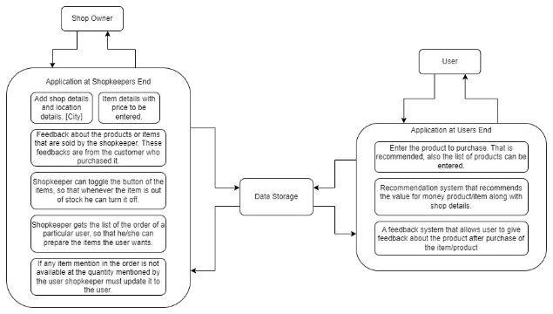
Block Diagram of the proposed system
The proposed system uses a recommendation system to suggest the best value for money products to users. The system takes into account various factors such as price, quality rating, location, and product availability to recommend the best shop to purchase the product. The recommendation system is designed to provide users with good quality products at a reasonable price, promoting customer satisfaction and loyalty.
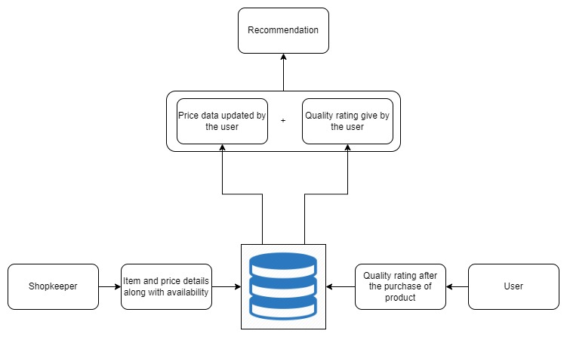
Recommendation system Design
VIII.IMPLEMENTATION

User Sign up pages
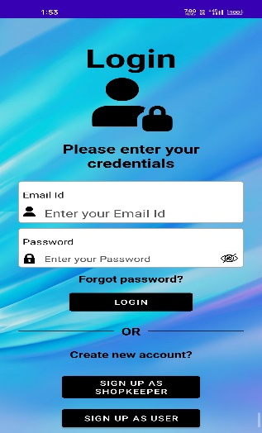
User Login Page
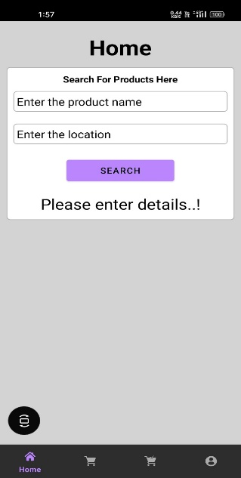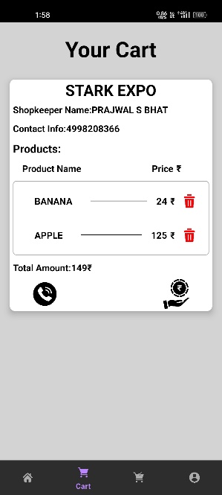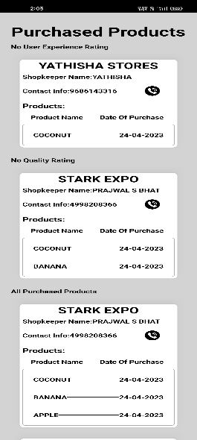
User Activity
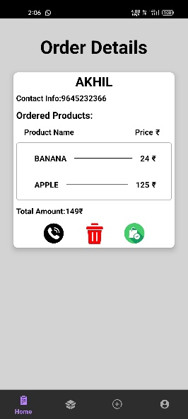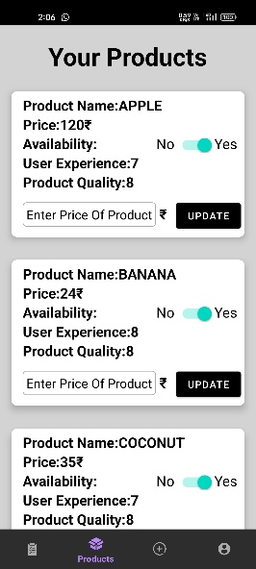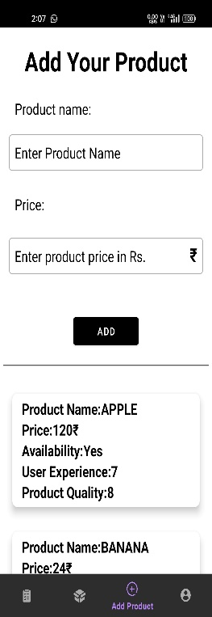
Shopkeeper Activity

Mail sent to both user and shopkeeper

VIII.CONCLUSION
The proposed e-commerce platform is designed to provide a convenient and efficient solution for both users and local shopkeepers. The system offers features such as inventory management, pricing and availability updates, and an advanced recommendation system that considers price, quality, and value for money. The system's user-friendly interface and advanced algorithms make it easy for users to find the best products at the best prices, while also allowing shopkeepers to manage their inventory and orders. The feedback mechanism ensures that the shopping experience is always improving. The system promotes and supports the growth of small businesses and local economies by connecting users with local shopkeepers. It is scalable and customizable, making it adaptable to the needs of different markets and industries. The proposed system has the potential to revolutionize the way people shop and make a significant impact in the world of e-commerce.
IX. REFERENCES
- H. Ding, X. Su, and Z. Xie, "Multi-models Dynamic Recommendation for Offline Clothing Sales," in Proceedings of the 2021 IEEE International Conference on Big Data and Smart Computing (BigComp), Feb. 2021, pp. 1-6, doi: 10.1109/BigComp50538.2021.00015.
- A. Mantha, Y. Arora, S. Gupta, P. Kanumala, Z. Liu, S. Guo, and K. Achan, "A Large-Scale Deep Architecture for Personalized Grocery Basket Recommendations," in Proceedings of the 2018 IEEE International Conference on Data Mining (ICDM), Nov. 2018, pp. 31-40, doi: 10.1109/ICDM.2018.00011.
- A. Xuecong and L. Zhaoming, "Design and Implementation of E-commerce Recommendation System Model Based on Cloud Computing," in Proceedings of the 2017 IEEE 3rd Information Technology and Mechatronics Engineering Conference (ITOEC), Oct. 2017, pp. 109-112, doi: 10.1109/ITOEC.2017.23.
- N. M. S. Iswari, Wella, and A. Rusli, "Product Recommendation for e-Commerce System based on Ontology," in Proceedings of the 2017 IEEE 4th International Conference on Industrial Engineering and Applications (ICIEA), Apr. 2017, pp. 133-138, doi: 10.1109/ICIEA.2017.7939263.
- Y. Pan and D. Wu, "Personalized Online-to-Offline (O2O) Service Recommendation Based on a Novel Frequent Service-Set Network," in IEEE Transactions on Services Computing, vol. 11, no. 1, pp. 28-41, Jan.-Feb. 2018, doi: 10.1109/TSC.2016.2594318.
- C. Li, M. He, M. Qaosar, S. Ahmed and Y. Morimoto, "Capturing Temporal Dynamics of Users' Preferences from Purchase History Big Data for Recommendation System," in IEEE Transactions on Systems, Man, and Cybernetics: Systems, vol. 48, no. 7, pp. 1137-1148, July 2018, doi: 10.1109/TSMC.2016.2619871.
- H. Abdullahi, M. Bader-El-Den, and R. Esmeli, "Using Word2Vec Recommendation for Improved Purchase Prediction," in 2020 IEEE International Conference on Industrial Engineering and Engineering Management (IEEM), 2020, pp. 163-167, doi: 10.1109/IEEM49952.2020.9378988.
- S. Zhang, D. Liu, S. Ji, J. Liang, and Y. Dong, "Research on Power Purchase Recommendation Algorithm based on User Collaborative Filtering," IEEE Access, vol. 8, pp. 139418-139428, 2020, doi: 10.1109/ACCESS.2020.3014201.
- R. A. Asmara, M. Z. Abdullah, and F. M. Wahyuningtyas, "Herbalife Nutrition Product Recommender System using Mamdani Fuzzy Logic," in 2021 International 54 Conference on Information Management and Technology (ICIMTech), IEEE, 2021, pp. 194-198.
- X. Zhang, "Personalized Recommendation Model for Mobile E-commerce Users," in 2018 IEEE 2nd Advanced Information Management, Communicates, Electronic and Automation Control Conference (IMCEC), Xi'an, China, 2018, pp. 1544-1547, doi: 10.1109/IMCEC.2018.8463251.
- PHATPICHA YOCHUM, LIANG CHANG, TIANLONG GU, AND MANLI ZHU, “Linked Open Data in Location-Based Recommendation System on Tourism Domain: A Survey”, Creative Commons Attribution 4.0 License, Received December 29, 2019, accepted January 11, 2020, date of publication January 17, 2020, date of current version January 27, 2020. Digital Object Identifier 10.1109/ACCESS.2020.2967120.
- Chi Yan, Yuliang Shi, “A Personalized Location Recommendation based on Convolutional Neural Network”, Institute of Electrical and Electronics Engineers, 2020 IEEE 5th Information Technology and Mechatronics Engineering Conference, 978-1-7281-4323-1/20/$31.00 ©2020 IEEE

