Abstract. Private Messenger is a secure communication tool that allows users to send messages, make voice and video calls, and share files within a closed network. Unlike traditional messaging services, the platform offers end-to-end encryption, ensuring that only authorized users have access to exchanged messages.

The platform is designed with a user-friendly interface that allows users to customize their privacy settings, including the ability to set up security groups for team collaboration. Messaging platform utilizes end-to-end encryption, secure authentication, and multi-factor authentication to ensure that messages and files are protected from prying eyes.

Additionally, the platform provides real-time notifications, archiving and search capabilities for easy message retrieval. This summary highlights the key features of a private webmail platform that make it an excellent choice for businesses, organizations, and individuals who
prioritize privacy and security in their communications

I. INTRODUCTION

In recent years, concerns about privacy and data security have become increasingly prevalent in the digital world, especially when it comes to communication. Many users are wary of using traditional messaging apps that collect and analyze their data, which may include personal information and confidential messages.

To address this issue, private network messaging platforms have emerged as a secure and encrypted communication tool that provides a safe environment for users to exchange messages and files without the risk of data breaches or unauthorized access.

Private network messaging platforms utilize end-to-end encryption, secure authentication, and multi-factor authentication to ensure that messages and files are protected from prying eyes. They also offer features such as self-destructing messages, message recall, and anonymous messaging, which provide users with additional layers of security and privacy
.
The increasing demand for privacy and confidentiality in digital communication has led to the rise of private network messaging platforms, which aim to offer a seamless and user-friendly experience. This platform is designed to meet the needs of individuals and businesses that value privacy and security in their communication. In this context, this article aims to explore the concept of private network messaging platforms in detail and highlight the benefits of using such platforms over traditional messaging apps

Private network messaging platforms are secure and encrypted communication tools designed to provide a safe environment for users to exchange messages and files without the risk of data breaches or unauthorized access. With the increasing concern for privacy and confidentiality in digital communication, these platforms offer an alternative to traditional messaging apps that may not be secure or may collect and store user data.

A private network messaging platform uses end-to-end encryption to ensure that only the sender and intended recipient(s) can access the message. This means that even the platform provider cannot read or access the content of the message. In addition, these platforms may use secure authentication and multi-factor authentication to ensure that only authorized users can access the platform and its features

II. LITERATURE REVIEW

1.A Study on the Adoption of Private Network File Sharing and Messaging Platforms (2018)

This study examines the factors that influence the adoption of private network file sharing and messaging platforms in organizations. The study identifies factors such as perceived usefulness, ease of use, security, and compatibility as key determinants of adoption. The study concludes that organizations that prioritize security and privacy are more likely to adopt private network file sharing and messaging platforms..

2.A Comparative Analysis of Private Network File Sharing and Messaging Platforms (2019)

This study compares four different private network file sharing and messaging platforms, namely Slack, Microsoft Teams, Zoom, and Wire. The study evaluates these platforms based on their features, security, and usability. The study concludes that Wire is the best option for private network file sharing and messaging due to its end-to-end encryption, open-source software, and user-friendly interface

3.A Study on the Security Risks of Private Network File Sharing and Messaging Platforms (2020)

This study investigates the security risks associated with private network file sharing and messaging platforms. The study identifies several security risks such as data breaches, malware infections, and phishing attacks. The study recommends the use of strong passwords, two-factor authentication, and regular security audits to mitigate these risks

4.An Analysis of LAN File Sharing Software (2020)

This study analyzes six different LAN file sharing software, namely Dropbox, Google Drive, Microsoft OneDrive, Syncthing, Resilio Sync, and Nextcloud. The study evaluates these software based on their features, performance, security, and usability. The study concludes that Nextcloud is the best option for LAN file sharing as it provides excellent security and privacy features.

5.An Analysis of the Usability of Private Network File Sharing and Messaging Platforms (2021)

This study analyzes the usability of six different private network file sharing and messaging platforms, namely Slack, Microsoft Teams, Zoom, Wire, Signal, and Telegram. The study evaluates these platforms based on their user interface, navigation, and features. The study concludes that Wire is the most user-friendly platform due to its simple and intuitive interface..
.
6.A Study on the Impact of Private Network File Sharing and Messaging Platforms on Employee Communication (2022)
This study examines the impact of private network file sharing and messaging platforms on employee communication. The study measures employee communication metrics such as responsiveness, collaboration, and productivity, and concludes that private network file sharing and messaging platforms improve employee communication by providing a secure and efficient way to communicate and share files.

III. SOCKETS AND SOCKET-BASED COMMUNICATION

Sockets provide a link for network operations at
the transport layer. Networkinguses the same sockets as
data I/O. In fact, socket handles are treated like data
handles.

So that the tcp handle can confirm that the information is exchanged to the application the attachment is associated to a harbour numberjava offers a collection of classes contained within the javanet bundle to speed up the creation of organize application programmes for socket-based.
Io streams that are used for information io are still pertinent the programming dialect utilized to execute socket-based communication is irrelevant this infers that java-written attachment programs can speak with java-written attachment programs composed in other programming dialects such as c or ca attachment is associated to a particular harbour on a server program running on a specific machine

The socket that the client inquired for a association to is being tuned in to by the server. In a idealize world, the server would favour the Socket connection for the particular port.
A Socket with a distinctive port will be sent to the server when it has been affirmed. Whereas the client is advertised a item association, the requires a unused port socket (in this way, a distinctive harbour number) so that it may proceed to observe for association demands on the previous way.

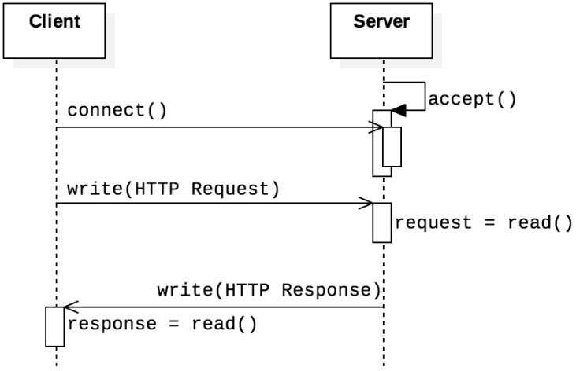

Fig.1 TCP SOCKET CONNECTION

Above Figure 1, Shows the tcp socket connection between server and client applications.

3.1 Server Socket PORT Creation

The server service creates a special socket type (socket server) to listen to client requests, when there is a communication request, the program creates a new socket from which it receives input and outputs data streams to exchange with clients. Socket abstraction is similar to these data points. A developer should open a socket do I/O, and then shut down.

Server socket Create a tcp connection for the port, listen on the clinet connection.

3.2 Server Acceptance

After creating a socket for the port,the socket must be in the client receiving connection state.

This accepts client connections that share data on streams over TCP listening on the port.

3.3 InputStream and OutputStream.

After accepting the client, the server/client needs
to create an input and output stream to share the data.

Data Input Stream Used to read HTTP (TCP/IP)
request data in bytecode format.

Output Stream Used to write data as bytecode to HTTP (TCP/IP) responses.

IV. JMS – Java Messaging Service
JMS (Java Message Service) is an API that provides the facility to create, send and read messages. It provides loosely coupled, reliable and asynchronous communication.
Asynchronous: To receive the message, client is not required to send request. Message will arrive automatically to the client.
Reliable: It provides assurance that message is delivered.
There are two types of messaging domains in JMS.
- Point-to-Point Messaging Domain
- Publisher/Subscriber Messaging Domain

4.1) Point-to-Point (PTP) Messaging Domain

One message is sent to one collector alone beneath the PTP an case of message-oriented middleware mother in utilize is line the message must be held by the line until the beneficiary is ready there’s no temporal dependency between the sender and collector within the PTP.

4.2) Publisher/Subscriber (Pub/Sub) Messaging Domain
Within the Pub/Sub, a single message is sent to all endorsers. It's comparable to broadcasting. As a message-oriented middleware in this occasion, Point is in charge of both holding the message and delivering messages securely.
There could be a worldly reliance between the distributer and supporter within the PTP
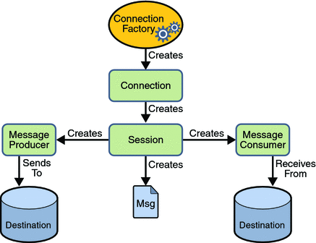

Fig.2 JMS Working Model

Above Fig.2 shows thw java messaging service(JMS) working model for both queue and topic.

V. JPA – Java Persistance API

JPA is brief for java determination api which is javas protest integration orm system gives a way for java applications to connected with social databases utilizing context-oriented operations.

JPA is portion of the java ee endeavor version stage and is utilized by numerous ORM devices such as sleep eclipselink and openjpa it characterizes comments and interfacing that permit designers to outline java objects to database table and perform crud make perused upgrade erase operations utilizing question pointers.

JPA moreover gives back for exchange administration caching and inquiries such as JPQL java determination inquiry dialect and criteria apiusing jpa designers can get it the complexity of sql and center on commerce reasons making information capacity more effective and less demanding to oversee too .

JPA too gives back for exchange administration, caching, and inquiry dialects such as JPQL (Java Persistance Query Language) and Criteria API

Since the same organization classes can be utilized totally different ventures and databases jpa makes a difference with code reusability the JPA has become a prevalent choice for java engineers because it streamlines application advancement by minimizing the sum of common code required it moreover gives a way to demonstrate diligent information in java making it less demanding to oversee and test applications over time

VI. IMPLEMENTATION RESULTS

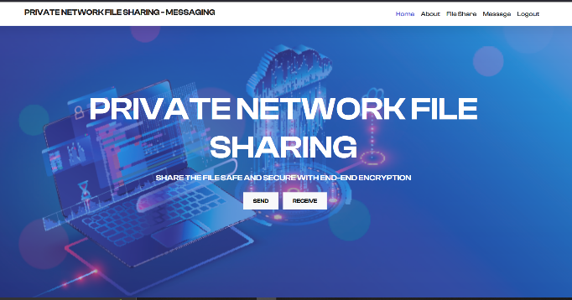

Fig.5.1 FILE SHARING HOMEPAGE

This Figure 5.1, Shows the options available in the module. The browse option is used for client to choose whether the client shares or receives the file data.

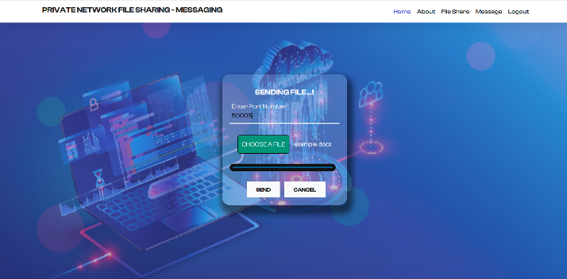

Fig.5.2 BROWSE TO CHOOSE FILE TO SHARE

This Figure 5.2, This module contains the input for the private port number which the user listens and can browse to choose the file and upolad it to the private port network.

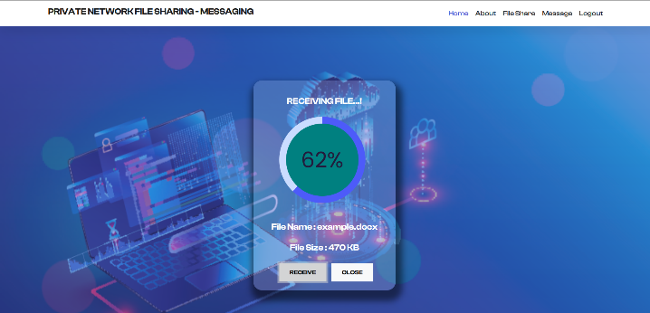

Fig.5.3 FILE RECEIVING MODULE

This Figure 5.3, This module contains the input for the private port that is created by the sender , inorder to share the data safe and secure.

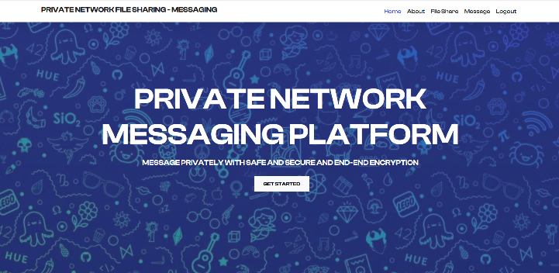

Fig.5.4 MESSAGE MODULE HOMEPAGE

This Figure 5.4, Shows the homepage for the private message. Here the user can choose to start messaging with other clients.

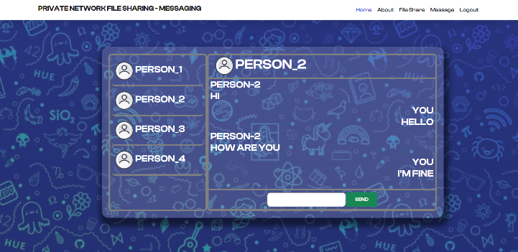

Fig.5.5 CHAT UI

This Figure 5.5, Shows the chat UI for the user who can choose the other user to send and receive message .

VII. CONCLUSION

Sockets can improve communication using application services as they allow to manage services that accept and return incoming raw data. time delay. Due to their capacity to handle administrations that take and return approaching crude information attachments can move forward communication.
When utilized with application administrations slack in time the major objective of the venture is to make unused communication instruments with tall benefit compactness as well as point by point data that permits the framework to screen the stream of information passages and reflects the impacts of advance adjustments on the framework progressive inquiries for server information

Future Scope of Improvement

Workaround sharing information by means of a attachment can be difficult particularly when sending gigantic records or when there’s a issue with organize inactivity future advancements will concentrate on expanding execution through superior blunder dealing with more successful information transport or way better compression strategies

Cross-platform enhancement: As of now, the same working framework and equipment are frequently utilized for socket-based record sharing. Future changes will likely concentrate on improving cross-platform compatibility, empowering clients to move information over other working frameworks counting Windows, macOS, and Linux.

Integration with cloud-based nearby record exchanges frequently employments socket-based record sharing whereas future progresses will center on joining cloud-based instruments as a arrangement this gives clients more opportunity and comfort by permitting information to be exchanged between their neighborhood gadget and cloud capacity portable help most desktops and portable workstations utilize socket-based record sharing future progressions will center on upgrading bolster for convenient gadgets such as smartphones and tablets permitting clients to effectively exchange information between such gadgets and other gear.

VI.REFERENCES

[1] Ahsan, M., Haider, J., Mc Manis, J. y Hashmi, M. (2014). Creating an intuitive software interface for wireless vehicle speed monitoring and data management. 9th International Symposium on Communications Systems, Networks, and Digital Signal Processing (CSNDSP 2014) Special Issue: Selected Papers The Institution of Engineering and Technology 2016 and IET Wirel. Sens. Syst., 2016, Vol. 6, Iss. 3, pp. 90-9990.
[2] Bishop, S., Fairbairn, M., Norrish, M., Sewell, P. y M. Smith (2018). Rigorous Test-Oracle Specification and Validation for TCP/IP and the Sockets API: Engineering with Logic. ACM Journal, Volume 66, Number 1, Article 1. Date of publication: December 2018
[3] Feng, P. y Wu, Q. (2022). Digital Teaching Management Deep learning-based Internet of Things system. Mobile Information Systems, 11 pages, Hindawi, Volume 2022, Article ID 3414935. https://doi.org/10.1155/2022/3414935
[4] Grazia, C., Klapez, M. y Casoni, M. (2021). The New TCP Modules on the Block: A TCP Pacing and TCP Small Queues Performance Evaluation. Digital Object Identifier for IEEE Access is 10.1109/ACCESS.2021.3113891.
[5] Hulaas, J., Binder, W. y Di Marzo, G. (2004). Enhancing Security for Java Grid Computing with Resource Control. Lecture Notes in Computer Science, pages 30-47 (containing subseries on Artificial Intelligence and Bioinformatics).
[6] Lagartos, I., Redondo, J. y Ortin, F. (2019). Java runtime metaprogramming services that are effective Journal of Systems and Software, Volume 153, 2019, Pages 220–237, ISSN 0164–1212, doi:10.1016/j.jss.2019.04.030.
[7] Ma, H. y Zhou, Q. (2021). Application of virtual instrumentation for computer networks in the creation of a remote detection system for construction equipment. 2021, Issue 10, Volume I, International Journal of Mechatronics and Applied Mechanics
[8] Marek, D.; Domanski, A., Domanska, J., Szyguła, J., Czachórski, T. y Klamka, J. (2021). Entropy 2021, 23, 619. Diffusion Model of a Non-Integer Order PI Controller with TCP/UDP Streams. The following DOI: 10.3390/e23050619
[9] The "Portable Library of Migratable Sockets" by Marian Bubak, Dariusz Bik, Dick van Albada, Kamil Iskra, and Peter Sloot was published in Scientific Programming, vol. 9, article ID 126087, 12 pages, in 2001. https://doi.org/10.1155/2001/126087
[10] Poslavsky, S. (2019). Rings :An effective polynomial ring library for Java and Scala. Pages 400–413 of Volume 235, February 2019, of Computer Physics Communications.
[11] Reznik, J., Ritter, T., Schreiner, R. y Lang, U. (2007). Security Aspects Development Driven by Models. Electronic Notes in Theoretical Computer Science, Volume 163, Number 2, April 16, 2007, Pages 65–79
[12] Rizwan, R.; Arshad, J.; Almogren, A.; Jaffery, M.H.; Yousaf, A.; Khan, A.; Ur Rehman, A.; Shafiq, M. Real-Time Data Visualisation Using Node-RED for the Implementation of an ANN-Based Embedded Hybrid Power Filter in Energies 2021, 14, 7127.Data Visualisation Node-RED https://doi.org/10.3390/en14217127
[13] Saenz, J., Esquembre, F., Garcia, F., De la Torre, L. y Dormido, S. (2015). Easy Java-Javascript Simulations Using an Architecture for New DevicesThis is where sponsors and financial support are acknowledged. It is recommended to use both capital and lowercase letters when writing paper titles. 2015, ISSN 2405-8963, Volume 48, Issue 29, IFAC-PapersOnLine, Pages 129–133.
[14] Shao, Y., Ott, J., Jia, Y., Qian, Z. y Mao, Z. (2016). The Security Implications of Android Unix Domain Socket Misuse. The 2016 ACM SIGSAC Conference on Computer and Communications Security's proceedings are titled CCS '16.2016 October Pages 80–91
[15] Sharif, H. y Gursoy, O. (2018). Java Native Socket Programming for Parallel Computing for Artificial Neural Network Training. Engineering and Natural Science Periodicals, Vol. 6, No. 1, Feb. 2018, p. 1–10
[16] Smith, D.G., and Wells, G.C. (2017). Java communication between processes in a Microsoft Windows environment. 29(3), 198–214, South African Computer Journal. https://doi.org/10.18489/sacj.v29i3.500
[17] Song, L., García-Valls, M. (2022). Improving Security of Web Servers in Critical IoT Systems through Self-Monitoring of Vulnerabilities. Sensors 2022, 22, 5004.
[18] Suherman, S., Deddy Dikmawanto, D., Hasan, S. y Al-Akaidi, M. (2021). Including the transmission control protocol header with the three pass protocol messages Vol. 22, No. 1, April 2021, pp. 442–449, Indonesian Journal of Electrical Engineering and Computer Science
[19] Suprianto, D., Wibowo, D., Setiawan, A. y Agustina, R. (2019). Integrated application architecture using socket TCP, client-server databases, and microcontrollers to enable efficient and secure student pick-up. 4th Annual Conference on Applied Science and Engineering. Physicists' Journal: Conference Series.
[20] Tsubouchi, Y., Furukawa, M. y Matsumoto, R. (2022). Discovering Dependencies across Network Services Using Low Overhead TCP/UDP Socket-based Tracing 30: 260–268 (Mar. 2022) Journal of Information Processing
[21] Zhang, C., Sadjadi, M., Sun, W., Rangaswami, R. y Deng, Y. (2010). A user-centered network communication broker for multi-media collaborative computing. Multimed Tools Appl (2010) 50:335-357. DOI: 10.1007/s11042-009-0385-6
[22] Nigel Davies, Gordon S. Blair, Keith Cheverst, and Adrian Friday. an emulator for networks that helps create adaptable apps. 1995, Ann Arbour, Michigan: 2nd USENIX Symposium on Mobile and Location Independent Computing.
[23] Kevin Fall. Network emulation in the vint/ns simulator. In 1999, the IEEE International Symposium on Computers and Communications published its proceedings.
[24] David B. Ingham and Graham D. Parrington. Delayline: A device for simulating wide-area networks. 313–332 in USENIX Computing Systems, 7(3), 1994.
[25] L. Rizzo. Dummynet: A straightforward method for assessing network protocols. January 1997 issue of Computer Communication Review, 27

