MOVIE RECOMMENDER SYSTEM USING MACHINE LEARNING
Dr.D.S.Hirolikar¹,Sakshi Gaikwad²,Kajal Jalan³,Pornima Maknikar⁴,Ashwini Morale⁵,Pearl Yadav⁶
Department of Information Technology
PDEA’s College of Engineering (Manjari B.K.)
Pune, India, 412307

---------------------------------------------------------------------***--------------------------------------------------------------------

1.ABSTRACT

In this research, we have a movie recommender system that can recommend movies to both new and existing customers. It searches movie databases for all of the relevant data, such as popularity that is required for a recommendation. We have applied both content-based filtering and collaborative filtering. To make a system that provide the exact movies to the users. The recommendation is also used for business purposes and to make strategies for organizations. Due to the growing demands of customers and user’s recommendation systems plays a huge role. These recommender systems also help us to utilize our time in the busy world by giving us more relevant searches. These systems are generally used with the movie’s websites or with many commercial applications and are of great use. It will make movies suggestions more relevant as per the need of the users.

1.INTRODUCTION
Our main goal is to create an improved recommender system that provides precise recommendations to the customer. Recommendation engines are generally a mixture of both content-based filtering and collaborative filtering. The Collaborative Filtering technique is based on the user's previous queries and experiences. We'll anticipate what other users with similar experiences would watch based on that, and then provide the user those recommendations. In collaborative filtering, we will make the customers or users’ recommendations and suggestions based on past experiences and behaviors. It works on the principle, for instance, you, have selected an item in the cart or you have purchased it from the website. The same types of recommendations it will show on the basis of your selections of items in the cart. Content-based filtering techniques make recommendations based on movie characteristics such

as genre, director, actor, plot, and so on. We can improve the recommendation by putting more emphasis on a specific attribute. The content-based filtering technique gives us recommendations that are based on the user’s interests. If the user has searched any of the item’s past history. This filter will do it works in its way by suggesting to us the same type of content which we are surfing earlier. This tactic is totally dependent on the taste of the customers. Nowadays, we basically use the mixture of both the filtration techniques and called it a hybrid filtration. So, the mixture of both of these types of filtrations will result in the new tactic that is the hybrid model. This model will give us a more precise approach to filtration techniques. The movie recommendation will be more useful in the movie recommendation. The choices will be given whatever user wants to get. It is relevant to user’s perception.

3. LITEATURE REVIEW
Authors of paper [2] discuss about recommendations of the movies. A movie recommendation is important in our social life due to its strength in providing improved entertainment. This system can suggest a set of movies to users based on their interest, or the popularities of the movies. A recommendation system is used for the purpose of suggesting items to purchase or to watch. They direct users towards those items which can meet their needs through large database of Information. A or a recommendation system is a subclass of information filtering system that will help to predict the "rating" or "preference" a user would give to an item [1][2]. They are primarily used in commercial applications. MOVREC also help users to find the movies of their choices based on the movie experience of other users in efficient and effective manner, without wasting much time in useless browsing.

4.METHODOLOGY
The Recommendation of algorithms that use several ways of organizing and classify information.
1.Collaborative Filtering
2.Content Based Filtering

1) Collaborative Filtering :
Filtering Collaborative filtering is based on the fact that products and people's interests have a relationship. Many recommendation systems employ collaborative filtering to uncover these connections and make an appropriate recommendation of a product that the consumer would enjoy or be interested in. The relation between user-based and item-based filtering is shown in Fig. 1.

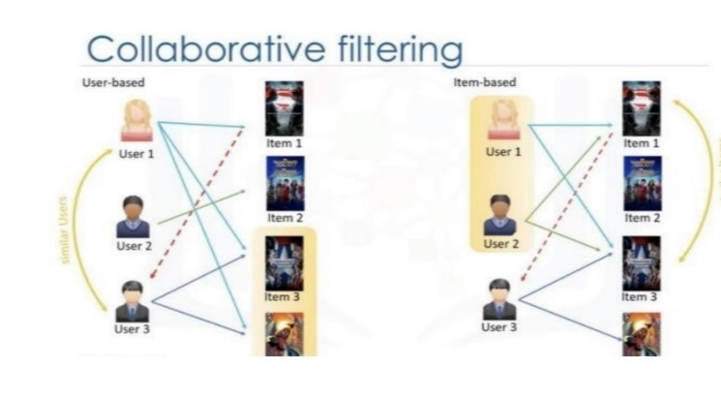
FIG :- USER BASED COLLABORATIVE FILTERING

Whenever we shop from Amazon or from other shopping sites, we are recommended some new products saying “Customers who bought this item also bought”. This algorithm of recommending new items to a user based on the interests and preferences of other similar users is nothing but collaborative filtering recommendation.

2) Content - Based Filtering:
Content-based filtering in recommender systems uses machine learning algorithms to predict and recommend new but similar items to the user's preference. Recommending products based on their characteristics is only possible if there is a clear set of features for the product and a list of the user’s choices. The recommender system stores previous user's data like clicks, ratings, and likes to create a user profile. The more a customer engages, the more accurate future recommendations are to be given. To understand this,

let’s use a simple example of how a content-based recommender system might work to suggest movies.
The recommendation system filters the movie on the basis of its properties. Content - based filtering
recommendation also known as Cognitive filtering uses item features to recommend other items similar to what the users like on their previous actions or feedback. It works by the data is taken from the user either explicitly or implicitly.
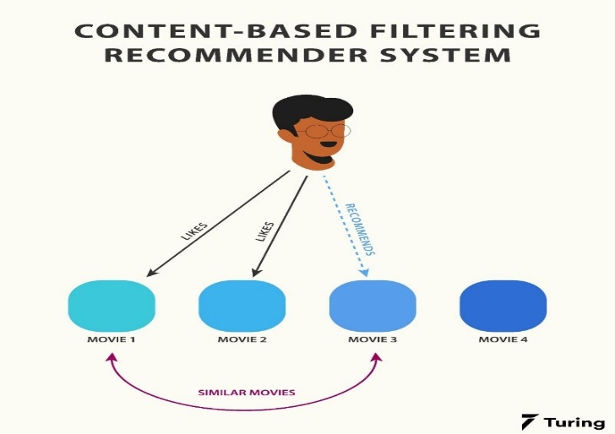
FIG :- CONTENT BASED FILTERING

The model automatically suggests the third movie rather than the fourth, since it is more similar or same to the first two movies. This similarity can be calculated based on the number of features like the actors and actresses in the movie, the director, the genre, the duration of the film, etc.

User based vs Item based :-
Collaborative filtering recommendation can be done in two ways:-
User based collaborative filtering.
Item based collaborative filtering.
In the user based filtering, we find out the similar users.
Whereas in the item based filtering, we find out the similar items.
Evaluation Metrics :-
There are many evaluation metrics for Recommender systems but we are going to discuss only four of them.
1. Mean average precision at K.
2. Coverage.
3. Personalisation.
4. Intralist similarity.
1 .Mean average Precision at K :-
The evaluation metric gives an insight over how relevant the list of recommended items are. Precision at K is the proportion of recommended items in the top-K set that are relevant to the user's.
2 .Coverage :-
Coverage is the percentage of items in the training data the model is able to recommend on a test set. It is the percentage of possible recommendations that the system can predict.
3.Personalisation :-
Personalisation is a great way to asses if a model recommends many of the same items to different users. It is the dissimilarity (1-cosine similarity) between user’s lists of recommendations.
4.Intralist similarity :-
Intralist similarity is the average cosine similarity of all items in a list of recommendations. Calculation uses features of the recommended items to calculate the similarity.

5. CONCLUSION :-
In this paper, we used a movie recommendation system based on machine learning algorithms. Consequently, users receive better suggestions as a result of collaborative filtering, which is based on their prior experiences and activities. To suggest movies to the user, we used the SVD algorithm in Collaborative Filtering. The fundamental problem with collaborative filtering is that if a new user has no previous experience, the recommender cannot provide relevant recommendations. It is also possible that collaborative filtering will fail to produce meaningful suggestions if the data becomes too large. This can be very useful and efficient system to recommend the movies easily. This movie recommendation is the user relevant . It gives the uers preferences movies.

6. REFERENCES :-
[1] Francesco Ricci and Loir Roach and Brachia Shapira, Introduction to Recommender Systems Handbook Recommender Systems Handbook, Springer, 2011, pp. 1-35J.
[2] "playboy Lead Rise of Recommendation Engines - TIME". TIME.com. 27 May 2010. Retrieved 1 June 2015.
[3] R. J. Mooney & L. Roy (1999). Content - based book recon emendation using learning for text categorization in Workshop Recom. Sys. Algo. and Evaluation.
[4] Husein Jafar Karimi; A.T.H. Sim and R. Saadat Oost A
Naïve Recommendation Model for Large Databases, International Journal of Information and Education Technology, June 2012.
[5] Prem Melville and Vikas Sindh Wani, Recommender Syse mms, Encyclopedia of Machine Learning, 2010.
[6] M. M. Reddy, R. S. Kamani and B. Surendra, "Analysis of Movie Recommendation Systems; with and without considering the low rated movies,"24-25 Feb,2020 International Conference on Emerging Trends in Information Technology and Engineering (ice-ETITE), Vellore, India, 2020, pp. 1-4, doi:10.1109/icy ETITE47903.2020.453.
[7] Naga Manjula. R.; Geethalakshmi, A.; “A Novel Scheme for Movie Recommendation System Using User Similarity and Opinion Mining”, International Journal of Innovative Technology and Exploring Engineering, vol: 8, 2019, pp: 316-322.
[8] Shaik, I.; Nutella, S.S.; Diwakar, T.; Nalla, S.; “K-means Clustering Algorithm Based on E-Commerce Big Data”, International Journal of Innovative Technology and Exploring Engineering, vol: 8, 2019, pp: 1910-1914.

