RoadToTech
(Web Based E-Learning Recommender System with the aid of ChatGPT)

V.Anirudh
(RA1911026040009)
Department of Computer Science,
SRM Institute of Science and Technology, Vadapalani Campus, Chennai, India
va2936@srmist.edu.in

Lakshmi Narayana R
(RA1911026040014)
Department of Computer Science,
SRM Institute of Science and Technology, Vadapalani Campus, Chennai, India
@srmist.edu.in

Daniel S
(RA1911026040049)
Department of Computer Science,
SRM Institute of Science and Technology, Vadapalani Campus, Chennai, India
@srmist.edu.in

Mrs.Prasanna Devi
Head of Department
Department of Computer Science,
SRM Institute of Science and Technology, Vadapalani Campus, Chennai, India
@srmist.edu.in

- ABSTRACT
The objective of this project is to create a specialized learning platform for IT skills that guides users from the beginning to the end of their learning journey. The platform includes three key features: a search function, progress tracking, and gamification. The search function allows users to easily locate relevant courses and resources by entering keywords or phrases. The progress tracking feature enables users to monitor their progress through the course and personal goals. Gamification elements, such as points, badges, and leader boards, are incorporated to make the learning experience more stimulating and gratifying. The primary motivation behind this project is to save users time by streamlining the resource search process, thereby enabling them to focus more on learning. The platform is user-friendly, with an intuitive interface and a dashboard that provides access to different functions and displays user progress. Before launching publicly, the platform will be tested with a small group of users. As a large language model, ChatGPT will serve as a foundation for implementing this project.

- LITERATURE SURVEY
1. The Enhanced Learning Resource Recommendation Based on Online Learning Style Model (AROLS) [June15,2020] is an adaptive recommendation based on online learning style. It is evaluated by comparing actual learning resources used by students with recommended resources, precision measuring correct recommendations, and recall measuring percentage of learning resources used. Accuracy depends on quality of survey data, limited availability of resources, and system not being able to capture learning.

2. Toward Selection of Trustworthy and Efficient E- Learning Platform[September 20, 2021]. The methodology for selecting a trustworthy and efficient e-learning platform can be broken down into four steps: defining requirements, researching platforms, evaluating platforms, and selecting the most suitable platform. Platforms should be evaluated for speed, reliability, and user experience to meet user needs. The selection of an e-learning platform can be limited by the user's budget, requirements, and needs, as well as its ability to handle large amounts of data and scale.

3. Provisioning Computational Resources for Cloud-Based e- Learning Platforms Using Deep Learning Techniques[June 18, 2021]. The accuracy of predictive analytics, reinforcement learning, and computer vision can be measured by the type of activity taking place in the e-learning platform. However, predictive analytics may not accurately predict resources needed for e-learning activities, reinforcement learning algorithms may not adjust parameters, and computer vision algorithms may not accurately classify activity.

4. E-Learning: Challenges and Research Opportunities Using Machine Learning & Data Analytics[June 25, 2018]. Data collection, pre-processing, feature extraction, machine learning, and evaluation are used to analyze and interpret data. Model selection, validation, performance evaluation, and visualization are used to gain insights and identify trends. Machine learning models can be difficult to scale due to data quality, model interpretability, time constraints, and cost.

5. A Semantic-Oriented Approach for Organizing and Developing Annotation for E- Learning[-September 11, 2011]. The proposed semantic-oriented approach for e-learning involves identification of semantic concepts, selection of appropriate techniques, development of models, integration into e-learning systems, and evaluation of performance. The proposed approach requires significant time and effort to develop annotation models, which may be limited by complexity and accuracy and need to be updated regularly.

6. Integration of Data Mining Clustering Approach in the Personalized E-Learning System [November 20, 2018]. Data mining clustering can be used to identify similar students, create personalized learning plans, and recommend courses and activities tailored to individual needs. It can be measured by comparing the performance of students who used the personalized plans to those who did not. However, it has limitations such as accuracy, complexity, and lack of personalized learning plans.

7. Feature Evaluation of Emerging E-Learning Systems Using Machine Learning: An Extensive Survey[May 5, 2021]. Statistical analysis and machine learning algorithms are used to evaluate e-learning systems using machine learning. Performance analysis is an important part of the evaluation, but it requires a large amount of data and difficulty in obtaining reliable and accurate data.

8. Learners on Focus: Visualizing Analytics Through an Integrated Model for Learning Analytics in Adaptive Gamified E-Learning[October 27, 2020]. The research project used qualitative and quantitative methods to measure the effectiveness of the Adaptive Gamified E-Learning system, limited to a single platform and relying on surveys and interviews.

9. (Base paper) AI based personalized e - learning systems: issues, challenges, and solutions [July 26, 2022]. AI-based personalized e-learning systems can be developed using a variety of approaches and technologies, such as natural language processing (NLP), machine learning algorithms, and deep learning techniques. The performance of AI-based personalized e-learning systems can be evaluated by measuring the accuracy and speed of the system in providing personalized content, as well as its scalability and ability to adapt to changing user preferences and content. However, AI-based personalized e-learning systems can be limited by the availability of data, the complexity of the algorithms used, the user’s understanding of the system, and the amount of time and resources available to develop and maintain the system.

10. Open Social Student Modeling for Personalized Learning[7 September 2016]. Open Social Student Modeling for Personalized Learning involves the use of open source software tools to collect, analyze, and visualize data from student interactions with educational materials. The analysis of the data can be complex and require specialized expertise, and the accuracy of personalized learning plans and feedback depends on the accuracy of the data collected. Studies have found that students who use personalized learning plans are more likely to complete tasks and achieve higher scores on tests, but the accuracy of the plans and feedback depends on the accuracy of the data collected.

- INTRODUCTION
The IT industry is constantly evolving, and keeping up with the latest trends and technologies can be a daunting task. With so many different skills to learn and tools to master, it can be difficult to know where to start. This is where the IT Skill Roadmap Generator comes in.

The IT Skill Roadmap Generator is a project that leverages the power of ChatGPT API to generate a personalized roadmap for IT professionals. By providing some basic information about their current level of expertise and their learning goals, users can receive a customized roadmap that outlines the skills they need to learn and the resources they can use to do so.

While the current version of the IT Skill Roadmap Generator focuses on generating a personalized roadmap, there are plans to add more features in the future. Some of these features include gamification elements that will make the learning process more engaging, content curation of videos and articles that will provide users with the best resources for each skill, and progress tracking that will help users stay motivated and on track.

With these features, the IT Skill Roadmap Generator will not only provide users with a roadmap for their learning journey but also create an interactive and engaging learning experience. The project has the potential to revolutionize the way IT professionals approach their skill development and help them stay up-to-date with the latest trends and technologies in the industry.

- ARCHITECTURE DIAGRAM
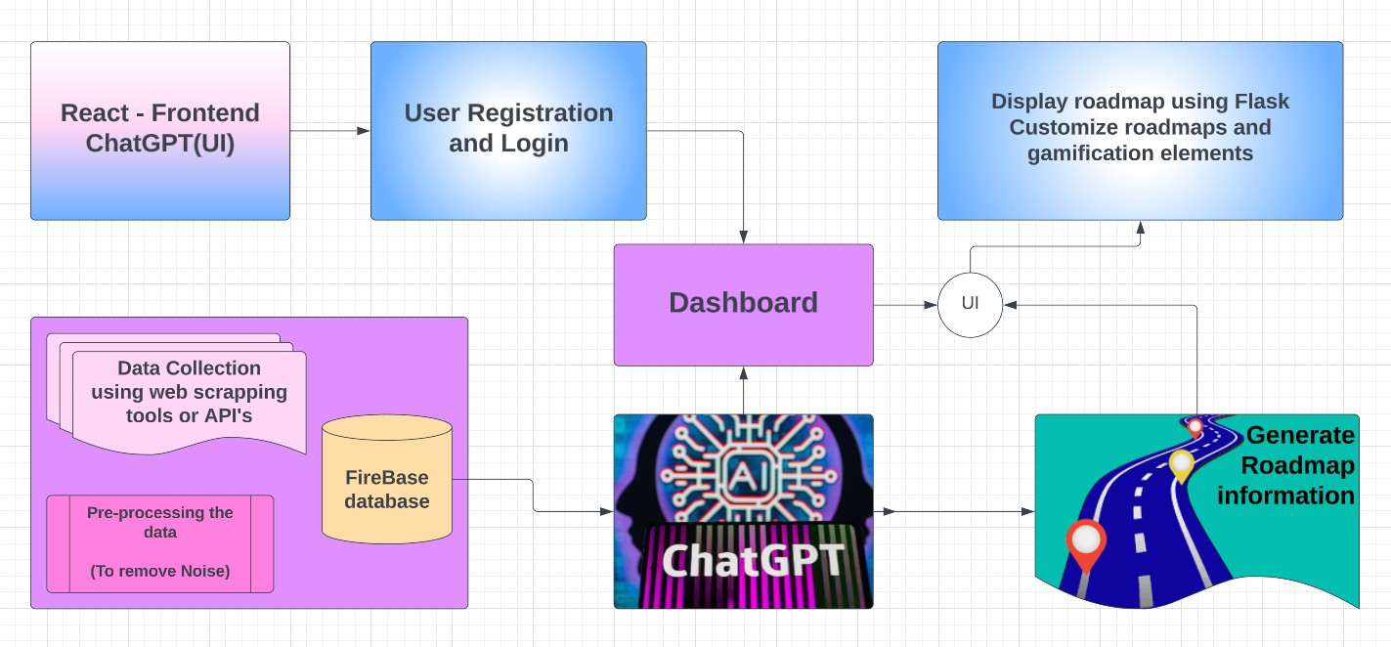
- UML
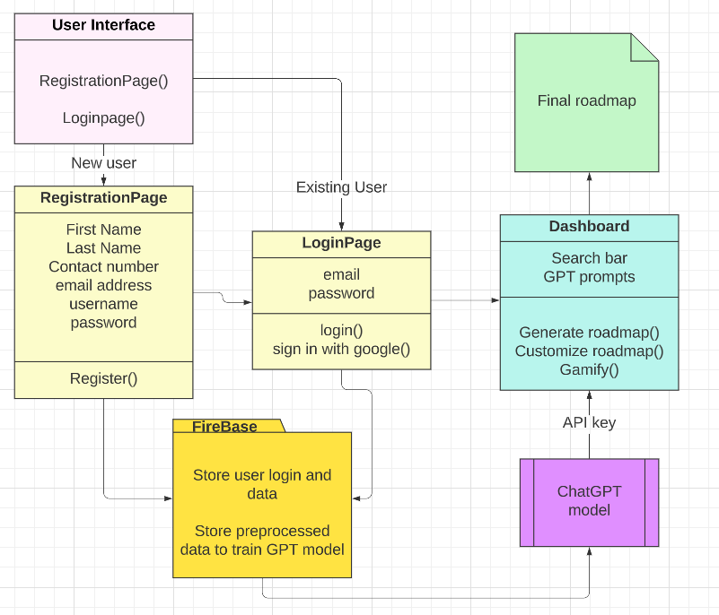

- METHODOLOGY
The process of generating an IT skill roadmap using the OpenAI API can be broken down into several steps. First, we need to create a prompt that accurately represents the user's input and requirements. The prompt should be designed to be as specific as possible, including relevant information such as the user's skill level, the desired technology, and the end goal.Next, we can use the OpenAI API to generate a roadmap based on the prompt we created. The API takes the prompt as input and uses GPT-3.5 architecture to generate a text response based on the input. The API provides a range of parameters, such as temperature, max_tokens, and stop words, to control the generation process and ensure that the output is relevant and accurate.Once the roadmap has been generated, we need to parse the response to extract the relevant information and present it to the user. This may involve using regular expressions or other parsing techniques to extract the relevant steps or tasks. Once the data has been extracted, it can be presented to the user in a user-friendly format, such as a list of tasks or a flowchart.

When creating the prompt, it is important to consider the user's specific needs and requirements. This may involve asking questions or gathering additional information from the user to ensure that the prompt accurately represents their needs. It is also important to consider the level of detail required in the prompt, as this can impact the accuracy and relevance of the generated roadmap. Overall, the methodology for generating an IT skill roadmap using the OpenAI API involves creating a specific and detailed prompt, using the API to generate a roadmap based on the prompt, parsing the response to extract relevant information, and presenting the information to the user in a user-friendly format. This process can help users to develop their skills and achieve their goals more efficiently and effectively.
- RESULTS AND OBSERVATIONS
7.1 Home-Page
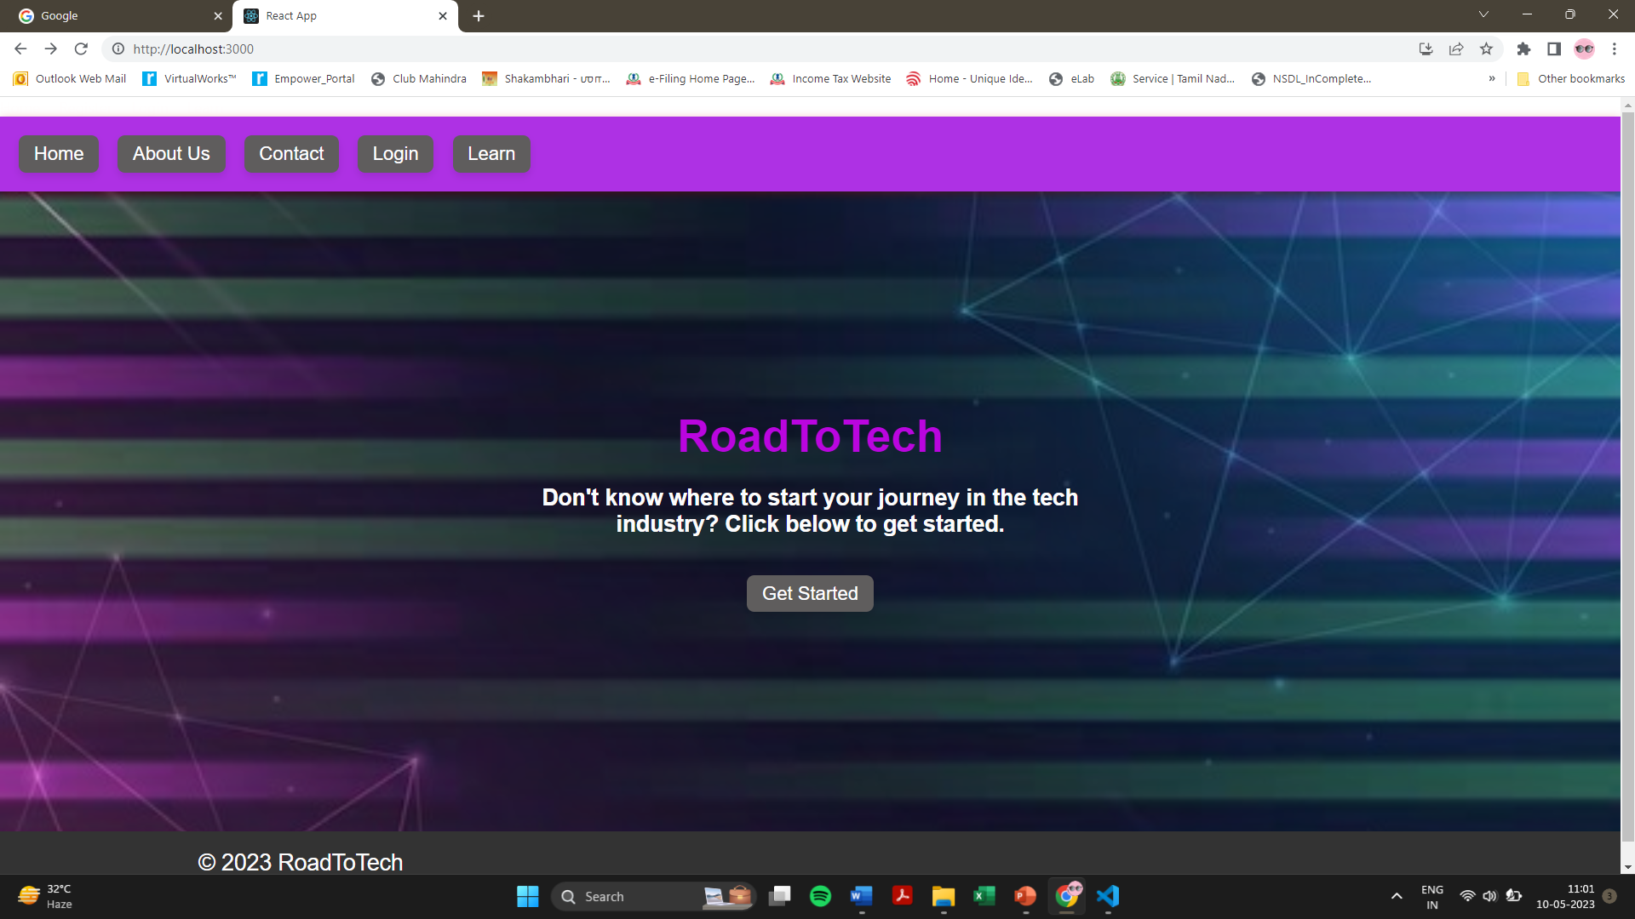

7.2 Registration Page
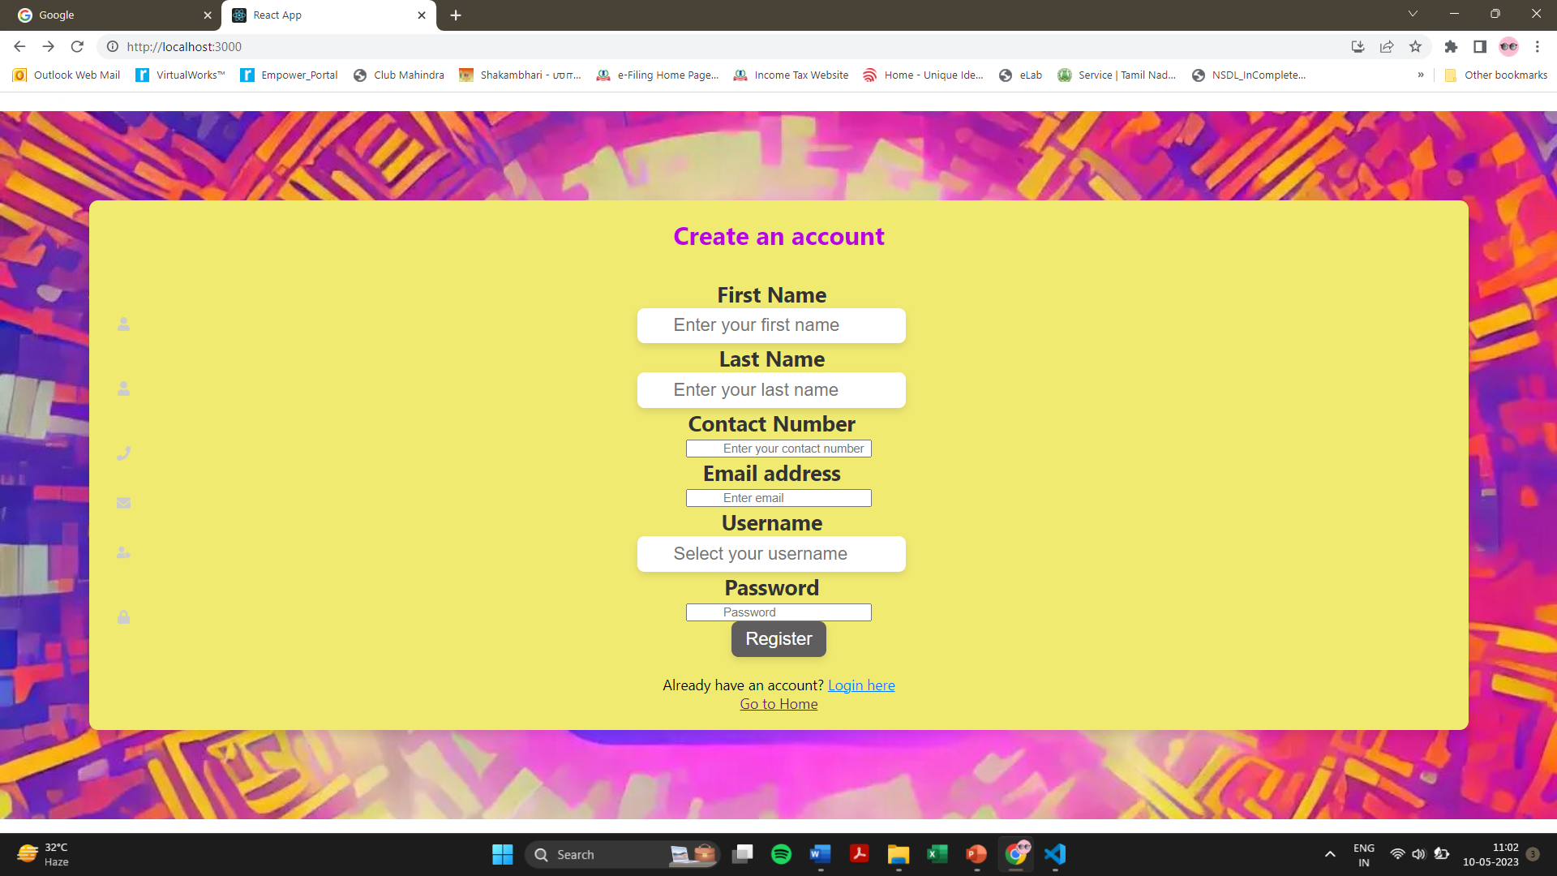

7.3 Login Page
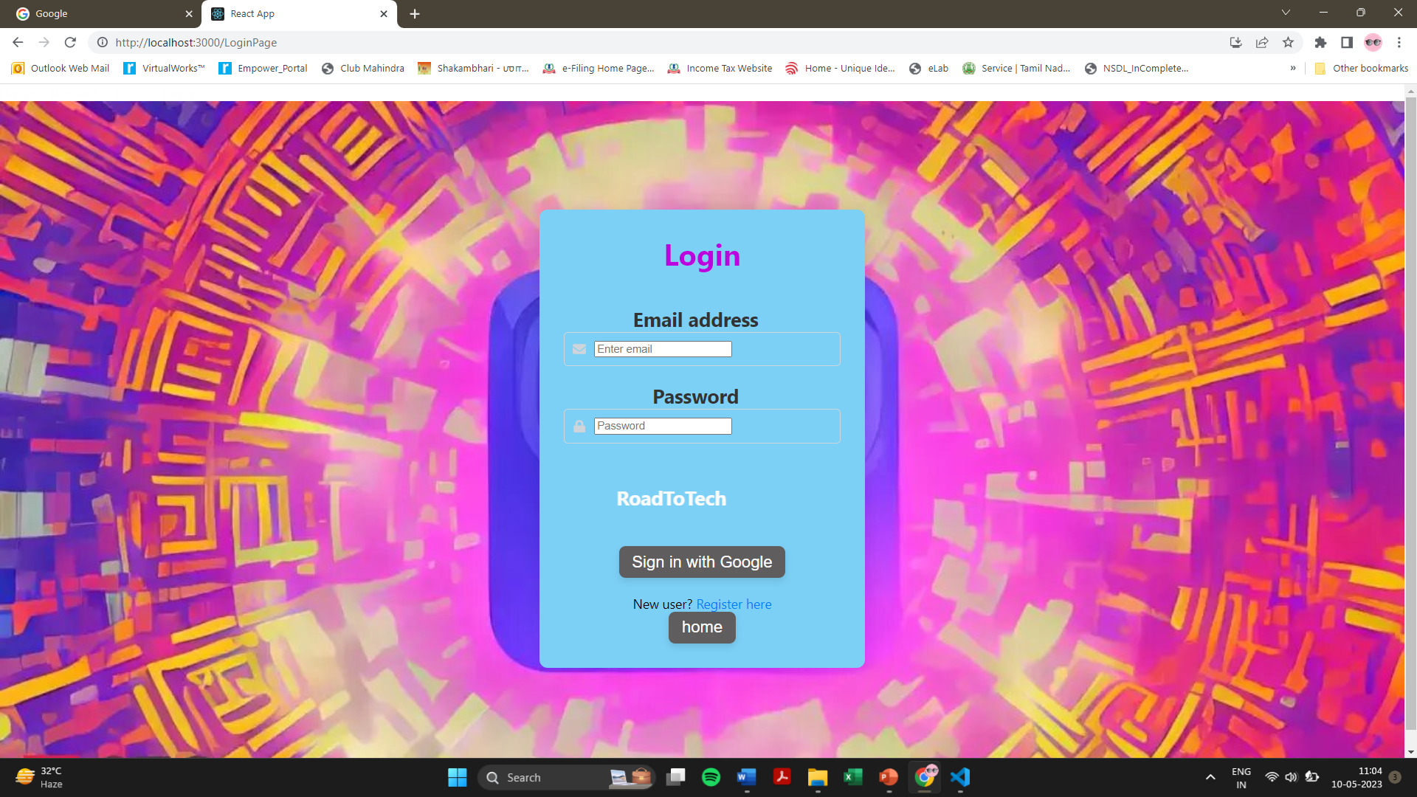

7.4 Learning component
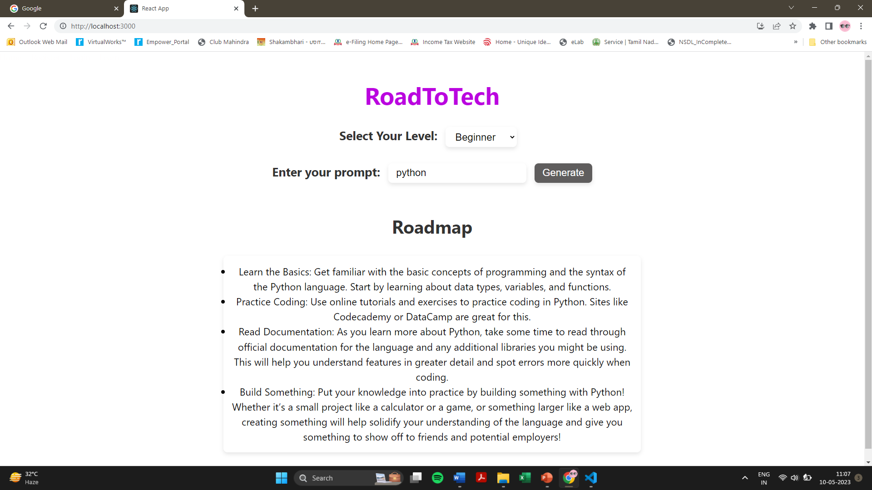

- CONCLUSION
In conclusion, the use of OpenAI's API has provided a valuable tool for generating IT skill roadmaps. By utilizing GPT-3's advanced natural language processing capabilities, we were able to generate personalized and comprehensive skill learning plans for both beginner and advanced programmers. Through careful prompt engineering, we were able to create prompts that effectively communicated the user's desired outcome and provided enough context for the API to generate relevant and informative responses. The API call was made by sending a POST request to the OpenAI API with the required headers and body parameters. The response from the API was then parsed and presented to the user in a readable format. Overall, the use of OpenAI's API has proven to be a powerful tool for generating IT skill roadmaps, and has the potential to revolutionize the way we approach skill acquisition and learning.

