Promoting Employee Value Proposition on Social Media for Employer Branding
Manisha¹, Dr Pratima Daipuria²
¹ PGDM Student, Jagan Institute of Management Studies, Rohini, Sector-5, Delhi.
² Professor, Jagan Institute of Management Studies, Rohini, Sector-5, Delhi.

---------------------------------------------------------------------***---------------------------------------------------------------------
Abstract - Abstract
The purpose of this paper is to explore the concept of employer branding on trending Social media platforms. With changing workforce practices such as hybrid working, remote working, and subsequent designing of Human resource policies by the firms, it is becoming imperative for firms to pay attention to employer attractiveness and how they appear as an organization to the outside world. There is a compelling need to create a strong case for businesses to have a strong employer branding strategy and evidently present it on the discussed social media platforms. The data for the study is collected through a questionnaire shared with respondents electronically to capture the perspective of employees of a start-up firm on employer branding, social media platforms, Employee Value Proposition (EVPs), and Employer attractiveness. The study will help start-ups and other companies to focus on the most important EVPs that will help them make more clear and effective employer branding strategies. The study also highlights the social media platforms which help them to communicate with the right set of potential candidates. Communicating their brand through social media will also be cost-effective for various start-up organizations.
Keywords: Employer Branding, Employee Value Proposition, Employer Attractiveness, Social Media

1. INTRODUCTION

Branding, nowadays, is not only focused on making an image for an organization’s product or service but also creating an image for that organization. Creating an identity for any organization helps them to differentiate itself from its competitors which helps in attracting and retaining the best human resource. The concept of creating an identity for an organization is known as Employer Branding. It is characterized as the development and communication of an organization's culture as an employer in the commercial center (Ambler and Barrow, 1996) Employer branding is a concept that has been there for the last 20 years, but with the changing times, the concept has gained importance. A study done on the Irish hotel industry suggests the application of employer branding as part of a talent management strategy to increase employee retention, improved performance, and sustainable competitiveness in a challenging employment market (Davern, 2021). Branding strategies are leveraged to influence human resource management systems and processes for better outcomes such as employee commitment, engagement, and productivity, reduced employee turnover intentions, and even better firm performance (Fulmer et al., 2003).
The main objective of the paper is to identify the top 5 Employee Value Propositions (EVPs) that an organization can use while creating a unique employer brand for itself. Another objective of the study is to suggest the top five social media platforms that can be effectively used by employers to communicate their branding messages. This study is relevant because it is imperative to identify and frame innovative HRM practice and unique dimensions of these practices.
2.1 Employee Value Proposition
To create good external and internal employer branding, companies focus a lot on their EVPs. EVP includes the advantages and incentives that a company provides to its employees in recognition of their significant efforts. EVP is an employee-centered approach influenced by current employees in line with existing, integrated workforce designing methods. Employees have a greater intention to stay when their organization delivers an EVP including development value, social value, and economic value. The impact of EVP on employees’ intention to stay is further strengthened by the psychological contract of the employee with the organization (Binu Raj A., 2021). In order to serve as a primary motivator for attracting talent, retaining it, and increasing employee engagement, EVP must be distinctive, relevant, and captivating. Tandehill (2006) linked this concept to employer branding and emphasizes that all organizations should articulate a statement defining why the overall work experience of their organization is better or superior to any other organization.
2.2 Social Media Platforms and Employer Branding
Since Covid -19 has led to the emergence of new organization systems and there is now a growing need for virtual or online organizational support structures in the context of employer branding (Connaughton & Lewis, 2020; Schmidt et al., 2016). The rise in the gig economy, the phenomenon of great resignation, moonlighting, etc. have resulted in employers focusing on branding through social media platforms. Separate streams of extant literature reveal that employees use social media to build connections with co-workers and develop online social capital (Huang & Liu, 2017)
Corporates have realized the power of Social Media platforms as a medium to share information related to practices and processes of the organization. It is important for organizations that want to make themselves known as trusted and valued employers, recruit prospective employees, to be present on commonly used social media platforms that are frequented by job seekers and recruiters.
The most popular social media platforms used by companies are LinkedIn, Instagram, and Facebook. As of March 17, 2023, Statista estimates there were 314.6 million active users on Facebook, 229 million active users on Instagram, and 99 million active users on LinkedIn. These platforms have emerged as a cost-effective option and also provide a better reach for the employer to connect with employees and potential candidates.
2.3 Employer Branding and EVPs
Employer branding is simply how people perceive a business as an employer. It depends on how it treats its workforce, how they view working there, and the culture of the business. Employer branding is a powerful tool for marketing a company to current and potential employees.
When asked about their experience working for a company, an existing employee is less likely to talk about the product and more likely to discuss the management, working environment, culture, and values. These factors are the EVPs that an employer offers to its employees. Furthermore, with the changing times’ modern media like digital media and social media has taken over traditional media platforms. Therefore, to build a successful employer brand social media platforms play a vital role.
Employer branding borrows its basic building blocks from the branding concepts (Morocko & Uncles, 2008). There is a passionate association between the employer and employee depending on brand image (Davis, 2008; Gaddi, 2008). Employer branding is a process of building the company’s identity through employees and prospective employees to distinguish the company from its competitors (Sivertzen et al., 2013). Based on a conference board report (Backhaus and Tikoo, 2004). Companies that make effective employer branding will give the company a competitive advantage, help employees internalize the company’s value and help in suppressing the amount of turnover. In building employer branding, there are three processes: developing the concept of value proposition, external bidding process, and thirdly making the brand’s promise through internal and organizational culture.
The first step in building an employer brand is developing the concept of the value proposition. Employee Value Proposition (EVP) is a set of associations and offerings provided by an organization in return for the skills, capabilities, and experiences an employee brings to the organization. It is an employee-centered approach that is aligned with existing, integrated workforce planning strategies as it has been informed by existing employees and the external target audience. (Minchington, 2005). Tandehill (2006) links this concept to employer branding and urges all organizations to articulate a statement defining why the overall work experience of their organization is better or superior to any other organization. The value proposition should identify the unique people policies, processes, and programs that demonstrate the organization’s commitment to i.e., employee growth, management development, ongoing employee recognition, community service, etc. It should list out the central reasons that people will choose to commit themselves to an organization.
2.4 Employer Branding & Organizational Attractiveness
A closely related concept to ‘employer branding’ is the notion of ‘employer attractiveness’. This concept has been broadly discussed in the areas of vocational behavior (Soutar & Clarke 1983), management (Gatewood et al. 1993), applied psychology (Jurgensen 1978; Collins & Stevens 2002), communication (Bergstrom et al. 2002), and marketing (Ambler & Barrow 1996; Gilly & Wolfinbarger 1998; Ambler 2000; Ewing et al. 2002).
The attractiveness of an organization is related to the way in which characteristics of the job and the organization are perceived (Ehrhart & Ziegert, 2005). Therefore, employer attractiveness mainly depends on the evaluation of an organization in terms of its corporate image (Kissel & Büttgen, 2015). Potential employees use perceptions of this corporate image as determinants of how it would be to work for this organization (Ehrhart & Ziegert, 2005). The concept of employer attractiveness has been used in multiple studies (Ahamad, 2019). Berthon et al. (2005) define employer attractiveness as ‘the envisioned benefits that a potential employee sees in working for a specific organization’ (p. 156). Based on the available literature, the EVPs mentioned in Table 1 are included in the study.
Table1: List of top selected EVPs (source: Self)
S.No | EVP | Explanation
1 | Work Environment | A decent working environment is a condition where individuals can do their jobs in an ideal, secure, healthy, and comfortable way (Sedarmayanti, 2003)
2 | Work-Life Balance | Work-life balance can be defined as satisfaction and good functioning at work and at home with a minimum of role conflict (Greenhaus, 2002).
3 | Job Security | Job security can be defined as the degree to which institutes offer stable positions for their employees (Herzberg, 1968).
4 | Clarity of Policies | A policy is a set of general guidelines that outline the organization’s plan for tackling an issue. Policies communicate the connection between the organization’s vision and values and its day-to-day operations.
5 | Corporate Social Responsibility | The International Organization for Standardization (ISO) describes CSR as a balanced approach for organizations to address economic, social, and environmental issues in a way that aims to benefit people, the community, and society.
6 | Learning & Development- | The goal of learning and development is to develop or change the behavior of individuals or groups for the better, sharing knowledge and insights that enable them to do their work better or cultivate attitudes that help them perform better (Lievens, 2011)
S.No | EVP | Explanation
7 | Good Infrastructure | Workplace amenities and facilities are things provided for the health, safety, welfare, and personal hygiene needs of employees. They include toilets, shelter, seating, dining rooms, change rooms, drinking water, personal storage, and washing facilities. They also include work environment facilities such as workspace, temperature, and air quality, lighting, and flooring.
8 | Health Insurance | Employee health insurance is a benefit extended by an individual's employer to their employees. It does not only cover the person working for the employer but also covers the rest of the family members under the policy.
9 | Ethics and Values | Organizational values are the guiding principles that provide an organization with purpose and direction. They help companies manage their interactions with both customers and employees.
10 | Challenging nature of work | According to OECD (2016) it is likely that the skill set, enabling individuals to compete in the future labor market, will be changing over time. Following this argumentation, a more complementary skill set will be needed, ranging from literacy and numeracy skills to the right socio-emotional skill set needed to work collaboratively and flexibly.

2.5 Employer Branding & Social Media
In a competitive market as organizations are in, being able to attract high-quality employees is seen as a competitive advantage for an organization (Priyadarshini et al., 2017). Earlier, the official websites used to be the source of information for potential candidates but with the popularity of the internet, there is a decrease in the use of organizational websites by employers due to the shift towards social networking sites (Bradwell & Reeves, 2008). Social networking sites are also called social media.
Another advantage of using social media is the option to easily share one's identity, which can effectively be used by organizations to communicate their organizational identity. Employer branding builds a good employer image and proposes valuable and attractive value. Because of the well-developed audio-visual tools, an organization is more likely to effectively communicate the employer’s brand personality than when using other media channels (Kissel & Büttgen, 2015). Therefore, the Internet and social media channels make it easier for potential employees to estimate their fit with the organization (Gregory et al., 2013). The scope of 10 social media platforms selected for the study is mentioned in table 2.
Table 2: List of Social Media platforms (source: self)
S.No | Social Media Platform | Details
1 | LinkedIn | LinkedIn is mainly used for promoting professional skills. Users on LinkedIn pay much more attention to building profiles and identities with a secondary focus on relationships and reputation. In this social media platform, all kinds of organizations are able to approach the key individuals, or in other words, key top talents. (Kietzmann 2011.)
2 | Indeed | Current and former employees can provide ratings and evaluations as well as answer a survey about their experience working for your firm through Indeed Company Pages. Job searchers are 2.7 times more likely to apply for a position at a company after visiting its Indeed Company Page, on average. All employers can use Company Pages for free, and a premium edition is available if you want access to more sophisticated branding and analytics features. With Indeed Company Pages Premium, firms can actually reach 7 times more job seekers with their story.
3 | Glassdoor | Glassdoor provides the perfect place to manage your employer brand, allowing you to engage job seekers by letting them know about your company and workplace culture. It has a variety of solutions, from branded job postings to job ad advertising and a customizable company page.
4 | Twitter | Twitter is vastly used for the purpose of building conversation between users, with a secondary focus on sharing, identity, and reputation. Moreover, by using Twitter, each organization can build up a strategic plan to approach targeting key individuals. (Kietzmann 2011.)
5 | Facebook | Facebook has been famous of allowing people to establish online relationships between users with secondary focus on presence, identity, reputation 28 and conversation. For that reason, by utilizing Facebook, organizations can approach the target individuals and to improve brand engagement and loyalty and especially can take advantage of eWOM.
6 | Instagram | Instagram’s scroll-friendly layout and image-centric content make it an ideal outlet for branded posts. Business posts fit in seamlessly with personal posts in the feed, making content from brands feel more organic.
7 | YouTube | YouTube is mainly used for sharing videos with the secondary concerns of improving reputation, joining groups, and starting a conversation related to the video uploaded. (Kietzmann 2011.)
8 | Monster | Monster helps you showcase, monitor, and fortify your employer brand. So more potential employees who are the right fit can find your company as a natural part of their journey.
9 | Naukri | Naukri can be visualized as a meta memory. It has value creation powers by driving up efficiencies. It provides potential consumers with a single point of contact between consumers and a diverse set of marketers (meta market), this creates opportunities for facilitators such as bringing the recruiters and job seekers together and reducing economic and psychic costs. By becoming a one-stop solution within an activity cluster naukri.com has been able to build significant mind share. (Srikant Kapoor, 2019)
10 | Snapchat | The photo and video messaging app allows users to send videos and pictures that self-destruct after a few seconds. Using Snapchat offers low risk while experimenting with creative multimedia content to increase engagement.

3 Objective
i) To identify the top five EVPs that can be used for employer branding strategies.
ii) To identify the top five social media platforms that can be used for employer branding communication.
3.1 Methodology
The study is descriptive in nature and a questionnaire was designed to collect the data. There were 7 questions, pertaining to demographics, and the factors motivating people to join any organization. The questionnaire used a ranking scale. The respondents were employees working in start-ups, above the age of 21 years in Delhi NCR region. The sample size of the study is 35 and 19 males and 16 females volunteered to participate.
An initial discussion with experts and employees working in a leading start-up was conducted to identify EVPs. The top 10 EVPs that emanated from the discussion were identified and further used in this study. Both social media platforms and EVPs are ranked on a scale of 1 to 10 (1 being the highest and 10 being the lowest) to find the top 5 EVPs and the top 5 social media platforms that can be used by start-ups to make their employer branding strategies. Further, the Employer Attractiveness scale comprising five dimensions of employer branding, interest value, social value, economic value, developmental value, and application value (Pierre Berthon et al, 2005) is used in the study to establish employer branding aspects. A questionnaire was prepared and circulated amongst 50 employees working in a start-up. 35 filled questionnaires were found relevant to be considered in the study for analysis.

- Data Analysis
The objective of the study is to address the employer branding practices that employees in new-age organizations such as start-ups, hybrid working, and remote working models are looking to increase retention of employees as well as create a fulfilling work environment. Addressing these issues and their presentation on social media platforms can lead to better EVPs and help organizations design their social media branding strategy in a better manner.
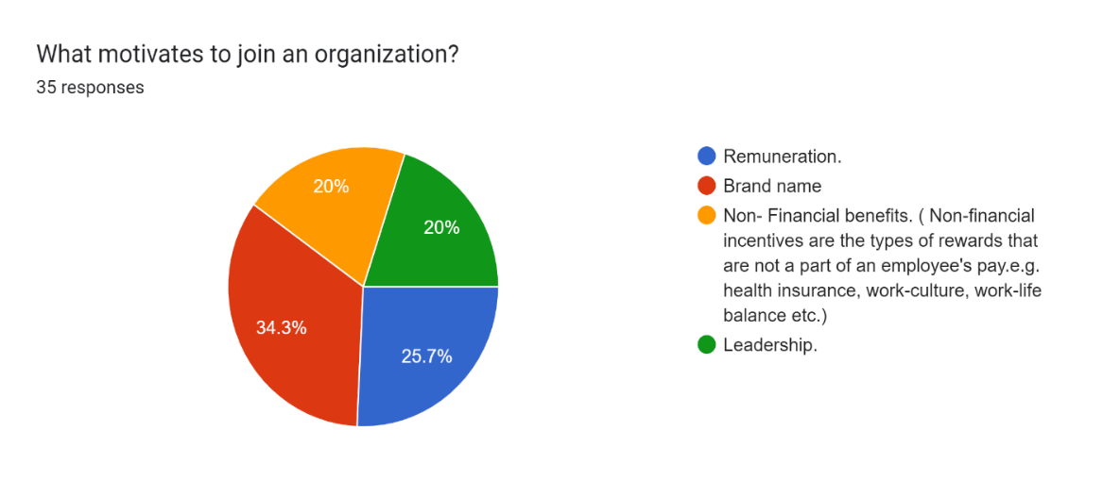
Figure1: Factors motivating potential candidates to join an organization
According to the responses obtained, the brand name is the highest-ranked factor that prospective employees look for while searching for companies. 34% of respondents opted for brand name as the motivating factor for joining an organization followed by remuneration,

leadership, and non-financial benefits. Around 88% of respondents reported checking the social media accounts (figure 2) of a company before joining it.
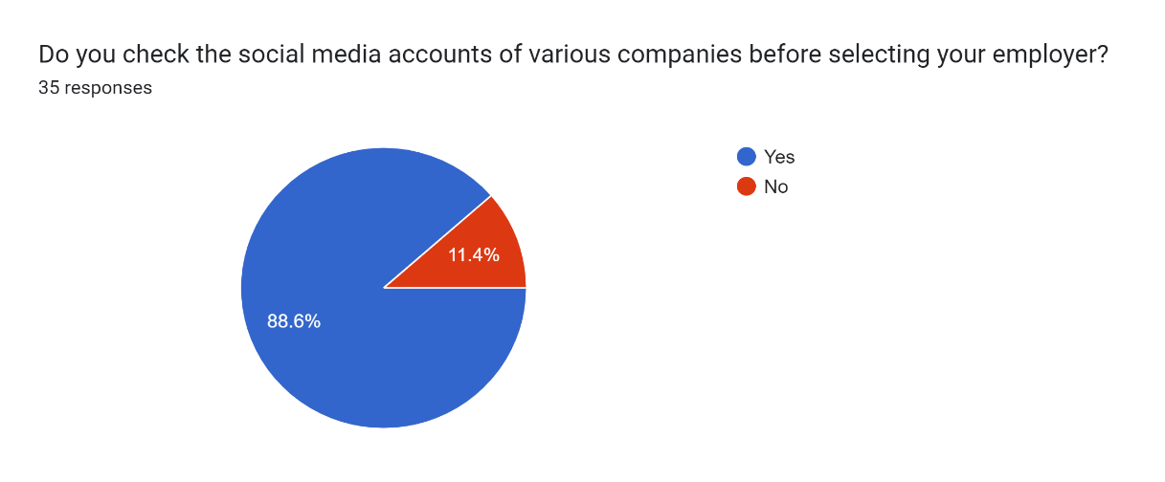
Figure 2: Percentage of respondents checking social media account of prospective employer.

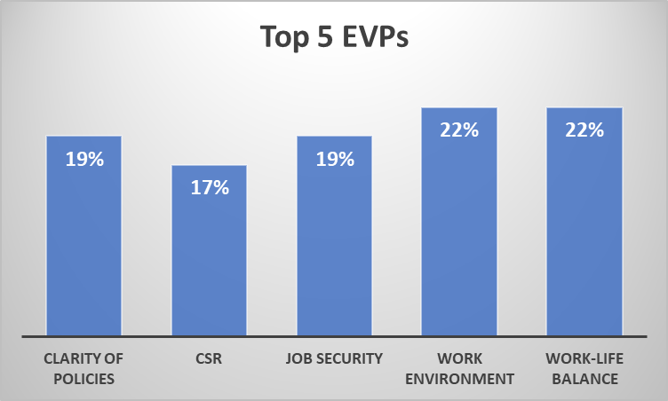 Figure 3: Top 5 EVPs as per respondents
According to the Figure 3, the rankings obtained through the questionnaire for the top 5 EVPs. For 1st rank, Work environment got the highest number of responses which is 16. Work-life balance also had 16 responses for the 2nd rank, similarly, clarity of policies and job security got 14 responses for the 3rd and 4th rank respectively. For the 5th rank, CSR got 12 responses.
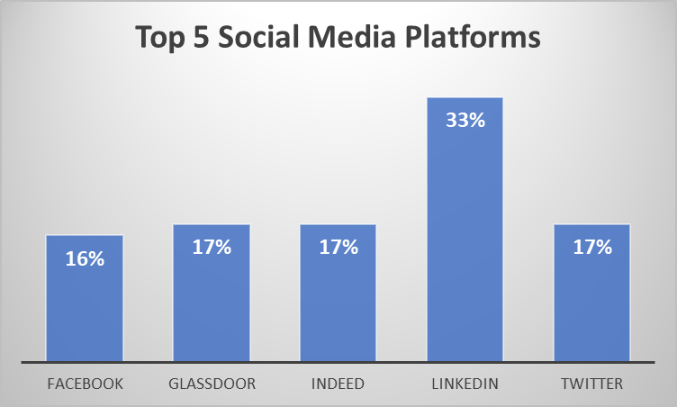Figure 4: Top 5 social media platforms
Figure 4 shows the rankings obtained through the questionnaire. LinkedIn got the highest number of responses as the most preferred social media platform followed by Indeed, Glassdoor, Twitter, and Facebook.
- Discussion and Implications
Organization Attractiveness has a direct association with employee motivation, talent attractiveness, and talent retention. Since most job seekers are available on Social Media platforms, it is important that Corporates carefully design their employer branding strategies. The following areas are the ones that affect the work performance of employees.
  - Work Environment
A BLCG Employer Branding Framework was proposed by Ghadeer Mohamed Badr Eldin Aboul-Ela (2016) BLCG stands for Bloom-Live-Connect-Grow. Live dimension includes; a salary scheme, fair rewards and bonus system, appropriate compensation, a sense of workplace empathy and compassion, a pleasant working place, supportive corporate culture, fair holidays, appropriate retirement packages, dynamic business process, work-life balance, and good industrial health and safety programs. One of the most active research organizations represents an Australian company Employer Brand International which conducts wide employer branding studies According to the edition of EBI, 2013, the best candidates or best employees are interested in an environment conducive to teamwork (48%), the obligation of the employer to develop employee (36%), an innovative company culture (36%), and a company that is constantly evolving (35%).
According to Berthon et. Al( 2005). ‘Interest value’, assesses the extent to which an individual is attracted to an employer that provides an exciting work environment, and novel work practices and that makes use of its employee’s creativity to produce high-quality, innovative products and services. Hence, a work environment can play a crucial role while developing employer branding strategies.
5.2 Work-Life Balance
With the changing dynamics and definition of the workplace, organizations are framing policies that are employee-centric and can exude greater control over work and life for everyone including parents (Daipuria, P., &Kakar, D., 2013). It is a matter of great concern for many companies where unsatisfactory work-life balance issues are negatively affecting employee turnover.
The ‘interest value’ and ‘social value’ of the employer attractiveness scale (Berthon et. al 2005) include psychological benefits also. Also, as per the Randstad Employer Brand Research (REBR) Survey 2020, the Indian workforce while choosing an attractive employer has chosen work-life balance as the most important EVP. It is important for the employer to create a supportive environment where employees can rightfully manage their personal and professional life, especially post-pandemic. To handle work/life balance, Friedman and Greenhaus emphasize that working adults learn to build networks of support at home, at work, and in the community. The conflict between work and family has real consequences and significantly affects the quality of family life and career attainment of both men and women. Promoting and encouraging the right balance between work and home or other important aspects of life will also add to employer branding attractive value (Maurya et al, 2021), which will attract high-quality applicants, as well as, retain the skills of the best employees. For any organization, employer branding is the most basic way to promote itself. And, it can be achieved by working upon the work-life balance factor, as both are interlinked to each other. (Dr. Guru Basava Aradhya, Ms. Chinna Rathi., Ms. Urvashi Khurana, 2021).
  - Clarity of Policies
Clarity of policies is vital as it lays the foundation of empowerment. Communicating about clarity of policies can help an employer to build a brand image that portrays a culture of transparency and equality in the workplace. Clarity of policies also ensures compliance in the organization. It also helps in maintaining accountability, consistency, and setting clear expectations for the employees.
The Live dimension of the BLCG Employer Branding Framework (Ghadeer Mohamed Badr Eldin Aboul-Ela, 2016) also mentions the dynamic business process, fair rewards, and bonus system, fair holidays, appropriate retirement packages, good industrial health, and safety programs. In a study by Chopra et al (2022), compensation and benefits, career opportunities, work–life balance was found to be primary antecedents of employer branding. And these could only be translated to EVP by clear policy communicated to the employees.
  - Corporate Social Responsibility
Lindholm, L. (2018) conducted a content analysis of the website communication of IT companies and established a strong integration of CSR activities of the company with employer branding at both internal and external levels. CSR activities would also help in retaining existing employees as they feel a sense of self-image and prestige conveyed about their working place to the external environment. According to Bloom’s dimensions; a prestigious employer, corporate social responsibility practices, the positive image conveyed to the general public, type of industry, the scope of international operations, comprehensive website, the employer is a market leader, range of products and services, employer’s ability to differentiate itself from competitors, vision, mission, and core values, employer’s country of origin and the ability to maintain a positive reputation. (Ghadeer Mohamed Badr Eldin Aboul-Ela,2016). Integrating corporate social responsibility into brand positioning strategies has become a key concept for the brand marketing of many companies. (Kamel Ben Youssef, Thomas, Leicht, Michela Pellicelli & Philip J. Kitchen, 2017). Increasingly, management recognizes the need to promote socially responsible business practices to achieve a sustained strategic advantage (Luo and Bhattacharya, 2006; Sen, Bhattacharya, and Korschun, 2006) and to enhance a corporation’s reputation. Usually, it should be the responsibility of any organization to work for the development of their society. Although not all companies are fulfilling their CSR those who are doing it honestly are getting its benefits in terms of building their external image in society. However, during the pandemic times, many companies came forward to help society such as Tata Group, one such brand that has built a strong corporate image based on its social initiatives.
By investing in corporate social responsibility, corporations can secure competitive advantages, and financial benefits (Luo and Bhattacharya, 2006), build brand awareness (Hoeffler and Keller, 2002) and create brand legitimacy (Luo and Bhattacharya, 2006; Uggla, 2006; Vaaland et al., 2008; Werther Jr and Chandler, 2005).
  - Job Security
According to the Randstad Employer Brand Research (REBR) Survey 2020, the Indian workforce while choosing an attractive employer has chosen Job security as the third most important EVP. In the BLCG Employer Branding Framework Grow dimension is concerned with the factors related to an employee’s potential growth, self-development, progression in the workplace, and job security for future growth.
Job Security helps employees to have a feeling of economic stability. However, job security is not only important for an employee but it is also equally important from the point of view of an employer. Job security ensures the stability of your employees. More stability will lead to less attrition in the organizations. Although, external factors like recession, pandemics, etc. also have a strong impact on job security. But an employer should try their best to provide job security to their employees to reduce attrition. Job security can also play a vital role in employer branding as the companies that have higher attrition rates are not preferred by potential candidates.
The brand is the most valuable asset for a company, and as a result, brand management becomes an essential activity in most companies (Backhaus and Tikoo, 2004). In addition to companies focused on developing their brand through product development and corporate brand, branding can also be used in human resource management or known as” employer branding” (Backhaus and Tikoo, 2004). Employer branding is a process of building the company’s identity through employees and prospective employees to distinguish the company from its competitors (Sivertzen et al., 2013). Based on a conference board report (Backhaus and Tikoo, 2004). Companies that make effective employer branding will give the company a competitive advantage, help employees internalize the company’s value, and help in suppressing the amount of turnover.
The expectations of employees have changed with the changing times. Remuneration is not the only that is now being expected from the employer, EVPs like work environment, work-life balance, clarity of policies, job security, and investment in CSR activities to attract stakeholders (Binu Raj, A., N., A.J. and A.K., S., 2022), etc. have gained importance. In fact, there are employees and potential candidates who can compromise on the remuneration but want other EVPs should be provided by the employers. Having good and effective employer branding strategies becomes critically important for Startups as they need to make a brand name for themselves for future developmental purposes. The budget constraints restrict start-ups to spend much on building an employer brand.
Family and employee-centric HR practices that specifically address employee needs can help businesses reverse the trend of employee turnover and reap desired results from well-drafted talent management and employer branding practices. ("Towards effective talent management and employer branding: The importance of employee perception of work-life balance", 2021)
REFERENCES
- Berthon, P. & Ewing, M. & Hah, L.L.. (2005). Captivating company: Dimensions of attractiveness in employer branding. International Journal of Advertising. 24. 151-172. 10.1080/02650487.2005.11072912.
- Binu Raj, A., N., A.J. and A.K., S. (2022), "Building corporate reputation through corporate social responsibility: the mediation role of employer branding", International Journal of Social Economics, Vol. 49 No. 12, pp. 1770-1786. https://doi.org/10.1108/IJSE-09-2021-0541.
- Blogger, G. (n.d.). Importance of Employee Job Security for Workplace Success. Retrieved from https://www.yoh.com/blog/importance-of-employee-job-security-for-workplace-success
- Chopra, A., Patel, G. and Sahoo, C.K. (2022), "A critical assessment of employer branding to retain knowledgeable workforce: study on current employees of the information technology firms", VINE Journal of Information and Knowledge Management Systems, Vol. ahead-of-print No. ahead-of-print. https://doi.org/10.1108/VJIKMS-02-2022-0036
- Daipuria, P., & Kakar, D. (2013). Work-Life Balance for Working Parents: Perspectives and Strategies.
- Dr. Guru Basava Aradhya S, Chinna Rathi. K, & Urvashi Khurana. (2021). Impact of Employer Branding on Work-Life-balance of IT Employees in Bangalore. PalArch’s Journal of Archaeology of Egypt / Egyptology, 18(09), 327-338. Retrieved from https://archives.palarch.nl/index.php/jae/article/view/9317
- Employer Branding. (n.d.). Retrieved from https://hiring.monster.com/help-center/traditional-products/employer-branding/
- Employment News, Trends & Insights | Mondo Staffing. (n.d.). Retrieved from https://mondo.com/insights/
- FIGURSKA , & MATUSKA. (2013). Employer Branding As A Human Resources Management Strategy . Human Resources Management & Ergonomics, VII.
- Ghadeer, Mohamed & Badr, Eldin & Aboul-Ela, Ghadeer. (2016). Employer branding: What constitutes " An Employer of choice?. Journal of Business and Retail Management Research.11.
- Indeed, I. (no date) How to improve employer branding with Indeed, Available at: https://www.indeed.com/hire/resources/howtohub/how-to-improve-employer-branding-with-indeed (Accessed: April 29, 2023).
- Kalińska-Kula, Magdalena & Staniec, Iwona. (2021). Employer Branding and Organizational Attractiveness: Current Employees’ Perspective. EUROPEAN RESEARCH STUDIES JOURNAL. XXIV. 583-603. 10.35808/ersj/1982.
- Kunzle, A. (2022, November 3). 14 employer branding social media examples & ideas. Retrieved from https://www.contentstadium.com/blog/employer-branding-social-media-examples/
- Lindholm, L. (2018), "The Use of Corporate Social Responsibility in Employer Branding", Koporcic, N., Ivanova-Gongne, M., Nyström, A.-G. and Törnroos, J.-Å. (Ed.) Developing Insights on Branding in the B2B Context, Emerald Publishing Limited, Bingley, pp. 73-93. https://doi.org/10.1108/978-1-78756-275-220181005

Lissaneddine, Zakaria & Alaoui, Lalla Amina & Laaroussi,

Ouiame & Laaroussi, Amale. (2021). Employer Branding

Through Social Media: The Case of Moroccan Customer

Relation Centers.
- Maurya, K.K., Agarwal, M. and Srivastava, D.K. (2021), "Perceived work–life balance and organizational talent management: mediating role of employer branding", International Journal of Organization Theory & Behavior, Vol. 24 No. 1, pp. 41-59. https://doi.org/10.1108/IJOTB-12-2019-0151
- Media & Entertainment Industry in India - Indian Media Industry. (2023, March 9). Retrieved from https://www.investindia.gov.in/sector/media.
- Newsome, P. (2020, August 6). Why Instagram is a Great Platform to Display Your Employer Brand. Retrieved from https://www.4cornerresources.com/blog/why-instagram-is-a-great-platform-to-display-your-employer-brand/
- Pawar, Avinash & Charak, Kuldip. (2015). Employee Value Proposition Leading to Employer Brand: The Indian Organizations Outlook
- Policies and Procedures in the Workplace: The Ultimate Guide. (n.d.). Retrieved from https://www.caseiq.com/resources/policies-and-procedures-in-the-workplace-the-ultimate-guide/
- Prameka, A. S., Sanusi, A., Futari II, O., & Kusnayain, Y. I. (2021). The Influence of Employer Branding Towards Generation Z Students Attractiveness on Start-up Unicorn. Hasanuddin Economics and Business Review, 5(2), 36. https://doi.org/10.26487/hebr.v5i2.2910

Puri, Diwakar. (2018). Developing the Scale to Measure Employer Attractiveness. Annals of the University Dunarea de Jos of Galati. 3. 99-123. 10.26397/eai1584040923.
- Soper, J. (2023, February 10). Glassdoor vs Indeed: Comparison, Pricing & Features. Retrieved from https://fitsmallbusiness.com/glassdoor-vs-indeed/
- (2021), "Towards effective talent management and employer branding: The importance of employee perception of work-life balance", Development and Learning in Organizations, Vol. 36 No. 1, pp. 46-48. https://doi.org/10.1108/DLO-04-2021-0074
- Van Hoye, Greet & Lievens, Filip. (2007). Social Influences on Organizational Attractiveness: Investigating If and When Word of Mouth Matters. Journal of Applied Social Psychology. 37. 2024 - 2047. 10.1111/j.1559-1816.2007.00249.x.
- Verlinden, N. (2021, August 18). Organizational Values: Definition, Purpose & Lots of Examples. Retrieved from https://www.aihr.com/blog/organizational-values/
- Vulpen, E. V. (2020, January 22). Learning and Development: A Comprehensive Guide. Retrieved from https://www.aihr.com/blog/learning-and-development/.

