A STUDY OF DUMPING OF WASTE IN SEA AND ITS EFFECTS ON ENVIRONMENT

AUTHOR
I. NITHISH KUMAR
Reg. no. ( 131801091 )
B.A., LL.B., (Hons), 4th YEAR
Saveetha School of Law
Saveetha Institute of Medical and Technical Sciences
Chennai-600077

CO-AUTHOR
Dr. R. Chandrasekar
Associate Professor
Saveetha School of Law
Saveetha Institute of Medical and Technical Sciences
Chennai-77

A STUDY OF DUMPING OF WASTE IN SEA AND ITS EFFECTS ON ENVIRONMENT

AUTHOR: I. Nithish Kumar
CO AUTHOR: Dr. R. Chandrasekar

ABSTRACT:

This Research about dumping of waste in sea and its effects on the environment, communities around the world used the ocean for waste disposal, including the disposal of chemical and artificial wastes, radioactive wastes, trash, munitions, sewage sludge, and defiled trolled material. Pollution - unwanted waste released to air, water, and land by human activity - is the largest environmental cause of disease in the world today. It is responsible for an estimated nine million premature deaths per year, enormous economic losses, erosion of human capital, and degradation of ecosystems. Ocean pollution is an important, but insufficiently recognized and inadequately controlled component of global pollution. It poses serious threats to human health and well-being. The nature and magnitude of these impacts are only beginning to be understood.In particular this is the case for wastes which will become submerged since the dispersion in internal layers of the sea can be very weak. Various criteria for selection of dumping sites are discussed, and especially the significance of the physical conditions and their variability is demonstrated. The lack of reliable theoretical models is stressed, for instance for predicting the depth of penetration of sludge wastes, and the limited scientific knowledge about many of the relevant aspects in general is emphasized.The deleterious effects of plastic debris on the marine environment were reviewed by bringing together most of the literature published so far on the topic.

KEYWORD:
Waste from sewers, industrial effluents, garbage dump, plastics.

INTRODUCTION :

In history, communities around the world used the ocean for waste disposal, including the disposal of chemical and artificial wastes, radioactive wastes, trash, munitions, sewage sludge, and defiled trolled material. Little attention was given to the negative impacts of waste disposal on the marine terrain. Indeed less attention was concentrated on openings to reclaim or exercise similar accoutrements . Wastes were constantly ditched in littoral and ocean waters grounded on the supposition that marine waters had an unlimited capacity to mix and dispersewastes.In October 1972, Congress legislated the Marine Protection, Research and Sanctuaries Act. occasionally pertained to as the Ocean Dumping Act, declaring that it's the policy of the United States to regulate the jilting of all accoutrements which would negatively affect mortal health, weal or amenities, or the marine terrain, ecological systems or profitable possibilities.Limited disposal of wastes and other accoutrements into the ocean degrades marine and natural coffers and acts mortal health pitfalls. For nearly 50 times, EPA’s Ocean Dumping Management Program has stopped numerous dangerous accoutrements from being ocean ditched, worked to limit ocean jilting generally, and worked to help adverse impacts to mortal health, the marine terrain, and other licit uses of the ocean from pollution caused by ocean jilting. There are several contributing factors to ocean jilting. neglectfulness, ignorance, and lack of effective disposal systems are just some of the biggest causes. Since 70 of the earth is filled with water, the abysses and the swell continue to face all manner of jilting, especially in terms of waste material deposits from diligence, sewerage, tankers and manufactories.The jilting of trash, similar as plastics and construction waste, has also exacerbated the situation. It isn't a new environmental concern as a matter of fact, it continues to escalate. Any deliberate disposal at ocean of wastes or other matter from vessels, aircraft, platforms, or other man- made structures at ocean, and any deliberate disposal at ocean of vessels, aircraft, platforms, or other man- made structures at ocean. Ocean is more ancient than the mountains, and burdened with the recollections and the dreams of TimeThen are the cited causes and goods of ocean jilting, including results to the matter.

OBJECTIVES:
- To assess the activities involved for the proposed and determine the type, nature and estimated volumes of waste to be generated.
- To identify any potential environmental impacts from the generation of waste at the site.
- To recommend appropriate waste handling and disposal measures / routings in accordance with the current legislative and administrative requirements .
- To categorize waste material where practicable for disposal considerations public filling areas and landfill.

REVIEW OF LITERATURE:

1. (Clark, A., & Masumi, 2021) The colorful weight conditioning at the harborage persistently contributes to the problem of ocean jilting. jilting frequently takes place from the weight that sweeps from the vessels as they leave the harbor. In most cases, it occurs during the junking of wastes similar to sediment, coal and limestone from the sundeck. This is one of the impregnable conditioning at the harborage that constantly contributes to ocean jilting.neglectfulness in Terms of Sewer and Industrial Waste Dumping.
2. (Degnarain, 2020) The intensity of careless jilting of seamster and artificial wastes into the ocean has increased the magnitude and scale of ocean jilting, especially considering the volume of sewage coming from vessels, homes, diligence, and manufactories. Due to neglectfulness, the wastes from seamsters and diligence aren't treated before they're discharged into the ocean.
3. (Greenpeace, 2019) In some cases, the seamster drainage systems run directly into the ocean with all the dangerous accouterments similar as contagions, bacteria, cryolite, mercury, lead and DDT. What’s more, some of the artificial wastes indeed contain radioactive accoutrements .For a long time, mortal populations have considered ocean jilting as a necessity or a rather safe system of disposing of waste.
4. (Jeff Gottlieb, 2009) People have, for a long time, held on the belief that jilting trash in the ocean dilutes and reduces the toxin of the accoutrements .The point is, ocean jilting is incompletely caused by ignorance and lack of acceptable knowledge on the belief that jilting trash in the ocean dilutes and reduces the toxin of the accoutrements.
5. (Windevohxel, 2003) The point is, ocean jilting is incompletely caused by ignorance and lack of acceptable knowledge on the impacts of releasing trash and other poisonous substances into the ocean. As long as people hold on to the belief that it’s safe to dispose of trash in the ocean, ocean jilting won't cease. Spillage From Offshore equipages and oil painting Tankers Spillages from coastal equipment and oil painting tankers are high examples of the contributors to ocean jilting.
6. (MooreC J, 2002) It generally occurs moreover on a large scale due to accidents that unmask massive volumes of oil painting on the ocean face or without knowledge, where small quantities of oil painting are blurted into the ocean from oil painting tankers or by tanker vessels. Large scale oil painting tumbles are among the worst recorded cases of ocean jilting in history. One similar notable script is the Gulf of Mexico oil painting slip that resulted in the death of thousands of ocean brutes.Direct Discarding of Waste Accoutrements.
7. (Kayastha, 2022) Non-degradable and one- time- use accoutrements similar as plastics frequently find a way into the abysses because of direct jilting. It qualifies as one of the major contributing factors to ocean jilting on the account that once the accoutrements are introduced in the abysses, they last there for hundreds to thousands of times. A veritably good illustration of the destructive impacts of direct jilting of plastic into the ocean is the Pacific Ocean Garbage Patch.
8. (Goddard G, 1997) Mining of Essence Ores Essence ores released from regions where drill mining is done, especially near water systems similar as aqueducts and gutters, ultimately affect ocean jilting. The reason for this is that the essence ores are continuously deposited in the aqueducts and gutters to high poisonous situations, after which they're carried by the water systems and discharged into the ocean.
9. (Rodgers, 1997) Deep- ocean mining and the exertion of mining essence ores conterminous to abysses also has a direct impact on ocean jilting. For example, deposits of iron, arsenic, mercury and sulfur are associated with deep- ocean gold mining. Lack of Strict Regulations and Observation ActsThe absence of strict nonsupervisory and observation acts to control the problem of ocean jilting is another huge contributor to the imminence.

10. (Swanson D W, & Miller S L, 2002) The non supervisory authorities and individualities assigned the task of monitoring and observing the regions that are largely likely to be affected habitually take a aft seat rather than being at the van at executing the laws put in place to guard against ocean jilting. This is the reason some people and manufacturers take advantage, thereby engaging in direct jilting and the discharge of artificial waste into the ocean.
11. (Burroughs, R. H., 1991) Runoffs From the Land One of the major causes of ocean jilting is the runoff from the land runoffs, especially from the agrarian fields. numerous growers use chemical diseases in their fields. The excess of the same, blends with the irrigation water and inflow to the nearest water body which also, eventually empties into the ocean and pollutes it. Cargo Related Accidents Occasionally it so happens that the weight carrying poisonous accoutrements meets an accident. It might affect some accidental oil painting.
12. (Guardian, 2008) Internationally, incineration at the ocean is also regulated under the London Convention and London Protocol, which are ocean jilting covenants. The United States is a Contracting Party to the London Convention. The United States has inked the London Protocol, which is intended to contemporize and ultimately replace the London Convention; still, the Senate has not ratified the convention.
13. (Yonhap, 2021) Under the London Convention, incineration of artificial waste and sewage sludge is banned. The London Convention defines “ incineration at ocean ” as the deliberate combustion of wastes and other matter the deliberate combustion of wastes and other matter on marine incineration installations for the purpose of their thermal destruction. Combustion associated with conditioning incidental to the normal operation of vessels, platforms and other manmade structures is barred from the compass of this description.
14. (Sjoblom, K., & Linsley, 1994) Marine incineration installation means a vessel, platform, or other manmade structure operating for the purpose of incineration at the ocean. Under the London Protocol, incineration at the ocean and the import of wastes and other accoutrements for incineration at the ocean is banned. The London Protocol defines “ incineration at ocean ” as the combustion on board a vessel, platform or other man- made structure at ocean of wastes or other matter for the purpose of their deliberate disposal by thermal destruction.

15. (Riviera Newsletters, 2008) The banned incineration at ocean doesn't include the incineration of wastes or other matter on board a vessel, platform, or other man- made structure at ocean if similar wastes or other material were generated during the normal operation of that vessel, platform, or other manmade structure at ocean.There’s a lot we can do to save our abysses. The stylish place to start is to keep them clean and not throw anything into them. It’s also a good idea to keep the strands clean. Garbage on the sand can fluently end up in the water. Another thing we can do is to stop pouring chemicals down the drain similar as makeup or oil painting. Stop using poisonous ménage products and do n’t overwater our meadows, in other words, conserve water.
16. (Ringbom, H., & Henriksen, 2017) Cargo vessels both accidentally and designedly discharge crude oil painting into the ocean. As far as ocean pollution goes, this is one of the primary causes. Other reasons for marine pollution are the jilting of artificial waste. These products contain poisons including mercury, PCBs, PAHs, and radioactive material, all of which contaminate the ocean. Heavy rains and cataracts wash trash and debris into the waters.
17. (McCullagh, 1996) Mortal waste and sewage water that has been incompletely treated or undressed goes into the ocean.This is called “ scrap jilting ” and is one of the world’s leading causes of ocean pollution. motorcars emit carbon dioxide due to fossil energies being burned. This leads to air pollution. The carbon dioxide in the air reaches the ocean and becomes acid rain which also pollutes the water.
18. (Maritime Executive, 2019) Oil painting tumbles are dangerous for marine life and can affect coral reefs that thrive in the ocean. In fact they can greatly affect the life cycle. The gills of fish can be congested by revealed oil painting which can block respiration.However, marine shops will die because it affects photosynthesis and its process, If the sun is blocked.
19. (Marine Defenders, 2018) Bottles and other plastics including bags can suffocate or choke ocean brutes. Allowing their food, they may eat them. Plastic particulars are one of the major causes of death among turtles. They suppose plastic bags look like doormat and try to eat them.These poisons not only affect marine life, but they affect humans as well. For illustration, let’s say the fish are defiled, if someone were to catch a fish and eat it, they could get food poisoning. If scrap is ditched into the ocean, the oxygen in the water could be depleted. This results in poor health for marine life due to lack of oxygen. creatures similar to seals, dolphins, penguins, harpies, jumbos, and herring could all die.
20. (Lebling, K., & Northrop, 2020) The goods of ocean jilting are due to our neglectfulness. Roughly two thirds of the world’s marine lives have been covered with chemicals we throw down the drain every day similar to household cleansers. It may do you good to flash back that marine life is a part of our food chain. Not only do we eat fish and other marine life, but so do other creatures. Aquatic brutes are a main food source for other fish and bears.

MATERIALS AND METHOD :

The researcher obtained the primary source of data by conducting an empirical study on seeking responses from the general public based on a questionnaire and also relied on secondary sources of data such as books, journals, e-sources, articles and newspapers. The present research is conclusive, descriptive and based on empirical design. Qualitative data was generated to test the research hypothesis. This research paper used the empirical type of research which is done by the survey method. The sampling size of the paper is 200. Statistics is on percentage analysis. The independent variables are Age, gender, educational qualifications and Occupations.The dependent variables are questionnaires . The primary sources are taken from the general public in the form of survey methods. The information was collected from secondary sources from journals, articles, books and reports of the presidency and non governmental organizations.
INDEPENDENT VARIABLE:
Here Independent variable is the Gender, Age, educational qualification .
DEPENDENT VARIABLE:
Here awareness is the dependent variable in dumping of waste in sea and its effects on environment
HYPOTHESIS:
NULL HYPOTHESIS:
There is no significant change in dumping of waste in sea and its effects on environment
ALTERNATE HYPOTHESIS:
There is a significant change in the dumping of waste in sea and its effects on environment

ANALYSIS :

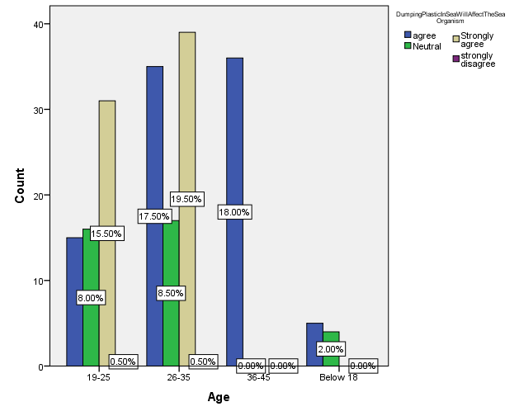

RESULTS:

This question was asked to the general public. Dumping of plastics in sea will affect the sea organisms which leads to environmental degradation.most of the people strongly agreed because of the factory wastages mixed in sea so that most of the sea animals are more affected by the dumping of plastic.

Legend:

Figure 1 represents the age of the respondent. The result revealed the Age of the respondent.46% of the respondents had most of their opinion .

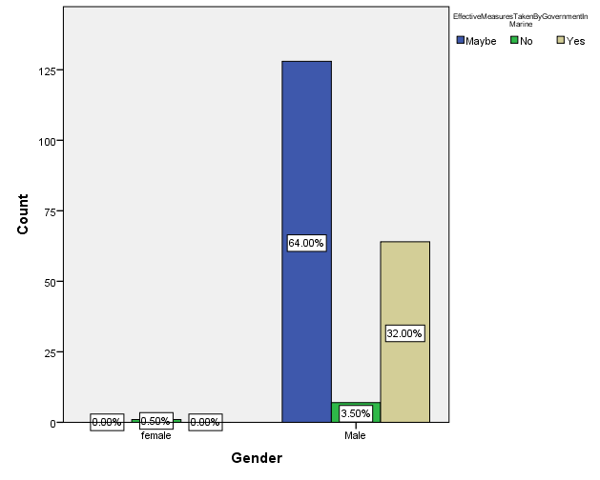

RESULTS:

This question asked to the general public, Whether the government really concentrated on marine pollution and took effective measures, most people stated that maybe because they are not aware about the government role in marine pollution.

LEGEND:
Figure 2 represents the age of the respondent. The result revealed the Age of the respondent.46% of the respondents had most of their opinion .

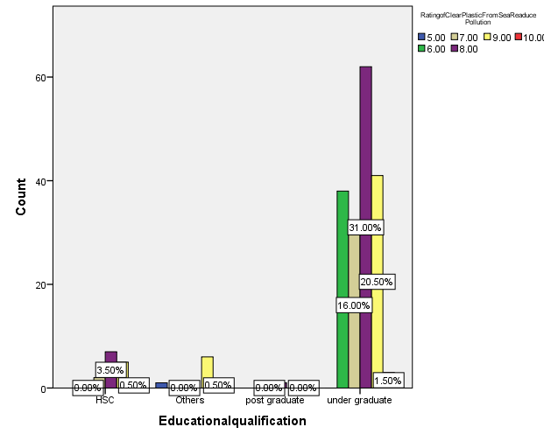
RESULT:
this question asked to the general public, rate in your opinion how far cleaning of plastic from the sea will reduce the marine pollution, this question asked to the education qualification category people, they answered that 31% of people given opinion about 5 scale.

LEGEND:
Figure 3 represents the age of the respondent. The result revealed the Age of the respondent.46% of the respondents had most of their opinion .

RESULTS:

This question asked to the general public, Whether the government really concentrated on marine pollution and took effective measures, this question asked to the gender category people, most people stated that maybe because they are not aware about the government role in marine pollution.

LEGEND:
Figure 4 represents the age of the respondent. The result revealed the Age of the respondent.46% of the respondents had most of their opinion .

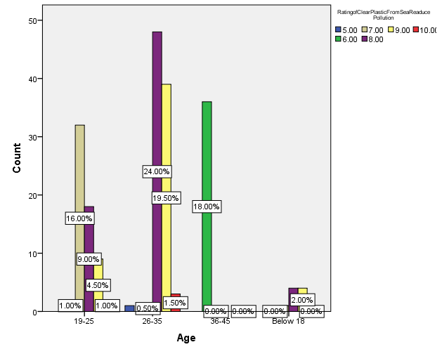
RESULT:

This question asked the general public, rate in your opinion how far cleaning of plastic from the sea will reduce marine pollution, this question was asked to the age category ategory people, they answered that 24% of people gave an opinion about 10 scale.

LEGEND:

Figure 5 represents the age of the respondent. The result revealed the Age of the respondent.46% of the respondents had most of their opinion .

DISCUSSION:
The question asked to the general public, rate in your opinion how far cleaning of plastic from the sea will reduce the marine pollution, this question asked to the education qualification category people, they answered that 31% of people given opinion about 5 scale. this question asked to the general public, rate in your opinion how far cleaning of plastic from the sea will reduce the marine pollution, this question asked to the education qualification category people, they answered that 31% of people given opinion about 5 scale. This question asked to the general public, Whether the government really concentrated on marine pollution and took effective measures, this question asked to the gender category people, most people stated that maybe because they are not aware about the government role in marine pollution. This question asked to the general public, Whether the government really concentrated on marine pollution and took effective measures, this question asked to the gender category people, most people stated that maybe because they are not aware about the government role in marine pollution. This question asked the general public, rate in your opinion how far cleaning of plastic from the sea will reduce marine pollution, this question was asked to the age category ategory people, they answered that 24% of people gave an opinion about 10 scale.

LIMITATION:
The major limitation of the study is that though the researcher has done the research on the dumping of waste in sea industrial waste and the majority of the response is from the non industrial area , male and female respondents gave their opinion on the basis of information shared by the people.

SUGGESTION:
World leaders who face the ocean pollution, admit its growing troubles, engage civil society and the global public, and take bold, substantiation- grounded action to stop pollution at source will be critical to precluding ocean pollution and securing mortal health.Prevention of pollution from land- grounded sources is crucial. barring coal combustion and banning all uses of mercury will reduce mercury pollution. Bans on single- use plastic and better operation of plastic waste reduce plastic pollution.

CONCLUSION:

The potential impacts of waste arisings from the construction and post construction phases development has been assessed. In order to suitably manage the potential environmental effects full consideration should be given to the re-use of surplus clean material on site or within other development projects once material balances are known. In view of the large volumes of material to be removed during the advance and construction works would assist in reducing impacts to known pressures on the filling capacity of public filling areas. All mitigation measures outlined within this section should be in place to control or eliminate the potential impacts to the environment from waste generation for the development site.Ocean pollution is a global problem. It arises from multiple sources and crosses public boundaries. It's the consequence of reckless, shortsighted, and unsustainable exploitation of the earth's coffers. It endangers marine ecosystems. It impedes the product of atmospheric oxygen. Its pitfalls to mortal health are great and growing, but still partly understood. Its profitable costs are only beginning to becounted.Ocean pollution can be averted. Like all forms of pollution, ocean pollution can be controlled by planting data- driven strategies grounded on law, policy, technology, and enforcement that target precedence pollution sources. numerous countries have used these tools to control air and water pollution and are now applying them to ocean pollution. Successes achieved to date demonstrate that broader control is doable. Heavily weakened harbors have been gutted, arms rejuvenated, and coral reefs restored.Prevention of ocean pollution creates numerous benefits.

REFERENCE:
- Ajibade, Fidelis O., et al. “The Threatening Effects of Open Dumping on Soil at Waste Disposal Sites of Akure City, Nigeria.” International Journal of Environment and Waste Management, vol. 27, no. 2, 2021, p. 127, https://doi.org/10.1504/ijewm.2021.112947.
- Akinbile, Christopher, et al. “The Threatening Effects of Open Dumping on Soil at Waste Disposal Sites of Akure City, Nigeria.” International Journal of Environment and Waste Management, vol. 27, no. 2, 2021, p. 1, https://doi.org/10.1504/ijewm.2021.10030610.
- Alexander, D. E., and Rhodes W. Fairbridge. Encyclopedia of Environmental Science. Springer Science & Business Media, 1999.
- Bergmann, Melanie, et al. Marine Anthropogenic Litter. Springer, 2015.
- Dutta, Tanmoy, et al. “Interaction of Avian Assemblages with the Local Environment of Solid Waste Disposal Area: A Case Study from Pramodnagar Waste Dumping Ground in Kolkata Metropolitan City.” Ecology, Environment and Conservation, vol. 28, no. 01s, 2022, pp. 16–16, https://doi.org/10.53550/eec.2022.v28i01s.016.
- Edhisono, Sutarto. “Jatibarang Final Solid Waste Dumping Site of Semarang City and Its Problems.” Waste Technology, vol. 3, no. 1, 2015, https://doi.org/10.12777/wastech.3.1.22-26.
- Faden, Mike. “California Cracks Down on Food Waste Dumping.” Frontiers in Ecology and the Environment, vol. 3, no. 10, 2005, p. 523, https://doi.org/10.2307/3868603.
- Fujikura, Manami. “Japan’s Efforts Against the Illegal Dumping of Industrial Waste.” Environmental Policy and Governance, vol. 21, no. 5, 2011, pp. 325–37, https://doi.org/10.1002/eet.581.
- International Maritime Organization. Guidelines for the Implementation of MARPOL: Annex V. 2012.
- James, Harrison. “5 Dumping of Waste at Sea.” Saving the Oceans Through Law, 2017, https://doi.org/10.1093/law/9780198707325.003.0005.
- Jenkins, S. H. “Disposal of Chemical Waste in the Marine Environment. Implications of the International Dumping Conventions.” Water Research, vol. 16, no. 3, 1982, p. 363, https://doi.org/10.1016/0043-1354(82)90197-x.
- Ketchum, Bostwick. Ocean Dumping of Industrial Wastes. Springer Science & Business Media, 2013.
- Lear, D. W., et al. “Effects of Ocean Dumping on a Temperate Midshelf Environment.” Ocean Dumping of Industrial Wastes, 1981, pp. 485–502, https://doi.org/10.1007/978-1-4684-3905-2_25.
- Liu, Sai-Him Jeffrey, et al. Illegal Dumping of Hazardous Waste in Hong Kong. https://doi.org/10.5353/th_b3125408.
- Mohan, S., and R. Gandhimathi. “Solid Waste Characterisation and the Assessment of the Effect of Dumping Site Leachate on Groundwater Quality: A Case Study.” International Journal of Environment and Waste Management, vol. 3, no. 1/2, 2009, p. 65, https://doi.org/10.1504/ijewm.2009.024700.
- Nielsen, S. P., et al. “Collective Doses to Man from Dumping of Radioactive Waste in the Arctic Seas.” Science of The Total Environment, vol. 202, no. 1-3, 1997, pp. 135–46, https://doi.org/10.1016/s0048-9697(97)00110-1.
- Roh, Jae Sup, et al. “PROHIBITING INDUSTRIAL WASTE SEA DUMPING: EFFECTS ON THE WASTE INDUSTRY.” Global Marketing Conference Proceeding, 2014, https://doi.org/10.15444/gmc2014.05.10.14.
- Spellman, Frank R. “Ocean Dumping.” The Science of Waste, 2021, pp. 29–50, https://doi.org/10.1201/9781003252665-5.
- Squires, Donald Fleming. The Ocean Dumping Quandary: Waste Disposal in the New York Bight. SUNY Press, 1983.
- Urooj, Afshan, et al. “Effects of Dumping Solid Waste on Water Quality of Surface Water Bodies.” Journal of Plant and Environment, vol. 1, no. 1, 2019, pp. 21–24, https://doi.org/10.33687/jpe.001.01.3575.

PLAGIARISM:

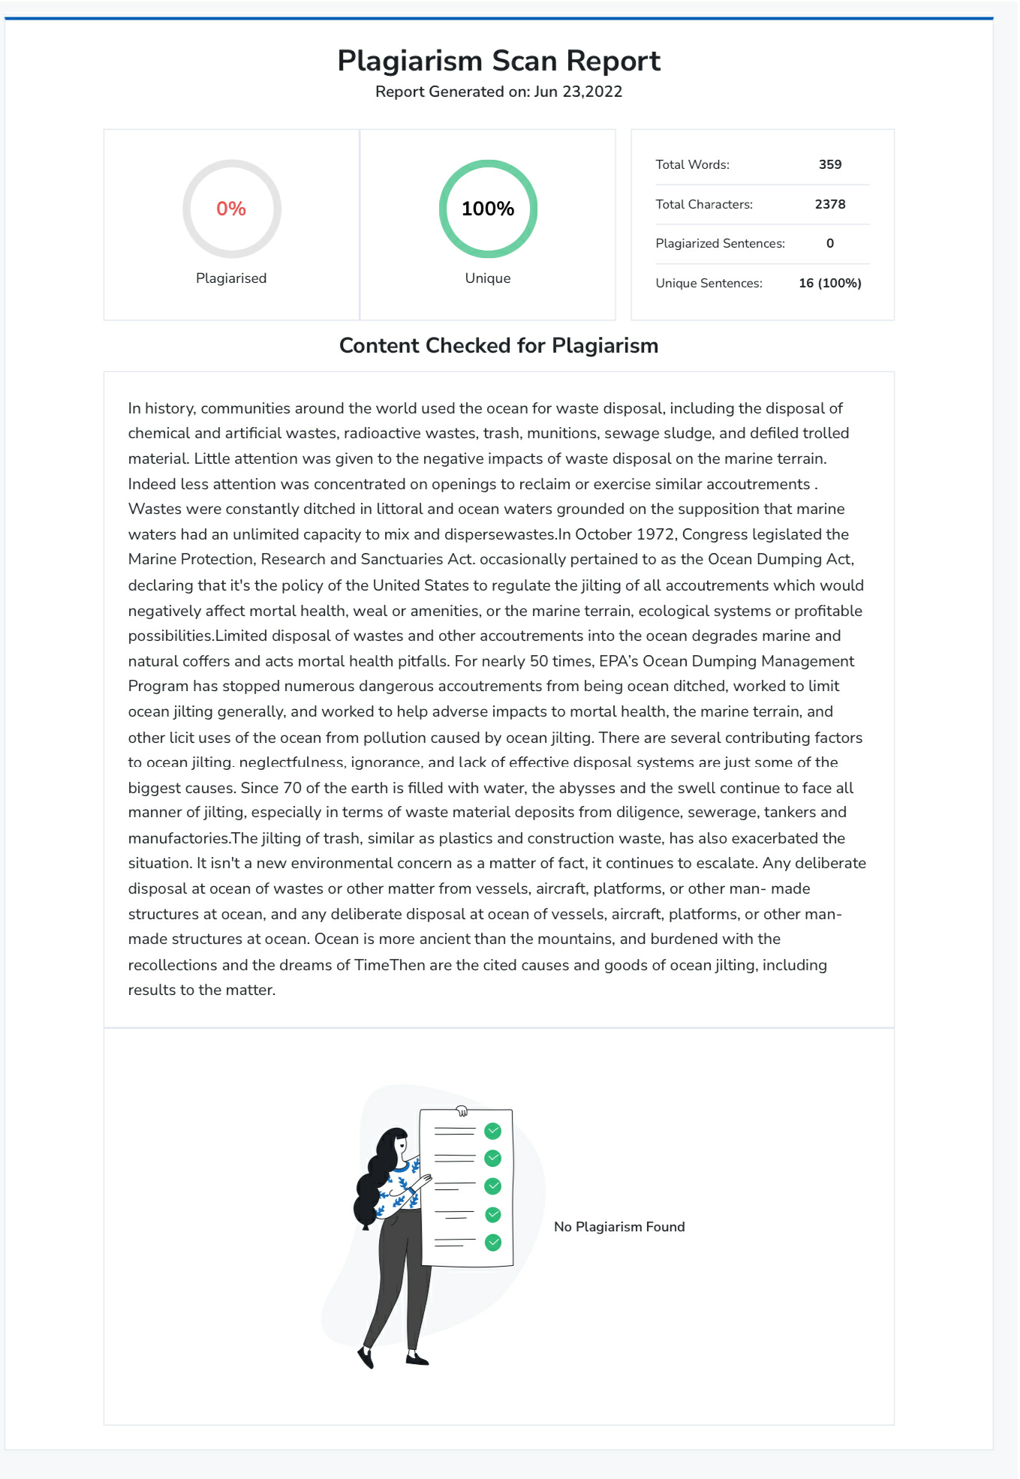
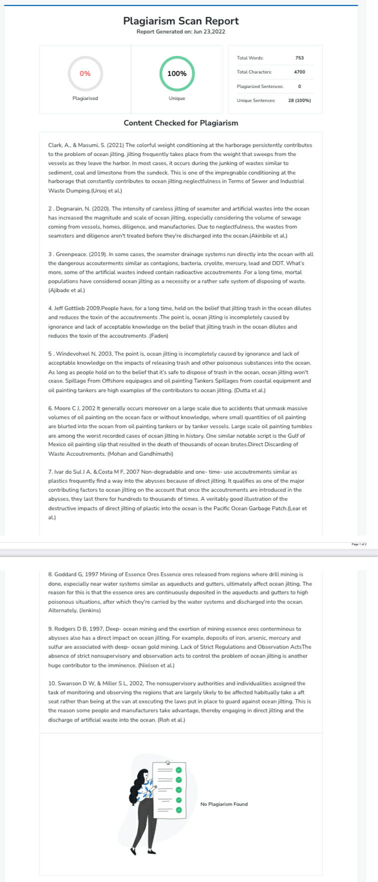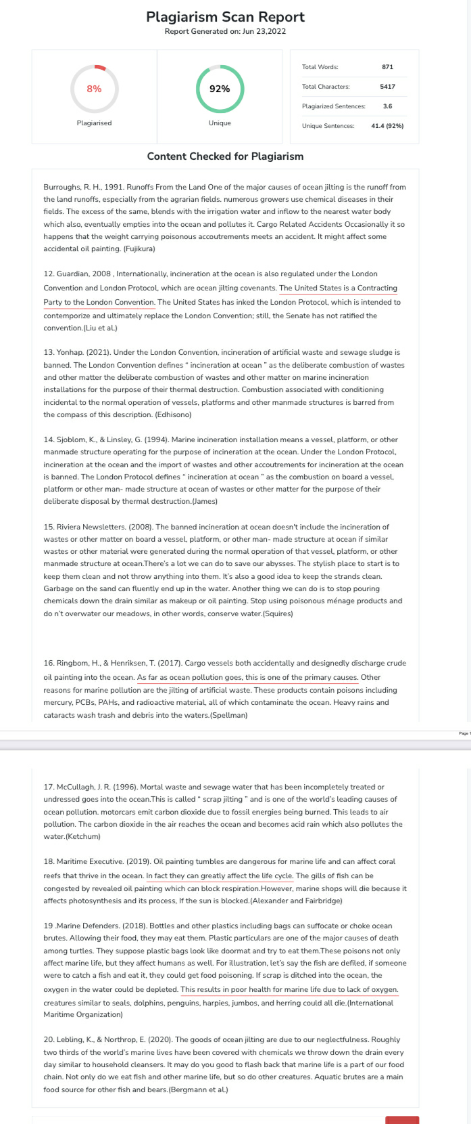

AUTHOR : I.Nithish kumar reg. no : 131801091 BA.(LL.B)(Hons) Saveetha School of Law, Saveetha Institute of Medical and Technical Sciences, Chennai-77
Co-Author: Dr.R. Chandrasekar, Associate Professor, Saveetha School of Law, Saveetha Institute of Medical and Technical Sciences, Chennai-77

