
Journal Title

ISSN

www.
stmjournals.com

AI based OCR for Text Recognition from Handwritten
Documents

¹Mr.Ramdas Bagawade, ²Rohit Kharat, ³Kishor Matsagar, ⁴Shravani Kharade
Department of Computer Engineering,
Government College of Engineering and Research Avasari Khurd, Pune, India

Abstract
OCR (Optical Character Recognition) is a technology that enables the conversion of scanned images of printed or handwritten text into machine-readable characters that can be edited, searched, and analyzed electronically. It is developed for the English language text recognition. With OCR, the conversion happens easily and with lesser delicacy to the original content. Users can edit, format, and search the document which makes it more user-friendly. Once OCR converts a given input handwritten document into word and text format, users can store their documents on their local systems as well as on our server depending on the need of an user. This will be useful for the businesses that heavily depend on this system as the need of physical storage is excluded. This project includes various features and one of the most useful features such as this will be further useful for the disabled peoples by addition of TTS (Text to Speech). For building this software, we have used Convolutional Neural Networks. We provided a user-friendly platform for the users in which users can take advantage of these systems by uploading the text file or an image file and obtain the desired digitally formatted text and word file. Also, OCR consists of a voice assistant which will read out the output information, which will be helpful for disabled people.

Keywords: Artificial Intelligence (AI) , OCR, CNN, Tensorflow, Python

*Author for Correspondence E-mail: rpbagawade.comp@gcoeara.ac.in Tel:

INTRODUCTION
Before the invention of OCR, converting physical text to digital was manual work and was very time consuming. A person has to retype the whole content of the document, which is the most time-consuming task and it might lead to miscalculations. With OCR, the conversion happens quickly and with adequate accuracy to the original content.
Once OCR converts a hard copy into its digital form, users can edit, format, and search the document. They can also share it easily via mail, include it in a website, and store it in a document. Naturally, this eliminates the need for physical storage space, a cost- savings for businesses that heavily depend on documentation, similar to mortgage brokers or legal enterprises. By utilizing a combination of OCR and AI / Machine Learning (ML), teams can now employ machines to convert handwritten text more accurately and detect any potential errors that may occur during the conversion process.
We have built an AI based OCR for text recognition from handwritten documents for the English language. AI can better interpret handwriting as well, opening up opportunities for digitizing a wider range of documents. Handwriting still presents a bigger challenge to AI due to the uniqueness of each individual, but with the large handwriting training data, machines are gaining more ability on that as well. This project aimed to understand, develop and improve the OCR software which will be helpful for blind people to know the content either handwritten or text document on the paper. For building the model, we have used the concept of Deep Learning.

- RELATED WORKS
Some of the previously carried out research papers proved to be very insightful for our project and the most referred one research paper among those is, “AI Based Reading System For Blind Using OCR'' [1] helps users to take a picture by using a phone camera and upload in the upload section of the website. The image will be scanned and the application then reads the text from the given image and converts the output in the form of speech. This OCR is developed in concern with the blind peoples and to make it easy for them. The speech output is generated by using the Text To Speech Module.
“Handwritten Optical Character Recognition” [2] research paper aims to summarize previous research work on different languages of handwritten character recognition systems. And to identify new research areas within the OCR domain. For classification various methods are used in this research paper such as artificial neural network (ANN), Kernel methods, Statistical methods, Template matching techniques Structural pattern recognition. Here researchers studied languages including English , farsi/Persian script, Urdu language, Chinese language etc.
“Optical Character Recognition for electronic invoices using AWS Services”[3], this research paper not only gives a brief overview of all the different techniques involved in the process of Optical Character Recognition but the main aim of this paper is to showcase a fully-fledged real time OCR web application for Invoices.
In the research paper,“A Survey on various Optical Character Recognition Techniques”[4]. This research paper gives a brief overview of all different techniques and methods in the process of OCR. In the research paper “Artificial Neural Network Based Optical Character Recognition”[5], it deals with recognition and classification of character from the given image. For recognition purposes certain geometrical properties and topological properties are necessarily calculated. For classification an artificial neural network is used which helps in defining character uniquely by means of feature vectors.

- RESEARCH METHODOLOGY

We have used datasets like IAM dataset, Mnist dataset for building our model. We have trained a model with the help of techniques like Convolutional Neural Network (CNN).
Major Steps in the methodology of our system involves:

1.Image source:
This phase comes in offline hand-written character recognition. Image source can be from any digitized tool. A scanner or a camera captures the image and is sent to the next phase.
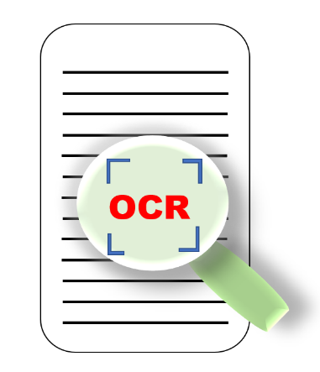
Fig.1 Capturing an image

2.Image pre-processing:
In this step, the input image is pre-processed to improve its quality and make it suitable for OCR. OpenCV and PIL are used for Image Pre-processing. This includes operations such as :
- Skew Correction
PIL(Python Imaging Library) has several features for image processing including skew correction.
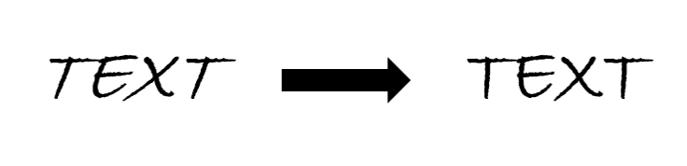
Fig.2 Skew Correction

- Noise Removal
Noise removal means removing unwanted parts of an image as shown below.
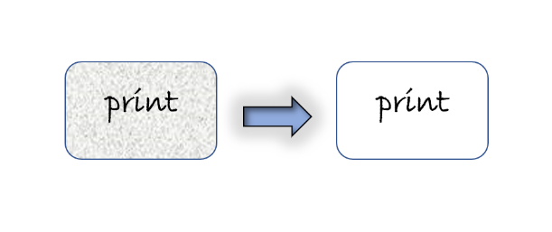
Fig.3 Noise Removal

- Binarization
Converts a gray-scale image into a binary image.

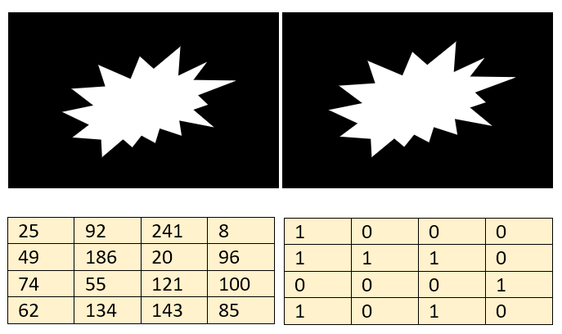
Fig.4 Binarization of an image

- Contrast Enhancement
Contrast enhancement helps the model to use an image which is highly enhanced as a result of which contrast enhancement becomes a prominent step. OpenCV is used for contrast enhancement too.

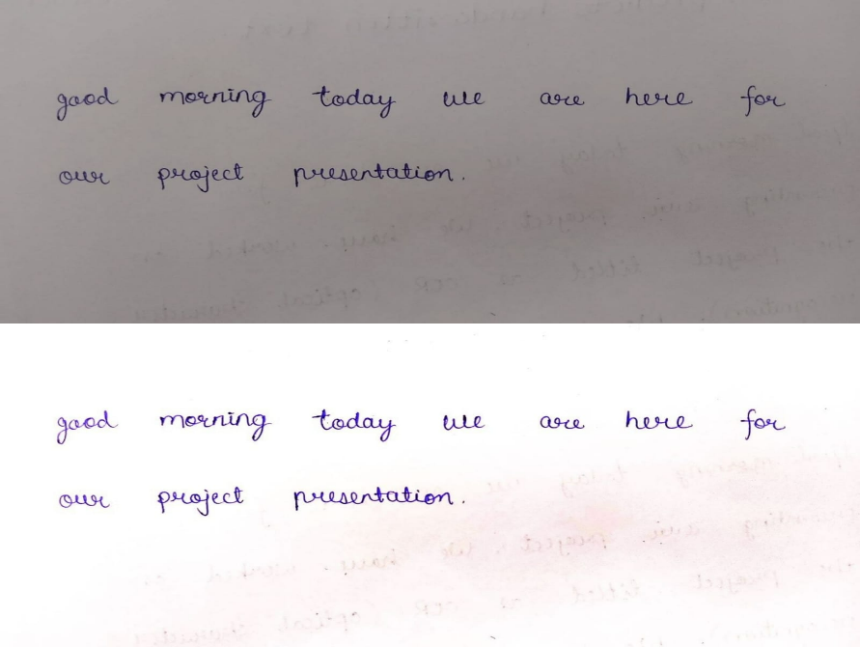

Fig.5 Contrast Enhancement

3.Text detection:
The pre-processed image is then analyzed to locate the regions containing text. OpenCV is used in this phase too. This involves techniques such as :

- Contour Analysis
Contour analysis is a technique used in image processing and computer vision to extract useful information from the shape and structure of objects in an image.

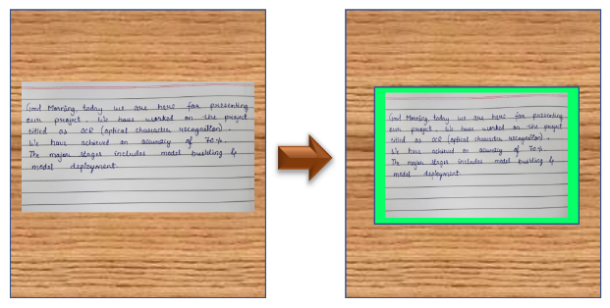
Fig.6 Contour of an image

- Connected Component Analysis
Connected Component Analysis (CCA) is a process in image processing that involves identifying and labeling connected regions of pixels in an image.

4.Character Segmentation:
In this step, the text regions are segmented into individual characters. This involves identifying spaces between characters separating them from each other. Since some characters might be connected to each other, they can be assumed to be one character if we only use the labeling approach.
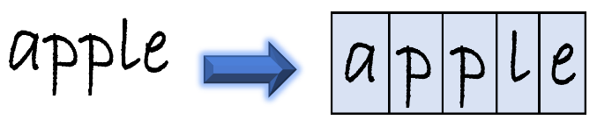
Fig.7 Character Segmentation

5.Features Selection:
Feature selection is an important step in character recognition, as it helps to identify the most relevant features that can accurately distinguish between different characters. We have used 2 major algorithms for this technique, those are Principal Component Analysis(PCA) and Correlation based Feature Selection(CFS).

6.Text Recognition:
Text Recognition involves identifying characters and the group it resembles. In this step, the segmented characters are recognized by comparing them to a database of known characters. Also, characters are concatenated to form words and thereby forming lines. This is done using various techniques such as template matching, feature extraction, and machine learning algorithms. SVMs can be used to classify the input image into character classes. SVMs are widely used in image recognition tasks and can achieve high accuracy rates.

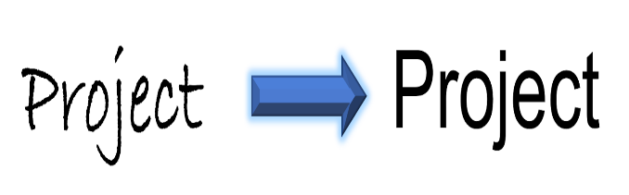
Fig.8 Text Recognition

7.Post-processing:
Finally, the recognized text is subjected to post-processing to correct any errors and improve its accuracy. Also, we have provided audio assistance which reads all the predicted content which will help blind people to know the content on the paper.

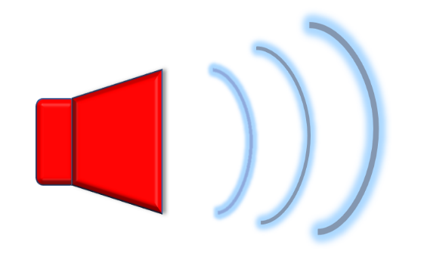
Fig.9 Audio Assistance

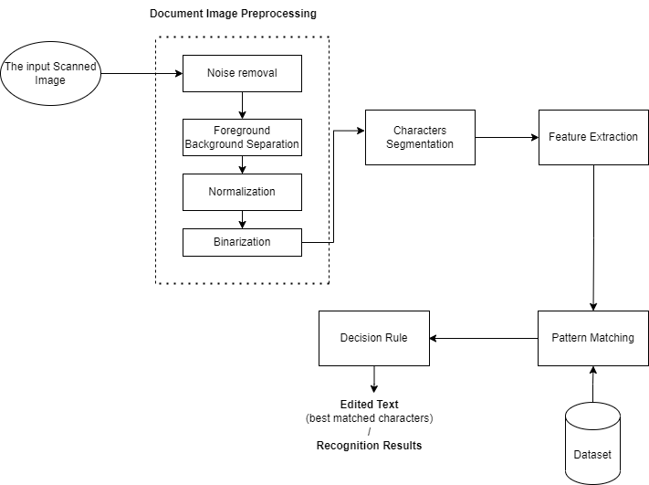
Architecture of OCR System:

Fig.10 Architecture of OCR System

RESULT ANALYSIS
Reference | Model | Accuracy
[5] | ANN | 85.83%
[6] | CNN | 88.5%
[7] | Decision Tree | 86.9%
[8] | Discrete wavelet transform (DWT) and Euclidean distance metric (EDM) | 90%
[9] | Hidden Markov Model | Over 98%
Our Project | CNN | 89-91%

Our model has an accuracy of 89-91% in which we have used CNN as an algorithm to train it. Reading the predicted text is an additional feature of our project which helps disabled people.
Screenshots of our project website are as shown below:

Without Output:

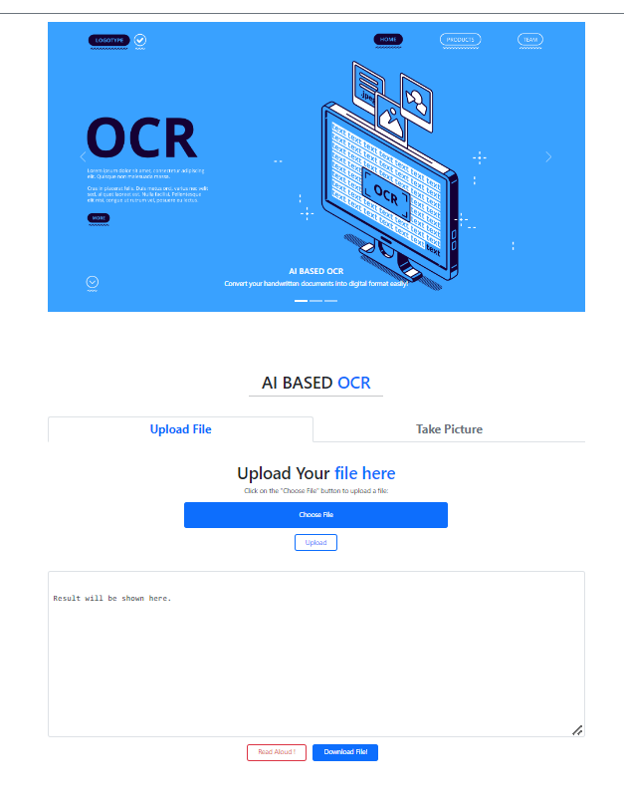

Fig.11 Website Without Output

With Output:
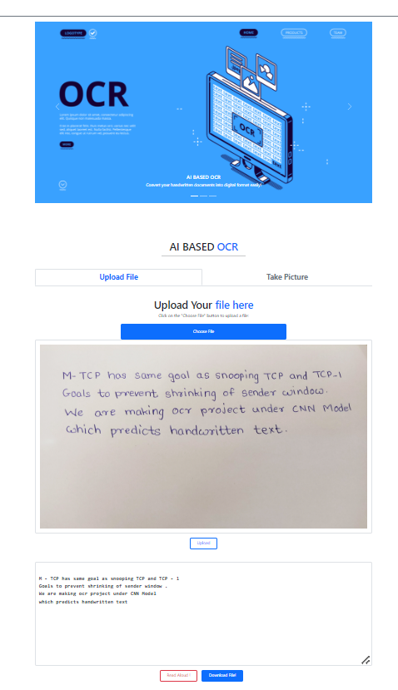

Fig.12 Website With Output

CONCLUSIONS
This project will be in use for only the English language and aimed to understand, develop and improve the open OCR software, by improving the accuracy of the OCR model . We have come to the conclusion that CNN performs better than other algorithms for such a recognition type of dataset. Also, content recognition is only beginning to reveal the potential of Artificial Intelligence. The system has its advantages such as less time complexity, very small database and high adaptability to untrain inputs with only a small number of features to calculate.
Our software converts input handwritten/non-handwritten text formatted documents into digital text formatted documents, but it is utilized more for handwritten stuff. Also we have also added an additional feature which audio reads all the predictions on the screen.

ACKNOWLEDGMENTS
We would like to express our sincere gratitude to everyone who has supported us in the successful completion of our research paper "AI Based OCR For Text Recognition From Handwritten Documents”. Firstly, we extend our special thanks to our project guide, Dr. S.U. Ghumbre, for his delightful guidance and support throughout the project. His knowledge and expertise in the field of data science was instrumental in shaping our research .
We would also like to thank our faculty for their guidance and constant supervision. Their valuable inputs and feedback helped us to refine our research methodology and ensure the accuracy and validity of our results. We would also like to offer our sincere gratitude to our principal, Dr. D. R. Pangavhane, for providing us with all the necessary facilities and resources needed for our research. We are grateful for their continued support and encouragement throughout the project. Furthermore, we would like to thank our parents for their unwavering support and encouragement throughout our academic journey. Their motivation and belief in us have been our driving force and have inspired us to work harder and achieve our goals. We would also like to express our gratitude to our friends who helped us in finalizing this project within a limited time frame.
Lastly, we are thankful to our classmates whose instructions and suggestions were helpful in shaping our research and improving its quality. We appreciate their collaboration and support throughout our academic journey. Once again, we express our sincere gratitude to everyone who has supported us in the successful completion of our research paper. Regards.

REFERENCES

[1]. Abhishek Mathur, Prerna Sharma, Sujata Oak, Akshada Pathare (2019). “AI Based Reading System For Blind Using OCR.” 3rd International Conference On Electronics Communication And Aerospace Technology [ICECA 2019],Vol.3, Issue 7, 2019.

[2]. Jamshed Memon,Maira Sami,Rizwan Khan,Mueen Uddin,”Handwritten Optical Character Recognition.” IEEE, Vol.1, 28 July 2020.

[3] Sameer Patel,Sarvesh Pai,Vaibhav Vasani,Mittal B Jain, “Optical Character Recognition for electronic invoices using AWS Services.” International Research Journal of Engineering and Technology, 6(6), 3666-3669,Vol.4, Jan 2019.

[4]. Abin M Sabu, Anto Sahaya Das, “A Survey on various Optical Character Recognition Techniques.” Proc. IEEE Conference on Emerging Devices and Smart Systems (ICEDSS 2018), 2-3 March 2018.

[5]. Vivek Shrivastava, Navdeep Sharma, “Artificial Neural Network Based Optical Character Recognition.” Signal & Image Processing : An International Journal (SIPIJ) Vol.3, No.5, October 2012.

[6]. Rohini G. Khalkar, Adarsh Singh Dikhit, Anirudh Goel, Manisha Gupta, Shital S. Patil, “Deep Learning for Handwritten Text Recognition.” Turkish Online Journal of Qualitative Inquiry (TOJQI), Vol-12, 8 July 2021.

[7]. S. D. Connell and A. K. Jain, ‘‘Template-based online character recognition,’’ Pattern Recognit., vol. 34, no. 1, pp. 1–14, Jan. 2001.

[8] Dileep Kumar Patel, Tanmoy Som1, Sushil Kumar Yadav, Manoj Kumar Singh,” Handwritten Character Recognition Using Multiresolution Technique and Euclidean Distance Metric” JSIP 2012, 208-214

[9]. H. Bunke1, M. Roth1, E.G. Schukat-Talamazzini. Offline Cursive Handwriting Recognition using Hidden Markov Model

