ONLINE VOTING SYSTEM

Priyadarshini College Of Engineering, Nagpur.
Department of
Information Technology.

Prof. H. M. Kubade
Department: IT
Instituted:Priyadarshini College Of Engineering,
Nagpur,India.
Email:harshad.kubade@pcenagpur.edu.in

Name:-Anchal Bansod Name:Prachi Shahare
Department:-IT Department:-IT
Address:Nagpur Address:Nagpur
Email:-anchalbansod1234@gmail.com Email:prachishahare@gmail.com

ABSTRACT
Large space and manpower is
required to setup voting
booths in multiple areas
around city or village.
. High security has to be
maintained on the date of
election.
. Voter must visit the place
where voting booth is
arranged.
. Sometimes, voter needs to
stand in a queue for a long
time.
. Again, manpower is required
for volunteering and assistant
of voters at the place of voting.
. Voting process is done
manually on voting machine.
. Vote counting is done with
the manual process.
. Then there is a gap of few
days for results to be
displayed
. So if we see, here in
traditional voting system, we
need lot of manpower, energy,
and time to conduct this
process.
Keywords: HTML, CSS,Java Script, PHP,
MYSQL, phpMyAdmin,XAMPP.

1.INTRODUCTION
Now as we all know, almost
everything can be done
online.
. Like Money transfer,
Shopping, Booking, Teaching,
Data sharing, Admission s,
Job search, etc. And so many
other activities are done with
the help of internet.
. So with the easy access and
use of internet, we are going
to take this existing voting
system on advance level.
. We are going to develop an
online platform with high
security so that the same
process could be done
easily without the waste of
time, afford, and energy.
. So firstly, voters and gro
ups/candidates are required
to register on online voting
system.
. Once registration is done,
voter can easily vote to
their respected candidate or
group by just signing in
with the comfort of his/her
home.
. And similarly,
groups/candidates can do the
same as well as also monitor
their status with the comfort
of home.
. So this system will save a lot
of time, energy, and afford
for both voters and groups.

1.1 Problem Background:
In the recent times there are many
literatures on online voting has been
developed. While online voting has been an
area of research in the recent years, there
are efforts made to make online voting
system more secure. The use of insecure
Internet, and the resulting security Breaches
have been reported recently. So, the main issue now to resolve these security breaches
such as denial of service attack.

1.2 Problem Statement:
Our online voting system will make all voting process easy because in this system we will provide chatbot, which will help every user during the voting process. If any user has any kind of issue during the
process the chatbot will provide efficient solution for that issue. Our voting system will make the whole voting process cost efficient. Our voting system will give instant and unbiased poll result. Our voting
system will help us to keep track of voter. And our system is time efficient.

1.2 Research Objective:
The main objective of this study is to make a step forward in the direction of online voting platform by providing all the essential security levels. The objective of this study is to make the voting process easy, less time taking, and secure. Online
voting system eliminate the bogus voting whichcan occur in tradition voting schemes.

1.3Scope of Study
As we all know that there are many
organizations that conduct elections for the positions like “Group leader, Project leader, Employee of the month, and for some minor changes in working environment etc. In that case, online voting can very helpful
to conduct vote. People can cast their vote from anywhere. As colleges conduct elections for positions like president, vice president etc. for many college societies like CSI, Trinity etc, and other management
posts for students and online voting system
can be used on any cases like these
efficiently it can be customized according
to client need on any type of elections.

2. LITERATURE REVIEW
2.1 Background:
1. Voters
Voters are the people who will first sign up on online vot ing panel.
And then at the time of voting, they will login and do vote to their
respective group or candidate via system.

Following data from voter side will be provided to the system at the
time of registration :
. Name
. Mobile
. Address
. Status
. Votes
. Role (voter/group)
. Photo
. Password
Following are some Voter responsibilities:
. Registration on system
. Login to system
. Voting for the candidate

2. System
System is an online platform where election process is held. So the
voters and groups are registered here. And with the help of system,
voters ca n do voting and groups can monitor their status.

Following are given System responsibilities:
. Registration of both voter and candidate
. Display of registered candidates with respective
votes on homepage
. Display of registered candidates on voter dashboard if any
. Display of profile info and voting status on voterdashboard
. Display of profile info, voting status, and votes oncandidate dashboard
. Maintaining record for each candidate and voter without making any duplicate record.

3. Groups
Groups/Candidates/Parties are those who will be given votes at thetime of voting. And they can monitor their status by just doing login into system.

Following data from group/party side will be provided to the system
at the time of registration:
. Name
. Mobile
. Address
. Status
. Votes
. Role (voter/group)
. Photo
. Password

2.2 Product Perspective:
The product is an election conducting tool with a simple GUI and a Chatbot in it. This system is developed using php. Though product is stand-alone. It requires a
XAMPP server.

3. Modules of our System
Online voting is a portal through which a voter can cast his vote by registering themselves on the online voting platform. All the information about users is entered in database by which admin can verify the user. There are different tables in database
for users, candidates, result, admin. Each voter has to enter his all basic information like name, gender, state, email-id. This is the first page of the website known as the welcome page. It has all the page
options like Home, Polling Dates, Register,
Login, about us, Contact us, FAQs.

3.1 Home:
This is the registration page, where the
voter can register themselves. The users
have to enter their details which are
required by admin through registration
page. All the details registered on the portal
are saved in the respective database. The
Admin has authority to accept eligible user,
otherwise he has right to reject their
registration by providing reason of
rejection.

3.2 User Login:
After registering into the portal, their details
are saved to the database and sent to the
admin. The user can Login to the portal
with his unique USERNAME and
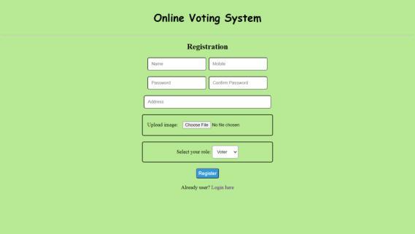
3.3 Admin Panel:
From here admin can login to his account
and can manage whole voting process by
adding new election, generating id for user,
verifying the users, generating result and
many more. He has the right to generate id
for user by verifying the users.

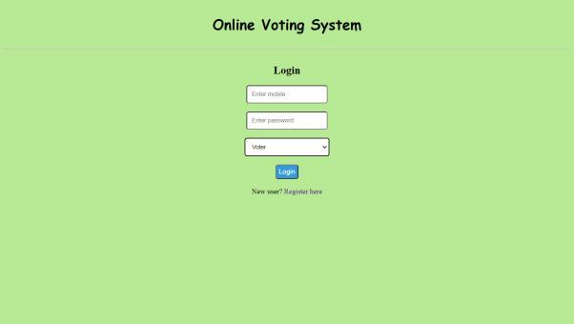

3.4 Election:
This a module which gives a list of all ongoing election, this module is accessible only to those users who have been verified by admin. By this module user can cast their vote by selecting a candidate of a particular
Election.
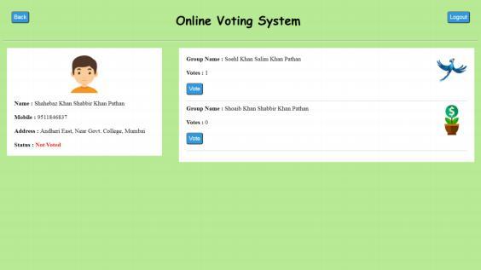

3.5 Result:
This module provides the results of all the completed elections; user has the right to see the result of elections. All the results are being generated by admin after the successful completion of the election.

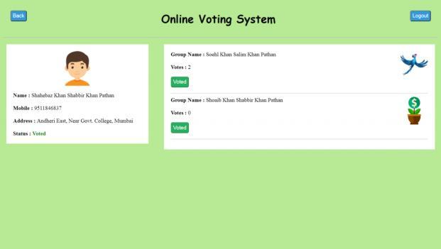
4.Technology used:
We have created this online voting portal by
using following technologies:
Front end: HTML, CSS, Bootstrap
Back end: - PHP, JavaScript
Database:- MySQL, phpMyAdmin
Server: - XAMPP

5. Conclusion:
So the final conclusion we make here is that our new online voting system is much better and easy to use than traditional voting system. Almost all problems that we have discussed in existing voting system are resolved by the help of this application. So the launch of this application would create many opportunities for those who are frequently involved in conducting elections for different purposes.

