OPTIMIZATION OF SOLAR POWER WITH BUCK BOOST CONVERTER
Divya B¹, P. Maruthupandi²,
¹PG Scholar, Power Electronics and Drives, Government college of Engineering, Salem
²Associate Professor, Dept of EEE , Government college of Engineering, Salem

---------------------------------------------------------------------***---------------------------------------------------------------------
Abstract – Solar Photovoltaics has proven itself to be the most dependable source for harvesting solar energy. The output of solar PVsystem relies upon solar radiation and temperature which vary throughout the day. This caused variations in the maximum power point (MPP) on the solar PV output characteristics curve. Therefore Maximum Power Point Tracking (MPPT) technique is used to track the MPP and extract maximum power out of the PV systems. The maximum power is fed to the Buck boost converter to regulate the output according to the load requirement by varying the duty cycle.

Key Words: Photovoltaics, PV system, solar, MPPT, converter, duty cycle

1.INTRODUCTION

Sun’s energy is one of the abundantly available natural sources in the world. It is one of the non renewable sources available in the present competiting environment. The suns energy is available throughout the day time but the ultimate aim is to extract the maximum energy from the sun which will compensate the day to days energy requirement. There are various methods available for tracking maximum power from the sun’s energy.
Electricity generation using solar photovoltaic technology has become the most viable option in the recent times. With exhaustion of fossil fuel reserves and rising concerns about the environmental impact of the use of fossil fuels in recent times, has led to increase in the use of solar. PV generated electricity is a clean and noise less source of energy with low maintenance cost.

2. Working of the proposed system

The working principle of the entire project is based on using the maximum solar energy received by the panel. The MPPT algorithm traces the maximum power point and gives the maximum power at the panels output. The panels output is given to the DC-DC converter specifically the Buck Boost Converter which regulates the dc power received from the panel.
The Buck Boost Converter works for the various duty cycle. If the output of the panel found to be low to match the load then by increasing the duty cycle (D>0.5) the output voltage of the converter will increase to match the load requirement. In this mode of operation the Buck Boost converter does the Boost operation.

If the output of the panel found to be high to match the load then y decreasing the duty cycle (D<0.5) the output voltage of the converter will decrease to match thee load requirement. In this mode of operation the Buck Boost converter does the Buck operation.
The MOSFET switch is used in the Buck Boost Converter. The switching of the MOSFET is done by using the TLP 250 gating circuit. The output voltage according to the load requirement can be adjusted by Buck Boost converter by varying the duty cycle.

2.1 Block diagram

The figure (Fig 2.1) depicts the block diagram of the proposed system. It consists of solar panel, Converter, MPPT Algorithm , PWM generation and load.[1]
Solar panel
Converter
Load

PWM Generation
MPPT Algorithm

Fig -2.1: Block diagram

2.2 Design aspects of the proposed

The design aspects of the proposed system contains the following equations [2] based on which solar panel has been modeled.
The current equations of the solar panel are
$I_{0 }={{(I}_{scn}+ K_{i }∆T)}/{e^{(∆TK_{v}+V_{ocn})/(aV_{t})}-1}$ ---------(2.1)
The photon current is given by
$I_{g }= \left[I_{gn }+\left(K_{i }∆T\right)\right]\left(G/G_{n}\right)$ ---------(2.2)

The diode current is given by

$I_{d }= I_{0 }[e^{\left(\frac{V}{V_{T }n}\right)}-1]$ ---------(2.3)

The current through the panel is given by

$I_{m }= I_{g}-I_{d}$ ---------(2.4)

The output equations of the converter is given by

$$V_{0}= -{(V_{in}D)}/{1-D}$$

The inductance and capacitance values are given by

$$L= \frac{V_{0}\left(1-D_{min}\right)}{∆i_{L}f_{s}} Henry$$

Where $∆i_{L}=10\% of (I_{in}+ I_{0})$

$$C= \frac{I_{0}D}{∆V_{0}f} farad$$

Where $∆V_{0}=2\% of V_{0}$

3. System Components

3.1 Solar Panel

The solar cell (Fig 3.1) produces a votage of 0.5 V. The current may vary from 1 – 10 A. The number of solar cells connected together forms an module. The number of modules connected together forms a panel. The number of panels connected together forms and array. The photovoltaic cell converts an light energy into an electrical energy. The solar cells are made up of silicon.
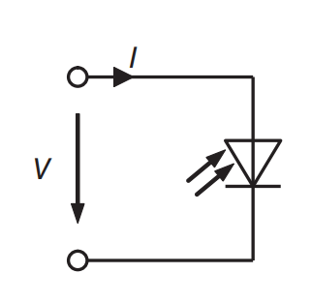

Fig -3.1: Equivalent circuit of solar cell

3.2 Buck BoostConverter

The Buck Boost Converter (Fig 3.2) is a DC – DC converter which varies the output voltage corresponding to the duty cycle. The duty cycle (D<0.5) converter Bucks the output voltage. The duty cycle (D>0.5) converter Boosts the output voltage. The input to the Buck Boost converter is obtained from the solar output. By adjusting the duty cycle the voltage will be maintained constant according to the load requirement.

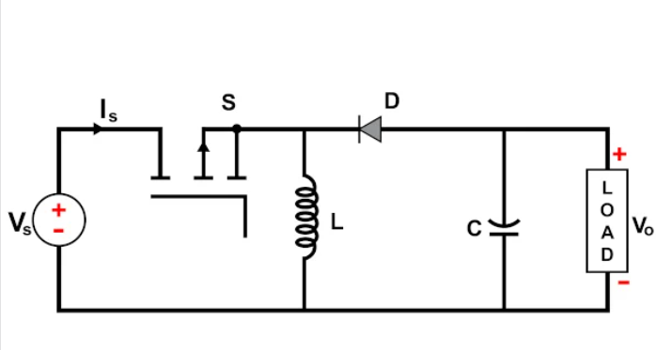
Fig -3.2: Power circuit of Buck Boost Converter

3.3 MPPT Algorithm
The MPPT algorithm (Fig 3.3) traces the maximum power ,where it occurs in the PV curve and obtains the corresponding voltage to the maximum power.[1,3,4,5,6,7,8,9,10,11,12,13]
Start

Calculate$∆I$

$$∆I :e$$

$$∆I<e$$

$$∆I>e$$

P = V.I
Iterate again

Trace Maximum Power and Corresponding Voltage

Set duty cycle

End

Fig -3.3: MPPT algorithm

The MPPT algorithm of the proposed is based of the current equation. The current equation is substituted in the Newton Raphson formula and iterated until the result is within the error limit. When the value within the error limit is reached the power found by the product of voltage and the current. From the PV curves obtained the maximum point is traced and the corresponding voltage to maximum power has been found.

4. Simulation and results

The simulation model shown in (Fig 4.1) of the proposed topic is simulated using the PLEX software and the plots are obtained. The simulation is done using the design equations in the chapter 2 of this paper.

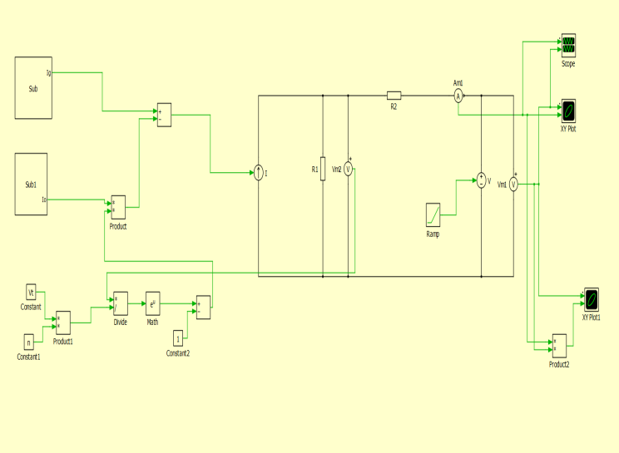

Fig -4.1: Simulation model

The simulation results for various irradiation (Fig 4.2) by keeping the temperature at the standard test condition is given below. The temperature under the standard test condition is $25℃$.The irradiations are varied from 100 to 1000 and the results are obtained.

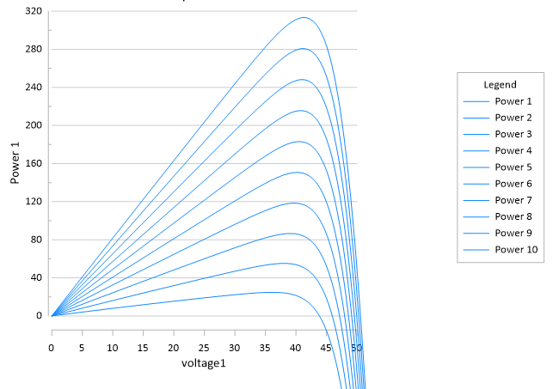
Fig -4.2: Plot between voltage and power
For varying irradiation

The simulation results for various temperature by keeping the irradiation at the standard test condition is given below. The irradiation under the standard test condition is 1000W. The temperature is varied and the results are obtained.

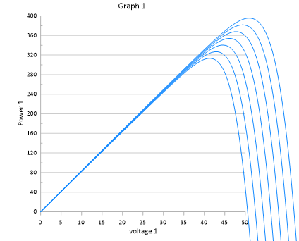
Fig -4.3: Plot between voltage and power
For varying temperature

The graph (Fig 4.4) with the tracking of maximum power for irradiation varying from 100 to 1000 is given below

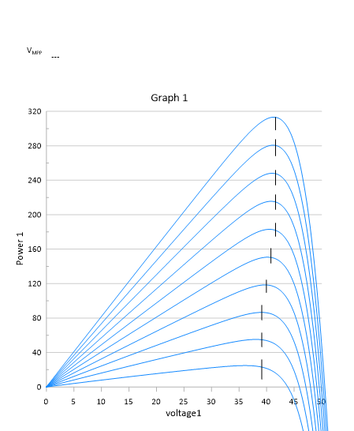

Fig -4.4: Plot between voltage and power for tracing Maximum power

The results obtained from the simulation circuit (Fig 4.1) is given in the form of tabulation (Table 4.5). It contains the Maximum power and the Corresponding voltage for various irradiation.

Table -4.5: Maximum power and corresponding voltage values

S.No | Irradiance | Maximum Power | Corresponding Voltage
1 | 100 | 23.4 | 38.29
2 | 200 | 52.73 | 39.12
3 | 300 | 86.65 | 39.12
4 | 400 | 121.48 | 39.12
5 | 500 | 149.90 | 39.95
6 | 600 | 183.51 | 41.62
7 | 700 | 214.83 | 41.62
8 | 800 | 246.91 | 41.62
9 | 900 | 282.81 | 40.79
10 | 1000 | 314.13 | 41.62
11 | 1100 | 340.10 | 41.85
12 | 1200 | 380.34 | 42.00

5. CONCLUSION

In this study the maximum power has obtainted by infusing MPPT algorithm. As solar is the clean and noise less renewable energy , the MPPT helps to utilize the maximum of extracted power. The Buck Boost converter monitors the solar output and performs the buck or boost operation to meet the load requirements. Thus the optimization of solar power using the Buck Boost Converter gives the maximum output power.

ACKNOWLEDGEMENT

The authors are immensely grateful to the department and institution for providing support the facilities for the successful completion of this work.

REFERENCES

[1]. J.S. Christy Mano Raj, A. Ebenezer Jeyakumar (2014) – A two stage successive estimation based maximum power point tracking technique for photovoltaics modules – Science Direect.

[2]. Photovoltaics Fundamentals, Technology and Practice – Konrad Merteens . Miinster University of Applied Sciences, Germany
.
[3]. Verma D, Nema S, Shandilya AM, Dash SK. Maximum power point tracking (MPPT) techniques: Recapitulation in solar photovoltaic systems. Renewable and Sustainable Energy Reviews. 2016 Feb 1;54:1018-34.

[4]. Salam Z, Ahmed J, Merugu BS. The application of soft computing methods for MPPT of PV system: A technological and status review. Applied Energy. 2013 Jul 1;107:135-48.

[5]. Mohanty P, Bhuvaneswari G, Balasubramanian R, Dhaliwal NK. MATLAB based modeling to study the performance of different MPPT techniques used for solar PV system under various operating conditions. Renewable and Sustainable Energy Reviews. 2014 Oct 1;38:581-93.

[6]. Ahmed J, Salam Z. An improved perturb and observe (P&O) maximum power point tracking (MPPT) algorithm for higher efficiency. Applied Energy. 2015 Jul 15;150:97-108.

[7]. Rezk H, Fathy A, Abdelaziz AY. A comparison of different global MPPT techniques based on metaheuristic algorithms for photovoltaic system subjected to partial shading conditions. Renewable and Sustainable Energy Reviews. 2017 Jul 1;74:377-86.
[8]. Ishaque K, Salam Z, Amjad M, Mekhilef S. An improved particle swarm optimization (PSO)–based MPPT for PV with reduced steady-state oscillation. IEEE transactions on Power Electronics. 2012 Jan 23;27(8):3627-38.

[9]. Ishaque K, Salam Z. A review of maximum power point tracking techniques of PV system for uniform insolation and partial shading condition. Renewable and Sustainable Energy Reviews. 2013 Mar 1;19:475-88.

[10]. Yang XS, Deb S. Multiobjective cuckoo search for design optimization. Computers & Operations Research. 2013 Jun 1;40(6):1616-24.

[11]. Nugraha DA, Lian KL. A Novel MPPT Method Based on Cuckoo Search Algorithm and Golden Section Search Algorithm for Partially Shaded PV System. Canadian Journal of Electrical and Computer Engineering. 2019 Jul 23;42(3):173-82.

[12]. Mohapatra A, Nayak B, Das P, Mohanty KB. A review on MPPT techniques of PV system under partial shading condition. Renewable and Sustainable Energy Reviews. 2017 Dec 1;80:854- 67.

[13]. Belkaid A, Colak I, Isik O. Photovoltaic maximum power point tracking under fast varying of solar radiation. Applied energy. 2016 Oct 1;179:523-30.

