AN EXPERIMENTAL STUDY ON PARTIAL REPLACEMENT OF FINE AGGERAGE WITH WALNUT SHELL IN A CONCRETE MIX.
Javaid Ahmad Para Parvinderjeet Kaur
Student Assistant Professor
Indo Global Group of Colleges Indo Global Group of Colleges
+91-9149891335 +91-7696500835
javaidahmadpara@gmail.com pkslatch@gmail.com

ABSTRACT-Concrete is the most popular binding material that is being used for many years and is serving the purpose of binding very effectively. Concrete doesn’t represent a single material. It is the combination of binding material, aggregates, and water. Concrete has many applications in design and construction industries. It has become indispensable and very popular because of its accessibility and ease of manufacturing. Even though numerous binding materials have been invented in the construction industry, the usage of this wonderful material has not decreased but has been increasing every day. But in the recent days, the manufacture of concrete ingredients is posing many problems. This study examined the effect of walnut shells of walnut as fine aggregate on the fresh and hardened properties of cement mortar before and after being subjected to elevated temperatures.
Key Words: Concrete ,Cement walnut shell , Compressive strength, Flexural strength
INTRODUCTION
Concrete is the most popular binding material that is being used for many years Band is serving the purpose of binding very effectively. Concrete doesn’t represent a single material. It is the combination of binding material, aggregates, and water. Concrete has many applications in design and construction industries. It has become indispensable and very popular because of its accessibility and ease of manufacturing. Even though numerous binding materials have been invented in the construction industry, the usage of this wonderful material has not decreased but has been increasing every day. The walnut-concrete samples seemed to have lower density, and lower initial and total surface water absorption compared to control samples. Similar findings were obtained for compressive strength. However, it was confirmed that walnut shell can be used as light replacement material instead of fine aggregate up to 30% at 0.38 water/cement ratio without adversely affecting the acceptable compressive strength for structural Portland cement concrete. The promising results indicated the potential of using walnut shell for producing structurally applicable and environmental friendly concrete.
Cement-The most common cement used in construction is ordinary Portland cement conforming to IS: 12269- 1987.This type of cement is typically used in construction and is readily available from a variety of sources. The cement is fresh and uniform colour. The cement is free from lumps and foreign matter. The fineness is used to quantify the surface area of cement.
Fine Aggregate-The locally available river sand is used as fine aggregate in the present project. The sand is free from clay, silt, and organic impurities. The sand is tested for various properties like specific gravity, bulk density etc…., and accordance with IS 2386-19637.
Coarse Aggregate-Crushed granular aggregate obtained from the local quarry is used as the coarse aggregate. The aggregate used is free from any of the deleterious substances. The aggregates are found to contain percentage of alkalis within prescribed limits which may otherwise provoke the alkali-aggregate reaction. The aggregates that are used satisfy the properties according to IS 2386-19638
Walnut Shell-Walnut is an important crop with historical account cultivation dates back to Babylon (Iraq) 2000 B.C., it is cultivated throughout the world’s temperate regions for its edible nuts [43]. The walnut shell is lingocellulosic material forming the thin endocarp or husk of the walnut tree fruit. The shells may be burned or otherwise disposed in landfill. The shells of walnut (SW) were collected from waste of consumed walnut at Anbar government. The particles of SW were cleaned by water, then left to dry by exposure to sun rays for at least one week. The dried SW’s particles were crushed through using mill apparatus to convert into smaller size that comparable to used sand.
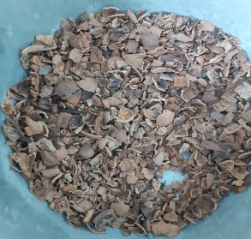
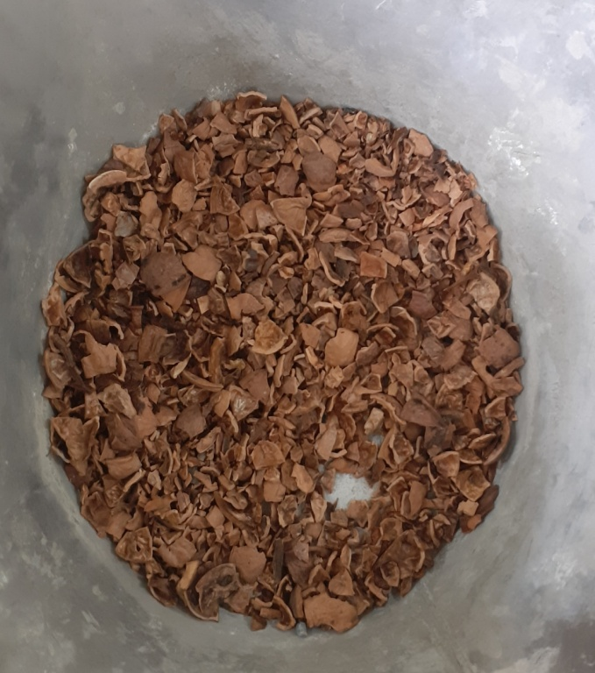
LITERATURE REVIEW
Alabadan, B. A., et al. (January-June 2005), This paper studies on partial replacement of ordinary Portland cement (OPC) with Bambara groundnut shell ash (BGSA) in concrete. The ash contained 10.91% CaO, 2.16% Fe2O3, 4.72% MgO, 33.36% SiO2, 1.75% Al2O3, 16.18% K2O, 9.30% Na2O, 6.40% SO3, 6.02% CO3 and 9.20% HCO3. 10%, 20%, 30%, 40% 50% and 0% ash was used in the mix to replace cement. The strength of cement/ash concrete increased with curing period but decreased with increasing ash percentage. The highest strength was 31.24N/mm2 and 20.68N/mm2 at 28 days for 0% and 10% ash respectively.
B.A. Alabadan et al. (2006) Estimates the Potentials of Groundnut Shell Ash as Concrete Admixture, Pozzolanic materials have long demonstrated their effectiveness in producing highperformance concrete. Artificial pozzolanas such as rice husk ash have gained acceptance as supplementary cementing materials in many parts of the World. This work evaluates the potentials of groundnut shell ash (GSA) as a partial replacement for ordinary Portland cement (OPC) in concrete.
B.H. Sada, Y.D. Amartey, S. Bako (2013) Studied Investigation into the use of Groundnut shell as a fine aggregate replacement. The suitability of groundnut shell as a constituent material in concrete was investigated by replacing proportions by volume of fine aggregate (river sand) with groundnut shells. Physical properties of cement, groundnut shells, and aggregates were determined. Concrete cubes measuring 150x150x150mm were cast. Groundnut shells were used to replace fine aggregate at 0, 5, 15, 25, 50 and 75% replacement levels Increase in percentage of groundnut shells in the cubes led to a corresponding reduction in densities of the cubes and compressive strength values. At a replacement value of 25% and above, of fine aggregate with groundnut shells; lightweight concrete was produced which could be used where low stress is required. Hence groundnut shells can be used for the production of lightweight concrete.
Buari T.A et al. (2013) Describe the Characteristics Strength of groundnut shell ash (GSA) and Ordinary Portland cement (OPC) blended Concrete in Nigeria as the Pozzolanic activity of GSA increases with the increase of time. GSA is a good Pozzolanic material which reacts with calcium hydroxide forming calcium silicate hydrate. The specific gravity of the GSA gotten was less than that of the OPC it replaced, this means that a considerably greater volume of cementations Materials will result from mass replacement.
F. A. Olutoge1 et al. (2013) Describe the Characteristics Strength and Durability of Groundnut Shell Ash (GSA) Blended Cement Concrete in Sulphate Environments. From the result of the tests and analysis carried out, the following conclusions were drawn: The Groundnut Shell Ash blended cement concrete haven proven resistance to magnesium sulphate, sodium sulphate, and calcium sulphate Media and would perform better in soils containing these media (MgSO4, Na2SO4, and CaSO4). Concrete as its Slump values decreases with increasing GSA replacement. The compressive strength value of the GSA/OPC blended concrete at 10% replacement level performed better and would be acceptable and considered as a good development for construction of masonry walls and mass foundations in any sulphate environment.
METHODOLOGY
Compressive Strength Test-Concrete specimens cubes are tested to determine the compressive strength by automatic compressive testing machine as per IS: 516-1969. The results of the compressive strength test carried out are shown in the table and graph below. It shows that compressive strength increases as the days of cubes curing increase and decreases when the percentage of wal nut shells increase. At 0% walnut shell and 100% cement that served as the control, compressive strength increased from 13.66 N/mm2 at 7 days to 21.58 N/mm2 at 28days.

Flexural Strength Test-It is the standard test, to determine the flexural strength of concrete in an indirect way. This test could be performed in accordance with IS: 516-1959. The bed of the testing machine shall be provided with two steel rollers, 38 mm in diameter, on which the specimen is to be supported, and these rollers shall be so mounted that the distance from center to center is 60 cm for 15.0 cm specimens or 40 cm for 10.0 cm specimens. The load shall be applied through two similar rollers mounted at the third points of the supporting span that is, spaced at 20 or 13.3 cm centre to centre. The load shall be divided equally between the two loading rollers, and all rollers shall be mounted in such a manner that the load is applied axially and without subjecting the specimen to any torsional stresses or restraints .

Water Absorption Test-Water absorption gives us idea on the internal structure of Walnut.Walnut having more absorption or more porous in nature and are generally considered unstable,unless found to be acceptable based on strength,impact and hardness tests. About 2kg of walnut sample is taken washed it to remove fines and then places in the wire basket.The wire basket is then immersed in water,which is at a temperature of 220C to 320C. Immediately after immersion the entrapped air is removed from the sample by lifting the basket 25mm above the base of the tank and allowing it to drop 25 times at a rate of about 1 drop per second. The basket with walnut are kept completely immersed in water for a period of 24 hours. The basket and Walnut are weighed while suspended in water which is at a temperature of 220C to 320C. The basket and Walnut are removed from water and dried with dry absent cloth. The surface dried Walnut are also weighed. The Walnut is placed in a shallow tray and heated to 100 to 1100C in the oven for 24 hours later it is cooled in an air tight container and weighed. Weight of saturated walnut in air W1=2.4 kg Weight of oven dried Walnut in air W2=1.9 kg Water absorption (%)=[(W1-W2)*100]/W2 = 26 %
Permeability Test-This standard covers the method for determining the permeability of cement mortar and concrete specimens either cast in the laboratory obtained by cutting out cores from existing structures. The test consists in subjecting the mortar or concrete specimen of known dimensions, contained in a specially designed cell, to a known hydrostatic pressure from one side, measuring the quantity of water percolating through it during a given interval of time and computing the coefficient of permeability . The test permits measurement of the water entering the specimen as well as that leaving it. Calibrating the Reservoir - Each reservoir shall be calibrated under the operating pressures of 5 kg/cm2 to 15 kg/cm2 With the reservoir drain-cock and the shut-off valve between the reservoir and the cell closed, and with the air bleeder valve open, the reservoir shall be filled with water. The reservoir drain-cock shall then be opened to flush out any air and closed again. The reservoir shall be refilled to a point above the zero mark of the gauge-glass scale; the bleeder valve shall be closed and the desired air pressure applied. The draincock shall be carefully opened to bring the water to the zero mark and quickly closed. Water shall then be drawn off and caught in 250 ml increments in a graduated jar and the level in the gauge-glass read on the scale. The calibration constant for the reservoir shall be expressed in millilitres per division of the scale.
CONCLUSION
• The properties of fine aggregate and coarse aggregate used. The fineness modulus of fine aggregate is 6.104 and confirm zone. The fineness modulus of the 20mm coarse aggregate is 2.385. The mix proportions for M25 grade concrete.
• The compressive strength of concrete with 0%, 5%, 10%, 15%, 20%,replacement of Coarse Aggregate with walnut shell cured in normal water for 7, 14, and 28days have .reached the target mean strength tables7,8,9,10,11
• The flexural strength of concrete with 0%, 5%, 10%, 15%, 20% replacement of Coarse Aggregate with walnut shell cured in normal water for 7, 14, and 28 days have reached the target mean strength tables.
Scope of Future use
We can use it in all types of building structures ,due to the permeability of concrete we use it internally not externally to the buildings , and also we can not use it in cold regions because of bad weather conditions because the concrete fails in durability test.
REFERENCES
1. Sada, B. H., Y. D. Amartey, and S. Bakoc. "An Investigation Into the Use of Groundnut as Fine Aggregate Replacement." Nigerian Journal of Technology32.1 (2013): 54-60.
2. Arora, N. K., S. C. Kang, and D. K. Maheshwari. "Isolation of siderophore-producing strains of Rhizobium meliloti and their biocontrol potential against Macrophomina phaseolina that causes charcoal rot of groundnut." Current Science (2001): 673-677.
3. https://community.data.gov.in/groundnut-production-of-various-states-in-2013- 14
4. http://hibondcement.com/opc-cement.html
5.https://archive.org/details/gov.in.is.12269.1987
6.Sengul, O. Tasdemir, C and M. A. Tasdemir. (2005), Mechanical Properties and Rapid Chloride Permeability of Concrete with ground Fly Ash. Materials Journal. 102(6): 414-421
7.Bengtsson, C.P. and Whilken, J.H., Farm Structures in tropical climates: A textbook for structural Engineering and Design. FAO/SIDA Cooperative

