PROJECT MANAGEMENT SYSTEM
Dr K Thanuja¹, P. Sakethram reddy², P. Sharuk khan³, N. Gunavardhan reddy⁴ ,
¹K.Thanuja ,Assistant Professor, Department of Computer science and Engineering
^{2,3,4,5}Students, Department of Computer science and Engineering
^{Emails: 1} k.tanuja@reva.edu.in
Reva university, Rukmini Knowledge Park, Kattigenahalli, SH 104, Srinivasa Nagar, Bengaluru, Karnataka 560064

Abstract— Project management system is brought into development to overcome the existing manual transmission process of the project reports. The existing process is very hectic, time consuming and also can inculcate a numerous number of human errors. It will be providing a user friendly platform for the users (students as well as teachers) to interact with each other, share their progress and also maintain the deadlines accordingly. The special “PING” feature will be inculcated in the project that will help to notify the students if he/she is running behind schedule .also the feature of automatic generation of the certificates i.e. the certificates will be provided automatically to the students once the entire process of the project has been completed is also an eye catcher. In all this will overcome the manual and time consuming existing system and will help to make the process speedy and also error free mostly to be implicated at the institutional level.

Keywords: project report, online submission, evaluation system, manual process, hectic, time consuming, human errors, user friendly, students, teachers, interact, share progress, deadlines, PING feature, notify, behind schedule, automatic generation, certificates, speedy, error free, institutional level.
I. INTRODUCTION
The Online project report submission and evaluation system is a highly innovative web application that offers a plethora of benefits to students and lecturers. With this system, students can easily submit their project reports online, eliminating the need for manual transmission of tasks. The system enables students to update their project report's progress, and lecturers can view the progress and provide feedback promptly.
Impersonation is one of the critical risks associated with manual transmission of project report-related tasks. However, the proposed system has been designed with tight security measures to reduce impersonation to a large extent. This ensures that the authenticity and integrity of project reports are maintained, which is essential for academic excellence.
As technology advances, there is a growing need for systems that can simplify and streamline academic processes, such as project report submission and evaluation. The proposed system is well-positioned to meet this need by providing a highly efficient and reliable platform that is accessible to all stakeholders.
One of the key advantages of the proposed system is its user-friendly interface, which makes it easy for students and lecturers to navigate and manage their project reports. The system also facilitates online discussions and document sharing between students and lecturers, enhancing collaboration and knowledge sharing.
Moreover, the proposed system incorporates automated notifications that are sent to lecturers and students via their registered mobile numbers when students are added to project groups. This ensures that all stakeholders are kept informed and up-to-date throughout the submission and evaluation process. The system also disables the upload button automatically after the deadline, ensuring that no late submissions are accepted.
In conclusion, the Online project report submission and evaluation system is a highly innovative and efficient web application that offers numerous benefits to both students and lecturers. It leverages the latest technology and security measures to provide a secure, reliable, and user-friendly platform that simplifies the project report submission and evaluation process.

1.1. Objectives And Motivation
Objectives:
The proposed project management system aims to achieve several objectives that can improve the efficiency and accuracy of project management. Firstly, the system aims to facilitate online processing and submission of project reports, replacing the existing manual process that is time-consuming and prone to errors. This can save time and effort for both students and teachers and reduce delays in the project submission process.
Secondly, the system aims to generate accurate results by providing clear guidelines and evaluation criteria for project reports. This can ensure that project reports are evaluated objectively and fairly, providing students with constructive feedback to improve their skills and knowledge.
Thirdly, the system aims to reduce chaos and manual errors by providing a centralized platform for students and teachers to collaborate and manage project activities. This can help to streamline workflows, reduce miscommunications, and ensure that project activities are completed on time.
Fourthly, the system aims to help management improve institutional facilities by viewing reports and data easily. This can provide valuable insights into the performance of students and teachers, enabling management to make informed decisions to improve the quality of education and facilities provided by the institution.

motivation:

The education sector is constantly evolving, and new trends are emerging with each passing day. One of these trends is the need for efficient management of project reports through online platforms. The proposed 'Online project report submission and evaluation system' aims to provide a solution to this need by offering a user-friendly platform for managing project reports online.
The system incorporates intelligence to enable automatic generation of certificates once the project report has been finalized or the deadline has passed. This feature eliminates the need for manual certificate generation, saving time and effort for both students and teachers. The primary motivation behind the system is to propose an intelligent solution that can be implemented in any organization to streamline the project report submission and evaluation process.
The system's intelligent features provide timely notifications and reminders to students, ensuring that deadlines are met and project reports are submitted on time. This can help to reduce delays and improve the efficiency of the project submission process. The system also provides a centralized platform for students and teachers to collaborate on project reports, enabling easy tracking of project progress and reducing the chances of miscommunications and errors.
Moreover, the system enables management to identify areas of improvement by viewing project reports and data easily. This can provide valuable insights into the performance of students and teachers, enabling management to make informed decisions to enhance educational practices and facilities. Overall, the proposed system aims to offer an intelligent and organized solution to manage project reports for any organization, enhancing the learning experience of students and improving the efficiency of project management.

II. Literature survey
Various research works have focused on developing electronic supervision systems for final year projects in universities. A prototype system for managing Computer Science final year projects was developed consisting of student and lecturer profiles, schedule monitoring and appointment modules. A logbook module is under development to document meetings between students and supervisors to address the increasing number of students unable to complete prototypes on time. However, the system remains incomplete.

Another e-supervision system provides quantitative assessment by automatically recording teacher activities to evaluate teaching abilities. The system collects web log information to supervise and assess teachers and department heads. It aims to reduce workload and facilitate communication. However, feedback, questionnaires and other features are lacking.

A university portal was designed to manage final year undergraduate projects and prevent duplication. It automates allocation of supervisors to students, allows students to communicate with supervisors and upload reports for review and feedback. It facilitates student clearance by restricting access to clearance forms until requirements are met.

An Online Project Evaluation and Supervision System (OPENS) for final year project proposals aims for paperless documentation. It allows coordinators, supervisors, evaluators and students to efficiently retrieve data and evaluate and monitor project progress. By reducing paper usage, it systematically and efficiently executes the final year project process. It also securely stores project information and evaluation scores.

In summary, existing systems focus on automating and streamlining supervision and evaluation of final year undergraduate projects through online portals and e-supervision systems. They aim to reduce workload, facilitate communication and monitoring, systematically manage projects and prevent duplication. However, existing systems remain limited and incomplete. Further work is needed for full implementation and additional features like feedback forms.

2.1 Problem Statement
The management of project reports at educational organizations is a challenging task that requires significant time and effort. The existing system of manual submission and evaluation of reports is prone to errors and delays, resulting in reduced efficiency and quality of education. The proposed Project Management System aims to address these challenges by providing a user-friendly online platform for managing project reports.

The existing system of manual submission and evaluation of project reports is time-consuming and prone to human errors. Additionally, it can cause delays in the submission process, as many students fail to submit their reports before the deadline. Moreover, the manual evaluation process requires a lot of workforce and takes a significant amount of time.
To overcome these challenges, the proposed system aims to reduce the manual work and improve the efficiency of the project management process. It offers an intelligent system that highlights the hidden relationships between different parameters, enabling easy analysis of the submitted reports. The system enables students to upload their reports phase-wise, making it easy to track the project progress and provide timely feedback.

The proposed Project Management System offers an online platform that is user-friendly and facilitates collaboration between students and teachers. It can provide valuable insights into the performance of students and teachers, enabling management to make informed decisions to improve the quality of education. By implementing the proposed system, educational organizations can provide better facilities and corrective measures to improve the quality of education.
In summary, the proposed Project Management System aims to address the challenges faced by educational organizations in managing project reports. It offers an intelligent and organized solution that reduces manual work and improves the efficiency and accuracy of the project management process. By implementing this system, educational organizations can enhance the quality of education and provide better facilities to students and teachers.

2.2 Proposed Solution
The proposed Project Management System offers a user-friendly platform that provides access to authenticated users, allowing students to submit their individual reports. The system ensures data security and accuracy and reduces the need for manual labor. The system also allows for resubmission of reports up until the deadline, ensuring that students have ample time to submit their reports.
The system incorporates intelligence to automatically generate certificates upon successful submission of the respective reports before the deadline is crossed. This feature eliminates the need for manual certificate generation and ensures that students receive their certificates in a timely manner. The system also highlights the hidden relationships between different parameters, providing valuable insights into the performance of students and teachers.

The proposed system aims to create an upgraded facility system that surpasses the constraints of the current system. It prioritizes data security and accuracy, implements proper controls for higher-level officials, and minimizes the amount of manual data entry required. The system aims to decrease processing time, increase efficiency, and provide superior service. It is designed to be user-friendly and interactive, ensuring timely submission and evaluation of project reports.

Overall, the proposed Project Management System offers an intelligent and organized solution for managing project reports that can be implemented in any educational organization. The system reduces the need for manual labor, enhances data security and accuracy, and ensures timely submission and evaluation of project reports. By implementing this system, educational organizations can improve their project management process, enhance the learning experience of students, and provide better facilities to teachers and staff.

III. METHODOLOGY
The proposed system utilizes an Agile software development methodology. This involves breaking down the system into individual modules developed incrementally in an iterative manner.
Unlike the Waterfall methodology, the Agile approach engages in continuous development and testing concurrently throughout the project lifecycle. The Agile methodology focuses on four key principles:
Valuing individuals and interactions over processes and tools. This means focusing on people and collaboration rather than strict plans and methodologies.
Valuing working software over comprehensive documentation. The focus is on developing working systems over excessive documentation. Documentation is developed as needed.
Valuing customer collaboration over contract negotiation. Close collaboration with customers and end-users is prioritized to ensure the system meets their needs rather than strict contracts.
Responding to change over following a plan. Flexibility and adaptability to changes in requirements and priorities are emphasized over rigidly following initial plans. Plans can evolve through collaboration.
In summary, the Agile methodology adopts an iterative approach to incremental development with continuous testing. It focuses on people, adaptation to changes and developing working systems that meet customer needs rather than strict methodologies, documentation and contracts. This flexibility and responsiveness aims to build the right system that satisfies users. The proposed system leverages these Agile principles by developing the system in modules through continuous development and testing with collaboration from stakeholders.
The key distinction from the Waterfall model is the iterative and incremental development of working systems with continuous testing and stakeholder collaboration. The Waterfall model follows a linear sequence of stages with little room for changes, prioritizing documentation and upfront planning. In contrast, the Agile methodology is flexible, collaborative and focused on building systems that work for end-users in an iterative manner.
3.1. System design
There are three users in the proposed system: The admin, the faculty and the students. The admin is the first user.
• The admin can add and view students as well as faculty.
• He has the responsibility to maintain the updated project titles, phases and all the parameters.
• Only the students of that particular batch are allowed access to their respective projects by the batch no and password as allotted by the admin.
• The Admin adds the facilities to the system like education, infrastructure, digital infrastructure and general.
• The admin can add, update and delete project titles.
• For example, if a new project has to be added or a new student is to be allotted to any group then it can be done by the admin.
• The admin is allowed to allocate and DE allocate faculty member as well.
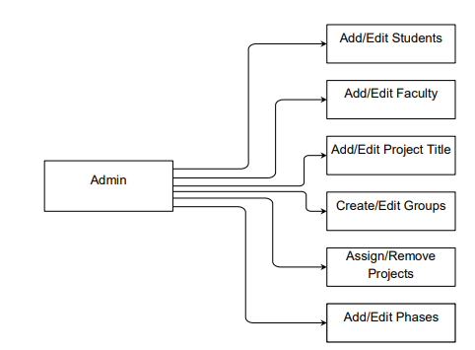 Figure 3.1: System Architecture for Admin
The faculty of the institution are the second user.
• To view any submitted report the faculty first must log in the system using his/her credentials for the respective batch they have been allotted to.
• The faculty can view the project and the details after he/she has logged in successfully.

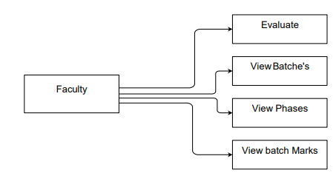
Figure 3.2: System Architecture for Faculty
• Thereafter the faculty can also evaluate the report for marks as well as download a copy of the same into their system so that they can verify it and upload it back to the portal back into the students side with the respective changes to be made marked in as notes so that the students can correct it and upload the final report back again with corrections.
• After the deadline is crossed, the marks allotted by the faculty automatically gets finalized.
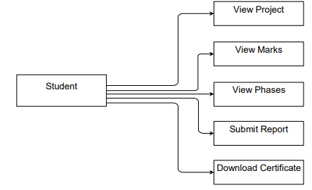
Figure 3.3: System Architecture for Student
The students of the institution are the third user.
• To submit the report, the students must log in using their credentials as per issued to them by the admin.
• The student can view the project and the details after he/she has logged in successfully.
• Each student is supposed to submit their individual reports phase wise within the deadline embarked.
• Once the report has been submitted and the student wishes to submit the updated copy of the same, it’s possible to do so only within the deadline
3.1.1 Use case diagram

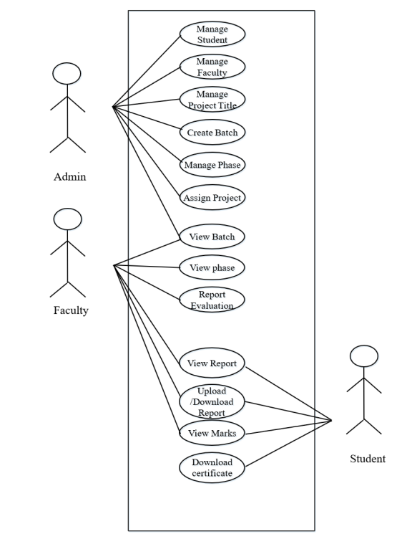
The above use case shows a very clear picture of the functionalities that can be executed by the individual actors of the scene. The stakeholders are affected accordingly

3.2 Database Design

A database stores and organizes data. The term database refers to a wide range of systems, from a single dataset to complex tools like SQL Server. A data model conceptually describes the problem domain, including entities, attributes, relationships and constraints. It translates the conceptual model into a physical database implementation using a database management system (DBMS).

The main benefits of a DBMS are reducing manual work, performing calculations, maintaining error-free reports and quickly validating information. A DBMS provides flexibility in data storage, retrieval and report generation. It determines data needs, how data is processed, and the operating system stores the data.

The proposed system's database design consists of tables like:

Admin: Contains admin username, password, etc.
Faculty: Contains faculty name, age, gender, qualifications, experience, contact information, etc.
Batch_Group: Contains batch number, ID and password.
Group: Contains student IDs and their group.
Phase: Contains phases for the year.
Project_Batch_Group: Contains batch number, assigned faculty, project title, start and end date.
Student: Contains student details.
Upload: Contains report uploads and resubmission details.
In summary, the database will store and organize all the information required for the system, with different tables for each entity and their attributes. The DBMS will allow for flexibility in data management, calculations, report generation and validation to reduce manual work and errors. The conceptual data model is translated into a physical database with a DBMS.

The tables represent the different entities, their attributes and relationships in the system. The Admin, Faculty, Student and Group tables contain user details. The Batch_Group, Phase and Project_Batch_Group tables organize students into groups, phases and projects. The Upload table tracks report submissions and resubmissions.

The database aims to create an integrated system for managing and monitoring final year projects with its data storage, relationships and management capabilities. The DBMS enhances functionality, automation and robustness.

3.4 System implementation
The implementation of the proposed database design involves creating tables to store the relevant information for the system. The tables are designed based on the entities and their attributes, such as Admin, Faculty, Batch_Group, Group, Phase, Project_Batch_Group, Student, and Upload. Each table contains the necessary fields, data types, and relationships to ensure data integrity.
The implementation process also involves selecting an appropriate database management system (DBMS) such as MySQL or Oracle, and installing it on a server or local machine. Access rights are then granted to authorized users to ensure data security.
Once the DBMS is set up, the tables are created and populated with data based on the system requirements. The data is validated to ensure that it conforms to the specified data types and constraints. Access controls are implemented to restrict access to sensitive information, and backup and recovery mechanisms are put in place to protect against data loss or corruption.
The database is then integrated with the proposed system to enable the storage, retrieval, and processing of data. The system interacts with the database using SQL queries, stored procedures, and other database operations to perform data management, calculations, report generation, and validation.
Overall, the implementation of the proposed database design aims to create an integrated system for managing and monitoring final year projects with its data storage, relationships, and management capabilities. The DBMS enhances functionality, automation, and robustness, providing flexibility in data storage, retrieval, and report generation to reduce manual work and errors. The database design translates the conceptual data model into a physical database implementation using a DBMS.

IV. IMPLEMENTATION

The successful implementation of a new system design is a crucial phase in the system development life cycle. To achieve this, the proposed system will utilize MySQL as the database, HTML, JS, and CSS for the front-end, and PHP for the back-end. The system will analyze student reports, and generate certificates automatically once the submission deadline has passed. Only students who submit reports in the specified format within the given timeframe will receive certificates. The selection of these platforms and languages was based on careful evaluation and consideration of their suitability for the project. Additionally, strict coding guidelines were followed to ensure efficient and error-free implementation.

4.1 Pseudo Code

Pseudo code is an informal high-level description of the operative principles of the algorithm and computer programs. The pseudo code for the 3 users are given below.

4.1.1 Admin
Step 1: Login as Admin using the credentials. Options like ‘Add Faculty’,’ Add Student’, ‘Assign Projects’ etc. are provided.

Step 2: The admin clicks on ‘Add Student’ button. A new window will be displayed asking for the details of the same. Step 3: The admin enters the details and proceeds.
Step 4: The admin sees another option asking to “Import Students”. The admin can also add an entire class of students here by importing a “.csv” file
Step 5: After all the relevant information are added the admin can now create project batches and also assign the students as well as faculty to them which he/she has added earlier.
Step 6: the phases for the particular year for which the report is to be submitted by the students is also created by the admin. Step 7: The admin logs out of the application.

4.1.2 Faculty
Step 1: Login as Faculty using the credentials. Options like ‘View Batches’, ‘View Phase’ and ‘Logout’ are provided.
Step 2: When the faculty clicks on the ‘View Batches ' button, the new windows appears where there is a list of all the batches that are under the respective faculty members. The faculty here can view all the marks allotted as well as can also carry out phase wise evaluation of the uploaded reports and assign marks accordingly.
Step 3: The report can be either sent back to the student with note on corrections to be made or the marks can be finalized there itself.
Step 4: The faculty logs out from the application.

4.1.3 Student
Step 1: Login as Student using the credentials. Options like ‘View Project Details’, ‘View Phase Marks’ and ‘Logout’ are provided.

Step 2: When the student clicks on the ‘View Project Details' button, the new windows appears where the options like “PDF” and “Submit document” appears. The student first views the format in which he/she should submit the report through the “PDF” which has been sent by the admin and later on they upload their report through the “Submit document” button. Step 3: The report is sent successfully to the faculty. Step 4: If it’s the second time the upload is being made then the “Resubmission” button appears instead of the “Submit” button and functions the same. Step 5: The student logs out from the application.

V SYSTEM REQUIREMENTS

5.1 Functional Requirements
5.1.1 Software Requirements
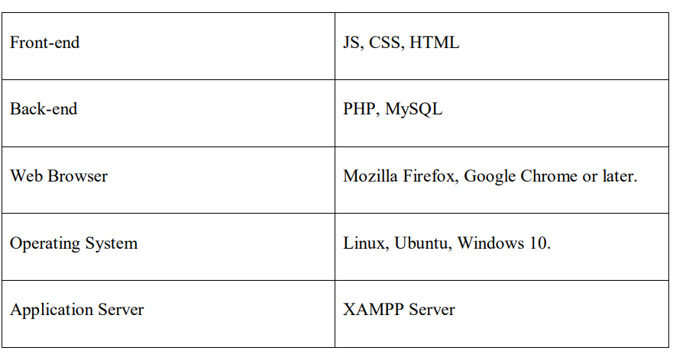
Table 4.1: Software Requirements

5.1.2 Hardware Requirements
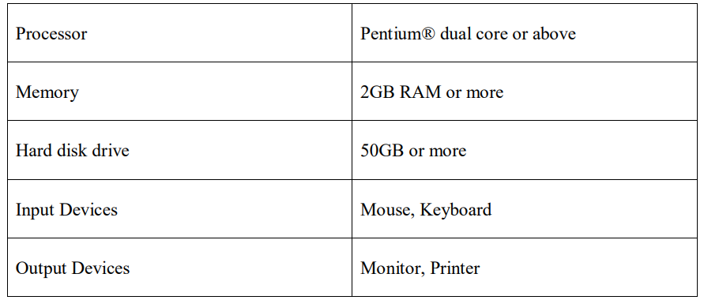
Table 4.2: Hardware Requirements

VI. EXPERIMENTAL RESULTS AND EVALUATION

6.1. RESULTS AND DISCUSSION
RESULTS AND DISCUSSION
The proposed system provides certificates generated from the system. The output shows the hidden relationships between the different entities of our system. The final certificate is generated automatically once the deadline is over and the report was sent successfully by the individual students. The hidden relationships elaborate the need of improvement in different parameters facilitated by the institution.
SNAPSHOTS
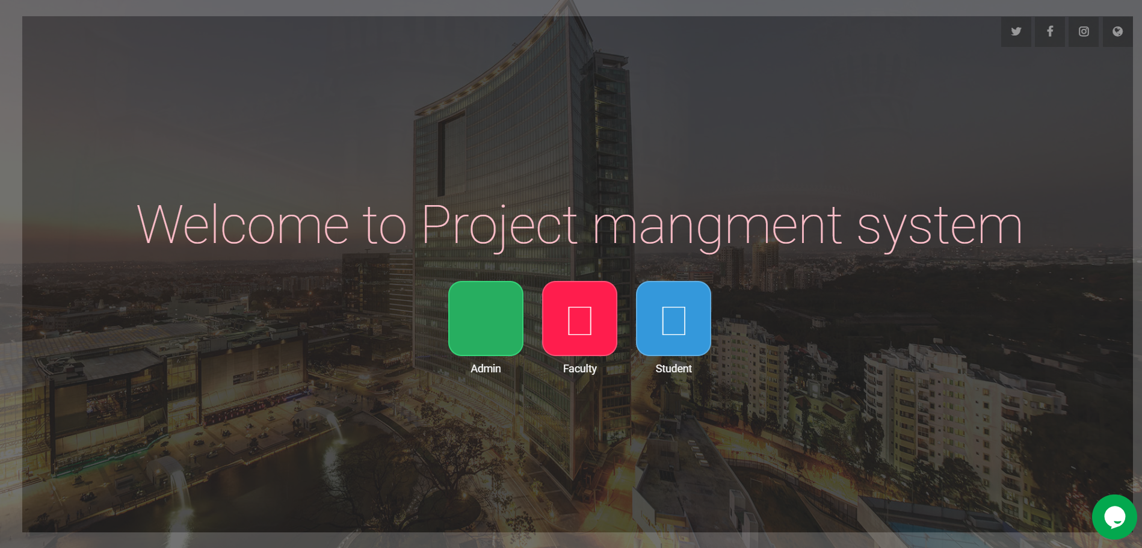
Figure 8.1: Home Page

The home page consists of the login portals for admin, faculty and the student. The respective users can login accordingly and perform the respective tasks
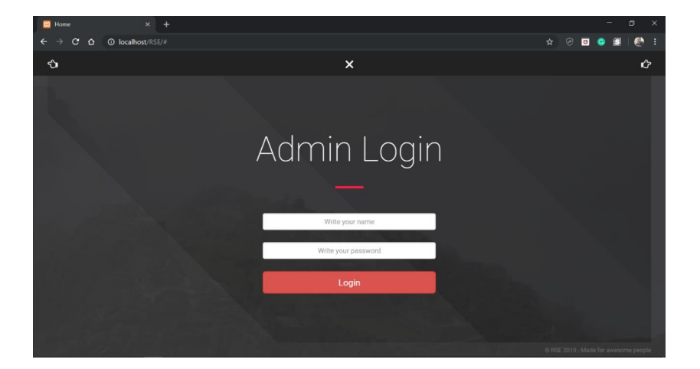
Figure 8.2: Admin Login Page
The above panel shows the login options for both the admin, the student and the faculty separately. The username and the password are the authentication credentials used here. Can switch login by clicking on the back or forward hand pointer on the top sides each.

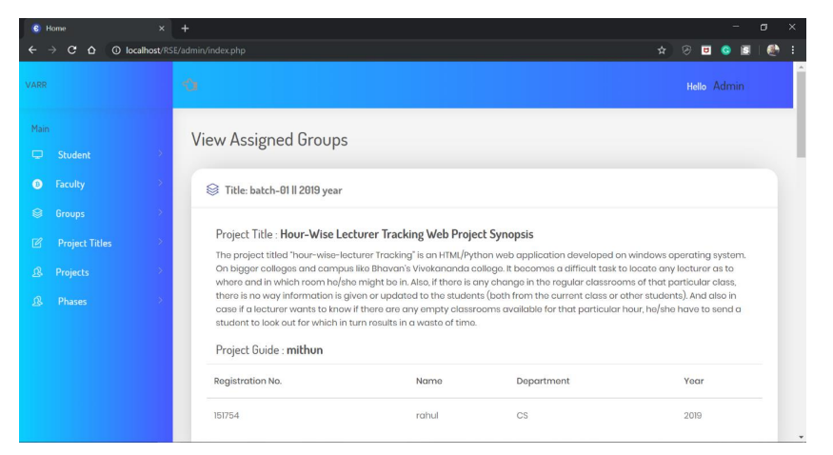
Figure 8.3: Admin Main Page
The above snapshot is of the admin main page. The admin here is given the privilege of adding students, faculty as well as creating phases and adding the students respectively to the respective project groups and also can import the list of entire class of students as under.
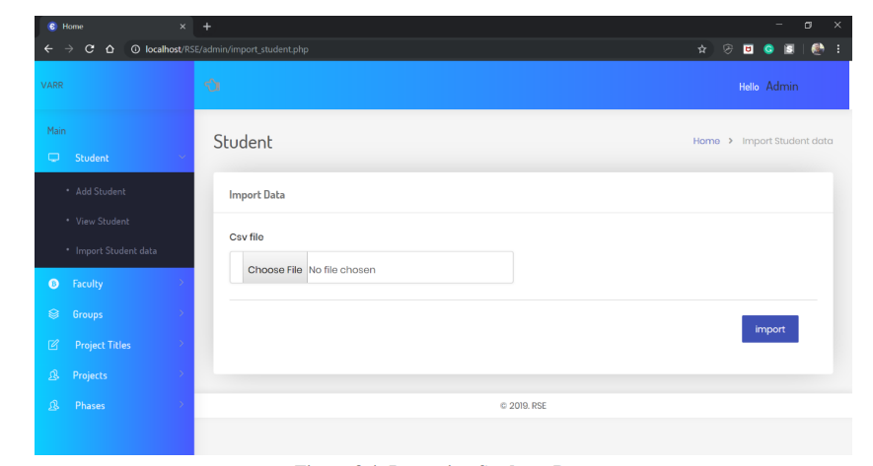
Figure 8.4: Importing Students Data
Here the admin can import the entire list of students in the form of a .csv file and also if some student was not mentioned in the list, he/she can be also manually entered by the admin later on or as preferred.

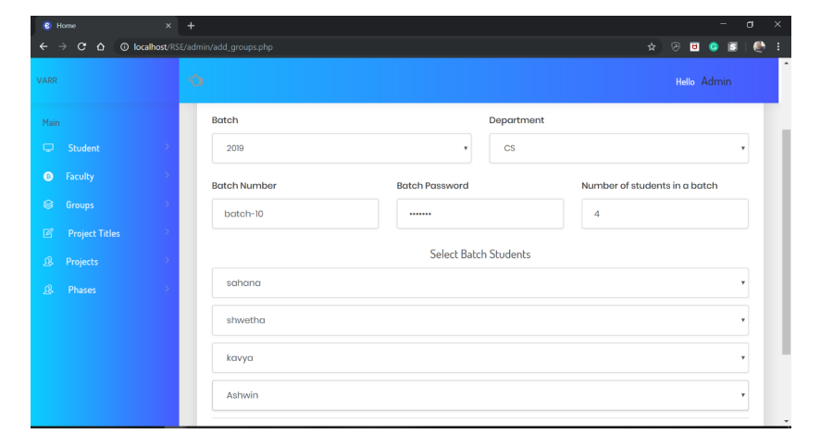
Figure 8.5: Creating Batches
This panel provides a display for creating the project batches and adding the respective student the that project group. here the eye catching feature is that firstly the system does not allows the admin to add more than 4 students in a batch and also the students who are being already allotted to any project group will not be displayed in the selection list.
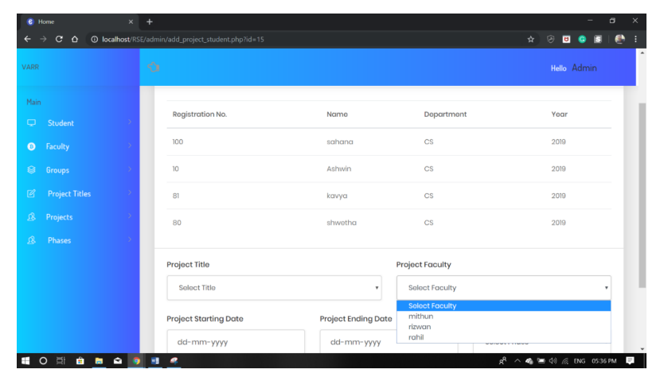
Figure 8.6: Assigning Projects
The batches have been designed and now in the above window the admin will assign the faculty for that particular batch. As soon as the faculty is assigned to that batch the student as well as the faculty member will get an alert message in their phone regarding the same. one faculty can be assigned to more than one projects.
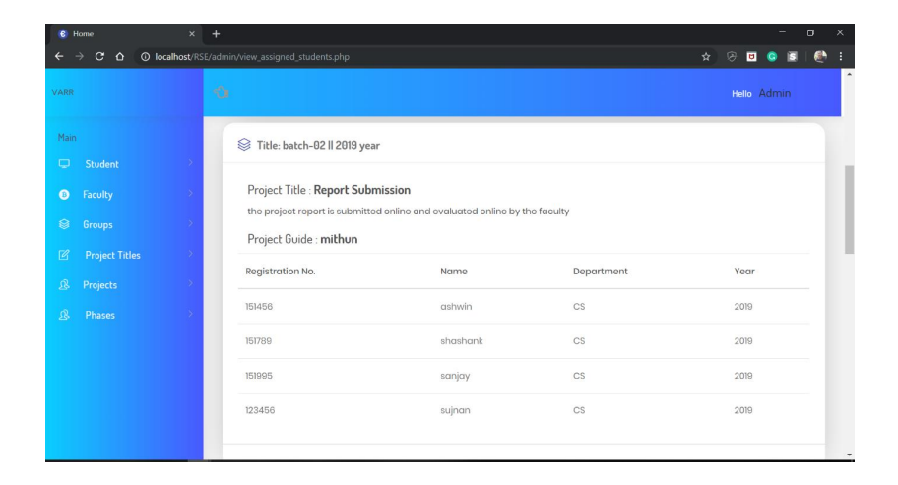
Figure 8.7: View Assigned Projects by Admin
Here the final view can be obtained of the projects along with the faculty assigned to them and the students in that particular project_batch.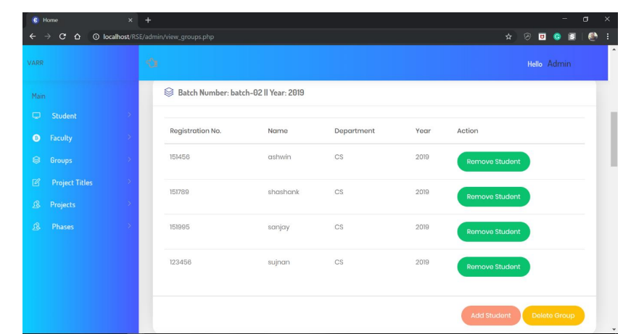 Figure 8.8: View Groups by Admin
If in the previous step some mistake was made by the admin in adding the students, here they can remove the student or students from the batch or they can also delete the entire group as well. If any batch has less than 4 members, extra members can also be added here.
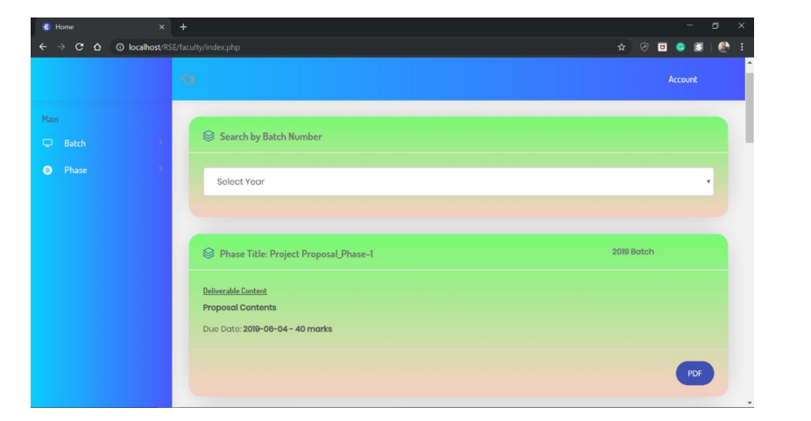
Figure 8.9: Faculty Home Page
The faculty logs in here by using their respective login credentials .As we can see that one faculty can be added to more than one batch ,all the details will be visible here of all the batches he /she is been allotted to.
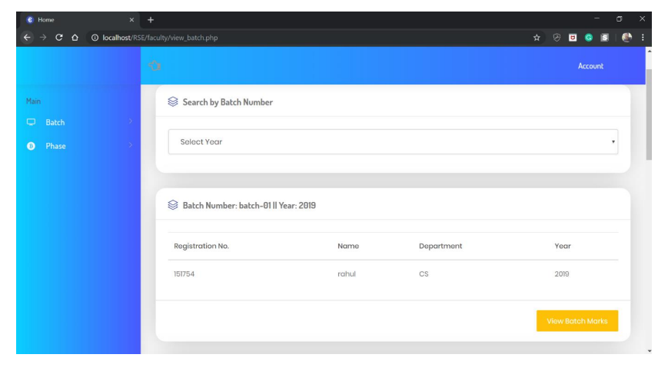
Figure 8.10: View Assigned Batches by Faculty
Here year wise filter exists where in the faculty can view the filtered out detailed allotments to that particular batch and also can view the batch marks assigned to that batch students for their respective report.
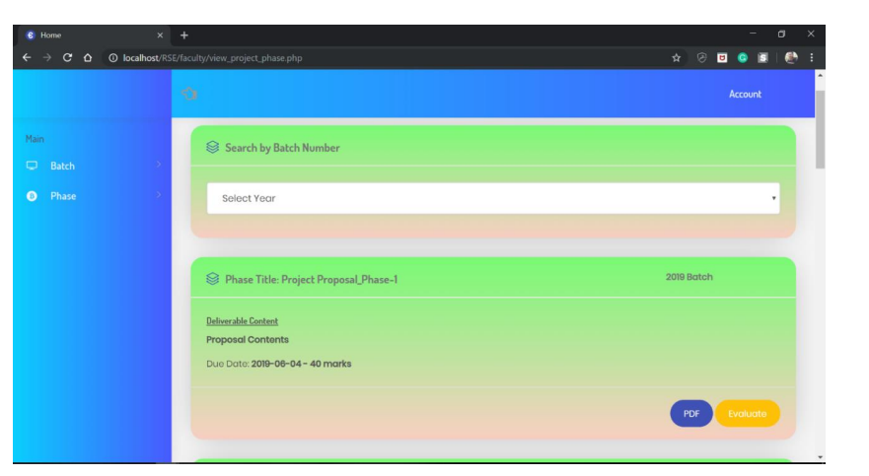
Figure 8.11: View Phases by Faculty
The faculty can view the phases here and can also View a sample copy of PDF uploaded by admin. If already the students have sent the report, the faculty can evaluate in over here.

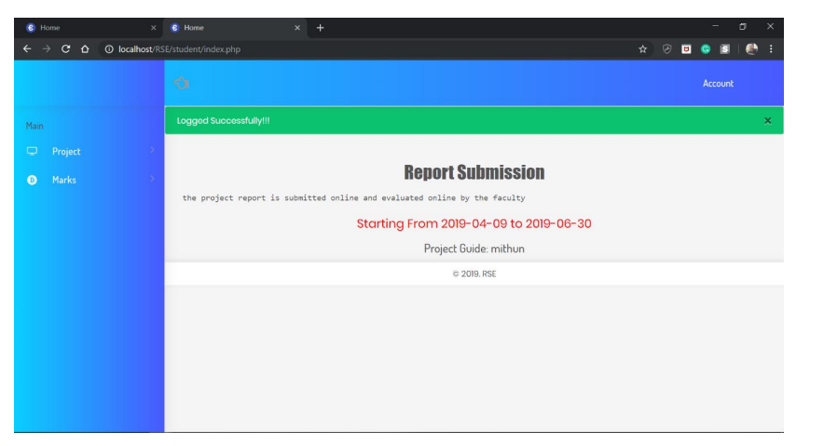
Figure 8.12: Student Home Page
This page is visited when the student logs in with his/her respective batch no and password. They can view only their batch and only their own respective reports here.
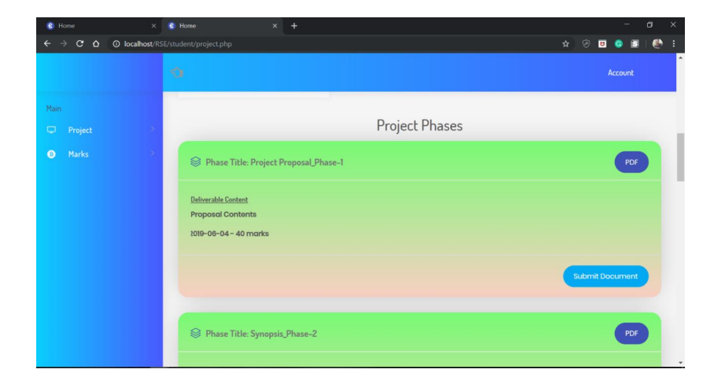
Figure 8.13: View Phase by Student
Here the student can view sample copy of PDF uploaded by admin to and they can refer it to send their individual reports from the “Submit Document” button.
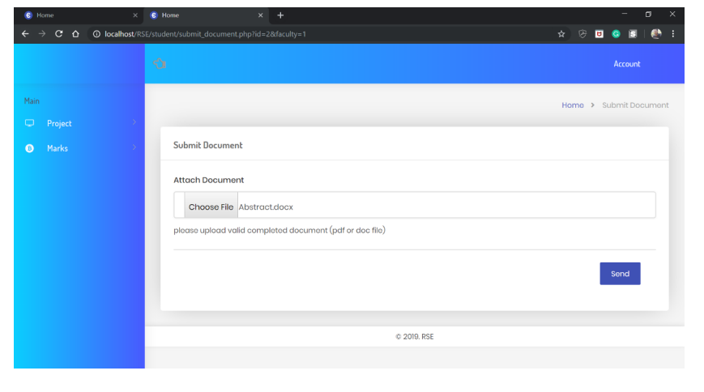
Figure 8.14: Submit Document by Student
Here the student can upload the pdf format file into the portal and click on the send button to send it to the faculty.
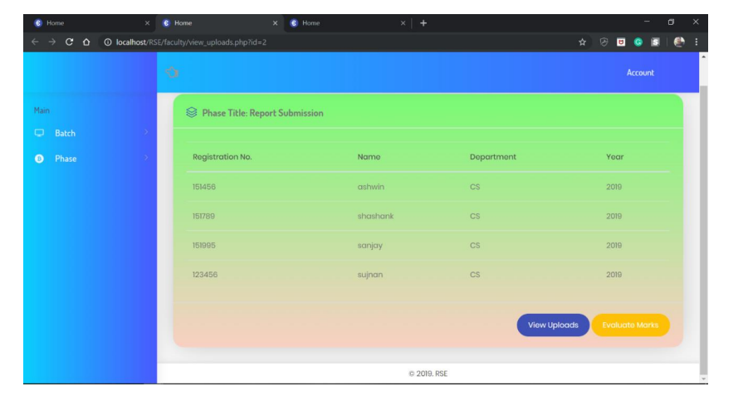
Figure 8.15: Page to View the Uploaded Doc By Faculty
Here the faculty can view the file sent by the students. He/she can evaluate it and also can marks corrections if any. The reports get opened in a new tab from where it’s even possible for the faculty to download it on their system or check it there itself.
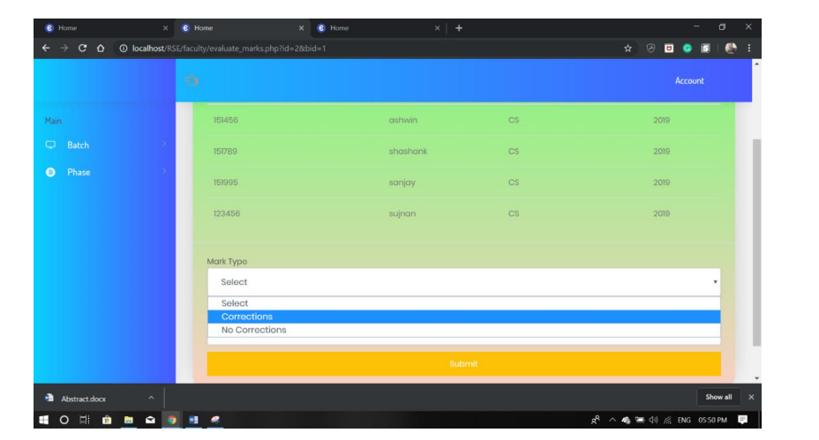
Figure 8.16: Page for Marks Allotment
Here comes the evaluation part by the faculty where he/she can allot the marks to the students and also can mark the corrections to be made as in the form of a note or even upload any file to be sent to the student for reference purpose. The marks allotted can be changed only till the deadline is not crossed else the same marks get automatically finalized.
VII. CONCLUSION
As technology continues to advance, the demands placed on systems are constantly increasing. The proposed system aims to address the limitations of previous versions, as identified in the literature survey. The system offers a more user-friendly interface, with smooth accessibility, and electronic marking of student project reports that can save time, effort, and expenses while improving accuracy and reliability. The flexibility of the system allows for the addition of new features and reusability. A valuable functionality that could benefit students would be the inclusion of a forum for project-related discussions. In the future, a platform for students to upload their project applications for instructors could also be added. Overall, the proposed system has the potential to greatly benefit institutions and their students.
VIII. REFERENCES

[1] Bakar, M. A., Jailani, N., Shukur, Z., & Yatim, N. F. M. (2011). Final year supervision management system as a tool for monitoring Computer Science projects. Procedia-Social and Behavioral Sciences, 18, 273-281.
[2] Albar, A. M. (2012). An electronic supervision system architecture in education environments. European Journal of Business and Management, 4(8), 140-148.
[3] Ademola, A., Adewale, A., & Ike, D. U. (2013). Design and development of a University portal for the management of final year undergraduate projects. International Journal of Engineering and Computer Science, 2(10).
[4] Ismail, S. I., Abdullah, R., Kar, S. A. C., Fadzal, N., Husni, H., & Omar, H. M. (2017, December). Online Project Evaluation and Supervision System (opens) for final year project proposal development process. In Research and Development (scored), 2017 IEEE 15th Student Conference on (pp. 210-214). IEEE
[5] https://en.wikipedia.org/wiki/Database
[6] https://en.wikipedia.org/wiki/PHP
[7] https://en.wikipedia.org/wiki/MySQL
[8] https://en.wikipedia.org/wiki/JavaScript
[9] https://en.wikipedia.org/wiki/Cascading_Style_Sheets
[10] https://en.wikipedia.org/wiki/HTML

