A STUDY ON PUBLIC OPINION ON TAXES ON MEDICAL PRODUCTS

SUBMITTED BY
K.B.PALANIVELRAJAN (131801009) (Author)
B.A, L.L.B.(Hons), I year
Saveetha School of Law, Saveetha Institute of Medical and Technical Science (SIMATS) ,
Saveetha University.

SUBMITTED TO
Mr. M. DHINESH(CO-Author)
Saveetha School of Law, Saveetha Institute of Medical and Technical Science (SIMATS) ,
Saveetha University,
Associate professor of Law

A STUDY ON PUBLIC OPINION ON TAXES ON MEDICAL PRODUCTS

AUTHOR: K.B.PALANIVELRAJAN
CO AUTHOR:M. DHINESH

Abstract:
Goods and Service Tax (GST) is an indirect tax collected in India for the supply of goods and services. The services provided under GST are divided into five different slabs 0%, 5%, 12%, 18% and 28%. In Medical Industry the GST Rate for medicines have been determined by way of the GST Council within the assembly held on the 3rd June, 2017. GST is levied underneath 5 different quotes, namely NIL, 5%, 12%, 18% and 28% primarily based on the HSN code of the object. No medicine has the highest percentage of 28% in the GST. Medicines and prescribed drugs are categorized under 37th chapter of HSN Code. HSN code or Harmonized System Nomenclature code number is a globally embraced product portrayal and coding framework created by the World Customs Organization (WCO). HSN code is utilized by in excess of 200 nations as for their traditions levies. As of now more than 98 % of the products in global countries exchange is grouped under HSN code, With the HSN code going about as universal order for merchandise, the Indian Government has chosen to the utilization of HSN code for characterization of merchandise under GST. This research follows non doctrinal type of research and the sampling method used in this survey is random method of sampling. The sample size is limited to and this analysis is done through SPSS tool for acquiring better and accurate results. This paper is based on primary data sources and a survey conducted by random sampling method.
Keywords: GST, Medical, HSN, Government, merchandise.

Introduction
Goods and Service Tax (GST) is one among the largest Tax reform in the era of Indian Indirect Taxation enterprise, which is the one hundred and twenty-2nd amendment exceeded because the Constitution’s One Hundred and Twenty Second Amendment Act, 2017 that become implemented via the July 1st, 2017 throughout the country(Mahanta). It subsumes 7-8 taxes like CST, VAT, excise responsibility, Service tax, and further excise responsibility, Luxury Tax, Entertainment Tax and lots of greater. GST is the unmarried taxation device in India which facilitates in removal time, cost and attempt. Under GST, goods and offerings are taxed at the charges of 0%, 5%, 12%, 18%, 28%. Different sectors have both superb and bad consequences on them including pharma area(Springer). GST changed nearly 17 federal and kingdom taxes with one uniform tax and eliminated the hassle springing up from more than one taxes. India is certainly one of the largest international locations in phrases of manufacturing of generics and the us of a pharmaceutical industry is now the 1/3 biggest inside the global in difficulty of extent and ranks, fourteenth in challenge of value(Mahanta; Vasanthagopal). The Indian fitness care zone is predicted to touch a hundred and fifty billion greenbacks by way of the stop of year 2017 looking at an increase of 70 billion dollar from 2012.(“India - Taxation”) For rationalizing the tax shape and optimizing the distribution there is a reduction in the cost of production and distribution which is helping the industry to pass the benefits to the purchaser. Presently the United States's GDP expenditure on fitness care area is about 5%(Amutha and mname Amutha). Hence through passing the GST invoice the focus of all industries has been hooked. Purpose of this evaluation is to attention the role of GST on Indian pharma zone with its pitfalls. GST is predicted to be a recreation-converting reform for the Indian economy in the medium to long time for the reason that it's going to flourish a common Indian marketplace and reduce the cascading effect of the tax on the value of products and services.(Amutha and mname Amutha; Garg) If implemented, GST will result in a whole overhaul of the Indian indirect tax gadget with wide-ranging implications together with tax shape, tax incidence, tax computation, tax fee, compliances, and credit utilization and reporting. It is also predicted that supply chain and other operational making plans possibilities and efficiencies may be available, depending on an enterprise's information.(Gramopadhye et al.) However, inside the quick-time period/transitional segment, all Industry, along with the pharmaceutical industry, are probable to stand a number of demanding situations, including probable poor economic influences, the need to evaluate existing deliver chain systems, the need for reconfiguration of IT systems and more(Sury, GST and Fiscal Federalism in India). It is, therefore, essential that organizations come to be widely known with the proposed GST legislation, start assessing the impacts that GST is in all likelihood to have on their commercial enterprise operations and begin to broaden/put into effect a plan to manipulate this mega-trade by using the anticipated implementation date.
Direct Taxes have been paid directly to the government. Indirect Tax is on the carrier provided rather than earnings. It changed into not directly paid to the government by the taxpayer however was gathered via the government.(Viswanathan) From intermediaries. These intermediaries later filed a tax return. The carrier quarter contributed to over 55% of obligation in India. Separate taxation became not required in any respect, and it only created troubles. Indian and imported goods are actually taxed at the identical rate. Under GST, several non-direct taxes have come collectively under one shed(Dahal). Atal Bihari Vajpayee added in this gadget in 2000, however it wasn't surpassed due to a few reasons. India's honorable Finance Minister, Arun Jaitley, brought this invoice on nineteenth December 2014, and it turned into exceeded by the house on sixth May 2015. All the states authorized the bill, after which it turned into given the inexperienced mild by means of President Pranab Mukherjee on 8th September 2016(Dahal; Mukherjee). After the state of no activity of GST, India’s obligation shape has turn out to be much more clean and difficult. India’s Tax to GDP ratio has elevated after the state of being inactive of GST.(&na; and &NA;; King; Vasanthagopal) Earlier, all of the taxes went to the vital executive. And it determined which nation will get what number of taxes accumulated. Now, the responsibility amassed is similarly divided between the center and the state government in the call of CGST and SGST. The aim of the study is about the tax on medical products.
Objectives
To study about the Government’s support towards taxes on Medical products, To study about the impact of GST on medical sectors, To study on HSN code on Medical products, To study about the positive effects of gst on medical products, To study about the Nil Gst medical products
Review of literature
Most of the medication cited below the 5% bracket are used to therapy malaria, HIV-AIDS, tuberculosis, and diabetes which were formerly charged VAT around 4%. Nicotine polacrilex gum is the only pharmaceutical product to be charged at a fee of 18%. Cipla, the logo which produces nicotine gums, will possibly be impacted from the price fixed at 18%. No explanation has been furnished by way of the authorities on the problem of producers running in excise-loose manufacturing zones paying more tax below GST.(Agarwal; McKinnon) Most of these manufacturers are competitive within the pharmaceutical industry is due to the excise advantage as they're located in foreign places. Earlier, Ayurvedic pills or drug treatments had been charged a median VAT of four% and excise of 1.5% due to the excise free production sector advantage.(Risstrom) Under GST, Ayurvedic medicines get dearer as they could be taxed at the rate of 12%. Since the distribution channel become no longer concerned within the fee of tax and submitting tax returns, they will now need to get registered and record the minimum 37 returns yearly as required below GST. A lot of the times, medicines are furnished without bills in India.(Agarwal) GST could cut back such practices as imparting medicine without the bill would not be beneficial for anybody inside the distribution chain. The government needs to still provide rationalization at the inclusion of the modern-day advantage for the producers under excise for working from the excise free production zones. The pharmaceutical enterprise is likewise asking for more information at the implementation of GST at the MRP of pharmaceutical products. In the last two decades, the Medical Devices Industry has gone through a metamorphosis - from being a domestic-industry- ruled sector previous to 1991 to conversion to import-dependence publish - New Economic Policy-1991, to being a non-regulated region previous to 2006 to law of 15 notified devices to the brand new Medical Device Rules announced in 2017(Stanbridge). The authorities have taken diverse steps to make certain that the medical devices region is taken into consideration as extensive as the opposite sectors. To take this further, a project force changed into constituted to put into effect more than a few hints, consisting of the segregation of medical gadgets from tablets. Currently, only 15 classes of clinical gadgets are regulated as tablets.(Katke; Sury, Goods and Services Tax (GST) in India: Background, Present Structure and Future Challenges; “Goods and Service Tax (GST): India”) The new set of regulatory practices objectives to put off those hurdles which will prepare India to meet the Medical gadgets sector requirements. These new policies shall for that reason beautify ease of doing business and make sure availability of fine medical gadgets. Also, for the first actual time, periodic renewal of licenses will not be required. Consequently, manufacturing and import licenses might be valid till it's far suspended or cancelled. The guidelines additionally intention to sell a subculture of self-compliance through producers of clinical gadgets. In addition, the producing licences for certain medical gadgets are granted without previous audit of the manufacturing website. In such instances, the manufacturer has to do self- certification of compliance with the critical requirements and on the idea of such certification, the licence might be issued. In 2017, the government additionally accredited the National Health Policy, which envisages the realisation of fine fitness care thru each promotive and preventive practice. Through this Policy, the health care machine may be made more potent and registries can be set up for sickness of public significance.(&na; and &NA;) One of the maximum essential regulations is the Draft National Medical Device Policy – 2015 that became proposed to reinforce the Medical Devices sector by means of decreasing dependence on imports, thereby giving impetus to the ‘Make in India’ initiative. Under this Policy, a unmarried-window mechanism may be provided to the enterprise to not simply recognition on self-reliance, but also paintings closer to making India the global hub of production in scientific gadgets.(Katke; Sury, Goods and Services Tax (GST) in India: Background, Present Structure and Future Challenges) Additionally, the Policy envisages hobby subsidy for MSMEs, concession on electricity price lists, seed capital and minimal or zero responsibility on uncooked materials, among others. Currently, the coverage is expecting inputs from stakeholders and their validation. Medical Devices, inclusive of surgical units, entice 6% principal excise responsibility and 5% Value Added Tax (VAT) and in conjunction with CST, octroi, access tax etc. Involves extra than thirteen%. With the new Goods and Services Tax regime, the rate is 12%. (&na; and &NA;; King)This new charge is fine to gain decrease expenses of manufacturing, and thereby proving beneficial to consumers. Technological advancement and understanding coupled with government help has proved to be fantastic for the arena. With Medical Parks deliberate in Gujarat, Andhra Pradesh and Maharashtra and emphasis on excellence in Research and Development (R & D), the medical devices enterprise in India is poised to cross a marketplace size of USD 50 billion by 2025. HSN (Harmonized System of Nomenclature) is an 8- digit code for identifying the proper rate of GST on special items as consistent with GST guidelines. If an organization has profits up to RS.1.5 Crore inside the previous economic yr then they want no longer point out the HSN code even as providing items on invoices. If a corporation has income extra than One and half Crore however up to 5 Cr then they wishes to say the 2 digit HSN code whilst offering goods on invoices. If turnover crosses 5 Cr then they shall mention the 4 digit HSN codes on invoices. Health care offerings for both humans and animals (veterinary medical services) are blanketed within the GST Act.(Katke) Under existing rules, there may be nil GST on health care offerings supplied with the aid of a licensed scientific practitioner, licensed medical or paramedical sanatorium. The same nil GST price additionally applies to any and all scientific offerings furnished in the course of transportation of an affected person by using ambulance. In case of veterinary fitness care services furnished to birds/animals at authorized clinics, the applicable GST charge is also nil. Initially there was confusion regarding GST fees on drug treatments and different medical consumables used throughout hospitalization (in-affected person treatment). In reaction to a query on this difficulty, the Authority of Advance Ruling (AAR) in Kerala has dominated that deliver of medicines, implants and other consumables used (e.G. Diagnostic supplies and surgical gadget) in the course of hospitalization will feature nil GST. As in line with the AAR, those are to be covered as part of composite resources blanketed as a part of healthcare services as a result the nil GST fee will be relevant. This enhance ruling is applicable to treatments finished at all registered hospitals, clinics and physicians across India.
Methodology
The present research is based on empirical study. And this research is made in Analytical and descriptive form in a science that the issues have been resolved into Elements and the structure of the issues has been described and classified. This is Widely used in social research and also in legal research form. The source of Information is from the primary sources which is gathered as a result of survey Questions and by reference of certain books and other such journal articles. In a Random Method about 1337 samples were collected for this survey. The sampling method was random sampling method. The independent variables are based on the sample’s Age, Gender, Qualification and Occupation. The dependant variables are based on the questions: 1. Lowest GST 5% is applicable only to Life saving drugs? 2. Do you know that the highest pharmaceutical products is 28% of GST? The study results were based on the chi square results.

Gender
 |  | Frequency | Percent | Valid Percent | Cumulative Percent
Valid | Female | 623 | 40.8 | 40.8 | 40.8
Valid | Male | 902 | 59.1 | 59.1 | 99.9
Valid | Transgender | 2 | .1 | .1 | 100.0
Valid | Total | 1527 | 100.0 | 100.0

Age
 |  | Frequency | Percent | Valid Percent | Cumulative Percent
Valid | 15-30 | 614 | 40.2 | 40.2 | 40.2
Valid | 31-50 | 799 | 52.3 | 52.3 | 92.5
Valid | 50 and above | 114 | 7.5 | 7.5 | 100.0
Valid | Total | 1527 | 100.0 | 100.0

Qualification
 |  | Frequency | Percent | Valid Percent | Cumulative Percent
Valid | Graduate | 1081 | 70.8 | 70.8 | 70.8
Valid | Higher secondary | 273 | 17.9 | 17.9 | 88.7
Valid | Others | 173 | 11.3 | 11.3 | 100.0
Valid | Total | 1527 | 100.0 | 100.0

Occupation
 |  | Frequency | Percent | Valid Percent | Cumulative Percent
Valid | Business | 571 | 37.4 | 37.4 | 37.4
Valid | Employee | 575 | 37.7 | 37.7 | 75.0
Valid | Others | 130 | 8.5 | 8.5 | 83.6
Valid | Student | 251 | 16.4 | 16.4 | 100.0
Valid | Total | 1527 | 100.0 | 100.0

Lowest GST 5% is applicable only to Life saving drugs?

Crosstab
 |  |  | 31. Lowest GST 5% is applicable only to Life saving drugs? |  | Total
 |  |  | No | Yes | Total
Occupation | Business | Count | 311 | 260 | 571
Occupation | Business | % within Occupation | 54.5% | 45.5% | 100.0%
Occupation | Employee | Count | 195 | 380 | 575
Occupation | Employee | % within Occupation | 33.9% | 66.1% | 100.0%
Occupation | Others | Count | 37 | 93 | 130
Occupation | Others | % within Occupation | 28.5% | 71.5% | 100.0%
Occupation | Student | Count | 90 | 161 | 251
Occupation | Student | % within Occupation | 35.9% | 64.1% | 100.0%
Total |  | Count | 633 | 894 | 1527
 |  | % within Occupation | 41.5% | 58.5% | 100.0%

Chi-Square Tests
 | Value | df | Asymptotic Significance (2-sided)
Pearson Chi-Square | 65.589ª | 3 | .000
Likelihood Ratio | 65.615 | 3 | .000
N of Valid Cases | 1527
a. 0 cells (0.0%) have expected count less than 5. The minimum expected count is 53.89.
The question asked towards the public was that the lowest gst 5% is applicable only to life saving drugs. The respondents replied of Business with 260 as Yes and 311 as No. The respondents replied of Employee with 380 as Yes and 195 as No. The respondents replied of Others with 93 as Yes and 37 as No. The total respondents said 894 as Yes and 633 as No.The respondents replied of Student with 161 as Yes and 90 as No. From the chi square test the value is less than 0.5 which says that the alternative hypothesis is accepted and the Null hypothesis is rejected.
Null Hypothesis: There is no significant relationship between life saving drugs and Occupation.
Alternative Hypothesis: There is no significant relationship between life saving drugs and Occupation.

Do you know that the highest pharmaceutical products is 28% of GST?

Crosstab
 |  |  | 32. Do you know that the highest pharmaceutical products is 28% of GST? |  |  |  |  | Total
 |  |  | Agree | Disagree | Neutral | Strongly agree | Strongly disagree | Total
Occupation | Business | Count | 68 | 85 | 195 | 175 | 48 | 571
Occupation | Business | % within Occupation | 11.9% | 14.9% | 34.2% | 30.6% | 8.4% | 100.0%
Occupation | Employee | Count | 58 | 52 | 236 | 220 | 9 | 575
Occupation | Employee | % within Occupation | 10.1% | 9.0% | 41.0% | 38.3% | 1.6% | 100.0%
Occupation | Others | Count | 28 | 18 | 16 | 47 | 21 | 130
Occupation | Others | % within Occupation | 21.5% | 13.8% | 12.3% | 36.2% | 16.2% | 100.0%
Occupation | Student | Count | 41 | 68 | 54 | 79 | 9 | 251
Occupation | Student | % within Occupation | 16.3% | 27.1% | 21.5% | 31.5% | 3.6% | 100.0%
Total |  | Count | 195 | 223 | 501 | 521 | 87 | 1527
 |  | % within Occupation | 12.8% | 14.6% | 32.8% | 34.1% | 5.7% | 100.0%

Chi-Square Tests
 | Value | df | Asymptotic Significance (2-sided)
Pearson Chi-Square | 148.645ª | 12 | .000
Likelihood Ratio | 147.573 | 12 | .000
N of Valid Cases | 1527
a. 0 cells (0.0%) have expected count less than 5. The minimum expected count is 7.41.

The question asked towards the public was that the highest pharmaceutical products is 28% of GST? The respondents replied of Business with 68 as Agree, 85 Disagree, 195 Neutral, 175 as Strongly agree, 48 as Strongly disagree. The respondents replied of Employee with 58 as Agree, 52 Disagree, 236 Neutral, 220 as Strongly agree, 9 as Strongly disagree. The respondents replied of Others with 28 as Agree, 18 Disagree, 16 Neutral, 47 as Strongly agree, 21 as Strongly disagree. The respondents replied of Student with 41 as Agree, 68 Disagree, 54 Neutral, 79 as Strongly agree, 9 as Strongly disagree. The total respondents said that 195 as Agree, 223 as Disagree, 501 as Neutral, 521 as Strongly agree, 87 as Strongly disagree. From the chi square test the value is less than 0.5 which says that the alternative hypothesis is accepted and the Null hypothesis is rejected.
Null Hypothesis: There is no significant relationship between pharmaceutical products and Occupation.
Alternative Hypothesis: There is no significant relationship between pharmaceutical products and Occupation.

Lowest GST 5% is applicable only to Life saving drugs?

Crosstab
 |  |  | 31. Lowest GST 5% is applicable only to Life saving drugs? |  | Total
 |  |  | No | Yes | Total
Gender | Female | Count | 283 | 340 | 623
Gender | Female | % within Gender | 45.4% | 54.6% | 100.0%
Gender | Male | Count | 350 | 552 | 902
Gender | Male | % within Gender | 38.8% | 61.2% | 100.0%
Gender | Transgender | Count | 0 | 2 | 2
Gender | Transgender | % within Gender | 0.0% | 100.0% | 100.0%
Total |  | Count | 633 | 894 | 1527
 |  | % within Gender | 41.5% | 58.5% | 100.0%

Chi-Square Tests
 | Value | df | Asymptotic Significance (2-sided)
Pearson Chi-Square | 8.077ª | 2 | .018
Likelihood Ratio | 8.787 | 2 | .012
N of Valid Cases | 1527
a. 2 cells (33.3%) have expected count less than 5. The minimum expected count is .83.

The question asked towards the public was that the lowest gst 5% is applicable only to life saving drugs. The respondents replied of Female with 340 as Yes and 283 as No. The respondents replied of Employee with 350 as Yes and 552 as No. The respondents replied of Student with 2 as Yes and 0 as No. The total respondents said that 894 as Yes and 633 as No. From the chi square test the value is less than 0.5 which says that the alternative hypothesis is accepted and the Null hypothesis is rejected.
Null Hypothesis: There is no significant relationship between life saving drugs and Gender.
Alternative Hypothesis: There is no significant relationship between life saving drugs and Gender.

Do you know that the highest pharmaceutical products is 28% of GST?

Crosstab
 |  |  | 32. Do you know that the highest pharmaceutical products is 28% of GST? |  |  |  |  | Total
 |  |  | Agree | Disagree | Neutral | Strongly agree | Strongly disagree | Total
Gender | Female | Count | 120 | 100 | 194 | 189 | 20 | 623
Gender | Female | % within Gender | 19.3% | 16.1% | 31.1% | 30.3% | 3.2% | 100.0%
Gender | Male | Count | 75 | 122 | 307 | 331 | 67 | 902
Gender | Male | % within Gender | 8.3% | 13.5% | 34.0% | 36.7% | 7.4% | 100.0%
Gender | Transgender | Count | 0 | 1 | 0 | 1 | 0 | 2
Gender | Transgender | % within Gender | 0.0% | 50.0% | 0.0% | 50.0% | 0.0% | 100.0%
Total |  | Count | 195 | 223 | 501 | 521 | 87 | 1527
 |  | % within Gender | 12.8% | 14.6% | 32.8% | 34.1% | 5.7% | 100.0%

Chi-Square Tests
 | Value | df | Asymptotic Significance (2-sided)
Pearson Chi-Square | 55.895ª | 8 | .000
Likelihood Ratio | 56.339 | 8 | .000
N of Valid Cases | 1527
a. 5 cells (33.3%) have expected count less than 5. The minimum expected count is .11.

The question asked towards the public was that the highest pharmaceutical products is 28% of GST? The respondents replied of Female with 120 as Agree, 100 Disagree, 194 Neutral, 189 as Strongly agree, 20 as Strongly disagree. The respondents replied of Male with 75 as Agree, 122 Disagree, 307 Neutral, 331 as Strongly agree, 67 as Strongly disagree. The respondents replied of Transgender with 0 as Agree, 1 Disagree, 0 Neutral, 1 as Strongly agree, 0 as Strongly disagree. The total respondents said that 195 as Agree, 223 as Disagree, 501 as Neutral, 521 as Strongly agree, 87 as Strongly disagree. From the chi square test the value is less than 0.5 which says that the alternative hypothesis is accepted and the Null hypothesis is rejected.
Null Hypothesis: There is no significant relationship between life saving drugs and Gender.
Alternative Hypothesis: There is no significant relationship between life saving drugs and Gender.
Conclusion
Overall, majority of the populace feels that the implementation of the GST will have a constructive effect on the Indian economy in the end, especially due to the truth that everyone the details and nitty grittiest of purchase and sales information is obvious and fully to be had for the cause of claiming GST credit. The Economic Survey in 2017-18 has introduced to light the fact that the wide variety of payers of indirect tax has multiplied, with the general public of them being voluntary. The Industry expects similarly standardization and simplification of GST costs and practices. Previously, the method of submitting taxes became tedious. The VAT and Service Tax had been to be filed in different departments and separate identity numbers. After the enactment of GST, all of this has come underneath one roof and below one single identification wide variety - the GST range. The GST Tax fee of a services or products is determined in keeping with its corresponding HSN code. Overall, inside the healthcare sector, GST has been a boon. It has caused better transparency inside the gadget. The tax quotes for all offerings, as well as products, has grow to be clear and extra specific. The reality maximum loved via the employees of predominant hospitals is that the brand new system is on line. This makes it a great deal simpler to report taxes with a click of the mouse.

REFERENCE
1.Agarwal, Anjali. Goods and Services Tax (GST): Impact on the Indian Economy. 2017.
2.Amutha, D. Mname, and D. mname Amutha. “Economic Consequences of GST in India.” SSRN Electronic Journal, doi:10.2139/ssrn.3098357.
3.Dahal, Rajib. “Constitutional Framework for Goods and Service Tax (GST) in India.” SSRN Electronic Journal, doi:10.2139/ssrn.1596522.
4.Garg, Shruti. “Towards GST Regime In India.” International Journal of Scientific Research and Management, 2015, doi:10.18535/ijsrm/v3i8.15.
5.“Goods and Service Tax (GST): India.” International Journal of Science and Research (IJSR), vol. 6, no. 7, 2017, pp. 603–07, doi:10.21275/art20175366.
6.Gramopadhye, Prof Vinayak R., et al. “A Research Paper on ‘Impact of GST on Service Sector of India.’” International Journal of Trend in Scientific Research and Development, vol. -2, no. -3, 2018, pp. 1698–701, doi:10.31142/ijtsrd11619.
7.“India - Taxation.” Foreign Law Guide, doi:10.1163/2213-2996_flg_com_097165.
8.Katke, Venkatesh Shantapppa. Goods and Services Tax (GST) In India. Lulu.com.
9.King, Elizabeth. “Intercompany Sale of Medical Devices.” Transfer Pricing and Corporate Taxation, pp. 89–100, doi:10.1007/978-0-387-78183-9_6.
10.Mahanta, Ratul. “GST in India: Expectations and Challenges.” Space and Culture, India, vol. 4, no. 2, 2016, p. 3, doi:10.20896/saci.v4i2.215.
11.McKinnon, M. C. “TAXATION AND THE MEDICAL PRACTITIONER.” Medical Journal of Australia, vol. 2, no. 25, 1965, pp. 1044–1044, doi:10.5694/j.1326-5377.1965.tb25426.x.
12.Mukherjee, Sacchidananda. “Present State of Goods and Services Tax (GST) Reform in India.” Evolution of Goods and Services Tax in India, 2019, pp. 60–88, doi:10.1017/9781108564120.005.
13.“UNJUST TAXATION OF DOCTORS.” Southern Medical Journal, vol. 8, no. 1, 1915, p. 72, doi:10.1097/00007611-191501000-00026.
14.Risstrom, Eric. “TAXATION AND THE MEDICAL PRACTITIONER.” Medical Journal of Australia, vol. 2, no. 20, 1965, pp. 851–55, doi:10.5694/j.1326-5377.1965.tb19329.x.
15.Springer, Rusla Anne. “Pharmaceutical Industry Influence: Doctors’ Persistent Illusion of Unique Invulnerability.” Indian Journal of Medical Ethics, 2019, pp. 01–03, doi:10.20529/ijme.2019.008.
16.Stanbridge, Ray. “Taxation.” The Business of Private Medical Practice, 2018, pp. 69–86, doi:10.1201/9781315384597-7.
17.Sury, M. M. Goods and Services Tax (GST) in India: Background, Present Structure and Future Challenges. 2017.
18.GST and Fiscal Federalism in India. 2018.
19.Vasanthagopal, R. “GST in India: A Big Leap in the Indirect Taxation System.” International Journal of Trade, Economics and Finance, 2011, pp. 144–46, doi:10.7763/ijtef.2011.v2.93.
20.Viswanathan, B. Goods and Services Tax (Gst) in India. 2016.
Plagiarism
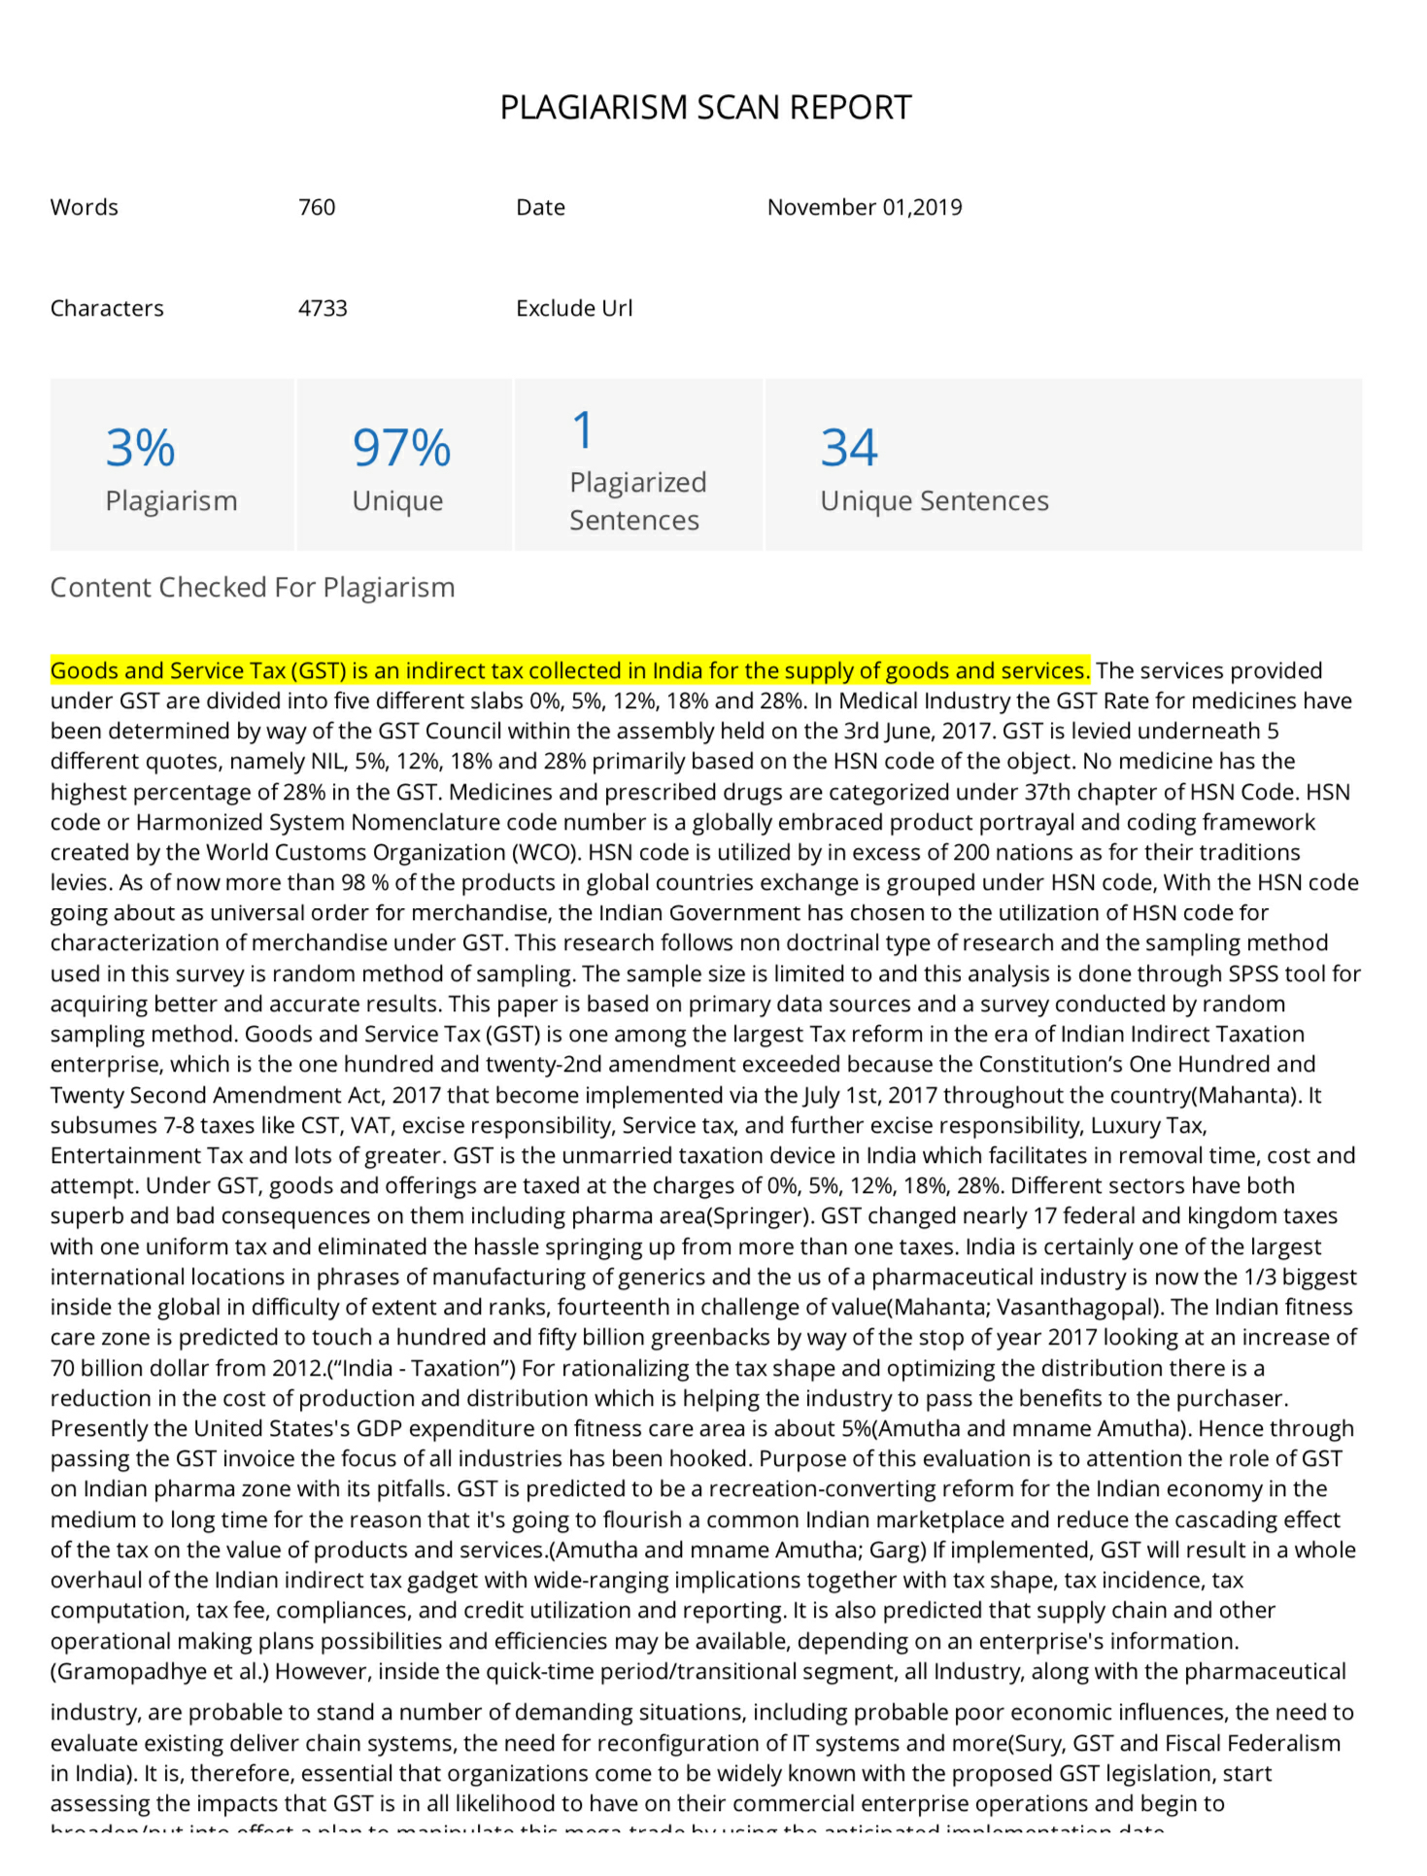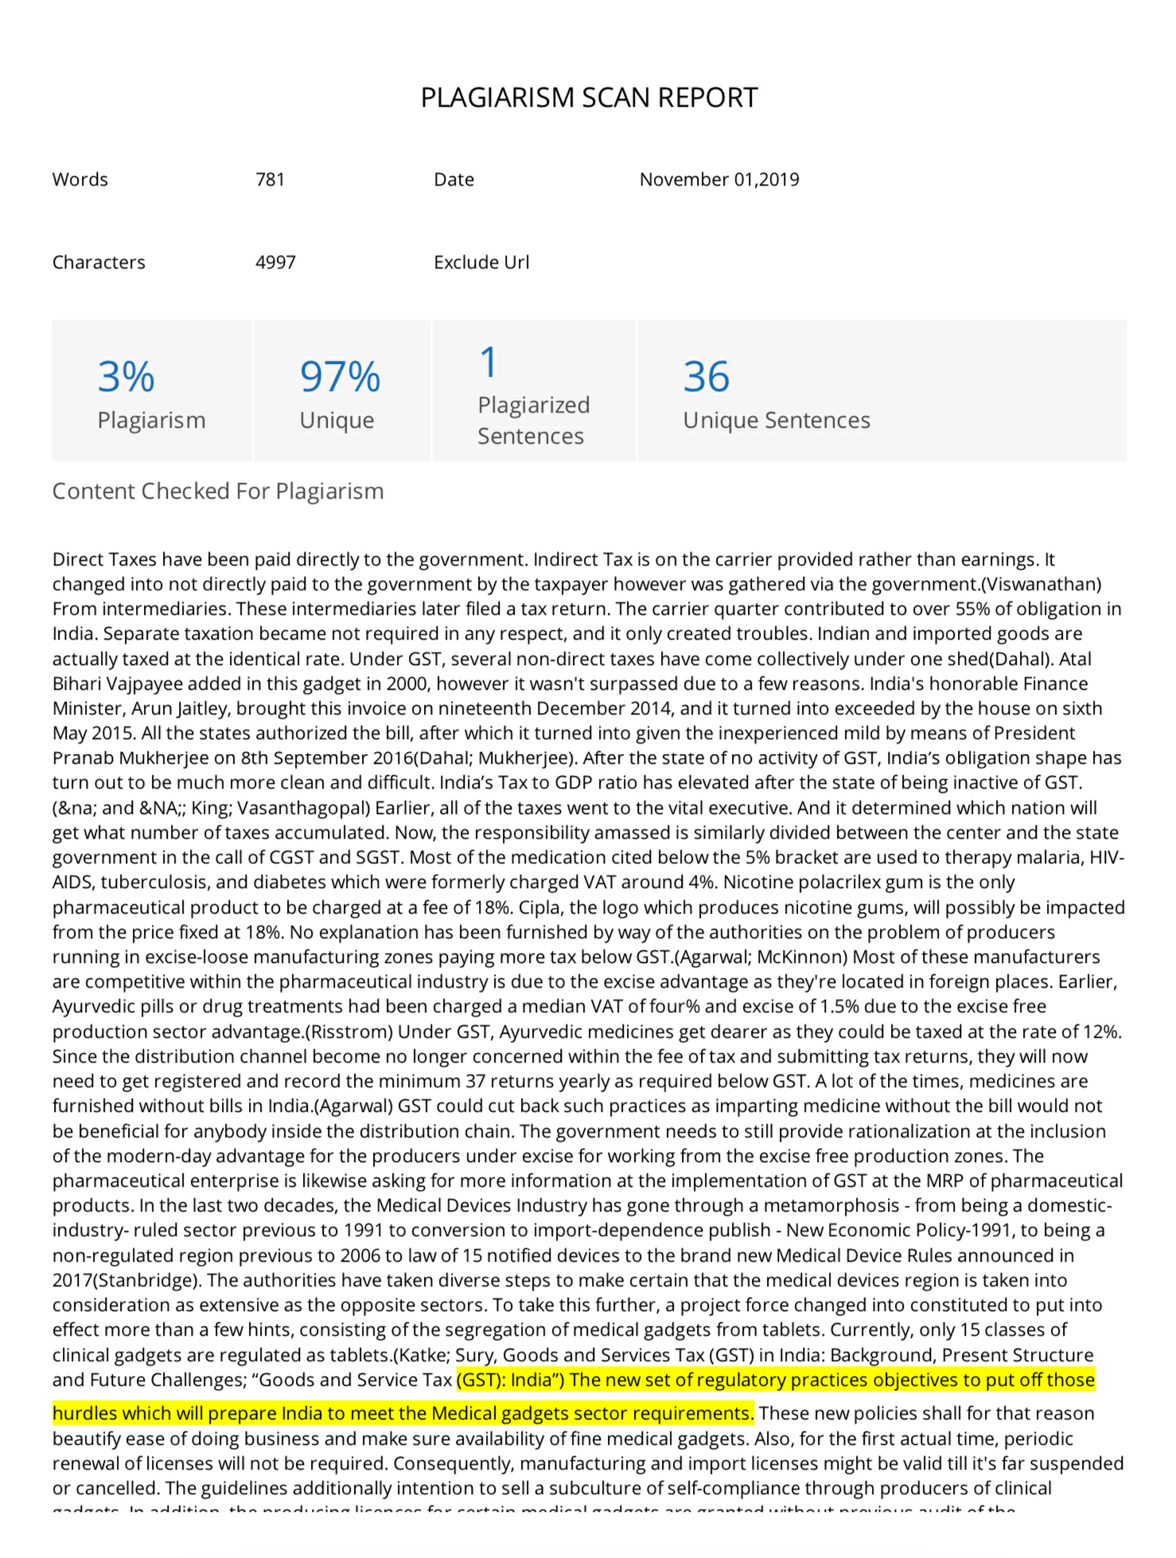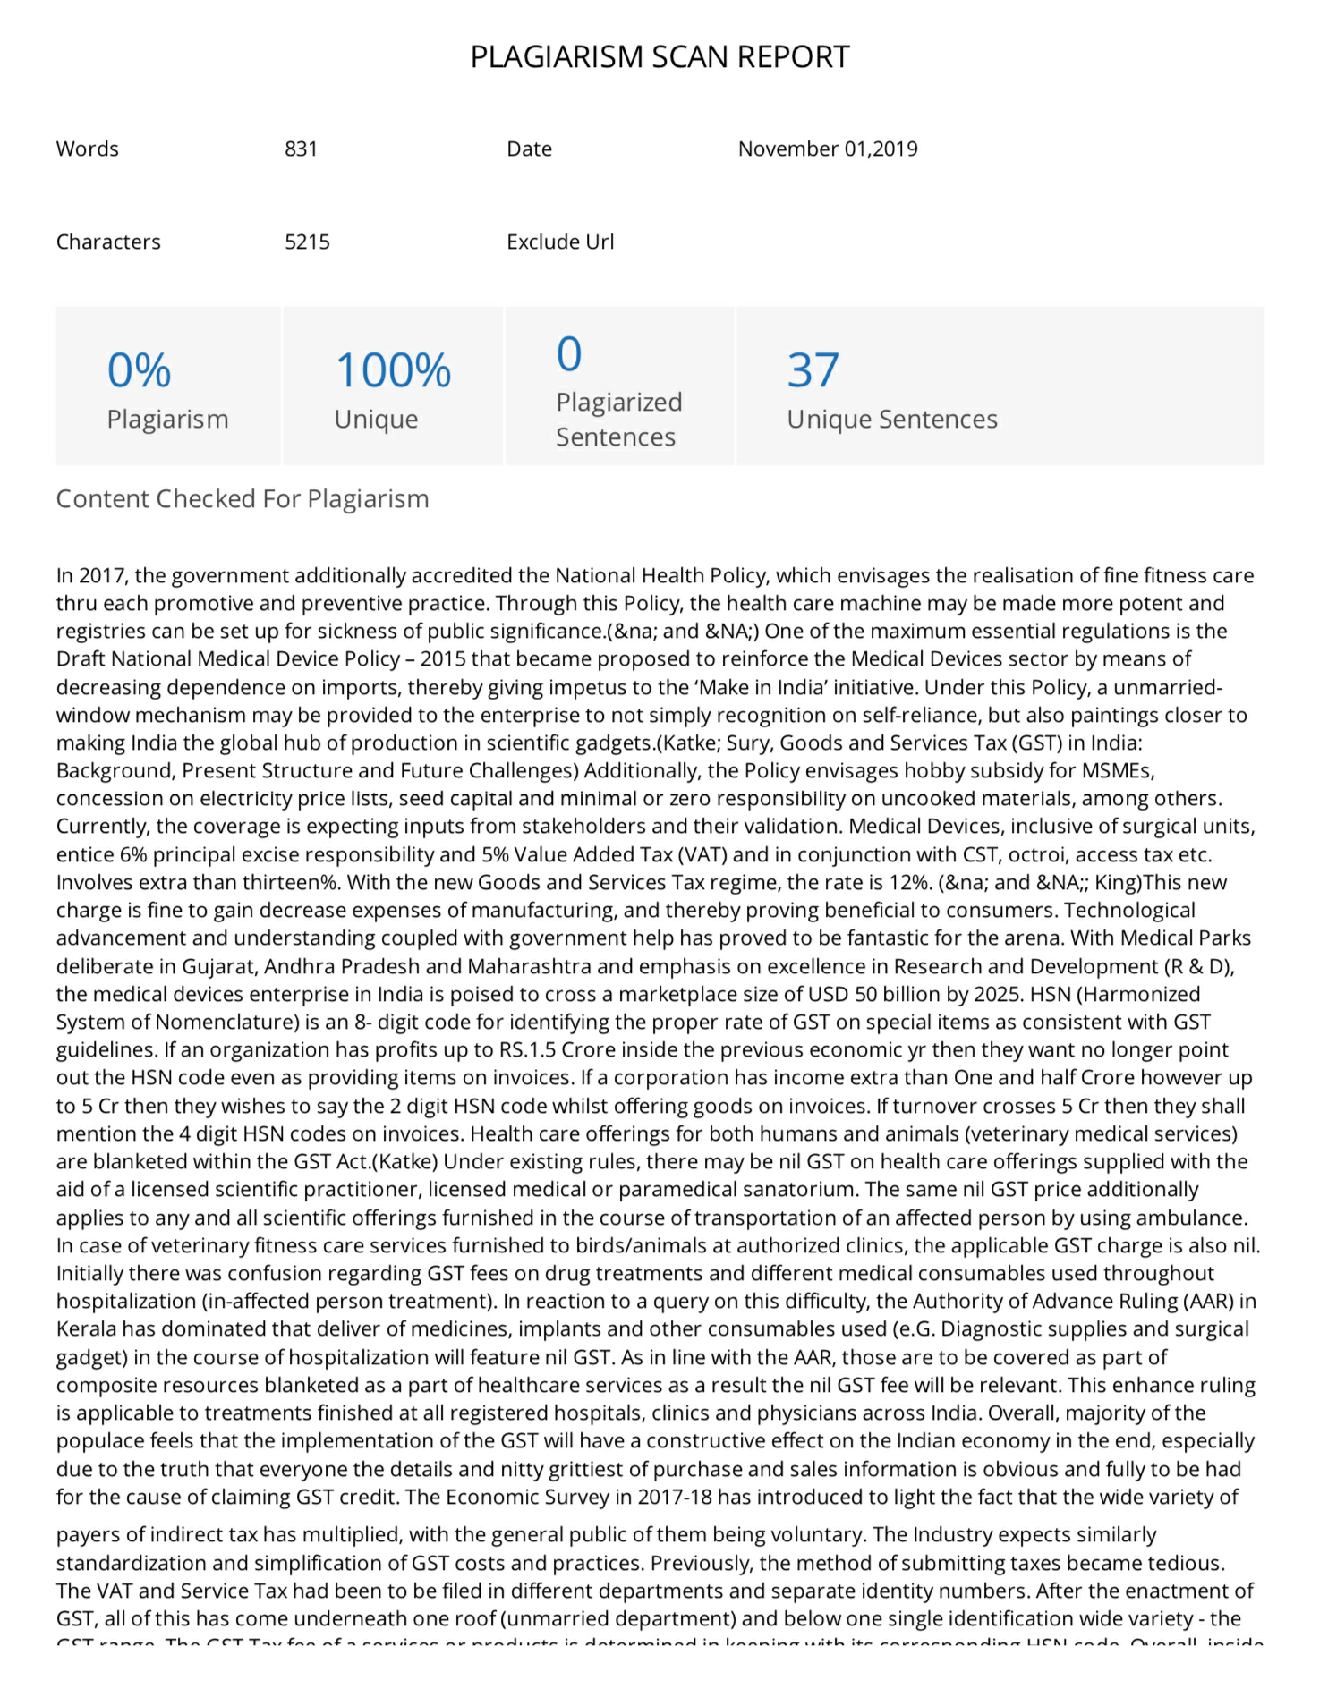

Saveetha School of Law, Saveetha Institute of Medical and Technical Science (SIMATS), Saveetha University,
Saveetha School of Law, Saveetha Institute of Medical and Technical Science (SIMATS), Saveetha University,

