Recommendation System for Crop Yield Prediction using Sensors in Agriculture Environment

Kavin Nandha M Rishi.B Dr. S Amudha
Department of Computational Department of Computational Assistant Professor, Department of
Intelligence Intelligence Computational Intelligence
SRM Institute of Science and SRM Institute of Science and SRM Institute of Science and
Technology, Technology, Technology,
Kattankulathur,India Kattankulathur,India Kattankulathur, India
kavin.nandha02@gmail.com jbrishiiyer@gmail.com amudhas@srmist.edu.in

Abstract— Agriculture is a back bone for our country and its economy. Now a days unlikely proper guidance is not available to farmers, due to this farmers are not able to analyze the nature of the soil and its requirements. This leads to depletion of farming. To overcome this we are aiming to analyze the soil through various parameters like Nitrogen-Potassium-Phosphorus Content in soil, Humidity, Temperature, Ph value of the soil, Rainfall using sensors in real-time. These parameters are obtained using both IoT Sensors and existing Data, are analyzed through ML Algorithm. Then Farmers can be guided with the details of the crop that is suitable for the soil and about Fertilizer, Pesticide, Water requirement.
Keywords— Arduino Uno, NPK Sensor, DHT 11 Sensor, Node MCU, Crop Yield, Flask Frame Work

Introduction
Agriculture is a vital area for future of human bieng and economy of India. It is first and foremost labour which is needed for existence. It also provides a substantial percentage of jobs. As the time goes the necessity for manufacturing has been expanding exponentially. In order to create in big number people are employing technology in a bad manner. New sorts of hybrid varietals are generated day by day. However, these kinds do not give the vital components as normally generated crop. Going by GOI data 30% land in India, i.e. 97 million hectares of agricultural land, is degraded. In the year 2014 to 2015, India faced a loss of 2.5% due to the degradation of land. India’s Crime Record says that nearly 3 lakhs farmers have committed suicide in last 25 years. Agriculture is a field without technological development. The lethargic behavior of farmers is the main reason for it. Urbanization and overpopulation lead to shortage of food products. Globalization leads to conversion of agricultural land to non agricultural area, which is used for industrial purpose. This is also a reason for shortage of agricultural products. The shortage of agricultural items is also rising day by day due to 2 primary factors, they are urbanization and over population. Overpopulation increases the need of agricultural resources and with the case of increasing population it emphasizes the better growth of farming products. The contradictory part in it is Urbanization converts land for commercial purposes. Basically the rural land for farming is diminishing day by day and that is directly proportional to agricultural products. Therefore, the need of an hour is to take a look at the issue attentively and attention is provided to boost the crop output by using the resources cautiously without squandering the present resources. In agricultural process farmers working with cash crops are still prosperous and farming prevails in those cases, but in the case of required crops farmers are facing loss. The reason for it is high production of those required crops and ignorance of farmers about the requirements for that crop.

LITERATURE REVIEW
According to the papers that we have referred we came to know that existing paper has provision to predict the crop that is suitable for that particular soil, about automatic irrigation and regarding optimal harvest date.

In this paper [1], 2 different ML algorithms are used in predicting the crop yield. SVM and Linear Regression are those 2 algorithms. Variable parameters can easily be validated using these 2 algorithms. Supervised models are the training models and they are faster than unsupervised models. Deep neural networks can be used for this process but they tend to reduce the speed as it involves more computational processes in analyzing the output.

In this paper [2], automatic drip irrigation is proposed. Each crop need a certain amount of water according to its need. That is calculated in this paper. The automatic irrigation is made easy using the system based on Micro Controller. Weather and Soil nutrients are the parameters that are considered in calculating water need. Quantity of the Water is predicted. Sensors are used for drip irrigation. Moisture content in the field is maintained through this method. In future water supply to the crops may be automated.

In this paper [3], a ML model is developed to find the utility of neural network. Evaluation of Artificial Neural Network is also done here. The analysis is basically between the actual and ANN.

In this paper [4], a recommendation system for predicting the soil type and suitable crop that can be grown in it is developed. A IoT system is developed for it. The data are stored in a cloud. NPK Sensor, temperature, Humidity, PH sensors are used for collecting the data. These sensors get data from time to time and send it to cloud server. Decision Tree and SVM algorithms are used for the recommendation system. It gives the suitable crop name according to the given input. This helps in farmers development.

In this paper [5], works on predicting or calculating the amount of crop production in that particular year for a particular field. A website is defined by the user to monitor these activities. Sensors are fixed to get all the required data. All the data are stored in a cloud. Further these data are processed. All living being depend on food, not only human. So Crop production is a very important aspect. If the amount of Crop that can be produced is predicted earlier then farmer can plan accordingly. He may even make deals according to the market rates and fluctuations. So this helps farmers in large scale.

In this paper [6], a system is developed to indicate farmers about the water need of the soil. This indication is sent through a email. Raspberry Pi is used as a connector. DHT 11 is the sensor which is used for detecting the humidity and temperature of the soil. This data stored in cloud. Decision tree is the algorithm which is used for predicting the results. These data are further saved in cloud for future usage.

In this paper [7], focuses on predicting the harvest date of crops. CNN is used to analyze old images of that particular crop. Solar radiation in future is calculated using websites. Both past data and future data are combined. Growth rate of the crop is estimated. Response is treated as Growth Rate. If the growth rate is 100 then the crop is ready for harvesting.

In this paper [8], proposes a system to predict the list of crops that can be cultivated in a particular soil. Many times farmers take a wrong decision in choosing the crops, due to which they face loss as that particular soil may not be suitable for it. So we are examining the climatic conditions and soil texture using which we are predicting the suitable crops. FC-28 is a sensor used to detect moisture in soil. DHT 11 is used in detecting humidity, temperature in soil. KG004 is the Rain Drop Sensor. REES52 is the PH Sensor. Gradient Boost, Logistic Regression, Random Forest, Decision Tree are the classification algorithms used. Gradient Boost gave better result.

In this paper [9], This paper aims at predicting the correct use of fertilizers according to the soil location and nutrients level in the soil. For this first data are obtained from IoT devices then classification techniques like Naive Bayesian, Linear Supporting Vector Classification and KNN algorithms are used for predicting the fertilizer. KNN gave best result.

In this paper [10], Crop yield prediction comprises projecting the yield of that particular crop using old data like rainfall, humidity, temperature and Ph. Crop is predicted using these factors. It provides us a concept for the best expected crop that can be grown in the given circumstances. These predictions may be done using ML system like Random Forest. It will give best predictions.

Methodology
1)Dataset Collection:
Collecting data helps you to capture a record of previous instances. Using it we can analyze the trends. From that ML algorithm predicts future changes. Models that predict are better as the data using which they are generated, thus better data acquiring procedures becomes vital to construct high-performing models. In this module, we collect the data from kaggle dataset archives.

2)Data Preprocessing:
Data cleansing is a very crucial stage in any machine learning effort. Here data cleansing is done to prepare the data that is used for analysis by deleting the data that may be erroneous, badly structured. Two visualizations for a given Pandas data frame df. The first visualization is a grid of histograms for each feature in the data frame. The histograms are arranged in a 3x3 grid, and each histogram has 12 bins. The fig size parameter sets the size of the plot. The second visualization is a heatmap of the correlation matrix of the data frame. The correlation matrix shows the pairwise correlation coefficients between all pairs of features in the data frame. The annot=True parameter displays the correlation coefficients on the heatmap. The plt.title function sets the title of the plot.

3) Training Model:
In this model the sample input is ran through the given algorithm to synchronize the actual and sample output. Result coming out of the correlation can be utilized to adjust the model. This is a iteraterative process. It is called model fitting. The correctness of the training dataset is crucial for the precision of the model.
Training Model in ML is the process of supplying an ML algorithm using data to help find, get suitable values for all characteristics involved.

4)Testing Model:
In this model test data is used to train the ML model.
Accuracy
The most widely used statistic to assess a model and is really not a clear predictor of the performance. The worst comes when classes become uneven.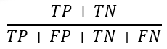
Precision
Percentage of +ve cases from the total predicted +ve incidents.
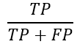
Recall/Sensitivity/True Positive Rate
Percentage of +ve cases from the total actual +ve incidents.
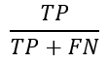
F1 score
Mean of precision and recall. Both contributes here.
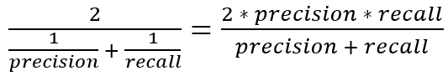

5)Flask Framework:
Front end of the website is the part with which the user instantly interacts. It encompasses everything that users view: colours, navigation menu, tables, buttons, graphs, videos, styles. Java script, CSS, HTML are utilized in constructing the front end. Flask is used for constructing web apps using python. We began by importing the Flask class. We then construct an instance of this class. The ‘name’ option is supplied which is the name of the application’s module or package. Flask requires this to learn where to search for resources like static files, templates. The route() decorator instruct Flask to identify the URL that activate our function. This function returns message that will be displayed to the user.

6)IoT:

- ARDUINO:

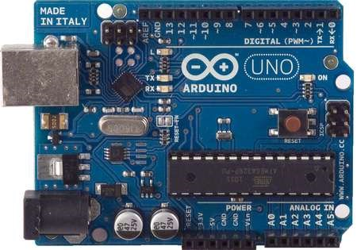
Fig 1. Arduino

Arduino is a micro-controller. It contains 14 digital I/O pins, 6 inputs for analogue, 1 ceramic resonator which is 16 Mega Herzt, 1 Universal Serial Bus(USB) connector, 1 Power connector, 1 ICSP header and 1 special button for resetting. It has everything required to support the microcontroller; just connect it with computer using a USB wire. It can be easily tampered and if it is damaged also it can replaced at low cost. Contemporary Arduino is based on UNO board. It is a first version.

- NODE MCU:
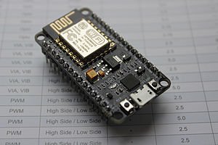
Fig 2. Node MCU

ESP8266:
• 32-bit CPU: Tensilic at 80 MHz
• 64 KB RAM and 96 KB of data RAM
• QSPI flash - 512 KB - 4 MB
• IEEE bgn Wifi
• WPA/WPA2 for authentication
• 16 GPIO
• SPI and I²C
• I²S is interfaced DMA
• UART is on pins that are dedicated
• 1x10 bit ADC
• 3xPWM

- DHT11:
DHT11 is simple, very low-cost digital humidity, temperature sensor. It employs a thermistor for monitoring the air and a humidity sensor, then puts a digital signal. Its extremely easy to use, but takes proper timing to gather data. The significant negative of the sensor is that, it collects fresh data for 2 seconds. So after 2 seconds the data becomes outdated. Comparing with DHT22, DHT11 sensor is less accurate, operates between a limited range of temperature or humidity, but this is smaller. It is also very cheap.

- 3V - 5V power
- 2.5mA is the maximum current usage
- Best for 20-80% humidity
- Best for 0-50°C temperature
- Sampling rate should not go beyond 1 Hz
- Size of the body should be 15.5mm, 12mm, 5.5mm
- 4 pins
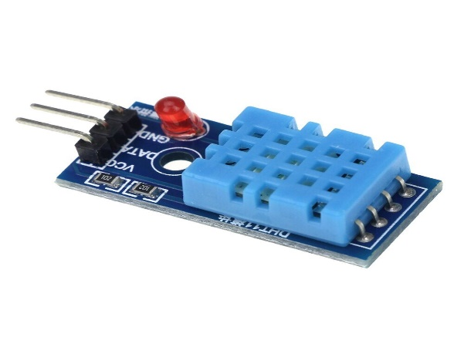
Fig 3. DHT 11

- NPK Sensor:
This NPK sensor is appropriate for measuring the level of nitrogen, potassium, phosphorous in that particular soil. It assists in assessing the fertility of the soil hence simplifying the systematic evaluation of the soil condition. Ratio is determined by dividing N,P,K value using least value of these 3. The range of the NPK Sensor is 0-1999mg/kg, and humidity is 5%-95%. The highest usage of power will be less than 0.15W.
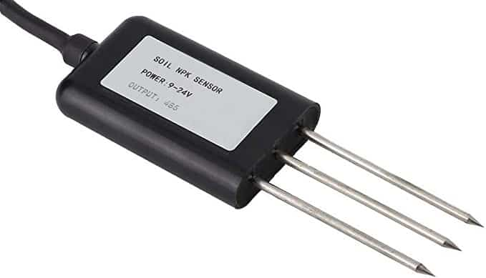
Fig 4. NPK Sensor

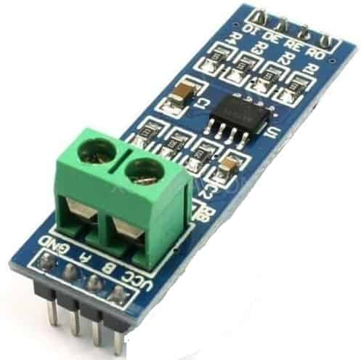
Fig 5. RS 485

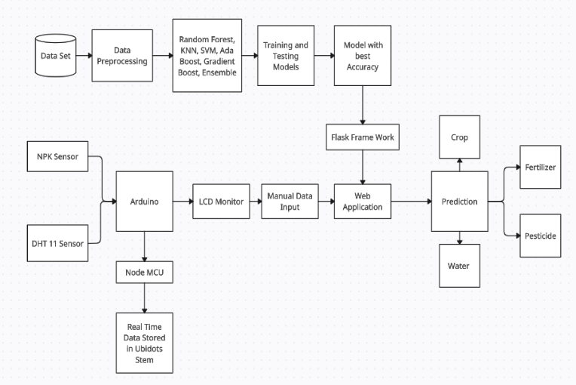
Fig 6. Block Diagram

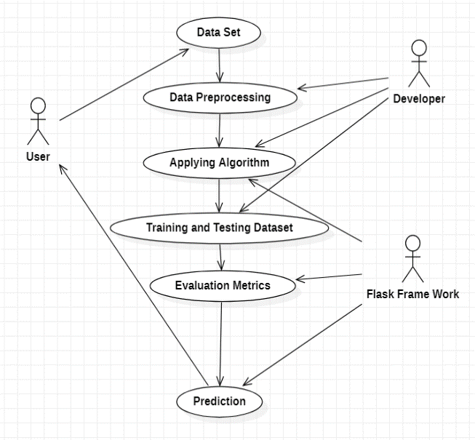
Fig 7. Use Case Diagram

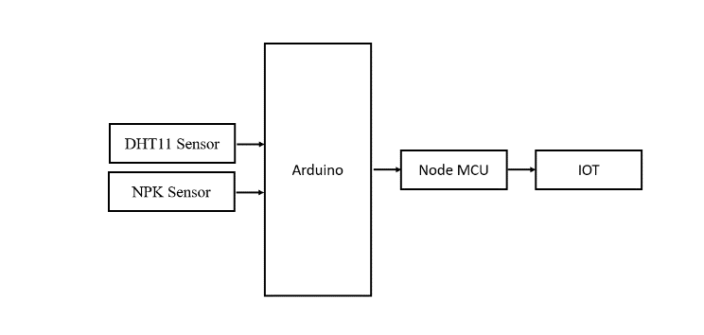
Fig 8. Block Diagram

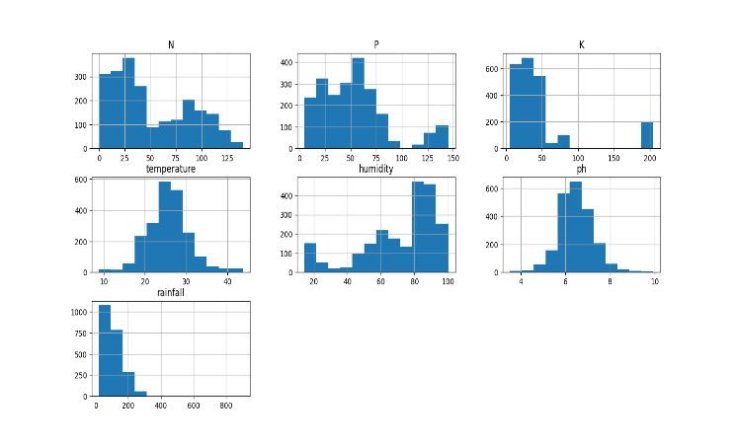
Fig 9. Data Range
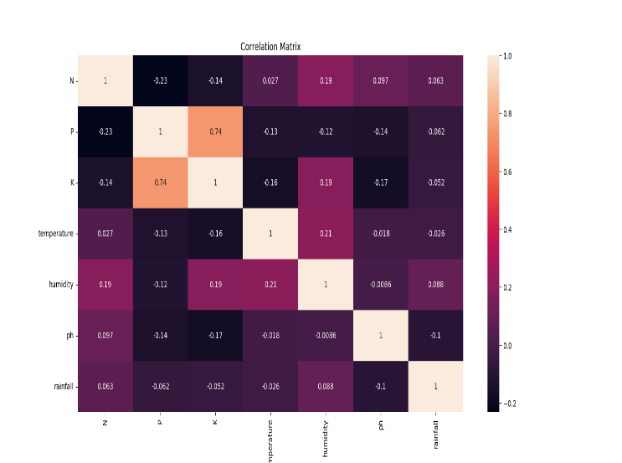
Fig 10. Correlation Matrix

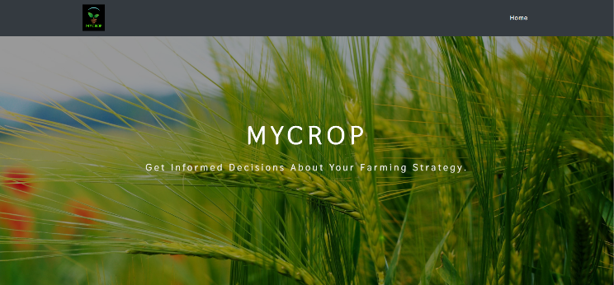
Fig 11. Home Page
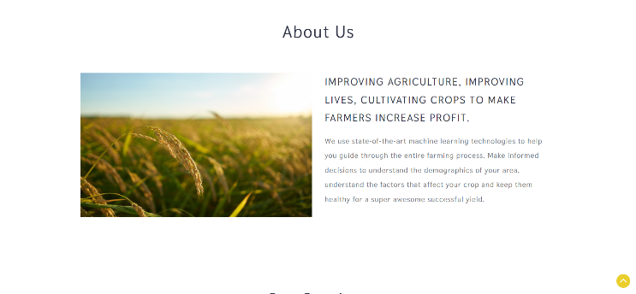
Fig 12. Introduction Page

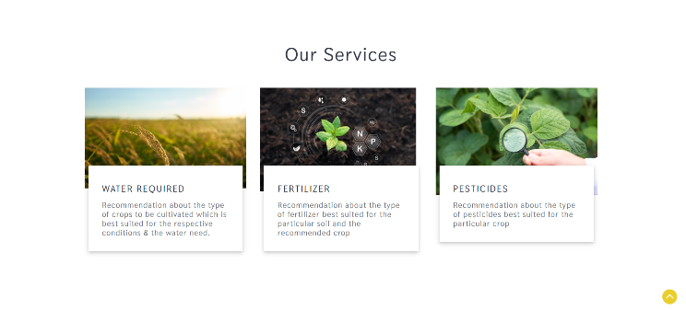
Fig 13. Services Provided


Fig 14. Data Input

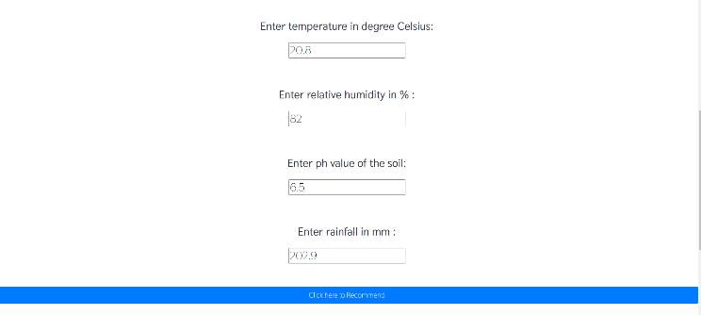
Fig 15. Data Input

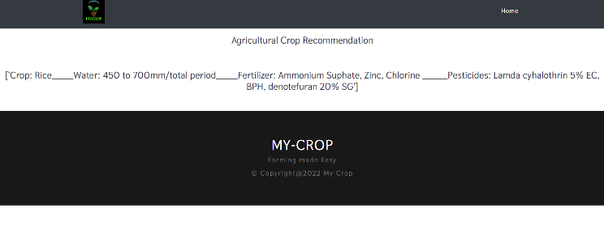
Fig 16. Result

RESULT AND ANALYSIS
We focused on getting direct and live data from field. The obtained data are stored in cloud in a website called Ubidots. These data are applied to website. This website helps farmers about the suitable crop that can be procured. This reduces agricultural losses and debts that arise due to improper farming. The created website gives appropriate details about the Crop, Water Requirement, Fertilizer and Pesticide needs of the crop based on given input. Nitrogen-Pottasium-Phosphorous content, Ph level in the soil, Humidity-Temperature in that area, Rain-fall in that area are given as input. Random forest-98%, KNN-96.6%, AdaBoost-27.2%, Gradient Boost-96.3%, SVM-94.7% algorithms are compared and out of this Random forest gave better accuracy of 98%. So we have used Random forest algorithm for prediction.

Future Scope
As per the given paper out of the 7 parameters 5 are taken using DHT11 and NPK Sensor. Ph in that particular soil and Rain-fall in that particular area is taken from existing data. So in future separate Sensors can be added to measure these parameters. We have designed a webpage for this purpose, in future a Mobile app can be developed for farmers. Mobile app will be more convenient for usage. Now we are manually feeding the data to the website after getting the data from sensors, but in future automatic data uploading method can be improved for better usage.

Reference
[1] Fatin Farhan Haque, Ahmed Abdel Gawad, Venkata Prasanth Yanambaka, Kumar Yelamarthi, “Crop Yield Analysis Using Machine Learning Algorithms.”, IEEE,2020.

[2] Shilpa Chandra, Samiksha Bhilare, Mugdha Asgekar, Ramya R. B, “Crop Water Requirement Prediction inAutomated Drip Irrigation System using ML and IoT.”, International Conference on Nascent Technologies in Engineering, 2021.

[3] Fatin Farhan Haque, Ahmed Abdelgawad, Venkata Prasanth Yanambaka, Kumar Yelamarthi, “Crop Yield Prediction Using Deep Neural Network”, IEEE, 2020.

[4] R. Reshma, V. Sathiyavathi, T. Sindhu, K. Selvakumar, “IoT based Classification Techniques for Soil Content Analysis and Crop Yield Prediction.”, IEEE, 2020.

[5] Gautam Gupta, Rashi Setia, Archana Meena, Bhavnesh Jaint, “Environment Monitoring System for Agricultural Application using IoT and Predicting Crop Yield using Various Data Mining Techniques.”, IEEE, 2020.

[6] Kasara Sai Pratyush Reddy, Y Mohana Roopa, Kovvada Rajeev L N, Narra Sai Nandan, “IoT based Smart Agriculture using Machine Learning.”, IEEE, 2020.

[7] JongMoon Choi, Noboru Koshizuka, “Optimal Harvest date Prediction by Integrating Past and Future Feature Variables.”, IEEE, 2020.

[8] Ashok Tatapudi, P Suresh Varma, “Prediction of Crops based on Environmental Factors using IoT & Machine Learning Algorithms”, IHITEE, 2019.

[9] Sri Laasya.Kanuru, Amit Kumar Tyagi, Aswathy S U, Terrance Frederick Fernandez, N Sreenath, Shashvi Mishra, “Prediction of Pesticides and Fertilizers using Machine Learning and Internet of Things.”, ICCCI, 2021.

[10] Dr. Y. Jeevan Nagendra Kumar, V. Spandana, V.S. Vaishnavi, K. Neha, V.G.R.R. Devi, “Supervised Machine learning Approach for Crop Yield Prediction in Agriculture Sector.”, IEEE, 2020.

[11] W. Klosgen, J.M. Zytkow, Handbook of data mining and knowledge discovery, Oxford University Press, 2002.

[12] Kiruthika M, Shweta T, Mritunjay O, Kavita S, “Parameter monitoring for the precision agriculture”, International Journal Of The Scientific Research and Innovation 2015.

[13] O.P. Uma Maheshwari, M Savitha, “A Study of IoT (Internet of Things) in agriculture”, International Journal of Innovative research in computer and communication Engineering.

[14] Dr. N. Suma, S. R. Samson, S. Saranya, G. Shanmugapriya, R. Subhashri “ IoT Based Smart Agriculture Monitoring System”, International Journal on Recent and Innovation Trends in computing and communication.

[15] Sandip Khot, M. Gaikwad, “Development of cloud based Light Intensity Monitoring system for Green house Using Raspberry Pi” , IEEE International conference on computing communication control and automation (ICCUBEA) Aug 2016.

