Power Generation using Footsteps
Dr.M.S.Mathpati, Shivani R. Atkale, Ankita A. Bansode, Vaishnavi S. Chavan

Abstract
In this paper, we have presented the design of power generation from footsteps by using piezo sensor. The power delivered in this paper will not contaminate the surrounding and it is also will not to relay upon the climate conditions. The paper proposes a novel technique for the creation of power utilizing piezo sensor sensors kept in crowded area which can ready to produce energy when force is applied on it.
Key words: Piezo sensor, electricity, pressure, footsteps.
1.Introduction
At present, electricity is the necessary part of human life in daily activities and demand of electricity is increasing exponentially day by day. modern technologies require a vast amount of power in the form electricity for its different operations. also, exponential increasing demands of electricity creating a gap between demand and supply. so main objective of present-day technology is to invent and provide a pollution free method of electricity from the growing human population that does not negatively impact the environment.
Piezo sensors generate electricity when we apply pressure on the sensor. Piezoelectric material acts as a transducer and pressure exerted by the moving people transformed into electric current.
2. Methodology
A working model of footstep power generation is demonstrated in this project, the basic model has been presented as a block diagram as a block diagram (fig. 1). To implement this model nine piezo sensors that connected in parallel. further that parallel connection of piezo sensors is connected to Arduino board. Arduino is a programmable open source which converts the analog input into digital output. Arduino is used to write and upload computer code to the physical board. Digital pins of the Arduino are connected to the LCD display which will display the count of footsteps and voltage generated and then generated energy is used to glow the lights along the stairs.
LCD Display
Piezo sensors connected in parallel

parallel
Arduino
uno

output
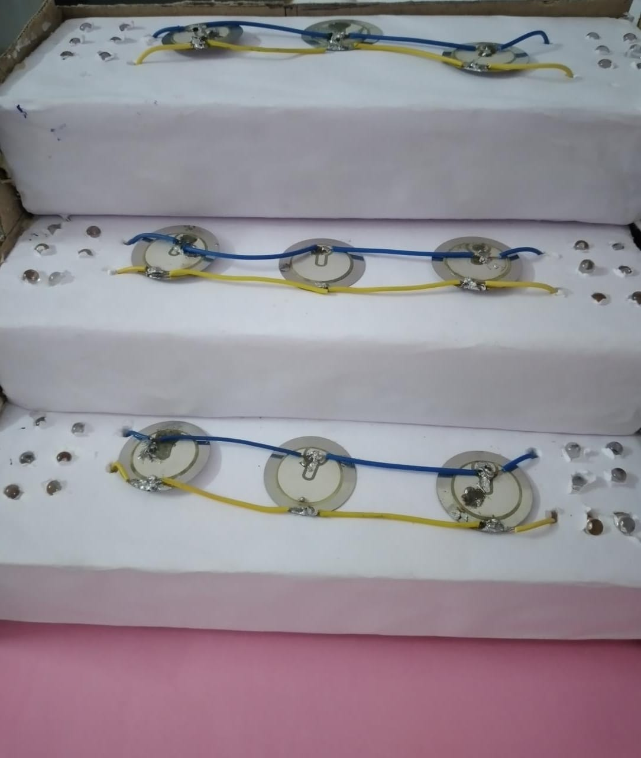
- Piezo sensors connected in parallel connection

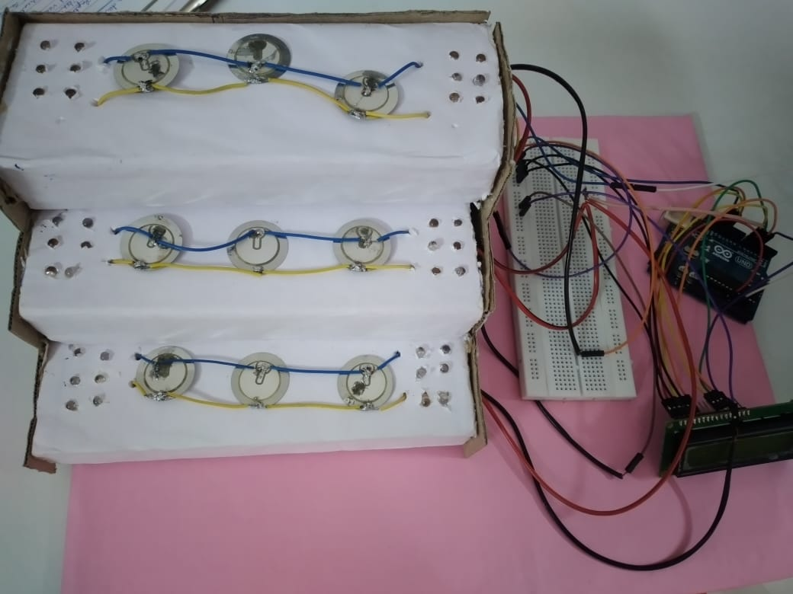
- Hardware implementation

2.1 How does Piezo sensors works

Piezoelectric effect is the ability of some piezoelectric materials (such as quartz, topaz, zinc oxide and etc.) to generate an electrical charge in feedback to the mechanical stress.
Also, the piezoelectric effect is reversible, which means when we apply mechanical stress to material, we receive some electrical charge on output. And, when we apply electricity to the piezoelectric material, then it compresses or stretch the piezoelectric material.

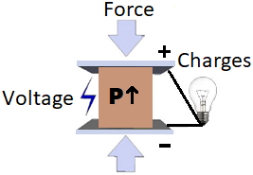

- A piezoelectric crystal is placed between two metal plates. At this point the material is in perfect balanced and does not conduct an electric current.
- Mechanical pressure is then applied to the material by the metal plates, which forces the electric charges within the crystal out of balance. Excess negative and positive charges appear on opposite sides of the crystal face.
- The metal plate collects these charges, which can be used to produce a voltage and send an electrical current through a circuit



3. Graph
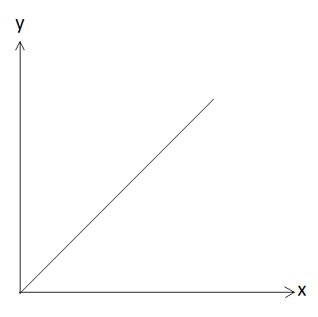
X Axis = weight
Y Axis = power
The above graph shows the relation between weight vs power generated. Here weight and power generated are directly praportional to each other. Hence, as we apply more force on piezosensors we get more power as output .

4. Advantages of this system
- This system does not need any fuel as input for its functioning.
- Pollution free.
- Low maintainance.
- Reduction in Waste of energy
- alternate way for power generation
5. Disadvantages
- High initial cost.
6. Application
- Public squares
- Educational centers like school , colleges , universities etc.
- Metro stations
- Streets
- Tempels
7. conclusion
This project is a well balanced model of energy generation . This model can be used as an alternative for power supply if implemented on large scale.The key component of this model is mechanical stress or pressure which is most occures when a person walks . After successful implementation of this project the energy created is used for low power appliances .

References
1] Prabhakaran R, Jayaprakash A, Vijay Anand. “Power Harvesting by Using Human Foot Step”- International Journal of Innovative Research in Science Engineering and Technology, vol.2, issue 7, July 2013
2] Ramesh Raja R, Sheri Mathew.” Power Generation from Staircase (steps)”- International Journal of Innovative Research in Science Engineering and Technology, vol.3, Issue 1, February 2014
3] Power Generation Using Foot Step Method
4] Itika Tandon, Alok Kumar. A Unique Step towards Generation of Electricity via New Methodology”- International Journal of Advanced Research in Computer and Communication Engineering, vol.3, Issue 10, October 2014
5] Kiran Bobby, Aleena Paul K, Anmol. C.V, Josie Ann Thomas, Nimisha K.K." Footstep Power Generation Using Piezoelectric Transducer”- International Journal of Engineering and Innovative Technology, vol.3, Issue 10, April 2014
6] Jose Ananth Vino, AP.” Power Generation Using Footstep”- International Journal of Engineering Trends and Technology, vol.1, Issue 2, May 2011.

