REAL TIME SECURE CLICKBAIT AND BIOMETRIC ATM USER AUTHENTICATION AND MULTIPLE BANK TRANSACTION SYSTEM

ABINAYA P, ARUNA DEVI S , MYTHILI S , SHIVANI P, MRS.R.BHUVANESWARI,M.E.,(Ph.D)
CSE & Selvam College Of Technology

---------------------------------------------------------------------***---------------------------------------------------------------------

Abstract - ATM or Computerized Teller Machines are generally utilized by individuals these days. Performing cash withdrawal exchange with ATM is expanding step by step. ATM is vital gadget all through the world. Secured ATM transaction were made with the use of 4 digit unique code called PIN(personal Identification Number).The method of transaction liable to suffer with the possibilities of fraudulent activities like phishing attack. This Proposes An Automatic Teller Machine Security Model That Uses Electronic Facial Recognition Using Deep Convolutional Neural Network (DCNN) .The advantages can be found as that face id unique for everybody. Face verification click bait link will be generated and sent to the registered number to verify the unauthorized user through some artificial intelligence, for remote verification .However, it obvious that customer’s biometric features cannot be replicated, this application will go a long way to solve the problem to account safety making it possible for the actual owner alone have access to his accounts. This application eliminated the possibility of fraud resulting from ATM card theft and copying.

Keywords: ATM ,Click Bait, PIN.

INTRODUCTION
  - Overview
Mechanized Teller Machines, prevalently alluded to as ATMs, and are perhaps of the most valuable headway in the financial area. ATMs permit
banking clients to benefit speedy self-adjusted exchanges, like money withdrawal, store, and asset moves. ATMs empower people to make banking exchanges without the assistance of a genuine teller. Likewise, clients can benefit banking administrations without visiting a bank office. Most ATM exchanges can be profited with the utilization of a charge or Master card. There are a few exchanges that need no charge or Master card.

History
In 1960, an American named Luther George Simjian designed the Bank diagram, a machine that permitted clients to store money and looks into it. The primary ATM was set up in June 1967 on a road in Enfield, London at a part of Barclays bank. An English designer named John Shepherd-Barron is credited with its creation. The machine permitted clients to pull out a limit of GBP10 at a time.

EXISTING SYSTEM
Existing ATM confirmation technique is the utilization of secret phrase PINs and OTP.As of now, ATM frameworks utilize something like an entrance card which generally has an attractive stripe (magstripe) and a decent Private Recognizable proof Number (PIN) for character check. A few different cases use a chip and a PIN which at times has a magstripe in the event that the chip flops as a

reinforcement for recognizable proof purposes. QR cash withdrawals were empowered so clients could discard their ATM cards and just output a QR-code on ATMs utilizing the QR application to pull out cash. A QRcode scanner is expected to identify code and unscramble data in put away in QRcode. Scanner should be introduced in the ATM machine to take input certifications from the client. We will give additional element to a current framework, so customary pulling out choice is likewise there. On opposite end, ATM machine will examine the QRcode created by 'GetNote'- android application and decode it with the critical put away in the data set. After decoding ATM will get required accreditations, for example, card number, sum, pin, cvv number on card and so on. It will confirm every one of the subtleties with the banks information base. After fruitful validation, money will be apportioned by the ATM machine. ATM security framework design that integrates both the unique mark and GSM innovation into the current PIN-based confirmation process. PIN confirmation is joined with finger impression acknowledgment, to recognize a client during ATM exchange. Finger impression is confirmed utilizing proficient details include extraction calculation. To guarantee the security while doing exchange through swipe machine, the client will affirm the exchange by an endorsement message through GSM innovation. In the two cases, area will be distinguished through GPS. On the off chance that any ill-conceived individual attempts to utilize the card it will naturally be hindered by the framework and detail data will be shipped off the client through the message. The calculations utilized in the current framework for biometric confirmation
are Gaussian Combination Models (GMMs), Fake Brain Organizations (ANNs), Fluffy Master Frameworks (FESs), and Backing Vector Machines (SVMs). LDA, PCA. Biometrics measure the one of a kind physical or social qualities of a person as a way to perceive or verify their character. Normal actual biometrics incorporate fingerprints, hand or palm calculation, and retina, iris, or facial attributes. Biometrics might be utilized for personality foundation. Another estimation that implies to have a place with a specific substance is looked at against the information put away comparable to that element. Assuming the estimations match, the declaration that the individual is whom they say they are is viewed as being verified. The calculations were prepared and tried utilizing a notable biometric information base which contains tests of face and discourse and comparability scores of five face and three discourse biometric specialists.

PROPOSED SYSTEM
This venture proposes a programmed teller machine multi modular security model that would join an actual access card and electronic facial acknowledgment utilizing Profound Convolutional Brain Organization. Facial Biometric Confirmation Framework utilizing Profound Learning Procedures Profound learning is a subset of AI, which, thusly, is a subset of computerized reasoning (man-made intelligence). With regards to Face acknowledgment, profound learning empowers us to accomplish more noteworthy exactness than conventional AI methods. Facial Biometric Validation Framework utilizing Profound Learning Techniques Deep FR framework with face finder and arrangement. Initial,

a face identifier is utilized to confine faces. Second, the countenances are adjusted to standardized authoritative directions. Third, the FR module is executed. In FR module, face hostile to mocking perceives Whether the face is live or parodied; face handling is utilized to deal with varieties prior to preparing and testing, e.g., presents, ages; Various models and misfortune capabilities are utilized to separate discriminative profound element while preparing; face matching techniques are utilized to do highlight arrangement after the profound elements of testing information are removed. CNN Face Acknowledgment Step Filters=32: This number shows the number of channels we that are utilizing to take a gander at the picture pixels during the convolution step. A few channels might get sharp edges, a few channels might get variety varieties a few channels might get frames, and so on. Eventually, we get significant data from the pictures. In the main layer the quantity of filters=32 is usually utilized, then, at that point, expanding the force of 2. Like in the following layer it is 64, in the following layer, it is 128 et cetera. Part size= (5,5): This shows the size of the sliding window during convolution, for this situation concentrate on we are utilizing 5X5 pixels sliding window. Strides= (1, 1): How quick or slow should the sliding window move during convolution. We are utilizing the most reduced setting of 1X1 pixels. Implies slide the convolution window of 5X5 (kernal_size) by 1 pixel in the x- pivot and 1 pixel in the y-hub until the entire picture is examined. Input shape= (64, 64, 3): Pictures are only grid of RGB variety codes. During our information pre-handling we have packed the pictures to 64X64, thus the normal shape is
64X64X3. Implies 3 varieties of 64X64, one for RGB colors each. kernel_initializer='uniform': When the Neurons start their calculation, some calculation needs to choose the incentive for each weight. That's what this boundary indicates.

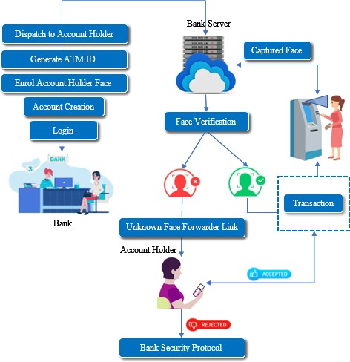

Fig 1:-Architecture

activation='relu': This indicates the initiation capability for the estimations inside every neuron. You can pick values like 'relu', 'tanh', 'sigmoid', and so on optimizer='adam': This boundary assists with tracking down the ideal upsides of each weight in the brain organization. 'adam' is one of the most helpful enhancers, another is 'rmsprop'batch_size=10: This determines the number of columns that will be passed to the Organization in one pursue which the SSE computation will start and the brain organization will begin changing its loads in view of the mistakes. At the point when every one of the columns are passed in the clusters of 10 lines each as determined in this boundary, then we call that 1-age. Or on the other hand one full information cycle. This is otherwise called little clump angle drop.

Consequently a legitimate worth should be picked utilizing hyperparameter tuning. Epochs=10: a similar movement of changing loads go on for multiple times, as indicated by this boundary. Unknown Face Check Connection Generator - At the point when the put away picture and the caught picture don't coordinate, it implies that he is an unapproved client. Face Confirmation Connection will be produced and shipped off client to check the character of unapproved client through a few committed counterfeit insightful specialists, for far off certificate, which either approves the exchange properly or signals a security-infringement caution to the financial security framework.

ATM SIMULATOR
ATM Test system is a Cutting edge testing application for XFS-based ATMs (otherwise called Progressed Capability or Open-Engineering ATMs). ATM Test system is a web innovation to permit ATM testing with a virtualized variant of any ATM. ATM Test system utilizes virtualization to give practical ATM reenactment, combined with mechanization for quicker, more proficient testing for face validation and obscure Face Forwarder Procedure.

FACE IDENTIFICATION
Subsequent to catching the face picture from the ATM Camera, the picture is given to confront identification module. This module distinguishes the picture locales which are probably going to be human. After the face location utilizing District Proposition Organization (RPN), face picture is given as contribution to the component extraction module to find the key elements that will be utilized
for characterization. The module creates an extremely short component vector that is alright to address the face picture. Here, it is finished with DCNN with the assistance of an example classifier, the extricated highlights of face picture are contrasted and the ones put away in the face data set. The face picture is then delegated either known or obscure. In the event that the picture face is known, comparing Card Holder is distinguished and continue further.

PREDICTION
In this module the coordinating system is finished with prepared ordered outcome and test Live Camera Caught Arranged record. Hamming Distance is utilized to compute the distinction as indicated by the outcome the forecast exactness will be shown.

UNKNOW FACE FORWARDER
Obscure Face Confirmation Connection will be produced and shipped off card holder to check the personality of unapproved client through a few committed counterfeit smart specialists, for far off certificate, which either approves the exchange suitably or signals a security-infringement caution to the financial security framework.

TRANSACTION MODULE
Enter the Withdrawal Cash, In this part, you need to enter your withdrawal sum and press enter. In any case, ensure your withdrawal sum doesn't surpass your equilibrium in the record any other way exchange will fizzle. Gather the Money. In this part, you need to gather your cash from the lower space of the machine. Take your cash before 30 seconds.

PERFORMANCE ANALYSIS
The significant focuses associated with the exhibition measurements are examined in light of the setting of this task: Genuine Positive (TP): There is a Face, and the calculations identify Card Holder. Misleading Positive (FP): There is no Face, however the calculations identify as Card Holder and show Card Holder name. Misleading Negative (FN): There is a Face, however the calculations don't identify Card Holder and name. Genuine Negative There is no Face, and nothing is being identified.

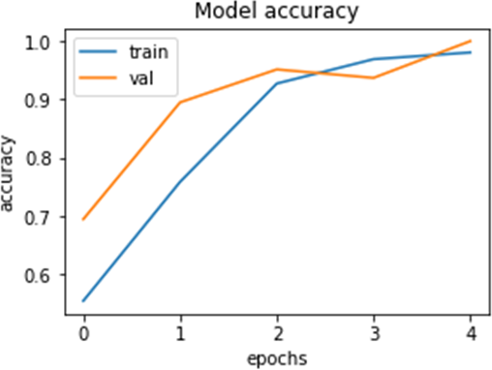

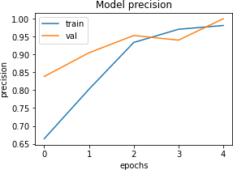

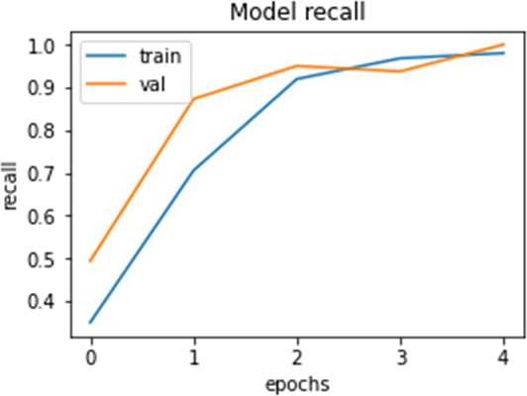

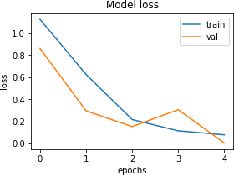
`

6. CONCLUSION
Biometrics as method for distinguishing and confirming record proprietors at the Mechanized Teller Machines gives the required and eagerly awaited answer for the issue of unlawful exchanges. In this venture, we have created to proffer an answer for the much-feared issue of fake exchanges through Robotized Teller Machine by biometrics and Obscure Face Forwarder that can be made conceivable just when the record holder is genuinely or far present. Accordingly, it takes out instances of unlawful exchanges at the ATM focuses without the information on the legitimate proprietor. Utilizing a biometric include for ID is solid and it is additionally strengthened when one more is utilized at validation level. The ATM security configuration consolidates the conceivable intermediary use of the current

security devices, (for example, ATM Card) and data (like PIN) into the current ATM security instruments. It includes, on constant premise, the financial balance proprietor in every one of the accessible and open exchanges.

FUTURE ENHANCEMENT
Later on, the acknowledgment execution ought to be additionally helped by planning novel profound component portrayal plans.

REFERENCES
- J. Liang, H. Zhao, X. Li, and H. Zhao, ''Face acknowledgment framework in light of profound lingering organization,'' in Proc. third Studio Adv. Res. Technol. Ind. (WARTIA), Nov. 2021, p. 5.
- I. Taleb, M. E. Amine Ouis, and M. O. Mammar, ''Access control utilizing mechanized face acknowledgment: In view of the PCA and LDA calculations,'' in Proc. fourth Int. Symp. ISKO- Maghreb, Ideas Apparatuses Knowl. Make due. (ISKO-Maghreb), Nov. 2020, pp. 1-5.
- X. Dish, ''Exploration and execution of access control framework in view of RFID and FNN-face acknowledgment,'' in Proc. second Int. Conf. Intell. Syst. Plan Eng. Appl., Jan. 2012, pp. 716-719, doi: 10.1109/ISdea.2021.400.
- A. A. Wazwaz, A. O. Herbawi, M. J. Teeti, and
S. Y. Hmeed, ''Raspberry Pi and PCs based face identification and acknowledgment framework,'' in Proc. fourth Int. Conf. Comput. Technol. Appl. (ICCTA), May 2020, pp. 171-174.

- A. Had, S. Benouar, M. Kedir-Talha, F. Abtahi,
M. Attari, and F. Seoane, ''Full impedance cardiography estimation gadget utilizing raspberry
PI3 and framework on-chip biomedical instrumentation arrangements,'' IEEE J. Biomed. Wellbeing Informat., vol. 22, no. 6, pp. 1883-1894,
Nov. 2020.
- Peter, K. J., Glory, G. G. S., Arguman, S., Nagarajan, G., Devi, V. V. S., & Kannan, K. S. (2011). Improving ATM security via face recognition. 2011 3rd International Conference on Electronics Computer Technology.
- Kim, G., Eum, S., Suhr, J. K., Kim, D. I., Park,
K. R., & Kim, J. (2012). Face liveness detection based on texture and frequency analyses. 2012 5th IAPR International Conference on Biometrics (ICB)
- Mustakim, N., Hossain, N., Rahman, M. M., Islam, N., Sayem, Z. H., & Mamun, M. A. Z. (2019). Face Recognition System Based on Raspberry Pi Platform. 2019 1st International Conference on Advances in Science, Engineering and Robotics Technology (ICASERT).
- Kar, S., Hiremath, S., Joshi, D. G., Chadda, V. K., & Bajpai, A. (2006). A Multi-Algorithmic Face Recognition System. 2006 International Conference on Advanced Computing and Communications.
- Jain, A. K., Klare, B., & Park, U. (2011). Face recognition: Some challenges in forensics. Face and Gesture 2011.

